WORLD_BANK_DATASET_ANALYSIS
Create Local Folders
VS Code: Open the newly created folder & check if GitHub is installed properly (git --version) in the terminal.
GitHub:
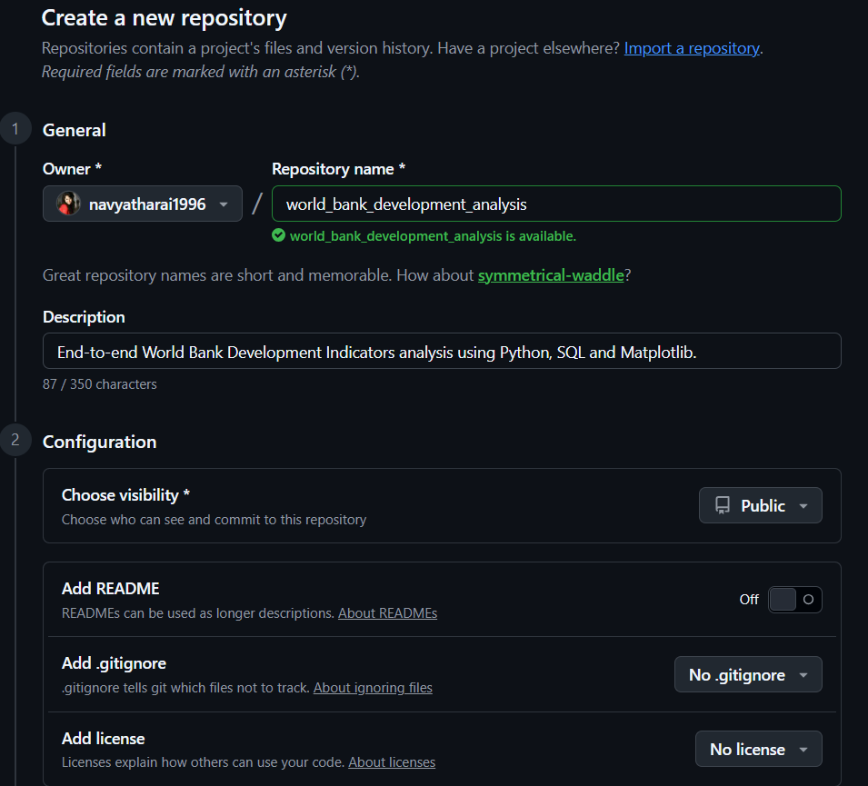

VS Code:
- PS D:\world_bank _development_analysis> git --version
git version 2.54.0.windows.1
- git init
Initialized empty Git repository in D:/world_bank_development_analysis/.git/

This command tells Git: "Start tracking every change inside this project."
From now on, Git can tell:
- which files changed
- who changed them
- when they changed
- restore older versions
- compare versions
Create a new file - .gitignore & paste the following inside:
# ======================================================
# Python
# ======================================================
__pycache__/
*.py[cod]
*$py.class

# ======================================================
# Virtual Environments
# ======================================================
.venv/
venv/
env/

# ======================================================
# Jupyter Notebook
# ======================================================
.ipynb_checkpoints/

# ======================================================
# VS Code
# ======================================================
.vscode/

# ======================================================
# Operating System Files
# ======================================================
.DS_Store
Thumbs.db

# ======================================================
# Environment Variables
# ======================================================
.env

# ======================================================
# Log Files
# ======================================================
*.log

# ======================================================
# Temporary Files
# ======================================================
*.tmp
*.temp

# ======================================================
# Python Packaging
# ======================================================
build/
dist/
*.egg-info/

# ======================================================
# Database Cache Files
# ======================================================
*.db
*.sqlite
# Microsoft Office Temporary Files
~$*
# Cleaned datasets
data/cleaned/*.csv

- Check Python Version: py –version
Python 3.14.4
- Create the Virtual Environment: py -m venv .venv // creates a new folder on the left
- PowerShell execution policy configuration:
Set-ExecutionPolicy -ExecutionPolicy RemoteSigned -Scope CurrentUser
- .\.venv\Scripts\Activate.ps1 //(.venv) should appear in the terminal

Create 2 more files in VS Code: README.md & requirements.txt
Install Python Libraries: This assignment requires-
- Read Excel
- Clean data
- Load to SQL
- Analyse data
- Visualise data

Task | Library
Read & clean Excel | pandas
Read Excel files | openpyxl
Numerical calculations | numpy
Graphs | matplotlib
Advanced visualisations | seaborn
Connect Python to MySQL | sqlalchemy
MySQL driver | pymysql
Jupyter notebooks | jupyter

Install: pip install pandas numpy openpyxl matplotlib seaborn sqlalchemy pymysql jupyter
Run Upgrade: python.exe -m pip install --upgrade pip
Verify the Python Interpreter: bottom right should show - .venv (Python 3.14.4)
Check the Git:
- git status
- git add . // adds everything in this project
- git status

If any word file was open & it created temporary $roject files, then close the Word file –
- git reset
- git status
- git add .
- git status

Create the First Git Commit: git commit -m “Initial Project Setup”
Check your Git Branch name:
- git branch
- git branch -M main // renames main branch to main
- git branch
Connect to GitHub:
- git remote add origin https://github.com/navyatharai1996/world_bank_development_analysis.git // get the link from GitHub repository
- git remote -v // verify it
- git push -u origin main // use it for 1st push only

Create a notebook: 01_data_import_and_exploration.ipynb
- import pandas as pd
- import numpy as np
- excel_file=”../data/raw/WDIEXCEL.xlsx” // relative path
- xls=pd.ExcelFile(excel_file) // type(xls)
- xls.sheet_names

Explore the Excel File:
- data_df= pd.read_excel(excel_file, sheet_name=”Data”) //read_excel – pandas loads 1st sheet by default if sheet_name is not defined.

- Data_df.shape

- Data_df.columns

- Data_df.columns.to_list()

- Data_df.info()

- Data_df.head()

- Data_df[“Country Name”].nunique()

- Data_df[“Indicator Name”].nunique()

- Data_df[[“Country Name”, “Indicator Name”]].head() //List inside the Dataframe, so double brackets

Check Duplicates:
- Df_data.duplicated().sum()
- Df_data.isnull().sum()
- print(f"Rows: {df_data.shape[0]}")
- print(f"Columns: {df_data.shape[1]}")
- print(f"Countries: {df_data["Country Name"].nunique()}")
- print(f"Indicators: {df_data["Indicator Name"].nunique()}")
- print(f"Duplicate Rows: {df_data.duplicated().sum()}")
f = formatted string - It lets you insert variables or expressions directly into a string.

Data Sheet is FACTS TABLE & Country sheet is the DIMENSION TABLE / METADATA.

# Observations:
* The workbook has 6 sheets
* Dataset is in wide format
* Dataset contains 3,96,970 rows & 70 columns
* The first 4 columns are of data type "string" and the rest are all "float" values
* Large number of missing values exist but 0 duplicate rows
* Total Unique Countries: 265
* Total Unique Indicators: 1498

Explore other Subsheets:
- df_country = pd.read_excel(excel_file, sheet_name = “Country”)
- df_country.shape
- df_country_columns.to_list()
- df_country.info()
- df_country.head()
- print(f”Unique Regions: {df_country[“Region”].nunique()}”)
- print(f”"How many countries are in each region: {df_countries[“Region”].value_counts()}”)

- df_series = pd.read_excel(excel_file, sheet_name=”Series”)

# Findings:
* Primary analytical worksheets are Data (Facts Table) - Main Dataset & Country / Series (Dimension Table / Metadata)
* Country sheet can be linked to the main Data using "Country Code"
* "Series Code" in series sheet is same as "Indicator Code" in data sheet
* We will need to convert the wide format data sheet to long format for simplifying SQL queries

Git status
Git add .
Git commit -m “Completed data exploration and workbook analysis”
Git push

Create a new notebook – 02_data_cleaning_and_transformation.ipynb
# Objectives
- Transform a wide dataset into a long format using pandas.
- Validate that no information is lost during transformation.
- Handle missing values.
- Prepare a dataset suitable for SQL analysis and visualization.

import pandas as pd
import numpy as np
excel_file = ("../data/raw/WDIEXCEL.xlsx")
df_data = pd.read_excel(excel_file, sheet_name="Data")

Lets UNPIVOT (sql) or MELT (pandas) – Transform the data
Syntax:
pd.melt( dataframe, id_vars=[], value_vars=[], var_name="", value_name="" )
df_long = pd.melt( df_data, id_vars=df_data.columns[:4], value_vars=df_data.columns[4:], var_name="Year", value_name="Value" )

Some year values are NaN - melt() doesn't remove them automatically, it converts them into rows too.
Do we need rows with missing values?? Replacing them with 0 can be a very misleading data (India’s Life Expectancy in 1970 is 0), null values also do not add up to any analysis.
Df_long.shape
Df_long.info()
Df_long.head()
Df_long.sample(5) // Random values every time
Df_long.sample(5, random_state=42) // "Uses the same random starting point every time."
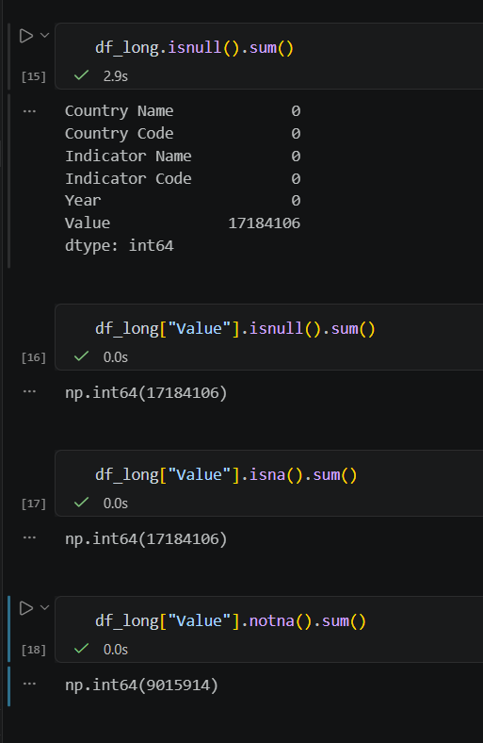

The actual dataset had 396,970 rows & 70 columns.
We kept 4 columns fixed & transformed the remaining 66. So,
396,970 × 66 = 26,200,020 is the current number of rows.
Total observations created: 26,200,020 | Useful observations: 9,015,914 | Empty observations: 17,184,106
Let's calculate the percentage of usable data:
- useful_data_percentage = (df_long["Value"].notna().mean()*100)
- print(round(useful_data_percentage))
df_long=df_long.dropna(subset=[“Value’])
df_long.shape
df_long.duplicated().sum()
df_long.info() // year is a string so convert to int
df_long["Year"] = df_long["Year"].astype(int)
df_long["Year"].min(), df_long["Year"].max()
df_long[“Value”].describe()
df_long.loc[df_long["Value"]==df_long["Value"].min()] // check the whole row with negative value if it makes sense
df_long.to_csv("../data/cleaned/cleaned_dataset_long_format.csv", index=False) // Save the dataset
check if the path exists now:
import os
os.path.exists("../data/cleaned/cleaned_dataset_long_format.csv") // TRUE
git status
git add .
git commit -m “”
git push // failed bcz of the large cleaned dataset.
Now,
git rm --cached data/cleaned/world_bank_long_format.csv
Add this to .gitignore:
# Cleaned datasets
data/cleaned/*.csv
git add .gitignore
git commit --amend --no-edit
git push

DATA SHEETS TO BE CONVERTED TO SMALLER DATASETS IN CLEANED FOLDER & HENCE,
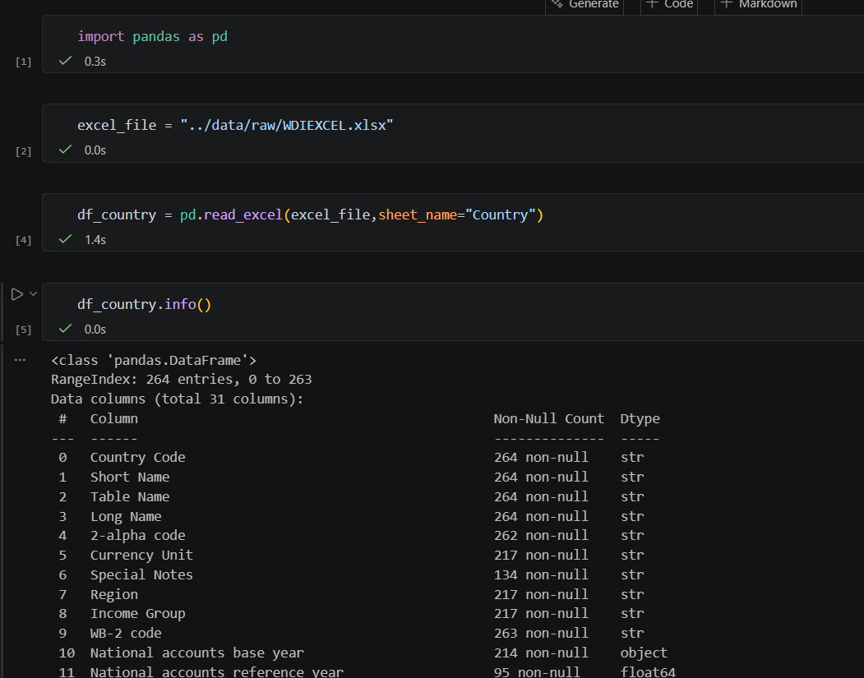
df_country = df_country[
[
"Country Code",
"Short Name",
"Table Name",
"Long Name",
"2-alpha code",
"Currency Unit",
"Region",
"Income Group"
]
]
df_country.to_csv("../data/cleaned/countries.csv", index=False)

df_series = pd.read_excel(excel_file, sheet_name="Series")
df_series = df_series[
[
"Series Code",
"Topic",
"Indicator Name",
"Short definition",
"Long definition",
"Unit of measure",
"Periodicity",
"Source"
]
]
df_series.to_csv("../data/cleaned/indicators.csv", index=False)

MY SQL WORKBENCH:
create database world_bank_database;
use world_bank_database;
save new sql file into local sql folder – 01_db_setup.sql
Right click – set as default schema
create table world_bank(
country_name varchar(100) not null,
country_code varchar(50) not null,
indicator_name varchar(100) not null,
indicator_code varchar(50) not null,
year int not null,
value double not null,
primary key(country_code, indicator_code, year));

Instead of guessing the length of the variable – you can test in python:
df_long["Indicator Name"].str.len().max()
df_long["Country Name"].str.len().max()

1 table can only have 1 Primary Key – That 1 primary key can consist of multiple columns = Composite Primary Key.

*********************************************************************************
create database world_bank_database;
use world_bank_database;

create table world_bank(
country_name varchar(100) not null,
country_code varchar(50) not null,
indicator_name varchar(100) not null,
indicator_code varchar(50) not null,
year int not null,
value double not null,
primary key(country_code, indicator_code, year)); /* Composite Primary Key */

describe world_bank;

create table countries(
country_code VARCHAR(10) PRIMARY KEY,
short_name VARCHAR(100),
table_name VARCHAR(150),
long_name VARCHAR(200),
alpha2_code CHAR(2),
currency_unit VARCHAR(100),
region VARCHAR(100),
income_group VARCHAR(100) );

CREATE TABLE indicators (
indicator_code VARCHAR(50) PRIMARY KEY,
topic VARCHAR(255),
indicator_name VARCHAR(255),
short_definition TEXT,
long_definition TEXT,
unit_of_measure VARCHAR(100),
periodicity VARCHAR(50),
source TEXT);
**********************************************************************************
Create new file – 02_data_import.sql:

Load the .csv file into MySQL:
SHOW VARIABLES LIKE 'local_infile'; // ON = good to go;
Off then,
SELECT VERSION();
SET GLOBAL local_infile = 1;
SHOW VARIABLES LIKE 'local_infile'; // It will now show ON

LOAD DATA LOCAL INFILE
'D:/world_bank_development_analysis/data/cleaned/world_bank_long_format.csv'
INTO TABLE world_bank
FIELDS TERMINATED BY ','
ENCLOSED BY '"'
LINES TERMINATED BY '\n'
IGNORE 1 ROWS;

Loading Subsheets:

LOAD DATA LOCAL INFILE
'D:/world_bank_development_analysis/data/cleaned/countries.csv'
INTO TABLE countries
FIELDS TERMINATED BY ','
ENCLOSED BY '"'
LINES TERMINATED BY '\n'
IGNORE 1 ROWS;

LOAD DATA LOCAL INFILE
'D:/world_bank_development_analysis/data/cleaned/indicators.csv'
INTO TABLE indicators
CHARACTER SET utf8mb4
FIELDS TERMINATED BY ','
OPTIONALLY ENCLOSED BY '"'
ESCAPED BY '"'
LINES TERMINATED BY '\r\n'
IGNORE 1 ROWS;

SHOW VARIABLES LIKE 'local_infile';
SELECT VERSION();
SET GLOBAL local_infile = 1;
SHOW VARIABLES LIKE 'local_infile';

LOAD DATA LOCAL INFILE
'D:/world_bank_development_analysis/data/cleaned/world_bank_long_format.csv'
INTO TABLE world_bank
FIELDS TERMINATED BY ','
ENCLOSED BY '"'
LINES TERMINATED BY '\n'
IGNORE 1 ROWS;

LOAD DATA LOCAL INFILE
'D:/world_bank_development_analysis/data/cleaned/countries.csv'
INTO TABLE countries
FIELDS TERMINATED BY ','
ENCLOSED BY '"'
LINES TERMINATED BY '\n'
IGNORE 1 ROWS;

LOAD DATA LOCAL INFILE
'D:/world_bank_development_analysis/data/cleaned/indicators.csv'
INTO TABLE indicators
CHARACTER SET utf8mb4
FIELDS TERMINATED BY ','
OPTIONALLY ENCLOSED BY '"'
ESCAPED BY '"'
LINES TERMINATED BY '\r\n'
IGNORE 1 ROWS;

select count(*) from world_bank;
select count(*) from countries;
select count(*) from indicators;

New file: 03_data_validation.sql

/* Inspect the Data */
select COUNT(*) FROM world_bank; // 9015914 rows loaded
select * from world_bank limit 10;
select min(year), max(year) from world_bank;
select count(distinct country_code) from world_bank;
select count(distinct indicator_code) from world_bank;
select count(*) from world_bank where value is null;

git add .
git commit -m “Created MySQL database, imported the database & made initial checks”
git push

New File – 04_indicators_discovery
-- LISTING ALL THE INDICATORS
SELECT
indicator_code,
indicator_name,
topic,
unit_of_measure
FROM indicators
ORDER BY indicator_name;

-- GDP INDICATORS
SELECT
indicator_code,
indicator_name,
topic,
unit_of_measure
FROM indicators
WHERE indicator_name LIKE '%GDP%'
ORDER BY indicator_name;

-- POPULATION INDICATORS
SELECT
indicator_code,
indicator_name,
topic,
unit_of_measure
FROM indicators
WHERE indicator_name LIKE '%population%'
ORDER BY indicator_name;

-- INTERNET INDICATORS
SELECT
indicator_code,
indicator_name,
topic,
unit_of_measure
FROM indicators
WHERE indicator_name LIKE '%internet%'
ORDER BY indicator_name;

-- LIFE EXPECTANCY INDICATORS
SELECT
indicator_code,
indicator_name,
topic,
unit_of_measure
FROM indicators
WHERE indicator_name LIKE '%life expectancy%'
ORDER BY indicator_name;

-- CO2 INDICATORS
SELECT
indicator_code,
indicator_name,
topic,
unit_of_measure
FROM indicators
WHERE indicator_name LIKE '%CO2%'
ORDER BY indicator_name;

-- ENERGY INDICATORS
SELECT
indicator_code,
indicator_name,
topic,
unit_of_measure
FROM indicators
WHERE indicator_name LIKE '%energy%'
ORDER BY indicator_name;

-- EDUCATION INDICATORS
SELECT
indicator_code,
indicator_name,
topic,
unit_of_measure
FROM indicators
WHERE indicator_name LIKE '%education%'
ORDER BY indicator_name;

-- COUNTRY LOOKUP
SELECT
country_code,
short_name,
region,
income_group
FROM countries
ORDER BY short_name;

New File – 05_country_analysis
-- India's GDP Trend

/*First find the Indicator Code */
SELECT
indicator_code,
indicator_name
FROM indicators
WHERE indicator_name = "GDP (current US$)";

/*Now use Country Name */

SELECT year, value FROM world_bank
WHERE country_code = 'IND'
AND indicator_code = "NY.GDP.MKTP.CD"
ORDER BY year;

// values are represented in billions & upto 2 decimal places
SELECT year, ROUND(value / 1000000000, 2) AS GDP_Billion_USD FROM world_bank
WHERE country_code = 'NZL'
AND indicator_code = 'NY.GDP.MKTP.CD'
ORDER BY year;

//values are represented with commas keeping the actual numbers
SELECT year, FORMAT(value, 0) AS GDP_USD FROM world_bank
WHERE country_code = 'AUS'
AND indicator_code = 'NY.GDP.MKTP.CD'
ORDER BY year;

// Comparison
SELECT country_name, year,
ROUND(value/1000000000,2) AS GDP_Billion_USD
FROM world_bank
WHERE indicator_code='NY.GDP.MKTP.CD'
AND year=2024
AND country_code IN ('IND','AUS','NZL')
ORDER BY GDP_Billion_USD DESC;

// Top 10 countries by GDP (2024)
select country_name, year, round(value/1000000000,2) as GDP_Billion_USD
from world_bank where year=2024
and indicator_code="NY.GDP.MKTP.CD"
order by value DESC LIMIT 10;

-- Count Countries by Region
SELECT region, COUNT(*) AS total_countries
FROM countries where region is not null
GROUP BY region
ORDER BY total_countries DESC;

-- Remove " " whitespaces from Region
select count(*) from countries
where region ="";

select count(*) from countries
where trim(region) = "";

-- Rewrite
SELECT region, COUNT(*) AS total_countries
FROM countries where region is not null
AND region <> ""
GROUP BY region
ORDER BY total_countries DESC;

-- Count Countries by Income Group
select count(*) from countries
where income_group = "";

select concat("[",income_group,"]"), count(*) from countries
group by income_group;

SELECT income_group, LENGTH(income_group) AS len,
HEX(income_group) AS hex_value, COUNT(*) AS total
FROM countries GROUP BY income_group;

SELECT short_name, region, income_group
FROM countries WHERE income_group IS NULL
LIMIT 10;

UPDATE countries
SET income_group = NULL
WHERE HEX(income_group) = '0D'; // Edit- preferences – sql editor – toggle safe mode option – reconnect to DBMS

-- Rewrite
select income_group, count(*) as total_countries from countries
where income_group is not null
group by income_group order by total_countries desc;

-- GDP Trend of India (using JOIN)
select wb.year, c.short_name, round(wb.value/1000000000,2) as GDP_BILLIONS
from world_bank wb
inner join countries c
on wb.country_code=c.country_code
where wb.country_code='IND'
and wb.indicator_code="NY.GDP.MKTP.CD"
order by wb.year;

-- Adding Indicator Details
select wb.year, c.short_name, i.indicator_name, round(wb.value/1000000000,2) as GDP_BILLIONS
from world_bank wb
inner join countries c
on wb.country_code=c.country_code
join indicators i
on wb.indicator_code=i.indicator_code
where wb.country_code='IND'
and wb.indicator_code="NY.GDP.MKTP.CD"
order by wb.year;

-- Compare IND / AUS/ NZ
select wb.year, c.short_name, i.indicator_name, round(wb.value/1000000000,2) as GDP_BILLIONS
from world_bank wb
inner join countries c
on wb.country_code=c.country_code
join indicators i
on wb.indicator_code=i.indicator_code
where wb.country_code IN("IND","AUS","NZl")
AND wb.year=2024
and wb.indicator_code="NY.GDP.MKTP.CD"
order by wb.value desc;

New File - 06_business_analysis.sql
-- Top 10 Largest Economies (2024)
select c.short_name, round(wb.value/1000000000,2) as GDP_IN_BILLIONS
FROM world_bank wb
join countries c
on wb.country_code=c.country_code
where wb.year=2024
and wb.indicator_code="NY.GDP.MKTP.CD"
order by wb.value desc Limit 10;

-- Top 10 Smallest Economies (2024)
select c.short_name, round(wb.value/1000000000,2) as GDP_IN_BILLIONS
FROM world_bank wb
join countries c
on wb.country_code=c.country_code
where wb.year=2024
and wb.indicator_code="NY.GDP.MKTP.CD"
order by wb.value asc Limit 10;

-- GDP by Income Group2024
select c.income_group, round(avg(wb.value)/9000000000,2) as AVG_GDP_BILLIONS
from world_bank wb
join countries c
on wb.country_code=c.country_code
where wb.year=2024
AND income_group IS NOT NULL
and wb.indicator_code="NY.GDP.MKTP.CD"
group by c.income_group ordER BY AVG_GDP_BILLIONS desc;

-- GDP by Region 2024
select c.region, round(avg(wb.value)/9000000000,2) as AVG_GDP_BILLIONS
from world_bank wb
join countries c
on wb.country_code=c.country_code
where wb.year=2024
and c.region<>""
and wb.indicator_code="NY.GDP.MKTP.CD"
group by c.region ordER BY AVG_GDP_BILLIONS desc;

-- Countries Above Average GDP 2024
select avg(value) from world_bank
where year=2024 and indicator_code="NY.GDP.MKTP.CD";

SELECT c.short_name, ROUND(wb.value/1000000000,2) AS GDP_Billion FROM world_bank wb
JOIN countries c
ON wb.country_code = c.country_code
WHERE wb.year = 2024
AND wb.indicator_code = 'NY.GDP.MKTP.CD'
AND wb.value >
(
SELECT AVG(value) FROM world_bank
WHERE year = 2024 AND indicator_code = 'NY.GDP.MKTP.CD'
)
ORDER BY wb.value DESC;

Git status
Git add .
Git commit -m “Completed SQL database setup and business analysis queries”
Git push

New File – 07_window_functions.sql
Syntax:
ROW_NUMBER() OVER ( [PARTITION BY partition_column1, partition_column2, ...] ORDER BY sort_column1 [ASC | DESC], sort_column2 ... ) AS row_num

A concise answer is:
- ROW_NUMBER(): Every row gets a unique number, even if values tie.
- RANK(): Equal values share the same rank, and the next rank is skipped.
- DENSE_RANK(): Equal values share the same rank, but no rank numbers are skipped.

ROW_NUMBER()
Rank | Country
1 | USA
2 | China
3 | Japan
4 | India

RANK()
Rank | Country
1 | USA
2 | China
2 | Japan
4 | India

DENSE_RANK()
Rank | Country
1 | USA
2 | China
2 | Japan
3 | India

-- Assign a unique rank to the top GDP countries in 2024.
select row_number() over (order by wb.value desc) as row_num,
c.short_name,
ROUND(wb.value/1000000000,2) AS GDP_Billion
FROM world_bank wb
JOIN countries c
ON wb.country_code = c.country_code
WHERE wb.year = 2024
AND wb.indicator_code = 'NY.GDP.MKTP.CD'
AND c.region IS NOT NULL;

-- Replace Row() with Rank()
SELECT
RANK() OVER (ORDER BY wb.value DESC) AS GDP_Rank,
c.short_name,
ROUND(wb.value/1000000000,2) AS GDP_Billion
FROM world_bank wb
JOIN countries c
ON wb.country_code = c.country_code
WHERE wb.year = 2024
AND wb.indicator_code = 'NY.GDP.MKTP.CD'
AND c.region IS NOT NULL;

-- Dense Rank()
SELECT
DENSE_RANK() OVER (ORDER BY wb.value DESC) AS GDP_Rank,
c.short_name,
ROUND(wb.value/1000000000,2) AS GDP_Billion
FROM world_bank wb
JOIN countries c
ON wb.country_code = c.country_code
WHERE wb.year = 2024
AND wb.indicator_code = 'NY.GDP.MKTP.CD'
AND c.region IS NOT NULL;

-- What was India's GDP every year, and what was it in the previous year?
select wb.year, round(wb.value/1000000000,2) as GDP_BILLIONS,
LAG(ROUND(wb.value/1000000000,2)) over (order by wb.year) as Prev_Year_GDP
from world_bank wb
where wb.country_code="ind" and wb.indicator_code="NY.GDP.MKTP.CD"
order by wb.year;

-- Year-over-Year GDP Change
SELECT wb.year, ROUND(wb.value/1000000000,2) AS GDP_Billion,
ROUND(
LAG(wb.value)OVER(ORDER BY wb.year)/1000000000,
2) AS Previous_GDP,

ROUND(
(wb.value - LAG(wb.value)OVER(ORDER BY wb.year))/1000000000,
2) AS GDP_Change

FROM world_bank wb
WHERE wb.country_code='IND' AND wb.indicator_code='NY.GDP.MKTP.CD'
ORDER BY wb.year;

-- GDP Growth % (Current - Previous)/ Previous × 100
SELECT wb.year, ROUND(wb.value/1000000000,2) AS GDP_Billion,
ROUND(
((wb.value - LAG(wb.value)OVER(ORDER BY wb.year))/LAG(wb.value)OVER(ORDER BY wb.year))*100,
2) AS GDP_Growth_Percent
FROM world_bank wb
WHERE wb.country_code='IND'
AND wb.indicator_code='NY.GDP.MKTP.CD'
ORDER BY wb.year;

-- Lead()
SELECT wb.year, ROUND(wb.value/1000000000,2) AS GDP,
LEAD(ROUND(wb.value/1000000000,2))OVER(ORDER BY wb.year) AS Next_Year_GDP
FROM world_bank wb
WHERE wb.country_code='IND' AND wb.indicator_code='NY.GDP.MKTP.CD'
ORDER BY wb.year;

-- CTE (Common Table Expressions)
SELECT c.short_name, ROUND(wb.value/1000000000,2) AS GDP_Billion,
DENSE_RANK()OVER(ORDER BY wb.value DESC) AS GDP_Rank
FROM world_bank wb
JOIN countries c
ON wb.country_code = c.country_code
WHERE wb.year = 2024
AND wb.indicator_code = 'NY.GDP.MKTP.CD'
AND c.region IS NOT NULL;

WITH GDP_RANKING AS
( SELECT c.short_name, ROUND(wb.value/1000000000,2) AS GDP_Billion,
DENSE_RANK()OVER(ORDER BY wb.value DESC) AS GDP_Rank
FROM world_bank wb
JOIN countries c
ON wb.country_code = c.country_code
WHERE wb.year = 2024
AND wb.indicator_code = 'NY.GDP.MKTP.CD'
AND c.region IS NOT NULL )
Select * from GDP_RANKING
LIMIT 10;

-- OR

WITH GDP_Ranking AS (
SELECT c.short_name, ROUND(wb.value/1000000000,2) AS GDP_Billion,
DENSE_RANK() OVER(ORDER BY wb.value DESC) AS GDP_Rank
FROM world_bank wb
JOIN countries c
ON wb.country_code = c.country_code
WHERE wb.year = 2024
AND wb.indicator_code = 'NY.GDP.MKTP.CD'
AND c.region IS NOT NULL
)
SELECT * FROM GDP_Ranking
WHERE GDP_Rank <= 10;

-- Find the country with the highest GDP in each region - CTE + Window Functions
SELECT c.region, c.short_name, ROUND(wb.value/1000000000,2) AS GDP_Billion,
DENSE_RANK() OVER
(
PARTITION BY c.region
ORDER BY wb.value DESC
) AS Region_Rank
FROM world_bank wb
JOIN countries c
ON wb.country_code = c.country_code
WHERE wb.year = 2024
AND wb.indicator_code = 'NY.GDP.MKTP.CD'
AND c.region <> "";

WITH Regional_GDP AS
(
SELECT c.region, c.short_name, ROUND(wb.value/1000000000,2) AS GDP_Billion,
DENSE_RANK() OVER
(
PARTITION BY c.region
ORDER BY wb.value DESC
) AS Region_Rank
FROM world_bank wb
JOIN countries c
ON wb.country_code = c.country_code
WHERE wb.year = 2024
AND wb.indicator_code = 'NY.GDP.MKTP.CD'
AND c.region <> ""
)
SELECT region, short_name, GDP_Billion
FROM Regional_GDP
WHERE Region_Rank = 1
ORDER BY GDP_Billion DESC;

-- Find the top 3 countries by GDP within each region.
WITH Regional_GDP AS
(
SELECT c.region, c.short_name, ROUND(wb.value/1000000000,2) AS GDP_Billion,
DENSE_RANK() OVER
(
PARTITION BY c.region
ORDER BY wb.value DESC
) AS Region_Rank
FROM world_bank wb
JOIN countries c
ON wb.country_code = c.country_code
WHERE wb.year = 2024
AND wb.indicator_code = 'NY.GDP.MKTP.CD'
AND c.region <> ""
)
SELECT region, short_name, GDP_Billion, region_rank
FROM Regional_GDP
WHERE Region_Rank <=3;

Git status
Git add .
Git commit -m “Advanced Analysis”
Git push

#PYTHON DATA VISUALISATION
New notebook: 04_data_visualization.ipynb
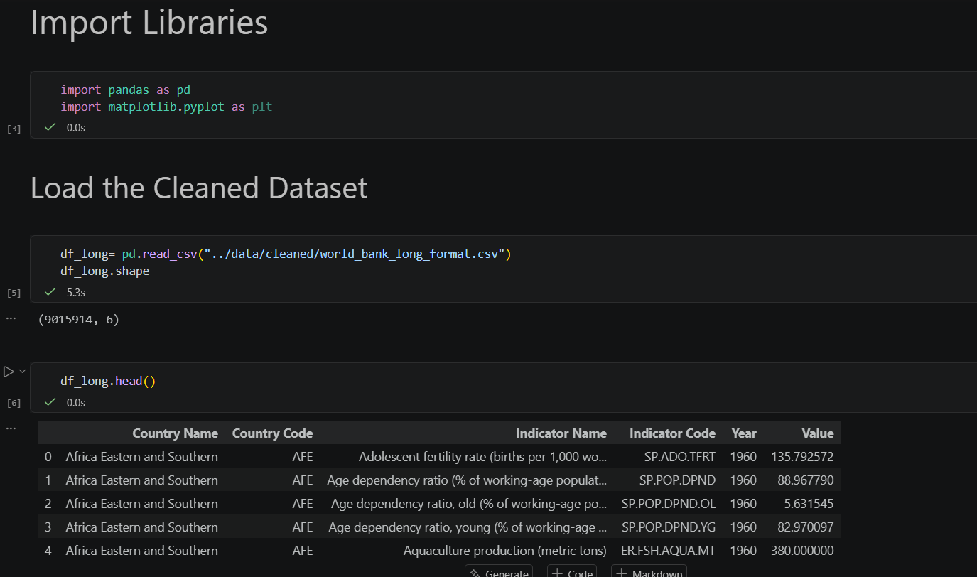
Analyse with a Small Dataset:
- gdp_2024=df_long[
(df_long["Year"]==2024) & (df_long["Indicator Code"]=="NY.GDP.MKTP.CD")
].copy()

- gdp_2024["GDP_Billion"] = gdp_2024["Value"]/1000000000
- gdp_2024.head()

- top_10_gdp = gdp_2024.sort_values("GDP_Billion", ascending=False).head(10)

to remove “WORLD”, High INCOME, OECD members, IDA & IBRD total FROM COUNTRIES – and show actual top 10 countries:
merge GDP DATA with Country Metadata:
- gdp_2024 = gdp_2024.merge(
countries[["Country Code", "Short Name", "Region", "Income Group"]],
on="Country Code",
how="left"
)

- gdp_2024 = gdp_2024[gdp_2024["Region"].notna()].copy()
- top_10_gdp = gdp_2024.sort_values("GDP_Billion",ascending=False).head(10)
- top_10_gdp[ ["Short Name", "GDP_Billion"] ]

plt.
├── bar() → bar chart
├── barh() → horizontal bar
├── plot() → line
├── scatter() → scatter
├── hist() → histogram
├── boxplot() → boxplot
└── pie() → pie chart

1st Chart:
- plt.figure(figsize=(10,6))
- plt.barh(top_10_gdp["Short Name"][::-1], top_10_gdp["GDP_Billion"][::-1])
- plt.xlabel("GDP (US$ Billion)")
- plt.ylabel("Countries")
- plt.title("Top 10 Countries by GDP, 2024")
- plt.tight_layout()
- plt.show()

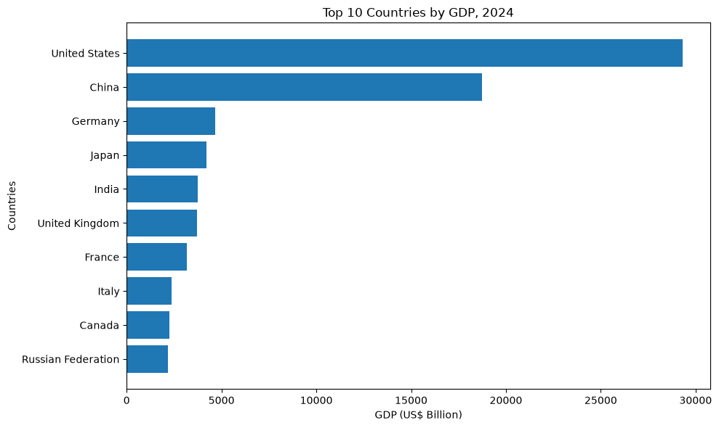

Syntax: plt.text( X position, Y position, Text to display )
Improved Code:
for bar in bars:
plt.text(
bar.get_width(),
bar.get_y() + bar.get_height()/2,
f"{bar.get_width():,.0f}",
va="center"
)

{ VALUE : FORMAT }
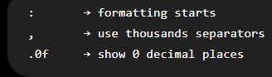

Run Full Code:
- plt.figure(figsize=(10, 6))
- bars = plt.barh(
- top_10_gdp["Short Name"][::-1],
- top_10_gdp["GDP_Billion"][::-1]
- )
- for bar in bars:
- plt.text(
- bar.get_width(),
- bar.get_y()+ bar.get_height()/2,
- f"{bar.get_width():,.0f}",
- va = "center"
- )
- plt.xlabel("GDP (US$ Billion)")
- plt.ylabel("Country")
- plt.title("Top 10 Countries by GDP, 2024")
- plt.tight_layout()
- plt.show()

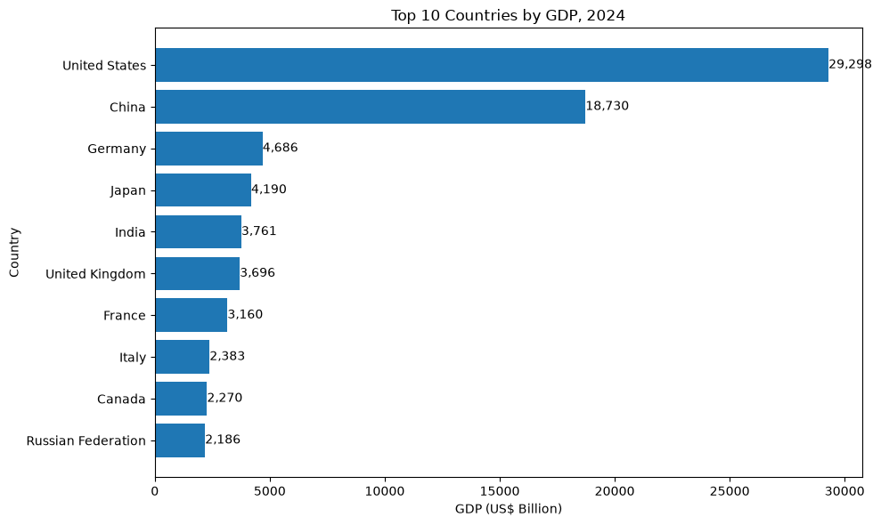
### Key Insight
The United States had the largest GDP among the countries analysed in 2024, at approximately US$29.3 trillion, followed by China at US$18.7 trillion. There is a substantial gap between the two largest economies and the remaining countries in the top 10. India ranked fifth with GDP of approximately US$3.76 trillion.

- india_gdp = df_long[
(df_long["Country Code"] == "IND") & (df_long["Indicator Code"] == "NY.GDP.MKTP.CD")
].copy()

- india_gdp.head()
- india_gdp["GDP_Billion"] = india_gdp["Value"]/1000000000
- india_gdp.head()
- india_gdp = india_gdp.sort_values("Year")
- india_gdp[ ["Year", "GDP_Billion"] ].head(10)

- plt.figure(figsize=(12, 6))
- plt.plot( india_gdp["Year"], india_gdp["GDP_Billion" )
- plt.xlabel("Year")
- plt.ylabel("GDP (US$ billions)")
- plt.title("India GDP Trend, 1960–2024")
- plt.tight_layout()
- plt.show()

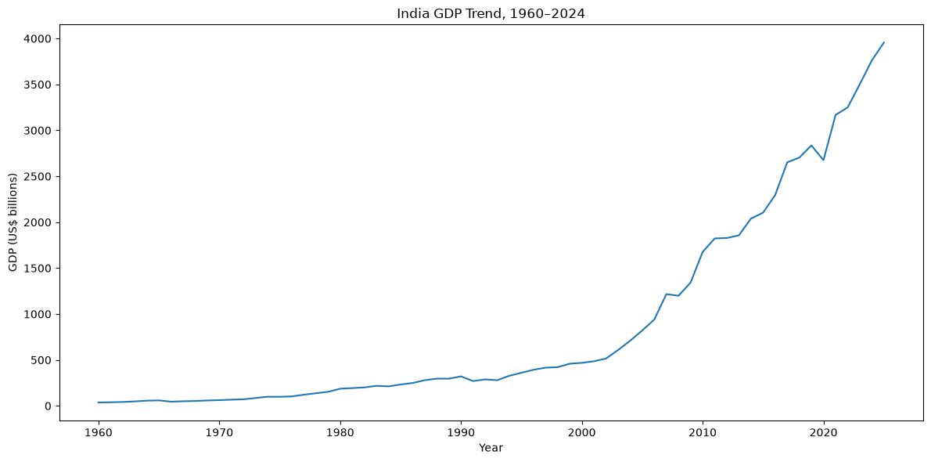

Place the legends in the chart…
Syntax: plt.annotate(text, xy, xytext=None, arrowprops=None, **kwargs)
- plt.figure(figsize=(12, 6))
- plt.plot(
- india_gdp["Year"],
- india_gdp["GDP_Billion"],
- marker="o",
- markersize=3
- )
- for x, y in zip(india_gdp["Year"], india_gdp["GDP_Billion"]):
- plt.annotate(
- f"{y:,.0f}",
- (x, y),
- xytext=(0, 6),
- textcoords="offset points",
- ha="center"
- )
- plt.xlabel("Year")
- plt.ylabel("GDP (US$ billions)")
- plt.title("India GDP Trend, 1960–2024")
- plt.tight_layout()
- plt.show()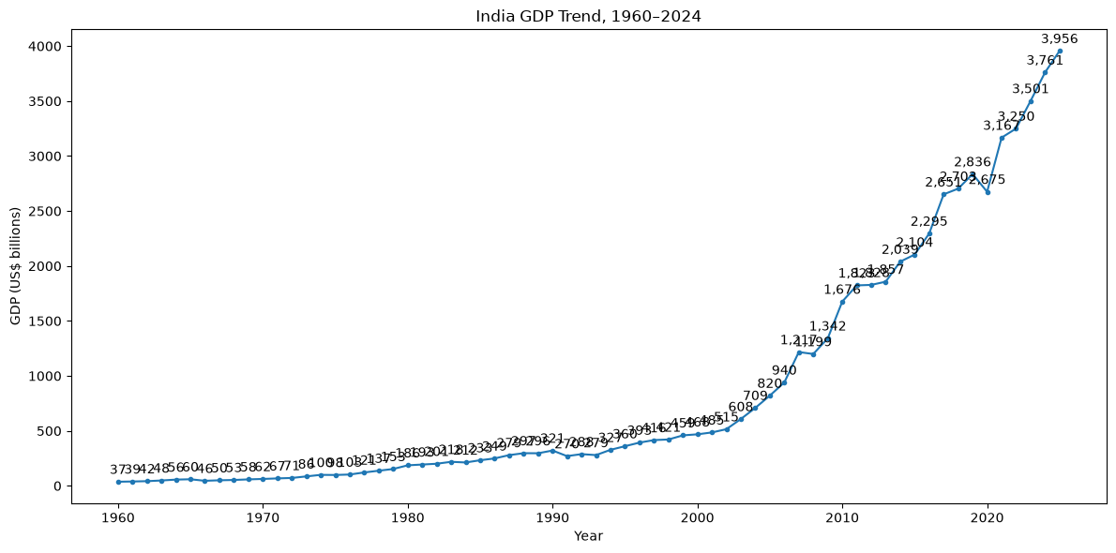
- plt.figure(figsize=(12, 6))
- plt.plot(
- india_gdp["Year"],
- india_gdp["GDP_Billion"],
- marker="o",
- markersize=3
- )
- plt.xlabel("Year")
- plt.ylabel("GDP (US$ billions)")
- plt.title("India GDP Trend, 1960–2024")
- plt.tight_layout()
- plt.show()
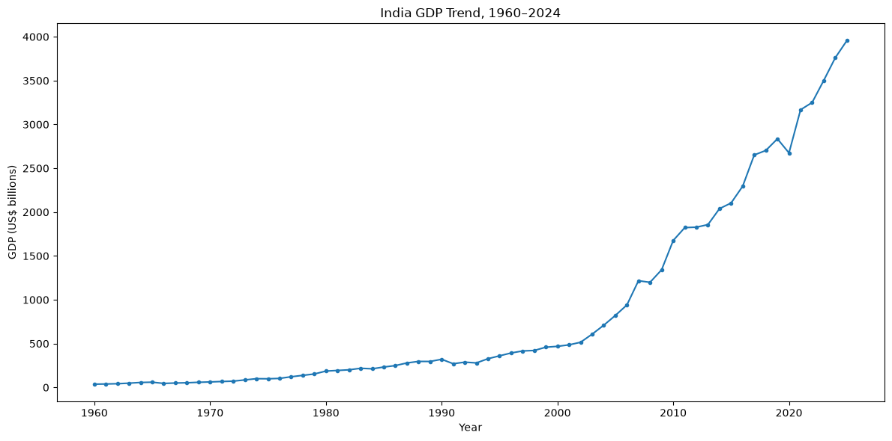
- plt.figure(figsize=(12, 6))
- plt.plot(
- india_gdp["Year"],
- india_gdp["GDP_Billion"],
- marker="o",
- markersize=3
- )
- # Years we want to label
- label_years = [1960, 1980, 1990, 2000, 2010, 2020, 2024]
- for year in label_years:
- row = india_gdp[india_gdp["Year"] == year].iloc[0]
- plt.annotate(
- f"{row['GDP_Billion']:,.0f}",
- (row["Year"], row["GDP_Billion"]),
- xytext=(0, 8),
- textcoords="offset points",
- ha="center"
- )
- plt.xlabel("Year")
- plt.ylabel("GDP (US$ billions)")
- plt.title("India GDP Trend, 1960–2024")
- plt.tight_layout()
- plt.show()
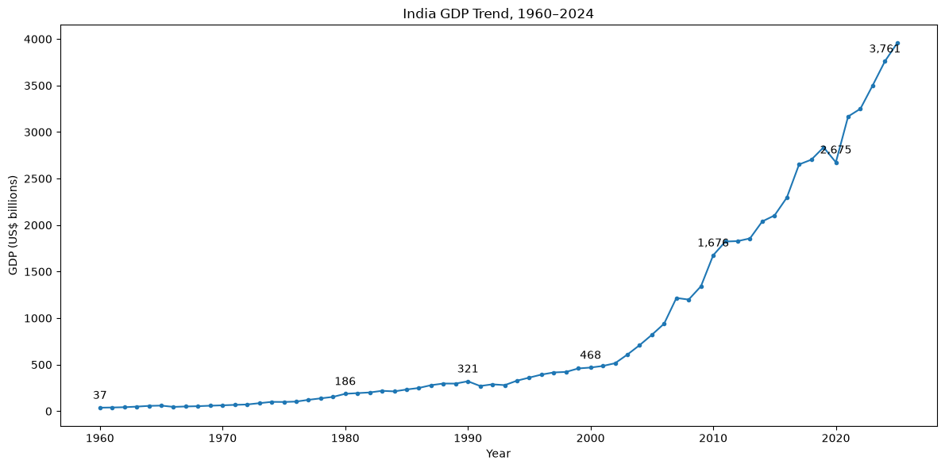
- india_gdp[["Year", "GDP_Billion"]]
### Key Insight
India's nominal GDP increased substantially from approximately US$37 billion in 1960 to US$3.76 trillion in 2024. The long-term trend shows a marked acceleration in the pace of GDP expansion from the early 2000s onward, with a noticeable decline around 2020. As this measure is reported in current US dollars, changes reflect economic growth as well as inflation and exchange-rate movements.

Top 10 Countries by GDP Growth Rate:
- gdp_2023 = df_long[
(df_long["Year"] == 2023) &
(df_long["Indicator Code"] == "NY.GDP.MKTP.CD") ].copy()
gdp_2024 = df_long[
(df_long["Year"] == 2024) &
(df_long["Indicator Code"] == "NY.GDP.MKTP.CD") ].copy()

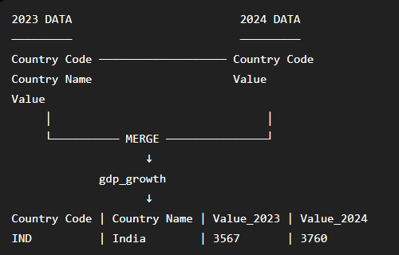
- gdp_growth = gdp_2023[ ["Country Code", "Country Name", "Value"] ].merge(
gdp_2024[["Country Code", "Value"]],
on="Country Code",
suffixes=("_2023", "_2024")
)
Now calculate the percentage growth:
Growth % = ((New GDP − Old GDP) /Old GDP) ------------------- × 100
- gdp_growth["GDP_Growth_%"] = (
(gdp_growth["Value_2024"] - gdp_growth["Value_2023"])
/ gdp_growth["Value_2023"]
) * 100

- gdp_growth[ ["Country Name", "GDP_Growth_%"]].sort_values(
"GDP_Growth_%", ascending=False).head(10)

Create top 10 Dataset:
- top_10_growth = (gdp_growth.sort_values("GDP_Growth_%", ascending=False).head(10))
- top_10_growth[["Country Name", "GDP_Growth_%"]]

- plt.Figure(figsize=(10,6))
- bars = plt.barh(
- top_10_growth["Country Name"][::-1],
- top_10_growth["GDP_Growth_%"][::-1]
- )
- for i in bars:
- plt.text(
- i.get_width(),
- i.get_y() + i.get_height()/2,
- f"{i.get_width():.1f}%",
- va = "center"
- )
- plt.xlabel="GDP Growth %"
- plt.ylabel = "Countries"
- plt.title = "Top 10 Countries by Nominal GDP Growth, 2023–2024"
- plt.tight_layout()
- plt.show()
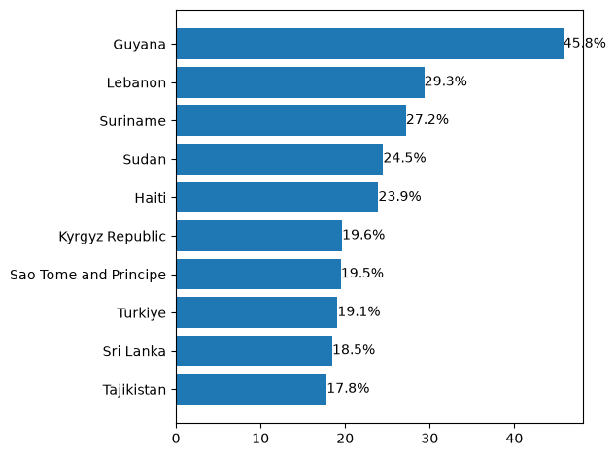
### Key Insight
Guyana recorded the highest year-over-year increase in nominal GDP among the countries analysed, at approximately 45.8%, followed by Lebanon at 29.3% and Suriname at 27.2%. These figures represent changes in GDP measured in current US dollars and should not be interpreted as real GDP growth because inflation and exchange-rate movements can also influence the result.

GDP trend comparison: India vs Australia vs New Zealand.
- comparison_gdp = df_long[
(df_long["Country Code"].isin(["IND", "AUS", "NZL"])) &
(df_long["Indicator Code"] == "NY.GDP.MKTP.CD")
].copy()

- comparison_gdp.head()
- comparison_gdp["GDP_Billions"] = comparison_gdp["Value"]/1000000000
- comparison_gdp.head()
- comparison_gdp = comparison_gdp.sort_values(["Country Code", "Year"])
- comparison_gdp.head()

- plt.figure(figsize=(12, 6))

- for c in ["IND", "AUS", "NZL"]:

- country_data = comparison_gdp[comparison_gdp["Country Code"] == c]
- country_name = country_data["Country Name"].iloc[0]

- plt.plot(
- country_data["Year"],
- country_data["GDP_Billions"],
- label=country_name
- )

- ax = plt.gca()

- ax.set_xlabel("Year")
- ax.set_ylabel("GDP (US$ billions)")
- ax.set_title("GDP Comparison: India, Australia and New Zealand")

- ax.legend()

- plt.tight_layout()
- plt.show()

ax because I assigned the label with = istead of (“”)
gca = get current axes

“How does average GDP differ across World Bank income groups?”
Create the income-group dataset:
- gdp_2024 = gdp_2024.merge(
countries[["Country Code", "Income Group"]],
on="Country Code",
how="left")

- gdp_2024.head()
- gdp_2024.loc[gdp_2024["Country Code"].isin(["IND", "AUS", "NZL"]),
["Country Name", "Country Code", "Income Group"]]
- gdp_2024["GDP_Billions"] = gdp_2024["Value"] / 1_000_000_000
- gdp_2024.loc[
gdp_2024["Country Code"].isin(["IND", "AUS", "NZL"]),
["Country Name", "Country Code", "GDP_Billions", "Income Group"]]
Example: avg_salary = df.groupby('Department')['Salary'].mean()
- income_gdp = (
gdp_2024
.dropna(subset=["Income Group"])
.groupby("Income Group", as_index=False)["GDP_Billions"]
.mean()
)
- income_gdp

Seaborn has its own plotting functions too, which is why you can write:
- sns.barplot(...)
- sns.scatterplot(...)
- sns.boxplot(...)
- sns.histplot(...)
- sns.heatmap(...)

- import seaborn as sns
- plt.figure(figsize=(10, 6))
- ax = sns.barplot(
- data=income_gdp,
- x="GDP_Billions",
- y="Income Group"
- )
- ax.set_xlabel("Average GDP (US$ billions)")
- ax.set_ylabel("Income Group")
- ax.set_title("Average GDP by World Bank Income Group, 2024")
- plt.tight_layout()
- plt.show()
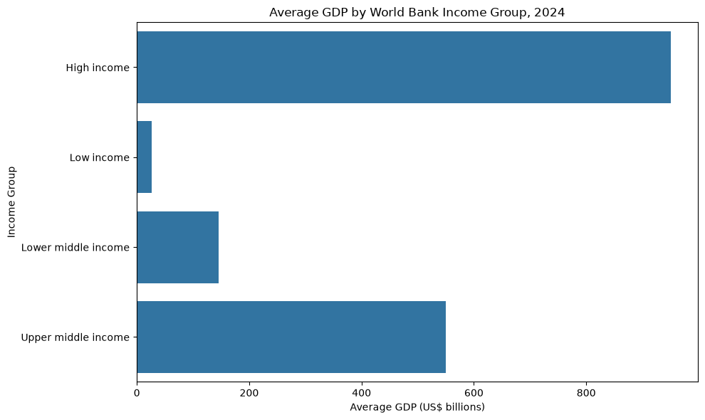
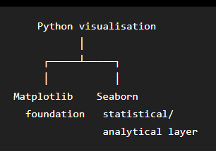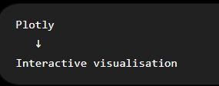
-- 3-Year Moving Average of India's GDP ------- IN SQL FILE 05-----
SELECT year, ROUND(value / 1000000000, 2) AS GDP_Billion,
ROUND(
AVG(value) OVER(
ORDER BY year
ROWS BETWEEN 2 PRECEDING AND CURRENT ROW ) / 1000000000, 2) AS GDP_3Y_Moving_Avg
FROM world_bank
WHERE country_code = 'IND'
AND indicator_code = 'NY.GDP.MKTP.CD'
ORDER BY year;

IN PYTHON NOW -----------
- india_gdp["GDP_3Y_Moving_Avg"] = (
india_gdp["GDP_Billion"]
.rolling(window=3)
.mean()
)
- india_gdp.head()
- plt.figure(figsize=(12, 6))
- plt.plot(
- india_gdp["Year"],
- india_gdp["GDP_Billion"],
- label="Actual GDP"
- )
- plt.plot(
- india_gdp["Year"],
- india_gdp["GDP_3Y_Moving_Avg"],
- label="3-Year Moving Average"
- )
- plt.xlabel("Year")
- plt.ylabel("GDP (US$ billions)")
- plt.title("India GDP vs 3-Year Moving Average, 1960–2024")
- plt.legend()
- plt.tight_layout()
- plt.show()

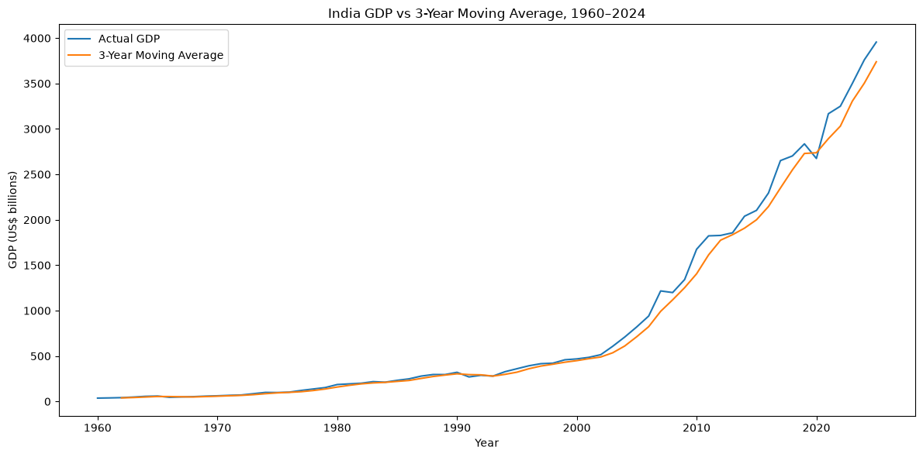

- population_2024 = df_long[ (df_long["Year"] == 2024) & (df_long["Indicator Code"] == "SP.POP.TOTL") ].copy()
- population_2024.head()
- population_2024.shape

- population_2024 = population_2024.merge( countries[["Country Code", "Short Name", "Region", "Income Group"]], on="Country Code", how="inner" )
- population_2024.head()
- population_2024.shape
- gdp_2024_scatter = gdp_2024[
["Country Code", "GDP_Billions"]
].copy()
- gdp_2024_scatter.head()
So now we can attach each country's GDP to its population record:
- population_gdp = population_2024.merge(
gdp_2024_scatter,
on="Country Code",
how="inner"
)
- population_gdp.head()
Remove World Bank Aggregates & Null Region:
- population_gdp = population_gdp[
population_gdp["Region"].notna()
].copy()
- population_gdp.shape
- population_gdp.head(10)
Convert population to millions:
- population_gdp["Population_Millions"] = (
population_gdp["Value"] / 1_000_000
)
- population_gdp.head()
- sns.scatterplot(
- data=population_gdp,
- x="Population_Millions",
- y="GDP_Billions"
- )
- plt.xlabel("Population (millions)")
- plt.ylabel("GDP (US$ billions)")
- plt.title("Population vs GDP, 2024")
- plt.tight_layout()
- plt.show()
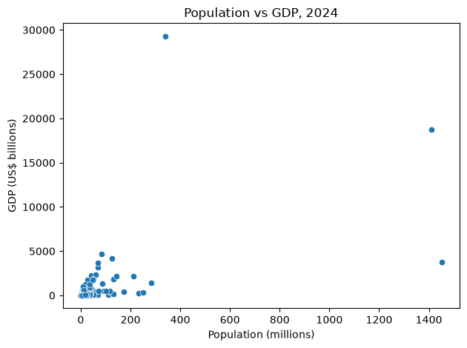

- New Terminal – pip install scipy
- Pip show scipy

- From scipy.stats import pearsonr

- correlation, p_value = pearsonr(
population_gdp["Population_Millions"],
population_gdp["GDP_Billions"])

- print("Correlation:", correlation)
- print("P-value:", p_value)
- Correlation: how strongly are population and GDP linearly related?
- P-value: is that relationship statistically significant?
Pearson correlation ranges from: -1 ←──────── 0 ────────→ +1
-1 strong negative
-0.7 moderate/strong negative
0 no linear relationship
+0.5 moderate positive
+0.7 strong positive
+1 perfect positive

- sns.regplot(
- data=population_gdp,
- x="Population_Millions",
- y="GDP_Billions"
- )
- plt.xlabel("Population (millions)")
- plt.ylabel("GDP (US$ billions)")
- plt.title("Population vs GDP, 2024")
- plt.tight_layout()
- plt.show()
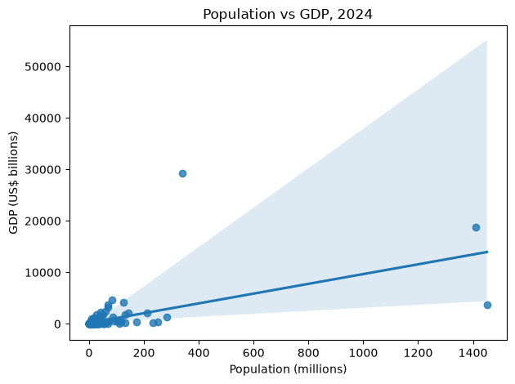
10 most populous countries and their GDP:
- population_gdp.nlargest(10, "Population_Millions")[["Country Name", "Population_Millions", "GDP_Billions"]]
- population_gdp["GDP_Per_Capita"] = (
population_gdp["GDP_Billions"] * 1_000_000_000
/ (population_gdp["Population_Millions"] * 1_000_000)
)
- population_gdp.nlargest(10, "GDP_Per_Capita")[["Country Name", "GDP_Per_Capita"]]
- population_gdp.groupby("Income Group")["GDP_Per_Capita"].mean().sort_values(ascending=False).round(2)
- income_pc = (population_gdp.groupby("Income Group")["GDP_Per_Capita"].mean().sort_values(ascending=False).round(2))

- plt.figure(figsize=(9, 5))

- bars = plt.bar(
- income_pc.index,
- income_pc.values
- )

- plt.xlabel("Income Group")
- plt.ylabel("Average GDP per Capita (US$)")
- plt.title("Average GDP per Capita by Income Group, 2024")

- for bar in bars:
- plt.text(
- bar.get_x() + bar.get_width() / 2,
- bar.get_height(),
- f"${bar.get_height():,.0f}",
- ha="center",
- va="bottom"
- )

- plt.tight_layout()
- plt.show()
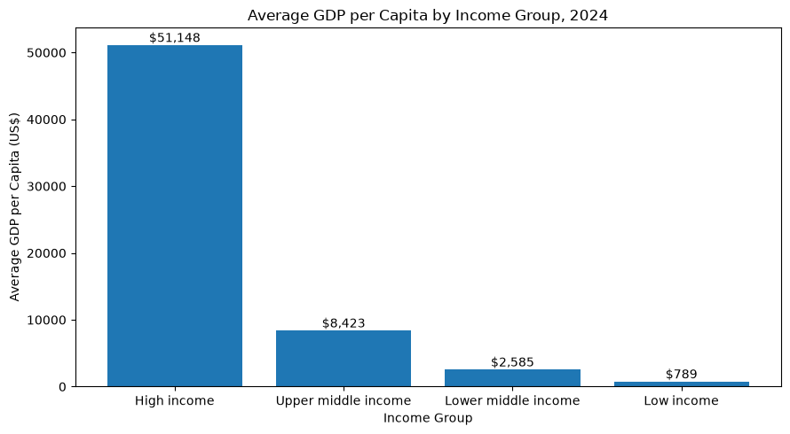
Find the indicators we want:
Let's start by seeing the exact indicator names available for:
- GDP
- Population
- Life expectancy
- Unemployment
- Internet usage

- df_long[
df_long["Indicator Name"].str.contains(
"life expectancy|unemployment|internet", case=False,
na=False )][["Indicator Name", "Indicator Code"]].drop_duplicates().head(50)

- life_expectancy_2024 = df_long[
(df_long["Year"] == 2024) &
(df_long["Indicator Code"] == "SP.DYN.LE00.IN")
].copy()
- life_expectancy_2024
Keep only actual Countries:
- life_expectancy_2024 = life_expectancy_2024.merge(
- countries[["Country Code", "Region"]],
- on="Country Code",
- how="inner"
- )

- life_expectancy_2024 = life_expectancy_2024[
- life_expectancy_2024["Region"].notna()
- ].copy()
- life_expectancy_2024.shape
- life_expectancy_2024
Extract Internet usage for 2024:
- internet_2024 = df_long[
- (df_long["Year"] == 2024) &
- (df_long["Indicator Code"] == "IT.NET.USER.ZS")
- ].copy()

- internet_2024
- internet_2024 = internet_2024.merge(
- countries[["Country Code", "Region"]],
- on="Country Code",
- how="inner"
- )
- internet_2024
- internet_2024 = internet_2024[
- internet_2024["Region"].notna()
- ].copy()
- internet_2024
- internet_2024["Value"].isna().sum()
- internet_2024.shape

- internet_lookup = internet_2024[ ["Country Code", "Value"] ].copy()
- population_gdp = population_gdp.merge(internet_lookup, on="Country Code", how="inner")
- population_gdp.head()

- population_gdp = population_gdp.rename(
- columns={
- "Value_x": "Population",
- "Value_y": "Internet_Usage"
- }
- )

- population_gdp[
- ["Country Name", "Population", "GDP_Billions", "GDP_Per_Capita", "Internet_Usage"]
- ].head()

- population_gdp = population_gdp.merge(
- life_expectancy_2024[["Country Code", "Value"]],
- on="Country Code",
- how="inner"
- )

- population_gdp = population_gdp.rename(
- columns={
- "Value": "Life_Expectancy"
- }
- )

- population_gdp[
- [
- "Country Name",
- "Population",
- "GDP_Billions",
- "GDP_Per_Capita",
- "Internet_Usage",
- "Life_Expectancy"
- ]
- ].head()

- population_gdp[
- [
- "Population",
- "GDP_Billions",
- "GDP_Per_Capita",
- "Internet_Usage",
- "Life_Expectancy"
- ]
- ].isna().sum()

Create the Matrix:
- correlation_matrix = population_gdp[
- [
- "Population",
- "GDP_Billions",
- "GDP_Per_Capita",
- "Internet_Usage",
- "Life_Expectancy"
- ]
- ].corr()

- correlation_matrix.round(2)

- plt.figure(figsize=(10, 7))
- sns.heatmap(
- correlation_matrix,
- annot=True,
- fmt=".2f",
- cmap="coolwarm",
- center=0
- )
- plt.title("Correlation Between Development Indicators, 2024")
- plt.tight_layout()
- plt.show()
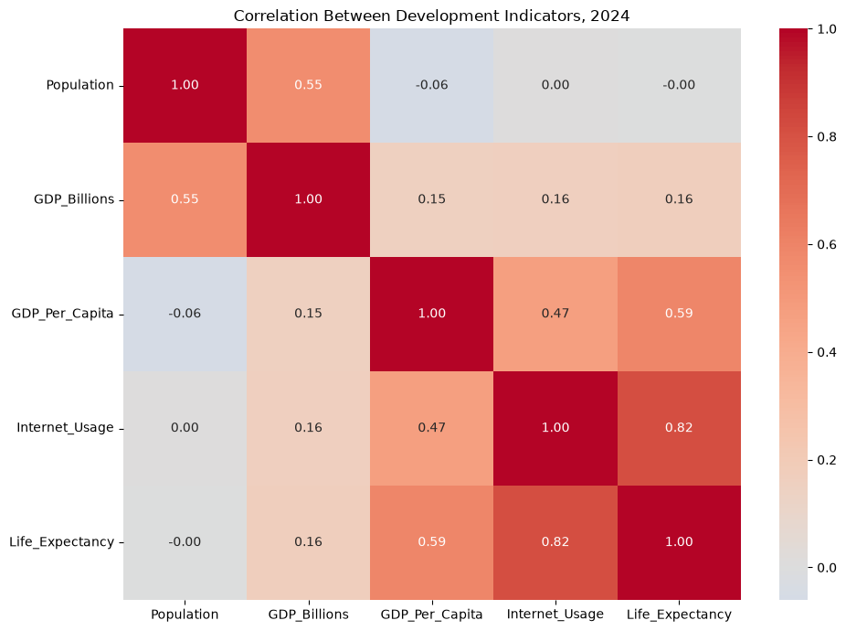

- Q1 = population_gdp["GDP_Per_Capita"].quantile(0.25)
- Q3 = population_gdp["GDP_Per_Capita"].quantile(0.75)

- IQR = Q3 - Q1

- lower_bound = Q1 - 1.5 * IQR
- upper_bound = Q3 + 1.5 * IQR

- print("Q1:", Q1)
- print("Q3:", Q3)
- print("IQR:", IQR)
- print("Lower bound:", lower_bound)
- print("Upper bound:", upper_bound)

- gdp_per_capita_outliers = population_gdp[
- population_gdp["GDP_Per_Capita"] > upper_bound
- ]

- gdp_per_capita_outliers[
- ["Country Name", "GDP_Per_Capita", "GDP_Billions", "Population_Millions"]
- ].sort_values("GDP_Per_Capita", ascending=False)

GDP = Country’s total economy
GDP per Capita (Person) = Total GDP / Total Population
Git add .
Git commit -m “Python Data Visualisation”
Git push
The pct_change() method in pandas calculates the fractional change (relative difference) between the current element and a prior element.
- india_gdp["GDP_YoY_Growth"] = ( india_gdp["GDP_Billion"].pct_change() * 100 ) india_gdp[ ["Year", "GDP_Billion", "GDP_YoY_Growth"] ].head(10)

- india_gdp[
- ["Year", "GDP_Billion", "GDP_YoY_Growth"]
- ].sort_values(
- "GDP_YoY_Growth",
- ascending=False
- ).head(10)

- india_gdp[
- ["Year", "GDP_Billion", "GDP_YoY_Growth"]
- ].sort_values(
- "GDP_YoY_Growth",
- ascending=True
- ).head(10)

- plt.figure(figsize=(12, 6))
- plt.plot(
- india_gdp["Year"],
- india_gdp["GDP_YoY_Growth"],
- label="GDP YoY Growth"
- )
- plt.axhline(0, linestyle="--")
- plt.xlabel("Year")
- plt.ylabel("GDP YoY Growth (%)")
- plt.title("India GDP Year-on-Year Growth, 1960–2024")
- plt.legend()
- plt.tight_layout()
- plt.show()
