WORLD_BANK_DATASET_ANALYSIS
Create Local Folders
VS Code: Open the newly created folder & check if GitHub is installed properly (git --version) in the terminal.
GitHub:
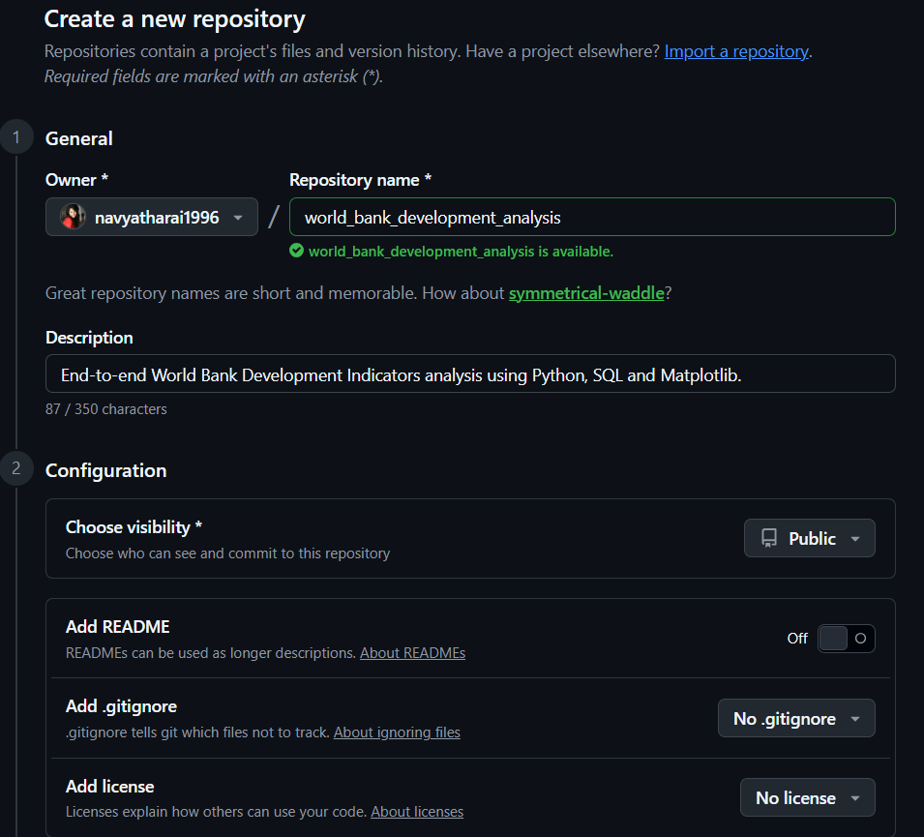

VS Code:
- PS D:\world_bank _development_analysis> git --version
git version 2.54.0.windows.1
- git init
Initialized empty Git repository in D:/world_bank_development_analysis/.git/

This command tells Git: "Start tracking every change inside this project."
From now on, Git can tell:
- which files changed
- who changed them
- when they changed
- restore older versions
- compare versions
Create a new file - .gitignore & paste the following inside:
# ======================================================
# Python
# ======================================================
__pycache__/
*.py[cod]
*$py.class

# ======================================================
# Virtual Environments
# ======================================================
.venv/
venv/
env/

# ======================================================
# Jupyter Notebook
# ======================================================
.ipynb_checkpoints/

# ======================================================
# VS Code
# ======================================================
.vscode/

# ======================================================
# Operating System Files
# ======================================================
.DS_Store
Thumbs.db

# ======================================================
# Environment Variables
# ======================================================
.env

# ======================================================
# Log Files
# ======================================================
*.log

# ======================================================
# Temporary Files
# ======================================================
*.tmp
*.temp

# ======================================================
# Python Packaging
# ======================================================
build/
dist/
*.egg-info/

# ======================================================
# Database Cache Files
# ======================================================
*.db
*.sqlite

- Check Python Version: py –version
Python 3.14.4
- Create the Virtual Environment: py -m venv .venv // creates a new folder on the left
- PowerShell execution policy configuration:
Set-ExecutionPolicy -ExecutionPolicy RemoteSigned -Scope CurrentUser
- .\.venv\Scripts\Activate.ps1 //(.venv) should appear in the terminal

Create 2 more files in VS Code: README.md & requirements.txt
Install Python Libraries: This assignment requires-
- Read Excel
- Clean data
- Load to SQL
- Analyse data
- Visualise data

Task | Library
Read & clean Excel | pandas
Read Excel files | openpyxl
Numerical calculations | numpy
Graphs | matplotlib
Advanced visualisations | seaborn
Connect Python to MySQL | sqlalchemy
MySQL driver | pymysql
Jupyter notebooks | jupyter

Install: pip install pandas numpy openpyxl matplotlib seaborn sqlalchemy pymysql jupyter
Run Upgrade: python.exe -m pip install --upgrade pip
Verify the Python Interpreter: bottom right should show - .venv (Python 3.14.4)
Check the Git:
- git status
- git add . // adds everything in this project
- git status
Create the First Git Commit

