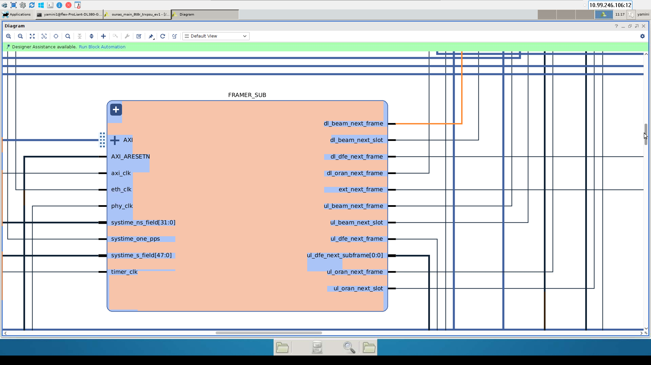

Inputs:
Axi_clk=125MHz
Eth_clk=156.25MHz
Phy_clk=368.64MHz
Timer_clk=250MHz
Systime_ns_field
Outputs from ORAN subsystem
Systime_s_field
Systime_one_pps
Dl_beam_next_frame
Dl_beam_next_slot
inputs to beamer subsystem
Ul_beam_next_frame
Ul_beam_next_slot
Dl_oran_next_frame-------will be the input to the ORAN subsystem
Ul_oran_next_frame----will be the input to the Beamer and ORAN subsystem
UL_oran_next_slot ----will be the input to the beamer subsystem
Dl_dfe_next_frame will be the input to the din in extend_n_clk which in turn output will be connected to the TDD subsystem input(dl_next_frame)
UL_dfe_next_frame----input to the OFDM Demod subsystem
UL_dfe_next_subframe---input to the PRACH demod subsystem

Ext_next_frame---will be the input to the din in extend_n_clk which in turn connected to the one of the input in the multiplexer

