LOW-PHY
OFDM MODULATOR AND DEMODULAOR PRACH Demodulator

Main FW/SW requirements of the product
Parameter | Requirements
Frequency bands | N78: 3300-3700 MHz
Radio configuration | 8T8R TDD
Supported technology | 5G NR
Beamforming | Predefined BF & weight based dynamic BF
Numerology | 15 kHz, 30 kHz
O-RAN compliance | CUSM-planes
Synchronization options | SyncE, 1588 PTP (LLS C1-C3)
Number of carriers | 8 DL / 8 UL
DL EVM | <3.5% with 256QAM at full power
OBW | 200 MHz
IBW | 400 MHz
Number of Antenna ports | 8
Antenna Calibration port | Yes
Fronthaul | Option 7-2x, 2 x 25Gbps SFP28

LOW-PHY
PHY processing on the O-RU side of the fronthaul interface, including FFT/iFFT, digital beamforming, and PRACH extraction and filtering.

OFDM Modulator

Signal Diagram

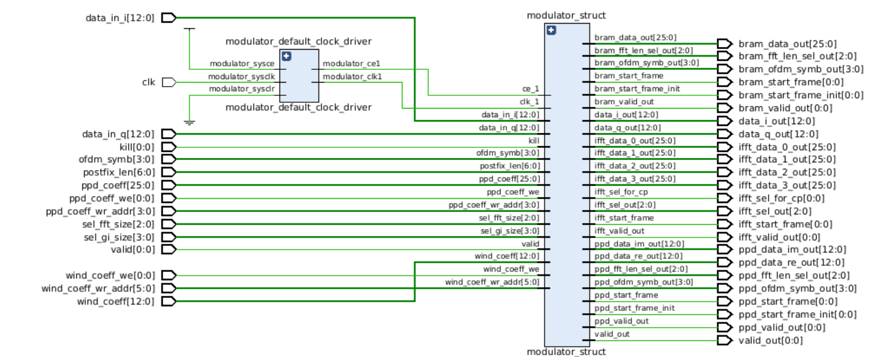

Description

The OFDM Modulator block receives 8 parallel AXI4-Stream data streams associated with the transmit antennas. For each stream, samples of different carriers (1-8 carriers in total) are separated in the time domain and alternated on an OFDM symbol-by-symbol basis. The symbols are transmitted in the carrier index first, time domain index second order to minimize the depth of the buffer. The AXI4-Stream flow control is applied.
The received symbols are passed through the GI Insert, TX Phase Predistortion (PPD), and IFFT processing blocks. The GI Insert and TX PPD are full custom PL-based blocks. The IFFT block is a Xilinx IP-core using the hardened primitives of the RFSoC-DFE. The OFDM Modulator utilizes 8 FFT primitives as 8 parallel processing channels (one for each of 8 antennas). Samples from the IFFT block output (for one TD symbol, all carriers, and all 8 antennas) are stored in a buffer.
The buffer is read in a different order aligned with the input interface of the DFE subsystem. Time-domain samples are aggregated in 4 streams (AXI4-Stream buses). Each stream includes samples of all carriers and a pair of antennas: 0-1, 2-3, 4-5 and 6-7. Samples follow w/o dynamic flow control with full throughput (constant one sample per clock cycle) on the 122.88 x 4 MHz clock rate. Samples are alternated for antenna first and carrier second order. The samples read from the buffer are passed through the CP insert and windowing operation and sent to the block output.
The carrier alternation pattern has the length of 8. The following carrier TD sample rates are supported: 122.88 x 2 MHz, 122.88 MHz, 122.88 / 2 MHz and 122.88 / 4 MHz. Any combinations of sample rates providing a length-8 pattern of carriers are supported, for example:
- 8 carriers, 122.88 / 4 MHz each, the carrier pattern is [c0, c1, c2, c3, c4, c5, c6, c7];
- 3 carriers, one carrier of 122.88 MHz and two carriers of 122.88 / 2 MHz, the carrier pattern is [c0, c1, c0, c2, c0, c1, c0, c2];
- 2 carriers, 122.88 MHz, the carrier pattern is [c0, c1, c0, c1, c0, c1, c0, c1];
- 1 carrier, 122.88 x 2 MHz, the carrier pattern is [c0, c0, c0, c0, c0, c0, c0, c0];
- Any other valid combinations of listed sample rates giving 122.88 x 2 MHz of the total sample rate.
Each sample rate is associated with a list of component carrier bandwidths:
- 200 MHz for the 122.88 x 2 MHz sample rate, a single carrier;
- 60 to 100 MHz for the 122.88 MHz sample rate, up to 2 carriers;
- 30 to 50 MHz for the 122.88 / 2 MHz sample rate, up to 4 carriers;
- 5 to 25 MHz for the 122.88 / 4 MHz sample rate, up to 8 carriers.
Note that for the actual carriers widths less than 200, 100, 50 and 25 MHz respectively, the actual OBW will be lower than 200 MHz which is a fundamental limitation of the RFSoC-DFE SoC device (the hardened DFE primitives).
The OFDM Demodulator block operates symmetrically in the inverse order. The block receives TD samples in 4 parallel AXI4-Streams with aggregation of two antennas within each of them: 0-1, 2-3, 4-5 and 6-7. The samples are alternated in the antenna index first, carrier index second order, the same carrier index patterns and sample rates as for the OFDM Modulator are supported. The input samples are passed through the CP removal and windowing operation and then buffered for reordering. The samples are read in the OFDM symbol-by-symbol order, carrier first, time-domain symbol index second and passed to the FFT block utilizing 8 FFT hardened primitives (one for each of 8 antennas).
The calculated FD samples are passed through full custom PL-based RX PPD and GI removal stages and then sent to the output of the block in 8 parallel AXI4-Stream buses associated with 8 receive antennas.

The OFDM Modulator performs the following steps:
- receiving input data (AXI Stream) and start_frame pulse signal from Beamer subsystem
- crossing input data from clock region 368.64 MHz to clock region 491.52 MHz
- insertion GI in accordance with current bandwidth
- implementation the function of phase pre-distortion to compensate the received OFDM signal phase shift caused by the carrier frequency offset between transmitter and receiver taking into account current CC_ID (Component Carrier Index)
- preparing data and control signals for delivering to HW DFE IFFT IP
- the data conversion from frequency to time domain by means of HW DFE IFFT IP
- storage data in time domain for correct normal CP (cyclic prefix) insertion and performing data for delivering to DFE in accordance with the carrier alternation pattern and AP (antenna port) number. Current version of OFDM modulator is supposed for 1 AP
- implementation TX-windowing procedure.

OFDM Modulator Input IP Interface

368.4 MHz 491.52MHz

GI insert
The Guard Interval is the ratio of the Cyclic Prefix "CP" time to the inverse FFT time "T(IFFT)." The guard interval is used to eliminate inter-symbol and inter-carrier interference. A copy of the last guard interval T(GI) of the useful symbol period "T(IFFT)", termed Cyclic Prefix "CP", is used to collect multipath, while maintaining the orthogonality of the subcarriers. Each symbol is transmitted for a slightly longer time, extended symbol time T(s), than the active (or useful) symbol time T(IFFT). The extra time is the guard interval

- A guard interval is added to each symbol to minimize the channel delay spread and intersymbol interference

- Data copied from the end of the symbol onto the beginning like a nose cone

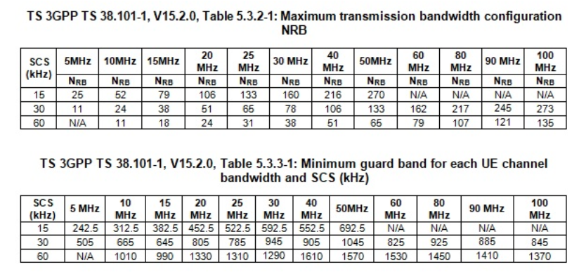

The minimum guardband for each UE channel bandwidth and SCS is specified in Table 5.3.3-1, Table 5.3.3-1: Minimum guardband for each UE channel bandwidth and SCS (kHz)

NOTE: The minimum guardbands have been calculated using the following equation: (BWChannel x 1000 (kHz) - NRB x SCS x 12) / 2 - SCS/2, where NRB are from Table 5.3.2-1.

(100 x10^6 x1000x 10^3 – 273 x 30x10^3)/2 – 30x10^3/2

Interface Diagram

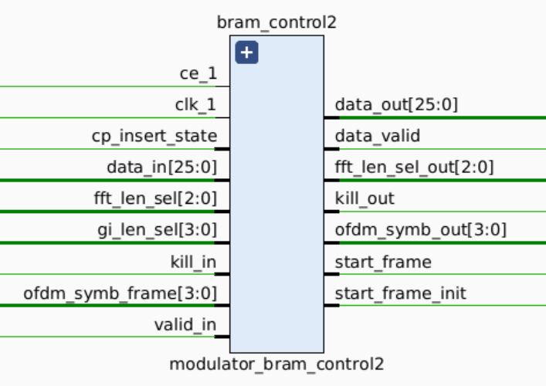
Figure 1 Interface DIagram

Signal description
Signal Name | port | Description
clk_1 | input | Number of lanes used in AURAXII link
cp_inset_state | input
data_in | input | Data width of all user AXI data combined
fft_len_sel | input | Width of keep signal of all user AXI interface combined
gi_len_sel[3:0] | input | Used to select GI period of GI MUX
kill_in | input | Asyn_reset
ofdm_sym_frame[3:0] | input | OFDM symbol number
valid_in | input | Asserted high when input data’s are valid
fft_len_sel_out | output
data_valid | output | Asserted high when data_out is valid
data_out[25:0] | output | Output data, contains zero padding and actual IQ samples
start_frame | output | Identifies the start of the frame
start_frame_init | output | Identifies the start of the frame

Sublevel block diagram and description of GI insert

The below block diagram represents GI interface, Through register interface gi_len_sel signal gets value.
Based on the predefined constant GI_MUX gives output.
For 100 MHz bandwidth, gi_len will be 410 and data_len will be 3276.
The main functionality of the GI inset module is adding gi_len times of zero followed bt 3276 IQ samples then second GI(410 times of zeros)
The FSM logic implemented to generate datas (as mentioned point no 3) along with valid

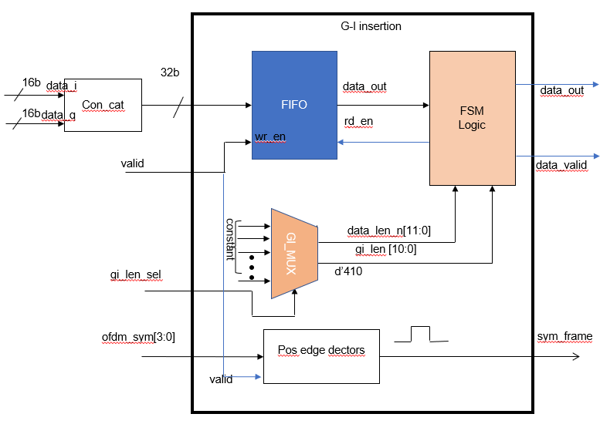
Figure 2 BD of GI

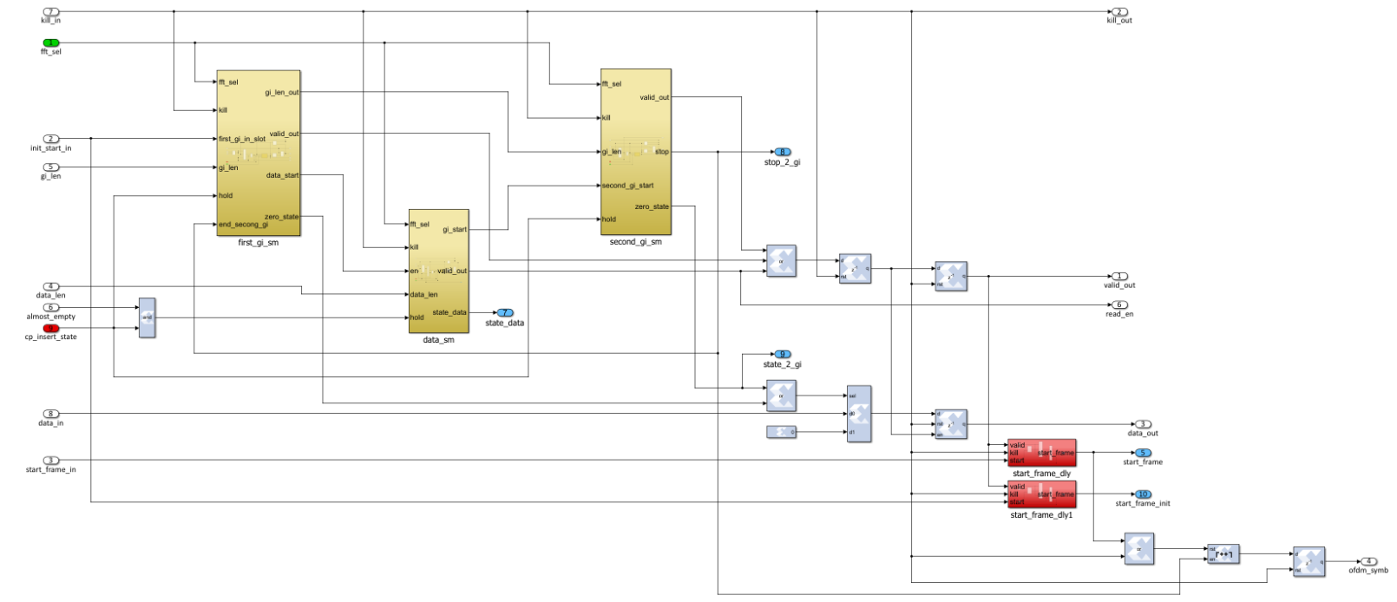
Figure 3: FSM LOGIC

Tx Phase Predistortion

This module performs multiplication and accumulation with phase coefficients and input data’s

Interface Diagram
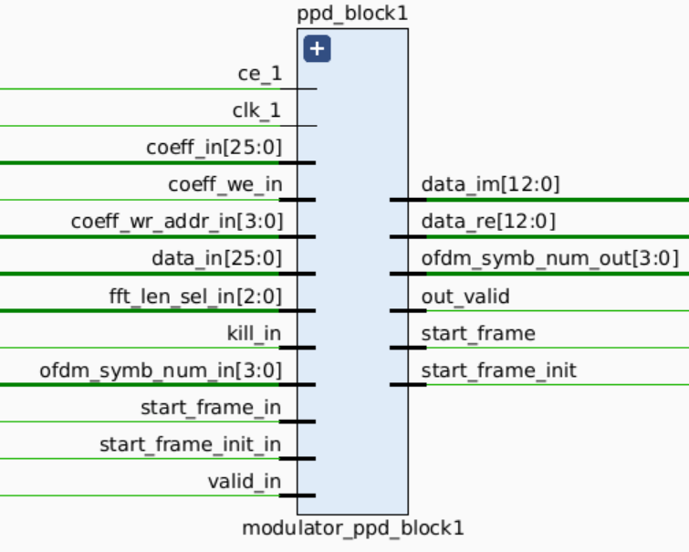

Signal description
Signal Name | port | Description
clk_1 | input | clk
Coeff_in[25:0] | input
Coeff_wr_in | input | Data width of all user AXI data combined
Coeff_wr_addr[3:0] | input | Address to dual port RAM, where
Data_inl[25:0] | input | Used to select GI period of GI MUX
kill_in | input | Asyn_reset
ofdm_sym_frame[3:0] | input | OFDM symbol number
valid_in | input | Asserted high when input data’s are valid
fft_len_sel_out | output
out_valid | output | Asserted high when data_im/data_re is valid
data_im[12:0] | output | Output data, contains actual IQ samples with multiplied and Accumulated coefficient
data_re[12:0] | output | Output data, contains actual IQ samples with multiplied and Accumulated coefficient
start_frame | output | Identifies the start of the frame
start_frame_init | output | Identifies the start of the frame

Sublevel block diagram and description of Tx Phase Predistortion

- After bram control logic(GI insertion) the I and Q samples moved into PPD block
- Inside PPD block, Block control logic was present, here only coefficient value getting changed, based on the coefficient_in.
- coefficient_in and coeff_wr_addr_in are getting value through register interface
- Inside block control logic, Dual port RAM was present where the coefficient values are stored
- Based on wr_addr and coefficient in Dual port RAM generates coefficient
- Coefficient and Input data are multiplied and accumulated in DSP48E2(hard Xilinx IP)

Sublevel block diagram and description of Tx Phase Predistortion
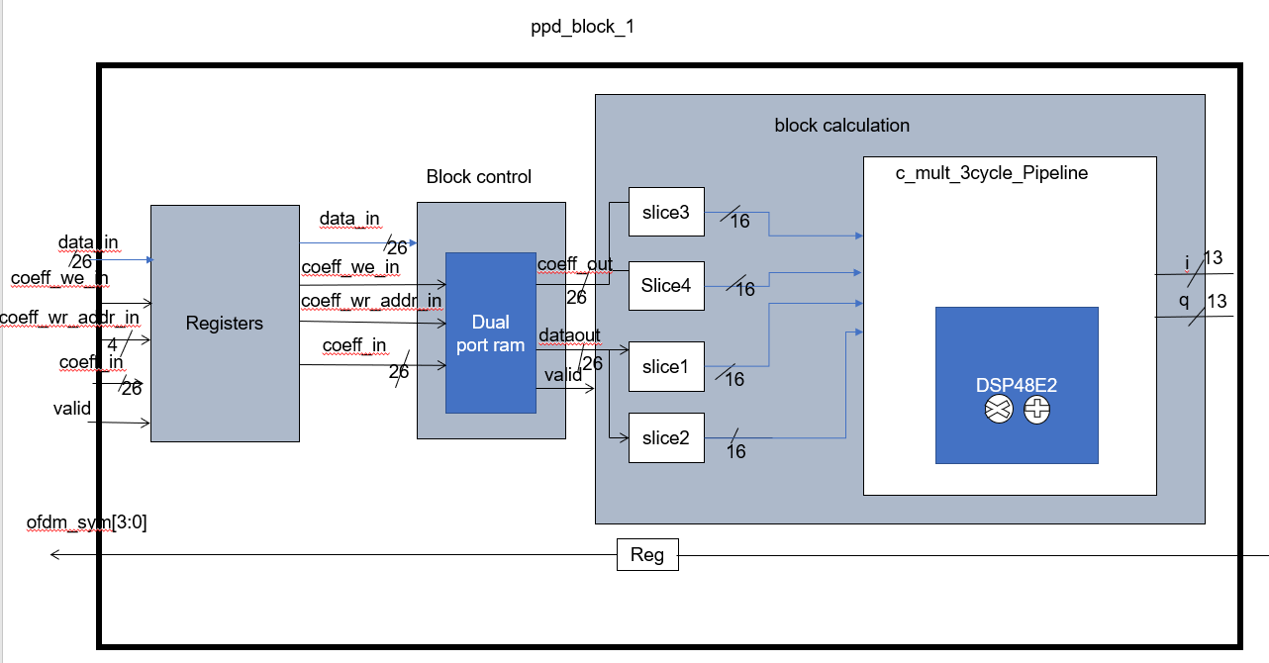

Waveform/Timing

iFFT
The RFSoC DFE Fast Fourier Transform LogiCORE IP uses the Fast Fourier Transform (FFT) custom primitives in the RFSoC DFE devices to implement a scalable and efficient FFT processing block.

The RFSoC DFE FFT core can implement the FFT component of an OFDM communication system, including those based on the 3GPP LTE standard and the 3GPP 5G-NR standard. The core can implement both inverse FFT for the downlink and forward FFT for the uplink.

Interface Diagram

The RFSoC DFE FFT core interfaces are shown in the following figure.
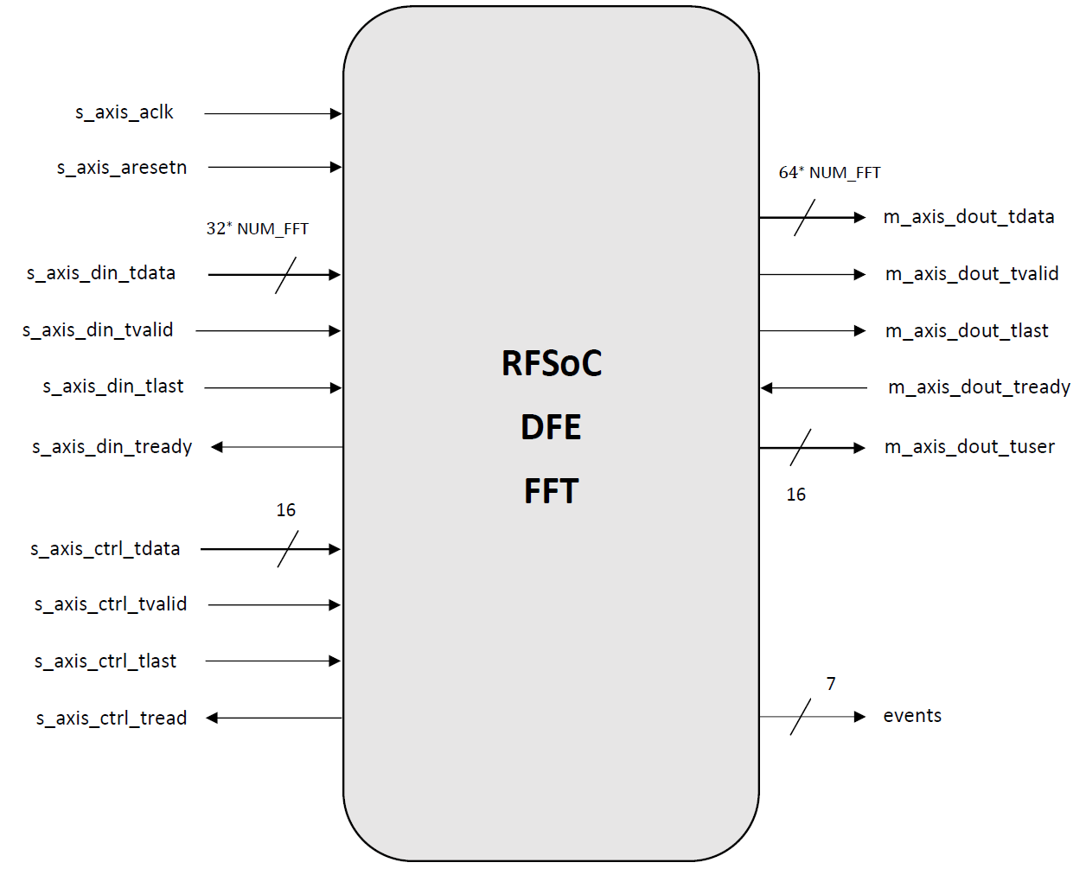
Figure: Core Ports

Control interface port/Signal description
Port Name | I/O | Clock | Description
s_axis_ctrl_tdata[15:0] | I | s_axis_aclk | Control word for the DFE FFT core. The format is  described in the following table.
s_axis_ctrl_tvalid | I | s_axis_aclk | 'Valid' handshake signal for the control stream interface. The core uses this to indicate the upstream that a new control word is available.
s_axis_ctrl_tready | O | s_axis_aclk | 'Ready' handshake signal for the control stream interface. The core uses this to indicate that a control word can be accepted.

- The control interface port TDATA is used to change the IP core from FFT to Inverse FFT.

- TDATA is the control word for the DFE FFT core and it consists of a 16-bit format as shown below.
15 9 8 5 4 3 0

Reserved | Maximum Point Size | Direction | Point size
Control Word TDATA Field Format

- By this, if the Direction Control field bit is ‘0’ then it performs inverse FFT and if it is ‘1’ then it performs FFT operation.

NOTE: For remaining all the ports information, they are same as mentioned in the Demodulator
DFE FFT Ports Configuration.

Interfacing to IFFT core:
The data input, data output, and control input interfaces all use a standard AXI4-Stream handshake interface to control the transfer of data and control words. You must write a control word on the control packet interface to determine the parameters for each input data block. The core contains a small control FIFO buffer with 16 entries so that control words can be written before the start of the corresponding data blocks if required. When the control buffer is full, the core will drive s_axis_ctrl_tready Low to indicate that no further control words can be accepted.

When the DFE FFT core is generated with support for multiple channels, configuration and
control parameters such as block size and transfer direction are common across all channels.
The core accepts a new data sample on any cycle on which s_axis_din_tready and
s_axis_din_tvalid are both High. If new input data is not available on a given clock cycle, it
is possible to pause the input operation by driving s_axis_din_tvalid Low for one or more
clock cycles. However, be aware that doing this midway through an input block will stall the
whole FFT processing pipeline, including any ongoing output operation, if the number of pause
cycles inserted exceeds the capacity of the input data FIFO buffer (which is 16).

Once the core has processed a block and is producing output data, it drives
m_axis_dout_tvalid High for the output block duration. If the optional output flow-control
feature is enabled, the output operation can be stalled by driving m_axis_dout_tready Low
for one or more cycles during the output block. However, be aware that doing so will stall the
whole FFT processing pipeline, including any ongoing input operation, if the number of pause
cycles inserted exceeds the capacity of the input data buffer. If the optional output flow-control
feature is disabled, data output will be continuous from the core for the duration of the block.
When the core has received a complete block of data, if the control FIFO is empty, then further
input samples will be buffered. Once a new control word is written, FFT processing input can
resume. To achieve 100% throughput, it is necessary to provide the control word for the each
data block at the same time as the first sample of the block, or earlier.
Configuration TAB:
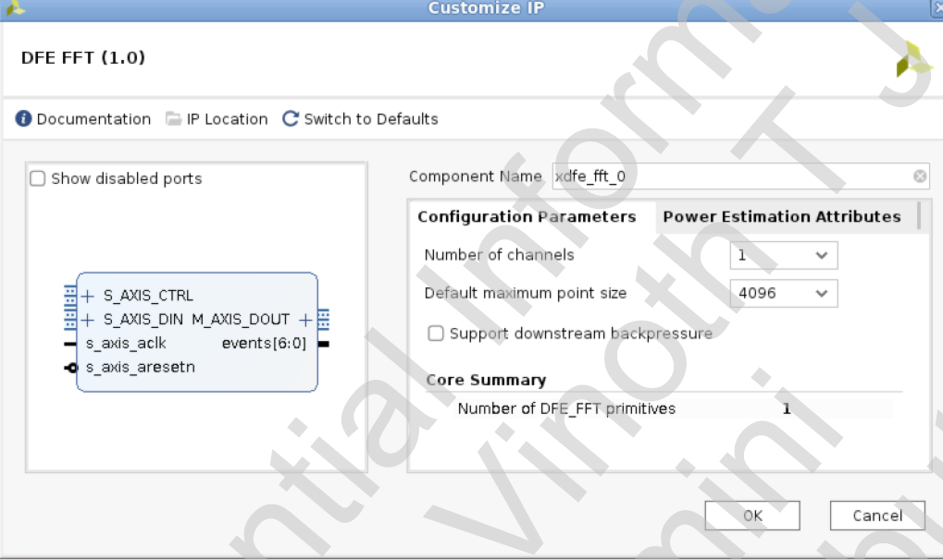
• Number of channels: Determines the number of parallel DFE FFT channels that are provided
by this instance of the IP core. The default value is 1. The maximum value supported is 8.
• Default maximum point size: Determines the initial setting for the maximum point size
control. This must be a power of two. The default value is 4096, which is the largest
supported value. The minimum supported value is 256.
• Support downstream backpressure: When set to TRUE, the data output can be stalled by the
downstream logic using the TREADY signal on the output AXI4-Stream interface. The latency is increased by two clock cycles. When set to FALSE, data output cannot be stalled.

Power Estimation Tab
The RFSoC DFE FFT IP core supports power estimation. The Power Estimation Attributes tab in the IP customization dialog, shown below, allows power estimation parameters to be specified. The values set for these fields have no effect on the functionality of the core.

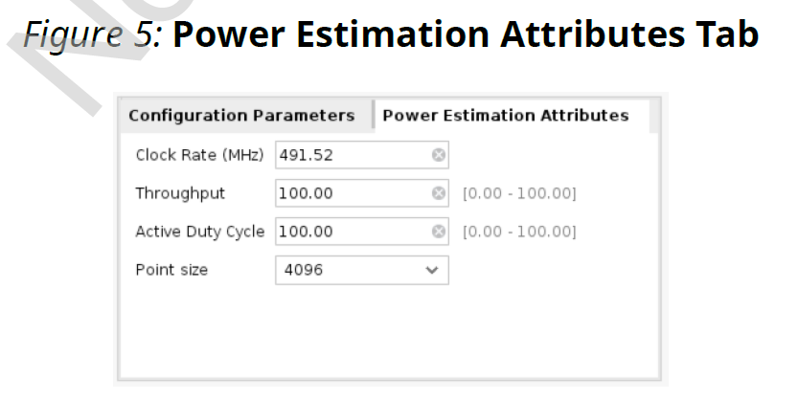

• Throughput: The expected data throughput as a percentage of the maximum available
throughput.
• Active Duty Cycle: The duty cycle of the core as a percentage, where 100% means the core is
always operational and 0% means the core is always deactivated.
• Point Size: The expected point size to be used for power estimation.
All of the parameters above can be set to an average number or a maximum number depending
on your power estimation goals.

PRB Calculation:
BW = 50 MHz
SCS = 15KHz
No. of RB = Channel BW – 2x Guard Bandwidth / one Resource block bandwidth
One Resource block bandwidth = RE * SCS
12 x 15KHz = 180 KHz

Eg1: (50 MHz – 2x 692.5 KHz)/180 KHz = (50x10^3 - 13,85,000 )/180 x10^ 3 = 270 PRBs

Eg2: (100 x10^6 – (2 x 845x10^3))/180x10^3 = 273 PRBs

FFT size Calculation :-

In Release 15, 3GPP has defined two frequency ranges: Frequency range 1 (FR1), which extends from 450 megahertz (MHz) to 7.125GHz, and frequency range 2 (FR2), which extends from 24.25 to 52.6GHz

FR1 cell bandwidth max 100Mhz.
For example, 100Mhz SCS = 30khz, 273RB.
No of sub carriers = 273*12 = 3276
FFT 2048 is not enough for sampling 3276 subcarriers, must be at least FFT 4096.

For example, 90Mhz scs 30khz, 245RB
No of sub carriers = 245*12 = 2940
FFT 2048 is not enough for sampling 3276 subcarriers, must be at least fft 4096.

Sublevel block diagram and description of ifft

Waveform/Timing
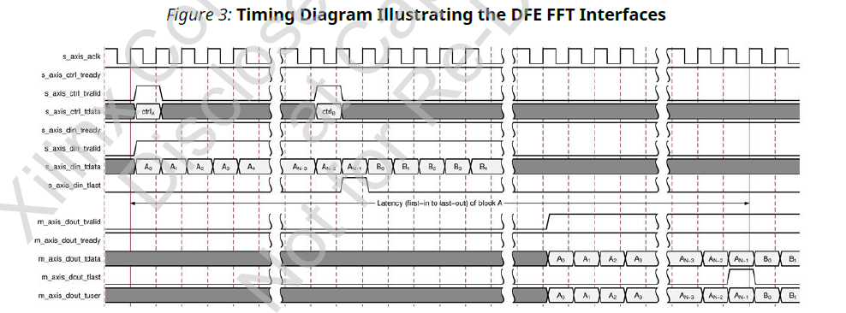

OFDM Modulator Input OP Interface

CP Insertion
Cyclic prefix insertion is used to reduce the inter symbol interference (ISI) in a multipath channel

The cyclic prefix acts as a buffer region or guard interval to protect the OFDM signals from inter symbol interference.
For to minimize the ISI a lot when we make the size of the symbol larger (the size of the delay spread becomes relatively minor compared to the larger size). But as much as we could increase this symbol size, the effects of ISI would always be present.
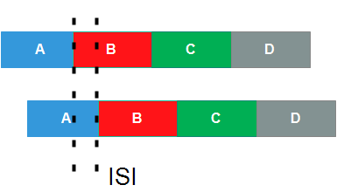

The one way to do this is by copying or duplicating an initial part of the symbol and inserting the end of it. And it acts as Cyclic Prefix.
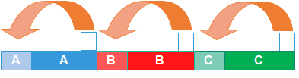
So that the CP copy a small part of the initial information (hence the name prefix) to the end of each symbol (hence the name cyclic).
Thus, the receiver can identify the end points of each symbol and correctly correlate the information, thereby eliminating the interference problem.
Scalable symbol durations and cp samples
The symbol duration in OFDM must be 1 / SCS So, each 15 KHz OFDM symbol duration (including CP) precisely equals
• 2 symbol durations with SCS = 30 KHz
• 4 symbol durations with SCS = 60 KHz
• 2 μ symbol durations with SCS = 2μ *15kHz
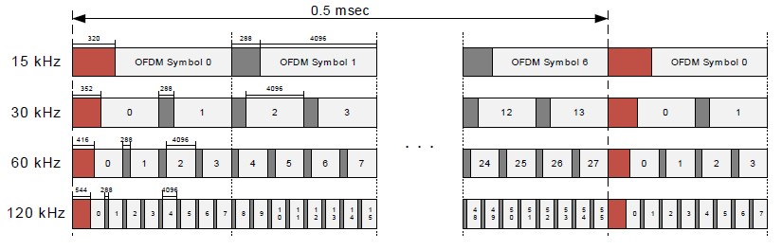

Calculating Cp Overhead
The CP overhead is a percentage ratio of CP time duration and Symbol time duration, for example 15KHz the NR symbol duration is 66.67 μs and CP duration is 5.2 µs. Then overhead can be calculated 5.2/66.67 = 7.8 % . Here the long symbol shall have more overhead as CP where as other symbols shall have less overhead. below table provides a summary of overhead for Normal CP for different sub carrier spacing.
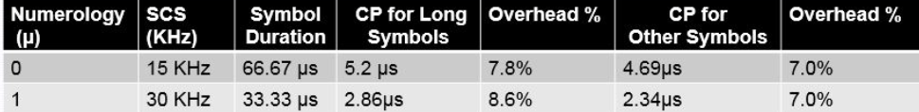

Interface Diagram
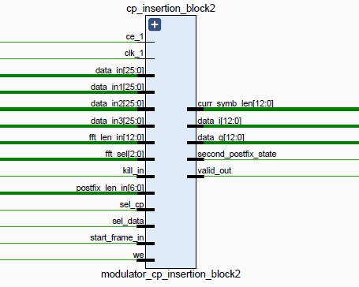

Signal description
Signal name | port | description
clk_1 | input | Clock signal
ce_1 | input | Clock enable signal
data_in[25:0] | input | input data 0 from the ifft output block
data_in1[25:0] | input | input data 1 from the ifft output block
data_in2[25:0] | input | input data 2 from the ifft output block
data_in3[25:0] | input | input data 3 from the ifft output block
fft_len_in[12:0] | input | fft size of 4096 samples
fft_sel[2:0] | input | 3 bit fft select
kill_in | input | Async reset
postfix_len_in[6:0] | input
sel_cp | input
sel_data | input
start_frame_in | input | Identifies the start of the frame
we | input | Write enable
curr_symb_len[12:0] | output | Which describes ofdm symbol size
data_i[12:0] | output | Imaginary type data to windowing block
data_q[12:0] | output | Real type data to windowing block
second_postfix_state | output
valid_out | output | Asserted high when output data’s are valid

Sublevel block diagram and description of Tx Phase Predistortion
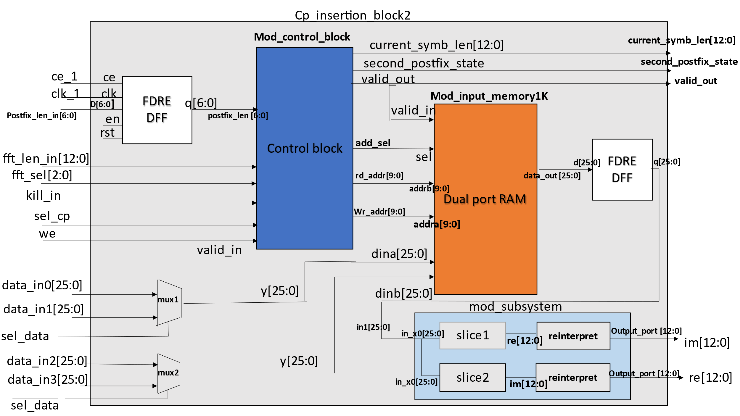
Control block :
The sub level control block in the cyclic prefix insertion block consists of different sub level blocks to perform the specific operations on data, The “choice_current_length” block which is present in control block is used to select the cp length and it also used to provide us a cp start address.
And in this block it performs multiplexer operations on data provided from two constants and shift operation on cp length, slicing on fft length input data.
The cp_start_address and fft_len are given to the wr_cnt block which performs logical(Ex-or), relational operations on data and also it generate pulse from the pulse generator block.
The cp-len, cp_start_addr, fft_len and fft-sel from choice_current_length block are given as input to the rd_sm block, the rd_sm block consists of a hold_sm block which produces start and stop bits and also it generates rd_address, wr_address, addr_select bits to the dual port ram block

Waveform/Timing
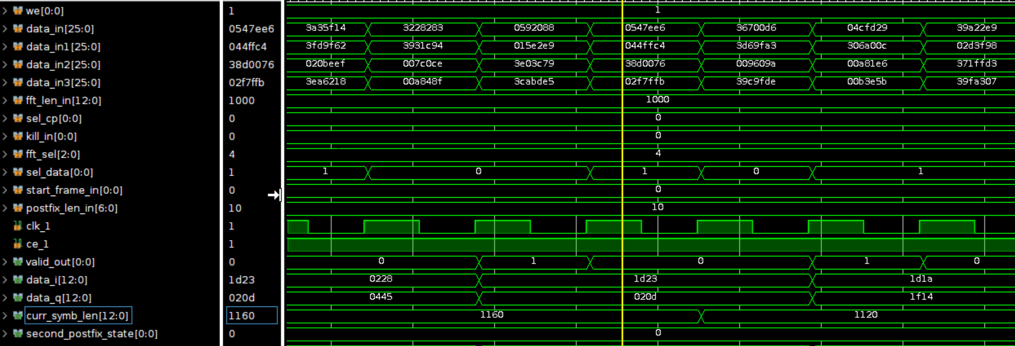

Windowing
Windowing reduces the amplitude of discontinuities at the boundaries of each finite sequence acquired by the digitizer.

Windowing is a technique which is used to process and analysis a smaller subset of data by taking from larger dataset.

It is a technique used to shape the time portion of your measurement data and to minimize edge effects that result in spectral leakage in the IFF spectrum.

By using window function correctly, the spectral resolution of your frequency domain will increase.

In the sub level block diagram of windowing block, it is having 3 sub level blocks:
- input_regs; which is used to store the input data and to interpret the given data for concatenation.
- block_control; it is used to control the data and it is also used to control the generation of the rd_addr coefficients and to store them in coefficients storage block and other data like rd_addr in the registers.
- block_calculation; in this block overall calculations are made using the converters, muxes and counters.
Here, counters are used to count the data receiving from the block_control block. Using the selection lines of the muxes, data is being selected for the calculating and generating the output data. And interpreter are used to execute the data which is in programming language without converting it into machine language.

In this windowing block, slice tiles are available which are used to cut the data by half to make ease for conversions and generating the outputs.

Interface Diagram
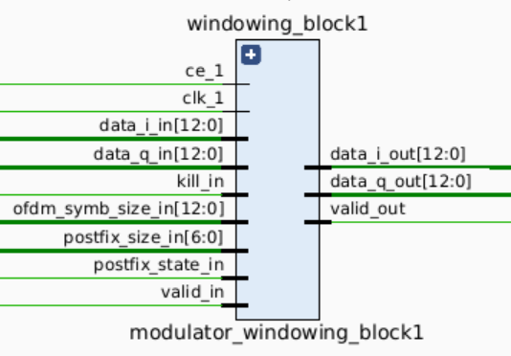

Signal description
Signal Port | Port | Description
ce_1 | Input | Clock Enable
clk_1 | Input | Clock
data_i_in [12:0] | Input | Data Input of ‘i’
data_q_in [12:0] | Input | Data Input of ‘q’
kill_in | Input
ofdm_symb_size_in [12:0] | Input
postfix_state_in [6:0] | Input
postfix_state_in | Input
valid_in | Input | Input Valid
data_i_out [12:0] | Output | Data Output of ‘i’
data_q_out [12:0] | Output | Data Output of ‘q’
valid_out | Output | Output Valid

Sublevel block diagram and description of Windowing Block
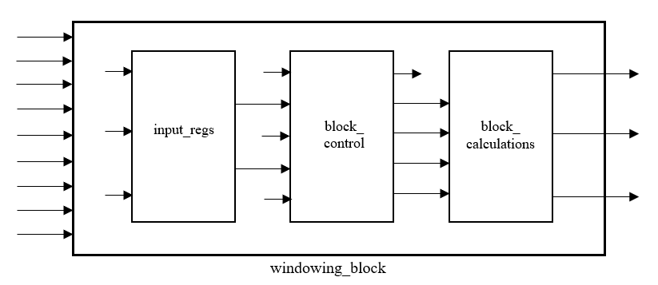

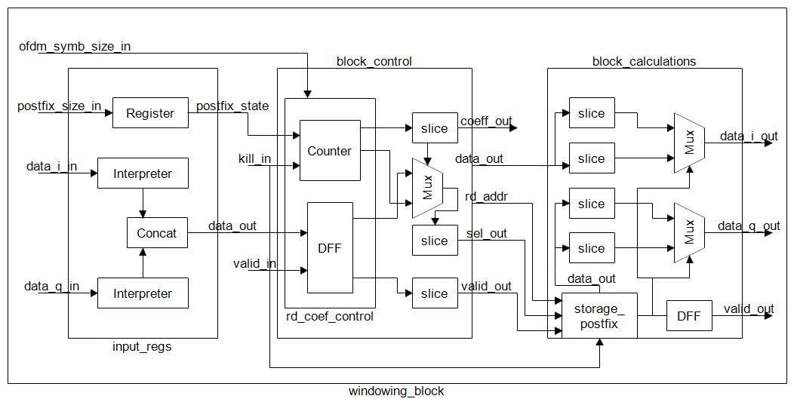

Waveform/Timing
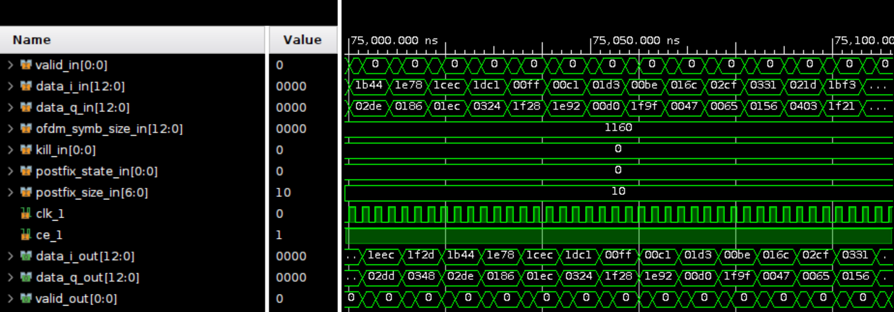

Register Space:
Modulator Output Interface –
Index | Signal Name | Description | Direction | Offset | Width
0 | service_reg | Current revision and data:  [31:16] – unused.  [15:0] – revision number:  [15:8] – major;  [7:0] – minor; | OUT | 0x00 | [31:0]
1 | kill | Synchronous reset of the encoder (active high). | IN | 0x04 | [0:0]
2 | max_point_size |  | IN | 0x08 | [31:0]
3 | ppd_coef_we | Enable signal indicates write enable for PPD coefficients. | IN | 0x0C | [0:0]
4 | ppd_coef_wr_addr | Write address for PPD coefficients. | IN | 0x10 | [7:0]
5 | ppd_coef_re | Real part of PPD coefficients. | IN | 0x14 | [12:0]
6 | ppd_coef_im | Imaginary part of PPD coefficients. | IN | 0x18 | [12:0]

IFFT out –
Index | Signal Name | Description | Direction | Offset | Width
0 | service_reg | Current revision and data:  [31:16] – unused.  [15:0] – revision number:  [15:8] – major;  [7:0] – minor; | OUT | 0x00 | [31:0]
1 | kill | Synchronous reset of the encoder (active high). | IN | 0x04 | [0:0]
2 | pattern | Output pattern for 1 occasion which is consist of 0-7 CC ID  [3:0] – output CC ID in 0 sample  [7:4] – output CC ID in 1 sample  …  [31:28] – output CC ID in 7 sample in occasion  Explanation:  [3:0]:  0-7 - output CC ID in appropriate sample;  15 – prohibited state. | IN | 0x08 | [31:0]
3 | cc_num_symb | [1:0] – num symb in occasion CC ID 0  [3:2] – num symb in occasion CC ID 1  …  [15:14] – num symb in occasion CC ID 7  Explanation:  0 – 0 symbols;  1 – 1 symbol;  2 – 2 symbols;  3 – 4 symbols; | IN | 0x0C | [15:0]
4 | wind_coef_we | Enable signal indicates write enable for windowing coefficients. The length of the coefficients massive and values should be specified from LLS. | IN | 0x10 | [0:0]
5 | wind_coef_wr_addr | Write address for TX Windowing coefficients. | IN | 0x14 | [5:0]
6 | wind_coef | TX Windowing coefficients. | IN | 0x18 | [12:0]
7 | postfix_len | Length of chosen postfix size in OFDM symbol for TX Windowing processing. | IN | 0x1C | [6:0]

OFDM Demodulator

Description
The OFDM Demodulator block operates symmetrically in the inverse order. The block receives TD samples in 4 parallel AXI4-Streams with aggregation of two antennas within each of them: 0-1, 2-3, 4-5 and 6-7. The samples are alternated in the antenna index first, carrier index second order, the same carrier index patterns and sample rates as for the OFDM Modulator are supported. The input samples are passed through the CP removal and windowing operation and then buffered for reordering. The samples are read in the OFDM symbol-by-symbol order, carrier first, time-domain symbol index second and passed to the FFT block utilizing 8 FFT hardened primitives (one for each of 8 antennas).
The calculated FD samples are passed through full custom PL-based RX PPD and GI removal stages and then sent to the output of the block in 8 parallel AXI4-Stream buses associated with 8 receive antennas.
The OFDM Demodulator performs the following steps:
• receiving input data and start_frame pulse signal;
• based on start_frame makes the removing of CP and implementation of RX_windowing function;
• implementation the function of phase pre-distortion on RX side. The coefficients of phase pre-distortion should be agreed with TX side in the following way:
- rx_coeff = conj(tx_coeff);
• the signal conversion from time to frequency domain (by means of FFT Block);
• discard of Guard Bangs and conversion data to AXI Stream Interface.
The OFDM Demodulator is designed for signal bandwidths 100, 90, 80, 70, 60 MHz according to 5G NR specification.
A high-level view on the OFDM Demodulator IP architecture (for single antenna port) is depicted in the following figure.
High Level OFDM Demodulator IP

PRACH Filtering
A frequency domain physical random access channel (PRACH) filter for PRACH signal recovery, wherein the PRACH signal is received in an uplink signal multiplexed with one or more other channels having a different subcarrier spacing than a subcarrier spacing of the PRACH, the method comprising: indices for PRACH recovery, wherein the indices for PRACH recovery comprise sample indices within orthogonal frequency division multiplexing (OFDM) symbols and requisite sample indices;
an inverse discrete Fourier transform (IDFT) with down-sampling circuit configured to compute down-sampled PRACH signal data from frequency domain symbols using the sample indices within the OFDM symbols for a format of a PRACH sequence of the PRACH signal; and
an OFDM symbol mapping circuit configured to map the PRACH signal data to PRACH requisite samples using the requisite sample indices for the format of the PRACH sequence.

- It helps gNB to adjust the uplink timings of the UE in addition to other parameters.
WHY RACH
- i) Achieve UP link synchronization between UE and eNB
- ii) Obtain the resource for Message 3 (e.g, RRC Connection Request)
When RACH used
- i) Initial access from RRC_IDLE;
- ii) RRC Connection Re-establishment procedure;
- iii) Handover;
- iv) DL or UL data arrival during RRC_CONNECTED when UL synchronisation status is "non-synchronised";
- v) Transition from RRC_INACTIVE;
- vi) To establish time alignment at SCell addition;
- vii) Request for Other SI
- viii) Beam failure recovery.

DPD
Digital predistortion (DPD), which linearizes the power amplifier
It is used to increase the efficiency of Power Amplifier

CFR
For the downlink, the digital front-end includes crest factor reduction, which reduces the peak-to-average ratio of the OFDM signal

