O-RU 8T8R 5G NR BSP FPGA Test Plan

Revision History
Revision No. | Date | Description of Change | Author | Approved By
v0.1 | 30-Apr-2022 | First Release | Capgemini | Muthukumar Arunachalam
v0.2 | 19-Sept-2022 | Second Release | Capgemini
Table of Contents
- 1. Introduction 5
1.1 Purpose and Scope 5
1.2 References 5
- 2. Test Sequence and Connections 7
2.1 Testing sequence diagram 7
2.2 Testbench connection diagram 8
- 3. Testbench SW/HW requirements 9
3.2 Testbench PC Software Configuration 10
3.3 Boot binaries Required for Testing 10
3.4 Lab measurement and test instruments and licenses 11
- 4. Test Cases 12
4.1 Reset test 12
4.2 JTAG test 13
4.3 Memory test 13
4.4 BSP Initialization 18
4.5 Serial interface testing 23
4.6 BSP functional testing 26
4.7 Modem functional testing 31

List of Figures

Figure 1: Testing Sequence Diagram 7
Figure 2: O-RU Hardware 8

Chapter
1

Introduction

Purpose and Scope

This document specifies the test scenarios, required to bring up the BSP and LowPHY SW and FW on the Ounas board. It includes the test sequence diagram, test case procedure description, the required equipment and expected outcome definition.
The O-RAN Conformance tests can be considered for design exhaustive testing, wherever it is applicable, based on the product requirements specification.

References

- O-RAN Alliance Working Group 4 Management Plane Specification v06.00
- Product Requirements 8T8R NEC MB5434 V1.0
- O-RAN-WG4.CUS.0-v06.00
- O-RAN.WG4.MP.0-v06.00
- O-RAN.SFG.O-RAN-Security-Protocols-Specifications-v02.00

Chapter
2

Test Sequence and Connections

Testing sequence diagram

Figure 1: Testing Sequence Diagram

Testbench connection diagram

Figure 2: O-RU Hardware

Chapter
3

Testbench SW/HW requirements

The below provided list of HW and SW equipment is required for functional testing of the deployed FW/SW designs on Ounas board.

Testbench Configuration
- Device under test (DUT): TRXPSU PCB + 8T8R_PA PCB – 1.
- A x86 PC with one 25GbE Base-R network interface and two 1000Base-T Ethernet network interfaces – 1.
Possible options (one of the following):
  - A PC motherboard with two 1000Base-T Ethernet network interfaces.
  - A PC with one 1000Base-T Ethernet network interface on the motherboard and one 1000Base-T Ethernet network interface on a PCI-E network card that should be compatible with Linux OS.
  - A PC with one 1000Base-T Ethernet network interface on the motherboard and one 1000Base-T Ethernet network interface on a USB3.0 network card that should be compatible with Linux OS.
- Xilinx RFSoC JTAG Cable:
  - A JTAG cable to connect the DUT to the testbench PC. One of the following:
    - SmartLynq Data Cable (https://www.xilinx.com/products/boards-and-kits/smartlynq-data-cable.html)
    - Digilent JTAG-HS3 Programming Cable (https://digilent.com/shop/jtag-hs3-programming-cable/)
  - If needed, an adapter or a cable to connect the JTAG cable to the DUT RFSoC JTAG interface connector.
  - A USB cable to connect the testbench PC to the Xilinx RFSoC JTAG cable.
- TI MCU JTAG Cable:
  - A JTAG cable to connect the DUT MCU to the testbench PC:
    - TMDSEMU200-U XDS200 USB Debug Probe (https://www.ti.com/tool/TMDSEMU200-U).
  - If needed, an adapter or a cable to connect the JTAG cable to the DUT MCU JTAG interface connector.
  - A USB cable to connect the testbench PC to the MCU JTAG cable.
- A USB cable to connect the testbench PC USB port to the DUT FTDI IC which provides USB-UART conversion for Xilinx RFSoC and MCU consoles.
- RJ-45 cables to connect the testbench PC to the laboratory network and to connect the DUT to the testbench PC.
- A USB flash drive (8+ GBytes) to create a bootable device when needed.
- Optical cable and media-convertors.
- Smart plug for remote power supply switch on/off.

Testbench PC Software Configuration

- Operating system: Xubuntu 20.04.4 or Xubuntu 22.04 (recommended if the test benches are going to be deployed after April 21, 2022).
- Remote access: OpenSSH server installed:
$ sudo apt install openssh-server
- Vivado Lab Solutions - 2021.2.1 (https://www.xilinx.com/support/download.html) with cable drivers installed. See https://www.xilinx.com/content/dam/xilinx/support/documentation/sw_manuals/xilinx2021_2/ug973-vivado-release-notes-install-license.pdf for additional details.
- TI Code Composer IDE v11.x (https://www.ti.com/tool/CCSTUDIO#downloads)
- One user account with sudo privileges.
- Testbench PC should have an IP address reserved by MAC on the laboratory network DHCP server – to have a predictable IP address for each testbench without any manual configuration on the testbench side.

Boot binaries Required for Testing

FW and Image Files | Path to the Files | Remarks
MCU Firmware
PL – Bit Files
PS – Boot Loader & Linux Images

- Operating system: Xubuntu 20.04.4 or Xubuntu 22.04 (recommended if the test benches are going to be deployed after April 21, 2022).
- Remote access: OpenSSH server installed:
$ sudo apt install openssh-server
- Vivado Lab Solutions - 2021.2.1 (https://www.xilinx.com/support/download.html) with cable drivers installed. See https://www.xilinx.com/content/dam/xilinx/support/documentation/sw_manuals/xilinx2021_2/ug973-vivado-release-notes-install-license.pdf for additional details.
- LM Flash Programmer Software for MCU programming
- One user account with sudo privileges.
- Testbench PC should have an IP address reserved by MAC on the laboratory network DHCP server – to have a predictable IP address for each testbench without any manual configuration on the testbench side.

Lab measurement and test instruments and licenses
- Digital Oscilloscope
- Keysight S5040A Open RAN Studio Player and Capture
- U5040BSCB Open RAN Studio
- U5040IQEB IQ Extraction Option for Open RAN Studio
- 89601200C Basic vector signal analysis
- 89601BHNC 5G NR modulation analysis
- N7631ORNC PathWave Signal Generation for 5G NR
- M9410A VXT PXIe Vector Transceiver

Chapter
4

Test Cases

Reset test

Test name: Ounas Reset Test
Test objective: validation of external (button) reset for RFSoC
Test setup: Assembled 8T8R TRXPSU board, power supply. The test execution is possible with BSP main FW written into the eMMC/QSPI memory.
Procedure:
- Assemble the test setup
- Power up the complete system
- Wait for Linux console login
- Press reset button
- After the reset, the Linux OS has to boot up and come up with console login prompt
Problems, found during testing:
Expected outcome: The PoR should be triggered
Test protocol:

JTAG test

Test name: Ounas JTAG Test
Test objective: Confirmation of RFSoC JTAG interface operation
Test setup: Assembled 8T8R TRXPSU board, SmartLynq Data Cable or similar, power supply, PC with installed Xilinx Vivado 2022.1, USB cable
Procedure:
- Assemble the test setup
- Power up the complete system
- Open Xilinx Vivado on PC and check for connected JTAG devices
Problems, found during testing:
Expected outcome: the RFSoC_DFE XCZU67DR device should be detected by Vivado tool
Test protocol:

Memory test

SD card test (EVM)

Test name: Ounas SD card Test
Test objective: Confirmation of RFSoC SD card interface operation
Test setup: Assembled 8T8R TRXPSU board, SmartLynq Data Cable or similar, power supply, PC with installed Xilinx Vivado 2021.2.1, USB cable, SD card, BSP FW debug project in Vitis
Procedure:
- Assemble the test setup
- Plug in the SD card with boot images
- Power up the complete system
- Login the Linux console (username: root / password: root)
- In the command line execute the command “test_sd.sh”
- Wait for test execution
Problems, found during testing:
Expected outcome: during the operation of test script, the disk space is written by a predefined data pattern and then read back and compared. If discrepancy is found – warning message appears.
Test protocol:

eMMC test

Test name: Ounas eMMC Test
Test objective: Confirmation of RFSoC ability to operate with eMMC memory
Test setup: Assembled 8T8R TRXPSU board with BSP loaded, PC with command line interface.
Procedure:
- Assemble the test setup
- Plug in the SD card with boot images
- Power up the complete system
- Login the Linux console (username: root / password: root)
- In the command line execute the command “test_emmc.sh”
- Wait for test execution
Problems, found during testing:
Expected outcome: during the operation of test script, the disk space is written by a predefined data pattern and then read back and compared. If discrepancy is found – warning message appears.
Test protocol:

QSPI test

Test name: Ounas QSPI Test
Test objective: Confirmation of RFSoC ability to operate with QSPI memory
Test setup: Assembled 8T8R TRXPSU board with BSP loaded, PC with command line interface.
Procedure:
- Assemble the test setup
- Power up the complete system
- After OS start-up, login into the system
- Check created partitions: cat proc/mtd
- Create temporary directory to mount test partition: mkdir /tmp/tmpfs
- Mount any partition: mount -t jffs2 /dev/mtdblock<number> /tmp/tmpfs/
- Check that it is empty: ls -l /tmp/tmpfs
- Create new file tmp.file on the partition: touch /tmp/tmpfs/tmp.file
- Check it: ls -l /tmp/tmpfs Result: file was successfully created
- Unmount partition: umount /tmp/tmpfs/
- Check that directory is empty: ls -l /tmp/tmpfs Result: directory is empty.
- Create another file tmp.file2 in temporary directory: touch /tmp/tmpfs/tmp.file2
- Check it: ls -l /tmp/tmpfs Result: file was successfully created
- Mount partition again: mount -t jffs2 /dev/mtdblock<number> /tmp/tmpfs/
- Check that file2 is not accessible and file1 is accessible: ls -l /tmp/tmpfs Result: tmp.file is presented and tmp.file2 is not
- Remove all files from directory: rm -rf /tmp/tmpfs/*.
- Check it: ls -l /tmp/tmpfs Result: directory is empty
- Unmount partition: umount /tmp/tmpfs/.
- Check that file2 is accessible again: ls -l /tmp/tmpfs Result: tmp.file2 is presented and tmp.file is not
- Delete it: rm -rf /tmp/tmpfs/*
- Check it: ls -l /tmp/tmpfs
Problems, found during testing:
Expected outcome: during test execution the described Result.
Test protocol:

EEPROM test

Test name: Ounas EEPROM card Test
Test objective: Confirmation of RFSoC ability to operate with EEPROM memory
Test setup: Assembled 8T8R TRXPSU board with BSP loaded, PC with command line interface
Procedure:
- Assemble the test setup
- Power up the complete system
- After OS start-up, login and enter in the command line interface: ‘test_eeprom.sh’
- Wait for test execution
Problems, found during testing:
Expected outcome: during the operation of test tool all disk space is written by a predefined data pattern and then read back and compared. If discrepancy is found – warning message appears.
Test protocol:

PS DDR test

Test name: Ounas PS DDR card Test
Test objective: Confirmation of RFSoC ability to operate with PS DDR memory
Test setup: Assembled 8T8R TRXPSU board, SmartLynq Data Cable or similar, power supply, PC with installed Xilinx Vivado 2022.1, USB cable, BSP FW debug project in Vitis
Procedure:
- Assemble the test setup
- Power up the complete system
- Create and setup PS memory test application in Xilinx Vitis IDE as described below. In order to execute PS DDR test, test application code should be placed in other segment of physical memory, e.g. in OCM (on-chip memory). Test fills all memory with multiple predefined pattern values, reads them back and compares. This implies use of separate FreeRTOS application, separate BSP and separate run procedure. All necessary code is auto-generated by Vitis IDE.
  - Switch to a new workspace location (File → Switch Workspace → Other). e.g. to ps_ddr_test_ws and create new platform project named ps_ddr (File → New → Platform Project).
Choose "Create from hardware specification (XSA)" and select appropriate XSA file location, copied in advance from PL git repo (‘link’, use develop branch)
  - Create new application project named ps_ddr_app (File → New → Application Project). Use ps_ddr platform for its creation. Use following parameters when asked:
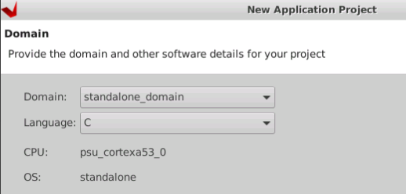
  - When asked, select "Zynq MP DRAM tests"
  - Open platform.spr file and select Board Support Settings for 'standalone on psu_cortex_a53_0', change stdin/stdout settings:
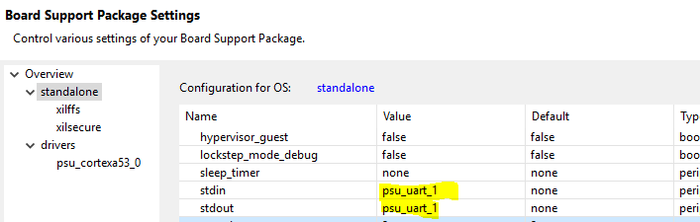
  - For ps_ddr_app select context menu and select "C/C++ Build Settings".
Select ARM v8 gcc compiler → Optimization → Optimization Level = Optimize more (-O2),
Select ARM v8 gcc compiler → Debugging → Debug Level = None
Press "Apply and Close" button.
  - Build all, pressing Ctrl+B combination
  - Create new Debug Configuration for System Application Debug:
'Debugger_ps_ddr_app-Default'
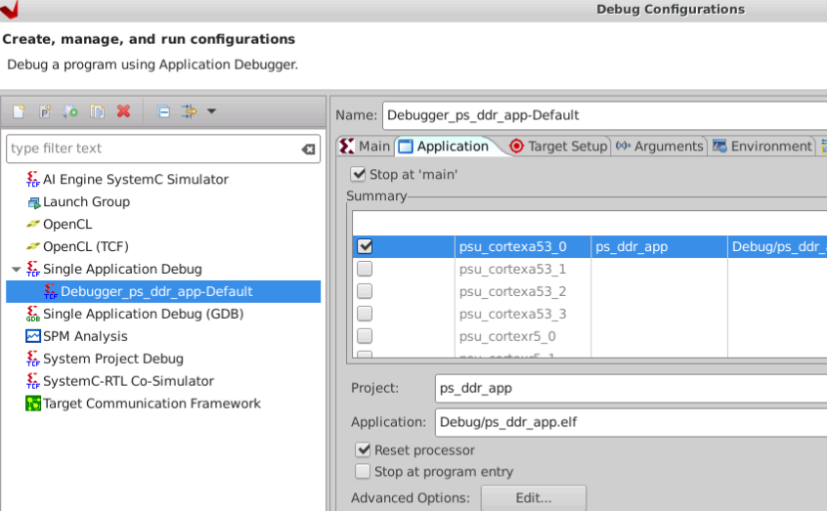
  - Setup this debug configuration as required, e.g.: set type of Connection to Remote/Local with respect to in-place actual settings.
If necessary, set JTAG TCK frequency to 10 MHz for stable work. in "Target Connection Details' window.
- Run 'Debugger_ps_ddr_app-Default' Debug Configuration in Vitis IDE debug project to upload bitstream and run PS software
- Wait for system boot-up and select “Test first 4GB region of DDR" option with pressing '8' in console.
- Wait for test execution
Second method to run DDR memory test from U-Boot Console
Power ON the board
Press ‘c’ immediately after the power ON
The bootup process will stop at U-Boot console
in u-boot prompt, run “help mtest” for the command usage
U-Boot> help mtest
mtest - simple RAM read/write test
Usage:
mtest [start [end [pattern [iterations]]]]
DDR start and end address has to be given as a parameter to the mtest command, pattern also has to be mentioned as a last parameter argument.
mtest <DDR Start Address> <DDR End Address> <Pattern>
Usage example:
mtest 0x20000000 0x22000000 0xaabbccdd
Problems, found during testing:
Expected outcome: test is passed if table column 'ERROR COUNT' is filled with zeroes only.
Pass/Fail message will be displayed after the mtest command execution
Test protocol:

BSP Initialization

Initial Firmware Installation
- Copy the Initial firmware BOOT.bin file to the bootable FAT32 partition of bootable SD card. Note that if this partition already has other BOOT.bin files, they should be renamed.
- Copy the Initial firmware FIT image (ITB image) to the bootable FAT32 partition of bootable SD card.
- Bootable SD card with Initial firmware image is ready to use.

Initial FW loading

Test name: Ounas BSB Initial FW Test
Test objective: To load the Initial board firmware
Test setup:
- Assembled 8T8R TRXPSU and 8T8R PA boards, USB-RS232 cable or any other cable to connect the board serial port to a PC;
- a PC with serial terminal software (PuTTY, TeraTerm, etc.) installed; bootable SD card with Initial firmware image installed.
- See the Initial Firmware Installation section of this document on how to create this bootable SD card.
Note: The SD card should be provisioned with Initial firmware image that is compatible with the board one need to boot
Procedure:
- Set SD card as the boot source for FPGA of the Ounas Board.
- Insert the bootable SD card with the Initial firmware image installed, into the SD Card slot on the board.
- Connect USB-RS232 or other serial console cable to the serial port.
- Open serial console of the Ounas board FPGA in the terminal application. For example:
$ minicom -b 115200 /dev/ttyUSB0
Serial console of Initial firmware uses the following settings:
Baudrate: 115200, one stop bit, no parity, no flow control.
The FPGA serial port number can be different for different boards. Also, it depends on the number of different serial cables, connected to the PC.
- Power on the whole system.
Problems, found during testing:
Expected outcome: Initial firmware boot messages should be displayed in the serial console.
Test protocol:

Programming of QSPI and eMMC with main FW

Test name: Ounas BSB Main FW Test
Test objective: To load the Main board firmware
Test setup: Assembled 8T8R TRXPSU and 8T8R PA boards, USB-RS232 cable or any other cable to connect the board serial port to a PC; a PC with serial terminal software (PuTTY, TeraTerm, etc.) installed; bootable SD card with Initial firmware image installed. See the Initial Firmware Installation section of this document on how to create this bootable SD card. Note, the SD card should be provisioned with Initial firmware image that is compatible with the board one need to boot. Build artifact (tar.gz archive) with Main firmware release image or Main firmware development image.
Procedure:
- Plug-in the bootable SD card to the PC;
- Copy the Main firmware installation image with .swu extension to the FAT32 partition of the bootable SD card;
- Unplug the bootable SD card from the PC;
- Perform Initial Firmware Boot Sequence, described in 3.4.1;
- Login to the Initial Firmware serial console with the following credentials:
    - Login: root;
    - Password: root
- If the Main Firmare image was copied to the bootable SD Card, go to the directory, to which the bootable SD card is automatically mounted:
# cd /run/media/mmcblk0p1
- Execute the following command to install Main firmware image:
Note, this step will destroy all data on QSPI and eMMC flash memory of the board because it will erase QSPI flash data and create a new partition table on the eMMC flash.
# swupdate -i ./fw_main_release_release-1.0.0.swu -e fw_main,bare_init -v -l 5
One should provide the path to the .swu file for the board as the -i argument value.
- This setup can also be used to restore the Boot Files and U-Boot environment on QSPI Flash of the board. To do this, execute the following commands, instead of the step 7 above:
  - To reinstall/restore Boot Files, execute the following command:
# swupdate -i ./fw_main_release_release-1.0.0.swu -e fw_main,boot_files -v -l 5
  - To reinstall/restore U-Boot environment, execute the following command:
# swupdate -i ./fw_main_release_release-1.0.0.swu -e fw_main,uboot_env -v -l 5
  - Note, after this command all manual changes in U-Boot environment are going to be lost.
- Once Main firmware installation is successfully completed, power off the board.
- Power on the whole system.
Problems, found during testing:
Expected outcome: Main firmware boot messages should be displayed in the serial console.
Test protocol:

Renesas 8A34002 system synchronizer bring-up

Test name: Ounas 8A34002 Bring-up
Test objective: To validate the configuration binary for the system synchronizer
Test setup: Assembled 8T8R TRXPSU board, digital oscilloscope, power supply
Procedure:
- Assemble the test setup
- Power up the complete system
- Wait for OS invite to enter the authentication data and login
- Upload 8A34002 configuration bin file and place it in: /lib/firmware with name idtcm.bim
- Go to IDT driver directory
- Unbind and bind back the 8A34002 to IDT driver
- Capture the clock signal waveform on the oscilloscope and analyze its parameters
Problems, found during testing:
Expected outcome: The measured signal parameters should be in the allowed accuracy range (Accuracy range need consensus with Flex).
Test protocol:

SI-8341 clock bring-up

Test name: Ounas SI-8341 ADC DAB input clock test
Test objective: To validate the configuration script for the SI-8341
Test setup: Assembled 8T8R TRXPSU board, digital oscilloscope, power supply
Procedure:
- Assemble the test setup
- Power up the complete system
- Wait for OS invite to enter the authentication data and login
- SI-5381 clock will be programmed as part of the Linux bootup.
- Capture the clock signal waveform on the below various test points by the oscilloscope and analyze its parameters
  - Probe points (TBD)
- Capture the clock signal waveform on the oscilloscope and analyze its parameters
Problems, found during testing:
Expected outcome: The measured signal parameters should be in the allowed accuracy range (Accuracy range need consensus with Flex).
Test protocol:

MCU FW loading

Test name: Ounas 8A34002 Bring-up
Test objective: To program the MCU firmware on the TI base MCU controller
Test setup: Assembled 8T8R TRXPSU board, power supply, UART connection to program MCU, LMFlash programmer windows software application
Procedure:
- Assemble the test setup
- Put the MCU manufacturing mode jumper on the Ounas board
- Power up the complete system
- Run “LMFlash programmer” application from Windows host machine
- In Application settings, keep baud rate as 115200 and chose the respective COM port
- Goto Program Tab, chose the MCU firmware binary file and click the program
- Wait for Program to be successful, progress bar will be bottom of the LMFlash programmer application.
- Remove the Jumper
- Close the LMFlash programmer application
- Open the serial port in Putty with 115200 baudrate
- Power down and power up the Ounas board
- The MCU firmware console will be accessible in the putty.
Problems, found during testing:
Expected outcome: If the MCU console is accessible, then the MCU programming is considered as PASS
Test protocol:

GPIO Init and Power Sequencing

Test name: Ounas 8A34002 Bring-up
Test objective: To enable the power sequencing by loading the MCU firmware on the TI base MCU controller
Test setup: Assembled 8T8R TRXPSU board, power supply, UART connection to see the MCU debug console.
Pre-requisite: MCU has to be programmed before performing this test case
Procedure:
- Assemble the test setup
- Connect the MCU debug console to the host machine
- Power up the complete system
- MCU firmware will do the power sequencing of the power chips
- Read the status of the different power groups by using ‘pmon’ command in the MCU console
Problems, found during testing:
Expected outcome: Check the PRGROUP status in the ‘pmon’ command
Test protocol:

Quad Core APU bootup in Linux

Test name: Ounas 8A34002 Bring-up
Test objective: To check the Quad core APU bring up in Linux console
Test setup: Assembled 8T8R TRXPSU board, power supply, UART connection to see the console.
Procedure:
- Assemble the test setup
- Connect the RFSoC debug console to the host machine
- Power up the complete system
- Wait for Linux console login prompt, Login to the Linux (username and password: root)
- Execute “cat /proc/cpuinfo”
- The output of the ‘cat /proc/cpuinfo’ should display the Quad core CPUs
Problems, found during testing:
Expected outcome: Check the CPU core numbers in the output
Test protocol:

USB Initialization

Test name: Ounas 8A34002 Bring-up
Test objective: To check the USB Initialization in Linux
Test setup: Assembled 8T8R TRXPSU board, power supply, UART connection to see the console.
Procedure:
- Assemble the test setup
- Connect the RFSoC debug console to the host machine
- Power up the complete system
- Wait for Linux console login prompt, Login to the Linux (username and password: root)
- Plug-In the USB mass storage device into USB port
- Check for USB device name using dmesg command
- Mount the USB device into a mount path. Example command “mount /dev/sdb1 /mnt”
- Create a sample text file into mount path touch /mnt/sample.txt
- Un mount the USB device file using the command ‘umount /mnt’
- Plug-in the same USB in another host machine
- Verify the sample.txt file is present in the USB device storage
Problems, found during testing:
Expected outcome: Check the operations of the file copy into USB device
Test protocol:

GPIO operations

Test name: Ounas 8A34002 Bring-up
Test objective: To check the USB Initialization in Linux
Test setup: Assembled 8T8R TRXPSU board, power supply, UART connection to see the console.
Procedure:
- Assemble the test setup
- Connect the RFSoC debug console to the host machine
- Power up the complete system
- Wait for Linux console login prompt, Login to the Linux (username and password: root)
- Plug-In the USB mass storage device into USB port
- Check for USB device name using dmesg command
- Mount the USB device into a mount path. Example command “mount /dev/sdb1 /mnt”
- Create a sample text file into mount path touch /mnt/sample.txt
- Un mount the USB device file using the command ‘umount /mnt’
- Plug-in the same USB in another host machine
- Verify the sample.txt file is present in the USB device storage
Problems, found during testing:
Expected outcome: Check the operations of the file copy into USB device
Test protocol:

Serial interface testing

RFSoC UART testing

Test name: Ounas UART test
Test objective: Confirmation of RFSoC UART interface init status
Test setup: Assembled 8T8R TRXPSU board with installed BSP and MCU SW/FW, USB to UART cable to host PC
Procedure:
- Assemble the test setup
- Connect the USB-UART cable between Ounas board and Host PC
- Open the Console application (Putty) with desired baud rate (115200)
- Power up the complete system
- Check the Console logs on the console application on the host machine
- If the debug prints are visible and user can see the bootup logs, then this test case can be considered as pass
Problems, found during testing:
Expected outcome: RFSoC bootup prints on the console
Test protocol:

RFSoC-MCU UART testing

Test name: Ounas UART test
Test objective: Confirmation of RFSoC UART interface operation
Test setup: Assembled 8T8R TRXPSU board with installed BSP and MCU SW/FW
Procedure:
- Assemble the test setup
- Power up the complete system
- Wait for OS invite to enter the authentication data and login
- Connect from RFSoC to MCU using UART and read MCU FW version: uart-client /dev/ttyPS1 –getversion. Result: command is successfully finished.
Problems, found during testing:
Expected outcome: MCU FW version is read back successfully
Test protocol:

SPI and I2C testing

Test name: Ounas I2C/SPI interface validation
Test objective: To validate the serial interface communication with each I2C and SPI slave IC Ounas board
Test setup: Assembled 8T8R TRXPSU board with installed BSP and MCU SW/FW, PC with terminal debug print
Procedure:
- Assemble the test setup
- Power up the complete system
- Wait for OS invite to enter the authentication data and login
- Enter to RFSoC console and run bash script “i2c_driver_tests.sh” with no arguments.
- RFSoC (Master) will sequentially write/read registers for each I2C (I2C devices list to be provided by Flex) and SPI slave IC. Corresponding response will be displayed in debug print on PC.
Problems, found during testing:
Expected outcome: The test script successfully run tests for I2C devices. All tests finished with green “PASSED” status. No test finished with red “FAILED” status
Test protocol:

GPIO

Test name: Ounas GPIO interface validation
Test objective: To validate the serial interface communication through the Ounas board GPIOs
Test setup: Assembled 8T8R TRXPSU board with installed BSP and MCU SW/FW, 8T8R PA board, digital oscilloscope, power supply, PC with terminal debug print
Procedure:
- Assemble the test setup
- Power up the complete system
- Wait for OS invite to enter the authentication data and login
- Connect oscilloscope probes to I2C SCL/SDA pins routed to the board test points. Setup trigger to catch I2C SDA/SCL signals. Run command (TBD) to generate I2C transaction and catch the signals.
- Connect oscilloscope probe to specified test points to detect GPIO signals. Run command (TBD) to change the state of tested GPIO line
Problems, found during testing:
Expected outcome: I2C and GPIO signals are detected at test points
Test protocol:

BSP functional testing

DAC and ADC functional testing

Test name: Ounas DAC interface validation
Test objective: To validate the RF DAC operation
Test setup: Assembled 8T8R TRXPSU board with installed BSP and MCU SW/FW, power supply, PC with terminal debug print, Spectrum Analyzer (up to 3.8 GHz at least)
Procedure:
- Assemble the test setup
- Power up the complete system
- Wait for OS invite to enter the authentication data and login
- Enable test signal (single-tone) generation at the maximum power in the range 3.3 – 3.6 GHz for RF channel #0
- Connect Spectrum Analyzer to Channel#0 RF connector of Ounas board. Check presence of desired signal.
- Perform steps 4-5 for other channels #1…7 (respect RF connectors of Ounas board)
Problems, found during testing:
Expected outcome: Desired signals are observed for all RF channels
Test protocol:

Test name: Ounas ADC interface validation
Test objective: To validate the RF ADC operation
Test setup: Assembled 8T8R TRXPSU board with installed BSP and MCU SW/FW, power supply, PC with terminal debug print and installed Xilinx Vivado 2021.2.1, RF generator (up to 3.8 GHz at least)
Procedure:
- Assemble the test setup
- Power up the complete system
- Wait for OS invite to enter the authentication data and login
- Connect RF Generator to the RF connector of Ounas board (channel #0). Enable RF test signal generation (single-tone in the range 3.3 – 3.6 GHz, input power should be not higher than -12 dBm).
- Use RFSoC application (Vivado with design debug probes) to catch ADC output waveforms.
- Perform steps 4-5 for other channels #1…7 (corresponded RF connectors of Ounas board)
Problems, found during testing:
Expected outcome: Desired signals are observed for all RF channels
Test protocol:

Heartbeat testing

Test name: Ounas heart-beat test
Test objective: To validate the MCU POR pulse generation in case of heart-beat absence from RFSoC
Test setup: Assembled 8T8R TRXPSU board with installed BSP and MCU SW/FW, power supply, PC with terminal debug print, digital oscilloscope
Procedure:
- Assemble the test setup
- Power up the complete system
- Wait for OS invite to enter the authentication data and login
- Connect the oscilloscope probes to RFSoC POR test point of the Ounas board.
- Enter to RFSoC console and run bash script “heart_beat.sh” with ‘disable’ argument
- Capture the POR pulse on the test point during the time interval of 5 sec after disabling the heart-beat messaging.
Problems, found during testing:
Expected outcome: RFSoC POR successfully generated after heart-beat messaging deactivation
Test protocol:

SFP interface testing

Test name: Ounas SFP interface Test
Test objective: Confirmation of RFSoC 10/25GbE interface operation
Test setup: Assembled 8T8R TRXPSU board with installed main BSP FW, power supply, PC with 25GbE network card and installed Xilinx Vivado 2021.2.1, USB cable, optical ethernet cable, SFP media-convertors, BSP FW debug project in Vitis with AXI Performance monitor and Traffic generator for 25GbE throughput measurements
Procedure:
- Assemble the test setup
- Power up the complete system
- Wait for OS invite to enter the authentication data and login
During system boot-up the required configurations will be made automatically: 8A34002 and re-timer IC will be initiated.
- Launch Vitis and create platform project
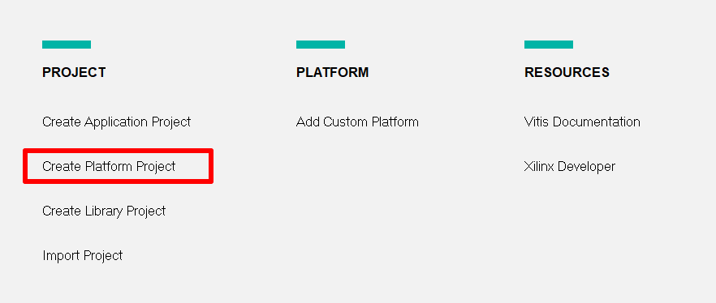
- Select XSA file and click “Finish” button
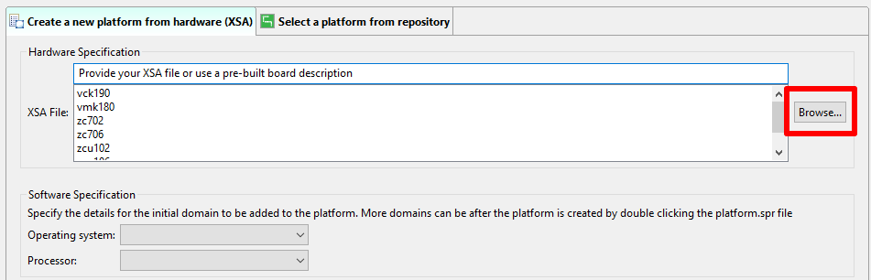
- Create Empty C++ Application project
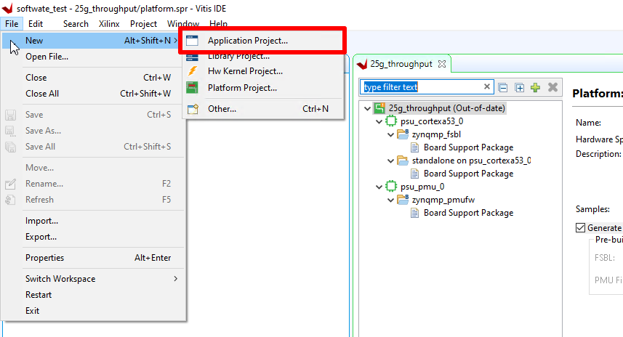
- In the opened Windows click Next, Next, then set the name of the project, Next.
Choose Empty Application (C++) and click Finish
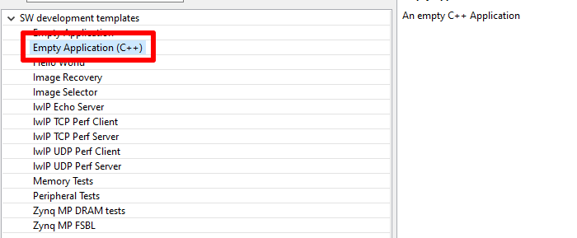
- Add Standalone application source files
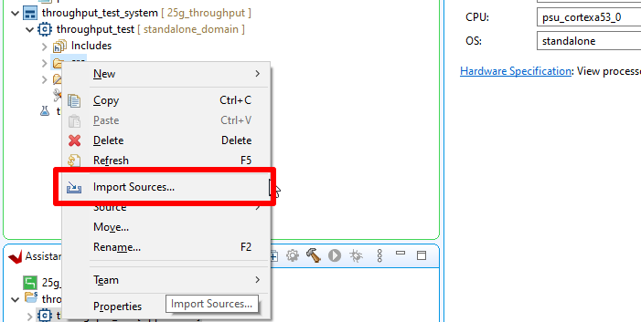
- Choose sources: (TBD)
- Configure debug session
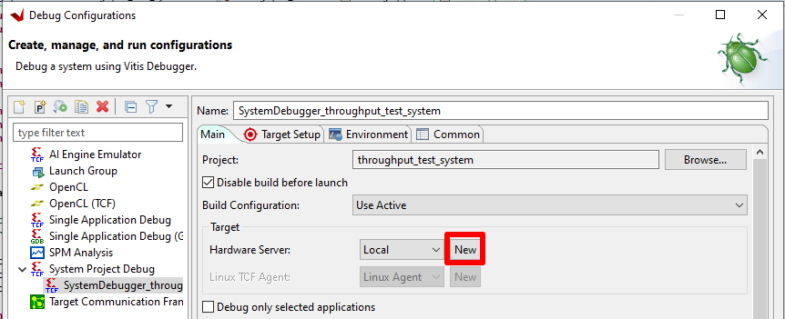

Configure connection settings and click Apply.

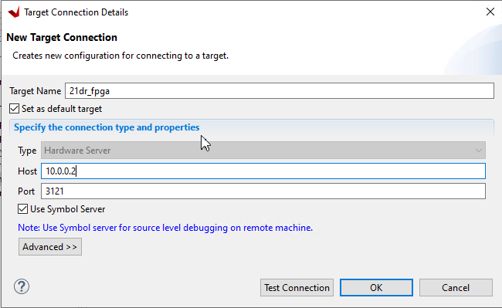

Configure Target Setup

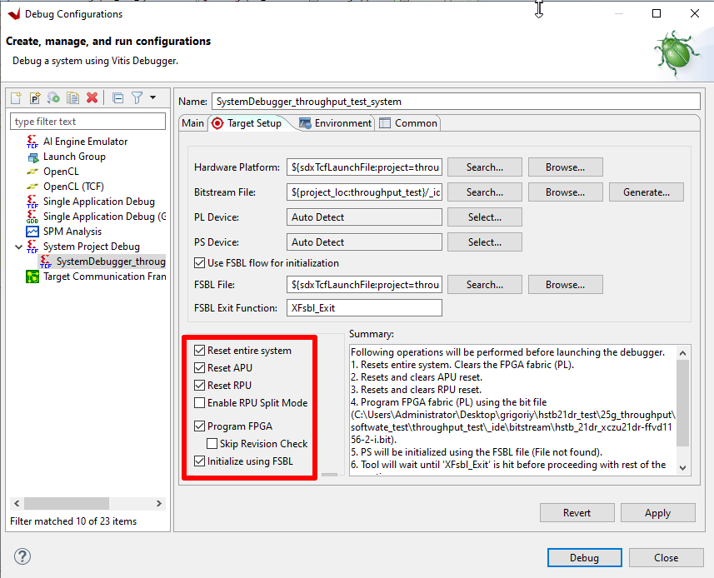

Click Apply button.
Build the Standalone application.
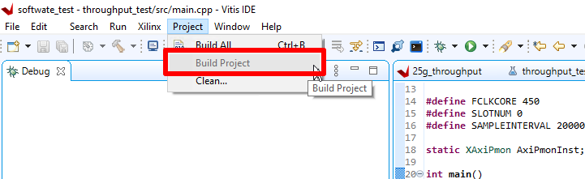

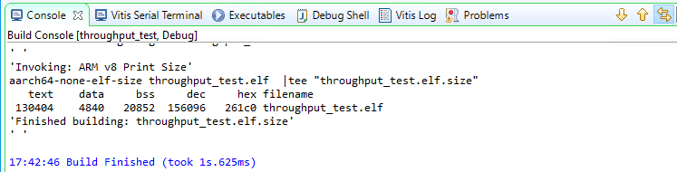
Result: Application was built. The bin file is available and one can start the debugging.
Run debug session.
Create break-points:
- On 46 line of main.cpp.
- On 55 line of main.cpp
Click play button.
- Launch Vivado 2021.2.1 and Open Hardware Manager and open new targets

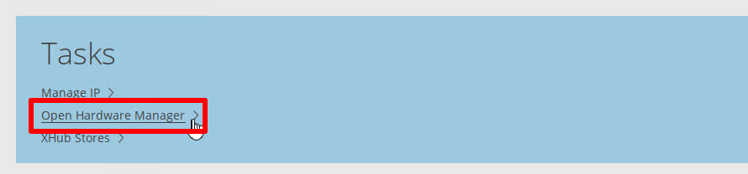

- Choose ILA file
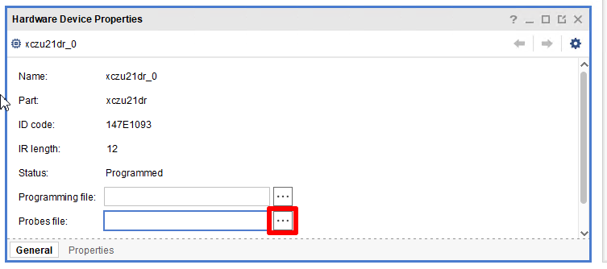
- In Vivado go to hw_vios and add all signals
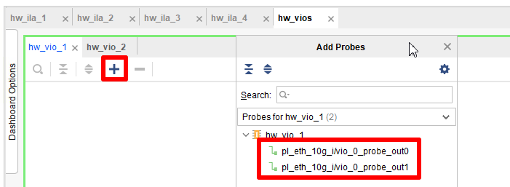

Vio_0_probe_out0 – start signal for traffic generator,
Vio_0_probe_out1 – stop signal for traffic generator

- Turn on Traffic generator.
- Click play button several times.
- Throughput will be calculated in CalcSpeedGbps_0 variable. The value in Gbps
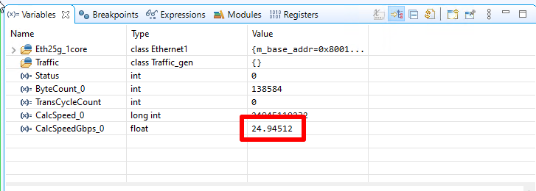
Problems, found during testing:
Expected outcome: The value of throughput on AXI Ethernet IP is reflected in the performance monitor window and close to the expected value of 25Gbps.
Test protocol:

Modem functional testing

O-RAN packet delay test

Test name: Ounas O-RAN delay test
Test objective: To validate the time synchronization between O-RU and O-DU and capability to operate within predefined intervals of RxWindow and C-Plane advance time.
Test setup: Assembled 8T8R TRXPSU board with installed BSP, Modem and MCU SW/FW, power supply, Keysight O-RAN studio server.
Procedure:
- Assemble the test setup
- Connect SFP interfaces of Keysight O-RAN Studio server and Ounas digital board.
- Power up the complete system
- Wait for OS invite to enter the authentication data and login
- Enter to RFSoC console and run bash script “modem_init.sh” with ‘packet_delay’ argument
- In Keysight O-RAN Studio GUI allow PTP synchronization and wait until time sync reaches the sufficient synchronization level (green button will indicate sync accuracy, PTP status tab will reflect the PTP information). Normally this should take around 30 seconds or less.
- In Keysight O-RAN Studio GUI from the File menu select and launch the DL scenario: ‘dl_delay_test’
- Capture the eCPRI packets statistics in the Ounas digital board terminal window.
Problems, found during testing:
Expected outcome:
The captured eCPRI packets statistics in the Ounas digital board terminal window should reflect the number of ‘late_packets’ and ’early_packets’ as zero percent, while the number of ‘packets on time’ should be 100%.
Test protocol:

O-RAN packets statistics test

Test name: Ounas O-RAN statistics test
Test objective: To validate the time synchronization between O-RU and O-DU and capability to acknowledge the received and transmitted eCPRI packets as ‘good’.
Test setup: Assembled 8T8R TRXPSU board with installed BSP, Modem and MCU SW/FW, power supply, Keysight O-RAN studio server.
Procedure:
- Assemble the test setup
- Connect SFP interfaces of Keysight O-RAN Studio server and Ounas digital board.
- Power up the complete system
- Wait for OS invite to enter the authentication data and login
- Enter to RFSoC console and run bash script “modem_init.sh” with ‘packet_stats’ argument
- In Keysight O-RAN Studio GUI allow PTP synchronization and wait until time sync reaches the sufficient synchronization level (green button will indicate sync accuracy, PTP status tab will reflect the PTP information). Normally this should take around 30 seconds or less.
- In Keysight O-RAN Studio GUI from the File menu select and launch the DL scenario: ‘dl_stats_test’
- Capture the eCPRI packets statistics in the Ounas digital board terminal window and capture the packets statistics in the ‘Counters and KPIs’ tab of O-RAN Studio GUI window.
Problems, found during testing:
Expected outcome:
The captured eCPRI packets statistics in the Ounas digital board terminal window should reflect the number of ‘good’ packets, different from zero, while the number of ‘bad’ packets should be 0. The captured eCPRI packets statistics in the O-RAN Studio GUI window should reflect the number of RxPackets and RxBytes as well as TxPackets and TxBytes, different from zero, while the number of ‘Rx Packets Bad FCS’ and ‘Tx Packets Bad FCS’ should be 0.
Test protocol:

O-RAN synchronization test

Test name: Ounas O-RAN PTP test
Test objective: To validate the time synchronization between O-RU and O-DU.
Test setup: Assembled 8T8R TRXPSU board with installed BSP, Modem and MCU SW/FW, power supply, Keysight O-RAN studio server.
Procedure:
- Assemble the test setup
- Connect SFP interfaces of Keysight O-RAN Studio server and Ounas digital board.
- Power up the complete system
- Wait for OS invite to enter the authentication data and login
- Enter to RFSoC console and run bash script “modem_init.sh” with ‘ptp’ argument
- In Keysight O-RAN Studio GUI allow PTP synchronization and wait until time sync reaches the sufficient synchronization level (green button will indicate sync accuracy, PTP status tab will reflect the PTP information). Normally this should take around 30 seconds or less.
Problems, found during testing:
Expected outcome:
O-RAN Studio GUI window shows at the bottom the green button indicating sync accuracy at sufficient level, PTP status tab reflects the PTP information with time offset rms <10ns.
Test protocol:

RFSoC_DFE radio-frequency digital convertor (RFDC) test

Test name: Ounas RFDC_DL interface validation
Test objective: To validate the RFDC DL path processing
Test setup: Assembled 8T8R TRXPSU board with installed BSP and MCU SW/FW, power supply, PC with terminal debug print, Spectrum Analyzer (up to 3.8 GHz at least)
Procedure:
- Assemble the test setup
- Power up the complete system
- Wait for OS invite to enter the authentication data and login
- Enable test signal (single-tone) generation at the maximum power in the range 3.3 – 3.6 GHz for RF channel #0
- Connect Spectrum Analyzer to Channel#0 TX RF connector of Ounas board. Check presence of desired signal.
- Connect the Channel#0 TX RF connector of Ounas board and Channel#0 RX RF connector of Ounas board (loopback)
- Use RFSoC application (Vivado with design debug probes) to catch ADC output waveforms.
- Perform steps 4-7 for other channels #1…7 (respect RF connectors of Ounas board)
Problems, found during testing:
Expected outcome: Desired signals are observed for all RF channels
Test protocol:

DL path e2e test with one channel

Test name: Ounas DL e2e test
Test objective: To validate the design DL path processing
Test setup: Assembled 8T8R TRXPSU and 8T8R_PA boards with installed BSP, Modem and MCU SW/FW, power supply, PC with terminal debug print, O-RAN Studio server with installed Keysight SW and licenses, Keysight vector transceiver with installed SW and licenses.
Procedure:
- Assemble the test setup
- Connect SFP interfaces of Keysight O-RAN Studio server and Ounas digital board.
- Power up the complete system
- Wait for OS invite to enter the authentication data and login
- Enter to RFSoC console and run bash script “modem_init.sh” with ‘dl_e2e’ argument
- Connect Keysight transceiver RF input port and Channel#0 RF port of Ounas 8T8R_PA board.
- In Keysight O-RAN Studio GUI allow PTP synchronization and wait until time sync reaches the sufficient synchronization level (green button will indicate sync accuracy, PTP status tab will reflect the PTP information). Normally this should take around 30 seconds or less.
- In Keysight O-RAN Studio GUI from the File menu select and launch the DL scenario: ‘dl_etm1.1_test’
- Capture the signal spectrum and signal parameters in Keysight Vector Signal Analyzer SW window.
- Perform steps 6-9 for other channels #1…7 (corresponded RF connectors of Ounas 8T8R_PA board)
Problems, found during testing:
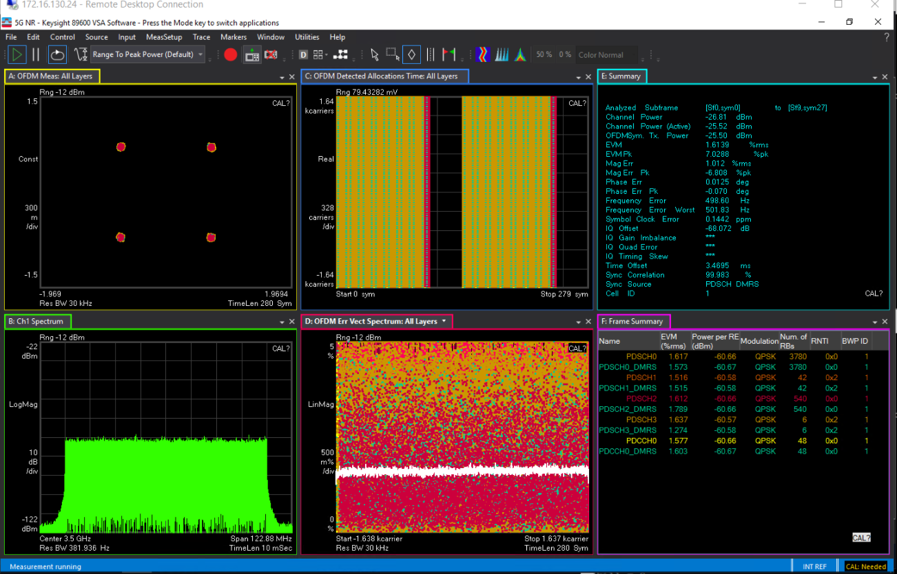
Expected outcome: Desired signals are observed for all RF channels, like shown in the below figure.
Test protocol:

PRACH e2e test with format 0

Test name: Ounas PRACH F0 e2e test
Test objective: To validate the design PRACH path processing
Test setup: Assembled 8T8R TRXPSU and 8T8R_PA boards with installed BSP, Modem and MCU SW/FW, power supply, PC with terminal debug print, O-RAN Studio server with installed Keysight SW and licenses, Keysight vector transceiver with installed SW and licenses.
Procedure:
- Assemble the test setup
- Connect SFP interfaces of Keysight O-RAN Studio server and Ounas digital board.
- Power up the complete system
- Wait for OS invite to enter the authentication data and login
- Enter to RFSoC console and run bash script “modem_init.sh” with ‘ul_e2e’ argument
- Connect Keysight transceiver RF output port and Channel#0 RF port of Ounas 8T8R_PA board.
- In Keysight O-RAN Studio GUI allow PTP synchronization and wait until time sync reaches the sufficient synchronization level (green button will indicate sync accuracy, PTP status tab will reflect the PTP information). Normally this should take around 30 seconds or less.
- In Keysight PathWave SW select from the file menu and load into the Keysight vector transceiver the PRACH scenario: PRACH_WaveForm.
- In Keysight O-RAN Studio GUI from the File menu select and launch the UL scenario: ‘ul_ PRACH_WaveForm_test’
- In Keysight O-RAN Studio GUI make a capturing of the received eCPRI packets sequence of a minimum duration of 3 seconds.
- Open the converted dump file in Keysight Vector Signal Analyzer SW and validate the PRACH signal parameters in GUI window.
- Perform steps 6-11 for other channels #1…7 (corresponded RF connectors of Ounas 8T8R_PA board)
Problems, found during testing:
Expected outcome: Desired signals are observed for all RF channels.
Test protocol:

UL e2e test with single channel

Test name: Ounas UL e2e test
Test objective: To validate the design UL path processing
Test setup: Assembled 8T8R TRXPSU and 8T8R_PA boards with installed BSP, Modem and MCU SW/FW, power supply, PC with terminal debug print, O-RAN Studio server with installed Keysight SW and licenses, Keysight vector transceiver with installed SW and licenses.
Procedure:
- Assemble the test setup
- Connect SFP interfaces of Keysight O-RAN Studio server and Ounas digital board.
- Power up the complete system
- Wait for OS invite to enter the authentication data and login
- Enter to RFSoC console and run bash script “modem_init.sh” with ‘ul_e2e’ argument
- Connect Keysight transceiver RF output port and Channel#0 RF port of Ounas 8T8R_PA board.
- In Keysight O-RAN Studio GUI allow PTP synchronization and wait until time sync reaches the sufficient synchronization level (green button will indicate sync accuracy, PTP status tab will reflect the PTP information). Normally this should take around 30 seconds or less.
- In Keysight PathWave SW select from the file menu and load into the Keysight vector transceiver the UL scenario: G-FR1-A5-11.
- In Keysight O-RAN Studio GUI from the File menu select and launch the UL scenario: ‘ul_G-FR1-A5-11_test’
- In Keysight O-RAN Studio GUI make a capturing of the received eCPRI packets sequence of a minimum duration of 3 seconds.
- Open the converted dump file in Keysight Vector Signal Analyzer SW and validate the UL signal parameters in GUI window.
- Perform steps 6-11 for other channels #1…7 (corresponded RF connectors of Ounas 8T8R_PA board)
Problems, found during testing:
Expected outcome: Desired signals are observed for all RF channels, like shown in the below figure
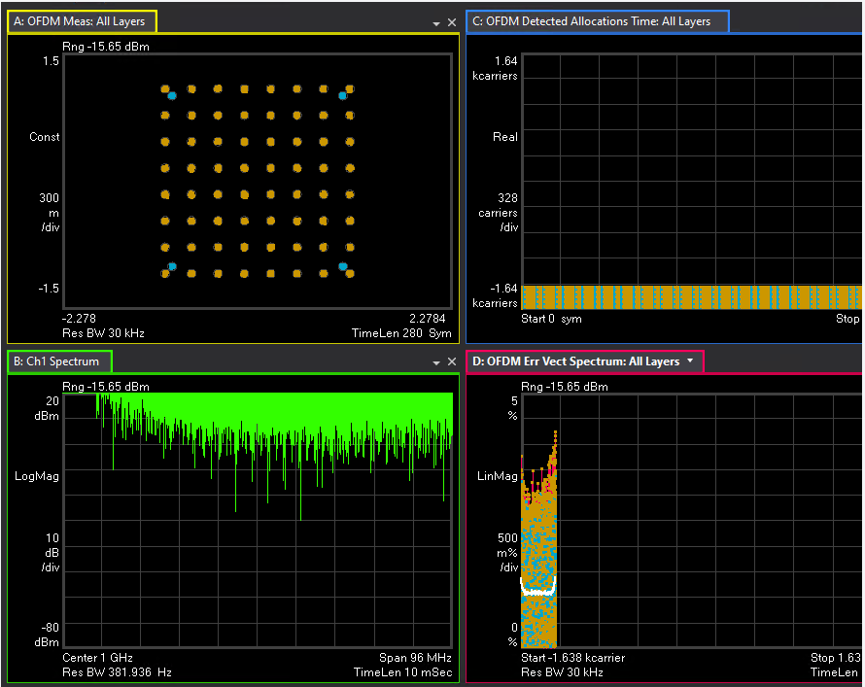
Test protocol:

RFSoC_DFE multi-tile synchronization (MTS) test

Test name: Ounas MTS validation
Test objective: To validate the RFDC DL path processing
Test setup: Assembled 8T8R TRXPSU board with installed BSP and MCU SW/FW, power supply, PC with terminal debug print, Spectrum Analyzer (up to 3.8 GHz at least)
Procedure:
- Assemble the test setup
- Power up the complete system
- Wait for OS invite to enter the authentication data and login
- Enable test signal (single-tone) generation at the maximum power in the range 3.3 – 3.6 GHz for RF channel #0
- Connect Spectrum Analyzer to Channel#0 TX RF connector of Ounas board. Check presence of desired signal.
- Connect the Channel#0 to Channel#7 TX RF connector of Ounas board and Channel#0 to Channel#7 RX RF connector of Ounas board correspondingly (loopback)
- Use RFSoC application (Vivado with design debug probes) to catch ADC output waveforms
- Enter to RFSoC console and run bash script “mts.sh”
- Use RFSoC application (Vivado with design debug probes) to catch ADC output waveforms.
Problems, found during testing:
Expected outcome: Signals are observed for all RF channels to be in phase after running MTS command:
Before MTS:
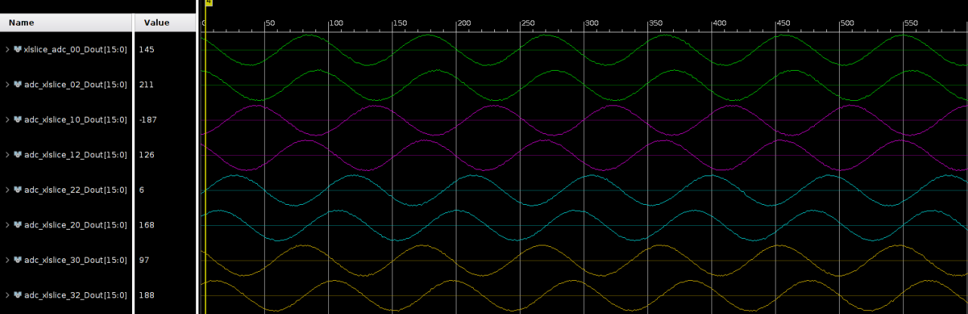
After MTS:
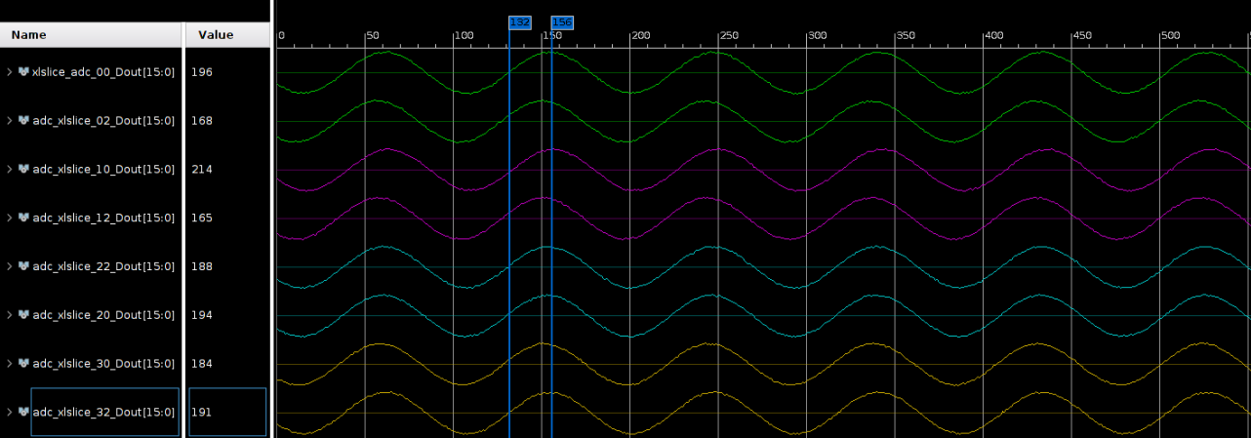
Test protocol:

TDD controller test

Test name: Ounas TDD controller validation
Test objective: To validate the GPIO TDD signals for managing analogue peripherals in various slot-format scenarios
Test setup: Assembled 8T8R TRXPSU board with installed BSP and MCU SW/FW, 8T8R PA board, digital oscilloscope, power supply, PC with terminal debug print
Procedure:
- Assemble the test setup
- Power up the complete system
- Wait for OS invite to enter the authentication data and login
- Connect oscilloscope probes to GPIO pins routed to the board test points. Setup trigger to catch GPIO signals.
- Enter to RFSoC console and run bash script “modem_init.sh” with ‘tdd’ argument
Problems, found during testing:
Expected outcome: GPIO signals are detected at test point.
Test protocol:

DL ID based beamforming test (DL BF)
The test methodology is the same as for test 4.7.5, but need at least two Vector transceivers to measure the phase difference b/w a pair of DL channels (TBD)

UL ID based beamforming test (UL BF)
The test methodology is the same as for test 4.7.7, but need at least two Vector transceivers to measure the phase difference b/w a pair of UL channels (TBD)

DL real-time weights based beamforming test (DL BF)
The test methodology is the same as for test 4.7.5, but need at least two Vector transceivers to measure the phase difference b/w a pair of DL channels (TBD)

UL real-time weights based beamforming test (UL BF)
The test methodology is the same as for test 4.7.7, but need at least two Vector transceivers to measure the phase difference b/w a pair of UL channels (TBD)

Multiple component carrier in DL test

Test name: Ounas DL 2CC test
Test objective: To validate the design DL path processing for two component carriers scenario
Test setup: Assembled 8T8R TRXPSU and 8T8R_PA boards with installed BSP, Modem and MCU SW/FW, power supply, PC with terminal debug print, O-RAN Studio server with installed Keysight SW and licenses, Keysight vector transceiver with installed SW and licenses.
Procedure:
- Assemble the test setup
- Connect SFP interfaces of Keysight O-RAN Studio server and Ounas digital board.
- Power up the complete system
- Wait for OS invite to enter the authentication data and login
- Enter to RFSoC console and run bash script “modem_init.sh” with ‘dl_e2e’ argument
- Connect Keysight transceiver RF input port and Channel#0 RF port of Ounas 8T8R_PA board.
- In Keysight O-RAN Studio GUI allow PTP synchronization and wait until time sync reaches the sufficient synchronization level (green button will indicate sync accuracy, PTP status tab will reflect the PTP information). Normally this should take around 30 seconds or less.
- In Keysight O-RAN Studio GUI from the File menu select and launch the DL scenario: ‘dl_2cc_test’
- Capture the signal spectrum and signal parameters in Keysight Vector Signal Analyzer SW window.
- Perform steps 6-9 for other channels #1…7 (corresponded RF connectors of Ounas 8T8R_PA board)
Problems, found during testing:
Expected outcome: Desired signals are observed for all RF channels.
Test protocol:

Multiple component carrier in UL test

Test name: Ounas UL 2CC test
Test objective: To validate the design UL path processing for two component carriers scenario
Test setup: Assembled 8T8R TRXPSU and 8T8R_PA boards with installed BSP, Modem and MCU SW/FW, power supply, PC with terminal debug print, O-RAN Studio server with installed Keysight SW and licenses, Keysight vector transceiver with installed SW and licenses.
Procedure:
- Assemble the test setup
- Connect SFP interfaces of Keysight O-RAN Studio server and Ounas digital board.
- Power up the complete system
- Wait for OS invite to enter the authentication data and login
- Enter to RFSoC console and run bash script “modem_init.sh” with ‘ul_e2e’ argument
- Connect Keysight transceiver RF output port and Channel#0 RF port of Ounas 8T8R_PA board.
- In Keysight O-RAN Studio GUI allow PTP synchronization and wait until time sync reaches the sufficient synchronization level (green button will indicate sync accuracy, PTP status tab will reflect the PTP information). Normally this should take around 30 seconds or less.
- In Keysight PathWave SW select from the file menu and load into the Keysight vector transceiver the UL scenario: Custom_2CC_UL.
- In Keysight O-RAN Studio GUI from the File menu select and launch the UL scenario: ‘ul_ Custom_2CC_UL_test’
- In Keysight O-RAN Studio GUI make a capturing of the received eCPRI packets sequence of a minimum duration of 3 seconds.
- Open the converted dump file in Keysight Vector Signal Analyzer SW and validate the UL signal parameters in GUI window.
- Perform steps 6-11 for other channels #1…7 (corresponded RF connectors of Ounas 8T8R_PA board)
Problems, found during testing:
Expected outcome: Desired signals are observed for all RF channels.
Test protocol:

Antenna calibration test

The Antenna calibration test methodology implies the real antenna to be connected to the Ounas Unit (TBD)

15kHz sub-carrier spacing (SCS) mode test

The test methodology for UL and DL is the same, as specified in 4.7.5 and 4.7.7, correspondingly, but with test scenarios for O-RAN Studio and Keysight PathWave Signal Generator SW, configured in a way of targeting 15kHz sub-carrier spacing mode. (TBD)

