FRAMER IPCORE DESIGN DOCUMENT
Steps to be followed to design the Framer IPCORE:
1)open the Vivado 2022.1
2)click on create project
3)then click on Toolscreate and package New IP
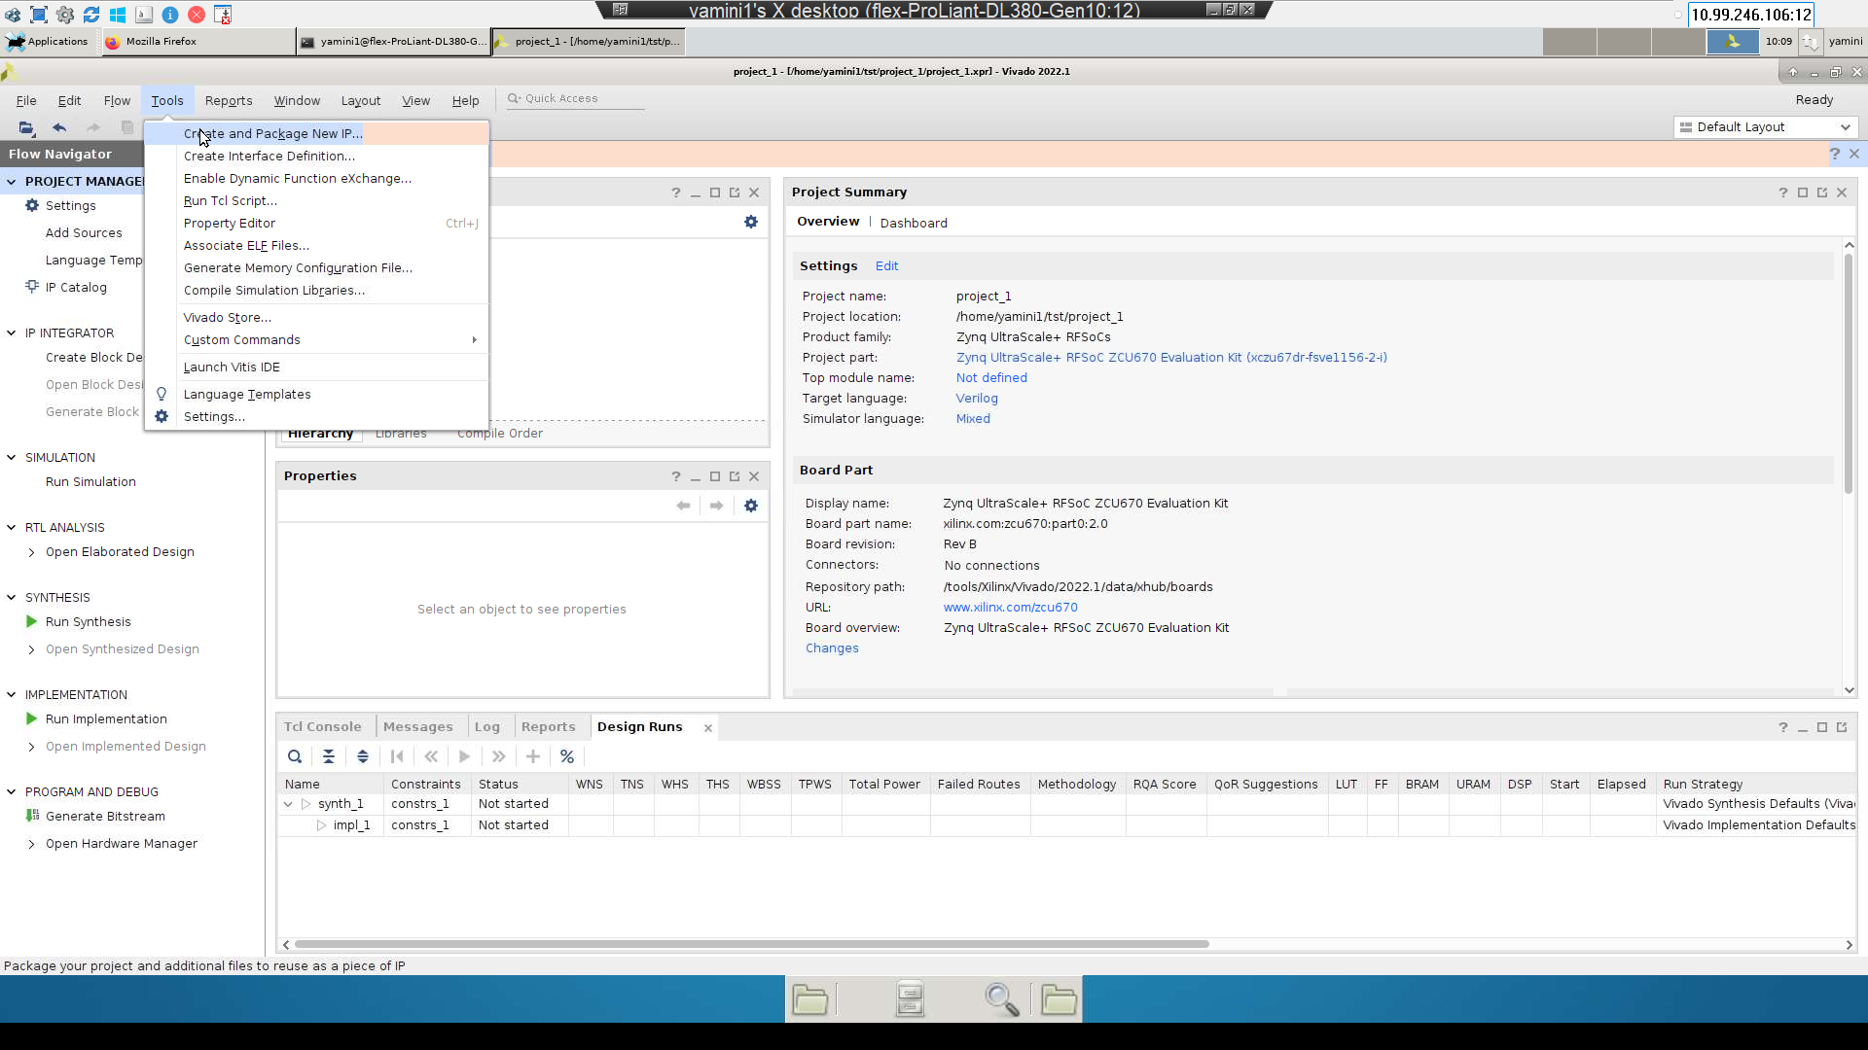

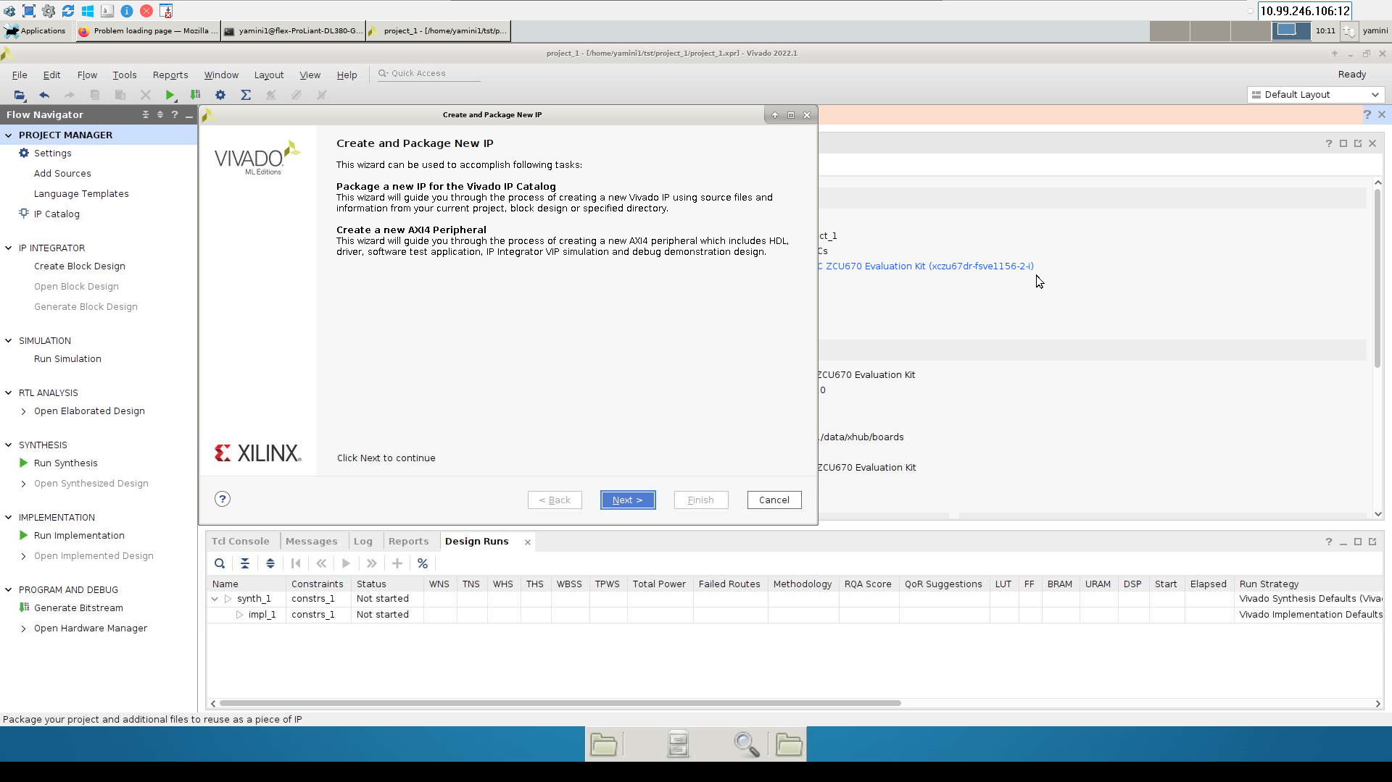
Then click on Next, click on Create a new AXI4 peripheral
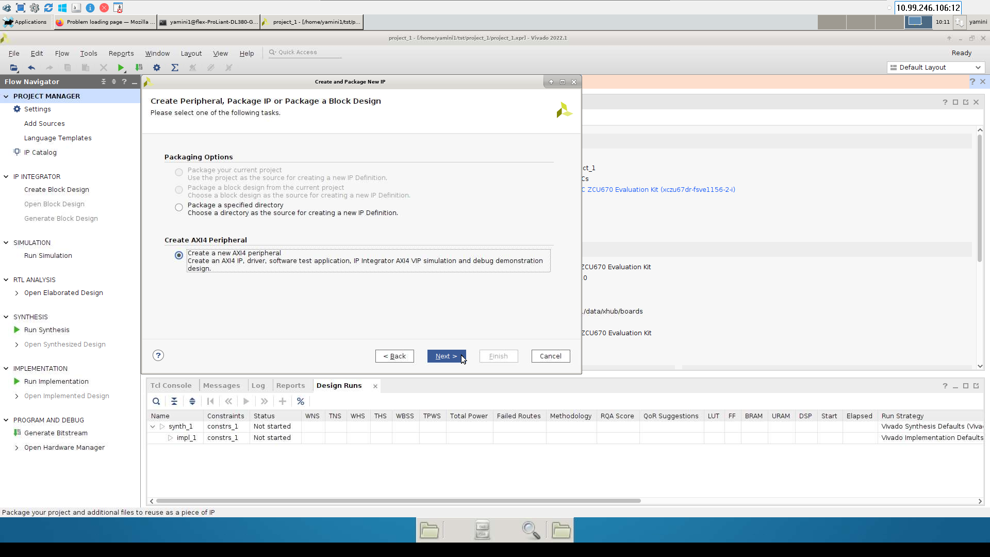
Click on Next

Enter the peripheral Details
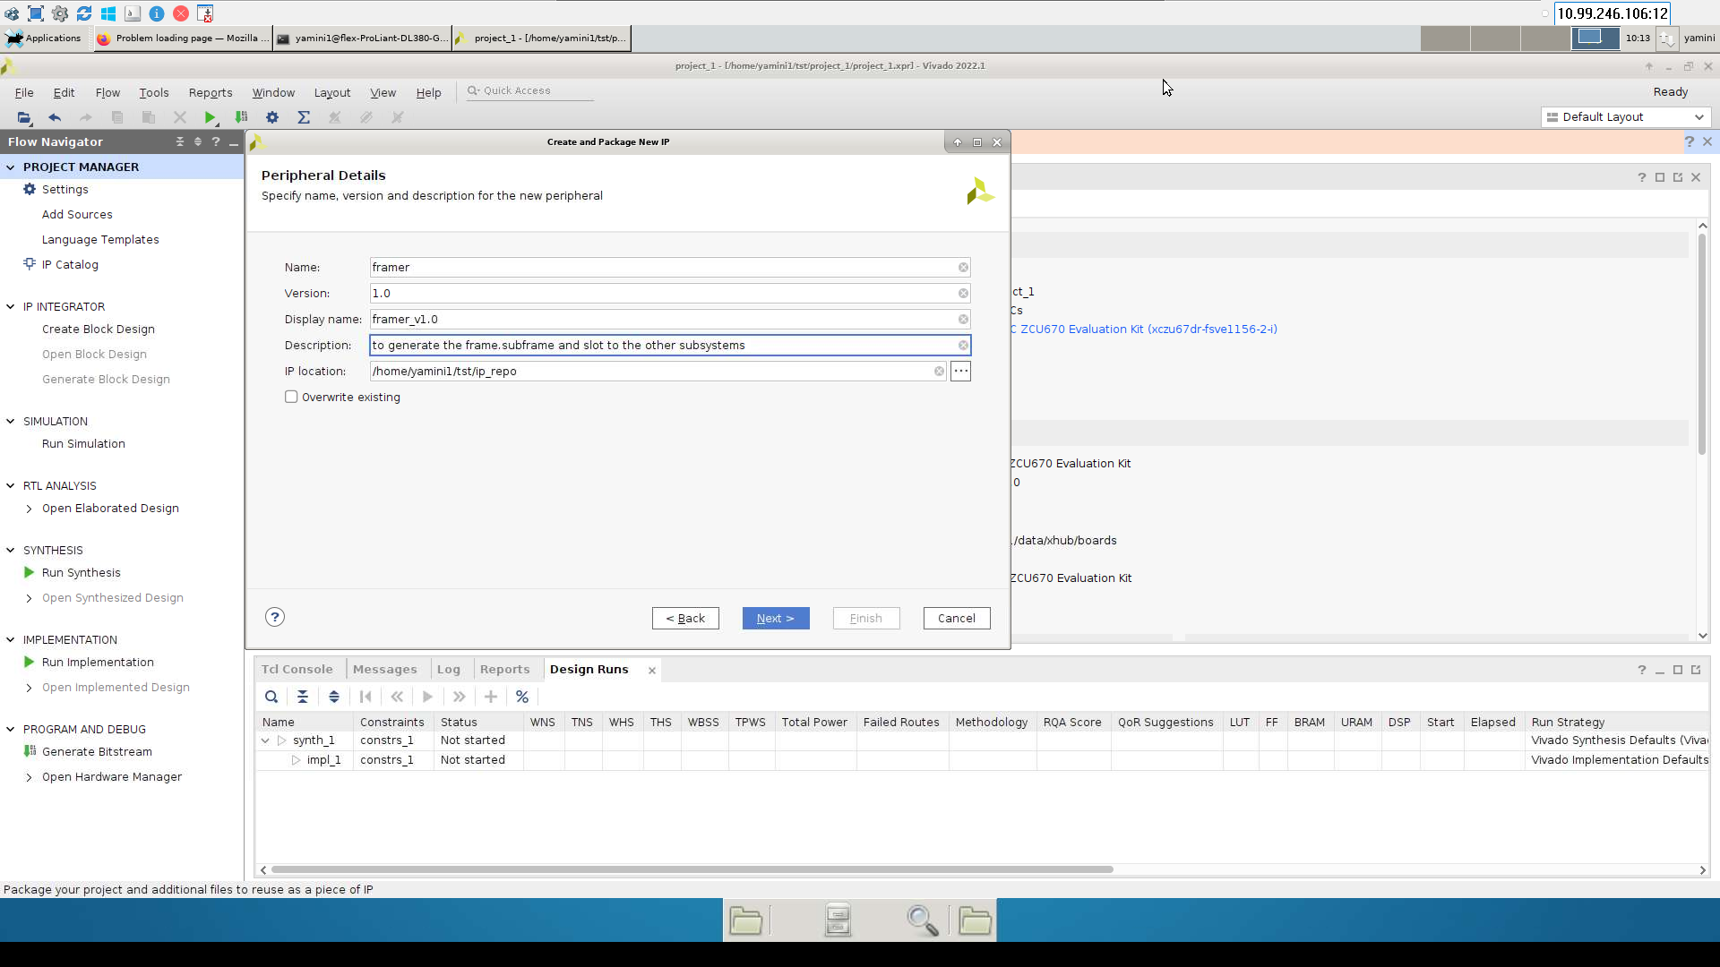

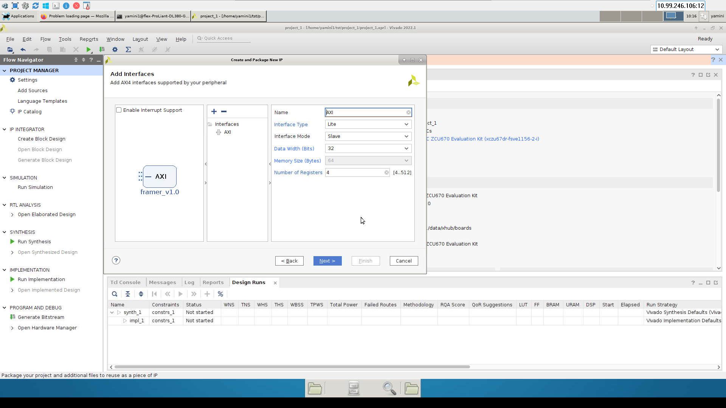

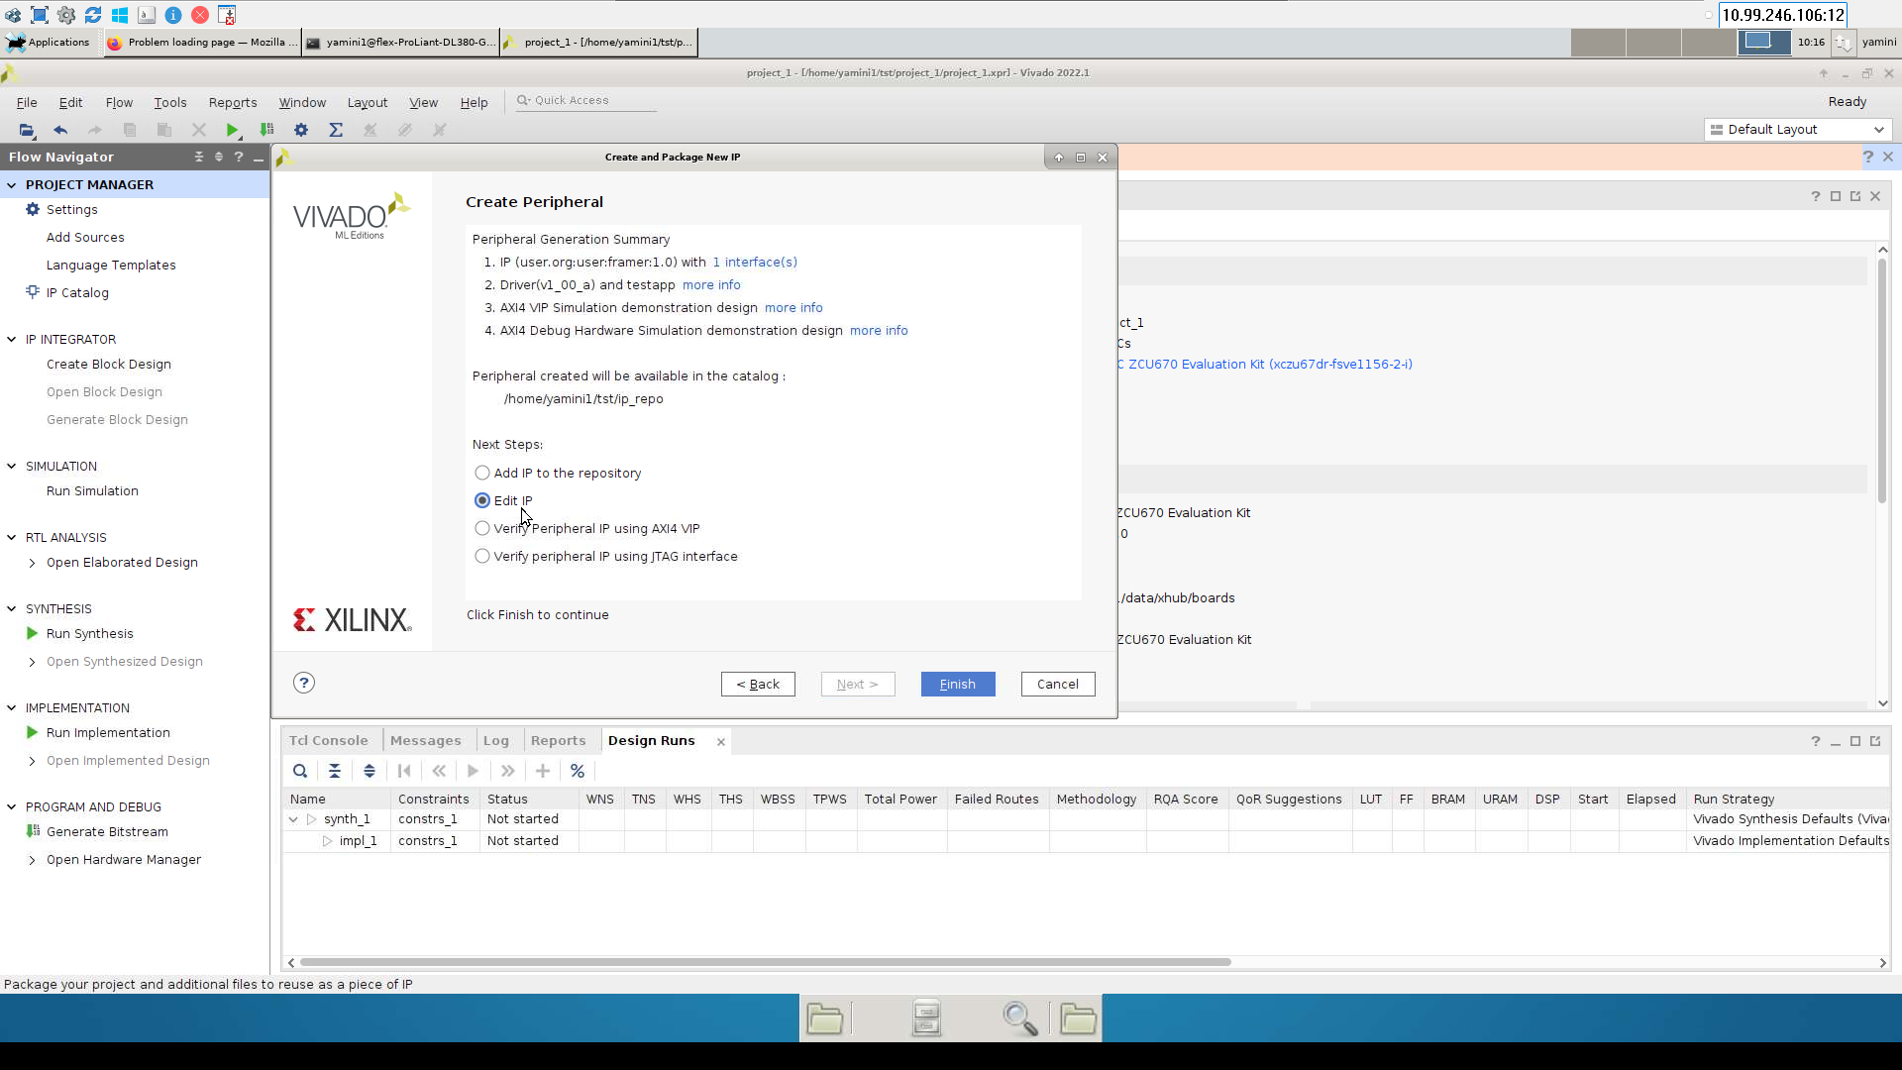

Ip_repo folder will be created in the following path.
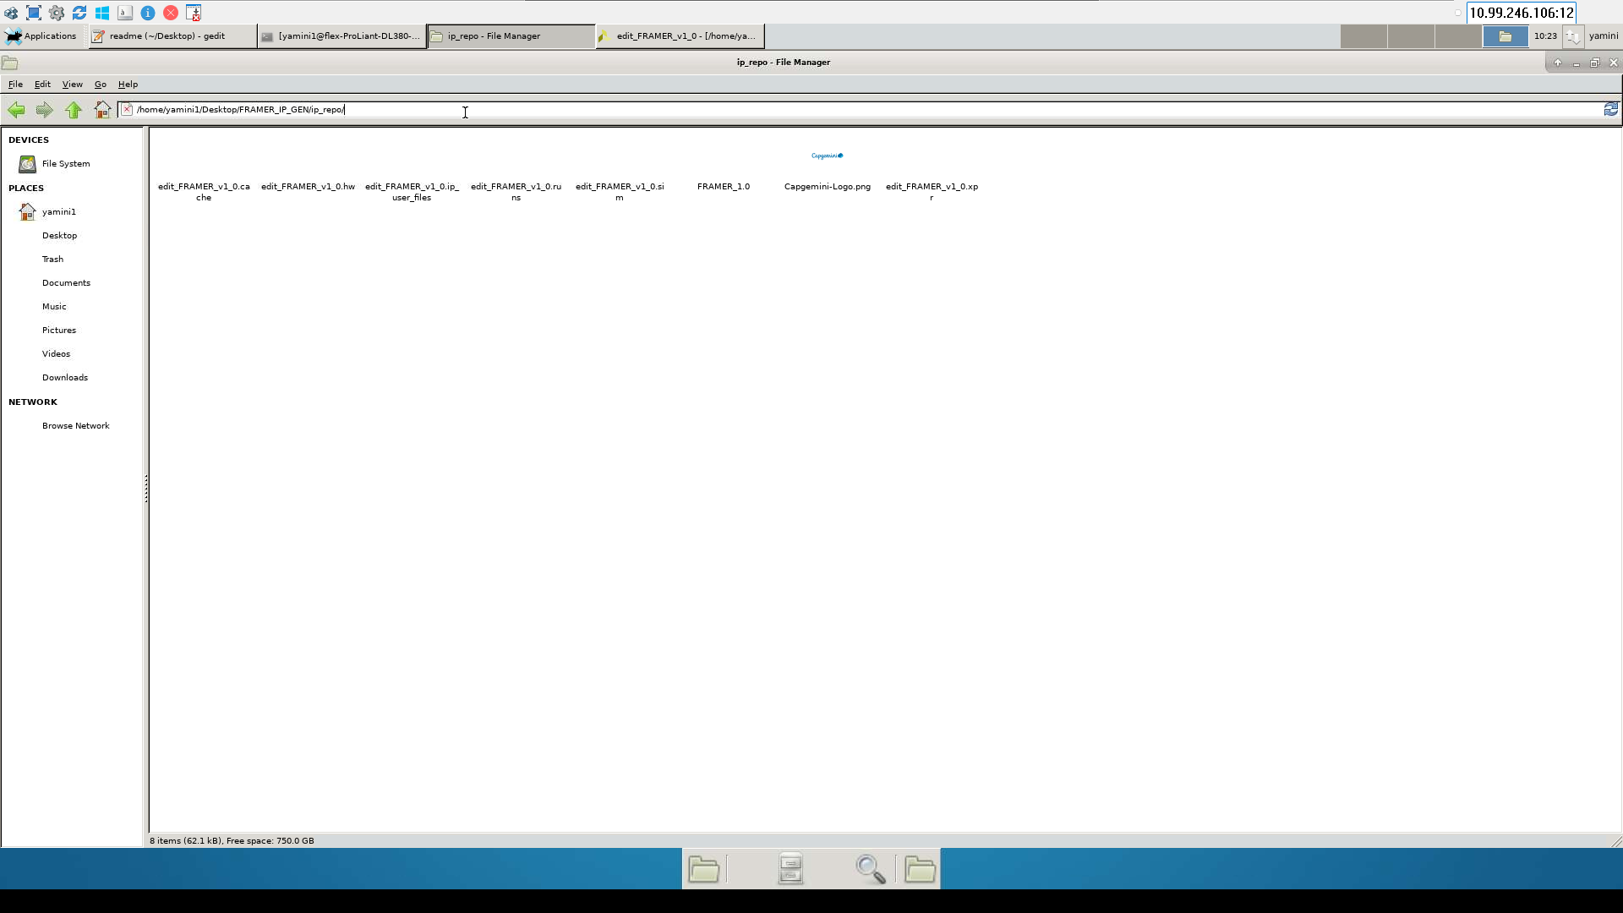

Click on .xpr file created in the iprepo folder and open the.xml file
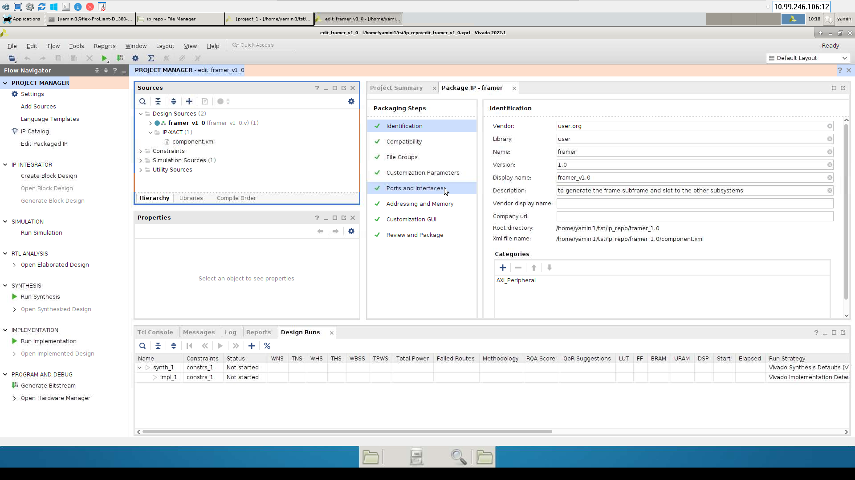

Click on .xml file the above tab will open we need to add all the parameters in ports and interfaces .For adding all the parameters we need to add all the respective hdl files and click on review and package ip core will be generated successfully.
The figure below is the simulation result obtained from the generated ipcore

