Trials we made to debug monolith booting issue:
- we added below line in grub menu entry console by interrupting boot to see boot logs.
set debug=all 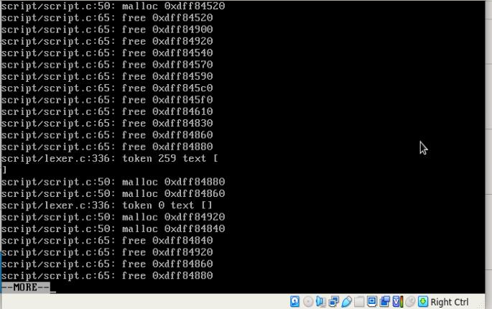

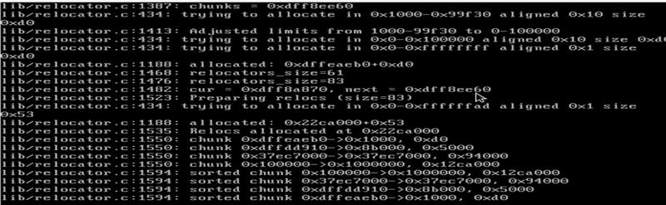

- we edited our grub console by comparing with Suman’s working VMDK as below:
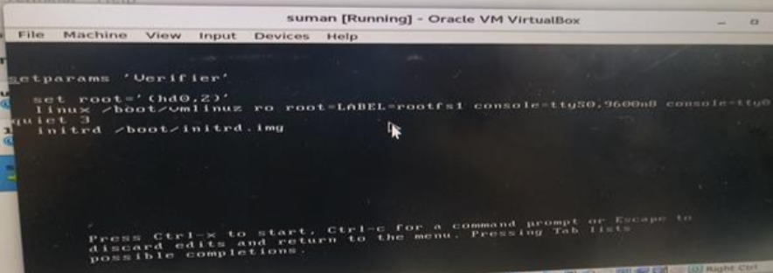
Likewise, we edited our Grub from root=/dev/sda2 to root=LABEL=rootfs1
root=/dev/sda2 to root=LABEL=rootfs2
root=/dev/sda2 to root=LABEL=rootfs3
root=/dev/sda2 to root=LABEL=rootfs
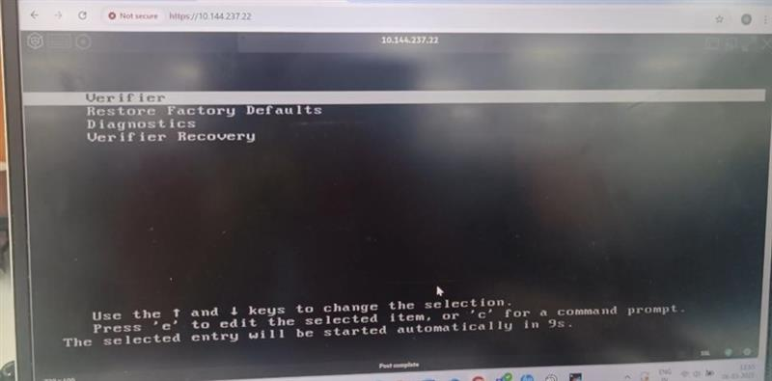
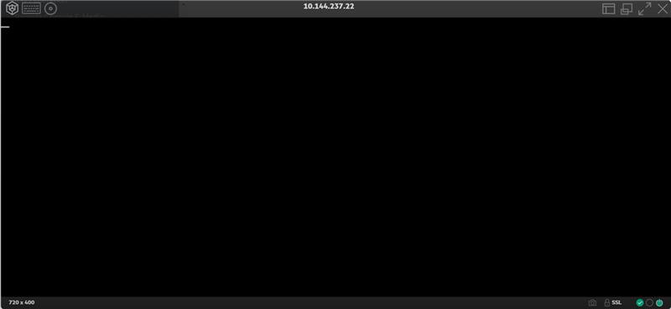
- We added prints in bvm-mkimg.sh, getting those prints while running following command
sudo PATH=$PATH:/root/software/exports/lin-vfr-x86_64-r/ ../rootfs/boot/install-tools/bvm-mkimg.sh -m monolith-nv40b-x86_64.jar -p nv40b -o monolith.vmdk -vkr 710011644928.vkr
As we can be able to see prints on vmdk boot console related to relocator.c and script.c.
We added debug prints in below source files to see them in boot console, to make sure whether we are building GRUB properly or not.
/root/software/vendors/grub2/lin-vfr-x86_64-r/grub-2.00/grub-core/lib/relocator.c
/root/software/vendors/grub2/lin-vfr-x86_64-r/grub-2.00/grub-core/script/script.c
vi vendors/grub2/grub-2.00/grub-core/script/script.c
vi vendors/grub2/grub-2.00/grub-core/lib/relocator.c
Compiled grub source using below command
make CFLAGS="-Wno-error=unused-function" -j$(nproc)
compiled rootfs source
make CPU=x86_64 DEBUG=no BOARDS=nv40b
Tested VMDK in Gen 11 VM we are unable to see added prints.
- Tested following Grub commands in Grub cli.
- ls
- ls (hd0, msdos2) & ls(hd0,msdo3)
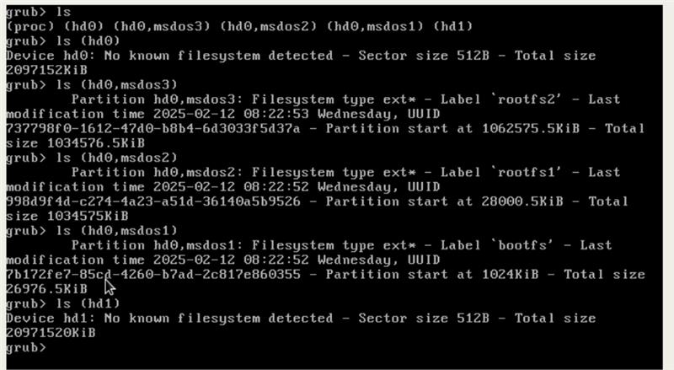
- ls (hd0, msdos2)\boot & ls(hd0,msdo3)\boot
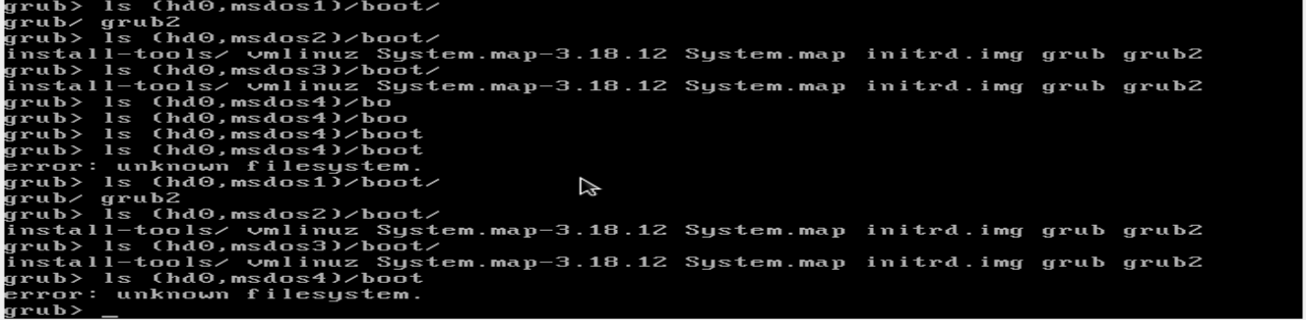

- when trying to load the kernel using grub cli as below: 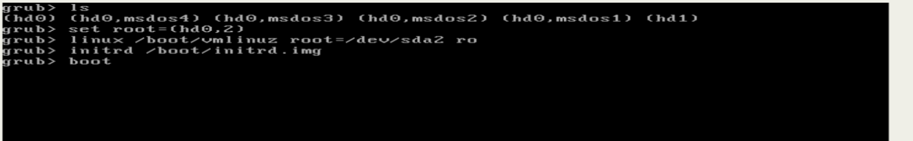

Boot is giving blank screen.
- I tried in similar way by setting set root=(hd0,3), facing same issue.
- lsmod

