How to Boot CentOS 7 Using UEFI
Method 1:

INDEX
1. Check Secure Boot Status
2. Write Your Own MOK Certificates
3. Sign Your Own GRUB/Kernel/SHIM
4. Dependencies
5. Install sbsigntools and efitools
6. Signing and Importing MOK Keys
7. Enable Secure Boot
8. Verify Secure Boot Status

1. Check Secure Boot Status
To check the current Secure Boot status, use the following command:
mokutil --sb-state
Initially, secure boot must be in disabled state.

2. Write Your Own MOK Certificates
To generate your own MOK certificates, use the following command:
openssl req -new -x509 -newkey rsa:2048 -keyout MOK.priv -out MOK.der -nodes -days 365 -subj "/CN=Custom MOK Key
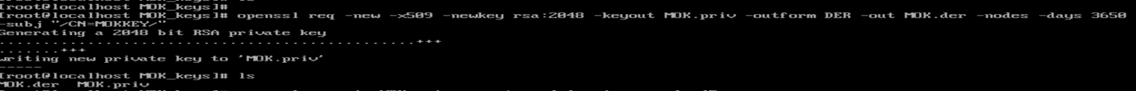
MOK.key and MOK.priv will be created.
To covert MOK.priv to MOK.pem use below command.
openssl req -new -x509 -key MOK.priv -out MOK.pem -days 365
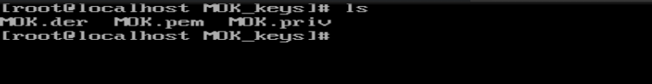

3. Sign Your Own grub/Kernel/shim using these MOK.pem
To sign shim:
sbsign --key MOK.priv --cert MOK.pem --output /boot/efi/EFI/centos/shmix64.efi.signed /boot/efi/EFI/centos/shimx64.efi
To sign grub:
sbsign --key MOK.priv --cert MOK.pem --output /boot/efi/EFI/centos/grubx64.efi.signed /boot/efi/EFI/centos/grubx64.efi
To sign kernel:
sbsign --key MOK.priv --cert MOK.pem --output /boot/vmlinuz-$(uname-r).signed /boot/vmlinuz-$(uname-r)

4. Dependencies
Install the following tools:
- sbsigntools
- efitools

5. Install sbsigntools and efitools
To install the required tools, follow these steps:
1. Create a work directory:
mkdir -p secu-os/install
2. Clone the repositories:
cd secu-os/install
git clone https://git.kernel.org/pub/scm/linux/kernel/git/jejb/sbsigntools.git
git clone https://git.kernel.org/pub/scm/linux/kernel/git/jejb/efitools.git
3. Install sbsigntools:
cd sbsigntools
./autogen.sh
./configure
make check
make install
make installcheck
4. Install efitools:
cd ../efitools
make
make install
NOTE: The installation must be successfully completed at each step without any error messages.

6. Importing MOK Keys
1. Import the MOK key:
mokutil --import /path/to/MOK.der
It prompts for the password twice; provide the same password both times.
2. Reboot the system and follow the on-screen instructions to enroll the MOK key.
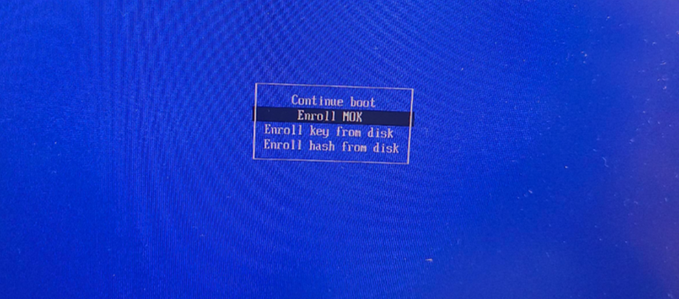

3. Provide the password you have created during MOK key Importing


7. Enable Secure Boot
Enter the BIOS/UEFI menu. Enable Secure Boot under the system utilities in iLO6.

8. Verify Secure Boot Status
To confirm Secure Boot is enabled, use the following command:
mokutil --sb-state

