Steps to Install CentOS 7 and Generation custom MOK

- Install Required Packages
sudo yum install -y openssl mokutil

- Edit the following file
sudo vi /etc/yum.repos.d/CentOS-Base.repo
[base]
name=CentOS-$releasever - Base
baseurl=http://vault.centos.org/7.2.1511/os/$basearch/
gpgcheck=1
gpgkey=file:///etc/pki/rpm-gpg/RPM-GPG-KEY-CentOS-7

[updates]
name=CentOS-$releasever - Updates
baseurl=http://vault.centos.org/7.2.1511/updates/$basearch/
gpgcheck=1
gpgkey=file:///etc/pki/rpm-gpg/RPM-GPG-KEY-CentOS-7

[extras]
name=CentOS-$releasever - Extras
baseurl=http://vault.centos.org/7.2.1511/extras/$basearch/
gpgcheck=1
gpgkey=file:///etc/pki/rpm-gpg/RPM-GPG-KEY-CentOS-7

sudo clean yum all
sudo yum update -y
sudo install -y openssl mokutil

- Create the MOK Key
cd /home/cg
openssl req -new -x509 -newkey rsa:2048 -keyout MOK.priv -outform DER -out MOK.der -nodes -days 36500 -subj "/CN=My Secure Boot MOK/"

- Sign the Kernel or Modules
sudo yum install -y kernel-devel
sudo /usr/src/kernels/$(uname -r)/scripts/sign-file sha256 /home/cg/MOK.priv /home/cg/MOK.der /boot/vmlinuz-$(uname -r)
sudo mokutil --import /home/cg/MOK.der

- Reboot the System
sudo reboot
During the boot process, you will be prompted with a MOK Manager screen. This is where you’ll enroll the MOK key.
Select Enroll MOK.
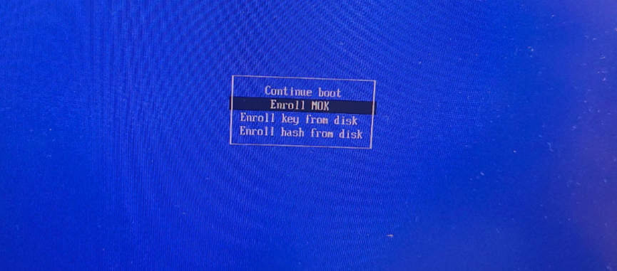
Choose Continue.

Enter the password you created earlier.
Confirm and finish the enrollment process.


- Verify Key Enrollment
mokutil --list-enrolled
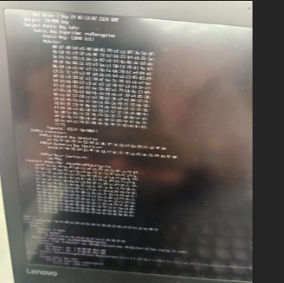
mokutil - - sb-state Enabled
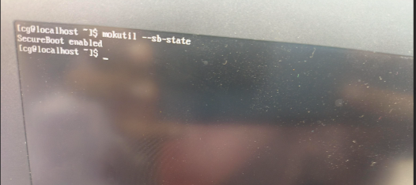

- Reset MOK key if required
sudo mokutil - -reset

