Procedure For Code Push and Merge Request

Content
1 Introduction 3
1.1 Purpose of the document 3
1.2 Scope 3
2 Pushing code to gitlab 4
2.1 Navigate to Your Local Repository 4
2.2 Initialize Git Repository (if not already done) 4
2.3 Add Remote Repository………………………………………………………………………………………………4
2.4 Check Remote URL …………………………………………………………………………….....................4
2.5 Add Files to Staging Area …………………………………………………………………………………4
2.6 Commit Changes……………………………………………………………………………………………..5
2.7 Push to GitLab………………………………………………………………………………….....................6
3 MERGE REQUEST 6
3.1 Create a New Branch 6
3.2 Make your changes 7
3.3 Stage and commit your changes 7
3.4 Push the branch 7
3.5 Create a Merge Request on GitLab 8
3.6 Go to your GitLab project 8
3.7 Navigate to the Merge Requests section 8
3.8 Create a new Merge Request 8
3.9 Merge Requests (MR)……………………………………………………………………………………….9
4 STEPS TO ASSIGN OWNER PERMISSION IN GITLAB…………………………………………………10
4.1 Navigate to the Project or Group……………………………………………………………………...10
4.2 Access the Manage Section……………………………………………………………………………..10
4.3 Select "Members"…………………………………………………………………………………………10
4.4 Add or Edit Member………………………………………………………………………………………10
4.5 Set the Role to "Owner"…………………………………………………………………………………11

Introduction

Purpose of the document
The purpose of this document is to provide a detailed overview of the steps taken to create a new repository, push the code and creating the merge requests and commits.

Scope
The aim of this document is to provide a detailed overview of the creation of a new GitLab repository, including the code push, merge requests and commits.

Pushing code to gitlab

2.1 Navigate to Your Local Repository:
Open a terminal and change to your local directory that contains the code.
cd ~/Device_Drivers
2.2 Initialize Git Repository (if not already done):
If you haven’t already initialized a Git repository in your local directory, run:
git init
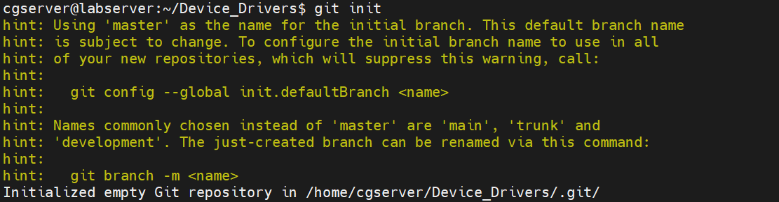
2.3 Add Remote Repository:
Add the URL of your GitLab repository as a remote.
git remote add origin git@gitlab.com:activity7144333/gitlablearning.git
2.4 Check Remote URL:
Verify that the remote URL has been added correctly.
2.5 Add Files to Staging Area:
Add all the files in your local directory to the staging area.
git add .
git status
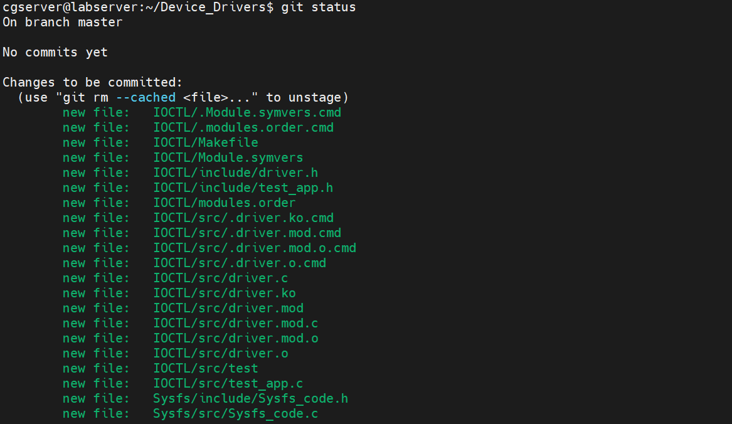
This status indicates that you have staged all the files in the Device_Drivers directory for the initial commit.
2.6 Commit Changes:
Commit the added files with a descriptive message.
git commit -m and press enter
Add commit message in 1st line and save the message by clicking ctrl+o , enter, ctrl+x , enter
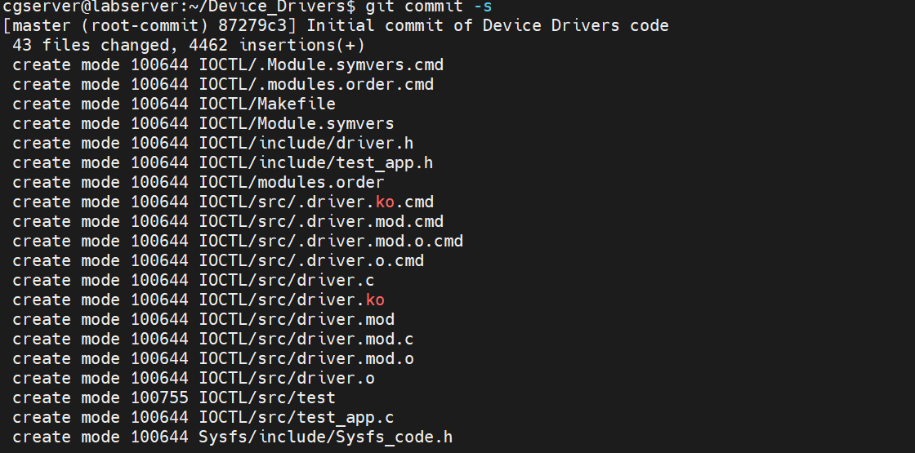

git branch
The branch you are currently on will be highlighted with an asterisk (*) next to its name.
2.7 Push to GitLab:
Push the committed changes to the main branch of your GitLab repository. If the main branch does not exist, you can push to master or create a new branch as needed.
git push -u origin master
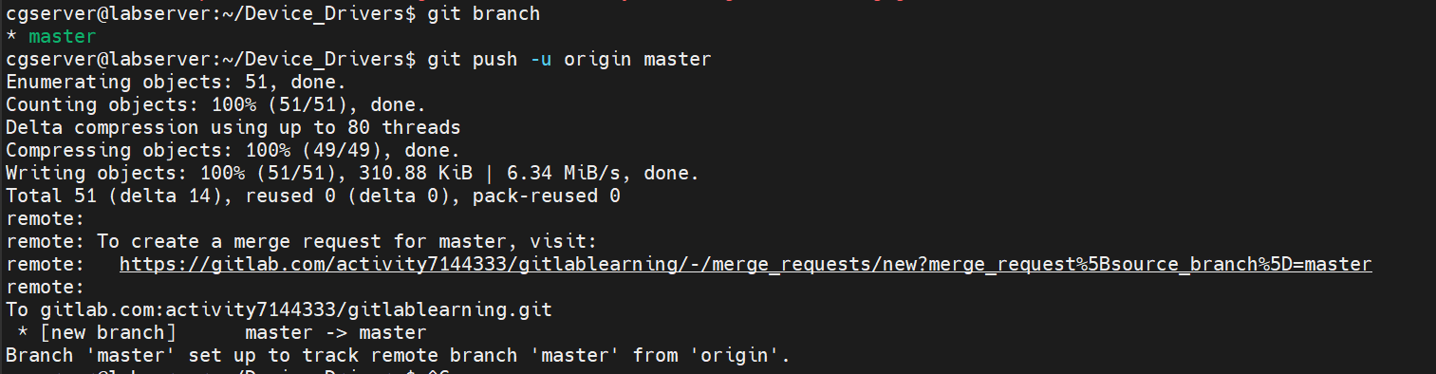

To create a merge request in your current GitLab repository (gitlablearning), you can follow these steps:

3 MERGE REQUEST

3.1 Create a New Branch:
Before creating a merge request, you typically work on a separate branch. This keeps the master branch clean and stable.
Example: git checkout -b devicetest
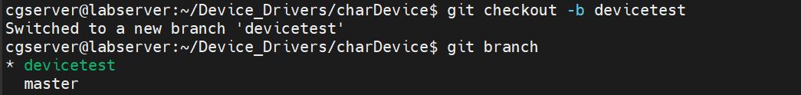
This command creates and switches to a new branch called devicetest.

3.2 Make your changes:
Edit files, add new features, or make any necessary changes in the devicetest.
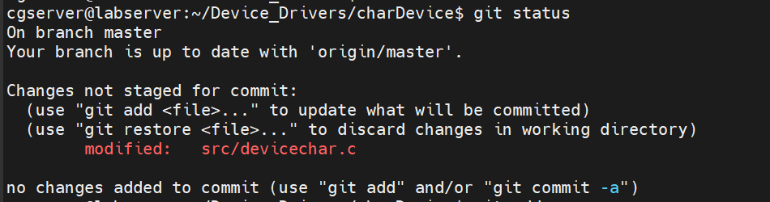
3.3 Stage and commit your changes:
- git add .
- git commit -m "Description of the changes you made"
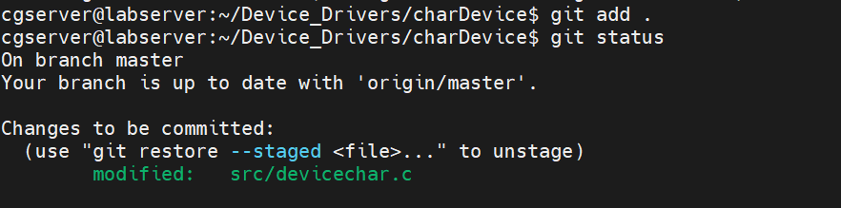

3.4 Push the branch:
- git push -u origin devicetest
This command pushes your devicetest to the GitLab repository and sets it to track the remote branch.
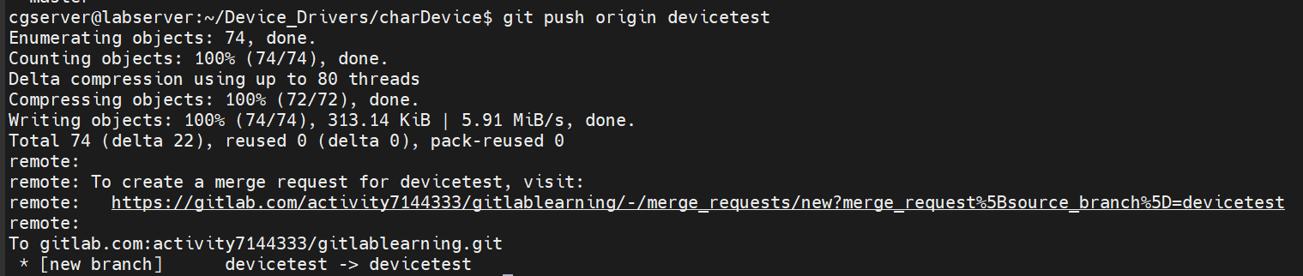

3.5 Create a Merge Request on GitLab:
Now that your branch is pushed to GitLab, you can create a merge request.
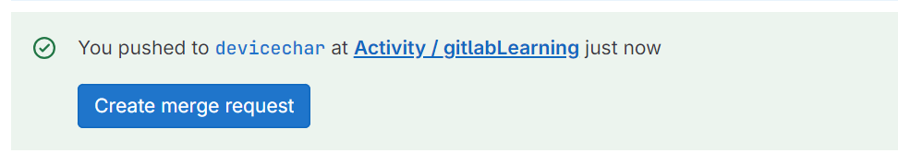
3.6 Go to your GitLab project:
Open your web browser and go to your GitLab project repository. The URL is likely https://gitlab.com/activity7144333/gitlablearning.
3.7 Navigate to the Merge Requests section:
On the left sidebar, click on "Merge Requests" to view existing merge requests or create a new one.
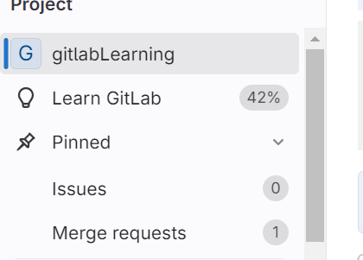

3.8 Create a new Merge Request:
Click on the "New merge request" button.
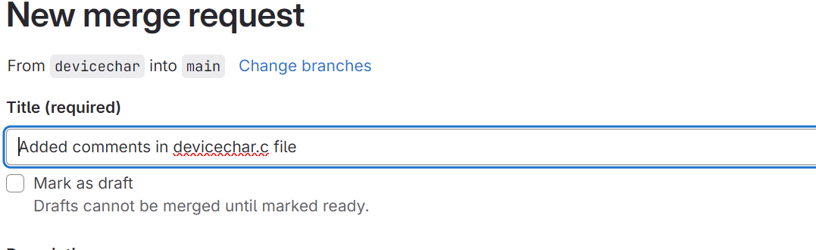
You will be prompted to select the source branch (devicechar) and the target branch (master or main).
GitLab will automatically suggest your new branch as the source branch since you just pushed it.
3.9 Merge Requests (MR):
A merge request in GitLab is a way to propose changes to a codebase. When developers want to merge their feature branch into a main branch (e.g., main or develop), they create a merge request. This request is then reviewed by other team members or maintainers.
Approval Process:
In a well-defined workflow, certain merge requests require approval from one or more team members before they can be merged. The approval process ensures that the code meets the project's quality standards and passes all required checks.

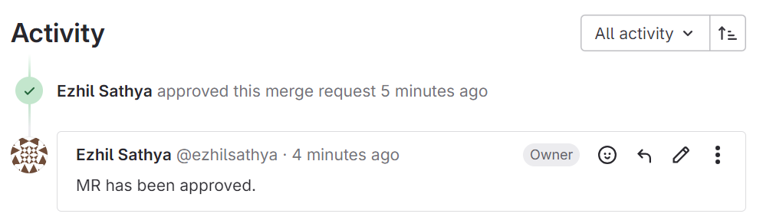

4 Steps to Assign Owner Permission in GitLab

4.1 Navigate to the Project or Group:

- Start by going to the specific project or group in GitLab where you want to assign the owner role.
Access the Manage Section:

4.2 Access the Manage Section:
On the left-hand sidebar, locate the "Manage" option. Clicking this typically reveals a dropdown menu.
Select "Members":
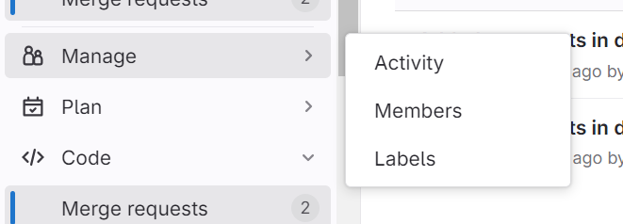

4.3 Select "Members":
From the dropdown menu under "Manage," select "Members." This option allows you to view and manage the members of the project or group.

4.4 Add or Edit Member:
In the "Members" section, you can either add a new member by searching for their username, email, or GitLab handle, or you can edit an existing member's role.

4.5 Set the Role to "Owner":

When adding or editing a member, you will see a dropdown menu for roles (e.g., Guest, Reporter, Developer, Maintainer, Owner). Select "Owner" from this list.
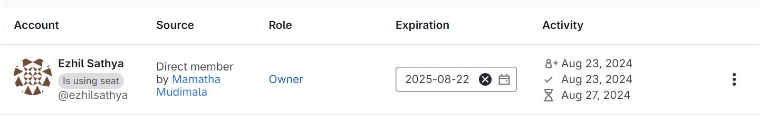
Confirm the action by clicking "Add to project" or "Update" depending on whether you're adding a new member or editing an existing one.
