

PES UNIVERSITY
100 feet Ring Road, BSK 3rd Stage, Bengaluru 560085

Department of Computer Science and Engineering`
Jan – May 2020

UE18CS252 -
Database Management Systems

Project Report

#Hotel Database Management System

By,
PES1201800230 - G. Navyadhara Gana Sai
4th Sem, Sec_A, Roll No. 11

PROJECT SUMMARY

The main objective of this project is to create a database management system for a hotel. The hotel can have multiple chains, which can further have multiple hotels. Therefore, we need an organized management system, which can easily manage all the operations and data of the hotel chains and hotels respectively.

The hotel database contains multiple tables with relationships among them. Defining the tables, and then later finding the FD are some key points. The schema has been 3nf normalised.

Sql has been used for the DDL of the schema. Have created all the tables and queries using SQL only and then. The foreign keys and relations have been preserved with care.

Two triggers have been created on bookings table, of which one triggers when some data is added into the table, while the other triggers when some data is deleted from the table.

The tables and DB have been queried by multiple queries of which some are complex, some are nested and some are simple queries.

Introduction 2
Data Model 2
FD and Normalization 2
DDL 3
Triggers 3
SQL Queries 3
Conclusion 3

Introduction
The main objective of this project is to create a database management system for a hotel. The hotel can have multiple chains, which can further have multiple hotels. Therefore, we need an organized management system, which can easily manage all the operations and data of the hotel chains and hotels respectively. The database will be managing the below areas of the hotel database management system.
− The hotel chains, their details.
− The hotels in each chain and their details and other information like the rooms and their description and discounts, etc.
− Information about employees and departments they work in.
− Information about guests.
− Managing bookings and other services used by the guests.

Data Model
Drawing an ER model for the database I have realised it is not quite understandable, so I have tried and made an ERR diagram which would be better in visualising the data. It has also the relational schema built together within it.

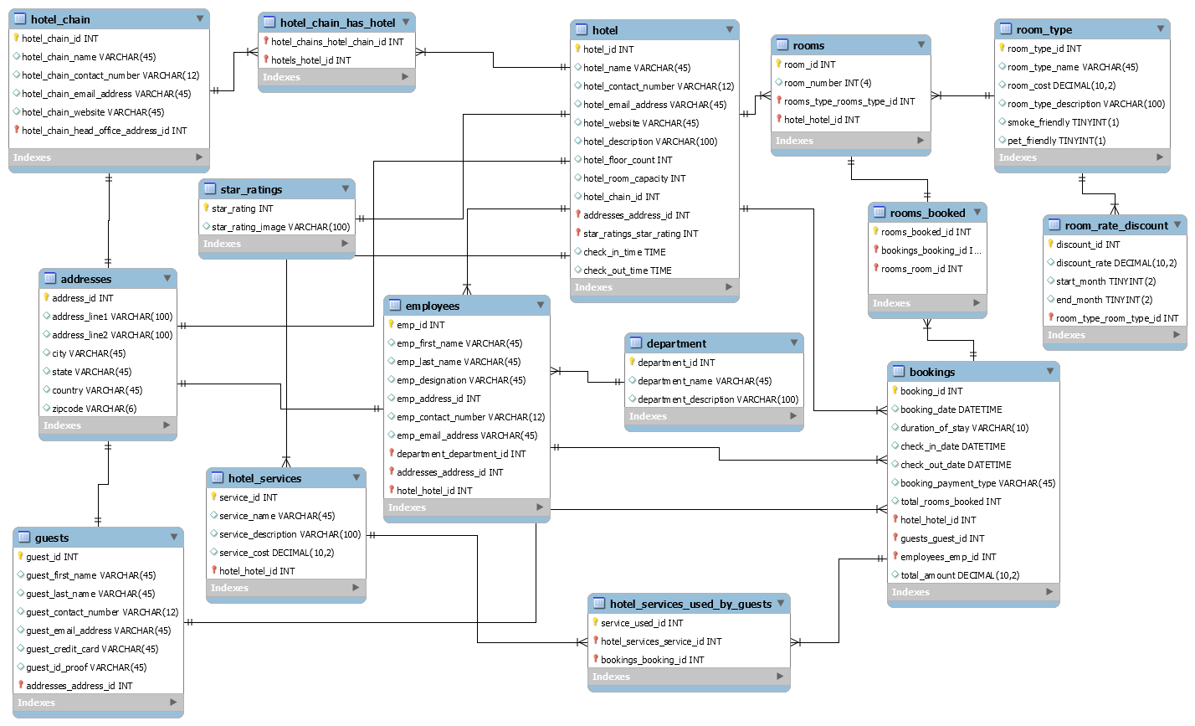

Some of the Tables in the DB:

Bookings table contains data about the booking made for rooms. The primary key for this table is booking_id.
The table has the following foreign keys:
-hotel_hotel_id - which has a many-to-one relationship with the hotel table.
-guests_guest_id - which has a many-to-one relationship with the guests table.
-employees_emp_id - which has a many-to-one relationship with the employees table.

hotel_services_used_by_guests table contains info about the services used by the guests. Primary key is service_used_id.
Two foreign keys:
-hotel_services_service_id - which relates to hotel_services table
-bookings_booking_id - relates to bookings table.

Employees table consists of data related to the employees. The primary key is employee_id.
There are three foreign keys,
-service_id that denotes many-to-one relations with the department table.
-address_id that denotes one-to-one relationship with the addresses table.
-hotel_id that denotes many-to-one relationship with the hotel table.

addresses table defines the information about the address of guests, hotels, hotel chains, employees. The primary key of the table is address_id.
It maintains one-to-one relationship with tables, hotel_chain, hotel, employees and guests

Guests table has the data about the guests that check in to the hotel. The primary key of this table is guest_id.
-There is one foreign key in this table, address_id that has one-to-one relationship with the address table

For the remaining tables,

Table | PrimaryKey | ForeignKeys
Hotel | Hotel_id | Addresses_addresses_id, star_ratings_star_ratings
Rooms | Room_id | Room_type_room_type_id,  Hotel_hotel_id
Room_type | Room_type_id | --------------------------------
Rooms_booked | Room_booked_id | Booking_booking_id, rooms_room_id
Star_ratings | Star_rating | ---------------------------------
Hotel_chain | Hotel_chain_id | Hotel_chain_head_office_address
Hotel_chain_has_hotel | ------------------------------ | Hotel_chain_hotel_id, hotel_hotel_id
Hotel_services | Service_id | Hotel_hotel_id
Department | Department_id | --------------------------------------
Room_type | Room_type_id | -------------------------------------

FD AND NORMALISTAION

Regarding the functional dependency, for every table in the database functional dependencies have been identified. For Example, in the table of addresses, the columns of the table are functionally dependent on address_id, which is the primary key of the relation is schema.

Table | Funtional Dependency  X->Y(Y is Dependent On X functionally)
Hotel | Hotel_id -> hotel_name, hotel_contact_number,hotel_website
Department | Depertment_id -> department_name,department_description
Bookings | Bookings_id –>booking_date,checkin_date,diration_of_stay.
Employees | Emp_id - > emp_first_name,emp_designation, emp_contact_number
Addresses | Address_id-> addres_line1, address_line2  Zipcode - >country, state,city
Guests | Guests_id - >guest_first_name, guest_last_name, guest_email_address, guest_credit_card
Rooms | Room_id - >room-number
Hotel_services | service-id->service-name,service-description, service-cost.

And in case we want to prove FD of two columns in a table,
* select count (distinct A) from table;
* select count (*) from (select distinct B, A from table) as t (A, B);
If both the above commands give the same count, we can conclude that B is functionally dependent on A. This could help us to check functional dependencies of two columns through SQL.

The FD’s have been identified in the beginning while constructing the ERR an have been implemented. Each of the tables in the database have a FD. For instance, Hotel has hotel_id, bookings have booking_id, guests have guest_id and all of these have been again rechecked using the above commands and verified.

Now, speaking of normalisation, a schema must be normalised to 3nf to be considered as a normalised one. So, I tried to achieve 3nf from the schema. 1nf is achieved by keeping the data scalar and ensuring there are no duplicate columns. 2nf is achieved by making the relations depend on Primary Keys. And in 3nf, it is made sure that all dependencies are only on the primary key of the tables.
There were violations which have been resolved, consider the below tables

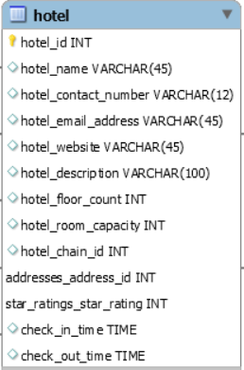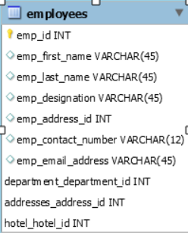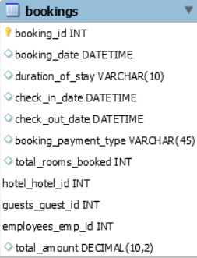

Here for suppose, consider employee table had addresses column in it. But employee has no direct relation to address. He is related to hotel and hotel has an address. So, this is an indirect relation and would be a violation to 3nf. Similarly, consider hotel has a column total_amount. But hotel doesn’t directly relate to amount. Amount is related to bookings and bookings have hotel_id, so basically hotel is indirectly related to the amount column. Placing it in hotel would be a violation of 3nf too.

Similarly, 2nf may have violation when employee name has been placed in the services used by column. All these have been resolved in order to achieve 3nf or Third Normal Form of the schema.

DDL
DDL (SQL), has been used in order to produce the physical database from the ERR model. Different operators have been used to create the database, which include DROP, CREATE, INSERT, DELETE, JOIN and some others too.
The following SQL Programmes have been written for creating the database:

Drop schema if exists hotel_db;
CREATE SCHEMA `hotel_db`;
use hotel_db;
-- ________________________________________________

CREATE TABLE IF NOT EXISTS addresses (
address_id INT NOT NULL,
address_line1 VARCHAR(100) NULL,
address_line2 VARCHAR(100) NULL,
city VARCHAR(45) NULL,
state VARCHAR(45) NULL,
country VARCHAR(45) NULL,
zipcode VARCHAR(8) NULL,
PRIMARY KEY (address_id)
);
INSERT INTO `addresses`(`address_id`, `address_line1`, `address_line2`, `city`, `state`, `country`, `zipcode`)
VALUES
(1,49, 'Dave Street', 'Kitchener','ON','Canada','N2C 2P6'),
(2,64, 'Victoria Street', 'Kitchener','ON','Canada','N2C 2M6'),
(3,79, 'Connaught Street', 'London','ON','Canada','N2C 2K3');

-- __________________________________________________

CREATE TABLE IF NOT EXISTS `hotel_db`.`hotel_chain` (
hotel_chain_id INT NOT NULL,
hotel_chain_name VARCHAR(45) NULL,
hotel_chain_contact_number VARCHAR(12) NULL,
hotel_chain_email_address VARCHAR(45) NULL,
hotel_chain_website VARCHAR(45) NULL,
hotel_chain_head_office_address_id INT NOT NULL,
PRIMARY KEY (hotel_chain_id, hotel_chain_head_office_address_id),
CONSTRAINT fk_hotel_chains_addresses1
FOREIGN KEY (hotel_chain_head_office_address_id)
REFERENCES addresses (address_id)
ON DELETE NO ACTION
ON UPDATE NO ACTION);

CREATE INDEX `fk_hotel_chains_addresses1_idx` ON `hotel_db`.`hotel_chain` (`hotel_chain_head_office_address_id` ASC);
INSERT INTO `hotel_chain`(`hotel_chain_id`, `hotel_chain_name`, `hotel_chain_contact_number`, `hotel_chain_email_address`, `hotel_chain_website`, `hotel_chain_head_office_address_id`)
VALUES
(1,'Best Western Hotels','456-865-8956','bw123@gmail.com','https://www.bestwestern.com/',6),
(2,'China Town Hotels','110-526-5647','chinatown123@gmail.com','https://www.chinatown.com/',16),
(3,'Elite Hotels','546-874-6547','elite.tea213@gmail.com','https://www.elitendhe.com/',17),
(4,'Cosmopolitan Hotels','852-741-9765','cosmo.hotels123@gmail.com','https://www.cosmopolitan.com/',18),
(5,'Prestige Hotels','657-784-3647','prestige2453@gmail.com','https://www.prestige.com/',19);

-- _____________________________________________________

CREATE TABLE IF NOT EXISTS `hotel_db`.`star_ratings` (
`star_rating` INT NOT NULL,
`star_rating_image` VARCHAR(100) NULL,
PRIMARY KEY (`star_rating`));

-- _____________________________________________________

CREATE TABLE IF NOT EXISTS `hotel_db`.`hotel` (
`hotel_id` INT NOT NULL,
`hotel_name` VARCHAR(45) NULL,
`hotel_contact_number` VARCHAR(12) NULL,
`hotel_email_address` VARCHAR(45) NULL,
`hotel_website` VARCHAR(45) NULL,
`hotel_description` VARCHAR(100) NULL,
`hotel_floor_count` INT NULL,
`hotel_room_capacity` INT NULL,
`hotel_chain_id` INT NULL,
`addresses_address_id` INT NOT NULL,
`star_ratings_star_rating` INT NOT NULL,
`check_in_time` TIME NULL,
`check_out_time` TIME NULL,
PRIMARY KEY (`hotel_id`, `addresses_address_id`, `star_ratings_star_rating`),
CONSTRAINT `fk_hotels_addresses1`
FOREIGN KEY (`addresses_address_id`)
REFERENCES `hotel_db`.`addresses` (`address_id`)
ON DELETE NO ACTION
ON UPDATE NO ACTION,
CONSTRAINT `fk_hotel_star_ratings1`
FOREIGN KEY (`star_ratings_star_rating`)
REFERENCES `hotel_db`.`star_ratings` (`star_rating`)
ON DELETE NO ACTION
ON UPDATE NO ACTION);

-- _____________________________________________________

CREATE TABLE IF NOT EXISTS `hotel_db`.`room_type` (
`room_type_id` INT NOT NULL,
`room_type_name` VARCHAR(45) NULL,
`room_cost` DECIMAL(10,2) NULL,
`room_type_description` VARCHAR(100) NULL,
`smoke_friendly` TINYINT(1) NULL,
`pet_friendly` TINYINT(1) NULL,
PRIMARY KEY (`room_type_id`));

-- ________________________________________________________

CREATE TABLE IF NOT EXISTS `hotel_db`.`rooms` (
`room_id` INT NOT NULL,
`room_number` INT(4) NULL,
`rooms_type_rooms_type_id` INT NOT NULL,
`hotel_hotel_id` INT NOT NULL,
PRIMARY KEY (`room_id`, `rooms_type_rooms_type_id`, `hotel_hotel_id`),
CONSTRAINT `fk_rooms_rooms_type1`
FOREIGN KEY (`rooms_type_rooms_type_id`)
REFERENCES `hotel_db`.`room_type` (`room_type_id`)
ON DELETE NO ACTION
ON UPDATE NO ACTION,
CONSTRAINT `fk_rooms_hotel1`
FOREIGN KEY (`hotel_hotel_id`)
REFERENCES `hotel_db`.`hotel` (`hotel_id`)
ON DELETE NO ACTION
ON UPDATE NO ACTION);

-- __________________________________________________________

CREATE INDEX `fk_rooms_rooms_type1_idx` ON `hotel_db`.`rooms` (`rooms_type_rooms_type_id` ASC);

CREATE INDEX `fk_rooms_hotel1_idx` ON `hotel_db`.`rooms` (`hotel_hotel_id` ASC);

-- ___________________________________________________________

CREATE TABLE IF NOT EXISTS `hotel_db`.`guests` (
`guest_id` INT NOT NULL,
`guest_first_name` VARCHAR(45) NULL,
`guest_last_name` VARCHAR(45) NULL,
`guest_contact_number` VARCHAR(12) NULL,
`guest_email_address` VARCHAR(45) NULL,
`guest_credit_card` VARCHAR(45) NULL,
`guest_id_proof` VARCHAR(45) NULL,
`addresses_address_id` INT NOT NULL,
PRIMARY KEY (`guest_id`, `addresses_address_id`),
CONSTRAINT `fk_guests_addresses1`
FOREIGN KEY (`addresses_address_id`)
REFERENCES `hotel_db`.`addresses` (`address_id`)
ON DELETE NO ACTION
ON UPDATE NO ACTION);

CREATE INDEX `fk_guests_addresses1_idx` ON `hotel_db`.`guests` (`addresses_address_id` ASC);
INSERT INTO `guests`(`guest_id`, `guest_first_name`, `guest_last_name`, `guest_contact_number`, `guest_email_address`, `guest_credit_card`, `guest_id_proof`, `addresses_address_id`)
VALUES (1,'Jane','Doe','132-456-8564','jane.doe@gmail.com',NULL,'/images/drivingLicense1023',1),
(2,'Jerry','Thachter','564-896-4752','jerry.ytsvg@gmail.com',NULL,'/images/passport45612',2),
(3,'Rihanna','Perry','745-986- 7451','rih.vfdj89@gmail.com',NULL,'/images/drivingLicense4889',3),

-- ____________________________________________________________
DROP TABLE IF EXISTS `hotel_database`.`department` ;

CREATE TABLE IF NOT EXISTS `hotel_db`.`department` (
`department_id` INT NOT NULL,
`department_name` VARCHAR(45) NULL,
`department_description` VARCHAR(100) NULL,
PRIMARY KEY (`department_id`));
INSERT INTO `department`(`department_id`, `department_name`, `department_descri ption`)
VALUES
(1,'Kitchen','cooking'),
(2,'Cleaning','sweep and mop'),
(3,'Front Staff','handle bookings and query resolution'),

DROP TABLE IF EXISTS `hotel_db`.`employees` ;

CREATE TABLE IF NOT EXISTS `hotel_db`.`employees` (
`emp_id` INT NOT NULL,
`emp_first_name` VARCHAR(45) NULL,
`emp_last_name` VARCHAR(45) NULL,
`emp_designation` VARCHAR(45) NULL,
`emp_contact_number` VARCHAR(12) NULL,
`emp_email_address` VARCHAR(45) NULL,
`department_department_id` INT NOT NULL,
`addresses_address_id` INT NOT NULL,
`hotel_hotel_id` INT NOT NULL,
PRIMARY KEY (`emp_id`, `department_department_id`, `addresses_address_id`, `hotel_hotel_id`),
CONSTRAINT `fk_employees_services1`
FOREIGN KEY (`department_department_id`)
REFERENCES `hotel_db`.`department` (`department_id`)
ON DELETE NO ACTION
ON UPDATE NO ACTION,
CONSTRAINT `fk_employees_addresses1`
FOREIGN KEY (`addresses_address_id`)
REFERENCES `hotel_db`.`addresses` (`address_id`)
ON DELETE NO ACTION
ON UPDATE NO ACTION,
CONSTRAINT `fk_employees_hotel1`
FOREIGN KEY (`hotel_hotel_id`)
REFERENCES `hotel_db`.`hotel` (`hotel_id`)
ON DELETE NO ACTION
ON UPDATE NO ACTION);

CREATE INDEX `fk_employees_services1_idx` ON `hotel_db`.`employees` (`department_department_id` ASC);

CREATE INDEX `fk_employees_addresses1_idx` ON `hotel_db`.`employees` (`addresses_address_id` ASC);

CREATE INDEX `fk_employees_hotel1_idx` ON `hotel_db`.`employees` (`hotel_hotel_id` ASC);

-- _____________________________________________________________

CREATE TABLE IF NOT EXISTS `hotel_db`.`bookings` (
`booking_id` INT NOT NULL,
`booking_date` DATETIME NULL,
`duration_of_stay` VARCHAR(10) NULL,
`check_in_date` DATETIME NULL,
`check_out_date` DATETIME NULL,
`booking_payment_type` VARCHAR(45) NULL,
`total_rooms_booked` INT NULL,
`hotel_hotel_id` INT NOT NULL,
`guests_guest_id` INT NOT NULL,
`employees_emp_id` INT NOT NULL,
`total_amount` DECIMAL(10,2) NULL,
PRIMARY KEY (`booking_id`, `hotel_hotel_id`, `guests_guest_id`, `employees_emp_id`),
CONSTRAINT `fk_bookings_hotel1`
FOREIGN KEY (`hotel_hotel_id`)
REFERENCES `hotel_db`.`hotel` (`hotel_id`)
ON DELETE NO ACTION
ON UPDATE NO ACTION,
CONSTRAINT `fk_bookings_guests1`
FOREIGN KEY (`guests_guest_id`)
REFERENCES `hotel_db`.`guests` (`guest_id`)
ON DELETE NO ACTION
ON UPDATE NO ACTION,
CONSTRAINT `fk_bookings_employees1`
FOREIGN KEY (`employees_emp_id` )
REFERENCES `hotel_db`.`employees` (`emp_id` )
ON DELETE NO ACTION
ON UPDATE NO ACTION);

CREATE INDEX `fk_bookings_hotel1_idx` ON `hotel_db`.`bookings` (`hotel_hotel_id` ASC);

CREATE INDEX `fk_bookings_guests1_idx` ON `hotel_db`.`bookings` (`guests_guest_id` ASC);

CREATE INDEX `fk_bookings_employees1_idx` ON `hotel_db`.`bookings` (`employees_emp_id` ASC);

-- __________________________________________________________________________________

CREATE TABLE IF NOT EXISTS `hotel_db`.`hotel_chain_has_hotel` (
`hotel_chains_hotel_chain_id` INT NOT NULL,

`hotels_hotel_id` INT NOT NULL,
PRIMARY KEY (`hotel_chains_hotel_chain_id`, `hotels_hotel_id`),
CONSTRAINT `fk_hotel_chains_has_hotels_hotel_chains1`
FOREIGN KEY (`hotel_chains_hotel_chain_id`)
REFERENCES `hotel_db`.`hotel_chain` (`hotel_chain_id` )
ON DELETE NO ACTION
ON UPDATE NO ACTION,
CONSTRAINT `fk_hotel_chains_has_hotels_hotels1`
FOREIGN KEY (`hotels_hotel_id`)
REFERENCES `hotel_db`.`hotel` (`hotel_id`)
ON DELETE NO ACTION
ON UPDATE NO ACTION);

CREATE INDEX `fk_hotel_chains_has_hotels_hotels1_idx` ON `hotel_db`.`hotel_chain_has_hotel` (`hotels_hotel_id` ASC);

CREATE INDEX `fk_hotel_chains_has_hotels_hotel_chains1_idx` ON `hotel_db`.`hotel_chain_has_hotel` (`hotel_chains_hotel_chain_id` ASC);

-- ____________________________________________________

CREATE TABLE IF NOT EXISTS `hotel_db`.`room_rate_discount` (
`discount_id` INT NOT NULL,
`discount_rate` DECIMAL(10,2) NULL,
`start_month` TINYINT(1) NULL,
`end_month` TINYINT(1) NULL,
`room_type_room_type_id` INT NOT NULL,
PRIMARY KEY (`discount_id`, `room_type_room_type_id`),
CONSTRAINT `fk_room_rate_discount_room_type1`
FOREIGN KEY (`room_type_room_type_id`)
REFERENCES `hotel_db`.`room_type` (`room_type_id`)
ON DELETE NO ACTION
ON UPDATE NO ACTION);

CREATE INDEX `fk_room_rate_discount_room_type1_idx` ON `hotel_db`.`room_rate_discount` (`room_type_room_type_id` ASC);

-- _____________________________________________________________

CREATE TABLE IF NOT EXISTS `hotel_db`.`rooms_booked` (
`rooms_booked_id` INT NOT NULL,
`bookings_booking_id` INT NOT NULL,
`rooms_room_id` INT NOT NULL,
PRIMARY KEY (`rooms_booked_id`, `bookings_booking_id`, `rooms_room_id`),
CONSTRAINT `fk_rooms_booked_bookings1`
FOREIGN KEY (`bookings_booking_id`)
REFERENCES `hotel_db`.`bookings` (`booking_id`)
ON DELETE NO ACTION
ON UPDATE NO ACTION,
CONSTRAINT `fk_rooms_booked_rooms1`
FOREIGN KEY (`rooms_room_id`)
REFERENCES `hotel_db`.`rooms` (`room_id`)
ON DELETE NO ACTION
ON UPDATE NO ACTION);

CREATE INDEX `fk_rooms_booked_bookings1_idx` ON `hotel_db`.`rooms_booked` (`bookings_booking_id` ASC);

CREATE INDEX `fk_rooms_booked_rooms1_idx` ON `hotel_db`.`rooms_booked` (`rooms_room_id` ASC);
-- _______________________________________________________________

CREATE TABLE IF NOT EXISTS `hotel_db`.`hotel_services` (
`service_id` INT NOT NULL,
`service_name` VARCHAR(45) NULL,
`service_description` VARCHAR(100) NULL,
`service_cost` DECIMAL(10,2) NULL,
`hotel_hotel_id` INT NOT NULL,
PRIMARY KEY (`service_id`, `hotel_hotel_id`),
CONSTRAINT `fk_hotel_services_hotel1`
FOREIGN KEY (`hotel_hotel_id`)
REFERENCES `hotel_db`.`hotel` (`hotel_id`)
ON DELETE NO ACTION
ON UPDATE NO ACTION);
CREATE INDEX `fk_hotel_services_hotel1_idx` ON `hotel_db`.`hotel_services` (`hotel_hotel_id` ASC);
INSERT INTO `hotel_services`(`service_id`, `service_name`, `service_description`, `service_cost`, `hotel_hotel_id`)
VALUES
(1,'24-hour Room Service','There will be 24-hour Room Service to take care of customers needs',20,1),
(2,'Currency Exchange','Foreign Currency Exchange facility available',80,1),
(3,'Laundry','Laundry/Dry Cleaning available same day',10,1);

-- ________________________________________________________

CREATE TABLE IF NOT EXISTS `hotel_db`.`hotel_services_used_by_guests` (
`service_used_id` INT NOT NULL,
`hotel_services_service_id` INT NOT NULL,
`bookings_booking_id` INT NOT NULL,
PRIMARY KEY (`service_used_id`, `hotel_services_service_id`, `bookings_booking_id`),
CONSTRAINT `fk_hotel_services_has_bookings_hotel_services1`
FOREIGN KEY (`hotel_services_service_id`)
REFERENCES `hotel_db`.`hotel_services` (`service_id`)
ON DELETE NO ACTION
ON UPDATE NO ACTION,
CONSTRAINT `fk_hotel_services_has_bookings_bookings1`
FOREIGN KEY (`bookings_booking_id`)
REFERENCES `hotel_db`.`bookings` (`booking_id`)
ON DELETE NO ACTION
ON UPDATE NO ACTION);

-- ________________________________________________
CREATE INDEX `fk_hotel_services_has_bookings_bookings1_idx` ON `hotel_db`.`hotel_services_used_by_guests` (`bookings_booking_id` ASC);
CREATE INDEX `fk_hotel_services_has_bookings_hotel_services1_idx` ON `hotel_db`.`ho tel_services_used_by_guests` (`hotel_services_service_id` ASC);
-- _______________________________________________

Triggers
Triggers for insert and delete into Bookings table have been created. And also a trigger fro missing info in employees table aslo has been created.

- On Audit and On Delete:

CREATE TABLE IF NOT EXISTS hotel_test.Bookings_Audit(
audit_id int NOT NULL PRIMARY KEY AUTO_INCREMENT,
`booking_id` INT NOT NULL,
`booking_date` DATETIME NULL,
`duration_of_stay` VARCHAR(10) NULL,
`check_in_date` DATETIME NULL,
`check_out_date` DATETIME NULL,
`booking_payment_type` VARCHAR(45) NULL,
`total_rooms_booked` INT NULL,
`hotel_hotel_id` INT NOT NULL,
`guests_guest_id` INT NOT NULL,
`employees_emp_id` INT NOT NULL,
`total_amount` DECIMAL(10,2) NULL,
action_type varchar(50) NOT NULL,
date_updated datetime NOT NULL
);

DROP TRIGGER IF EXISTS bookings_after_insert;

DELIMITER //

CREATE TRIGGER bookings_after_insert
AFTER INSERT ON bookings
FOR EACH ROW

BEGIN
INSERT INTO Bookings_Audit VALUES
(NULL,NEW.booking_id, NEW.booking_date, NEW.duration_of_stay, NEW.`check_in_date`, NEW.`check_out_date`, NEW.`booking_payment_type`, NEW.`total_rooms_booked`, NEW.`hotel_hotel_id`, NEW.`guests_guest_id`, NEW.`employees_emp_id`, NEW.`total_amount`,"INSERTED", NOW());
END//

DELIMITER ;

DROP TRIGGER IF EXISTS bookings_after_delete;

DELIMITER //

CREATE TRIGGER bookings_after_delete
AFTER DELETE ON bookings
FOR EACH ROW

BEGIN
INSERT INTO Bookings_Audit VALUES
(NULL, OLD.booking_id, OLD.booking_date, OLD.duration_of_stay, OLD.`check_in_date`, OLD.`check_out_date`, OLD.`booking_payment_type`, OLD.`total_rooms_booked`, OLD.`hotel_hotel_id`, OLD.`guests_guest_id`, OLD.`employees_emp_id`, OLD.`total_amount`,"DELETED", NOW());
END// DELIMITER;

-- ---------------------------DATA MISSING TRIGGER-----------------
USE hotel_db;

SET sql_notes = 0;

drop table if exists dataMissing;

create table dataMissing
(
emp_id INT not null,
message varchar(255) not null,
primary key(emp_id)

);

drop trigger if exists missing_data;

DELIMITER //

CREATE TRIGGER missing_data
BEFORE insert on EMPLOYEES
for each row
BEGIN
IF new.emp_contact_number IS null THEN
INSERT INTO dataMissing values(new.emp_id,concat('Hey ',new.emp_first_name,' please update your no'));
else if new.emp_designation IS null then
INSERT INTO dataMissing values(new.emp_id,concat('Hey ',new.emp_first_name,' please update designation'));
else if new.emp_email_address IS null then
INSERT INTO dataMissing values(new.emp_id,concat('Hey ',new.emp_first_name,' please update Mail Address'));
else if new.emp_last_name IS null then
INSERT INTO dataMissing values(new.emp_id,concat('Hey ',new.emp_first_name,' please update last name'));
end if;
end if;
end if;
end if;
END //

DELIMITER ;

SET sql_notes = 1;

Trigger Output:

For audit on delete trigger:
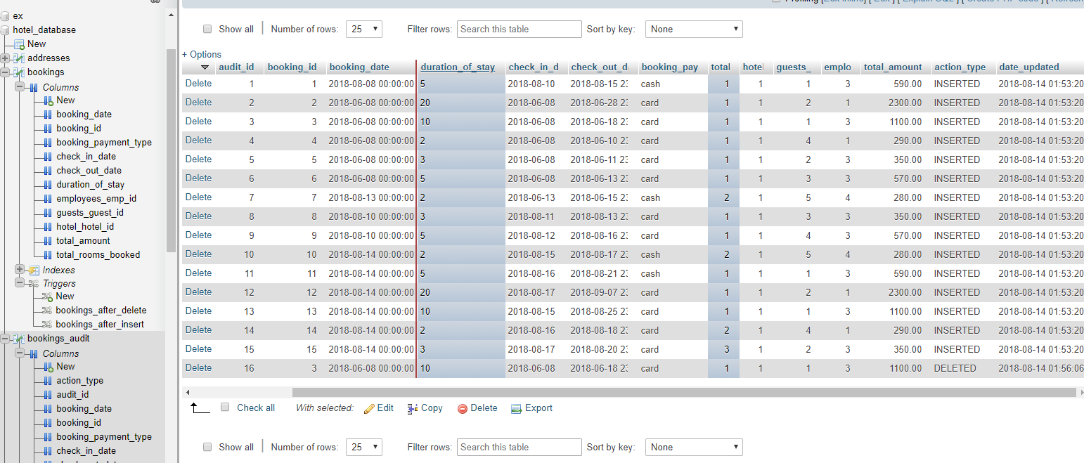
For Missing data trigger:

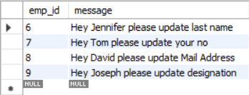

Inserted data:

- In Bookings Table

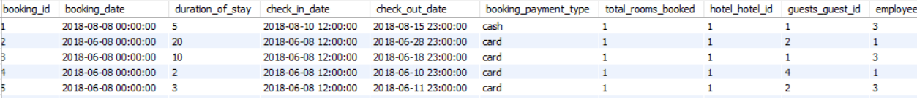
- In EMPLOYEES table

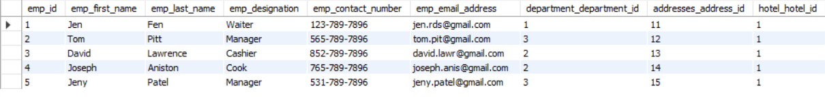

- In GUESTS table

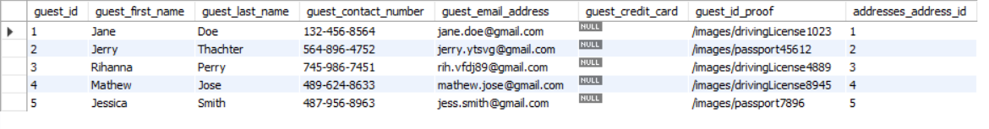

- In Hotel table

- In HOTEL_CHAIN table

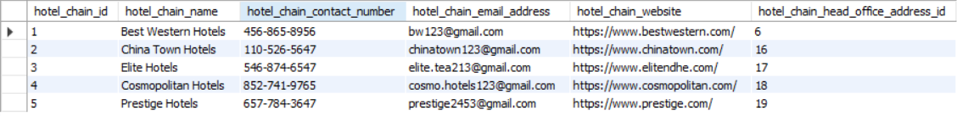

- In HOTEL_SERVICES table

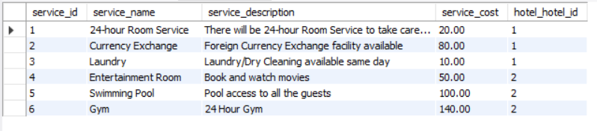

SQL Queries
Let us start with simple queries and later go with complex ones.
1) How many distinct guest have made bookings for a particular month?
SELECT guest_first_name, guest_last_name,guest_contact_number
FROM guests
WHERE guest_id IN
( SELECT distinct guests_guest_id -- get distinct guests
FROM bookings
WHERE MONTH(check_in_date) = 8); -- bookings for the month of August

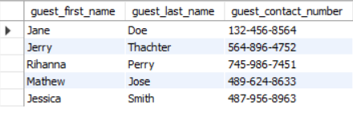

2) How many rooms are available in a given hotel?
SELECT h.hotel_room_capacity -SUM(b.total_rooms_booked) AS 'Available Rooms' -- get available rooms
FROM `bookings` b JOIN hotel h
ON b.hotel_hotel_id = h.hotel_id
WHERE booking_date LIKE '2018-06-08%' AND hotel_hotel_id = 1

The Output would be: 40

3) How many bookings a customer made in a single year?
SELECT count (*) AS 'Total Bookings' -- count of total bookings
FROM bookings
WHERE YEAR (booking_date) = 2018 AND guests_guest_id = 1;

The output would be: 4

4) List the rate for a given room at a given time of year?

SELECT ROUND((r_type.room_cost - ((r_dis.discount_rate * r_type.room_cost)/100)), 2) AS 'Room Rate' -- get room price on the basis od discount
FROM room_rate_discount r_dis JOIN room_type r_type -- join rate discount table with room type
ON r_dis.room_type_room_type_id = r_type.room_type_id
WHERE r_type.room_type_id
IN ( Select rooms_type_rooms_type_id from rooms where room_id = 1) -- get room type id for room with id 1
AND MONTH(NOW()) BETWEEN r_dis.start_month AND r_dis.end_month; -- get discount rate for current month

The Output: 103.00

5) Creating a View: View to get details of all the employees.
CREATE OR REPLACE VIEW hotel_employees AS
SELECT
emp_first_name AS 'First Name',
emp_last_name AS 'Last Name',
emp_email_address AS 'Email Address',
emp_contact_number AS 'Contact Number',
department_name AS 'Department'
FROM employees
JOIN department
ON department.department_id = employees.department_department_id;

To retrieve the view:
select *
from hotel_employees
order by 'First Name';

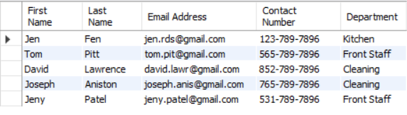
6) Creating a nested view for guest details:

-- create view named hotel_guests to get details of the guests
CREATE OR REPLACE VIEW hotel_guests AS guests
SELECT
guest_first_name AS 'First Name',
guest_last_name AS 'Last Name',
guest_email_address AS 'Email Address',
guest_contact_number AS 'Contact Number',
country,state,zipcode
FROM guests
JOIN addresses ON addresses.address_id = guests.addresses_address_id
WHERE guests.guest_id IN
(SELECT distinct guests_guest_id -- get distinct guests
FROM bookings
WHERE hotel_hotel_id = 1); -- for hotel(King George Inn & Suites) with id 1

-- to retrieve the view
select *
from hotel_guests
order by 'Last Name;

The Output for the following would be:

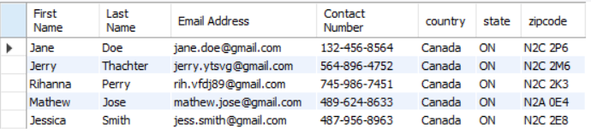

Conclusions

-Challenges Faced:
I faced most of the challenges in creating relationships among tables. I need to make sure that all the relationships created among tables are logical and follow the normalization rules. The most challenging part was creating the booking and the rooms table and its relationships with other respective tables.

-Summary
This was an attempt to create a database management system for hotel where a DBA can easily manage the hotels, rooms, bookings, guests, employees, departments, services, etc. and other things as well, easily and quickly. Overall, it is huge area and I tried to cover few of the parts of it. Thank you!

