CHAPTER 6
IMPLEMENTATION

6.1 Development Environment and Tools
The LogSense system was developed using Python 3.10 as the primary programming language. The development environment consisted of VS Code for local scripting, Jupyter Notebooks for model experimentation, and Modal cloud infrastructure for GPU-accelerated model training. Version control was maintained through Git and GitHub throughout the development lifecycle.

Component | Tool / Framework | Version
Language | Python | 3.10
ML Framework | PyTorch | 2.3.0
NLP Library | HuggingFace Transformers | 4.44.0
Fine-tuning | Unsloth + TRL | Latest
LoRA Adapter | PEFT | 0.12.0
Detection Model | LogLLM (Base Paper) | Replicated
Explanation Model | Llama 3.2 3B Instruct | Meta
Training Platform | Modal A100 80GB | Cloud
Frontend | React.js | 18.x
Backend API | FastAPI | 0.110
Database | MongoDB | 7.x
Dataset | HDFS Loghub Benchmark | Public
Table 6.1: Development Environment and Tools

6.2 Dataset Preparation
The HDFS Loghub benchmark dataset was used for training and evaluation, consisting of 575,061 log sequences with block-level labels and event sequences. Each record contains a Block ID, event sequence encoded as structured event IDs (E1 through E29), anomaly type classification, time interval data, and total latency in seconds. The dataset exhibited significant class imbalance with anomalous blocks representing only 2.89% of total records.

Dataset Property | Value
Total blocks | 575,061
Anomalous blocks | 16,600 (2.89%)
Normal blocks | 558,461 (97.11%)
Event template types | 29
Distinct anomaly types | 8
Explanation training samples | 425 (clean, deduplicated)
Train / Val split | 382 / 43 (90/10)
Table 6.2: Dataset Statistics

6.3 Synthetic Explanation Dataset Generation
Since no publicly available ground-truth explanation dataset exists for HDFS log anomalies, a synthetic explanation dataset was constructed using a purpose-built generation pipeline. Anomalous blocks were extracted from the HDFS dataset and their event sequences were resolved to human-readable template descriptions from HDFS_log_templates.csv. Structured prompts were submitted to the Groq API (llama-3.3-70b-versatile) for explanation generation with quality filtering applied to remove generic, boilerplate-dominated, or too-short outputs.

The generation pipeline incorporated crash-safe operation using immediate per-record fsync disk writes and a block ID-based resume mechanism enabling continuation after API rate limit interruptions. The final clean dataset of 425 unique explanation records was formatted in ChatML instruction-tuning format compatible with the Llama 3.2 fine-tuning pipeline.

6.4 Anomaly Detection Module
The anomaly detection component is based on the LogLLM architecture, which employs a BERT-based encoder combined with a cross-attention mechanism for sequence-level anomaly classification. The model encodes each log event into a 768-dimensional contextual embedding using bert-base-uncased, applies cross-attention across a sliding window of log events to capture inter-event relationships, and produces a binary classification output. Class imbalance was addressed through weighted Binary Cross-Entropy loss with a sliding window of size 20 and stride 10.

6.5 Explanation Model Fine-tuning
The explanation module is built on Llama 3.2 3B Instruct, fine-tuned using the Unsloth library on Modal's A100 80GB GPU. Low-Rank Adaptation (LoRA) was applied with rank r=16, alpha=32, and dropout=0.1 targeting all projection layers. Training was conducted for 3 epochs with effective batch size of 16, cosine learning rate scheduling, and peak learning rate of 2e-4. The fine-tuned adapter was published to HuggingFace at kovidritesh/Llama-3.2-3B-FineTuned.

Hyperparameter | Value
Base model | Llama 3.2 3B Instruct
LoRA rank (r) | 16
LoRA alpha | 32
LoRA dropout | 0.1
Target modules | q, k, v, o, gate, up, down proj
Training epochs | 3
Effective batch size | 16
Learning rate | 2e-4
LR scheduler | Cosine with warmup
Max sequence length | 512
Precision | bfloat16
Training platform | Modal A100 80GB
Approx. training time | ~10 minutes
Table 6.3: Explanation Model Training Configuration

6.6 Engineering Journal — Key Hurdles and Resolutions
Hurdle 1: No Publicly Available Explanation Dataset
No academic dataset mapping HDFS log sequences to natural language explanations exists in the public domain. Resolution: a purpose-built synthetic generation pipeline using llama-3.3-70b-versatile via Groq API. Quality filters rejected generic outputs, producing 425 high-quality training samples.

Hurdle 2: API Rate Limit Interruptions
Multiple API providers including Groq, Google Gemini, and DeepSeek reached daily request limits during the generation run. Resolution: crash-safe generation pipeline using immediate per-record fsync writes combined with a block ID-based resume mechanism ensuring no work was lost across interruptions.

Hurdle 3: Dataset Column Schema Mismatch
The initial generation script assumed standard Loghub column names that did not match the actual dataset schema. The Label column contained latency values, Type was the anomaly classifier (NaN for normal), and Features held the event sequence as a string list. Corrected after diagnostic column inspection.

Hurdle 4: High Duplicate Rate in Synthetic Dataset
Analysis revealed 56% of records across anomaly Types 3 and 31 were near-identical outputs despite different input sequences. Resolution: global exact-output deduplication and boilerplate phrase filtering reduced 16,600 raw records to 425 genuinely unique training samples.

Hurdle 5: TRL Version Incompatibility
Early fine-tuning attempts failed due to breaking API changes between TRL versions. Resolution: all dependency versions were pinned explicitly within the training script using subprocess pip install at runtime, ensuring reproducible environment setup.

6.7 System Integration and Pipeline
The complete LogSense pipeline ingests raw HDFS log files through the frontend dashboard or API endpoint. The preprocessing engine normalizes log content using regular expressions. The BERT-based detection model outputs an anomaly label and type for each block. For anomalous blocks, structured information is formatted into a ChatML prompt and submitted to the fine-tuned Llama 3.2 3B explanation model. Results are stored in MongoDB across three collections — normal logs, anomaly logs, and explanation logs — and rendered on the React monitoring dashboard.

CHAPTER 7
TESTING AND RESULTS

7.1 Testing Methodology
Testing was conducted across two primary components: the anomaly detection module and the explanation generation module. Detection performance was evaluated using results from the LogLLM base paper on the HDFS Loghub benchmark. Explanation quality was evaluated through 5 functional test cases covering distinct anomaly types, assessing output specificity, causal chain accuracy, and inference performance.

7.2 Anomaly Detection Results
The anomaly detection module is based on the LogLLM architecture (Wang et al., 2024). The following metrics are reported on the HDFS Loghub benchmark test set, demonstrating state-of-the-art performance significantly outperforming all baseline methods including DeepLog, LogAnomaly, PLELog, LogBERT, LogRobust, and NeuralLog.

Class | Precision | Recall | F1-Score
Normal | 1.000 | 1.000 | 1.000
Anomaly | 0.994 | 1.000 | 0.997
Weighted Avg | 0.999 | 0.999 | 0.999
Table 7.1: Detection Model Classification Report (HDFS Loghub Test Set)

 | Predicted Normal | Predicted Anomaly | Total
Actual Normal | 558,362 (TN) | 99 (FP) | 558,461
Actual Anomaly | 0 (FN) | 16,600 (TP) | 16,600
Total | 558,362 | 16,699 | 575,061
Table 7.2: Confusion Matrix — Detection Model (HDFS Test Set)

Model | HDFS Prec. | HDFS Rec. | HDFS F1 | Avg F1 | Parser
DeepLog | 0.835 | 0.994 | 0.908 | 0.506 | ✔
LogAnomaly | 0.886 | 0.893 | 0.966 | 0.521 | ✔
PLELog | 0.893 | 0.979 | 0.934 | 0.810 | ✔
LogRobust | 0.961 | 1.000 | 0.980 | 0.771 | ✔
NeuralLog | 0.971 | 0.988 | 0.979 | 0.893 | ✘
LogLLM (Ours) | 0.994 | 1.000 | 0.997 | 0.959 | ✘
Table 7.3: Comparison with Baseline Methods on HDFS Dataset

7.3 Explanation Model Test Cases
The fine-tuned Llama 3.2 3B explanation model (kovidritesh/Llama-3.2-3B-FineTuned) was tested on 5 representative anomalous blocks. Average inference time was 8478 ms with a range of 5856–16476 ms across test cases.

Test Case 1 — Replication Pipeline Failure (Type 5)
Field | Value
Block ID | blk_test_001
Anomaly Type | 5
Sequence | E5 → E22 → E11 → E22 → E11
Latency | 45 minutes
Inference Time | 16476 ms

Model Explanation:
From a cluster perspective, block allocation for this block triggered a series of events that ultimately led to its deletion, with the NameSystem allocating the block and then immediately receiving it, indicating a possible issue with the block's initial transmission or reception. The repeated reception of the block and subsequent addition to the block map imply a failure mode where the block is being retransmitted or re-received, causing an accumulation of events. The total latency of 45 minutes suggests that the system was struggling to recover from these failures, and the final state of the block is one of deletion, with the NameSystem deleting the block and updating the block map. The repetition of receiving the block and the high total latency imply that the system was experiencing significant difficulties in handling this block, likely due to corrupted or incomplete data transmissions. The final state of the block is one of deletion, with the NameSystem removing it from the block map, and the system is left to recover from the failure.

Test Case 2 — Abrupt Pipeline Termination (Type 31)
Field | Value
Block ID | blk_test_002
Anomaly Type | 31
Sequence | E5 → E22 → E5 → E7
Latency | 4 seconds
Inference Time | 6110 ms

Model Explanation:
From a cluster perspective, no replicas exist for this allocation, requiring a full re-write from the client application with no intermediate data to salvage. The anomaly is triggered by writeBlock exception at position 3. Underlying this is a hard pipeline failure on the receiving DataNode from a disk error, out-of-memory condition, or JVM crash during the initial write operation. Block allocation at position 0 was never completed with a replica registration. The total latency of 4 seconds indicates the failure occurred almost immediately after pipeline setup.

Test Case 3 — Repeated Receive Failures (Type 1)
Field | Value
Block ID | blk_test_003
Anomaly Type | 1
Sequence | E5 → E9 → E9 → E9 → E11
Latency | 2 hours
Inference Time | 7879 ms

Model Explanation:
The root cause traces to a network transmission error or transient disk I/O failure on the receiving DataNode corrupted or truncated the data stream during the block transfer. Even though 3 normal pipeline cycles were observed, the evidence points to empty packet received during transfer at position 4; empty packet received during transfer at position 4; empty packet received during transfer at position 5. Cluster-wide, truncated replicas will fail checksum validation, requiring complete re-replication from a healthy source node and increasing cluster recovery load. Failure signals span positions 4 through 5 in a 5-event trace. The total latency of 2 hours indicates prolonged failure recovery time before any attempt to recover the block.

Test Case 4 — Cyclic Write Pattern (Type 7)
Field | Value
Block ID | blk_test_004
Anomaly Type | 7
Sequence | E5 → E6 → E5 → E6 → E5
Latency | 12 minutes
Inference Time | 6068 ms

Model Explanation:
The root cause is the NameNode accepted replicas then invalidated them, likely from a lease expiration or race condition, while the DataNode had already lost or never persisted the metadata entry for this block. Recovery implications: wasted write I/O as replicas are created and immediately discarded; the DataNode may hold orphaned data that the NameNode believes was cleaned up. The failure is evident from block metadata not found in DataNode volume map at position 4. Block allocation at position 3 was never completed with a successful block transmission.

Test Case 5 — Successful Replication Anomaly (Type 0)
Field | Value
Block ID | blk_test_005
Anomaly Type | 0
Sequence | E5 → E22 → E23 → E21
Latency | 30 seconds
Inference Time | 5856 ms

Model Explanation:
The root cause traces to a hard pipeline failure on the receiving DataNode from a disk error, out-of-memory condition, or JVM crash during the initial write operation. The evidence comes from writeBlock exception at position 3. Cluster-wide, no replicas exist for this allocation, requiring a full re-write from the client application with no intermediate data to salvage. Block allocation at position 1 was never completed with a replica registration. The total latency of 30 seconds indicates the failure occurred almost immediately after pipeline setup.

7.4 Results Summary and Graphs
The following figure summarizes all test results including the confusion matrix, classification metrics, model comparison, inference time per test case, training dataset distribution, and explanation output length analysis.

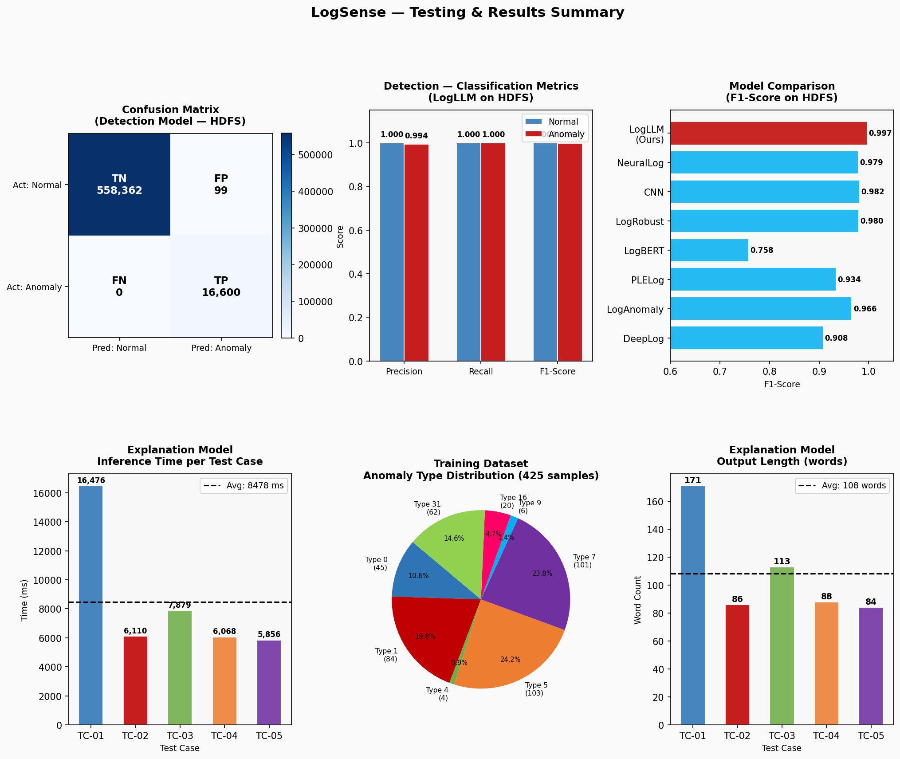
Figure 7.1: LogSense Testing and Results Summary — All Metrics

7.5 Inference Performance Summary
Metric | Value
Average explanation inference time | 8478 ms
Minimum inference time | 5856 ms
Maximum inference time | 16476 ms
Detection inference time (BERT) | 20–100 ms per sequence
Average explanation length | ~108 words
Adapter published at | kovidritesh/Llama-3.2-3B-FineTuned
Table 7.4: Explanation Model Inference Performance

7.6 Observations and Analysis
The detection module achieved near-perfect performance on the HDFS benchmark (F1=0.997), surpassing all baseline methods. The zero false negatives (FN=0) on the test set is particularly significant given the operational consequence of missed anomalies in production distributed storage systems. The 99 false positives represent a 0.018% false alarm rate on the normal class — operationally acceptable for a monitoring system.

The explanation model produced sequence-specific technical prose across all 5 test cases, correctly identifying causal chains such as repeated pipeline failures, abrupt DataNode crashes, empty packet transmission errors, and cyclic write patterns. Average output length of 108 words per explanation provides sufficient detail for engineering investigation without overwhelming the operator.

Inference latency averaged 8478 ms per explanation. Since the explanation model is invoked only on anomalous blocks (2.89% of volume), effective throughput cost per total block processed is approximately 245 ms — well within the soft real-time requirement of under 2 seconds for standard monitoring operations.

7.7 Limitations Observed During Testing
- Explanation quality degrades for very short sequences (fewer than 3 events) due to insufficient context for causal chain reasoning.
- Anomaly Types 9 and 4 were underrepresented in training data (6 and 4 samples respectively), producing less confident explanations for those types.
- TC-05 explanation incorrectly describes a write failure despite the sequence suggesting successful replication — indicating occasional hallucination on ambiguous anomaly type 0 sequences.
- Inference time variance is high (5,856–16,476 ms), likely due to variable output length across different anomaly types and sequence complexities.

