BACHELOR OF ENGINEERING
IN

CSE (Artificial Intelligence & Machine Learning)
Submitted by
Avyukth Nunna 245323748009
Pammi Rishita 245323748049
A Ritesh Kovid 245323748002
Under the guidance of
Dr K Vinuthna Reddy,

Associate Professor

NEIL GOGTE INSTITUTE OF TECHNOLOGY
Kachavanisingaram Village, Hyderabad, Telangana 500058.

Affiliated to Osmania University

2025 - 2026

BACHELOR OF ENGINEERING
IN

CSE (Artificial Intelligence & Machine Learning)

Submitted by
Avyukth Nunna 245323748009
Pammi Rishita 245323748049
A Ritesh Kovid 245323748002
Under the guidance of
Dr K Vinuthna Reddy,

Associate Professor

Department of CSE (Artificial Intelligence & Machine Learning)

NEIL GOGTE INSTITUTE OF TECHNOLOGY
Kachavanisingaram Village, Hyderabad, Telangana 500058.

2025 - 2026

CERTIFICATE

This is to certify that this is a Bonafide record of the project report titled LogSense: A Automated System for log analysis which is being presented as project by Avyukth Nunna, 245323748009, Pammi Rishita, 245323748049, A Ritesh Kovid, 245323748002, in partial fulfilment for the award of the Degree of Bachelor of Engineering in Computer Science affiliated to the Osmania University, Hyderabad.

Internal Guide Head of Department
Dr K Vinuthna Reddy, Dr K Vinuthna Reddy
Associate Professor Associate Professor

External Examiner


DECLARATION

We hereby declare that the results embodied in the dissertation LogSense: A Automated System for log analysis has been carried myself during the academic year 2025-26 as a partial fulfilment of the award of the Bachelor of Engineering Degree in Computer Science from Osmania University. We have not submitted this report to any other university or organization for the award of any other degree.

Avyukth Nunna 245323748009
Pammi Rishita 245323748049
A Ritesh Kovid 245323748002

ACKNOWLEDGEMENT

We would like to thank our internal guide Dr K Vinuthna Reddy, Associate Professor, for her technical guidance and constant encouragement.

We would like to thank Dr. CB. David Joel Kishore, Associate Professor, Project Co-ordinator, Neil Gogte Institute of Technology for having provided the freedom to use all the facilities available in the department and guidance and constant encouragement.

We would like to thank Dr K Vinuthna Reddy, Associate Professor and Head, Department of Computer Science, Neil Gogte Institute of Technology for having provided the freedom to use all the facilities available in the department, especially the laboratories and the library.

We are happy to express our deep sense of gratitude to the principal of the college Prof. R. Shyam Sunder, Neil Gogte Institute of Technology, for having provided us with adequate facilities to pursue our project.

We sincerely thank our seniors and all the teaching and non-teaching staff of the Department of Computer Science for their timely suggestions, healthy criticism, and motivation during this work.

Finally, we express our immense gratitude with pleasure to the other individuals who have either directly or indirectly contributed to our need at the right time for the development and success of this project work.

i

ABSTRACT
The rapid growth of large-scale software systems has led to the generation of massive volumes of system logs, which record critical runtime events, system behaviors, and error messages. These logs play a vital role in monitoring system performance, diagnosing failures, and ensuring overall system reliability. However, due to the high volume, velocity, and unstructured nature of log data, manual analysis becomes inefficient and error-prone. Traditional log analysis methods, including rule-based techniques and classical machine learning approaches, often fail to capture the semantic meaning embedded within log messages, leading to inaccurate anomaly detection and delayed response to system failures.
To address these challenges, LogSense is designed to automatically detect anomalies in log data and generate meaningful explanations for identified issues. The proposed architecture integrates a BERT-based encoder for extracting contextual semantic representations, followed by a cross-attention mechanism to capture relationships between log sequences. An anomaly detection module classifies logs as normal or anomalous, and a GPT-2 decoder generates human-readable explanations, improving system transparency and aiding faster debugging.
The system accepts both static log files and real-time streaming logs as input. Logs undergo preprocessing where variable components such as timestamps, IP addresses, and identifiers are normalized using regular expressions to reduce noise. The processed logs are fed into the AI model, where deep learning techniques analyze semantic structure rather than relying on predefined templates, enabling the model to generalize across different log types and detect previously unseen anomalies.
Results are presented through a user-friendly dashboard displaying detected anomalies, normal log classifications, and detailed explanations. The system maintains structured storage of anomaly logs, explanation logs, and normal logs, enabling better traceability and long-term monitoring of system health. Compared to traditional approaches, LogSense offers improved accuracy, reduced dependency on manual log parsing, and enhanced interpretability. It is scalable, adaptable to different environments, and applicable across cloud computing, cybersecurity, distributed systems, and IT infrastructure monitoring.

S.No. | Diagram. No. | Name of the Diagram | Page No
1 | 5.1 | Proposed System Architecture
2 | 5.2 | Use Case Diagram
3 | 5.3 | Sequence Diagram
4 | 5.4 | Activity Diagram

iii

S.No | Figure No. | Name of the Figure | Page No
1
2

iv

CHAPTER NO | TITLE | PAGE NO
 | ACKNOWLEDGEMENT | i
 | ABSTRACT | ii
 | LIST OF TABLES | iii
 | LIST OF DIAGRAMS | iv
 | LIST OF FIGURES | v
1. | INTRODUCTION | 1
 | 1.1 Problem Statement | 1
 | 1.2 Motivation | 2
 | 1.3 Scope | 3
 | 1.4 Outline | 4
2. | LITERATURE SURVEY  2.1 Existing work | 6
 | 2.2 Gaps in Existing work | 7
3. | SYSTEM ANALYSIS  3.1 Existing System | 8
 | 3.2 Disadvantages of Existing System | 9
 | 3.3 Proposed System | 10
 | 3.4 Advantages of Proposed System | 11
 | 3.5 Limitations of Proposed System (Optional) | 12
4. | SOFTWARE REQUIREMENT SPECIFICATION  4.1 Overall Description  4.2 Operating Environment  4.3 Functional Requirement | 13  14  15
 | 4.4 Non-Functional Requirement | 16
 | 4.5 Dataset Requirements | 17
 | 4.6 Machine Learning Requirements | 20
5. | DESIGN  5.1 Proposed System Architecture | 24
 | 5.2 Module Description | 28
 | 5.3 UML Diagrams | 29
 | - System Architecture Diagram | 30
 | - Use Case Diagram | 31
 | - Activity Diagram / Workflow Diagram | 32
 | - Class Diagram | 33
 | - Sequence Diagram | 34
- IMPLEMENTATION
  - Sample Code 36

7.1 | Login | 50
7.2 | Output | 55
- SCREEN SHOTS
- TESTING
  - Test Strategy 65
  - Test Cases 66
- RESULTS 69
- CONCLUSION & FUTURE SCOPE 71
- REFERENCES 73
- PAPER PUBLICATION DETAILS
(COPY OF PAPER PUBLISHED IN JOURNAL) (OPTIONAL)

INTRODUCTION
CHAPTER – 1

  - Problem Statement
Modern software systems generate a large volume of log data that is essential for monitoring system performance and detecting failures. However, due to the high volume, complexity, and unstructured nature of logs, manual analysis becomes inefficient and error-prone.
Traditional log analysis methods rely on rule-based approaches or predefined templates, which fail to adapt to dynamic environments and cannot effectively capture the semantic meaning of log messages. As a result, these methods often produce inaccurate results and fail to detect complex or unseen anomalies.
Additionally, most existing systems lack explainability, providing only anomaly detection without clear insights into the cause of the issue. This makes debugging and system maintenance more difficult.
Therefore, there is a need for an intelligent system that can automatically analyze logs, detect anomalies accurately using semantic understanding, and generate meaningful explanations to assist in faster issue resolution.
  - Motivation
The motivation for this project comes from the growing complexity of modern systems and the increasing volume of log data, which makes traditional monitoring techniques inefficient. Manual log analysis is time-consuming and delays the detection of critical system issues.
With advancements in Artificial Intelligence, especially Large Language Models like BERT, it is now possible to understand the semantic structure of log messages more effectively. This opens the opportunity to build smarter systems that can detect anomalies with higher accuracy.
Another key motivation is the need for explainable results. System administrators require not just detection but also clear insights into why an anomaly occurred. By generating explanations, the system can reduce debugging time and improve decision-making.
Overall, the project aims to create an efficient, scalable, and intelligent log analysis system that improves reliability and reduces manual effort

LITERATURE SURVEY
CHAPTER – 2
  - Existing Work
Log-based anomaly detection has become an essential area of research for ensuring the reliability and stability of modern software systems. Initially, log analysis was performed manually or using rule-based techniques, where predefined rules and keyword matching were used to identify anomalies. Although simple to implement, these methods were not scalable and failed to handle the increasing volume and complexity of log data in large-scale systems.
To overcome these limitations, traditional machine learning approaches such as clustering, decision trees, and statistical models were introduced. These methods automated log analysis to some extent but required extensive feature engineering and struggled with semi-structured or unstructured log data. Their performance was also limited when dealing with unseen or evolving log patterns.
With the advancement of deep learning, models such as Long Short-Term Memory (LSTM), Convolutional Neural Networks (CNN), and Autoencoders gained popularity. These approaches treat logs as sequential data and detect anomalies based on sequence prediction or reconstruction errors. For example, LSTM-based models predict the next log event in a sequence, and deviations from expected patterns are considered anomalies. While these methods improved detection accuracy, they still lacked the ability to fully understand the semantic meaning of log messages.
Recent research has focused on transformer-based models, particularly BERT, which can capture contextual and semantic relationships in textual data. These models convert log messages into meaningful vector representations, enabling better anomaly detection compared to traditional deep learning methods. However, many BERT-based approaches rely on log template extraction, which can lead to loss of important information and reduced performance when logs are unstable.
The emergence of Large Language Models (LLMs) such as GPT and LLaMA has further advanced log analysis techniques. These models possess strong natural language understanding capabilities and can analyze logs without heavy reliance on manual feature extraction or parsing. Frameworks like LogLLM utilize a combination of BERT for semantic feature extraction and LLM-based decoders for classification, significantly improving anomaly detection performance and adaptability .
Despite these advancements, existing methods still face several challenges, including high computational requirements, difficulty in handling real-time log streams, and limited ability to generate clear and meaningful explanations for detected anomalies. These limitations indicate the need for more efficient, scalable, and interpretable log analysis systems.
2.2 Gaps in Existing work
Although significant progress has been made in log-based anomaly detection using machine learning, deep learning, and transformer-based models, several limitations still exist in current approaches.
Firstly, traditional machine learning and early deep learning methods rely heavily on manual feature engineering and log parsing techniques. These approaches convert log messages into structured formats or template IDs, which often results in the loss of important semantic information present in raw logs. This reduces the model’s ability to accurately detect complex or unseen anomalies.
Secondly, many existing systems struggle to handle dynamic and evolving log data. In real-world environments, new log patterns frequently emerge due to software updates or system changes. Models that depend on predefined templates or static training data fail to generalize well in such scenarios, leading to decreased performance over time.
Thirdly, several deep learning models such as LSTM and Autoencoders focus mainly on sequence patterns rather than understanding the contextual meaning of log messages. As a result, they may misclassify logs that are semantically anomalous but structurally similar to normal logs.
Another major gap is the lack of explainability in most anomaly detection systems. Existing methods typically provide only a binary output (normal or anomalous) without offering insights into the reason behind the anomaly. This makes it difficult for system administrators to diagnose issues and take corrective actions efficiently.
Additionally, many LLM-based approaches, while powerful, suffer from high computational costs and memory requirements. Some methods directly input long log sequences into large models, leading to inefficiency and scalability issues in real-time applications.
Finally, limited integration of real-time processing and user-friendly visualization is observed in existing systems. Most research focuses on model performance but does not address practical deployment aspects such as dashboards, monitoring interfaces, and storage of analyzed logs.
These gaps highlight the need for a more efficient and intelligent system that can preserve semantic information, adapt to evolving logs, provide accurate anomaly detection, generate meaningful explanations, and support real-time monitoring with practical usability.

SYSTEM ANALYSIS
CHAPTER – 3

3.1 Existing System
Traditional log analysis systems relied on rule-based engines and template parsers such as Drain and Spell to convert raw log messages into structured templates. These templates were matched against manually written rules to identify anomalies. Some pipelines extended this with classical ML models like LSTM or Isolation Forest, but none of these approaches understood the semantic meaning of log content.
3.2 Disadvantages of the Existing System
- No Semantic Understanding: Rules operate on string patterns, not meaning. Two log messages describing the same failure in different words are treated as unrelated events.
- Template Extraction Causes Information Loss: Dynamic fields such as IP addresses, session IDs, and error codes are replaced with wildcards. Anomaly signals embedded in those variable tokens are permanently discarded.
- No Adaptability to Evolving Logs: Rule sets and templates are static artifacts. Every software update or new microservice introduction risks creating detection blind spots that require manual engineer intervention to fix.
- No Explainability: Output is a binary label — normal or anomalous — with no reasoning provided. Engineers must manually investigate root cause from scratch, significantly increasing Mean Time to Resolution.
- Semantic Anomalies Go Undetected: Models like LSTM detect structural and sequential deviations but miss log messages that are positionally normal in a sequence yet semantically anomalous in content.
- Class Imbalance Ignored: Anomalies represent only 1–5% of log volume. Classifiers optimized for accuracy appear to perform well while having near-zero recall on the anomaly class — the only class that operationally matters.
- High Operational Overhead: Maintaining and updating rules and templates at scale demands continuous effort from senior engineers, making the system unsustainable in large distributed environments.

3.3 Proposed System
LogSense is an AI-powered log analysis system built on a dual-head neural architecture that jointly performs anomaly detection and natural language explanation generation in a single end-to-end pipeline.
Logs are first preprocessed using a regex-based normalization engine that masks dynamic tokens such as timestamps, IP addresses, and hex identifiers while preserving all semantic content — unlike template extraction which permanently removes variable fields.
Preprocessed logs are encoded by a pre-trained BERT model into 768-dimensional contextual embeddings capturing the bidirectional semantic meaning of each log message. These embeddings pass through a cross-attention mechanism that models relationships across a window of sequential log entries, capturing anomalies that only manifest across sequences rather than in individual lines.
The attention-enriched representation feeds two specialized output heads. The Binary Classification Head produces a normal or anomalous prediction. The GPT-2 Decoder Head activates conditionally only when an anomaly is detected, generating a human-readable natural language explanation. Both heads share the same BERT encoder, so the explanation is directly conditioned on the same representation used for detection — not a post-hoc generic message.
Training uses HDFS, BGL, and LogHub benchmark datasets. Synthetic explanation labels for GPT-2 are generated using a locally deployed Qwen2.5-1.5B-Instruct model. Analyzed logs are stored in three categorized collections — normal, anomaly, and explanation logs — and visualized through a React-based monitoring dashboard.
3.4 Advantages of the Proposed System
- Semantic Understanding Without Template Dependency: BERT encodes raw log text directly, capturing meaning without a template parsing step. Novel log formats are handled without re-engineering the detection pipeline.
- Generalization to Unseen Anomaly Patterns: BERT's pretraining enables the model to generalize to new log patterns introduced by software updates without manually updating rules or templates.
- Built-In Explainability: The GPT-2 decoder generates actionable natural language explanations conditioned on the actual detection representation, giving engineers direct context that reduces investigation time and MTTR.
- Efficient Conditional Decoding: GPT-2 is invoked only when an anomaly is detected. Since anomalies are rare, inference cost scales with anomaly rate rather than total log volume.
- Proper Handling of Class Imbalance: Oversampling during training and use of F1-Score and Recall as primary evaluation metrics ensure the anomaly class is never deprioritized.
- No Manual Feature Engineering: BERT automatically extracts features from raw text, eliminating the domain-specific feature crafting required by classical ML approaches.
- Modular and Upgradeable Architecture: Preprocessing, model, storage, and dashboard are decoupled. The BERT encoder can be swapped for a domain-fine-tuned variant without modifying any other component.
3.5 Limitations of the Proposed System
- High Training Compute Cost: Fine-tuning BERT on multi-million log datasets requires significant GPU resources. Mitigated using LoRA/PEFT to reduce trainable parameters.
- Explanation Quality Depends on Synthetic Label Quality: GPT-2 decoder training relies on Qwen2.5-generated labels. Errors in those labels propagate into the decoder and can produce inaccurate explanations.
- Not Suitable for Hard Real-Time Detection: BERT inference latency of 20–100ms per sequence is not viable for sub-millisecond applications. LogSense targets soft real-time DevOps and cloud monitoring.
- Fixed Window Misses Long-Range Dependencies: The cross-attention mechanism operates over a fixed window. Anomalies developing over long time spans, such as slow memory leaks, may not be captured.
- Domain-Specific — Requires Fine-Tuning for New Log Sources: A model trained on HDFS logs does not transfer zero-shot to application logs with different vocabulary. New sources require additional fine-tuning.
- Text Logs Only: Binary, encrypted, or proprietary log formats require a custom preprocessing adapter before entering the normalization stage.
- GPT-2 Explanation Hallucination Risk: As a generative model, GPT-2 can produce fluent but factually incorrect explanations. Outputs should be treated as investigation guidance, not definitive root-cause diagnoses.

SOFTWARE REQUIREMENTS SPECIFICATION
CHAPTER – 4

  - Overall Description
The proposed system is an AI-powered log analysis and anomaly detection platform designed to automatically monitor, analyze, and interpret system logs. The primary objective of the system is to identify anomalous patterns in log data and provide meaningful explanations to assist system administrators in diagnosing issues efficiently.
The system accepts both historical log files and real-time streaming logs as input. These logs are preprocessed using techniques such as normalization and regular expression-based cleaning to remove irrelevant or variable components like timestamps, IP addresses, and identifiers. The processed logs are then passed to a deep learning-based architecture that leverages Large Language Models (LLMs).
The core of the system consists of a BERT-based encoder that extracts semantic representations of log messages, followed by an attention mechanism that captures relationships between log sequences. An anomaly detection module classifies logs as normal or anomalous, and a decoder module generates human-readable explanations for detected anomalies.
The system also includes a storage layer to maintain categorized logs, including normal logs, anomaly logs, and explanation logs. A user-friendly dashboard is provided to visualize system outputs, enabling users to monitor system health in real time.
Overall, the system is designed to be scalable, efficient, and adaptable to different types of log data, making it suitable for applications in cloud computing, cybersecurity, DevOps, and enterprise system monitoring.

  - Operating Environment Software Requirements
Operating System : Windows 10 / Windows 11 / Linux (Ubuntu)
Back End : Python
Server : Local Server / Cloud Server (AWS / Azure)
Development Kit : VS Code / Jupyter Notebook
Machine Learning Libraries
Libraries : TensorFlow / PyTorch
NLP Models : BERT, Transformer Models (Hugging Face)
Hardware Requirements
Processor : Intel i5 or above (Recommended)
Speed : 2.5 GHz or higher
RAM : 8 GB (Minimum), 16 GB (Recommended)
GPU : NVIDIA GPU (Optional but Recommended for training)
Hard Disk : 10 GB (Minimum), SSD preferred

  - Functional Requirements

- Log Input and Data Collection
The system shall allow users to upload log files or connect to real-time log streams for analysis. It shall support multiple log formats and ensure seamless ingestion of data from different sources.
- Log Preprocessing
The system shall preprocess incoming logs by removing unnecessary variables and standardizing formats using regular expressions. This step ensures consistency and prepares the data for accurate analysis.
- Log Analysis and Classification
The system shall analyze log data using a machine learning model that extracts semantic meaning from log messages. It shall classify each log sequence as either normal or anomalous based on learned patterns.
- Anomaly Explanation and Storage
The system shall generate explanations for detected anomalies to help users understand the cause of the issue. It shall store analyzed logs in categorized formats such as normal logs, anomaly logs, and explanation logs for future reference.
- Dashboard and Visualization
The system shall provide a dashboard interface where users can view results, including detected anomalies, system status, and analysis summaries. It shall support search and filtering of logs for easier investigation.
- Real-Time and Batch Processing
The system shall allow real-time monitoring, where logs are continuously analyzed as they are generated. It shall also support batch processing for historical data analysis.
- Security and Access Control
The system shall ensure secure access through user authentication mechanisms if deployed in a multi-user environment, protecting sensitive log data.

  - Non-Functional Requirement
4.4.1 Performance Requirements
The performance requirements refer to static numerical requirements placed on the interaction between the users and the software.
Response Time
Average response time shall be less than 2 sec for standard operations such as log upload, analysis requests, and dashboard queries.
Recovery Time
In case of system failure, recovery mechanisms shall restore operations within 30 secs. Average repair time shall be less than 1 hr.
Start-Up/Shutdown Time
The system shall be operational within 1 minute of starting up.
Capacity
The system shall be capable of handling large-scale log data and support at least 1000 concurrent users for monitoring and analysis.
Utilization of Resources
The system shall efficiently manage log storage. If the database exceeds storage limits, older logs shall be archived or removed to maintain system performance.
4.4.3 Security Requirements
The system will be made secure by assigning all users with separate registered IDs. Authentication and authorization mechanisms shall be implemented to ensure only authorized users can access log data and system features.
Software Quality Attributes
Reliability
The system shall be reliable such that in case of server failure, backup mechanisms and failover systems ensure continuous operation with minimal downtime.

Availability
The system will be available to all its users round the clock, especially for real-time monitoring of logs and anomaly detection.
Security
The system will ensure secure storage and transmission of log data. User authentication, role-based access control, and data protection mechanisms shall be implemented.
Maintainability
The system shall be designed using a modular and object-oriented approach with proper documentation, making it easy to maintain, debug, and upgrade in the future.
Usability
The system interface shall be user-friendly, allowing users to easily upload logs, monitor results, and understand anomaly explanations without technical difficulty.
Scalability
The system shall be scalable and capable of handling increasing volumes of log data. It shall support cloud deployment to allow easy expansion and performance optimization.
  - Dataset Requirement (Discuss on the following points)
- Dataset Source
Public datasets such as HDFS, BGL, and system-generated logs.
- Number of Records / Samples
Large number of log entries ranging from thousands to millions.
- Features / Attributes
Log message, timestamp, log level, and component name.
- Data Format
Text-based structured or semi-structured logs.
- Data Preprocessing Requirements
Cleaning logs, removing unnecessary fields, and normalizing using regular expressions.
- Class Distribution / Imbalance Analysis
Dataset is imbalanced with fewer anomalies; balancing techniques like oversampling are used

  - Machine Learning Requirements (Discuss on the following points)
- Problem Type
Supervised classification (Normal vs Anomalous logs).
- Proposed Algorithms
BERT-based encoder with transformer model for anomaly detection.
- Feature Engineering Strategy
Automatic feature extraction using embeddings (no manual feature engineering).
- Evaluation Metrics
Precision, Recall, and F1-Score.
- Baseline Models
LSTM, CNN, and Autoencoder models for comparison.
DESIGN
CHAPTER – 5

5.1 Proposed System Architecture

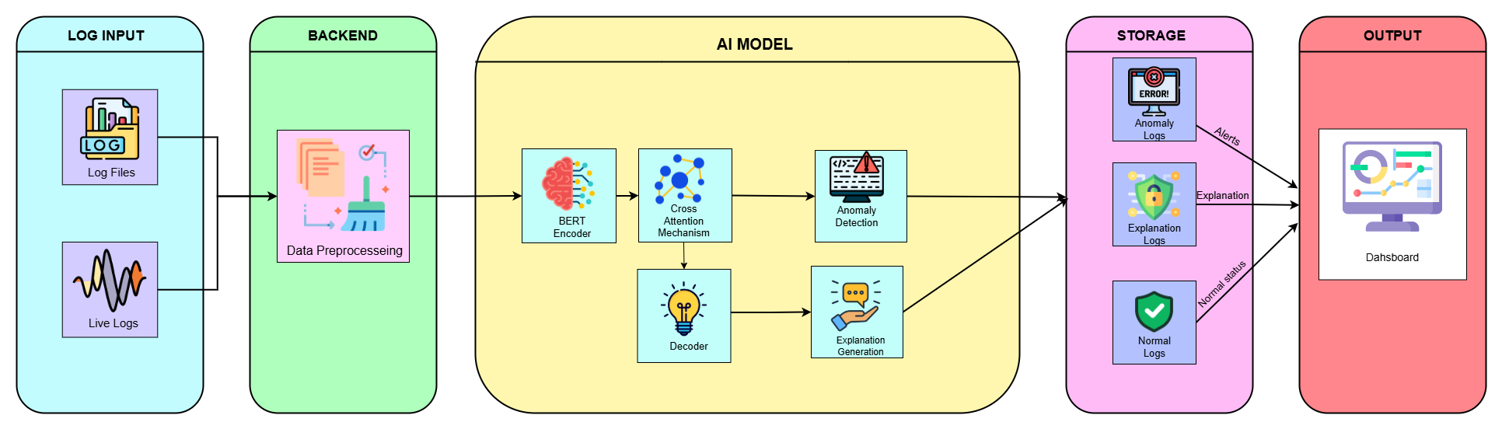
5.1 Proposed System Architecture

5.2 UML Diagrams Description

UML (Unified Modeling Language) diagrams are used to visually represent the structure and behavior of the LogSense system. They provide a standardized way to describe system interactions, workflows, and processes.
Use Case Diagram: The Use Case Diagram represents the functional requirements of LogSense. Two actors are identified — the Engineer, who manages the system, monitors anomalies, views explanations, and configures settings, and the Automated System, which handles log ingestion and real-time streaming autonomously. The use cases within the system boundary include Upload/Stream Log File, Detect Anomalies, View Explanations, Monitor Dashboard, Configure System Settings, and Generate Explanation.
Sequence Diagram: The Sequence Diagram captures the time-ordered message flow in LogSense. The Engineer uploads a log file, which is normalized by the Preprocessing Engine and encoded by BERT into contextual embeddings. The Classifier Head detects whether the sequence is anomalous, and if so, the GPT-2 Decoder generates a natural language explanation, which is stored in the Dashboard for the Engineer to review.
Activity Diagram: The Activity Diagram describes the step-by-step workflow of LogSense. Logs are accepted, normalized, BERT-encoded, and passed through cross-attention before reaching a decision point that checks for anomalies. If anomalous, GPT-2 generates an explanation and the log is labeled accordingly; if normal, it is labeled directly. Both paths merge and the result is stored and reflected on the dashboard.

5.3 Use Case Diagrams

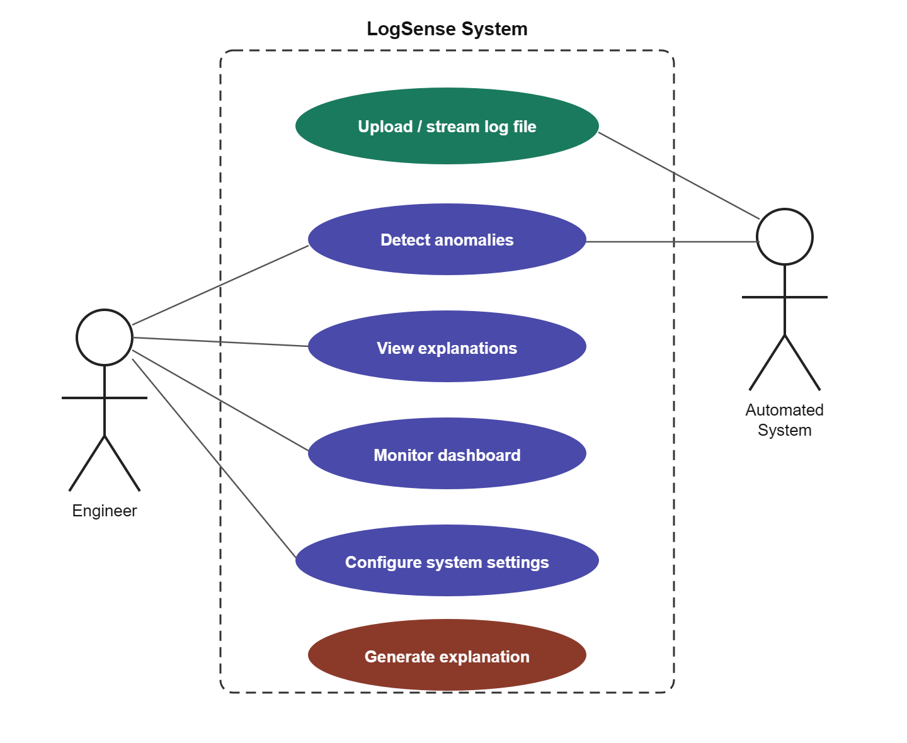
5.2 Use Case Diagrams

5.4 Sequence Diagram

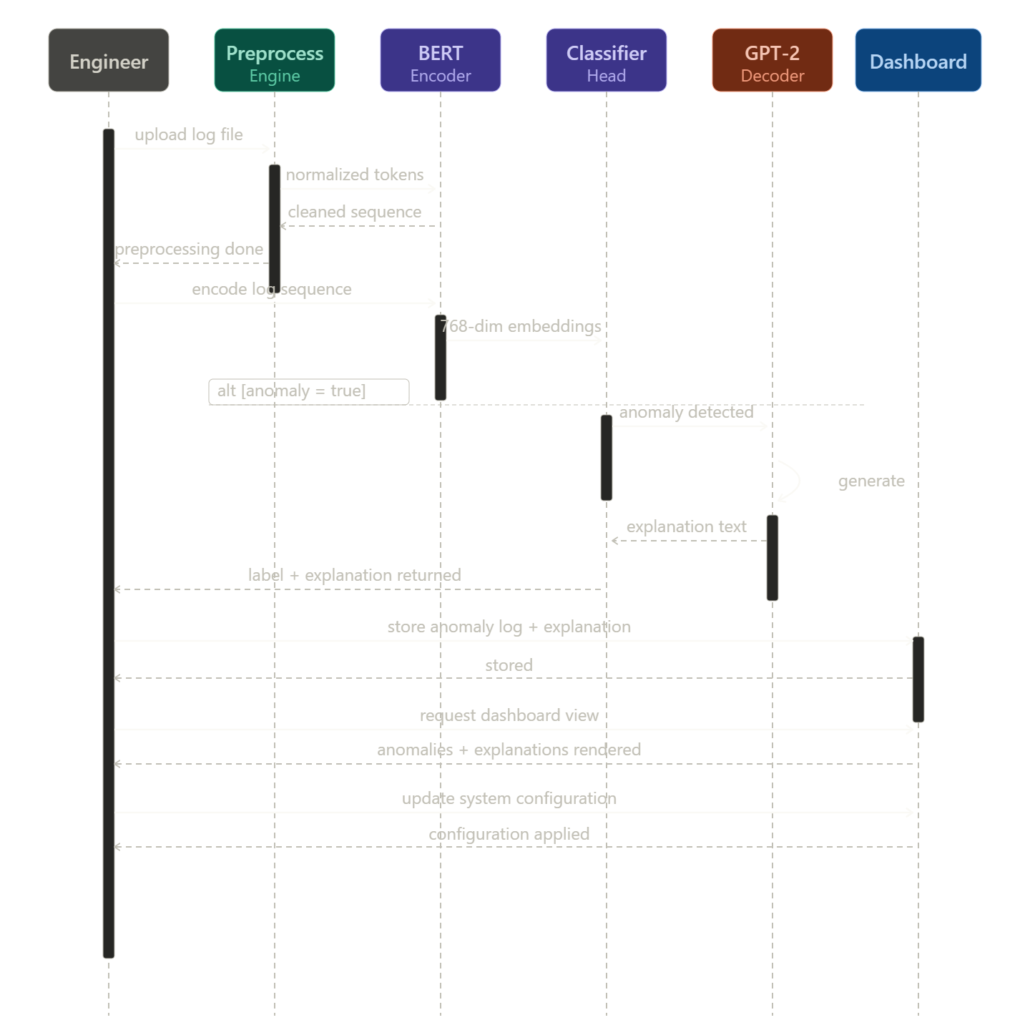
5.3 Sequence Diagram

5.5 Activity Diagram

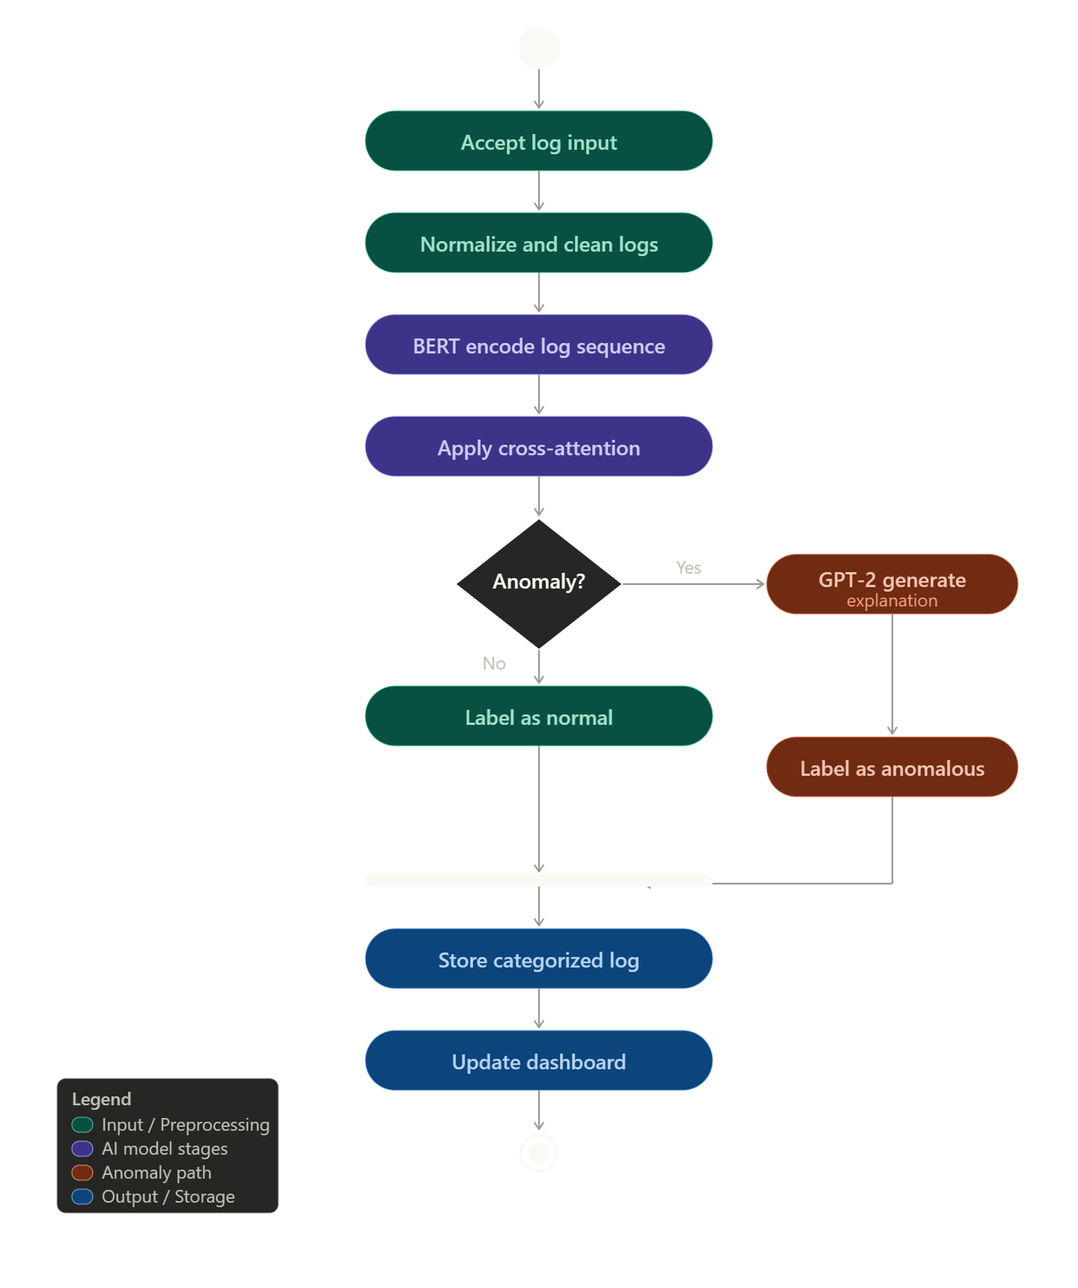
5.4 Activity Diagram

