Existing

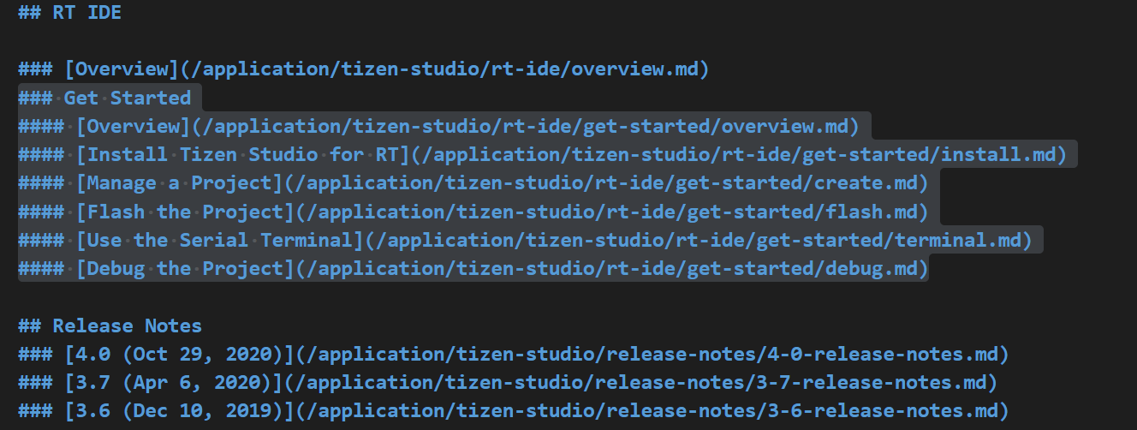

“How about retaining the left nav RT IDE> Overview (landing page alone)

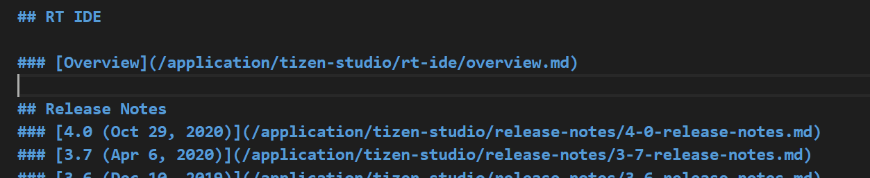

Will change the Left NAV Text from RT IDE to Tizen ID

(or we can change RT IDE to Tizen RT)

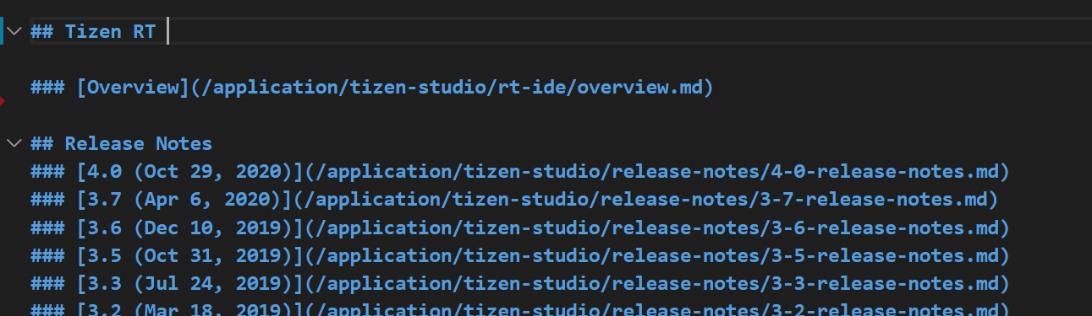

Overview (landing page) Existing

### [Overview](/application/tizen-studio/rt-ide/overview.md)

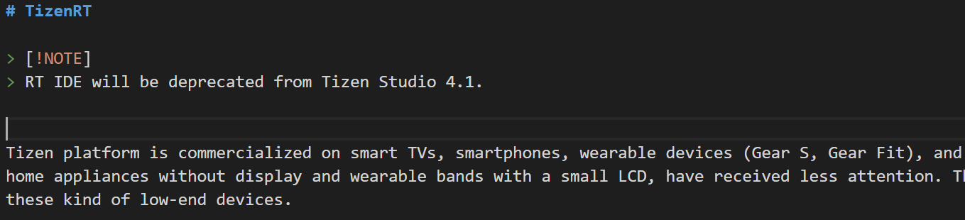

Will change to:

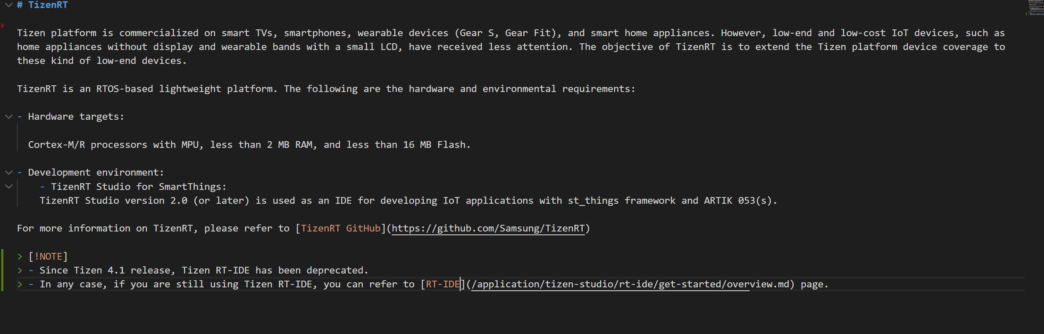

Note in the end with text:

Old Nav for RT-IDE

**## RT IDE**

**### [Overview](/application/tizen-studio/rt-ide/overview.md)**

**### Get Started**

**#### [Overview](/application/tizen-studio/rt-ide/get-started/overview.md)**

**#### [Install Tizen Studio for RT](/application/tizen-studio/rt-ide/get-started/install.md)**

**#### [Manage a Project](/application/tizen-studio/rt-ide/get-started/create.md)**

**#### [Flash the Project](/application/tizen-studio/rt-ide/get-started/flash.md)**

**#### [Use the Serial Terminal](/application/tizen-studio/rt-ide/get-started/terminal.md)**

**#### [Debug the Project](/application/tizen-studio/rt-ide/get-started/debug.md)**