HTTP
METHODS
A backend engineer's deep-dive into HTTP verbs, semantics,
Idempotency, PUT vs PATCH, OPTIONS, and the full CORS workflow.

GET | POST | PUT | PATCH | DELETE | OPTIONS

1. What is an HTTP Method?
An HTTP method (also called an HTTP verb) is the first token in an HTTP request line. It tells the server the intent of the request — not just what resource to act on (the URI), but how to act on it.
HTTP 1.1 (RFC 9110) defines nine standard methods. Six are used in everyday REST APIs. Two are critical for browsers. The spec imposes precise semantics on each — semantics that directly affect caching, proxy behavior, browser retries, and your API's contract with clients. Treating them interchangeably is a common beginner error with real consequences.
Why method semantics matter
A method's semantics are a contract, not a suggestion. Caches decide what to store based on the method. Browsers decide whether to retry failed requests based on idempotency. Proxies make routing decisions based on safety.

2. Core Properties: Safety & Idempotency
Every HTTP method can be characterized by two orthogonal properties. These are not implementation choices — they are part of the specification and clients rely on them.

Safe
A method is safe if it is read-only. Invoking a safe method must not cause any state change on the server. GET, HEAD, and OPTIONS are safe. Clients and proxies may call a safe method freely — automatic prefetching, speculative execution, and link crawlers are all valid because the method guarantees no mutation.

Idempotent
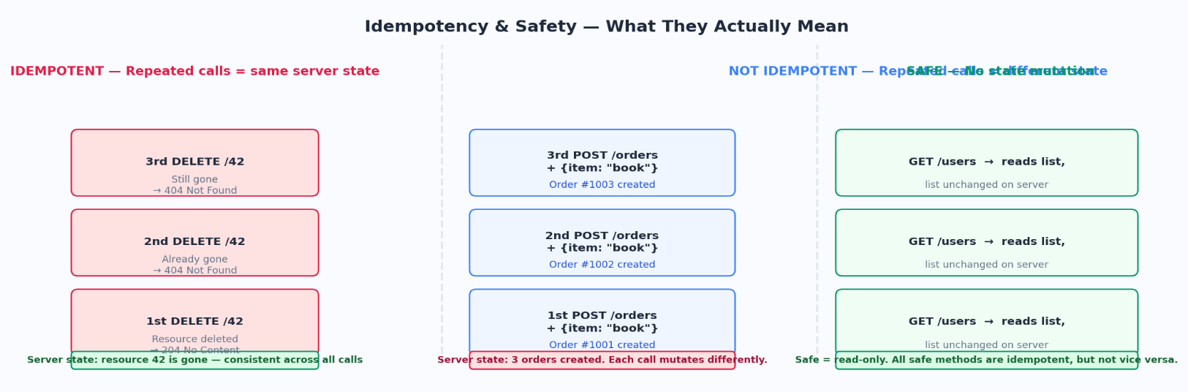
A method is idempotent if calling it N times produces the same server state as calling it once. Note: the response codes may differ across calls (404 vs 204 on repeated DELETE), but the server-side state remains consistent. GET, HEAD, PUT, DELETE, OPTIONS are idempotent. POST and PATCH are not.

Figure 1 — Idempotency vs Safety illustrated with real method behavior
Key distinction
All safe methods are idempotent, but not all idempotent methods are safe. DELETE is idempotent but not safe — it changes state. GET is both safe and idempotent.

3. HTTP Methods — Property Matrix
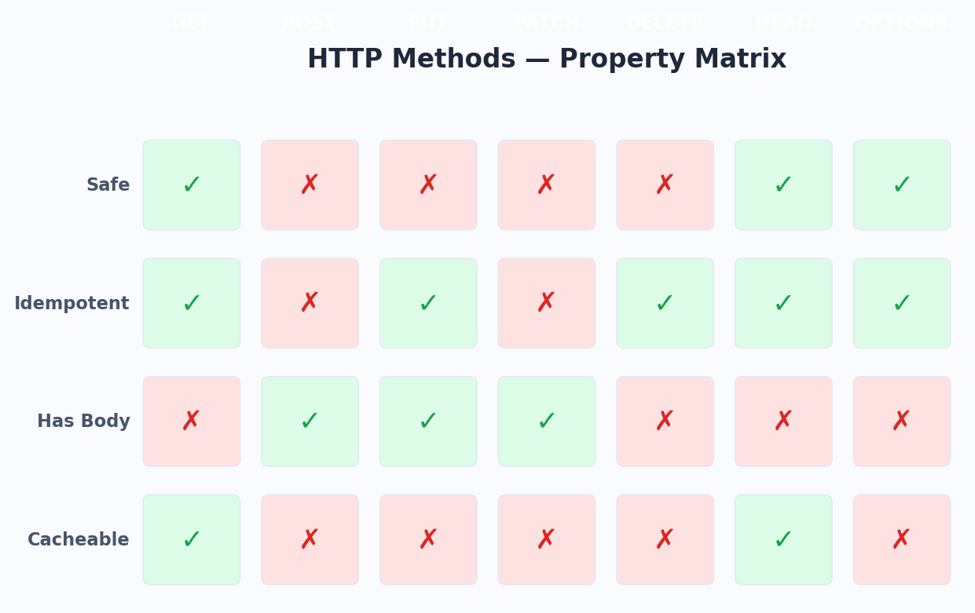
A quick reference showing how all major methods stack up against the core properties defined by RFC 9110.

Figure 2 — Property matrix across all standard HTTP methods

4. Methods in Depth

GET  Retrieve a resource | Retrieves a representation of the target resource. The server must not change state. The body is ignored if present.

Safe | Yes — read only, no server-side mutation
Idempotent | Yes — calling GET 100 times = calling it once
Request Body | Technically allowed but semantically undefined. Never send a body with GET.
Response Body | Yes — the resource representation (HTML, JSON, file, etc.)
Cacheable | Yes — strongest caching candidate of all methods
Status Codes | 200 OK, 304 Not Modified, 404 Not Found, 410 Gone, 401/403

How it works
The client sends the method, URI, headers, and no body. The server looks up the resource and returns it. GET is the mechanism behind every URL you visit in a browser, every API read, every CDN cache hit.
Caching mechanics
GET responses are cached aggressively by browsers, CDNs, and proxies. Cache-Control, ETag, and Last-Modified headers on the response control staleness. Subsequent GETs with If-None-Match or If-Modified-Since allow validation without re-sending the full body (304 Not Modified).
Common misuses
- Never use GET for operations that mutate state. Crawlers and prefetchers will trigger them.
- Never put sensitive data (tokens, passwords) in the URI — GET request URIs appear in server logs, browser history, and Referer headers.
- GET with a body — technically valid per RFC but no standard HTTP machinery uses it, and many servers strip the body.

POST  Submit data / Create | Submits data to be processed. Creates a new resource. The target URI is the parent collection, not the new resource.

Safe | No — always implies a state change on the server
Idempotent | No — submitting twice creates two separate resources
Request Body | Required — carries the data to be processed/created
Response Body | Typically yes — the created resource or a confirmation
Cacheable | Only if response includes explicit Cache-Control/Expires headers (rare)
Status Codes | 201 Created + Location header, 200 OK, 202 Accepted (async), 400, 409 Conflict

How it works
POST sends data in the request body. The server interprets it based on Content-Type. application/json triggers JSON parsing, multipart/form-data handles file uploads. The server creates a new resource, assigns it a URL, and returns 201 Created with a Location header pointing to the new resource.
When to use POST vs PUT
Use POST when the server assigns the resource identifier (POST /users creates user #42, #43, #44 — server decides the ID). Use PUT when the client knows and specifies the full URI (PUT /users/42 replaces the user at that exact location).
202 Accepted — async processing
If processing will take time (queueing a job, sending an email), return 202 Accepted immediately. The response body should include a way to check status (a job ID or polling URL). This decouples submission from completion.

PUT  Full replacement | Replaces the target resource with the request payload. The full representation must be sent. Creates if absent.

Safe | No — replaces/creates a resource
Idempotent | Yes — PUT /users/42 with the same body always results in the same state
Request Body | Required — must be the complete new representation of the resource
Response Body | Usually empty — 204 No Content. Or the updated resource with 200 OK.
Cacheable | No — PUT invalidates cached GET responses for the same URI
Status Codes | 200 OK (with body), 201 Created (if new), 204 No Content (no body), 400, 409

Semantics
PUT performs a full replacement. Whatever was at the URI before is gone and replaced by exactly what you sent. Missing fields are not preserved — they are wiped. This is PUT's defining characteristic and the core of the PUT vs PATCH distinction.
Create-or-replace (upsert)
If nothing exists at the URI, PUT creates it (201 Created). If something exists, it replaces it (200 or 204). This upsert behavior is unique to PUT — POST always creates, never replaces.

PATCH  Partial update | Applies a partial modification to a resource. Only the supplied fields are changed. Everything else is untouched.

Safe | No — modifies server state
Idempotent | Not guaranteed by spec — depends on patch format and implementation
Request Body | Required — the diff/patch document describing the change
Response Body | The updated resource (200 OK) or empty (204 No Content)
Cacheable | No
Status Codes | 200 OK, 204 No Content, 400, 404, 409 Conflict, 422 Unprocessable

Patch formats
PATCH's body is not raw JSON by default — it is a patch document in a format described by Content-Type:
- application/merge-patch+json (RFC 7396) — JSON object where absent keys are ignored, null values delete fields. Simplest.
- application/json-patch+json (RFC 6902) — Array of operations (add, remove, replace, move, copy, test). Explicit, powerful, atomically testable.
- application/json — Informal convention used by most REST APIs. Treat the body as a partial update. Not spec-compliant but universally understood.

Idempotency caveat
PATCH is not guaranteed idempotent. Example: PATCH {age: age+1} — calling it twice increments age twice. Whether PATCH is idempotent depends entirely on what the patch document does. Design your patch operations to be idempotent when possible.

DELETE  Remove a resource | Removes the target resource from the server. Idempotent — repeated deletes result in the same server state.

Safe | No — removes a resource
Idempotent | Yes — deleting a deleted resource still results in "resource is gone"
Request Body | Not typical. Avoid unless your server explicitly supports it.
Response Body | Usually empty — 204. Or a deletion confirmation with 200.
Cacheable | No — and it must invalidate cached representations of the URI
Status Codes | 204 No Content (preferred), 200 OK (with body), 404 Not Found (already gone)

204 vs 404 on repeated DELETE
The spec says idempotent, but does not mandate the status code. Returning 404 on the second DELETE is fine and technically accurate ("it does not exist"). Returning 204 is also valid ("the desired state — resource gone — is achieved"). Pick one and be consistent. 204 is more REST-conventional.
Soft delete pattern
In production systems, DELETE often triggers a soft delete — setting a deleted_at timestamp rather than physically removing the row. The HTTP semantics are identical from the client's perspective, but you retain history and the ability to recover data.

HEAD  Metadata without body | Identical to GET but the server must not send a response body. All response headers must match what GET would return.

Safe | Yes — read-only, no state change
Idempotent | Yes
Request Body | No
Response Body | None — the spec forbids it
Cacheable | Yes — same cache rules as GET
Status Codes | Same as GET — 200, 301, 404, etc.

Why HEAD exists
HEAD exists to check resource properties without paying the bandwidth cost of downloading the body. Practical uses:
- Check if a resource exists (200 vs 404) before attempting a full download.
- Read Content-Length to decide if a download is worth initiating.
- Check ETag or Last-Modified to see if a cached version is stale before re-downloading.
- Health checks — many load balancers probe endpoints with HEAD to avoid unnecessary data transfer.

5. Request-Response Flow by Method
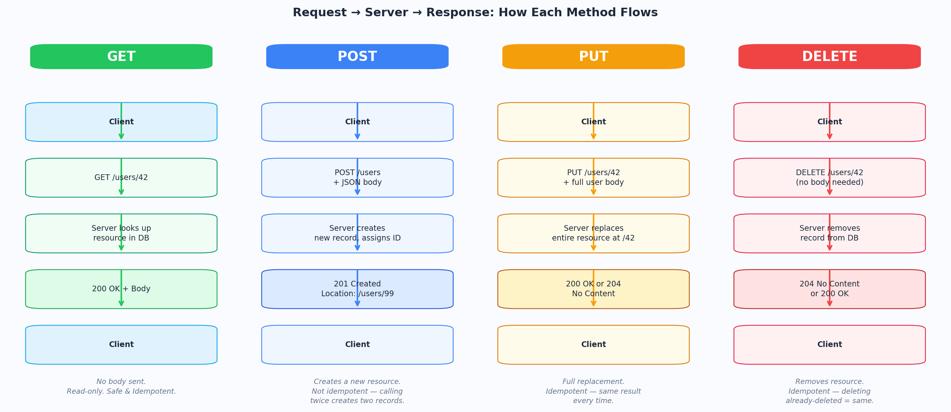
How the full round-trip looks for GET, POST, PUT, and DELETE — from client intent to server action to final response.

Figure 3 — Request → Server Processing → Response flow for the four primary methods

6. PUT vs PATCH — The Definitive Breakdown
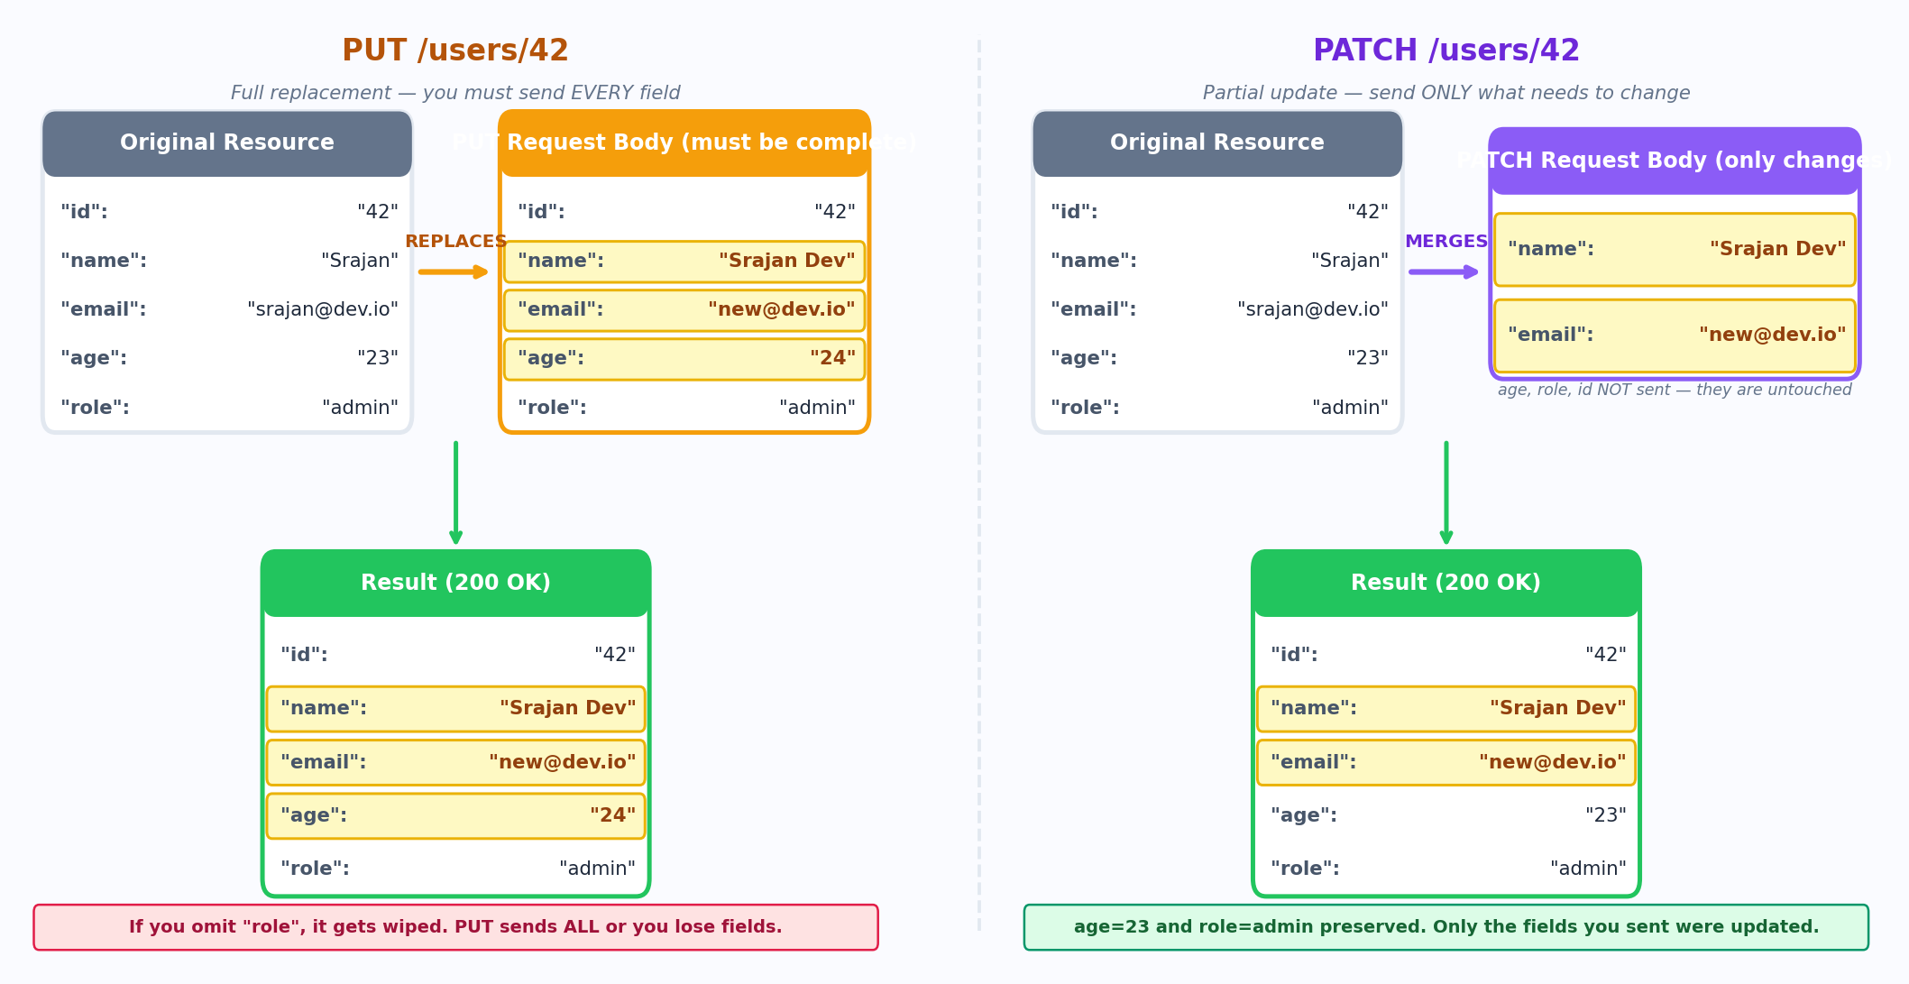
This is the most commonly confused distinction in REST APIs. The confusion comes from both methods being used for "update" operations, but their semantics are fundamentally different.

Figure 4 — PUT performs full replacement; PATCH performs a targeted merge

The Core Semantic Difference
PUT says: "This is the new complete state of the resource. Replace everything." PATCH says: "Here are the specific changes. Apply them. Leave everything else alone."
Property | PUT | PATCH
Sends | Complete resource representation | Only the fields that change
Missing fields | Wiped — replaced with nothing/default | Preserved — untouched
Idempotent | Yes — guaranteed by spec | Not guaranteed — depends on patch format
Bandwidth | Full payload every time | Minimal — only the diff
Use when | Client owns the full resource state | Partial, targeted field update
Atomicity | Full replacement is atomic | json-patch supports test-and-patch
RFC | RFC 9110 | RFC 5789

When to choose which
Use PUT when:
- You are implementing a configuration update — the client always sends the full config object.
- You want upsert semantics — PUT /feature-flags/dark-mode creates or replaces.
- You need guaranteed idempotency for retry-safe operations.

Use PATCH when:
- Clients only know the fields they want to change (e.g., changing display name without knowing other profile fields).
- The resource is large and sending it fully on every update is wasteful.
- You are building a mobile app where bandwidth is a constraint.
- You need atomic "test then update" semantics via json-patch operations.

Decision rule
Rule of thumb: If your client must fetch the resource first before updating it (to fill in the fields it is not changing), you should be using PATCH. If your client already holds the full representation and is simply persisting it, use PUT.

7. OPTIONS Method & CORS — In Depth

OPTIONS  Discover capabilities | Describes the communication options available for the target resource. The browser uses this for CORS preflight.

Safe | Yes — purely informational, no state change
Idempotent | Yes
Request Body | Optional — rarely used outside CORS context
Response Body | List of allowed methods (Allow header), or CORS headers
Cacheable | Yes — via Access-Control-Max-Age for CORS preflights
Status Codes | 200 OK or 204 No Content

Two uses of OPTIONS
OPTIONS has two distinct use cases that are often conflated:
- Manual capability discovery: a client sends OPTIONS /* or OPTIONS /endpoint to learn what methods the server supports. Response contains Allow: GET, POST, PUT, and DELETE.
- CORS preflight: the browser automatically sends OPTIONS before a cross-origin request that meets certain criteria. This is the dominant real-world use.

What is CORS?
CORS — Cross-Origin Resource Sharing — is a browser-enforced security mechanism built on top of the Same-Origin Policy (SOP). The SOP is a security rule that prevents a script running on https://app.com from reading responses from https://api.otherdomain.com. Without SOP, a malicious site could make authenticated requests to your bank using your cookies.
CORS is the relaxation mechanism — a way for servers to explicitly declare which origins they trust. It is entirely a browser concern. curl, Postman, and server-to-server calls are never subject to CORS.
Critical misconception to eliminate
CORS is enforced by the browser, not the server. The server always receives and processes the request. CORS only controls whether the browser exposes the response to the JavaScript that made the request.

When does a preflight fire?
The browser fires a preflight OPTIONS request before the actual request if any of these conditions are true:
- Method is not GET, POST, or HEAD.
- Content-Type is not one of: application/x-www-form-urlencoded, multipart/form-data, text/plain.
- The request includes custom headers (e.g., Authorization, X-Custom-Header).

Requests that do NOT trigger a preflight are called simple requests — a plain form POST or a GET with no custom headers. Simple requests go directly to the server, but the browser still checks the ACAO header on the response before exposing data to JS.

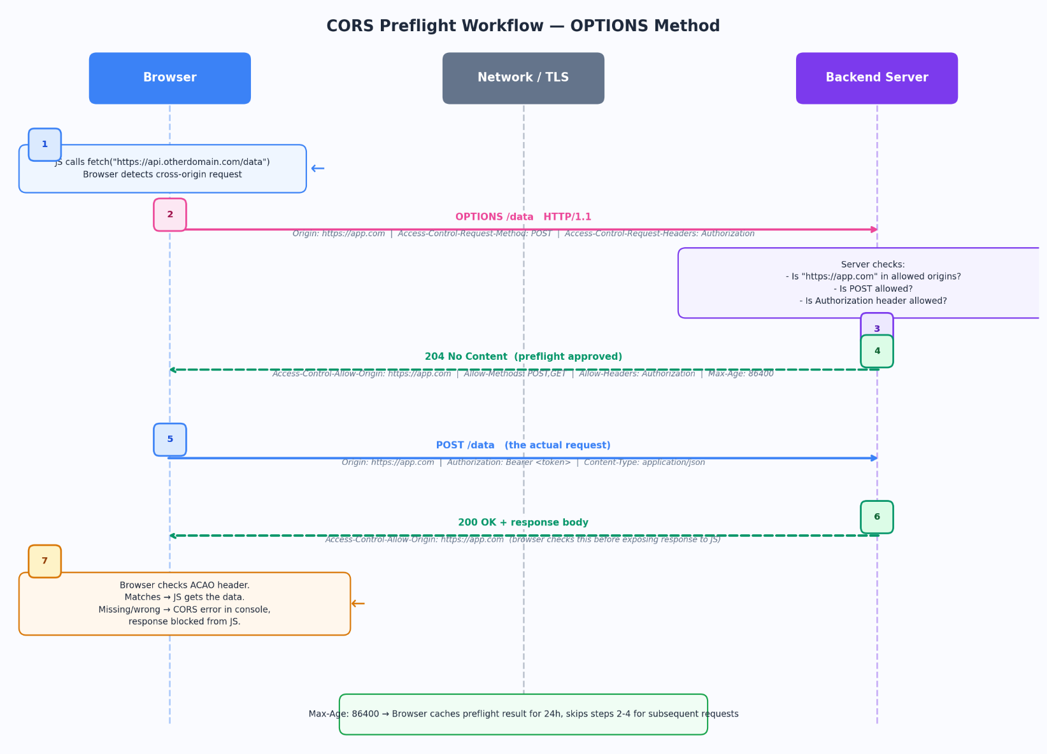
The Full CORS Preflight Workflow

Figure 5 — Complete CORS preflight sequence from browser fetch() to server response to JS access

CORS Response Headers — Explained
Header | Purpose & Values
Access-Control-Allow-Origin | Specifies which origin(s) can read the response. Either a single origin ("https://app.com") or "*" for any origin. Wildcard cannot be used with credentialed requests (cookies/auth headers).
Access-Control-Allow-Methods | Comma-separated list of HTTP methods the browser is permitted to use in the actual request. e.g., GET, POST, PUT, DELETE, PATCH.
Access-Control-Allow-Headers | Which request headers the browser is allowed to send. If the client sends Authorization, the server must list it here or the preflight fails.
Access-Control-Allow-Credentials | Set to "true" to allow cookies, Authorization headers, and TLS client certificates to be sent cross-origin. Requires ACAO to be a specific origin, not *.
Access-Control-Expose-Headers | By default, browsers only expose 7 "safe" response headers to JS. Use this to whitelist additional response headers that JS should be able to read.
Access-Control-Max-Age | Seconds the browser should cache the preflight result. During this period, repeat requests skip the OPTIONS step entirely. Max is browser-dependent (Chrome caps at 7200s).

Credentialed Requests
By default, cross-origin fetch/XHR does not send cookies or Authorization headers. To include them:
- Client: set credentials: "include" in fetch options.
- Server: respond with Access-Control-Allow-Credentials: true AND a specific (non-wildcard) ACAO header.
- If either side is missing, the browser blocks the response from JS.

Common CORS Errors and Their Causes
Error | Root Cause
No ACAO header on response | Server never set Access-Control-Allow-Origin. The most common cause.
ACAO is * but credentials: include | Wildcard + credentials is forbidden by spec. Use specific origin.
Preflight returns 404/405 | Server has no route for OPTIONS requests. Add an OPTIONS handler or configure your framework to auto-respond.
Missing header in Allow-Headers | Client sent a header (e.g. X-Request-ID) not listed in ACAO-Allow-Headers. Preflight fails.
Origin mismatch (http vs https) | http://app.com and https://app.com are different origins. Protocol is part of the origin.

Security note
CORS is a browser-only guard. Your server should not rely on CORS as a security layer. CORS simply controls browser script access. Implement authentication and authorization independently.

References
RFC 9110 — HTTP Semantics | RFC 5789 — PATCH | RFC 7396 — Merge Patch | RFC 6902 — JSON Patch | Fetch Living Standard (WHATWG CORS specification)

