HTTP
STATUS CODES
Everything from 100 to 511 — explained in plain language
with real examples, interview tips, and the reasoning behind each code.
1xx | 2xx | 3xx | 4xx | 5xx

1. What is an HTTP Status Code?
Every time your browser or app talks to a server, the server has to reply. And when it replies, the very first thing it sends back is a three-digit number. That number is the HTTP status code.
Think of it like a conversation. You ask someone a question — they can say "sure, here you go", "sorry, you got the wrong address", "I'm not telling you that", or "I crashed, give me a second." Status codes are the server doing exactly that — giving you a standardized, machine-readable answer about what happened with your request.
The three-digit format is intentional. The first digit always tells you the category of the response. The last two digits give you the specific situation within that category. So even if you've never seen a particular code before, knowing the first digit already tells you half the story.
Status codes are defined in RFC 9110 (the HTTP specification). They are a contract between client and server — both sides agree on what each number means so they can communicate without ambiguity.

2. The Five Classes at a Glance
Before diving into individual codes, you need to internalize the five families. Everything else is just a variation within these five themes.
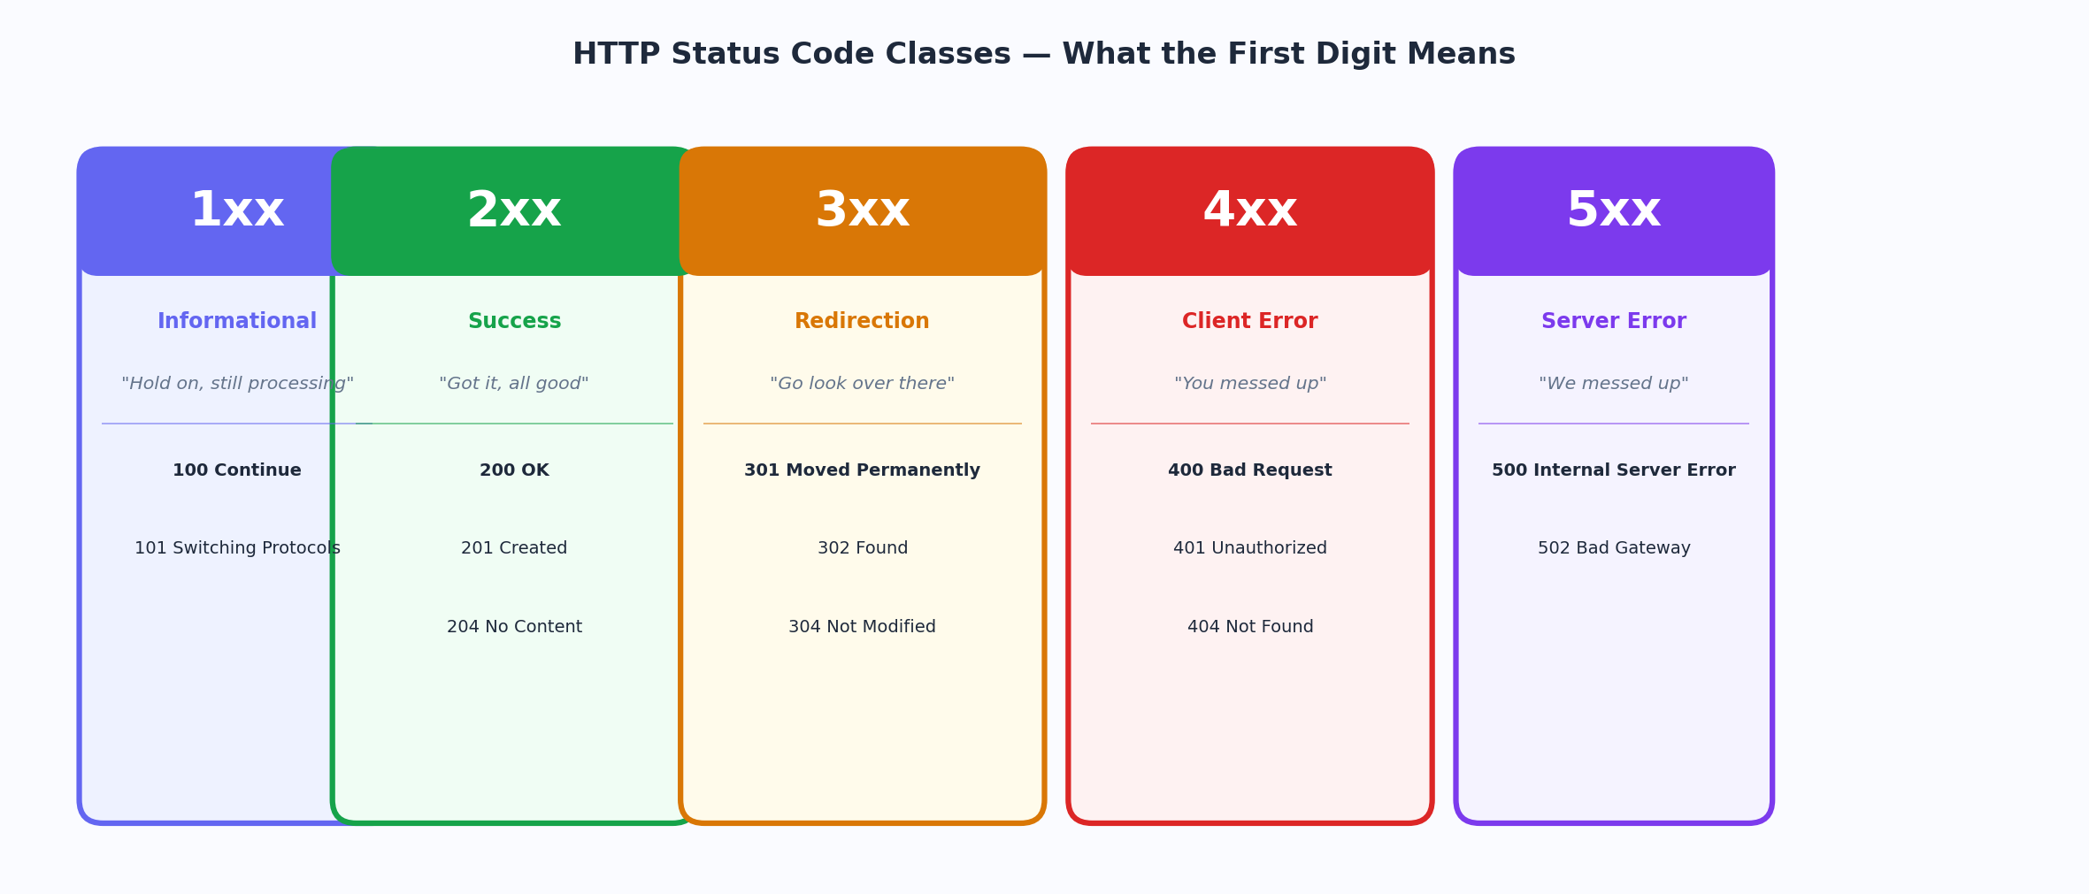
Figure 1 — The five HTTP status code classes and their plain-English meaning

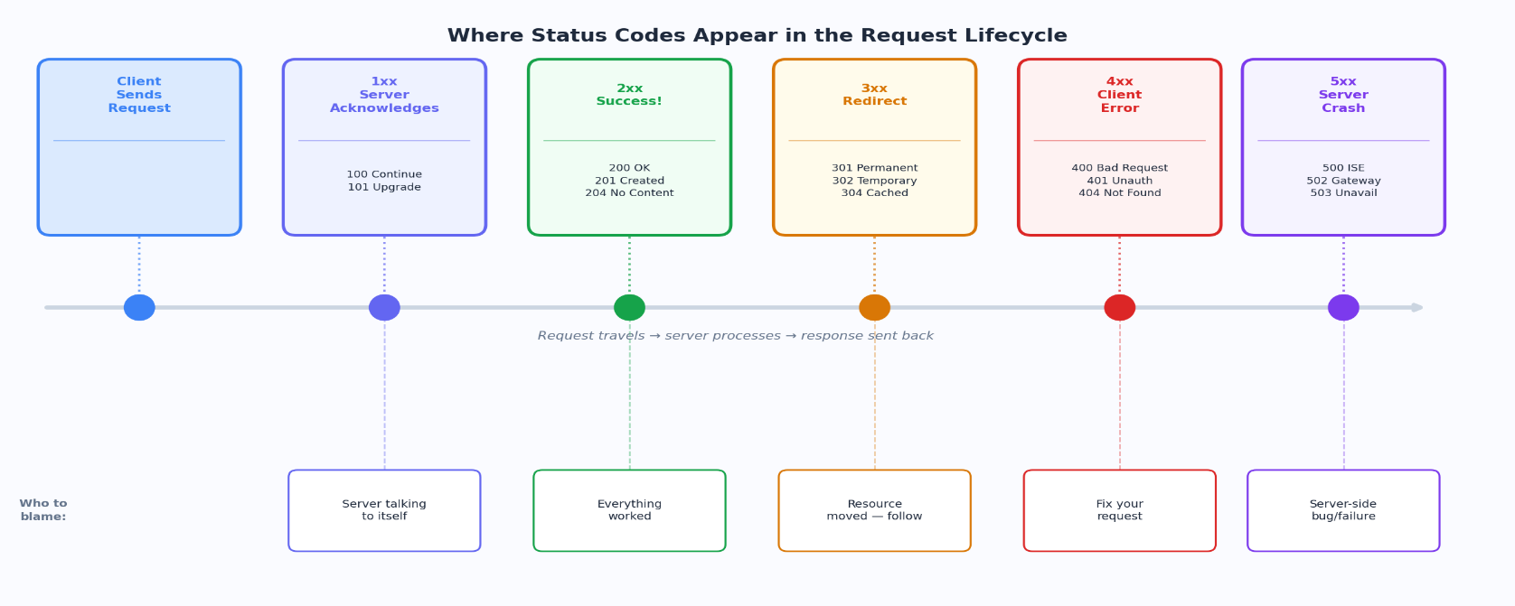
Figure 2 — Where each status class appears in the request-response lifecycle

Interview tip
If an interviewer says "what does a 4xx mean?", never just say "error". Say: "A 4xx means the client sent something wrong — the request itself has a problem, and fixing it on the server side won't help. The client needs to change something about what it sent."

3. 1xx — Informational
1xx  Informational | The server is saying "I received your request and I'm still working on it." These are interim responses — the actual response comes later. You will rarely deal with these in day-to-day API work.

The 1xx class is the quietest of the five. In most normal HTTP interactions, you never see a 1xx response at all — they exist for specific protocol upgrade or streaming scenarios. But they're worth knowing because they show up in WebSocket connections and file upload flows.

100 — Continue
Imagine you're about to upload a large file. Before you waste time sending 500MB, you ask the server: "Hey, will you even accept this?". The server replies with 100 Continue — meaning "yes, go ahead and send the body." Without this handshake, you might send a massive file only to get a 401 Unauthorized back, wasting all that bandwidth.
The client triggers this by sending the header Expect: 100-continue before the body. The server responds 100, and then the client sends the actual data.

101 — Switching Protocols
This is the handshake that upgrades an HTTP connection to WebSocket. When your frontend calls new WebSocket("wss://api.example.com/ws"), the browser first sends a standard HTTP request with the header Upgrade: websocket. The server replies with 101 Switching Protocols — and from that point on, the connection is no longer HTTP. It's WebSocket. Real-time chat, live notifications, multiplayer games — 101 is the gateway.
Code | Name | What it means
102 | Processing (WebDAV) | Server is processing a complex request that may take time. Prevents the client from timing out.
103 | Early Hints | Server sends preliminary headers (like Link: preload) before the final response, letting the browser start loading resources earlier.

4. 2xx — Success
2xx  Success | The request was received, understood, and accepted. Everything worked. These are the responses you want to see. But "success" doesn't mean the same thing for every operation — there are important distinctions within this class.

The 2xx class is your green light. But each code within it communicates something slightly different about what succeeded. A 200 means "here's your data". A 201 means "I created something new". A 204 means "it worked but I have nothing to give you back". Choosing the right 2xx code is part of designing a good API.
200 OK
Plain English | "Your request worked perfectly. Here's what you asked for."
Technical | The request succeeded. The response body contains the requested resource or the result of the operation. This is the default success response.
Where You See It | GET request returning data, PUT/PATCH returning the updated resource, login endpoint returning a token.
Real Example | GET /users/42 → 200 OK + { "id": 42, "name": "Srajan" }  POST /login → 200 OK + { "token": "eyJ..." }

201 Created
Plain English | "I created a new resource for you. Here's where you can find it."
Technical | A new resource was successfully created. The server SHOULD include a Location header pointing to the URL of the new resource. The body usually contains the created resource.
Where You See It | POST /users creates a new user. POST /orders creates a new order. POST /posts creates a new blog post.
Real Example | POST /users → 201 Created  Location: /users/99  Body: { "id": 99, "name": "Srajan" }
Note | If a POST creates something, return 201, not 200. This tells the client something new was born, not just that the operation completed. Most developers incorrectly return 200 for creation.

202 Accepted
Plain English | "I've received your request and queued it for processing, but I haven't done it yet."
Technical | The request was accepted for processing but the processing has not been completed — and may not ever complete (it could fail later). This is used for asynchronous operations.
Where You See It | Sending a mass email campaign, generating a large report, processing a video upload. The action takes time so you queue it and reply immediately.
Real Example | POST /emails/send-campaign → 202 Accepted  Body: { "jobId": "abc123", "status": "queued" }  GET /jobs/abc123 → 200 OK + { "status": "processing" }
Note | Always return a way for the client to check status — a job ID, a polling URL, or a webhook. 202 without a follow-up mechanism is frustrating to work with.

204 No Content
Plain English | "It worked, but I have nothing to send back. Don't expect any content."
Technical | The request succeeded but the server intentionally returns no body. Spec forbids a body with 204. Used for operations where the result is self-evident from the action.
Where You See It | DELETE requests (you deleted it — what would I even send back?), PUT/PATCH when you don't want to re-send the full object, logout endpoints.
Real Example | DELETE /users/42 → 204 No Content (no body)  PUT /settings → 204 No Content (saved, nothing to return)
Note | If your response body is empty, don't send 200 with an empty body — send 204. It's more honest and avoids clients trying to parse nothing.

Code | Name | What it means
206 | Partial Content | Used for range requests — client asked for bytes 0-999 of a file, server returns just that chunk. Powers video scrubbing and download resumption.
207 | Multi-Status | WebDAV response containing multiple independent operation outcomes in the body (one request, multiple results).
208 | Already Reported | WebDAV — used inside 207 to avoid listing the same resource twice.
226 | IM Used | The server returned a delta (diff) of the resource using Instance Manipulation (a rarely used HTTP extension).

5. 3xx — Redirection
3xx  Redirection | The resource you're looking for is somewhere else. The client needs to take additional action to complete the request — usually follow a new URL. The Location header tells the client where to go.

Redirects are everywhere on the web. When a company moves their website, when you get sent to the login page before accessing a dashboard, when your browser reuses a cached file — all of that is 3xx in action. The key thing to understand is that there are permanent redirects and temporary redirects, and choosing the wrong one has real consequences for SEO, browser caching, and user experience.
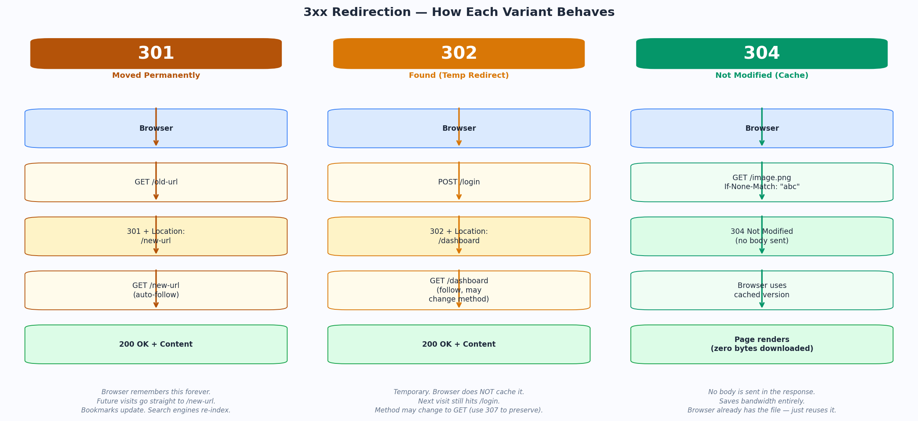
Figure 3 — How 301, 302, and 304 each behave differently in the browser

301 Moved Permanently
Plain English | "This resource has moved to a new address forever. Update your bookmarks."
Technical | The resource has permanently moved to the URL in the Location header. Browsers cache this redirect indefinitely — future requests go directly to the new URL without even asking the old one. Search engines transfer SEO ranking to the new URL.
Where You See It | Domain migration (http → https), URL restructuring (/blog/post-name instead of /post?id=5), merging duplicate pages.
Real Example | GET /blog/old-url → 301 Moved Permanently  Location: https://example.com/blog/new-url  (Browser auto-follows and caches this forever)
Note | Once a browser caches a 301, it will SKIP your old URL entirely on future visits. There's no way to "un-cache" it on user machines. Use 302 during testing, 301 only when you're certain.

302 Found (Temporary Redirect)
Plain English | "The resource is temporarily at a different address. Come back here next time."
Technical | The resource is temporarily at the URL in Location. The browser follows the redirect but does NOT cache it — next request will come to the original URL again. Method may change to GET (this is the historical browser behavior).
Where You See It | Post/Redirect/Get pattern after form submission, login redirect to dashboard, A/B testing redirects, maintenance pages.
Real Example | POST /login → 302 Found  Location: /dashboard  (Browser follows to /dashboard with GET)  (Next visit to /login still goes to /login — not cached)
Note | When you POST a form and the server returns 302, the browser follows with a GET. This is the Post/Redirect/Get pattern — it prevents "resubmit form?" popups on page refresh.

304 Not Modified
Plain English | "You already have the latest version. Use your cached copy — I'm not sending it again."
Technical | The client sent a conditional request (If-None-Match or If-Modified-Since). The resource has not changed, so the server returns 304 with no body, and the browser uses its cached version.
Where You See It | Static assets (images, JS, CSS) on websites. The browser caches them and checks if they've changed on revisit. This is how CDNs save enormous bandwidth.
Real Example | GET /logo.png If-None-Match: "abc123"  → 304 Not Modified (no body, zero bytes)  (Browser renders cached /logo.png)
Note | 304 has NO body — the spec forbids it. The whole point is that the client already has the content. This is one of the biggest bandwidth-saving mechanisms in HTTP.

Code | Name | What it means
303 | See Other | After a POST, redirect the client to GET another resource. Semantically cleaner than 302 for the Post/Redirect/Get pattern.
307 | Temporary Redirect | Like 302 but GUARANTEES the method stays the same. A POST redirected with 307 stays a POST (unlike 302 which browsers may change to GET).
308 | Permanent Redirect | Like 301 but GUARANTEES the method stays the same. The permanent version of 307.

Interview tip
301 vs 302 is a classic interview question. The key points: 301 is permanent and cached by browsers (SEO juice transfers), 302 is temporary and never cached (next visit still hits original URL). Also know 307 vs 302: 307 preserves the HTTP method, 302 may change POST to GET.

6. 4xx — Client Errors
4xx  Client Error | The server received your request just fine — but there was something wrong with what you sent. This is the client's fault. The fix must come from the client side. The server is working correctly.

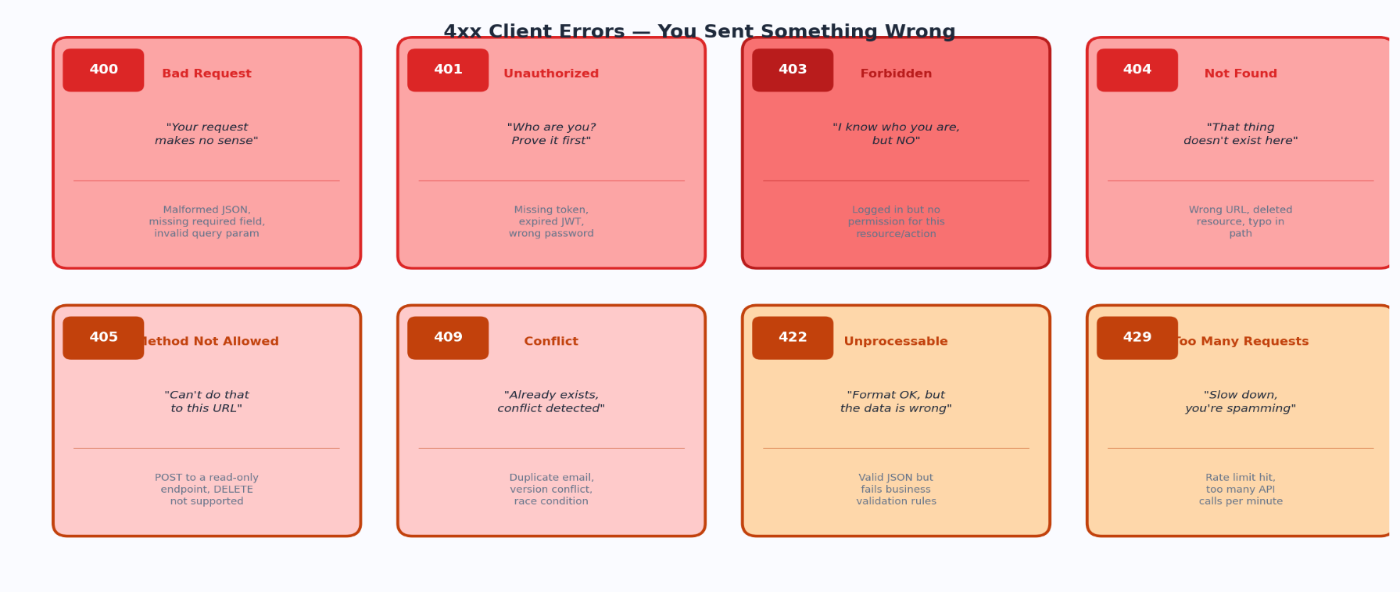
4xx errors are the most common type of error you'll deal with as a backend developer — because you're writing the server that returns them and the client that triggers them. The critical mental model here is: 4xx = client did something wrong. 5xx = server did something wrong. Don't confuse them. Returning a 500 when the user sent bad data is incorrect API design.

Figure 4 — The eight most important 4xx errors and their plain-English meaning

400 Bad Request
Plain English | "I can't understand what you're asking. Your request is malformed."
Technical | The server cannot process the request because the client sent something syntactically wrong. Malformed JSON, missing a required field, invalid query parameter type, request too large.
Where You See It | Sending invalid JSON in the body, missing a required field like "email" in a registration form, sending a string where a number is expected.
Real Example | POST /users Body: { name: "Srajan" } // missing "email" field  → 400 Bad Request  Body: { "error": "email is required" }
Note | 400 is the generic "your request is broken" response. Use it when you can't understand the request at all. For requests that are valid but fail business rules, prefer 422.

401 Unauthorized
Plain English | "I don't know who you are. You need to prove your identity first."
Technical | The request lacks valid authentication credentials. The server doesn't know who is making the request. It should return a WWW-Authenticate header telling the client how to authenticate.
Where You See It | Accessing a protected API without a token, sending an expired JWT, sending the wrong API key.
Real Example | GET /api/profile // No Authorization header  → 401 Unauthorized  WWW-Authenticate: Bearer realm="api"  Body: { "error": "authentication required" }
Note | The name "Unauthorized" is historically misleading — it should have been called "Unauthenticated". You haven't proved who you are yet. Once you authenticate, you might still get a 403.

403 Forbidden
Plain English | "I know exactly who you are — you just don't have permission to do this."
Technical | The server understood the request and knows who the client is (authenticated), but refuses to authorize the action. No WWW-Authenticate header is returned because authentication won't help.
Where You See It | Logged-in user trying to access another user's data, a regular user trying to hit an admin endpoint, trying to delete a resource you don't own.
Real Example | DELETE /users/99 Authorization: Bearer <valid-token-for-user-42>  → 403 Forbidden  Body: { "error": "you can only delete your own account" }
Note | Logging in again will NOT fix a 403. The problem is permissions, not identity. This is the key difference between 401 and 403.

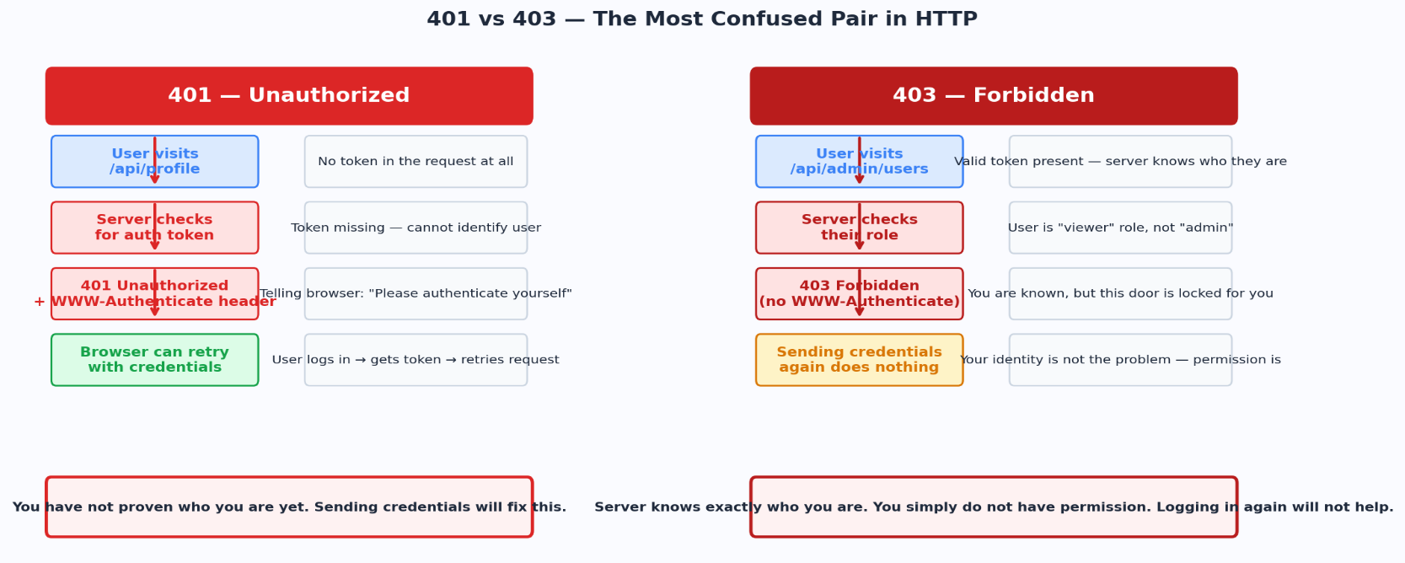
Figure 5 — 401 vs 403: the most commonly confused pair in HTTP

Interview tip
401 vs 403 is the most common status code interview question. Nail this: 401 = "who are you?" (authentication problem — fix it by sending credentials). 403 = "I know who you are, but no" (authorization problem — credentials won't help, you need more permissions).

404 Not Found
Plain English | "Whatever you're looking for doesn't exist here — at least not that I know of."
Technical | The server cannot find the requested resource. The URL doesn't match anything the server knows about. This could be because the resource never existed, or was deleted.
Where You See It | Visiting a URL that doesn't exist, accessing /users/9999 when user 9999 doesn't exist, a typo in an API endpoint URL.
Real Example | GET /users/9999 → 404 Not Found  GET /api/v1/prodcuts → 404 Not Found (typo: prodcuts)  GET /blog/deleted-post → 404 Not Found
Note | 404 can also be returned intentionally to hide that a resource exists. For example, if a user asks for /users/42 but doesn't have permission to see it, you might return 404 instead of 403 to not leak that user 42 exists.

405 Method Not Allowed
Plain English | "You can't use that HTTP method on this URL. The URL exists, but not for that action."
Technical | The request method is known but not allowed for the target resource. The response MUST include an Allow header listing the permitted methods.
Where You See It | Sending a DELETE to a read-only endpoint, trying to POST to a URL that only accepts GET, using PATCH on an endpoint that only supports PUT.
Real Example | DELETE /api/config → 405 Method Not Allowed  Allow: GET, PUT

409 Conflict
Plain English | "The request conflicts with the current state of the server. There's a collision."
Technical | The request cannot be completed because it conflicts with the current state of the resource. Common in scenarios involving uniqueness constraints, optimistic locking, or concurrent writes.
Where You See It | Trying to register with an email that already exists, editing a resource that was already modified by someone else (version conflict), trying to create a username that's taken.
Real Example | POST /users Body: { "email": "taken@example.com" }  → 409 Conflict  Body: { "error": "email already registered" }

422 Unprocessable Entity
Plain English | "Your request was formatted correctly, but the data inside it fails our rules."
Technical | The request is syntactically valid (not a 400) but semantically wrong. The server understands the content type and can parse the body, but the data fails business validation.
Where You See It | Sending valid JSON but with an age of -5, sending a future expiry date for a credit card, a password that doesn't meet complexity rules, a date range where end is before start.
Real Example | POST /users Body: { "email": "valid@email.com", "age": -5 }  → 422 Unprocessable Entity  Body: { "errors": [{ "field": "age", "message": "must be positive" }] }
Note | 400 vs 422: use 400 when the request format is broken (can't even parse it). Use 422 when you parsed it fine but the data violates your rules. 422 is the better choice for form validation errors.

429 Too Many Requests
Plain English | "You're sending too many requests too quickly. Slow down."
Technical | The user has sent too many requests in a given amount of time — rate limiting. The response should include a Retry-After header indicating when the client can try again.
Where You See It | API rate limits (100 requests/minute), brute force protection on login endpoints, DDoS mitigation.
Real Example | POST /api/search → 429 Too Many Requests  Retry-After: 60  X-RateLimit-Limit: 100  X-RateLimit-Remaining: 0

Code | Name | What it means
406 | Not Acceptable | Server cannot produce a response matching the Accept header. Client asked for XML, server only does JSON.
407 | Proxy Auth Required | Like 401 but the proxy between client and server requires authentication.
408 | Request Timeout | Server waited too long for the client to send the full request body and gave up.
410 | Gone | Like 404 but the server KNOWS the resource existed and was permanently deleted. Tells crawlers to remove it from indexes.
411 | Length Required | Request is missing the Content-Length header, which this server requires.
412 | Precondition Failed | A conditional header (If-Match, If-Unmodified-Since) evaluated to false — optimistic concurrency control failure.
413 | Content Too Large | Request body exceeds the server's size limit. Uploading a file that's too big.
414 | URI Too Long | The URL is longer than the server will process. Often from an infinite redirect loop.
415 | Unsupported Media Type | The Content-Type of the request body is not supported. Sending XML to a JSON-only endpoint.
416 | Range Not Satisfiable | The Range header in the request is outside the bounds of the file.
418 | I'm a Teapot | An April Fool's joke from 1998 (RFC 2324). The server refuses to brew coffee because it is a teapot. Still valid in the spec.
423 | Locked | The resource is locked (WebDAV). Can't modify until the lock is released.
425 | Too Early | Server unwilling to process a request that might be replayed (TLS Early Data).
426 | Upgrade Required | Client must upgrade to a different protocol (e.g., TLS) before the server will respond.
428 | Precondition Required | Server requires the request to be conditional (must include If-Match) to prevent lost updates.
431 | Request Header Too Large | Request headers are too large for the server to process. Common with massive cookie payloads.
451 | Unavailable For Legal Reasons | Content unavailable due to a legal demand (court order, DMCA). Named after Fahrenheit 451.

7. 5xx — Server Errors
5xx  Server Error | The server knows it failed. The request was valid — the client did nothing wrong. Something on the server side broke. The fix must come from the server side.

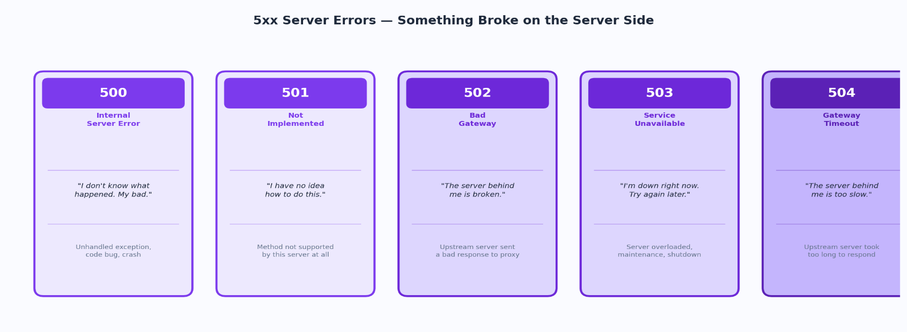
5xx errors are what you never want to return and always want to monitor. When your server returns a 5xx, it's telling the client: "you did nothing wrong, I'm the one who's broken." These are the errors that wake up on-call engineers at 3am. The client can't fix them — you have to.

Figure 6 — The five core 5xx server error codes and what causes each one

500 Internal Server Error
Plain English | "Something went wrong on our end and we don't want to expose the details."
Technical | The generic catch-all for server errors. Something unexpected happened that the server didn't know how to handle. It intentionally gives no details — exposing internal error messages would be a security risk.
Where You See It | Unhandled exceptions in code, division by zero, null pointer, database query fails unexpectedly, a bug in your business logic.
Real Example | GET /api/orders // Server throws unhandled exception in code  → 500 Internal Server Error  Body: { "error": "something went wrong" }  (actual error is logged server-side, not exposed to client)
Note | Never send the actual exception message or stack trace to the client. Log it server-side and return a generic 500. Stack traces reveal your code structure to attackers.

502 Bad Gateway
Plain English | "The server I'm proxying for gave me a broken response. It's not my fault."
Technical | A server acting as a gateway or proxy received an invalid response from an upstream server. Your Nginx or load balancer got a garbage response from your Node.js app and couldn't forward anything sensible.
Where You See It | Your Node.js app crashes — Nginx returns 502 to the client. Microservice A calls microservice B, but B is returning malformed responses.
Real Example | Client → Nginx (proxy) → Node.js app (crashed)  ← (no valid response from Node)  Client ← 502 Bad Gateway (from Nginx)
Note | 502 vs 503: 502 means the upstream server gave a bad response. 503 means the upstream server is unreachable/down. Both are gateway problems, but the cause is different.

503 Service Unavailable
Plain English | "I'm currently unable to handle requests. I'm either overloaded or down for maintenance."
Technical | The server is temporarily unable to handle the request — overloaded or down for maintenance. The response should include a Retry-After header so clients know when to try again.
Where You See It | Server is overloaded with too many requests, scheduled maintenance window, deployment in progress, database is down and all requests fail.
Real Example | GET /api/data // Server is at capacity  → 503 Service Unavailable  Retry-After: 120  Body: { "error": "service temporarily unavailable" }
Note | 503 is the correct response for planned maintenance. Set a Retry-After header. Monitoring systems and clients will respect it and back off instead of hammering the server.

504 Gateway Timeout
Plain English | "I'm a proxy and the server behind me took too long to respond. I gave up waiting."
Technical | The server acting as a gateway or proxy didn't receive a timely response from an upstream server. Like 502 but specifically a timeout rather than a bad response.
Where You See It | Nginx waiting for a slow database query, a microservice waiting too long for another microservice, a request hitting a lambda that exceeds its time limit.
Real Example | Client → API Gateway → Lambda function (timeout after 29s)  ← (no response before timeout)  Client ← 504 Gateway Timeout (from API Gateway)
Note | 502 = got a bad response. 504 = got no response (timed out). Both happen at the proxy/gateway layer.

Code | Name | What it means
501 | Not Implemented | The server does not support the functionality required to fulfill the request. The HTTP method is not recognized or implemented.
505 | HTTP Version Not Supported | The server does not support the HTTP version used in the request.
507 | Insufficient Storage | The server cannot store the representation needed to complete the request (WebDAV). Disk full.
508 | Loop Detected | Infinite loop detected while processing a WebDAV request.
510 | Not Extended | Further extensions to the request are required for the server to fulfill it.
511 | Network Auth Required | The client needs to authenticate to gain network access. Common on captive portals (hotel WiFi login pages).

8. Choosing the Right Code — The Decision Guide
One of the most common mistakes junior backend developers make is returning the wrong status code — usually 200 for everything, or 500 when the client sent bad data. Here's a simple decision flow.
Situation | Return This
GET request, resource found and returned | 200 OK + body
POST request created a new resource | 201 Created + Location header
Action succeeded, nothing to return | 204 No Content
Action queued/async — not done yet | 202 Accepted + job ID
Client sent malformed/unparseable request | 400 Bad Request
Client sent parseable but invalid data (validation) | 422 Unprocessable Entity
No credentials provided at all | 401 Unauthorized
Valid credentials, but no permission | 403 Forbidden
Resource does not exist at this URL | 404 Not Found
Resource existed but was deleted permanently | 410 Gone
Wrong HTTP method for this URL | 405 Method Not Allowed
Resource with that unique value already exists | 409 Conflict
Client is hitting the API too fast | 429 Too Many Requests
Unhandled exception in server code | 500 Internal Server Error
Server temporarily overloaded or in maintenance | 503 Service Unavailable
Proxy timeout waiting for upstream server | 504 Gateway Timeout

9. Interview Cheat Sheet
These are the distinctions interviewers love to ask about. Know these cold.
The pairs that always come up in interviews
401 vs 403: 401 = not authenticated (prove who you are). 403 = authenticated but not authorized (you're known but not allowed).
400 vs 422: 400 = can't even parse your request. 422 = parsed fine, but your data breaks the rules.
301 vs 302: 301 = permanent (browsers cache it, SEO transfers). 302 = temporary (never cached).
302 vs 307: Both temporary redirects. 302 may change POST to GET. 307 preserves the original method.
404 vs 410: 404 = might exist, might not. 410 = definitely existed, definitely deleted.
502 vs 503: 502 = got a bad response from upstream. 503 = server is down/overloaded entirely.
502 vs 504: 502 = upstream sent garbage. 504 = upstream didn't respond in time (timeout).
200 vs 201 vs 204: 200 = success with body. 201 = created new resource. 204 = success, no body.

References: RFC 9110 (HTTP Semantics) · RFC 7235 (HTTP Authentication) · IANA HTTP Status Code Registry · MDN Web Docs

