HTTP
CACHING
How browsers, CDNs, and proxies remember responses so they
never have to ask the server the same question twice.
Cache-Control | ETags | Freshness | Vary | Busting | Validation

1. What is HTTP Caching?
Here is the simplest way to think about it: every time your app asks the server for something, the server has to think, look it up, compute something, and send it back. That takes time and costs resources. Now imagine you ask the server for the exact same thing a thousand times in a row. Wouldn't it be smarter to just remember the first answer and reuse it?
That's exactly what HTTP caching does. It lets certain parts of the network — your browser, a CDN, a proxy server — store a copy of a response so they can serve it again later without bothering the origin server. The stored copy is called a cached response. The act of serving the stored copy instead of hitting the server is a cache hit. And the mechanism for deciding what to store, how long, and when to throw it away — that's what this whole document is about.
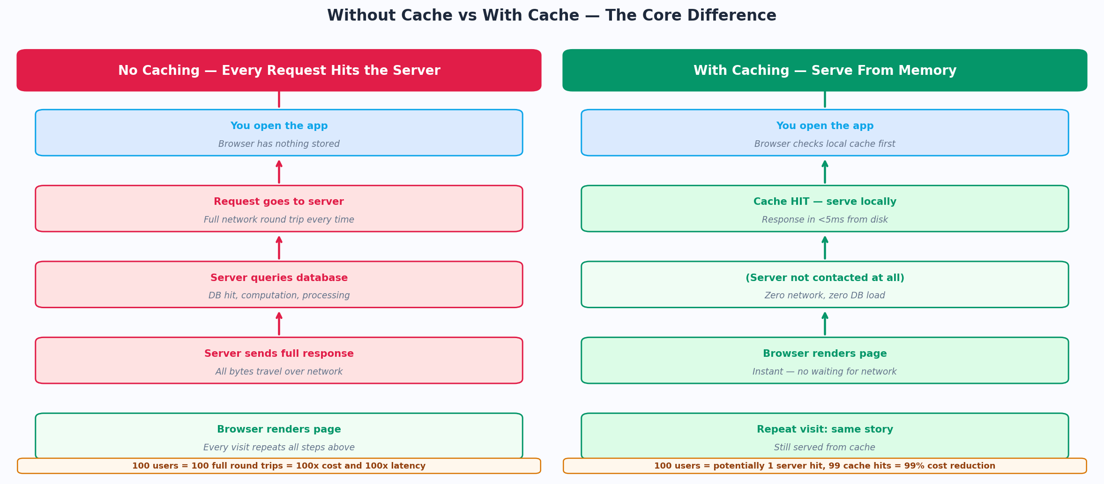
Figure 1 — The difference between serving every request from the origin vs serving from cache

Think of it like this
Think of a cache like a post-it note on your desk. Instead of walking to the filing cabinet every time you need someone's phone number, you wrote it down once. The post-it is the cache. The phone number is the response. The filing cabinet is the server.

Why does this matter for backend engineers?
Because you are the one writing the code that sends the headers that tell browsers and CDNs how to cache your responses. If you get those headers wrong, you end up with one of two problems:
- Too aggressive caching: users see stale, outdated content even after you've pushed an update. Frustrating and sometimes embarrassing.
- Too little caching: your server gets hammered with requests it's already answered, your response times are slow, and your infrastructure costs are high.

Getting caching right is one of the highest-leverage things you can do as a backend engineer. A well-cached API can handle 10x the traffic with zero additional servers.
Interview tip
If an interviewer asks "what is caching?", go beyond "storing responses". Say: "Caching is a mechanism to reduce latency and server load by storing copies of HTTP responses at intermediate points — browser, CDN, or proxy — and serving those copies for subsequent identical requests, with the origin server controlling freshness via headers."

2. Where Does Caching Happen?
Caching doesn't happen in just one place. There's a whole chain of systems between the user's browser and your server, and any of them can hold a cached copy of a response. Understanding each layer is important because different directives control different layers.
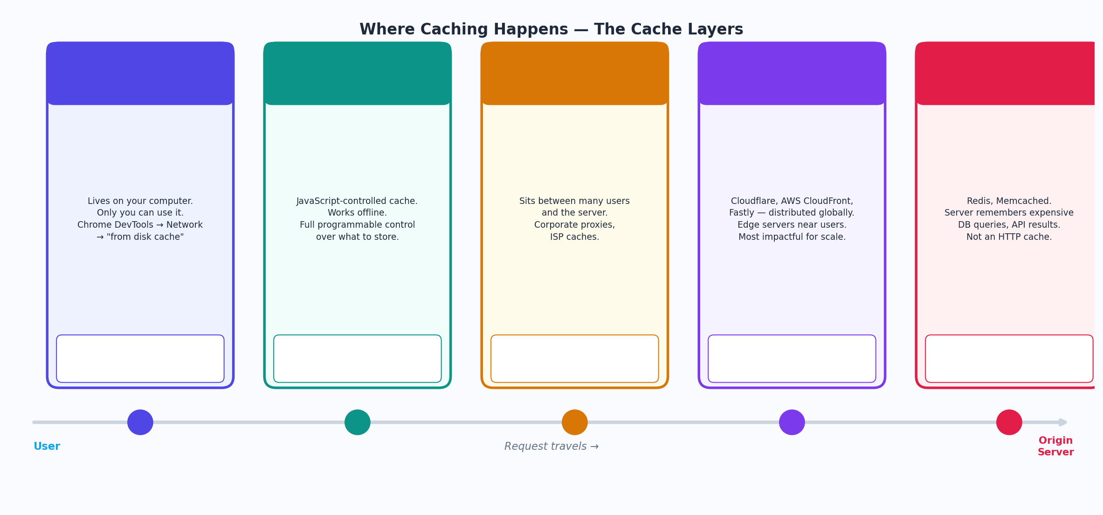
Figure 2 — The five cache layers, from browser to origin server

Browser Cache (Private Cache)
This lives on your computer — literally in a folder on your hard drive. Only you can use it. When Chrome says "from disk cache" in the Network tab, that's the browser cache serving the response without even touching the network. It is the fastest possible cache hit because nothing travels anywhere.
You control what goes into the browser cache using the Cache-Control and Expires headers. The private directive ensures only the browser stores it — not shared caches like CDNs.

CDN Cache (Shared Cache)
CDNs like Cloudflare, AWS CloudFront, and Fastly are distributed networks of servers placed geographically close to users all over the world. When a user in Mumbai requests your API, instead of the request traveling all the way to your server in the US, the nearest CDN edge node (maybe 5ms away instead of 200ms) can serve the cached response.
This is the most impactful cache layer for performance at scale. A CDN cache hit means your origin server sees zero traffic for that resource. The s-maxage directive specifically controls CDN cache duration while leaving browser cache duration intact.

Proxy / Shared Cache
Corporate networks, ISPs, and gateway proxies also cache responses. These are shared caches — one cached copy is served to all users going through that proxy. They respect the public directive. If you mark a response private, these shared caches will ignore it entirely.

Server-Side Cache (Redis / Memcached)
Not technically an HTTP cache, but worth mentioning. Redis and Memcached sit on the server side and cache expensive database queries or computed results. Your application checks Redis before hitting the database. This is application-level caching controlled by your code, not HTTP headers. But it works hand-in-hand with HTTP caching — together they form a complete caching strategy.
Remember
The key difference: browser cache = private, only you. CDN/proxy = shared, everyone gets the benefit. This distinction drives many of the Cache-Control directive choices.

3. Cache-Control — The Master Header
CC  Cache-Control | The most important caching header. A comma-separated list of directives that control who can cache, how long, and under what conditions. Sent in both requests and responses.

Cache-Control is the Swiss army knife of HTTP caching. Everything about how a response should be cached is communicated through this one header. You can have multiple directives separated by commas, and they stack — each one adds a rule on top of the others.
For example: Cache-Control: public, max-age=86400, stale-while-revalidate=3600 — that's three directives working together: anyone can cache it (public), it's fresh for one day (max-age), and after it goes stale, still serve it while refreshing in the background (stale-while-revalidate).
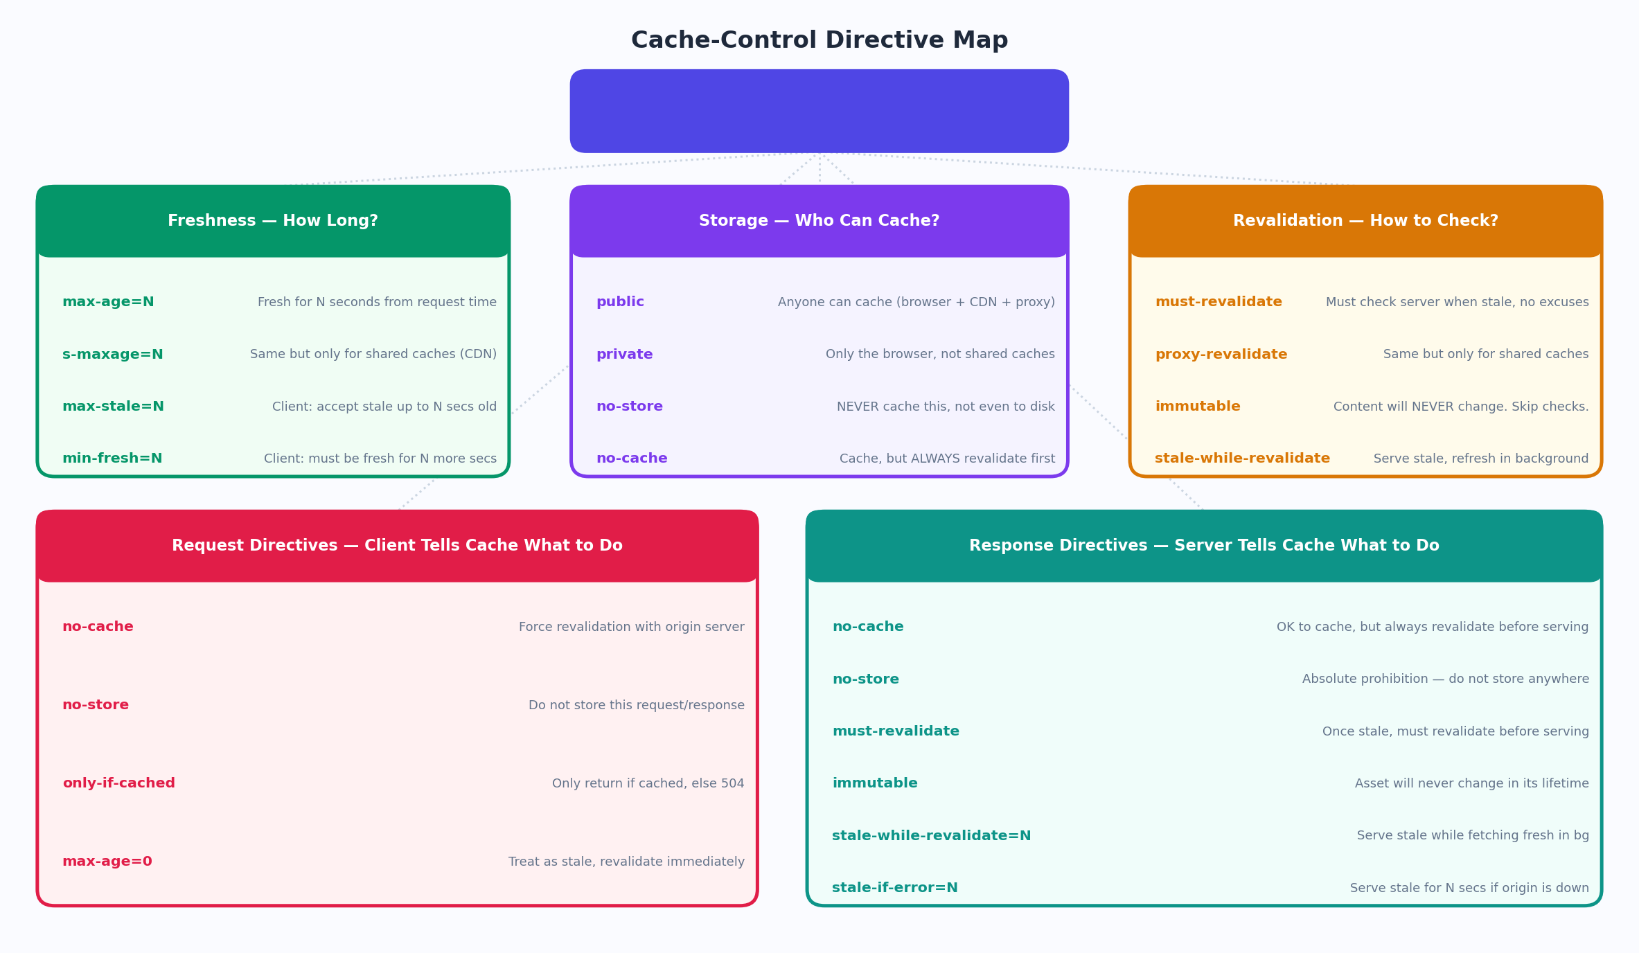
Figure 3 — Complete Cache-Control directive map: freshness, storage, and revalidation categories

Freshness Directives
Freshness directives answer the question: "How long is this response considered valid without asking the server?"
max-age =<seconds>
Plain English | "This response is good for N seconds from the moment you received it. Don't ask the server again until then."
Technical | Specifies the maximum amount of time in seconds that a response is considered fresh. After max-age seconds have passed since the request, the response is stale. Applies to both private (browser) and shared (CDN) caches.
When to Use | Static assets like images, fonts, and JavaScript bundles that don't change often. API responses that are acceptable to be slightly stale.
Example | Cache-Control: max-age=3600 // Fresh for 1 hour  Cache-Control: max-age=86400 // Fresh for 1 day  Cache-Control: max-age=31536000 // Fresh for 1 year (static assets)
Gotcha | max-age is measured from the Date header in the response, not from when you access the cached copy. If the response was cached 50 minutes ago and max-age=3600, you have 10 minutes of freshness left — not a full hour.

s-maxage =<seconds>
Plain English | "Same as max-age, but this rule is ONLY for shared caches like CDNs. The browser's max-age overrides this for the browser itself."
Technical | Overrides max-age and Expires but only for shared (public) caches. Lets you set a different cache lifetime for CDNs vs browsers. If a browser sees both max-age and s-maxage, it uses max-age. A CDN uses s-maxage.
When to Use | When you want CDNs to cache for longer (say, 1 day) but you want browsers to always check freshness more often (say, 1 hour). Common for API responses that are cacheable at the CDN level.
Example | Cache-Control: public, max-age=3600, s-maxage=86400  // Browser: fresh for 1 hour  // CDN: fresh for 1 day

stale-while-revalidate =<seconds>
Plain English | "After the content goes stale, you can still serve the old copy for up to N more seconds — but kick off a background refresh at the same time."
Technical | After max-age expires, instead of blocking the response until revalidation completes, the cache serves the stale response immediately while simultaneously fetching a fresh copy in the background. The next request gets the fresh version.
When to Use | API responses where a slightly stale answer is acceptable but you still want to keep the cache warm. News feeds, dashboards, recommendations — users get instant responses and fresh data starts flowing within seconds.
Example | Cache-Control: max-age=60, stale-while-revalidate=300  // For the first 60s: serve fresh copy directly  // Seconds 60-360: serve stale, refresh in background  // After 360s: must revalidate before serving
Gotcha | This directive dramatically improves perceived performance because no user ever waits for revalidation — someone else's request triggers it in the background. It's like having an assistant who preemptively refills the water jug before it runs out.

stale-if-error =<seconds>
Plain English | "If the server is down or erroring out, go ahead and serve the stale cached version for up to N seconds instead of showing users an error page."
Technical | Instructs caches to serve a stale response if the origin server returns a 5xx error or is unreachable, for up to the specified number of seconds. A resilience mechanism — your site stays up even if your server has a brief outage.
When to Use | Production APIs where you'd rather serve slightly old data than show a 503 error page. Especially valuable for read-heavy endpoints where stale data is acceptable.
Example | Cache-Control: max-age=300, stale-if-error=86400  // If server errors: serve up to 1-day-old cache  // Users see old data instead of error pages

Storage Directives — Who Can Cache?
These directives decide who is allowed to store a copy of the response. Get these wrong and you can accidentally expose private user data to shared caches, or accidentally prevent caching entirely.
public
Plain English | "Any cache in the world can store this response — browsers, CDNs, corporate proxies, ISPs. Anyone who sees this response may keep a copy."
Technical | Marks the response as cacheable by any cache, including shared caches. Needed when you want CDNs to cache your content. Without public, shared caches will only cache responses to requests without authorization headers.
When to Use | Any response that is not user-specific: API documentation, public product listings, news articles, public images, static assets.
Example | Cache-Control: public, max-age=86400  // CDNs will cache this — perfect for public content  Cache-Control: public, s-maxage=31536000, immutable  // Immutable static assets — cache forever on CDN

private
Plain English | "Only this specific user's browser can store this. CDNs and shared proxies must not cache it — it's personal data."
Technical | The response is intended for a single user and must not be stored by shared caches. The browser cache is fine, but CDNs and proxies must skip it. Use this for anything that contains user-specific data.
When to Use | User profile pages, account dashboards, authenticated API responses, anything with personal data, payment information, or authorization-specific content.
Example | Cache-Control: private, max-age=300  // Browser caches it for 5 mins  // CDN sees "private" and does NOT cache it  // Repeat requests: browser cache hit, server miss
Gotcha | If you forget to set private on user-specific responses, a CDN might cache User A's profile and serve it to User B. This is a serious data leak. Always use private for authenticated content.

no-store
Plain English | "Do not store this anywhere. Not on disk, not in memory. Delete it after you use it. This is sensitive data."
Technical | The absolute prohibition on caching. No part of the response (request or response) may be stored in any cache. This is the most aggressive cache prevention directive. Not even the browser should write it to disk.
When to Use | Login responses containing tokens, pages with payment information, medical records, anything under GDPR/HIPAA that should never persist beyond the current session.
Example | Cache-Control: no-store  // Nothing is ever written to disk  // Every request goes to the server — no exceptions  Cache-Control: no-store, no-cache // Belt and suspenders
Gotcha | no-store and no-cache are NOT the same thing. no-store means never write to disk. no-cache means you can write to disk but always revalidate before serving. This is one of the most misunderstood distinctions in all of HTTP caching.

no-cache
Plain English | "You can store this, but every single time you want to serve it — even if it's fresh — you must check with the server first. Don't serve stale data without asking."
Technical | Despite its name, no-cache does NOT mean "do not cache". It means the cached response must be revalidated with the origin server before serving it to a client. The cache stores the response and ETags, but always checks if it's still valid before using it.
When to Use | HTML pages and navigation responses where you always want the latest version but still benefit from conditional requests (304 saves bandwidth). Authentication-sensitive pages. Pages where freshness is more important than speed.
Example | Cache-Control: no-cache  // Browser stores it AND the ETag  // Every request: GET /page If-None-Match: "abc"  // 304 → serve cache (bandwidth saved)  // 200 → update cache with new version
Gotcha | This naming is one of HTTP's greatest gotchas. no-cache should have been called "always-revalidate". No-cache = cache it, always check. No-store = never cache. Ask about this distinction in any backend interview and you'll stand out.

immutable
Plain English | "This content will NEVER change in its entire existence. Don't bother revalidating it even when it goes stale. Trust the max-age completely."
Technical | Tells the browser that the response will not change over its freshness lifetime. When the browser is about to make a conditional request during max-age to revalidate, it skips the request entirely because the server has promised the content is immutable. Only valid with long max-age.
When to Use | Content-addressed / fingerprinted assets — files where a hash of the content is in the filename. If the content changes, the filename changes, so the URL changes. The current URL's content truly will never change.
Example | Cache-Control: public, max-age=31536000, immutable  // /app.3f9a2b.js will never change  // Browser NEVER sends a revalidation request  // When app changes → /app.8d1c4e.js (new URL)
Gotcha | Only use immutable when you are 100% certain the content at this URL will never change. This means you MUST use URL fingerprinting (content hash in filename). If you ever update the file at the same URL, browsers will serve the stale version indefinitely.

4. Freshness, Staleness, and the Cache Lifecycle
A cached response isn't valid forever. Every cached entry has a freshness window, and understanding what happens before, during, and after that window determines how your app behaves under different conditions.
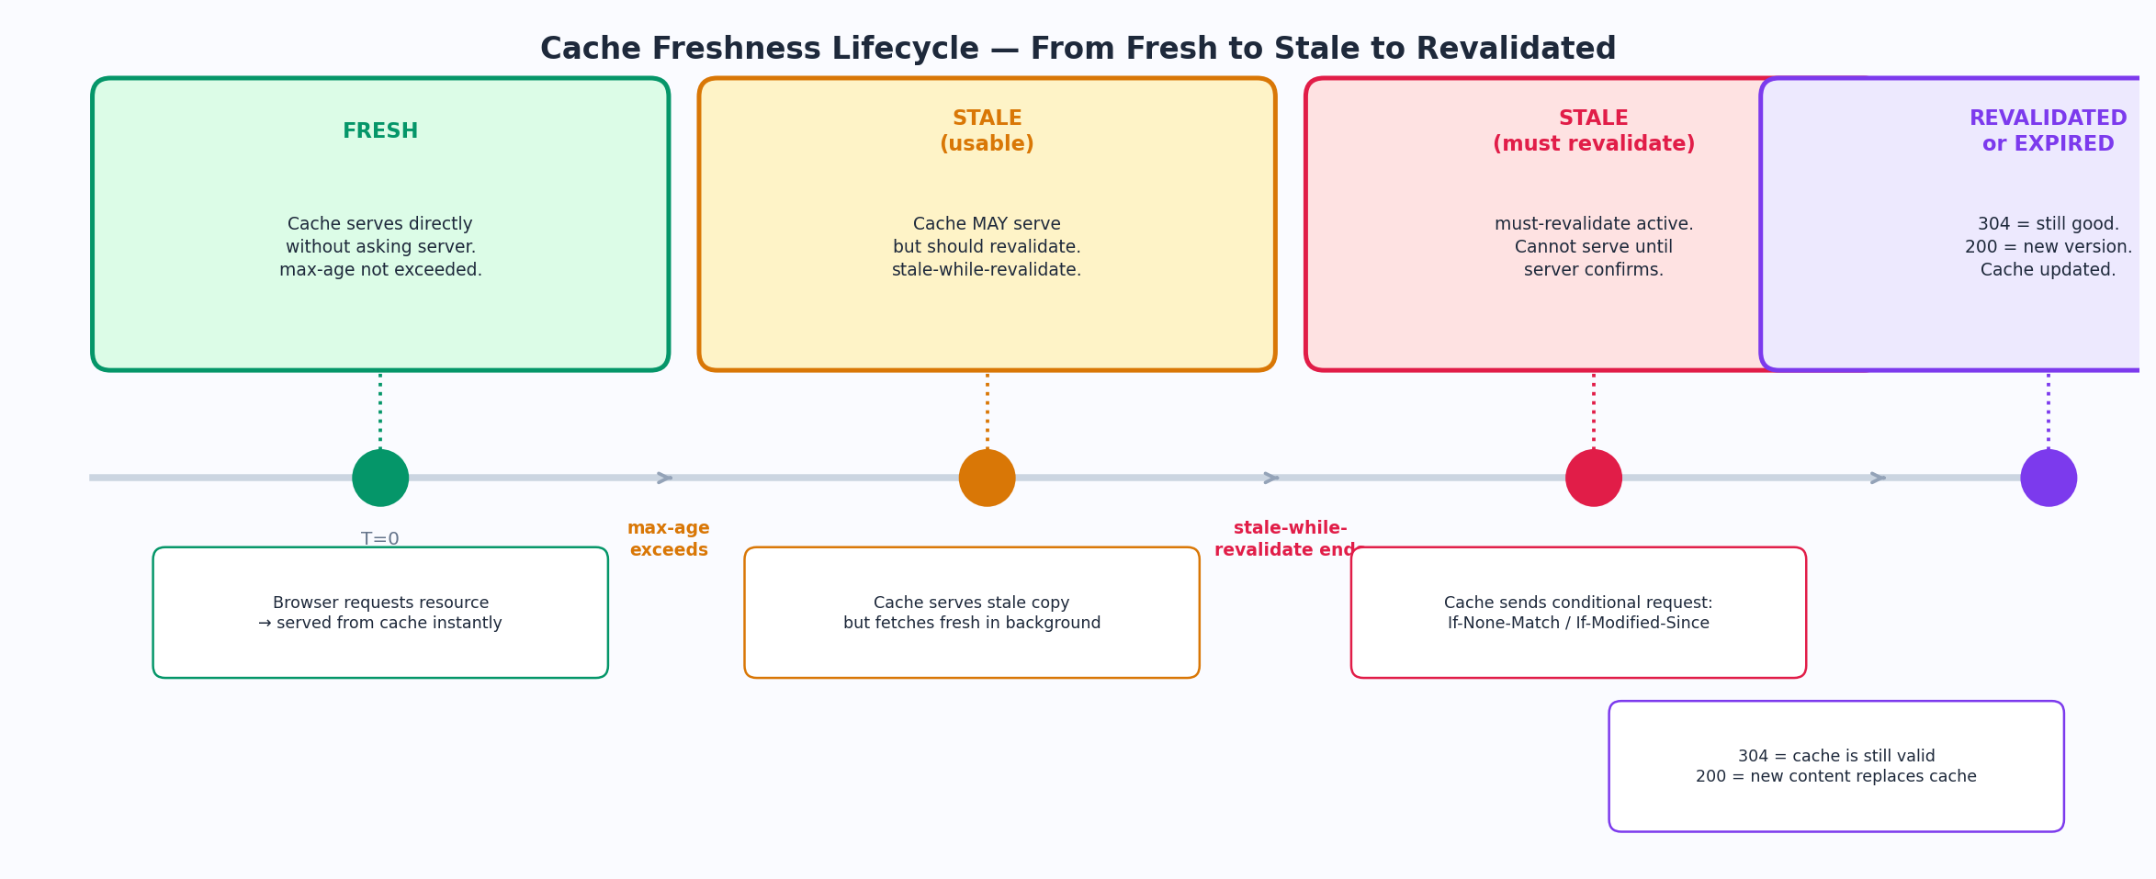
Figure 4 — The cache freshness lifecycle from initial response to revalidation

The Freshness Formula
A cached response's age is calculated as:
apparent_age = max(0, response_time - date_header)
freshness_lifetime = max-age (or s-maxage for shared caches)
is_fresh = (apparent_age + time_since_response) < freshness_lifetime

In plain terms: the cache measures how old the response is right now. If that age is less than max-age, it's fresh. If it's older, it's stale. Simple.

Fresh → Stale → Revalidated
When a response is fresh: the cache serves it immediately with no network request. This is the ideal state — free response, zero latency.
When a response is stale: the cache cannot serve it without checking. What happens depends on your directives. With stale-while-revalidate, it serves the stale copy and refreshes in the background. With must-revalidate, it must block and ask the server first.
During revalidation: the cache sends a conditional request — "I have version X, is it still good?" — and gets back either 304 Not Modified (use your copy, it's still valid) or 200 OK with a new body (replace your copy).
Interview tip
"What happens when a cached response goes stale?" is a great interview question. The answer: it depends on the directives. must-revalidate = block and ask. stale-while-revalidate = serve old + refresh in background. stale-if-error = serve old if server is broken.

5. Cache Validation — ETags and Last-Modified
When a cached response goes stale, the cache doesn't just throw it away and re-download everything from scratch. That would be wasteful. Instead, it sends a conditional request — essentially asking the server: "Has anything actually changed since I last fetched this?" If nothing has changed, the server replies with a tiny 304 response and the cache continues using what it has. If something has changed, it gets the new version.
Think of it like this
Imagine you have a copy of a book and you want to know if a new edition came out. Instead of buying the whole book again, you call the bookshop and say "I have the March 2024 edition — has it changed?" They say "nope, still the same" (304) or "yes, the April edition just dropped" (200 + new book). That phone call is the conditional request. ETags are the edition number.

ETags — Content Identity Tokens
An ETag (Entity Tag) is a unique identifier the server assigns to a specific version of a resource. It's usually a hash of the content. If the content changes at all — even one character — the ETag changes. The server sends it in the response, the browser stores it alongside the cached content, and the next time it asks for that resource, it includes the ETag in the If-None-Match header.
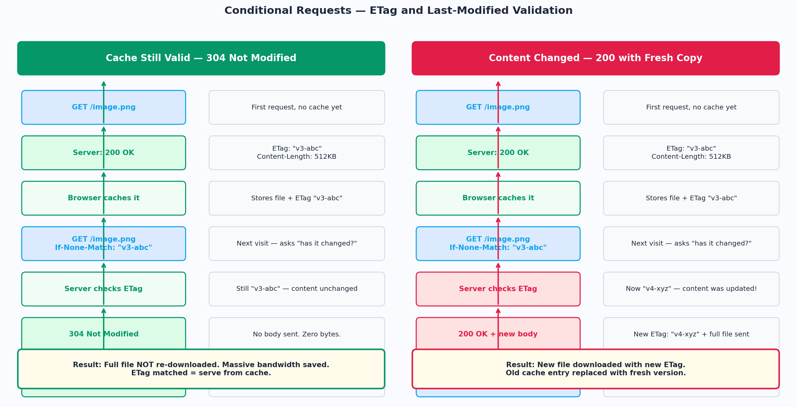
Figure 5 — ETag-based conditional requests: 304 when content unchanged, 200 when updated

Strong vs Weak ETags
Type | Format & Meaning | When to Use
Strong ETag | "abc123def" — Byte-for-byte identical guarantee. Even one byte difference = different ETag. | Static files, images, downloads where exact byte identity matters.
Weak ETag | W/"abc123" — Semantically equivalent but not byte-identical. Same content, maybe different compression. | Dynamically generated pages where the content is equivalent even if bytes differ slightly.

Last-Modified — Timestamp-based Validation
An older alternative to ETags. The server sends the date the resource was last changed in the Last-Modified header. The browser stores it and sends it back in If-Modified-Since on the next conditional request. The server compares the timestamp and returns 304 if nothing has changed since then.
ETags are preferred over Last-Modified because timestamps are imprecise (1-second granularity), can be wrong if a file is restored from backup without changing, and don't handle files that are "touched" without actual content changes. But Last-Modified is simpler and works fine for most static content.
Header | Direction | Pair | What it does
ETag | Response | If-None-Match | Server assigns version ID. Client sends it back to check if still valid.
Last-Modified | Response | If-Modified-Since | Server sends timestamp. Client sends it back to check if content changed since then.
If-None-Match | Request | ETag | Client asks: "If the ETag is still this value, don't re-send the body."
If-Modified-Since | Request | Last-Modified | Client asks: "If nothing changed after this date, give me 304."
If-Match | Request | ETag | Client says: "Only apply this change if the ETag still matches." Prevents overwriting.
If-Unmodified-Since | Request | Last-Modified | Client says: "Only apply this change if the resource wasn't modified since this date."

6. Cache Busting — Forcing a Fresh Download
Here's the paradox: you want to cache assets aggressively for performance — but when you push a new version of your app, you need browsers to download the new files immediately. Those two goals seem to conflict. Cache busting is how you solve this.
Cache busting is a technique where you make the URL of a resource change whenever its content changes. Since it's technically a different URL, the browser has nothing in cache for it and fetches fresh from the server. Old URLs are simply abandoned.
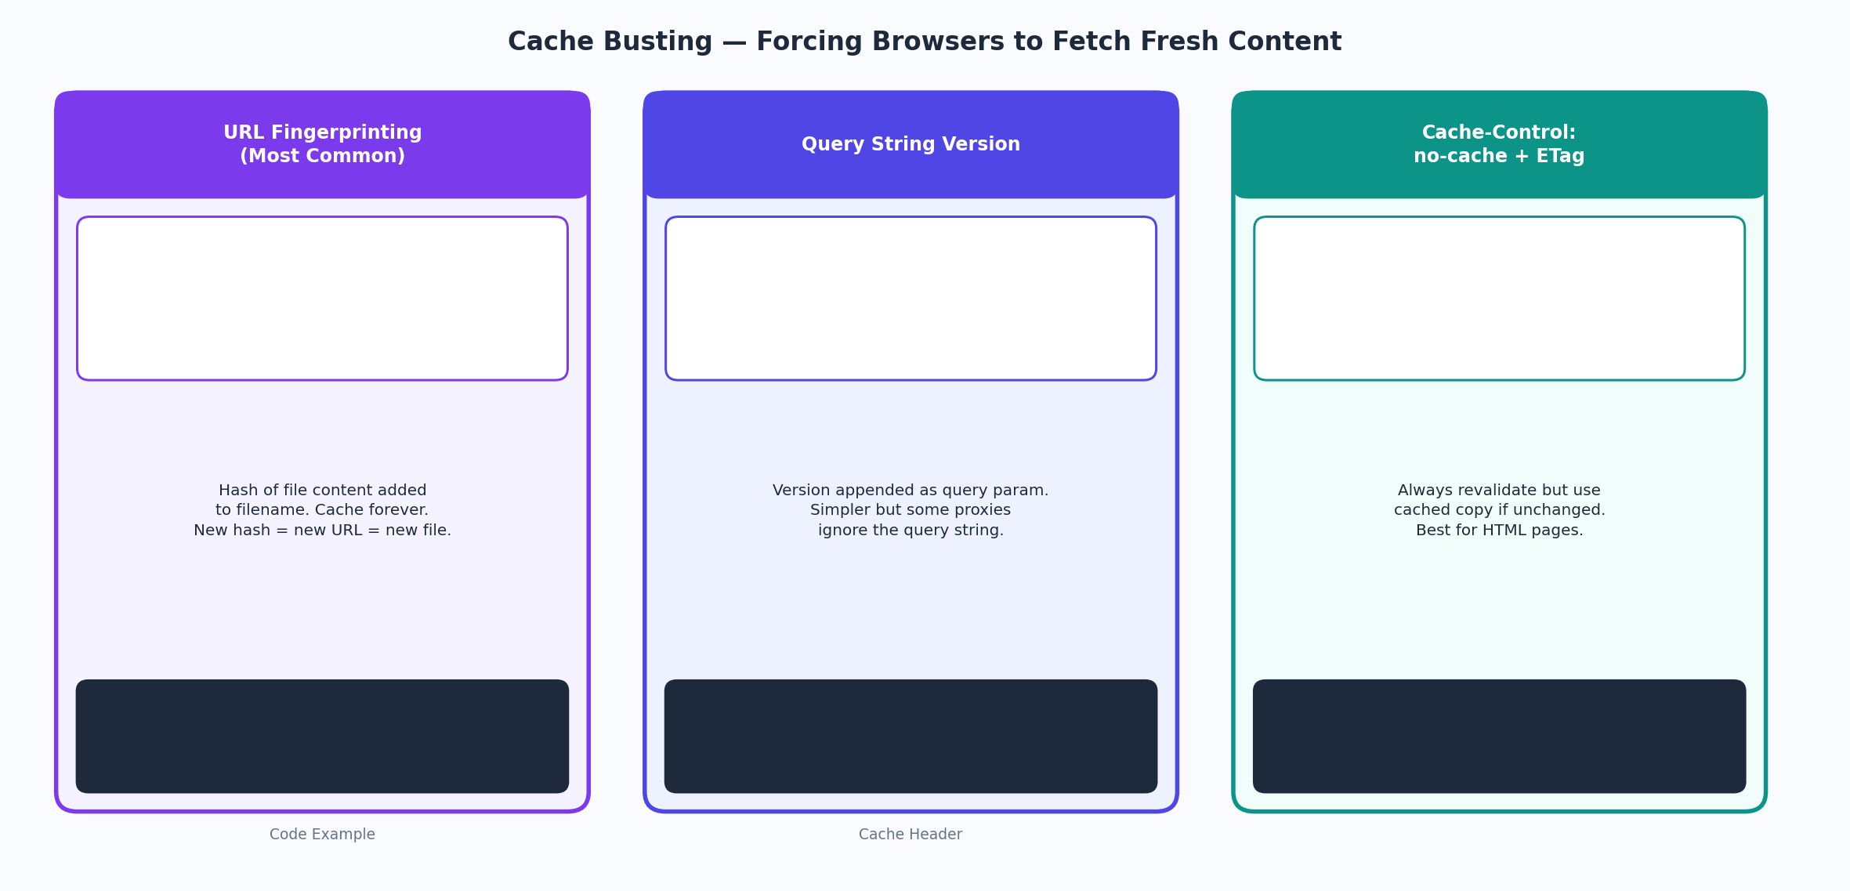
Figure 6 — Three cache busting strategies: URL fingerprinting, query strings, and no-cache + ETag

URL Fingerprinting — The Best Approach
Build tools like Vite, Webpack, and Parcel automatically generate a content hash and embed it in the filename during the build process. The file app.js becomes app.3f9a2b.js. If a single line of code changes, the hash changes, the filename changes, and the browser knows to fetch a fresh copy.
The beauty of this approach: because the URL will never change for the same content, you can set max-age=31536000, immutable — cache it for a year, tell the browser it will never change. Performance is maxed out. And whenever you ship new code, the new filename ensures a fresh download automatically.
Your HTML file (which references these assets) gets Cache-Control: no-cache — it's always revalidated, so browsers always get the latest HTML with the correct fingerprinted filenames. The HTML is your "menu" that points to the correctly versioned assets.
The production caching pattern
Pattern used by every serious production web app:
HTML: Cache-Control: no-cache (always revalidate, 304 saves bandwidth)
JS/CSS/Images: Cache-Control: public, max-age=31536000, immutable (fingerprinted URLs, cache forever)
API responses: varies by endpoint — some no-cache, some short max-age, some no-store

7. The Vary Header — Caching Multiple Versions
Here's a scenario. Your server returns compressed (gzip) responses to clients that support it and uncompressed responses to clients that don't. Both responses come from the same URL. If a CDN caches the gzip version and serves it to a client that can't decompress gzip, that client is broken.
The Vary header solves this. It tells caches: "This response might be different depending on the value of these request headers. Store a separate cached copy for each unique combination."
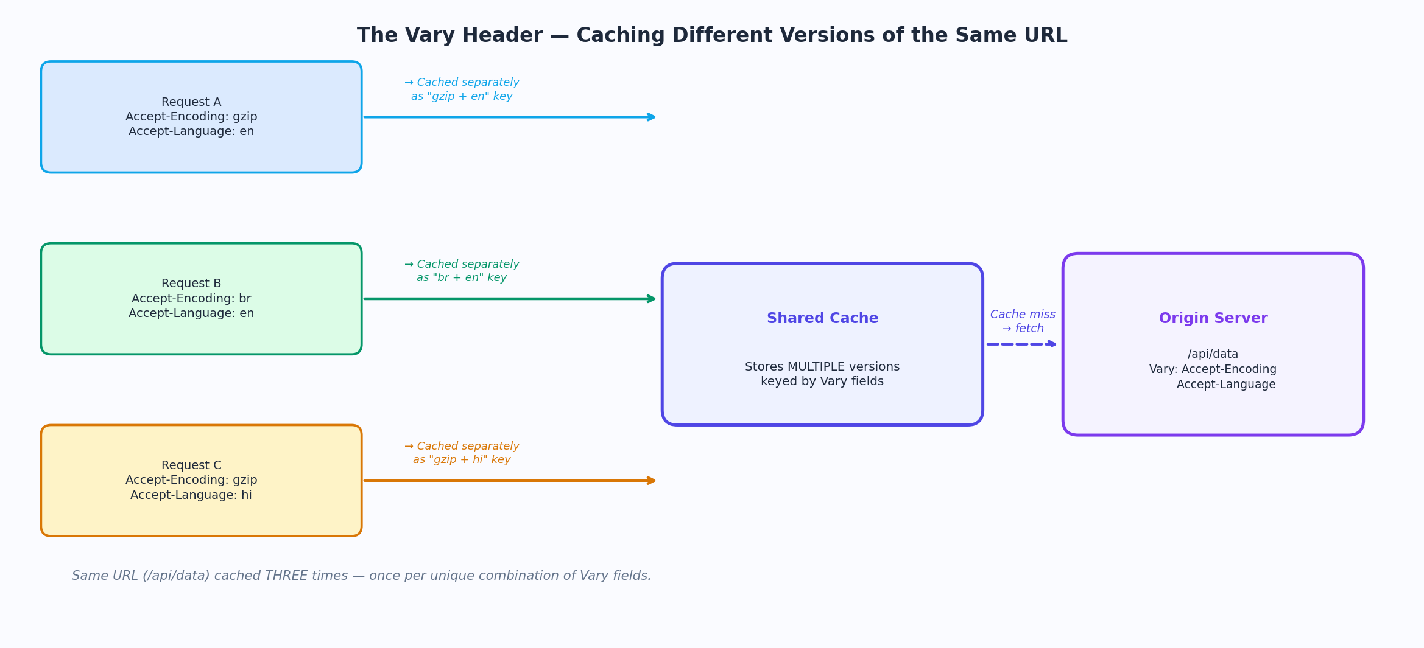
Figure 7 — Vary header causes three separate cache entries for the same URL

How Vary Works
When a cache sees Vary: Accept-Encoding, it stores the response keyed by both the URL AND the value of the Accept-Encoding header. A request with Accept-Encoding: gzip gets the gzip-cached version. A request with Accept-Encoding: br gets the Brotli-cached version. They don't conflict because they're stored as separate entries.
Vary Value | Why it's used | Cache behavior
Vary: Accept-Encoding | Different compression (gzip vs br vs none) | Separate cache entry per encoding
Vary: Accept-Language | Different language versions of same URL | Separate cache entry per language
Vary: Accept | Same URL returns JSON or HTML based on Accept | Separate cache per content type
Vary: Cookie | User-specific variations — WARNING: kills CDN caching | Almost never cached by CDNs
Vary: * | Response varies unpredictably — do not cache at all | CDNs treat as uncacheable

Vary: Cookie gotcha
Vary: Cookie effectively disables CDN caching because cookies differ per user, meaning every user would need their own cached copy — that's not caching, that's just the server. If you need per-user caching at the CDN, use tokens in the URL or configure your CDN with custom cache keys.

8. Legacy Headers — Pragma and Expires
Before Cache-Control existed in HTTP/1.1, developers used two older headers. You will still see them in the wild — especially in responses from older servers and in security tools. You need to know what they are even though you should use Cache-Control instead.

Pragma: no-cache
The HTTP/1.0 equivalent of Cache-Control: no-cache. When a browser or proxy sees this, it treats the response as needing revalidation. Still sometimes sent by security-conscious servers for maximum compatibility.
If a response has both Pragma: no-cache and Cache-Control: max-age=3600, Cache-Control wins for HTTP/1.1 clients. Pragma is only consulted if Cache-Control is absent.

Expires: <date>
Sets an absolute expiry timestamp for the response. The cache checks the current time against this date to determine freshness. An Expires date in the past means "already stale." If both Expires and max-age are present, max-age takes priority.
The problem with Expires is that it relies on the client's clock being correct. If a client's system clock is wrong, freshness calculations break. Cache-Control's relative max-age (seconds from now) avoids this entirely.
Old Header | Modern Equivalent
Pragma: no-cache | Cache-Control: no-cache
Expires: Thu, 01 Jan 1970 | Cache-Control: no-cache or max-age=0
Expires: <future date> | Cache-Control: max-age=<seconds>

9. Caching Strategy by Resource Type
There is no single "correct" caching strategy. Different types of resources have different needs, and the best caching config for each depends on how often they change and how badly stale data would hurt.
Resource Type | Recommended Header | Reasoning
Fingerprinted JS/CSS/Images | public, max-age=31536000, immutable | URL changes when content changes. Cache forever. Immutable = skip revalidation checks.
HTML Pages | no-cache (or max-age=0) | Always revalidate. HTML references other assets — you need the latest. ETags save bandwidth (304).
Public API (read-only data) | public, max-age=60, stale-while-revalidate=300 | CDN caches it. Users get fast responses. Background refresh keeps it current.
Private API (user-specific) | private, no-store | Never let CDNs or proxies cache personal data. No-store for sensitive info.
Authentication Endpoints | no-store | Tokens and credentials must never be cached anywhere. Period.
Downloadable Files | public, max-age=86400 | Files that don't change often can be cached for a day. Longer if versioned.
Real-time / Live Data | no-cache or no-store | Stock prices, live scores — stale data is harmful. Always fresh from server.
Service Workers / manifests | no-cache | Always revalidate so new service worker versions roll out promptly.
Redirects (301) | max-age=3600 or no-store | Permanent redirects are cached by browsers. Set a short max-age so you can change them.

10. Interview Cheat Sheet
These are the distinctions and concepts about HTTP caching that interviewers love to probe. Know these precisely.
The key distinctions — know these cold
no-cache vs no-store: no-cache means cache it but always revalidate before serving. no-store means never write to disk or memory at all.
max-age vs s-maxage: max-age applies to all caches (browser + CDN). s-maxage only applies to shared caches (CDNs, proxies). Both can coexist.
public vs private: public = any cache can store it. private = only the browser, not CDNs.
ETag vs Last-Modified: ETags are content hashes (precise). Last-Modified is a timestamp (imprecise — 1s granularity, clock drift issues). ETags win.
304 Not Modified: the server sends NO body. The client uses its cached copy. This is the point of conditional requests — bandwidth saving.
Cache busting: changing the URL when content changes. URL fingerprinting (hash in filename) is the best approach. Combine with max-age=31536000 + immutable.
Vary header: same URL can have multiple cached versions based on request headers (encoding, language). Vary: Cookie kills CDN caching.
immutable: only use when URL fingerprinting is in place. Tells browser to never send revalidation requests during the max-age window.
stale-while-revalidate: serve stale instantly, refresh in background. User never waits. Next request gets fresh version.
Cache invalidation: the hardest problem in caching. Solutions: short max-age, URL fingerprinting, CDN purge APIs, surrogate keys.

References: RFC 9111 (HTTP Caching) · RFC 9110 (HTTP Semantics) · RFC 7234 (HTTP/1.1 Caching) · MDN Web Docs · web.dev/caching

