MSC-Artificial Intelligence Data Visualization

A report which critically evaluates Group 4’s dashboard on the “Is vaccination improving the death rates of COVID-19”

Table of Contents
Overview 2
Dashboard Assessment 3
Editorial Thinking 4
Presentation, Interactivity and Annotation 7
Health Considerations 8
Suggestions for improvement 9
Conclusion 10
References: 11

Muhammad Nawab Anjum Lecturer: Usama Zidan
ID 21171479
Total Words 2381

Overview
Data visual, in its simplest form, is a graphical representation of data to understand patterns and communicate impressions. I think we all know the importance of data now. However, we still need to focus on key principles to create value and efficiency. Mistakes, confusions and misconceptions are widespread and created by our well-known data visualization designers and journalists.
"There are two goals when presenting data: convey your story and establish credibility."
— Edward Tufte
The application of the 5 key principles of good data visualisation design are:
- Tell The Truth (The job of the presenter is to inform the audience, not to impress them)
- Know your Audience (Show what you have in a way they want to see)
- Choose the right Chart (Accurate graph enhances information, hides inaccurate information.)
- Emphasize the important (Leave the useless to show value!)
- Form should follow function(The purpose of data is information, not images)
Gestalt psychologist Max Wertheimer, Kurt Koffka, and Wolfgang Kohler set out to understand how we humans can understand what we see from the violence around us. What they have found is that we try to create patterns, put things in the right ways, and lighten complex images. The basic premise of Gestalt psychology is that the human mind forms a "gestalt", and all of this has its own truth, independent of its components. The number of Gestalt Laws vary by literature. Here are the 9 that I found apply to Data Visualization.
- Law of Common Fate: We observe how the elements move together as a group at the same speed and / or direction.
- Law of Prägnanz (Simplicity): Our eyes look soft in difficult situations, preventing us from getting out of words.
- Law of Figure and Ground: We divide our visual world into figure and terrain. The figure is the object at the centres of our vision, and the earth is the background.
- Law of Continuity: Our hobby is to look at pictures as well as possible. The human eye follows lines, bends, or shapes to form a path.
- Law of Connectedness: We seem to see products that are related to a group, not products that are not related in the same way.
- Law of Enclosure: Objects are considered to belong to a group if they are closed in a way that creates boundaries or boundaries around them.
- Law of Closure: We like to see completed pictures or texts, even if the picture is incomplete.
- Law of Similarity: We look for the probabilities and differences of objects and connect objects similar to objects in a group.
- Law of Proximity: We see objects close together as a group.
Dashboard group 4 Detail
Total Group member | 4
Video Length | 6 minutes and 55 seconds
Member names | 1.Amir Alizadeh,2.Kwako Danso  3.Olaydayo, 4.Faryn McDonald

Dashboard Assessment
The subject of graphical representation for data needs to have a strong scientific base (Cleveland, 1984).
There is no evidence of data breaches in the dashboard, making it difficult for the public to understand the processing of the data.

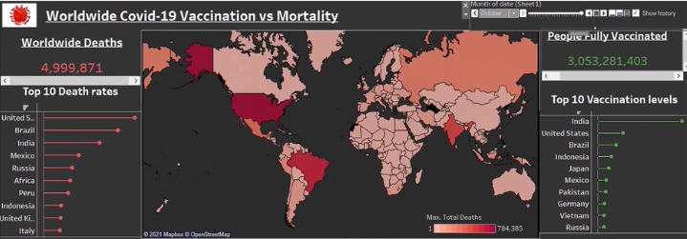
The panel is interactive (as seen in Figure 1). The group has looked at location maps around the world and applied colour schemes ranging from white to dark red for each location. White represents the natural state, red light represents the national number of deaths that has increased due to the spread of ubid-19 everywhere and dark red represents the number of deaths due to conflict. We can select a country from the world map by hovering, after it is hovering, then a text box will appear, there is a selection of country, status, immunization for 100, etc.

Few more points are below.
- In the first Page of the presentation, the title of the dashboard is mentioned correctly “Is vaccination improving the death rates of COVID-19”, Also in the second page the background of the dashboard is added correctly mean’s that’s the idea how to choose this data.
- Few member of the group spoke slowly and clearly, which allowed the audience to express themselves Said. This is for those with slow cognitive functions and someone who has difficulty speaking quickly.
- In the presentation especially slide 3 they missed some data and to not to show that is actually the total data is, and also missed comments in the code that is hard to understand what is the propose of this lines of code
- In slide 4 explanation is very good, the colour purpose, chart design and the arrow for indicating the context.
- Slide 4 and 5 is about the visualization that is awesome according to the standard shape, colour, shading or other qualities (Koffka, 1935).But some label values is not visible in the video.
- Slide 6 Conclusions is also well explained, The legends on the chart Max.Hops Patients,Max.New Deaths and Max.people fully vaccinated) is coloured accordingly .
- Slide 7 our Conclusions, there is some mistakes vaccine distribution table does not have any kind of header. So Gestalt Principle Simplicity is not fulfilling here
- Slide 8 Future Plan ,this is a good idea Groups 4 considering it for future plan it might be work in more accurate way in future, when everyone get vaccinated .

Editorial Thinking
There is evidence that the group intends to include and exclude. Introduction to their speech is often supported, up-to-date, Adequate and well-defined descriptive views with analyses to comment. This is a key part of data presentation, especially when making decisions the type of chart used for quality and statistical information and this approach is good by selecting the appropriate charts and folders for their data collection. However, there are issues pay a little attention to presentation and reading. He opposes provided by McKinley Levels of Performance (McKinley, 1986). Example;
- On slide Worldwide Covid-19 Vaccinations vs Mortality the title of the chart must follow the same pattern of words either first word Capital of lower but Vs is in small case whereas others words start from the capital . Also the Top 10 Vaccination levels has the same issue as well as vaccination Statics.
- On to the slide 3 the code is very blurred and commenting is missing, it is hard to understand what the purpose of the code is.


- On slide of Visualizations some countries name as not fitted in the proper way , as if we see the unit state we are unable to find that, also the chart line showing only one colour throughout the chart 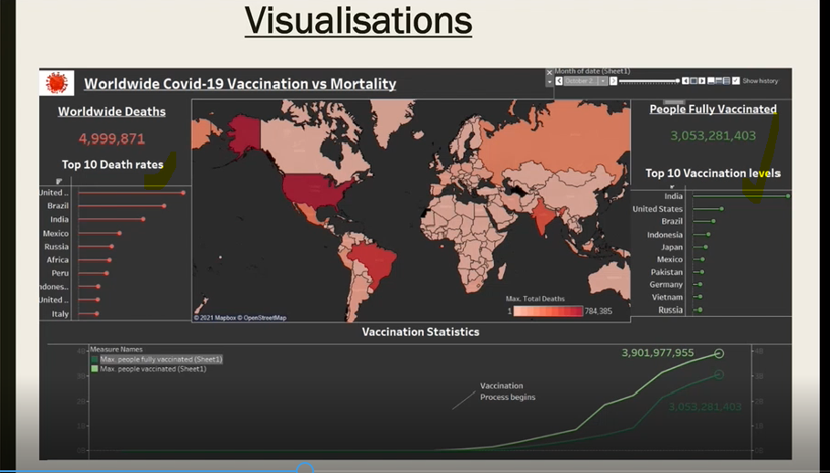
- Onto the slide 5 no proper explanation is done, also it is not full filling the Gestalt Principle Law of Continuity: Our hobby is to look at pictures as well as possible. The human eye follows lines, bends, or shapes to form a path.

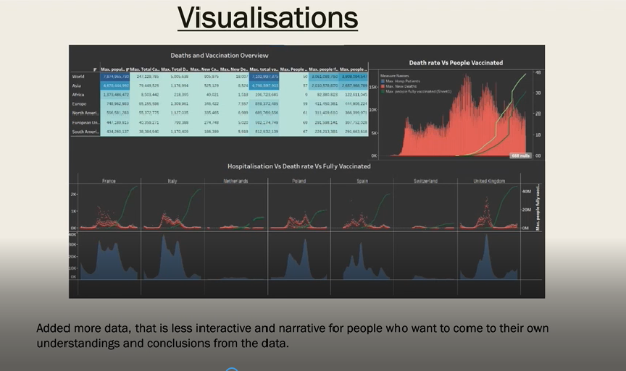
- On to the slide Our conclusion 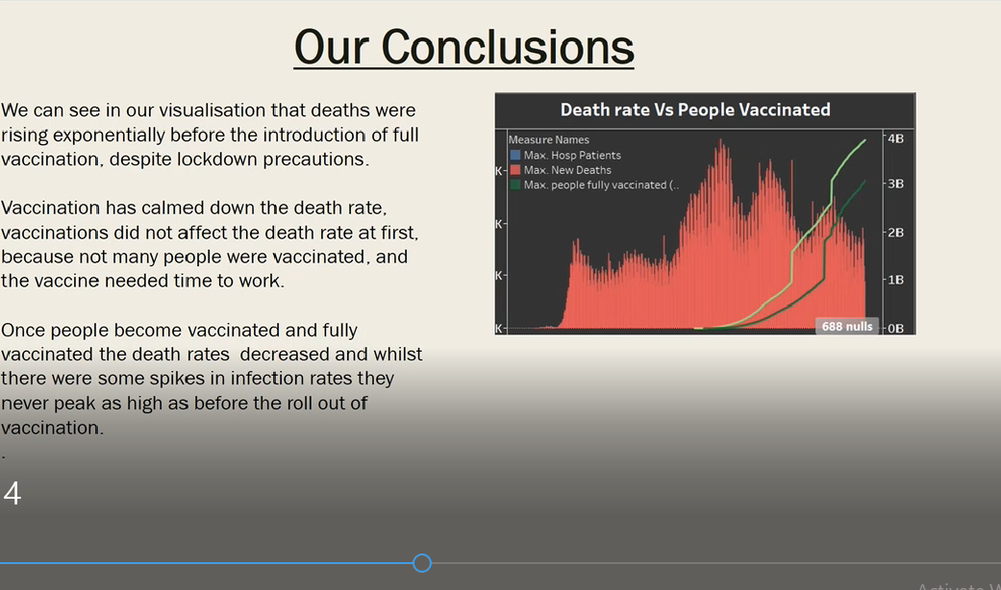
- There are too much for improvement, the first improvement is the Label of the chart is not following the Alphabet case, also data is not handled in proper way, if we see at the bottom of this chart 688 nulls in showing. They can handle the missing value in the dataset with different ways, few are bellows ,
- Deleting Rows with missing values
- Impute missing values for continuous variable
- Impute missing values for categorical variable
- Slide our conclusions 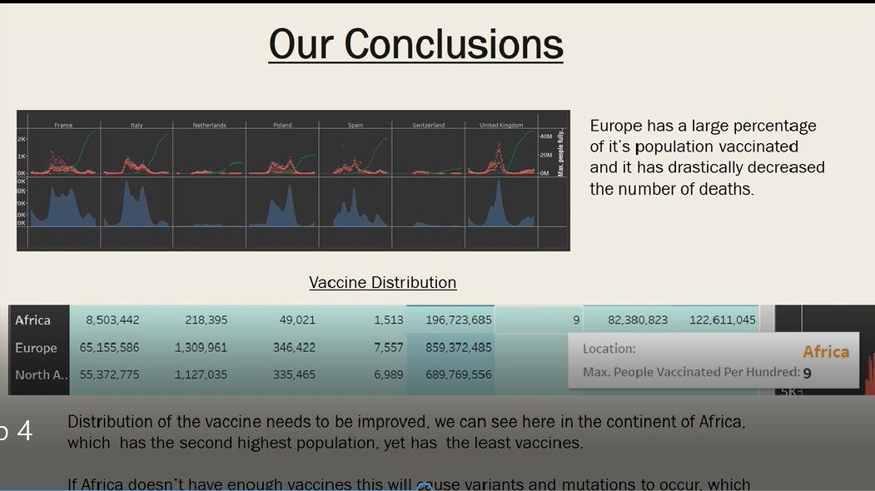
Gestalt law of the past which means that in some cases it is seen
Incentives are categorized according to previous experience. If two objects appear visible
Close, or small in body, the objects are more likely to be perceived together (Koffka, 1985)
- On the slide 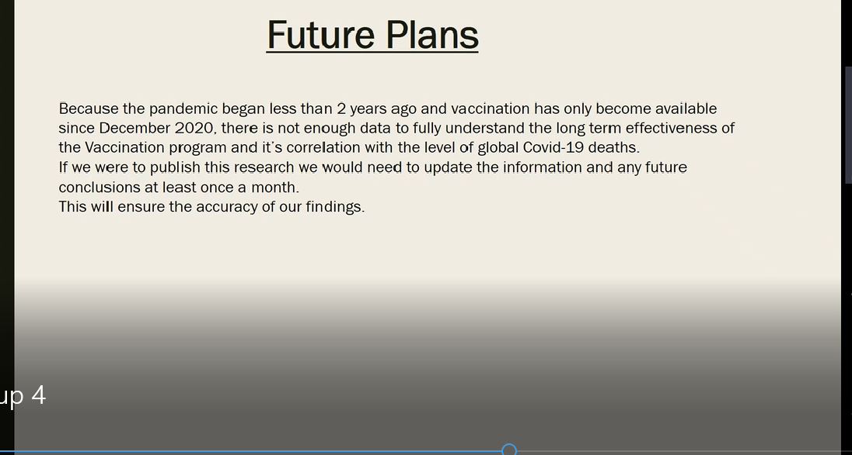
Group mention that they are using the December 2020 data, but I did not find any kind of data that is indicating the years or month.
- On the dashboard Filter criteria is not well managed , whenever they are change the filter data is showing the null values as we can see in the image bellow 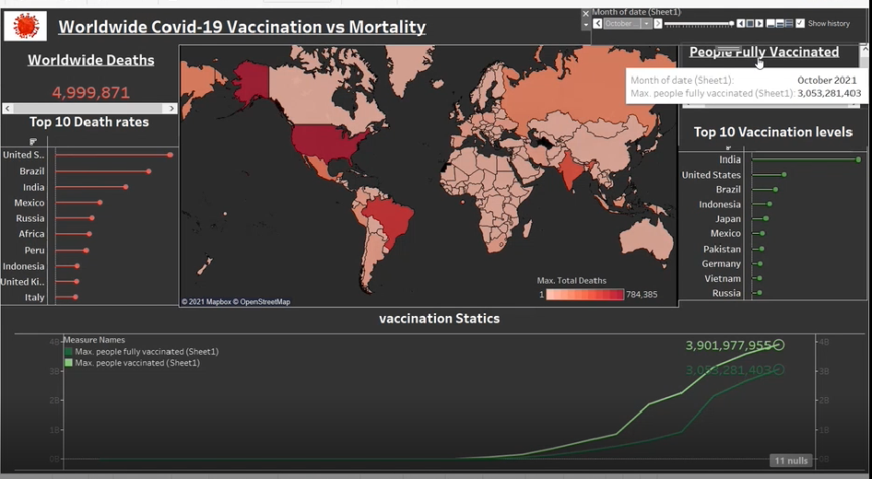
There is also no evidence of how they were created, as they do not indicate roles the responsibility of the people involved consequently points out the minor shortcomings of the editorial staff think. In addition, there is no direct link to the target audience the content is detailed, which I consider modest balanced. They direct consider it 100% accuracy without any involvement of cross questions.

Presentation, Interactivity and Annotation
The group 4 has design this video using Tableau (Interactive data visualization software) and showed Via MS team. So there are lot of thing to make if more attractive. There are different coloured pencils, highlighter and eraser to add more information to your slides. Additionally, you can use the laser tool to draw attention to a specific area of ​​the slide. Once you select the colour, just start adding content to your slide and it will be automatically saved to your slideshow. Now a days Cross platform is the main consideration for everything, i.e. would viewers be able to view this dashboard on another device other than a desktop computer. Group can make use the more Interactive mode of delivery e.g. Touchscreen laptops/tablet PCs

Health Considerations
The unit comes out in a quiet place with a sound that allows the viewer to take everything said and without interesting performances as not everyone can afford the same level of intelligence weights, especially those that determine recognition. Content prices are also included sliding is important. This is important because content size can be complex show. Add colour, font size, and style using uppercase, lowercase, bold and steep features can be enjoyed well, even by others with understanding the damage can be denied. However, there is a situation of this decision no normal meeting. For example, the red bottom of slide 2 has lowercase letters which makes the text invisible (see photo 1). This allows the viewer to analyse the data seems impossible and transcends the main meaning of empathy.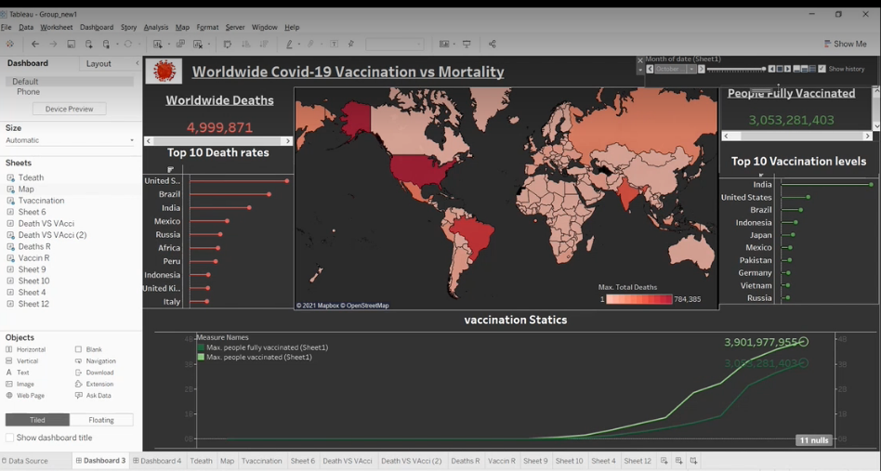

Image 2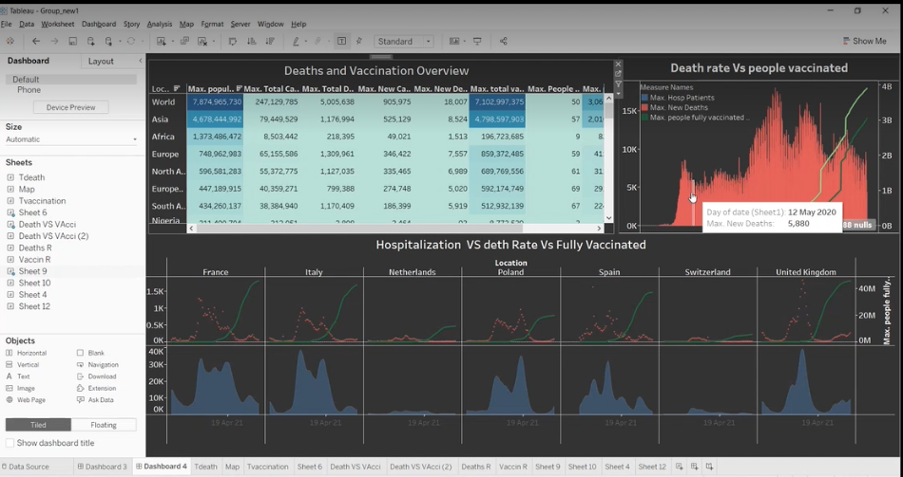

Excellent data representation there is evidence through many graphs. And colour maps, so it makes data easier to solve (Williams, 1984) although the group has legalized most of their shows, Captions and tags, there were occasions when they missed out. For example, the upper bar Graph One on the slide has no descriptions for X and Y axes, so both are confusing and Incorrect in data presentation and presentation.
There was no verbal or written evidence of timestamps. This can be a delay for some Viewers who want to focus only on a specific part that leads the viewer to despair.

Suggestions for improvement
Although teams complement the basic principles of good data, you see some of them time, it is only inconsistent, so this group can only correct it with evidence read their presentations one by one and then analyse the other group’s members.
Specific areas for improvement include;

- Make sure the relevant information spoken during the presentation is also displayed screen, for example. Have a written introductory summary / summary slide.
- They can use the Pie chart for Max.Hops Patients,Max.New Deaths and Max.people fully vaccinated) just to show up the ratio as Pie chart has great impact to the audience .
- It is a good idea to show up the extra label just for information for X label and for Y axis.
- For future always try to double check Case sensitive (Title Case) all the words must be start with lower case or with upper case.
- It is a good and professional way to give the reference, about the data where this data come from either with authenticity.
- Make sure you have pictures and charts and show them clearly
- Subtitles are also very import when you are dealing with worldwide datasets.
- Round your numbers
- Prioritize the simplicity
- Choose your layout carefully
- keep geographical integrity
- use animation options
- use more appropriate colour
- Use Timestamps
- Provide references for the work, as part of the academic practice and to promote the authenticity of the work. (Wouters, 2019)
- All highlighted information must have great emphasis and better clarification. (Few, 2008)
- Thank contributors at the end of their presentation. (Editorial Team, 2021)
Few more important points as showing the image
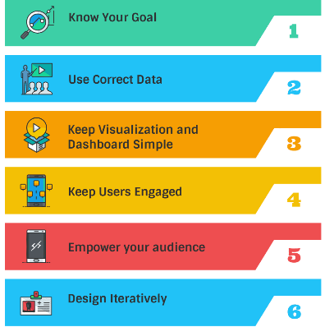

Conclusion
The topic chosen is of worldwide importance, including some in-depth reflections Proposals on areas where health organization may attract more attention, such as new pandemic. Group make a healthy oral presentation based on their goals with a presentation and a summary of the findings. using pydash and Tableau their display shows the ability to examine one, some, or all of the team members , Advanced methods for providing quick - use information (can be used PowerPoint and Excel). But there was no written summary that made this impossible those with visual impairments. The team has verified this presentation, I’m sure some they would see the main flaws that would make the picture better.In addition, Plotly has greater interactive features used in the industry
For example, increase and decrease when the WHO (World Health Organization) broadcasts the results of Verified vaccination from a particular Laboratories and again the group may set such characteristics. Group. However, a balance must be sought between the target audience and the number displays are used because interactivity can be too annoying for some

References:
Hayward, E. (2021, October 6). The Starter Guide to Data Visualizations. Klipfolio.Com. https://www.klipfolio.com/blog/starter-guide-to-data-visualizations
Deep, M. (2021, January 18). Principles in Data Visualization. Medium.Com. https://medium.com/nightingale/how-to-apply-gestalt-psychology-principles-in-data-visualization-6242f4f1a3de
WS, Cleveland, & McGill, R. (1984, September 1). Graphical Perception Jstor.Org. https://www.jstor.org/stable/2288400
Boone, N. (2015, January 1). Gestalt Principles of Design. Slideplayer.Com. https://slideplayer.com/slide/8636469
Few, S., & Edge, P. (2008, February 1). Practical Rules for Using Color in Charts. Github.Io. https://nbisweden.github.io/Rcourse/files/rules_for_using_color.pdf
Robnett, S., & Sexton, T. (2020, July 24). Tech topics during COVID-19 that are most discussed. Weforum.Org. https://www.weforum.org/agenda/2020/07/10-top-tech-topics-during-covid-19-india-china-us-eu/
Editorial Team, I. (2021, June 9). How to Conclude a Presentation: Tips and Examples. Indeed.Com. https://www.indeed.com/career-advice/career-development/how-to-conclude-a-presentation
Langfeldt, L., & Wouters, P. (2019, February 7). Citations, Citation Indicators, and Research Quality. Sage Journals. https://journals.sagepub.com/doi/full/10.1177/2158244019829575

