**EXP-14 Python Mini Project GROUP-12**

**ALARM CLOCK**

DESCRIPTION:

A simple Alarm clock using GUI in Python. The user can set an alarm and custom text message which pops up when the alarm rings. The user sets an alarm in 24hr format and custom text message in English. This application can be used as an alarm or pop up reminder while working.

PROGRAM FLOW:

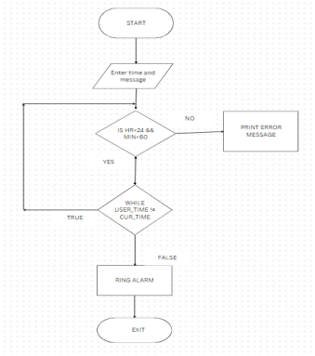

PACKAGES USED:

● TKINTER

● TIME

● DATETIME

● THREADING

● PYGAME

PROGRAM: https://github.com/nawadkar/Python-Mini-Project

OUTPUT:

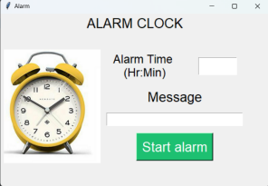

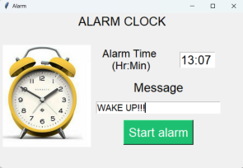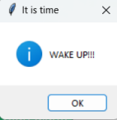Working model Pop up window

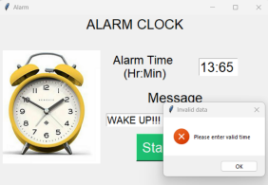

Invalid input with error message

CONCLUSION:

In conclusion, creating an alarm clock using Python is a fun and useful project for those looking to improve their coding skills. By using the time and datetime modules in Python, along with a graphical user interface library like Tkinter, you can build a simple yet effective alarm clock that can wake you up at the desired time. Overall, developing an alarm clock in Python is a great way to hone your programming abilities while also creating a practical tool that can improve your daily routine.

Future scope: Additional features like setting multiple alarms, custom alarm sounds, and snooze options, you can further enhance the functionality of your alarm clock.