P R O D U C T R E S E A R C H
Save My Exams Guided
Learning & Practice
Product walkthrough and competitive analysis of the new guided-study surfaces
Target: savemyexams.com (revision notes + exam questions, beta guided surfaces)
Method: live authenticated walkthrough, headless browser, 55 screens captured
Session: 2026-10-18, free tier, desktop viewport
Prepared by: SyllabAI product research (lane r4-api-b)

SyllabAI Research 2026-10-18

Table of Contents
1. Executive Summary
1. Executive Summary 1
2. Background, Objectives and Method 1
2.1 Background and objectives 2
2.2 Method and account note 2
3. The Signup Funnel 2
4. The Onboarding Wizard 3
5. Pricing of Record 4
6. Guided Study in Revision Notes (the core mechanic) 4
6.1 Entry points and the concept picker 5
6.2 The lesson loop: key points, confidence gate, layered plain-words 5
6.3 The understanding check 6
6.4 Pacing and interaction-cost observations 7
7. Guided Practice in Exam Questions 7
7.1 The mode toggle and session launcher 7
7.2 The adaptive session 8
7.3 Structured questions and Smart Mark 8
8. The Target Test Builder 9
9. Gating: Where the Paywall Actually Bites 10
10. Product Analysis and Implications for SyllabAI 10
10.1 The guided-learning pattern is content engineering, not model engineering 11
10.2 Where genuine AI sits: marking and the open question of chat 11
10.3 Funnel and monetisation lessons 11
10.4 Recommended follow-ups 11
Appendix A. Walkthrough Step Index 12
Appendix B. Evidence Inventory and Session Hygiene 12

Note: This Table of Contents is generated via field codes. To ensure page number accuracy after editing, please right-click the TOC and select "Update Field."

1. Executive Summary
This record captures a live, authenticated walkthrough of Save My Exams (savemyexams.com) conducted on 2026-10-18, focused on the platform's new guided learning and guided practice surfaces inside revision notes and exam questions. A research account was created through the public signup modal; the platform issued full access instantly with no email-verification step, which confirmed the operator-supplied premise and made the complete first-session funnel observable end to end. Fifty-five screenshots were captured as evidence and accompany this document.
Three findings matter most for SyllabAI. First, the guided learning mechanic is a deterministic content-decomposition pattern, not a live AI system in the observed path: each revision-note page is pre-split into numbered micro-lessons, each lesson distils the note into key points, asks the learner to self-rate confidence (low, medium, or high), and serves pre-written plain-words explanation layers before a five-question multiple-choice check with per-option explanations. Second, the interactive layer is deliberately free in this beta posture: guided study, guided practice sessions, AI marking of structured answers (Smart Mark), and the personalised Target Test builder all ran without a paywall in this session; the only hard wall encountered was PDF downloading, which raises a trial-conversion modal. Third, monetisation copy positions guided practice, the strengths and weaknesses tracker, instant feedback, and test building as Premium (GBP 10 per month billed annually), so the current open access reads as a deliberate land-grab for engagement data while the enforcement perimeter is limited to downloads.
For SyllabAI the pattern is directly portable: concept decomposition over an existing notes corpus, a lightweight confidence gate as an adaptivity proxy, and a check-for-understanding loop are inexpensive to build on top of structured content, while genuinely AI-driven marking and feedback remain the defensible premium layer. Section 10 develops these implications; sections 3 through 9 document the observed evidence in funnel order.

2. Background, Objectives and Method

2.1 Background and objectives
Save My Exams is a UK-curriculum revision platform (GCSE, IGCSE, A Level, IB, AP and related programmes) whose published content model - examiner-written revision notes and exam questions organised by exam board and topic - is the closest structural analogue to SyllabAI's own corpus. The operator directed a research pass on the platform's newly surfaced guided learning and guided practice features, with two objectives: record the complete account-creation and onboarding walkthrough, and analyse the guided surfaces' mechanics, entry points and gating. The session therefore doubles as a funnel study (how a new account is shaped in its first fifteen minutes) and a feature study (how the guided surfaces behave on the free tier).

2.2 Method and account note
The walkthrough was executed with a headless browser (agent-browser, Chromium) at a 1280-pixel desktop viewport on 2026-10-18 between approximately 15:20Z and 16:40Z. Every navigation, form fill and button press was performed through the browser automation surface, and each state transition was captured as a PNG screenshot; 55 evidence files accompany this record (Appendix B). A research account was created with the disclosed address syllabai.research.r4b@gmail.com and a locally generated password (stored outside this document tree with 0600 permissions; the credential is deliberately not reproduced here). The signup form required only full name, email address and password; no confirmation link, code or ownership check was demanded at any point, so the session could proceed as a fully authenticated user within seconds of submission. This is recorded as an observed property of the target's signup flow, consistent with the operator's prior information.
Scope limits: the walkthrough observed one session on the free tier only; no paid plan was purchased, so Premium-only behaviour is inferred from plan copy and wall modals rather than exercised. Behaviour behind metered limits (if any) may therefore exist but was not surfaced during this session. Findings are timestamped and may age quickly on a beta surface.

3. The Signup Funnel
The homepage carries two equivalent conversion CTAs, a persistent header button (Join now for free) and a hero variant, plus role links (I'm a student, I'm a teacher, I'm a parent) that all funnel toward the same modal. The signup modal offers Google OAuth as the primary path and a three-field email form beneath a separator: full name, email, password, with a show-password toggle and links to Terms and Privacy Policy. No marketing-consent checkbox is embedded in the modal itself; consent is collected one step later inside the onboarding wizard, which keeps the modal minimal and the form completion cost low.
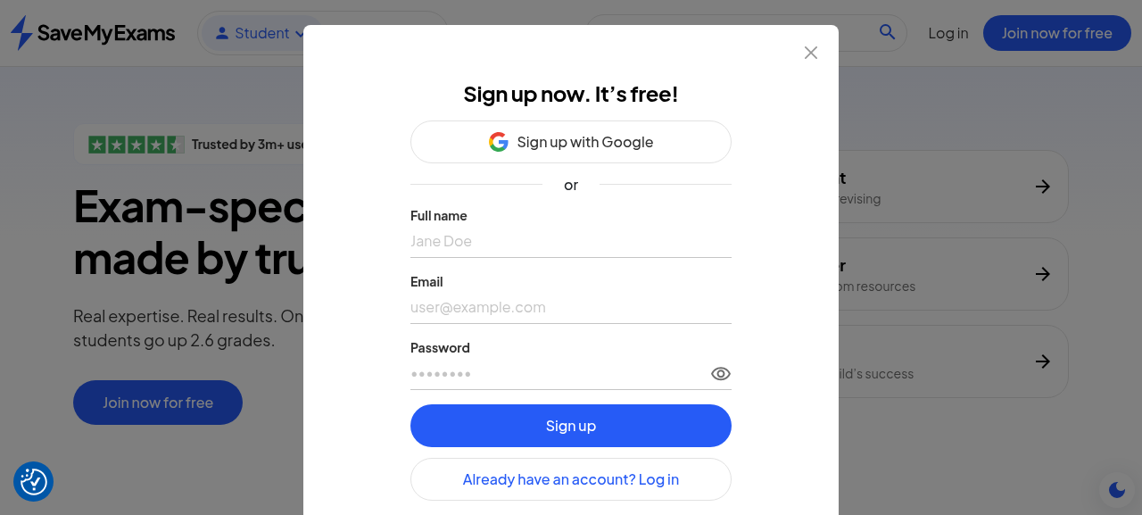
Figure 1. The signup modal: Google OAuth primary, three-field email form, no verification messaging.
Submitting the form transitions immediately to /welcome/about-you/ - the onboarding wizard - with no interstitial email-check screen. The absence of a verification wall was verified by behaviour rather than copy: the account was usable, course-aware and paywalled (in the monetisation sense) without ever opening a mailbox. The password policy accepted a generated 20-character mixed-alphanumeric string without friction.

4. The Onboarding Wizard
The post-signup wizard is a numbered, skippable pipeline that interleaves personalisation with persuasion. Its observed sequence, with the wizard's own progress indicator positions, is set out below. Two design choices deserve emphasis: the social-proof interstitial is placed inside the funnel (after persona selection) rather than before signup, and the wizard terminates on the pricing page rather than on a working surface, making the paywall the first 'product' screen a new user sees.
Step | URL | What it collects or shows
1. Persona | /welcome/about-you/ | Student / Teacher / Tutor / Parent-Guardian cards
2. Social proof | (same flow) | 3M-users banner with a review carousel; Continue
3. Marketing prefs | /welcome/marketing-preferences/ | Yes please / No thanks (declined in this session)
4. Personalisation | (continued) | Country + year group dropdowns; country pre-filled 'Hong Kong' by geo-IP default
5. Study goal | /welcome/your-goal/ | Top grades / confidence / understand topics / organisation; skippable
6. Exams | /welcome/your-exams/ | Multi-select levels (A Level, GCSE chosen)
7. Subjects | /welcome/your-subjects/ | Per-level subject pickers with exam-board sub-pickers and module options
8. School | /welcome/your-school/ | School-name autocomplete; skipped in this session
9. Study tools | /welcome/study-tools/ | Three-slide feature carousel (notes, topic questions, past papers)
10. Plan | /welcome/your-plan/ | Pricing page: the funnel terminus
Step 7 is the structurally interesting one. Subject selection is not a flat checklist: clicking a subject row expands an exam-board picker scoped to that subject and level (A Level Biology offered AQA, Cambridge CIE, OCR and an 'I'm not sure' fallback; A Level Maths added Edexcel; GCSE Biology offered AQA, Edexcel and WJEC). Choosing a board locks the radio group and marks the subject selected; A Level Maths additionally offered a module split (Mechanics, Pure, Statistics). This granularity means the account's very first session is already board-pinned per subject - the same curriculum-taxonomy discipline SyllabAI applies in its own content organisation - and it explains how later surfaces can route confidently between boards.
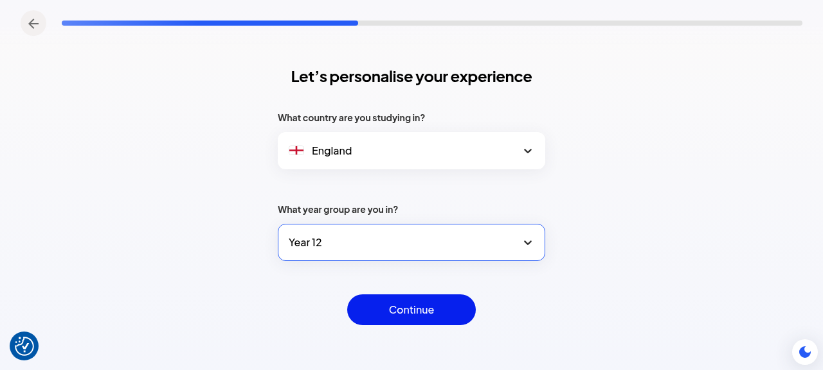
Figure 2. Personalisation step: country and year group dropdowns (geo-IP default observed).
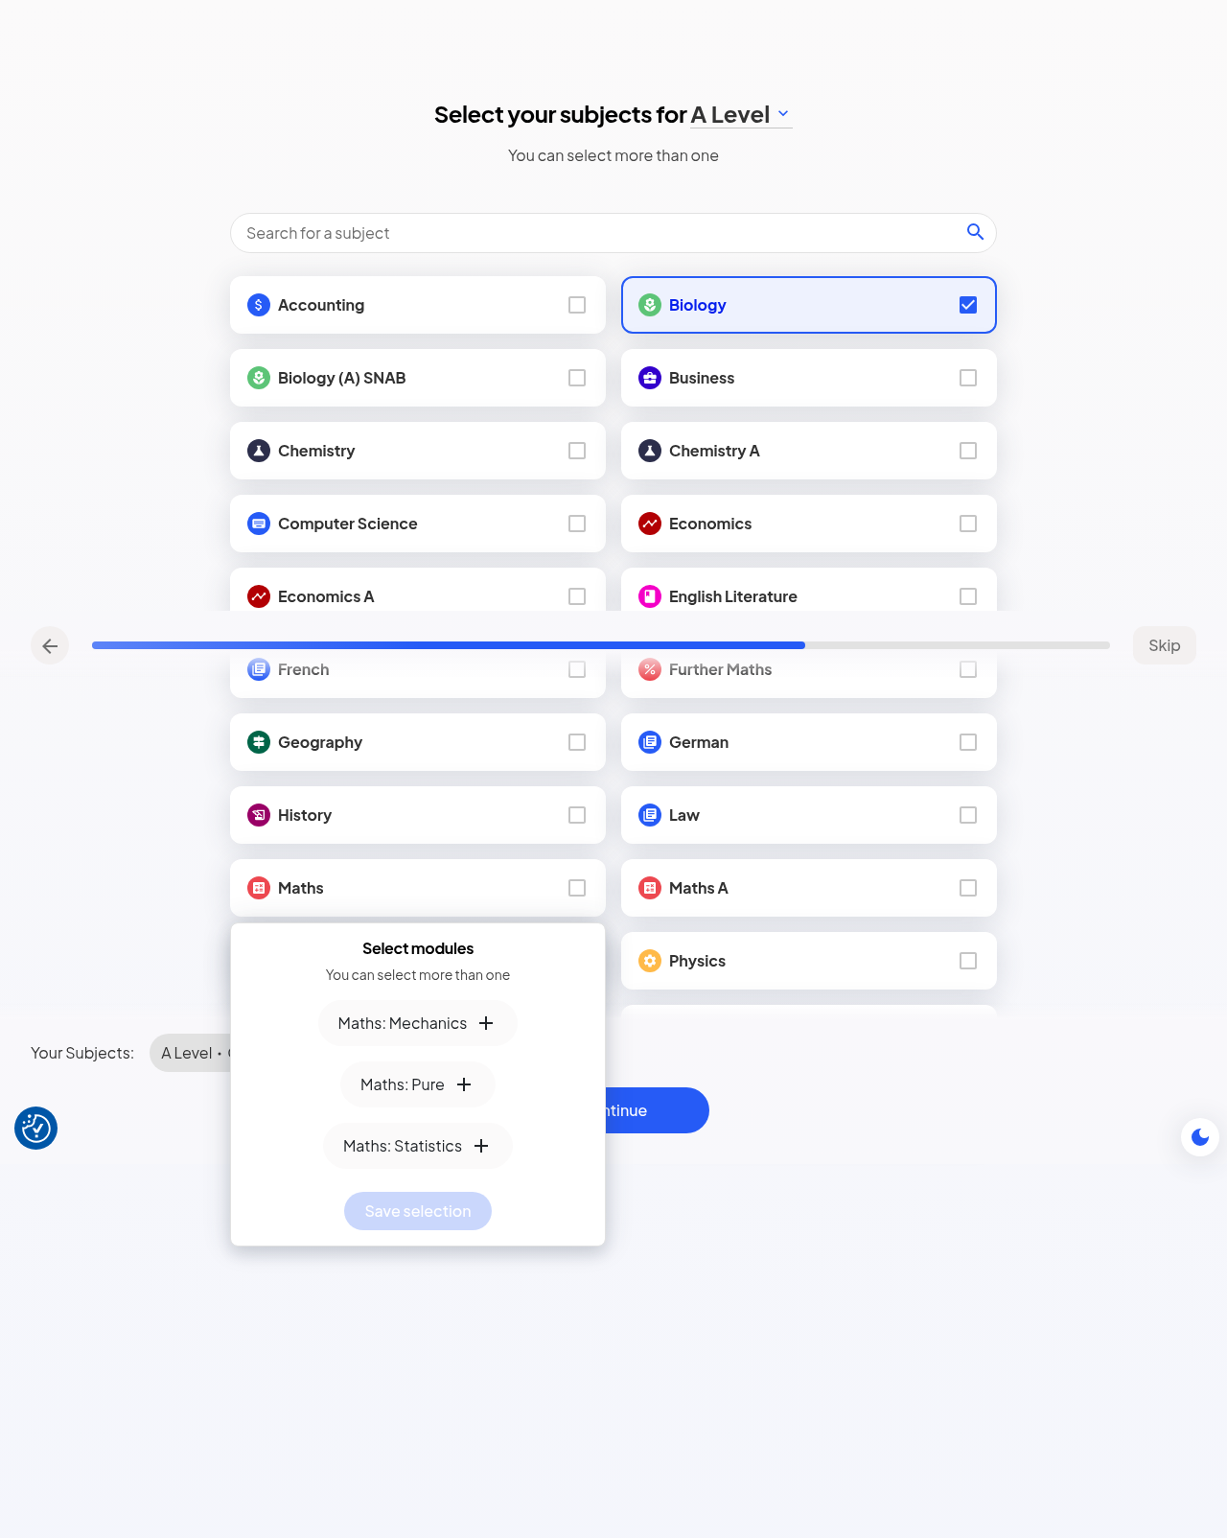
Figure 3. Subject step: board sub-pickers lock per subject (Biology CIE, Maths Edexcel); Maths modules listed.
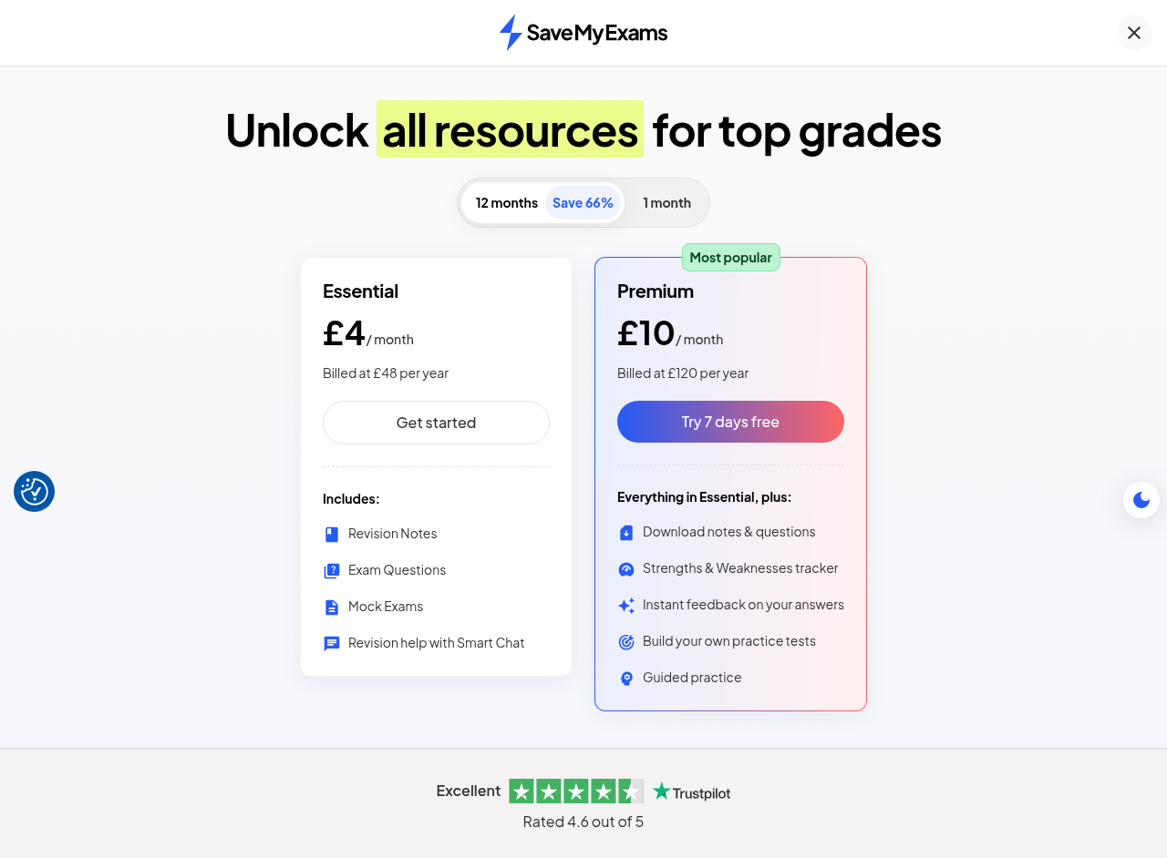
Figure 4. The wizard terminates on pricing: Essential and Premium cards, annual billing pre-selected.

5. Pricing of Record
The plan page offers a billing toggle with annual selected by default (a 'Save 66%' badge rewards the annual frame), two tiers, and a persistent seven-day free-trial hook on the Premium card. Prices observed on 2026-10-18 are reproduced below exactly as displayed. The Premium feature list is the platform's own framing of what the guided surfaces are worth, and it explicitly names Guided practice alongside the strengths and weaknesses tracker, instant feedback on answers, and test building - the four interactive capabilities this walkthrough then exercised on the free tier.
Table 1. Observed pricing (GBP), 2026-10-18
Plan | Annual (12 mo) | Monthly (1 mo) | Included (as displayed)
Essential | GBP 4 / month (billed GBP 48 / year) | GBP 11 / month | Revision Notes; Exam Questions; Mock Exams; Revision help with Smart Chat
Premium (most popular) | GBP 10 / month (billed GBP 120 / year); 7-day free trial | GBP 30 / month | Everything in Essential, plus: download notes and questions; Strengths & Weaknesses tracker; instant feedback on your answers; build your own practice tests; Guided practice
Two copy observations. The Smart Chat entry in Essential positions a conversational helper as a base-tier hook, while the genuinely adaptive-sounding capabilities are fenced into Premium. And the trial CTA ('Try 7 days free') is the only conversion path ever shown inside the product surfaces - it reappears in the header on every page and in the download wall documented in section 9.

6. Guided Study in Revision Notes (the core mechanic)

6.1 Entry points and the concept picker
Every revision-note page observed (sampled across A Level Biology OCR) carries a guided-study banner directly under the article header: 'Guided study available on this topic - Understand this topic with deeper explanations and understanding checks', with a Start guided study button, and the panel itself is badged Beta. Activating it opens an in-page panel that decomposes the note into numbered micro-lessons, each titled as a concept with a one-sentence 'This lesson teaches...' statement and its own Start button. The studied page (Studying Cells, exam code H420) decomposed into at least three concepts: 'Why Use Microscopes? Light Microscopy', 'Electron Microscopy: Higher Detail and Limitations', and 'TEMs and SEMs: Comparing Electron Microscope Images'. The decomposition reads as authored content structure rather than on-the-fly generation: lessons are stable, numbered, and phrased in the house style of the notes themselves.
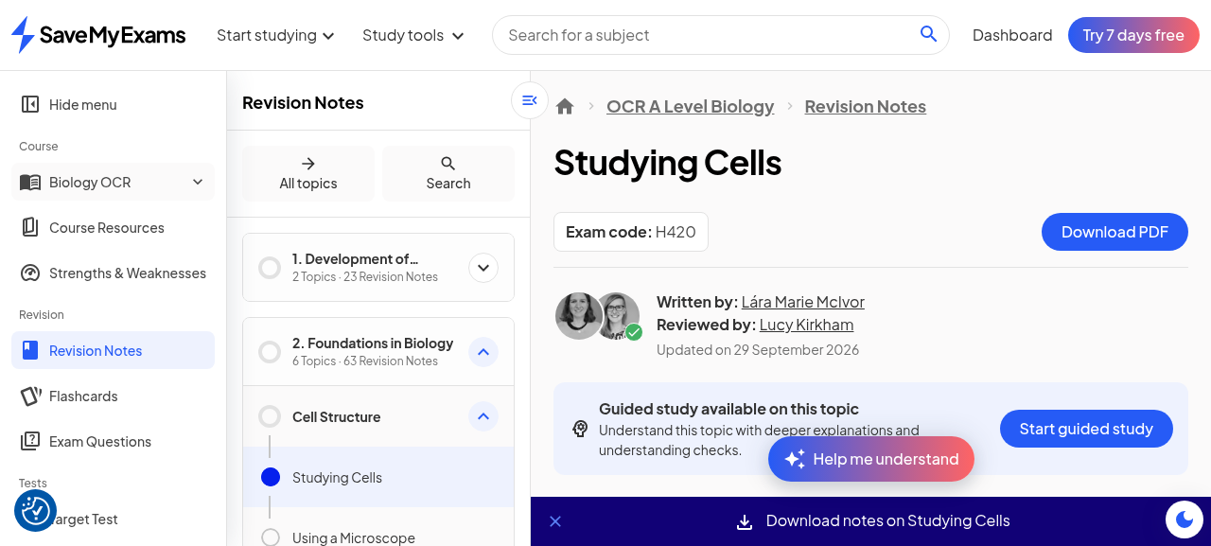
Figure 5. The note page header with the guided-study banner (Beta) and download CTA.
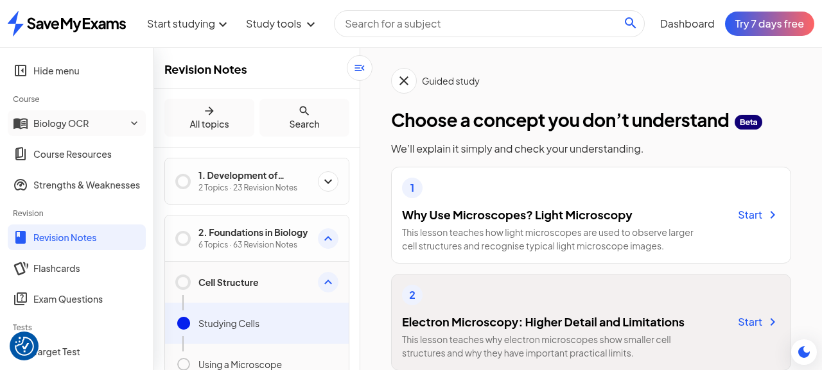
Figure 6. The guided-study panel: the note decomposed into numbered micro-lessons with per-lesson Start buttons.

6.2 The lesson loop: key points, confidence gate, layered plain-words
Entering a lesson does not leave the page; the note surface is replaced by a guided sequence. The first frame distils the concept into a 'Key points of understanding' list, then demands a self-rating - 'Select confidence level: Low / Medium / High' - before anything further is shown. Choosing Low (as this session did, to exercise the remedial branch) leads to a multi-stage 'In plain words' sequence: each Continue reveals one further pre-written layer that unpacks the concept in progressively applied detail (what microscopy is; how a light microscope forms an image; how resolution limits useful magnification; which structures are visible; practical advantages; a 'Helpful terms' glossary; and a worked image example). The branch is deterministic - the layers are fixed copy revealed stepwise, not generated per learner - yet the experience reads as adaptive because the learner's confidence choice controls how many layers are front-loaded before the check.
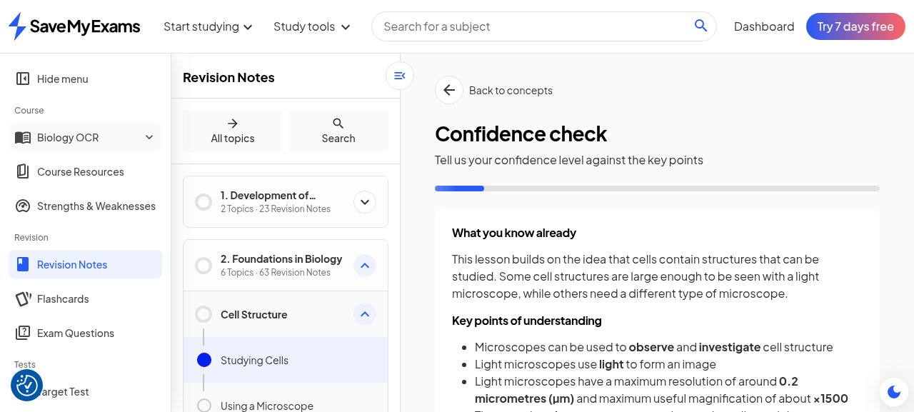
Figure 7. The confidence gate: key points distilled, then Low / Medium / High self-rating.
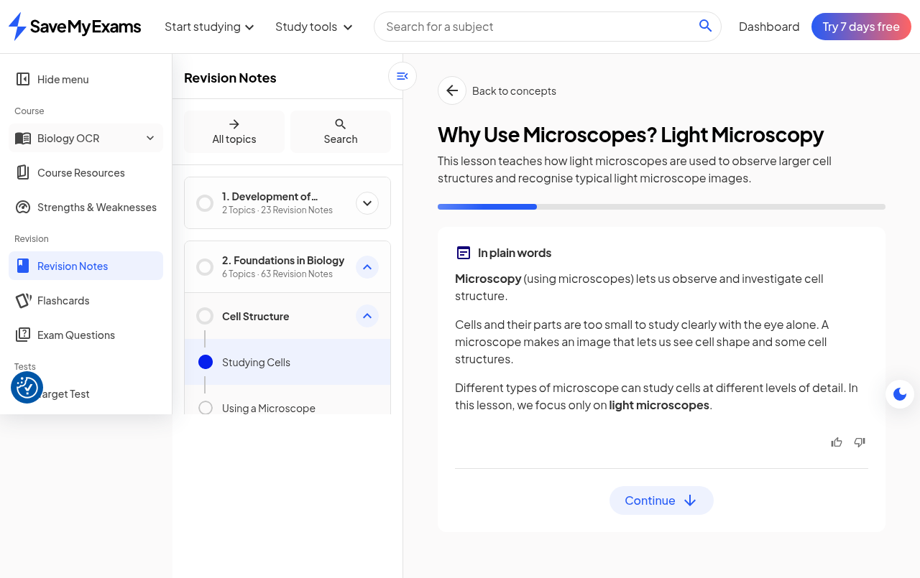
Figure 8. The Low branch: 'In plain words' layers revealed one Continue at a time.

6.3 The understanding check
After the explanation layers, a 'Check understanding' stage presents a five-question multiple-choice series ('Multiple choice, 1 of 5'), each question offering four options, a Submit answer action, a Review explanation action and a Next question action. Submitting a correct answer produced a confirmation with a thumbs-up glyph ('Great job!') followed by a full explanation of the correct option; the explanation text restates the underlying fact chain (resolution of about 0.2 micrometres implies useful magnification of about x1500) in the same register as the notes. Review explanation scrolls back to the lesson's explanation layers rather than opening a separate view - a small, effective reuse of the same content. The check ran to completion on the free tier with no wall, no counter and no trial prompt.
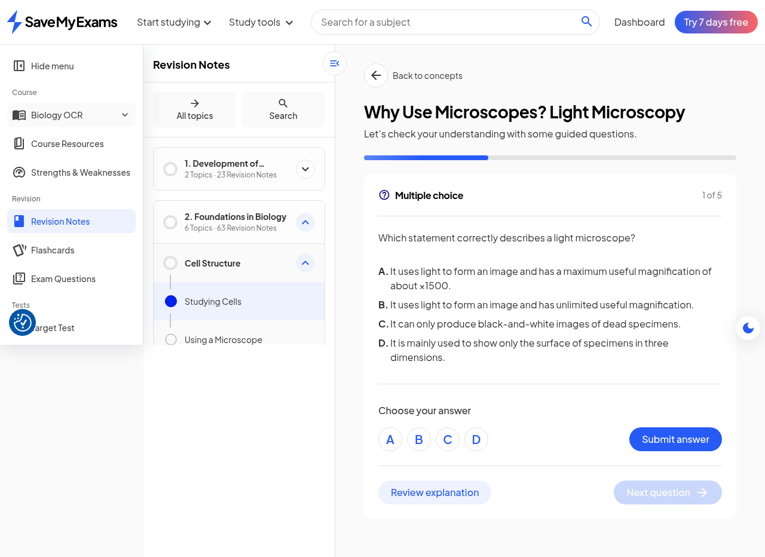
Figure 9. The understanding check: five guided multiple-choice questions.
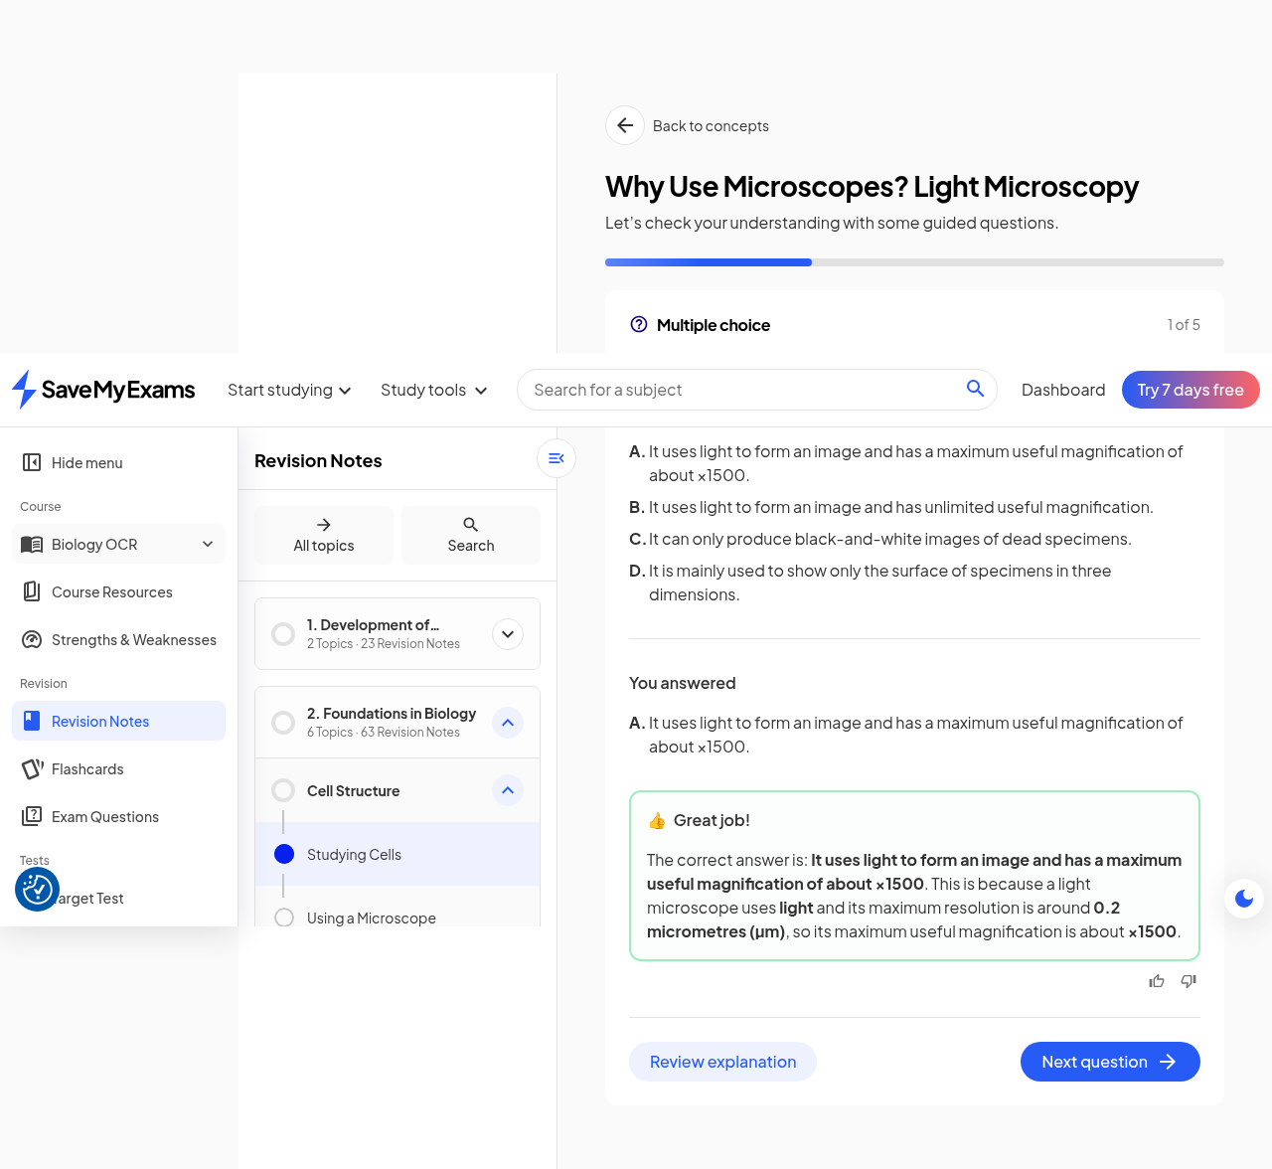
Figure 10. Per-option feedback after submission (correct-answer explanation; distractors each explained).

6.4 Pacing and interaction-cost observations
The observed lesson demanded roughly a dozen explicit interactions (confidence rating plus six or more Continue taps) before the first check question - a deliberately high engagement cadence that maximises session depth metrics and commits the learner to the format before any assessment. The trade-off is efficiency: a learner who already knows the concept must still step through the layers or rely on the confidence gate routing them quickly (the Medium and High branches were not exercised in this session and are recorded as unobserved). This pacing profile is a product decision worth noting for SyllabAI: self-rated confidence is the throttle, and the copy quality of the plain-words layers - not model intelligence - is what makes the remedial path feel personal.

7. Guided Practice in Exam Questions

7.1 The mode toggle and session launcher
On the exam-questions side, guided practice is a header-level switch on every topic page (sampled: Cell Structure, Structured Questions). Flipping it appends ?smart-practice=1 to the URL and swaps the page into a session launcher: counters for Questions, Score and Topic progress (initially 0, dash-percent and 0 percent), a 'How it works' panel promising (a) practise with all question types, (b) difficulty that adapts based on your answers, and (c) support when needed with personalised feedback, and a Start practising button. The same switch remains available to turn the mode off, returning the page to the static question bank.
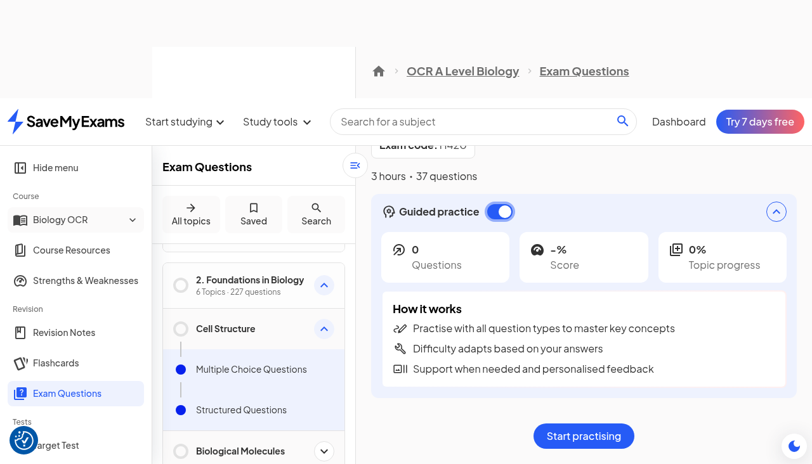
Figure 11. Guided practice ON: the adaptive-session launcher with counters and the 'How it works' panel.

7.2 The adaptive session
Start practising opens a question-at-a-time session. The first item served was a one-mark multiple-choice question with the standard four-option layout plus three elements worth copying: a Skip question control accompanied by learner-side difficulty tags ('Too easy', 'Too difficult', 'Not relevant') that feed the adapter with explicit signal rather than inference; and a session header whose counters updated after each answer (after one correct answer: 1 Question, 100 percent Score, Topic progress still 0 percent - implying topic progress is computed over the full 227-question topic bank, a long-horizon retention metric rather than a session metric). Answering produced the same per-option explanation pattern as the notes-side check: the correct option explained, then each distractor refuted in turn.
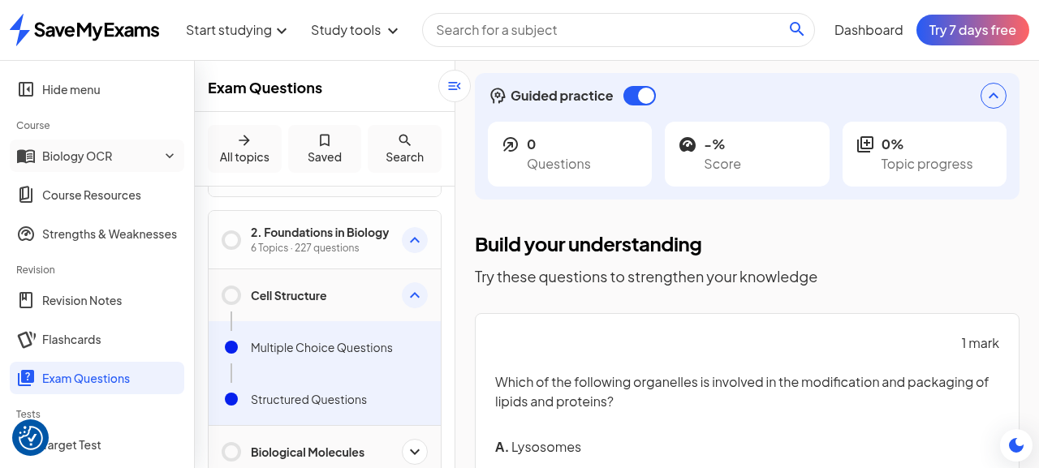
Figure 12. The adaptive session: one question at a time with skip + explicit difficulty tags.
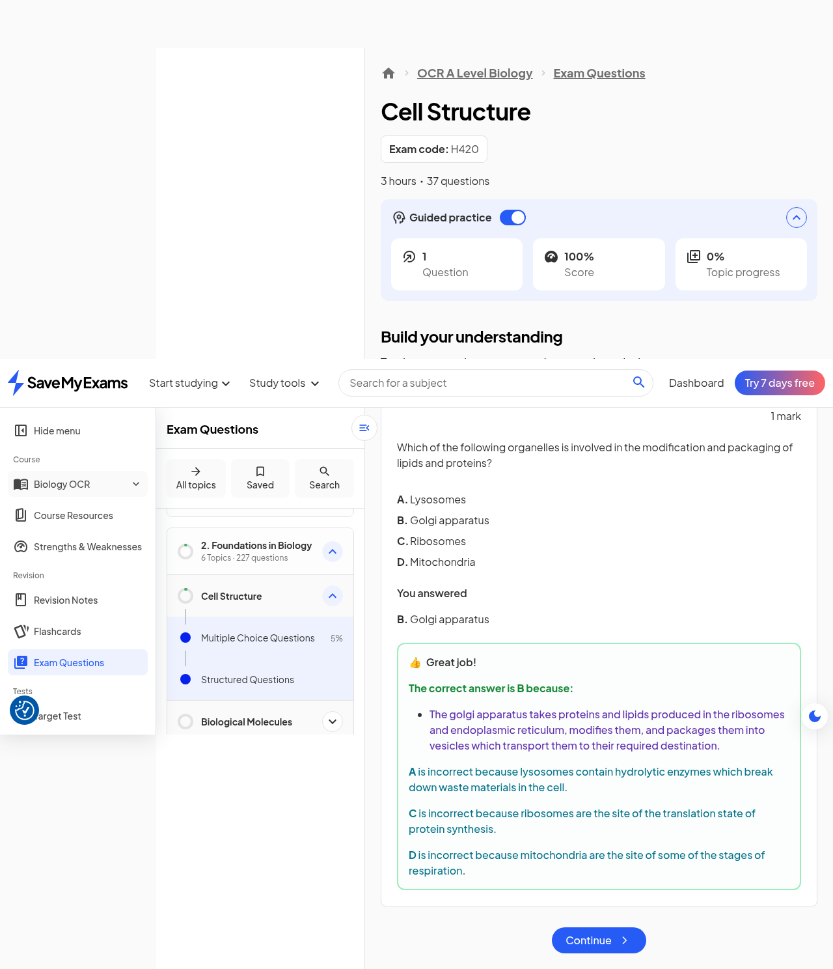
Figure 13. Post-answer feedback: per-option explanations in the session context.

7.3 Structured questions and Smart Mark
The session then served a five-mark structured question (identify structures A to E on a cell diagram) rendered with a rich-text answer field (a TipTap editor) offering Insert equation, Write and Upload input affordances - the upload path implying photo-of-work marking. The 'Smart Mark my answer' action submits the freeform answer to the platform's marking engine. The result returned in this session: a mark (1/5), a per-structure breakdown crediting and correcting each labelled part by name ('For structure E, you correctly identified the Golgi apparatus [1 mark]'), a 'Was this feedback helpful for improving your answer?' micro-survey, and View answer / Continue actions. This is genuine automated marking of extended answers, live on the free tier, and it is the strongest technical capability observed in the walkthrough.
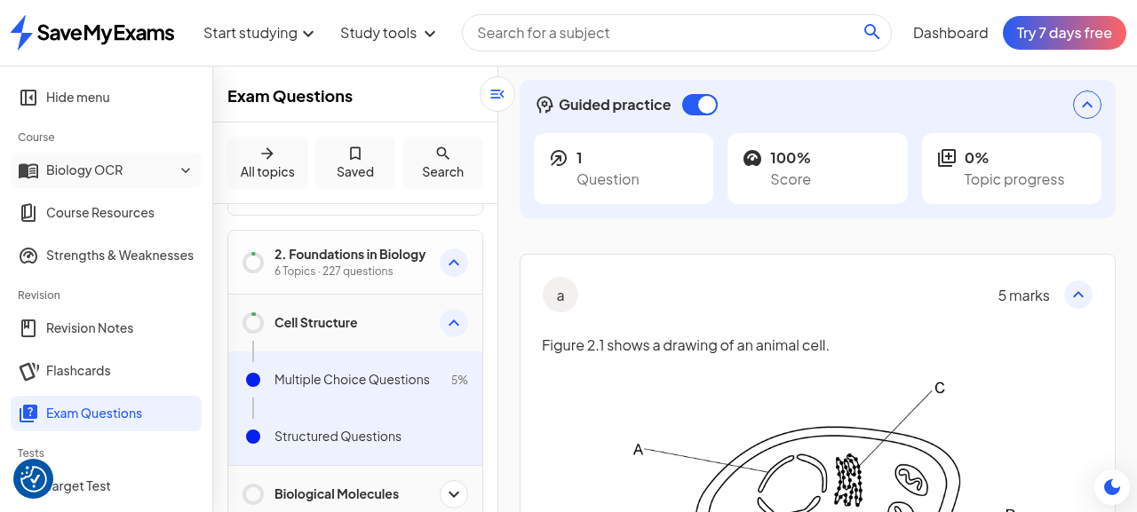
Figure 14. The structured question: marks scheme, rich-text answer with equation/upload affordances, Smart Mark action.
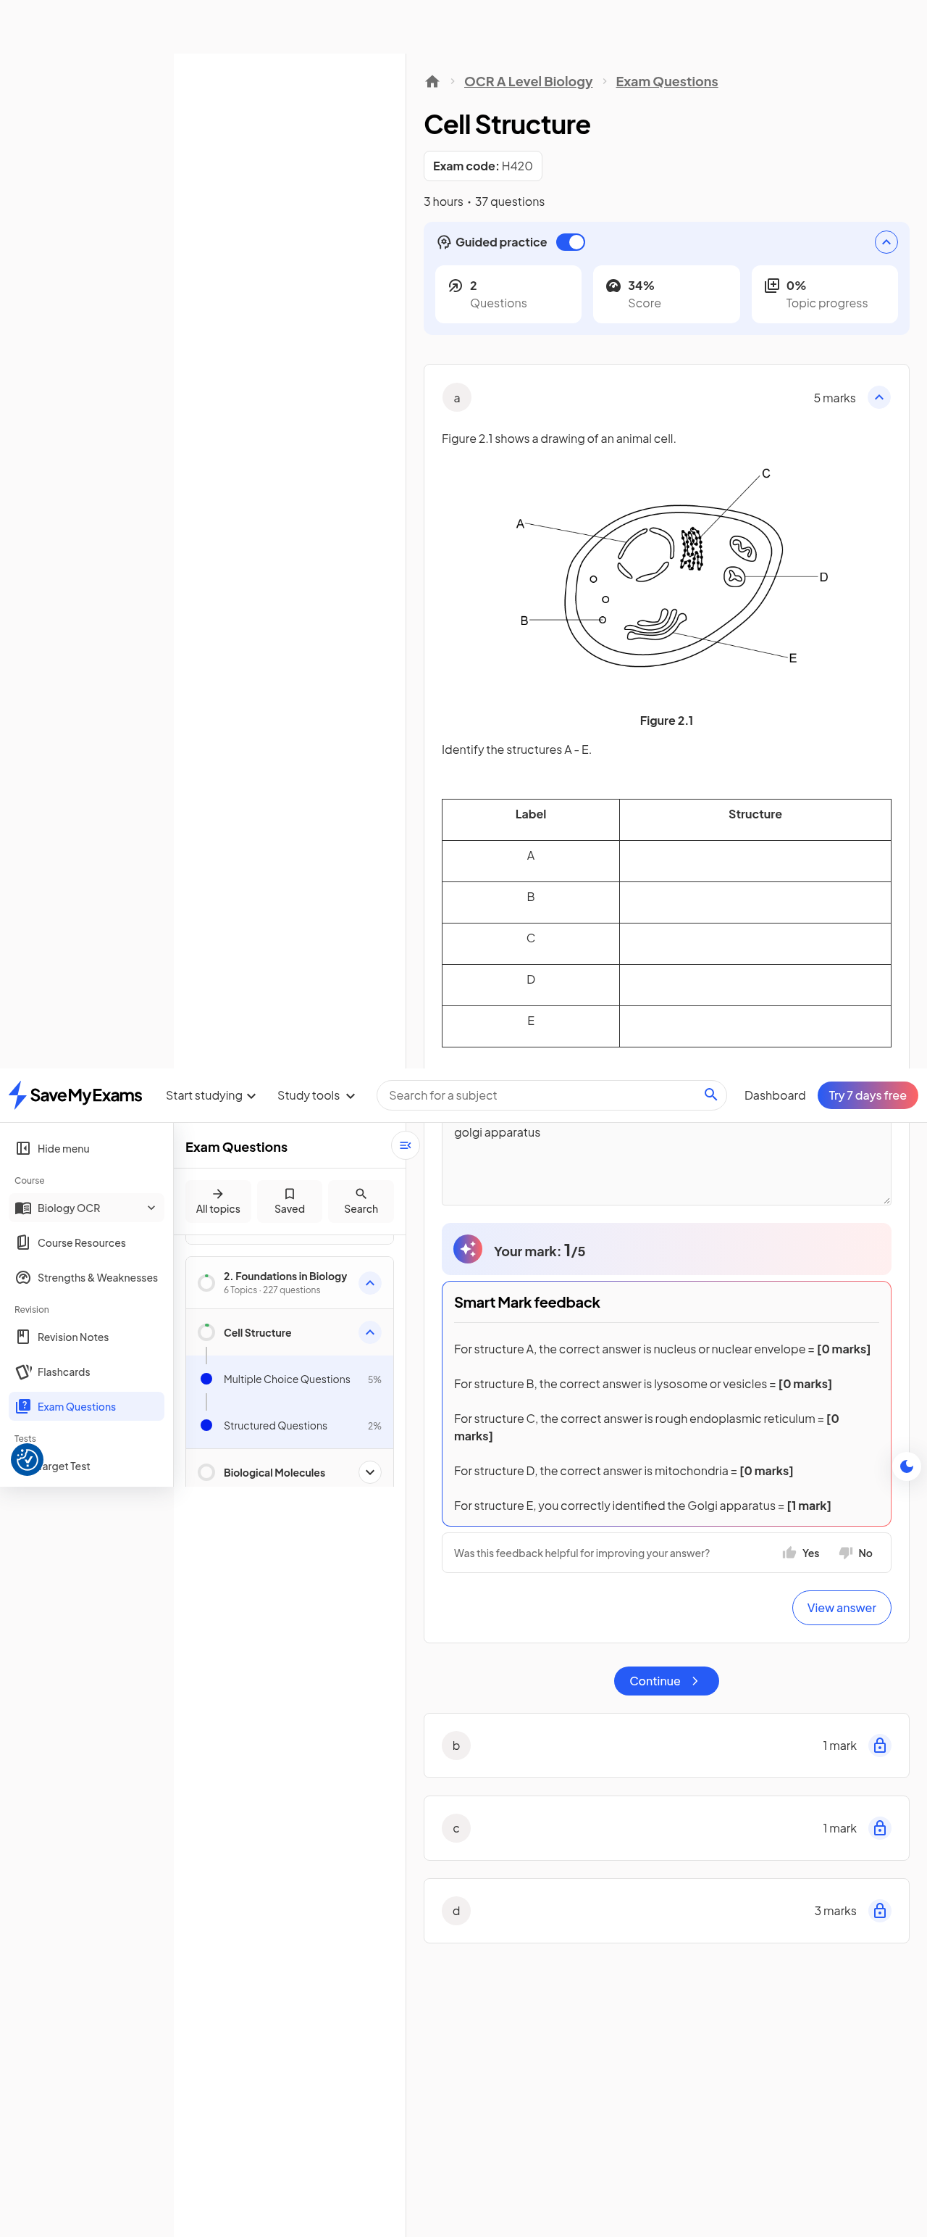
Figure 15. Smart Mark result: 1/5 with per-structure feedback and a helpfulness micro-survey.

8. The Target Test Builder
Target Tests are personalised generated assessments, reachable from the study-tools menu and from a per-course Target Tests page. The builder is a three-step in-page flow: (1) choose topics from the course's topic tree; (2) personalise - question type multi-select (Multiple choice, Short response, Extended response, Calculation, Diagram-based), difficulty multi-select (Easy, Medium, Hard), a test-length slider (5 to 120 minutes), and a timer setting; (3) launch, with two exits: Launch test (online, timed) and Launch as PDF (offline). Launching with minimal settings produced a generated assessment at a per-assessment URL within seconds, serving generated questions in sequence ('[1 mark] ... Answer and continue') under an 'OCR A Level Biology Target Test' header. As with the other interactive surfaces, no paywall interposed itself at launch on the free tier.
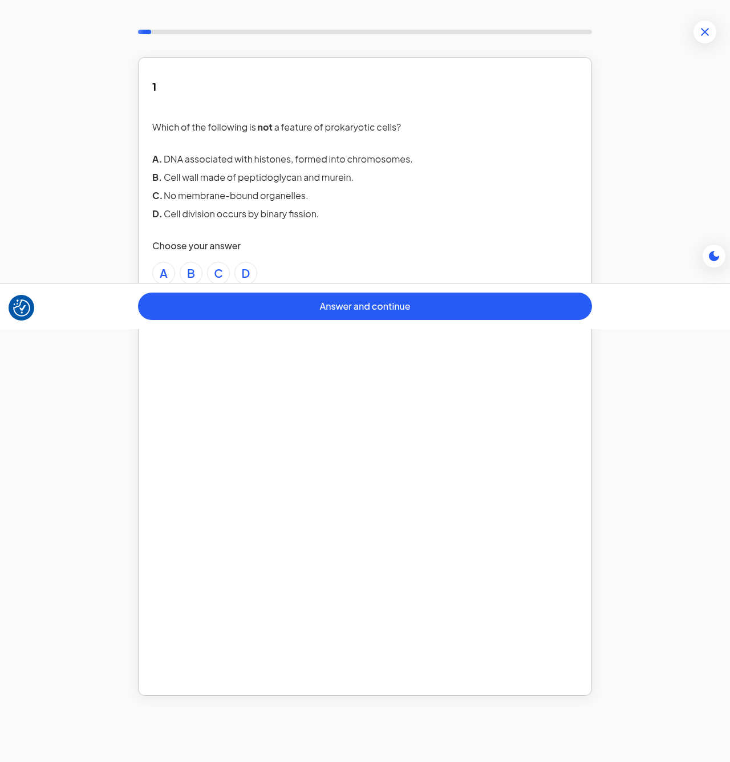
Figure 16. The generated Target Test: a per-assessment URL serving sequenced generated questions.

9. Gating: Where the Paywall Actually Bites
The session exercised every surface the pricing page reserves for Premium, and none of them enforced a wall. The single hard gate encountered was PDF downloading on a revision-note page: the Download PDF action opens a 'Download all revision notes' dialog whose only forward path is 'Start your 7-day free trial', with a 'download a free sample' link as the pressure-release escape. The dashboard also carries a persistent 'Try 7 days free' header CTA and an 'Add grades' affordance on course cards, but the interactive guided surfaces themselves were open. The capability-by-capability position of record is set out below.
Table 2. Free-tier behaviour of record, 2026-10-18 session
Capability | Plan copy position | Observed free-tier behaviour
Guided study (notes) | Not explicitly listed | Fully open (Beta badge); concept picker, confidence gate, layered explanations, 5-question checks
Guided practice (questions) | Premium | Fully open; adaptive session launched and served MCQ + structured items
Smart Mark (AI marking) | Instant feedback on your answers (Premium) | Fully open; 5-mark structured answer marked 1/5 with per-part feedback
Target Test builder | Build your own practice tests (Premium) | Fully open; generated test launched and served
Strengths & Weaknesses | Premium | Marketing hub open; per-topic breakdown data not surfaced to the free session
PDF downloads | Download notes and questions (Premium) | Hard wall: trial-conversion modal with free-sample escape
Signup / onboarding | Free | No verification wall; full access immediately
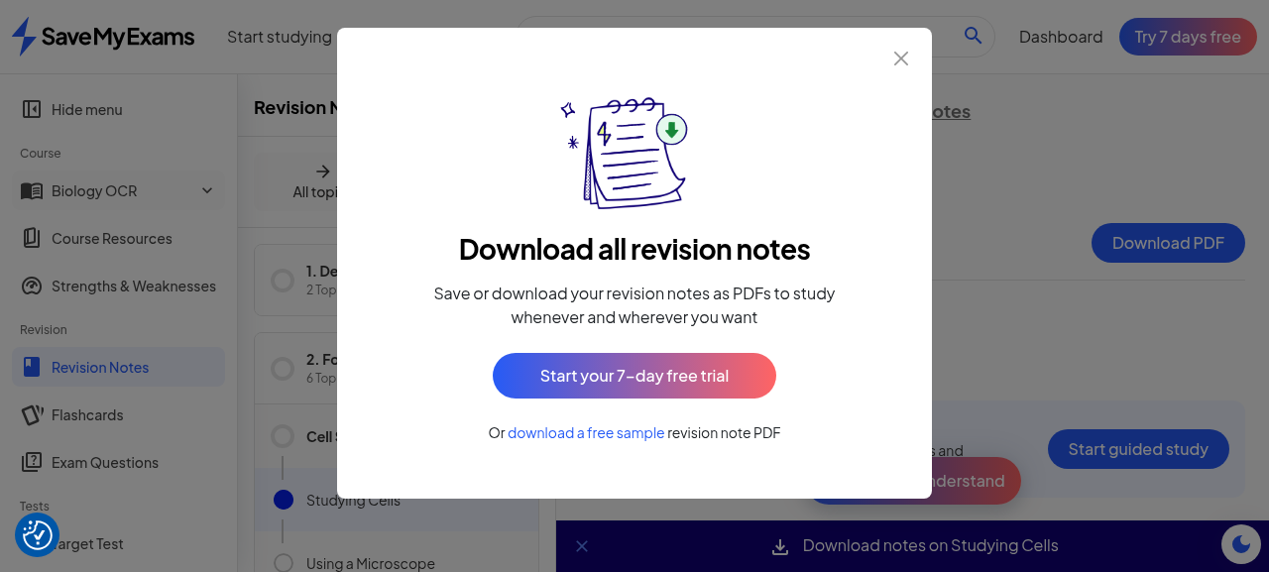
Figure 17. The one hard wall: the download dialog routes to the 7-day free trial.
The most economical reading: interactive features are open in this beta window to maximise engagement data and habit formation, while the enforced boundary sits on the capability whose value survives outside the platform (portable PDFs). Whether free access to Smart Mark and Target Tests is a permanent posture or a metered limit that simply was not reached in one session cannot be determined from a single pass; a follow-up session after sustained use would settle it. For competitive analysis purposes, though, the present experience is that SyllabAI's entire guided-loop equivalent is currently available on the target at zero cost.

10. Product Analysis and Implications for SyllabAI

10.1 The guided-learning pattern is content engineering, not model engineering
The observed mechanic decomposes into five reusable moves: (a) split a note page into concept-sized micro-lessons with teach-statements; (b) distil each into key-point lists; (c) gate progress on a self-rated confidence level; (d) serve pre-written layered re-explanations whose depth follows the rating; (e) close with a short check whose feedback explains every option. None of the five requires a live language model in the serving path - the adaptivity is a routing rule over authored layers. That is the strategic insight for SyllabAI: our existing notes corpus, already structured to the topic and sub-topic level with board-pinned questions and tiered citations, can carry the same pattern with modest authoring-tooling investment (a decomposition editor and a layer format), and the confidence gate is an honest, low-latency adaptivity proxy that avoids per-learner generation cost.

10.2 Where genuine AI sits: marking and the open question of chat
Two capabilities in the observed product do imply real inference: Smart Mark's marking of extended structured answers (per-part credit against a mark scheme, tolerant to phrasing) and the Essential-tier Smart Chat helper (not exercised in this session). These are the natural premium perimeter because they carry unit cost and their quality is defensible. SyllabAI's own tutor-chain work - grounded, citation-bearing answers with refusal laws and honest-unavailable states - is already positioned to exceed the observed marking experience if wrapped in the same per-part, mark-scheme-anchored presentation. The presentation itself (per-structure credit lines, helpfulness micro-survey, view-answer escape) is worth adopting wholesale: it converts a mark into feedback a learner can act on.

10.3 Funnel and monetisation lessons
Three funnel choices look deliberate and effective: verification is skipped entirely (lowest possible time-to-value; the account is born inside the product); the onboarding wizard collects board-level curriculum identity per subject (making every later surface board-accurate from minute one); and the wizard terminates on pricing so the plan frame precedes the first working session. The monetisation architecture separates portable value (PDFs - hard-walled) from engagement value (interactive loops - open during beta), which grows usage data and habit while keeping an enforced upgrade path. The pricing frame itself (annual pre-selected with a save badge, 7-day trial as the only in-product CTA, 'most popular' flag) is conventional but consistently executed. If SyllabAI adopts a guided tier, the counterpart decision - what to open and what to wall - should be taken with this data point in hand: the target currently walls only portability, not intelligence.

10.4 Recommended follow-ups
- Prototype the decomposition layer over one SyllabAI note topic (key points, confidence gate, two plain-words layers, one check) and time-to-build the authoring cost.
- Adopt the per-part marking presentation for structured questions (credit lines per mark point + helpfulness prompt) on top of the existing marking chain.
- Revisit the target after 4-6 weeks to observe whether free access to guided practice and Smart Mark persists or metering appears (a second session on the same account is the cheapest probe).
- Track the Beta badge: the guided-study surface is explicitly labelled beta, so the mechanic may still be in flux; re-walk one note page each month.
- Exercise the Medium and High confidence branches and the Smart Chat helper, which this session did not observe, before any architecture commitment.

Appendix A. Walkthrough Step Index
The table below maps the principal steps of the session to the evidence files in the accompanying screenshot set (all files in the sme-guided-learning-walkthrough directory; filenames zero-padded in walk order). Full-page captures are marked (f).
Table 3. Step index (abridged; 55 captures in total)
Stage | Evidence files
Homepage and signup modal | 01 (f), 02, 03
Onboarding: persona, social proof, marketing, personalisation | 04 (f), 05, 06, 07, 08
Onboarding: goal, exams, subjects + boards, school, tools carousel | 09, 10, 11, 12 (f), 13, 14, 15-17
Pricing terminus (annual and monthly) | 18 (f), 19
Dashboard and study-tools menu | 20 (f), 21
Notes surfaces and guided study | 22, 23, 24, 25, 26-32, 33, 34, 35, 36
Exam questions, guided practice session, Smart Mark | 37, 38 (f), 39 (f), 40, 41 (f), 42, 43 (f), 44, 45, 46 (f)
Target tests and the download wall | 47, 48, 49, 50, 51, 52 (f), 53

Appendix B. Evidence Inventory and Session Hygiene
Evidence set: 55 PNG captures plus this document, all under download/sme-guided-learning-walkthrough. Screenshots were taken by the automation session in walk order and were not retouched; page-visible text quoted in this record was transcribed from the same captures. The walkthrough was conducted on a disclosed research identity (syllabai.research.r4b@gmail.com; the generated password is stored separately with restricted permissions and is not reproduced in this record). No payment instruments were provided to the target, no content was bulk-downloaded, and the session's footprint is limited to ordinary single-user browsing: account creation, onboarding, and the interactive surfaces exercised by hand.
Caveat of record: all observations are of one session on 2026-10-18 on the free tier; Save My Exams badges the guided-study surface as beta, and both copy and enforcement may change without notice. Statements in this document about Premium behaviour are grounded in the platform's displayed plan copy and wall modals, not in a paid session.

