S Y L L A B A I R E S E A R C H S E R I E S
Product
Probes:
Pass 5
Save My Exams — Mock Exams, Flashcards & Strengths & Weaknesses
Lane: R4-api-b · SyllabAI v2 strangler-fig migration
Account: free-tier research account (single-account caveat)
Evidence: screenshots 167-198 · capture date 2026-10-19
Pipeline: docx-js R1/WM-1 · add_toc_placeholders · postcheck

SyllabAI · SME research series 2026-10-19

Table of Contents
Executive Summary
Executive Summary 1
Method, Scope and Account Posture 1
Strengths & Weaknesses 2
Entry surfaces and the landing narrative 2
The Strength score mechanic 3
Sorting, filtering and the score taxonomy 3
The threshold-unlock attempt: a disclosed negative result 4
Flashcards 5
Hub and the three-bucket taxonomy 5
Deck anatomy 6
The player loop 6
Player filters and navigation 7
Persistence proof 8
Mock Exams 8
Hub: sets and paper structure 8
The paper front-cover reproduction and the timer 9
Paywall boundaries: start, download, answers 10
Cross-Tool Synthesis 11
SyllabAI Implications Delta (DC-8 to DC-12) 11
Evidence Index 12
Residuals and Caveats 12

Note: This Table of Contents is generated via field codes. To ensure page number accuracy after editing, please right-click the TOC and select "Update Field."

Executive Summary
This addendum records the fifth first-hand exploration pass of savemyexams.com in the SyllabAI research series, covering the three surfaces named in the operator instruction: Mock Exams, Flashcards, and Strengths & Weaknesses (S&W). All work was performed on the same free-tier research account used in passes 1-4, on 2026-10-19, with the session restored from saved auth state after a workspace-snapshot regression wiped the local automation artefacts (auth state and dimensions cache) but not the evidence directory. Thirty-two new screenshots (files 167-198) were captured into the established evidence directory, continuing the file numbering of the previous passes.
Three headline findings emerge. First, Strengths & Weaknesses is a real analytics product, not a marketing stub: it computes a per-topic 1-5 strength score that unlocks only after at least ten questions have been answered in that topic, fed exclusively from the three assessment surfaces (Exam Questions, Target Tests and Mock Exams). The tool exposes two distinct no-data states, default weakest-first sorting and a four-way topic filter taxonomy (Weaker / Improving / Stronger / No topic score). Second, Flashcards is a full mastery-state ledger rather than a static card list: every card carries a tri-state classification (Still learning / Know / Revisit) that persists server-side, together with the resume position inside a deck, and the in-player filters combine card state with lesson scope. Third, Mock Exams is the strongest premium anchor observed to date on this property: the free tier receives an authentic exam-cover reproduction with a live countdown timer, but the questions themselves are never rendered, and the trial modal gates start, download and answers alike.
The pass also contributes a persistence proof for the flashcard state machine (ratings and deck position survive a full page reload), a disciplined negative result on the S&W threshold-unlock attempt (an invisible cookie-consent modal and accessibility-tree virtualisation defeated scripted answering this pass, while the equivalent interactive flow was already proven in pass 4), and five new SyllabAI design implications numbered DC-8 to DC-12, continuing the lineage established in the Smart-Chat/Mark design spec.

Method, Scope and Account Posture
The pass followed the established round-opening checklist. Secrets under /home/z/my-project/.secrets/ were verified present with 0600 permissions; the syllabai-v2 clone was fetched first and fast-forwarded to origin/main (ab6ba58) with a clean working tree. The workspace had again been restored from a stale snapshot: the SME auth state (scripts/sme/auth.json) and the dimensions cache (dims.json) were gone, while the 177-file evidence directory survived intact. This recurring regression class was disclosed in earlier passes and was remediated the same way: fresh login from the 0600-protected credential file (values never printed), followed by an immediate re-save of the browser auth state.
Login on savemyexams.com succeeded without any verification wall, re-confirming the property generalisation recorded in pass 2. One interface detail worth logging: the login page hosts a modal dialog with its own field set, and filling the underlying page fields first does nothing; the dialog fields must be filled and submitted. After login the browser landed on /members/ and the saved state was refreshed for future passes.
Probing was conducted with the agent-browser headless CLI, alternating accessibility snapshots, JavaScript evaluations for state reads (bucket counters, CSS class evidence such as Flashcard_flipped, dialog text) and full-page screenshots. Free-tier posture was respected throughout: no paid action was taken, no trial was started, and every paywall boundary encountered was documented rather than bypassed. The only DOM interventions were removal of covering consent widgets so that underlying controls could be clicked, and these are disclosed inline where they mattered.

Strengths & Weaknesses

Entry surfaces and the landing narrative
Strengths & Weaknesses is a first-class entry in the student study-tools navigation, listed between Smart Mark and Flashcards. Its global URL, /study-tools/strengths-and-weaknesses/, serves a marketing landing rather than the tool itself: the hero promise is "Strengths & Weaknesses to focus on what counts", supported by three benefit bullets (see S&W by topic; know what to revise aligned with your exam spec; save time by focusing only where it counts), a "Why students love our Strengths & Weaknesses guidance" section with three card headings (Direction you can trust; See your progress; Beat the overwhelm), and a three-step usage guide. The Explore button on the landing is only an anchor to the #resources section of the same page, not a link into the tool.
The usage guide is mechanically informative and is quoted here because it states the data-flow contract of the whole feature. Step 1, Answer questions: "Work through our examiner written Exam Questions, Target Tests and Mock Exams. Each attempt builds a picture of your performance across topics." Step 2, Check your breakdown: "At the end of tests and in your course overview, see a clear breakdown of your Strengths & Weaknesses by topic and subtopic." Step 3, Focus your revision: target weak areas first. The landing therefore commits the product to two display surfaces (end-of-test and course overview) and three feeding surfaces (Exam Questions, Target Tests, Mock Exams).
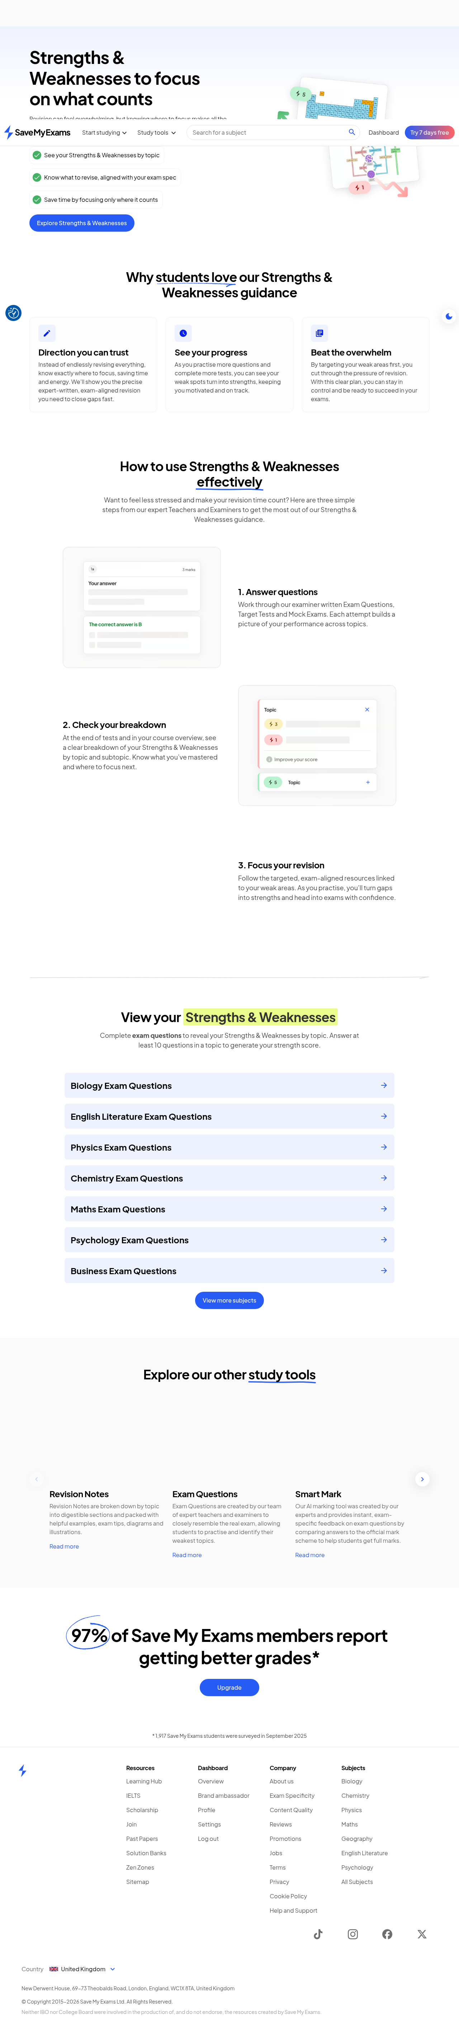
Figure 1. S&W marketing landing (full page): hero promise, benefit bullets, three-step usage guide.

The Strength score mechanic
The tool itself lives inside the course context at /a-level/biology/cie/25/strengths-and-weaknesses/, reachable from the course overview page and from a third course tab labelled Strengths & Weaknesses alongside Revision and Tests. The page is headed "Strength score" with the defining rule quoted verbatim: "Progress through exam questions and see your strengths and weaknesses by topic. Answer at least 10 questions in a topic, via Exam Questions, Target Tests or Mock Exams, to get a strength score." A three-item scale legend runs alongside the list: 1 = Lowest, 5 = Highest, and a third chip, No score, for topics without enough data.
For the research account, which had answered roughly two to three questions in a single topic during pass 4 and none anywhere else, the topic list rendered twenty-two visible rows in two clearly differentiated states. The touched topic (The Microscope in Cell Studies) shows the state "Score not yet unlocked" with the sub-copy "Answer more questions to unlock your strength score" and expands to its sub-topic list. Every other topic shows "Score not available" with no unlock hint. The distinction matters: the product separates partial progress (engagement exists, threshold not met) from zero engagement, which is exactly the primitive a re-engagement system needs.
State | Trigger | Copy shown | Reading
Score not yet unlocked | Some attempts recorded in the topic, fewer than 10 | "Answer more questions to unlock your strength score"; row expands to sub-topics | Partial engagement; positive nudge framed as unlock, not failure
Score not available | No attempts recorded in the topic | "Score not available" | Zero engagement; no nudge copy at all
Score 1-5 | At least 10 attempts in the topic | Numeric chip on the 1-5 scale | Mastery estimate per topic, classified by the filter taxonomy
No score (legend) | Threshold unmet or insufficient spread | Legend chip beside 1 Lowest / 5 Highest | Explicit third state in the scale legend
Table 1. The four data states of the Strength score list as observed on a near-empty account.

Sorting, filtering and the score taxonomy
The list ships with two controls. The sort dropdown defaults to "Sort by weakest first" and offers exactly three orders: Weakest first, Strongest first and Course order. The filter button carries a badge with the count of active filters (Filters [4]) and exposes four checkboxes, all checked by default: Weaker topics, Improving topics, Stronger topics and No topic score. The filter labels reveal the classifier that sits on top of the raw 1-5 score: a topic is not just scored, it is bucketed into weaker / improving / stronger, implying a trajectory component (direction of travel) in addition to the level component, plus the explicit no-score bucket.
Cross-referencing pass 4: the teacher persona flip exposed the same strength-score page with the same 10-question threshold, 1-5 scale, weakest-first sort and filters, so the surface is persona-invariant; what changes under the teacher persona is the surrounding chrome, not the analytics. The paid posture is also on record: the pricing page names the "S&W tracker" as a Premium feature, yet on the free tier the tool is fully visible with real (mostly empty) account data and no trial modal fired at any point during this pass. The monetisation boundary for S&W, if enforced anywhere, was not encountered on this account.
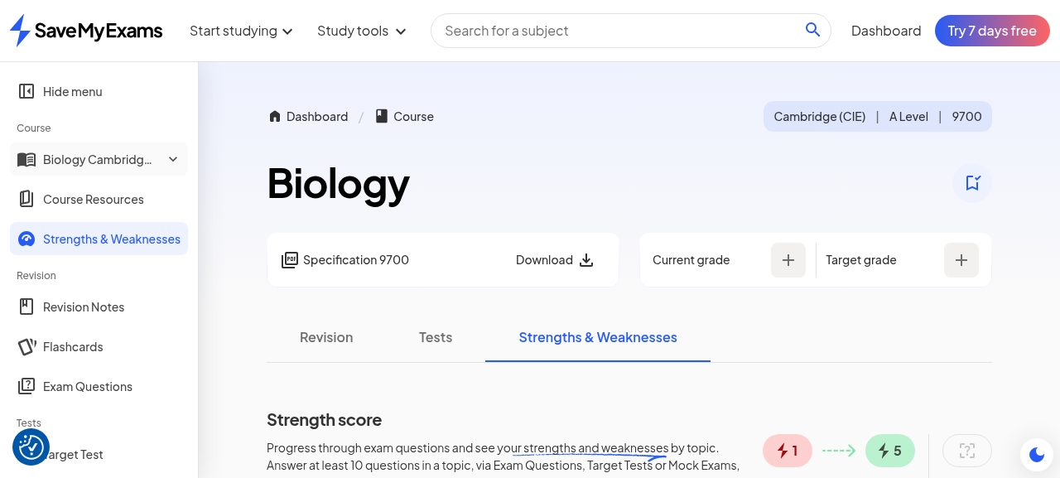
Figure 2. Course-level S&W tool: Strength score heading, threshold copy, 1-5 / No-score legend.
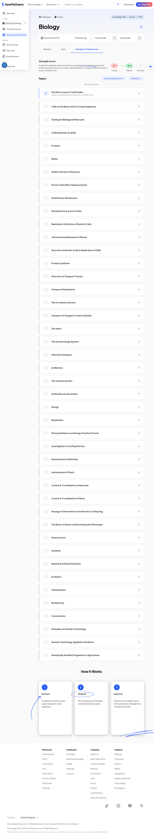
Figure 3. Topic list (full page): "Score not yet unlocked" on the touched topic vs "Score not available" elsewhere.
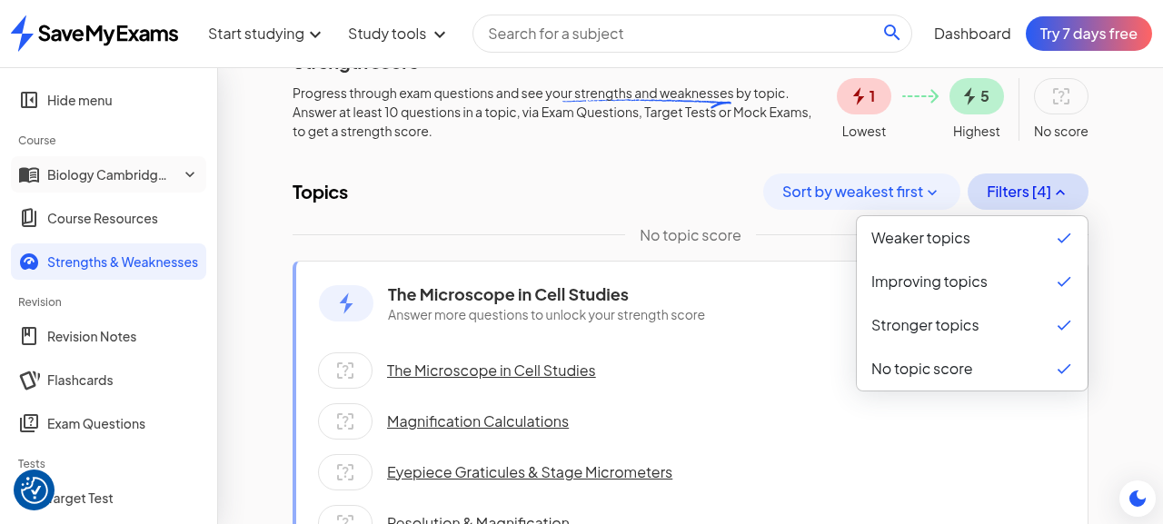
Figure 4. Filter dropdown: Weaker / Improving / Stronger / No topic score (all checked) beside the sort control.

The threshold-unlock attempt: a disclosed negative result
The natural next step was to cross the 10-question threshold in the touched topic and observe a real score. The MCQ question set for topic 1 (2 Topics, 89 questions) exposes Easy/Medium/Hard tabs with a numbered question strip, and the first question was already answered in pass 4 (its option buttons render disabled with a green fill and a New answer affordance). Scripted answering of questions 2 onward was attempted with JavaScript-driven click sequences: navigation to each question succeeded (the URL gains a hash such as #easy-2), but option selection never registered in React state, and two root causes were identified. First, an invisible CookieYes consent modal (class cky-modal, "Opt-out Preferences") remained in the DOM as a fixed, high-z-index layer that intercepted pointer events even while visually undetectable; it was found by geometry scan and neutralised. Second, after the interventions the question area stopped appearing in the accessibility tree altogether (virtualised or aria-suppressed), so trusted element clicks could not be re-targeted reliably either.
The attempt is filed as a negative result with two mitigations. The interactive MCQ flow itself (select option, Submit, green fill, praise card, per-statement reasoning, New answer) was already proven first-hand in pass 4 on the same surface, so no behavioural knowledge is lost; and the S&W mechanic is documented from its own UI copy and both no-data states, which is the design-relevant part. The residual is that a real 1-5 score has not yet been observed populated; it remains available to any future pass willing to answer ten questions manually through the browser, roughly ten minutes of interaction.

Flashcards

Hub and the three-bucket taxonomy
Flashcards is the next entry below Strengths & Weaknesses in the study-tools navigation, and the course-level hub sits at /a-level/biology/cie/25/flashcards/. The hub opens with three aggregate state chips, each pairing a label with an emoji and a live count: "Still learning 🤔", "Know 😃" and "Revisit 💭", each rendered disabled while the count is zero. Below the chips, the hub lists every sub-topic as a deck row grouped under its topic heading, each row carrying a progress bar (all zero for this account) and a card-count-prefixed link such as "0 The Microscope in Cell Studies".
The taxonomy is the same tri-state vocabulary that the Smart Chat pitfalls prompt used when it rendered an in-voice flashcard in pass 2 (misconception items offered to Flashcards with a dual hook), which confirms the buckets are the product-wide currency of flashcard mastery rather than a local invention of one screen. The presence of a third bucket, Revisit, distinct from Still learning, implies a scheduling semantics (cards to come back to, rather than cards being learned); the pass did not observe a card enter Revisit, so its trigger is logged as unconfirmed.
Bucket | Emoji | Observed semantics | Set by
Still learning | 🤔 | Card not yet mastered; counted on hub chip and player filter | Learner pressing "Still learning" after seeing the back
Know | 😃 | Card self-assessed as known; count incremented immediately | Learner pressing "I know this"
Revisit | 💭 | Cards queued to come back; no observed transition this pass | Unconfirmed (no card entered it)
Not viewed yet | — | Default state; exposed only in the player filter | Absence of any rating
Table 2. Flashcard mastery buckets as observed; the first three render as hub chips with emoji and counts.
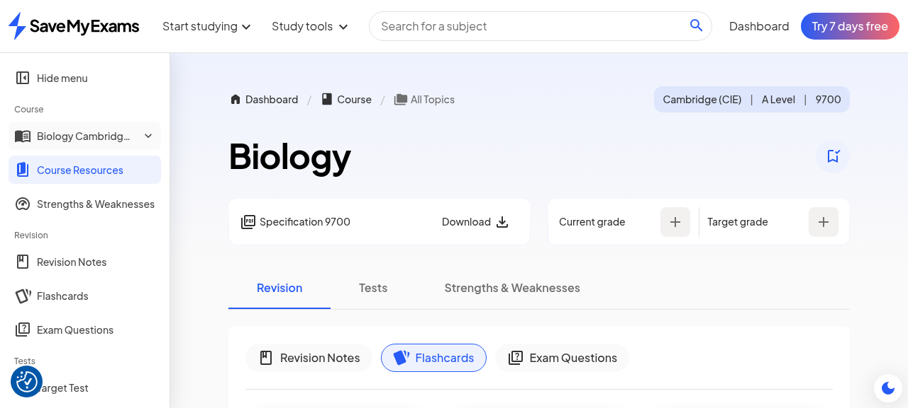
Figure 5. Flashcards hub: tri-state chips (disabled at zero) and per-subtopic deck rows with progress bars.

Deck anatomy
A deck page (URL pattern /flashcards/1-cell-structure/1-1-the-microscope-in-cell-studies/) carries a sidebar tree of all sixteen course topics with per-topic progress bars and topic question counts, an All topics shortcut and a deck search. The deck under study aggregates the five lessons of sub-topic 1.1: The Microscope in Cell Studies, Magnification Calculations, Eyepiece Graticules & Stage Micrometers, Resolution & Magnification and Calculating Actual Size. Its size, read from the player header after the first rating, is 33 cards. A sticky "Start studying" button anchors the top of the page and opens the player; before any rating the player header reads 1/33 and the aggregate chips read zero.
Card content is two-sided question/answer in the classic sense, with at least two observed formats: direct questions ("Why must a specimen be thin for viewing with a light microscope?" with back "So that light can pass through it, allowing the specimen to be seen clearly.") and cloze/true-false items ("A biological drawing should use sharp, continuous lines with no ____." back "...no shading."; "True or False? A specimen must..."). This matches the authored-corpus posture of the rest of the property: the decks are authored per sub-topic, not generated from the learner's chat history, while the chat-to-flashcard hook (pass 2) routes authored cards rather than synthesising bespoke ones.
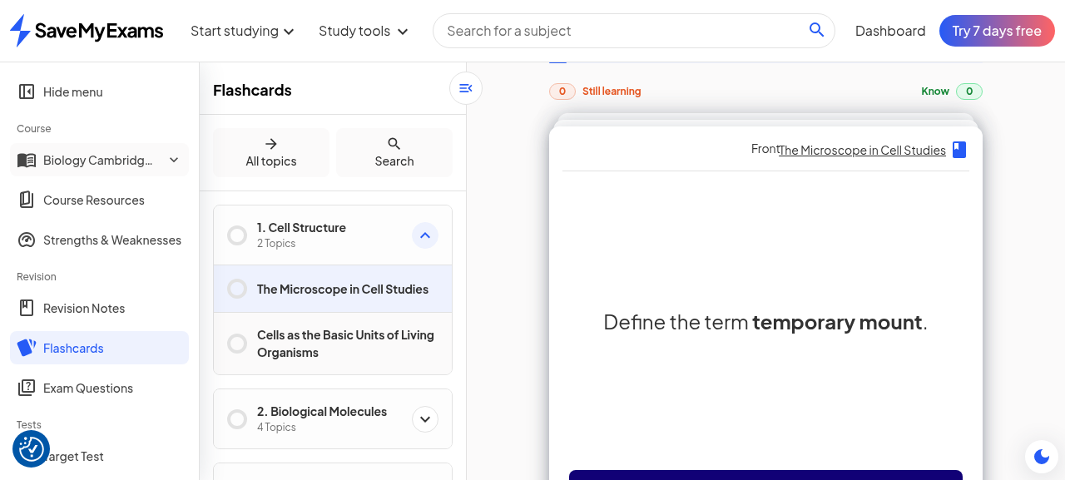
Figure 6. Deck page: sidebar tree with progress bars; 1.1 deck aggregating five lessons.

The player loop
The player presents one card at a time with the front face up and an explicit affordance labelled "Click on the card to flip it" (confirmed as the aria-label of the card button). Flipping adds the class Flashcard_flipped to the card container (read directly from the DOM) and reveals the back. Below the card sit three controls: Previous flashcard, Still learning and I know this. Rating with I know this advanced the header counter from 1/33 to 2/33 and incremented the Know chip to 1; rating the next card ("Define the term temporary mount.") with Still learning incremented that chip to 1 without advancing mastery anywhere else. A "Go to next topic" link is present in the player chrome, giving the loop an exit into the next deck once the learner is done.
Two design details deserve recording. The rating controls are always visible, including on the front of the card, so a learner can rate from recall before flipping; this is a deliberate self-testing affordance, and it means the product trusts the learner to rate honestly rather than forcing answer-then-rate. And the previous-card control makes the loop reversible, which pairs with the write-once-per-card semantics implied by the buckets: ratings can be revised by navigation even though the bucket update happens at press time.
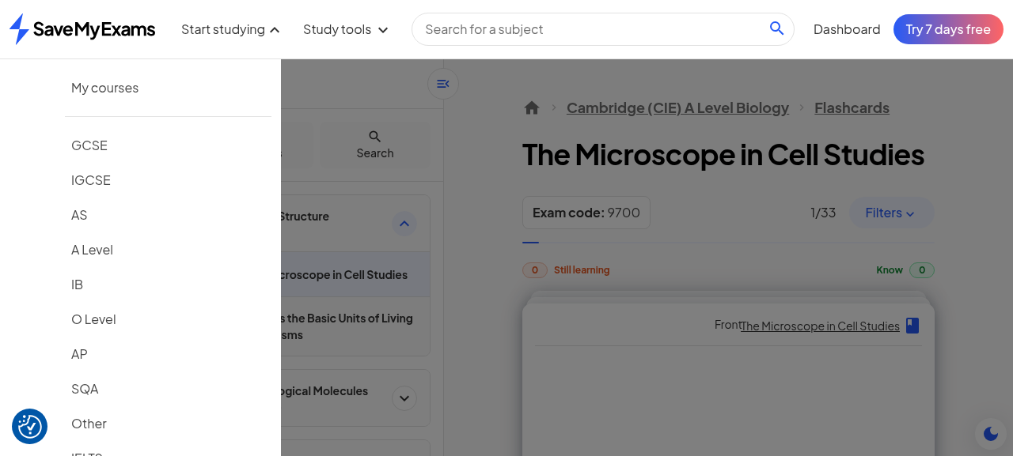
Figure 7. Card front with flip affordance and rating controls visible before flipping.
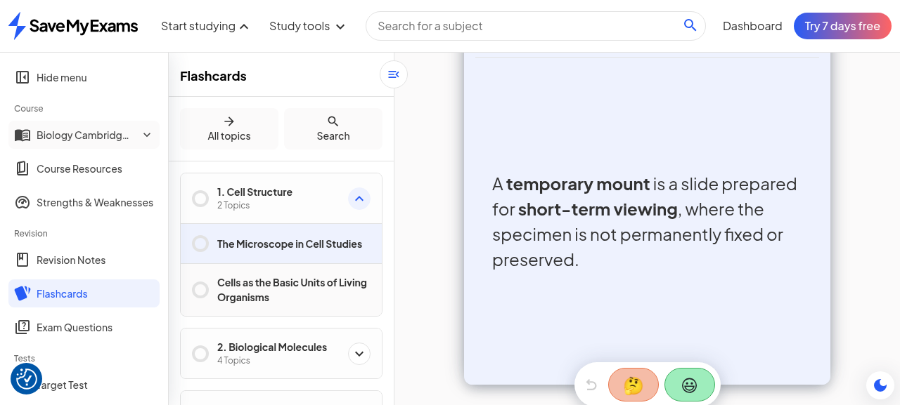
Figure 8. Card after flip: DOM class Flashcard_flipped set; back face answers the front question.
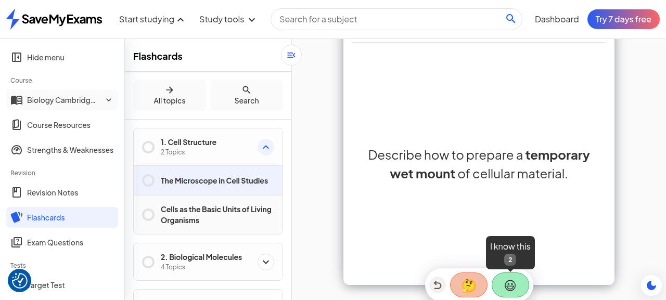
Figure 9. After rating: header 2/33, Know chip at 1; next card front "Define the term temporary mount."

Player filters and navigation
The player header carries a Filters button whose dropdown exposes two filter families simultaneously: card state (Not viewed yet, Still learning, I know this) and lesson scope (one checkbox per lesson contributing to the deck, all five of sub-topic 1.1 listed by name). This means the deck is not an atomic unit but a query over cards, and the learner can, for example, re-run only the cards they failed last time, or drill a single lesson. The question-number strip seen on Exam Questions sets has no direct equivalent here; instead the header fraction (2/33, later 3/33) plus the Previous control serve as position memory.
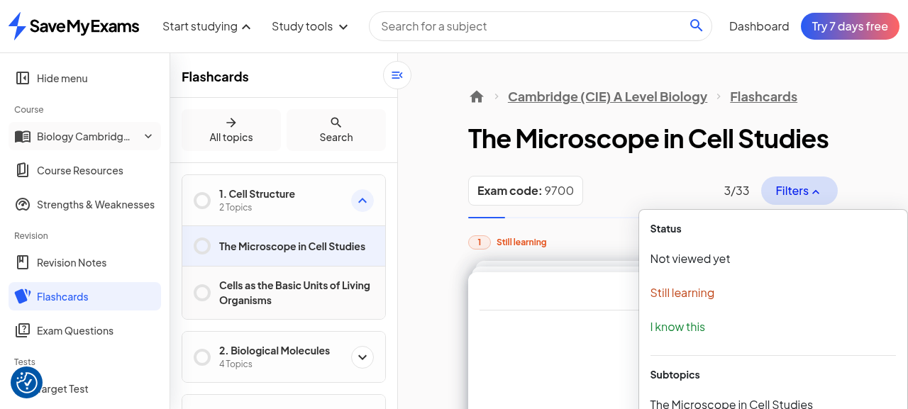
Figure 10. Player Filters: card-state family (Not viewed yet / Still learning / I know this) plus per-lesson family.

Persistence proof
To determine whether the mastery state lives in the client session or on the server, the deck page was fully reloaded after the two ratings. The state survived completely: the header resumed at 3/33 (the position the pass left off at), and both aggregate chips (Still learning 1, Know 1) were correct after reload. Deck position and per-card buckets are therefore server-side persisted for the account, not session-local; the resume behaviour additionally means a learner returning to a half-finished deck continues where they stopped rather than restarting. Screenshot 198 records the post-reload state.
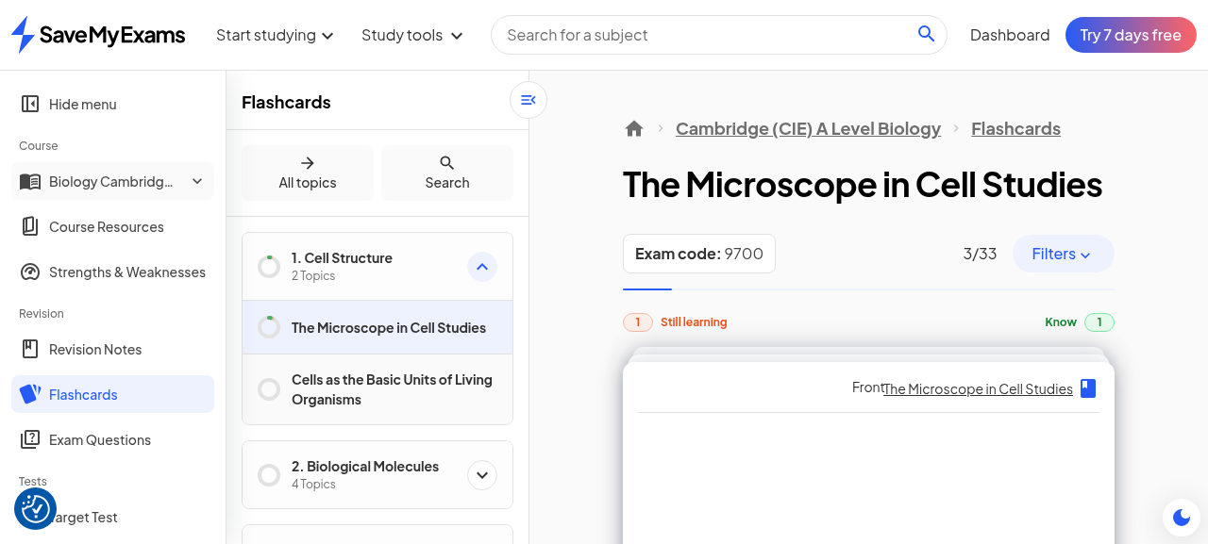
Figure 11. Post-reload deck state: 3/33 position and both bucket counts survive (server-side persistence).

Mock Exams

Hub: sets and paper structure
Mock Exams sits at the top of the Tests group in the course navigation, above Target Test and Past Papers. The course hub at /a-level/biology/cie/25/mock-exams/ organises the material into two sets, labelled Set A and Set B, each containing the full five-paper CIE assessment structure: Paper 1: Multiple Choice; Paper 2: AS Level Structured Questions; Paper 3: Advanced Practical Skills; Paper 4: A Level Structured Questions; and Paper 5: Planning, Analysis and Evaluation. Every paper row renders a state chip, "Paper not started" on this account, and three affordances: View paper (the interactive surface), a dropdown button for downloading, and View answers. The URL slug for Set A is set-1, a small label/slug divergence worth knowing for deep links.
Paper (per set) | Format | Observed metadata
Paper 1: Multiple Choice | 40 MCQs, one mark each | Total 40 marks; 1 hour 15 minutes; four options A-D; cover reproduced on free tier
Paper 2: AS Level Structured Questions | Structured questions | Listed with same state chip; not opened this pass
Paper 3: Advanced Practical Skills | Practical skills paper | Listed; not opened this pass
Paper 4: A Level Structured Questions | Structured questions | Listed; not opened this pass
Paper 5: Planning, Analysis and Evaluation | Planning/evaluation | Listed; not opened this pass
Table 3. Mock exam matrix: two sets x five CIE papers per course; Paper 1 opened and characterised first-hand.
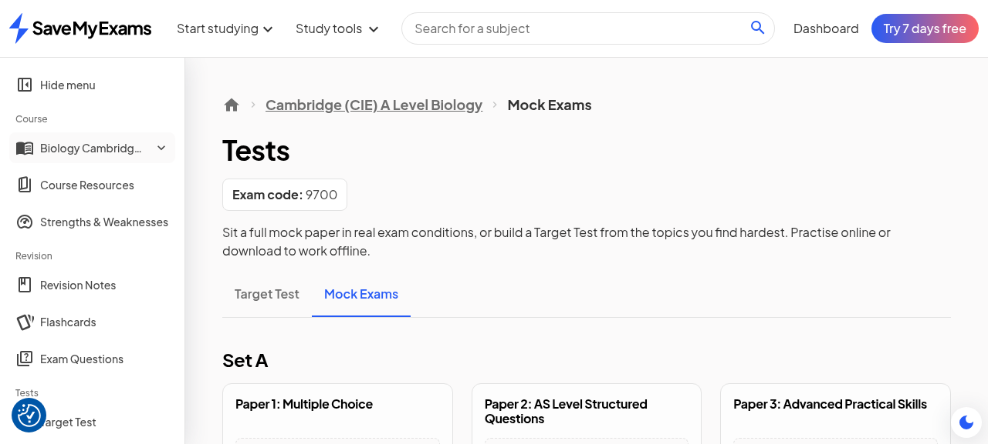
Figure 12. Mock Exams hub: Set A/B, five papers each, "Paper not started" chips, View paper / Download / View answers.

The paper front-cover reproduction and the timer
View paper opens an intro page for "Set A Paper 1: Multiple Choice Mock Exam" carrying the authentic front-matter of the CIE paper: "Answer all questions"; "For each question there are four possible answers A, B, C and D, choose the one you consider correct"; "The total mark for this paper is 40"; "Each correct answer will score one mark"; a Materials list (scientific calculator, pencil); and a note suggesting scrap paper for longer questions. One line is the marking promise of the surface and deserves verbatim status: "DON'T FORGET! Submit your paper at the end to receive marks and review your answers - using AI, mark schemes or solutions." The same page introduces the timer with a dismissible tooltip: "The countdown starts automatically to help you track time; it won't affect your exam when it ends. Press to hide it anytime.", with a Got it acknowledgement and a Hide timer control.
Pressing Start renders the exam view, and the fidelity is the point: it is a reproduction of the official exam cover, down to "Candidate Surname", "Other names", "Centre Number", "Candidate Number" fields, the paper title "Cambridge (CIE) A Level Biology Paper 1: Multiple Choice (Set A)", the dated session line "Monday 19 October 2026, Morning (Time: 1 hour 15 minutes)", and a "Total Marks / 40" box. The countdown rendered live at 01:15:00 and was observed ticking. The simulation posture is deliberately exam-like rather than quiz-like; combined with the auto-starting timer, the surface trains sitting a paper, not revising a topic.
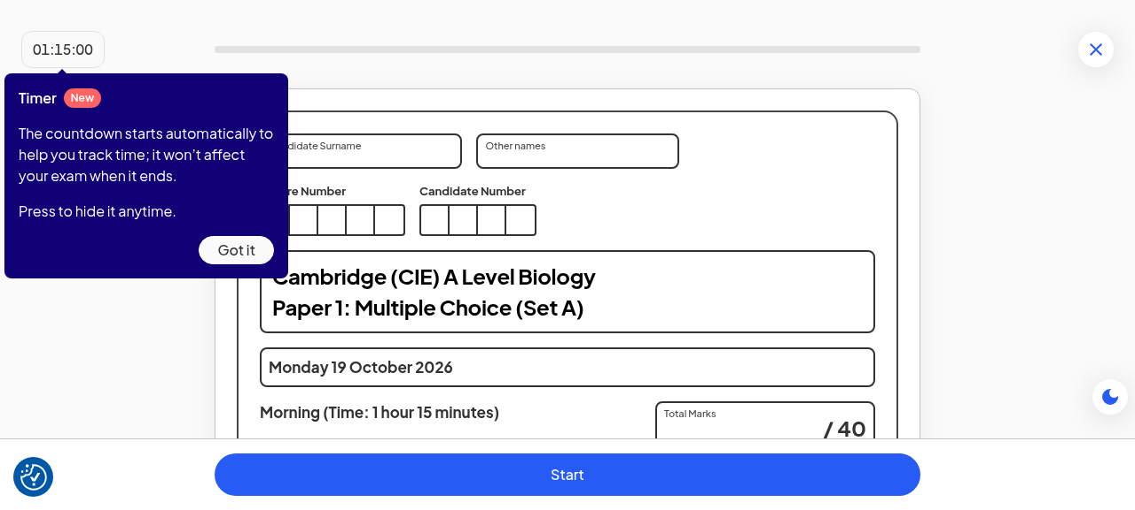
Figure 13. Paper 1 intro: front-matter copy, marking promise, timer tooltip with Got it.
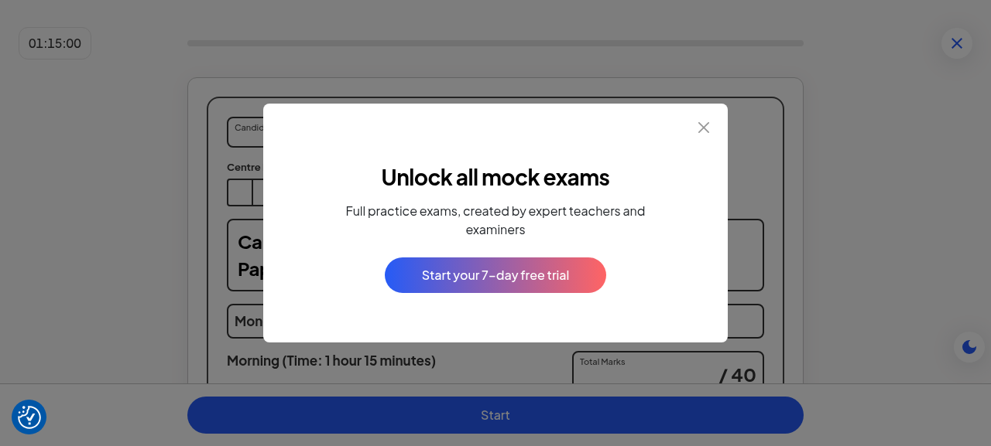
Figure 14. Exam view behind the trial modal: CIE cover reproduction, candidate-number fields, dated session line, live 01:15:00 timer.

Paywall boundaries: start, download, answers
The exam view is where the free tier ends, and the boundary is a hard gate rather than a nag. A modal titled "Unlock all mock exams" with the copy "Full practice exams, created by expert teachers and examiners" and the CTA "Start your 7-day free trial" fires over the started paper; dismissing it returns to the intro page, and re-pressing Start re-fires it. Decisively, the question bodies are never rendered to the free account at all: the DOM contains the cover and controls but no Question 1 text and no option buttons, so there is nothing to interact with even behind the modal. Reloading the start URL restores the same cover preview, confirming the preview state is the free-tier resting state.
The other two affordances gate identically. The per-paper Download dropdown exposes a View answers button alongside the download action, and clicking View answers fires the same Unlock-all-mock-exams trial modal (screenshot 192). The download path itself is the PDF wall already documented in pass 1 (trial modal with a free-sample escape hatch), so the mock surface contributes a third gated verb to the property's paywall map: interactive start (new this pass), PDF download (known), and answers (known for question sets, here confirmed for mocks). No partial data accrues to the free account from the surface: no per-question attempts, no marks, and therefore no S&W feed, which sharpens the contradiction noted below.
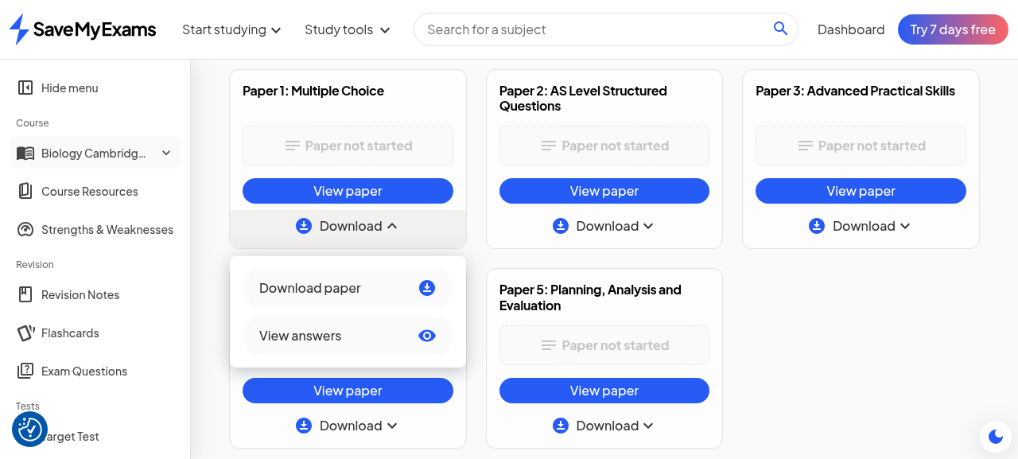
Figure 15. Per-paper dropdown open: View answers affordance beside the download action.
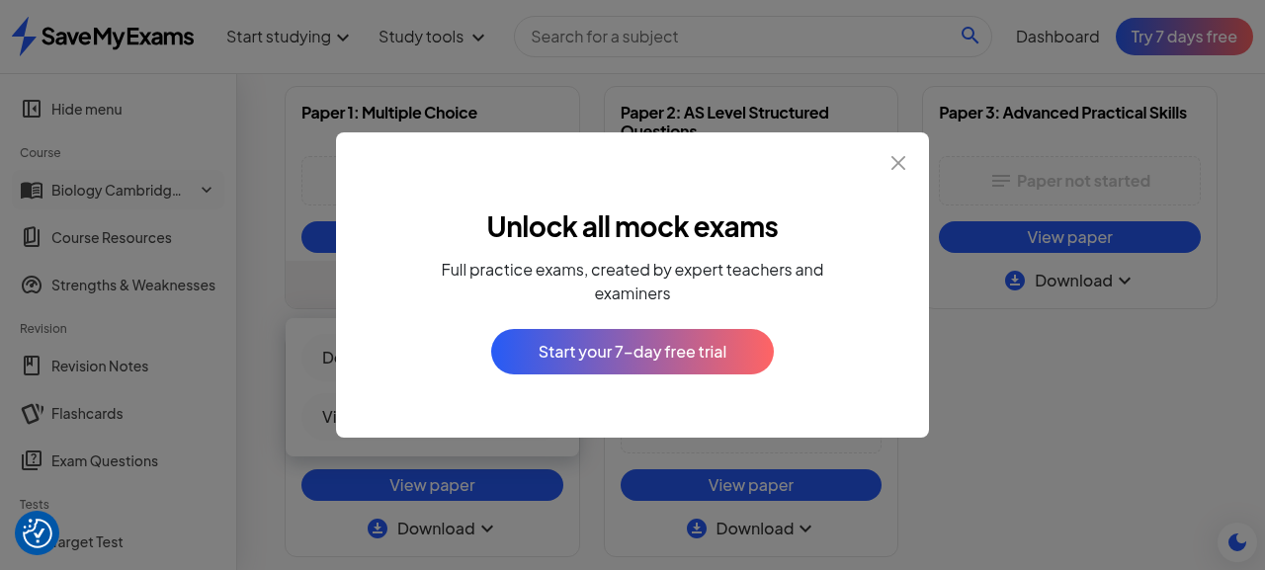
Figure 16. View answers fires the same "Unlock all mock exams" trial modal on the free tier.

Cross-Tool Synthesis
The three surfaces slot into the property's economy cleanly, and one tension is worth naming. The S&W contract names three feeding surfaces: Exam Questions, Target Tests and Mock Exams. On the free tier, exactly two of the three are usable: Exam Questions answered freely in passes 3-4 (with Smart Mark re-marks paywalled), and the Target Test builder generated a live assessment freely in pass 1 (guided-practice starts became gated in pass 3). Mock Exams, the third feeder, is now the hardest-gated surface on the property, so a free learner's strength profile can only ever be built from the two weaker-fidelity feeders; the most exam-realistic data source is premium-only. For the product this is coherent monetisation (the mock is the climax of the funnel); for the analytics it means free-tier S&W profiles systematically under-represent exam-condition performance.
The Tests family also clarifies its internal division of labour. Target Test (pass 1) is a builder: the learner composes scope, question types, difficulty and duration, and the system generates an assessment. Mock Exams is fixed and authoritative: authored full papers mirroring the board's structure, timed like the real sitting, with a cover that mimics the official document. The former serves targeted revision; the latter serves dress rehearsal. Both submit into the same marking/review machinery promised by the intro copy (AI, mark schemes or solutions), which keeps the review experience uniform even though the paper sources differ.
Finally, the flashcard ledger and the S&W profile are complementary mastery records: the former is self-reported, per-card, sub-topic-granular and instantly writable; the latter is performance-derived, per-topic, threshold-gated and only as good as the attempt data behind it. The Smart Chat pitfalls prompt (pass 2) already routes misconceptions into flashcards; no equivalent handoff from S&W rows into targeted practice was observed this pass, which is a natural next-link in the chain (a Weaker topic row that offers the matching Exam Questions set or deck).
Surface | Free-tier reach this pass | Premium boundary | Feeds S&W?
Exam Questions | Full bank; MCQ flow + Smart Mark first marks | Re-marks (Unlock Smart Mark modal) | Yes (primary feeder)
Target Test | Builder generated a live assessment (pass 1) | Guided-practice starts gated (pass 3) | Yes
Mock Exams | Cover preview + live timer only | Start, Download, View answers all gated; questions never rendered | Named in the contract, unusable free
Flashcards | Full loop: flip, rate, filters, persistence | None observed this pass | No (self-reported ledger, separate from score)
Table 4. Free-tier reach versus premium boundaries across the surfaces probed in this pass.

SyllabAI Implications Delta (DC-8 to DC-12)
The following implications continue the numbered lineage of the Smart-Chat/Mark design spec (DC-1 to DC-7) and are candidates for the spec's next revision. Each states the observed mechanic and the design decision it suggests for SyllabAI v2, with pointers to the machinery named in the spec where relevant.
ID | Observation (first-hand) | SyllabAI design decision
DC-8 | Flashcards carry a tri-state mastery bucket (Still learning / Know / Revisit) plus resume position, both persisted server-side across reloads (screenshot 198) | Extend the engagement rollup (GradedEvidencePublisher lineage) with a durable per-object mastery ledger; resume position is a first-class field, not scroll state
DC-9 | S&W gates a 1-5 score behind 10 attempts per topic and distinguishes "not yet unlocked" (partial) from "not available" (zero) | Never render a single empty-state for analytics; ship the two-state no-data model so partial engagement is rewarded with an unlock path, and keep the threshold copy on the surface that enforces it
DC-10 | Mock surface reproduces the official exam cover (candidate number, dated session, /40) with an auto-starting, hideable countdown; questions gated behind trial | Anchor the premium tier on authentic simulation artefacts, not feature checklists; the free preview must still deliver the exam-day feel to make the wall aspirational
DC-11 | Player-level filters combine card state (not viewed / still learning / know) with lesson scope inside the running deck | Make filters a property of the session player, not the library page; a re-run-mistakes-only action is the highest-value default filter and pairs with DC-8's ledger
DC-12 | S&W names exactly three feeder surfaces (Exam Questions, Target Tests, Mock Exams) while the richest feeder is premium-only | If v2 gates an assessment surface, profile completeness degrades for free users; either add a free feeder of exam-like fidelity or disclose the coverage gap in the profile UI
Table 5. New design implications from pass 5, continuing the DC-1..DC-7 lineage of the design spec.

Evidence Index
All evidence lives in download/sme-guided-learning-walkthrough/ and continues the global numbering from pass 4 (which ended at file 166). Thirty-two PNGs were captured this pass (167-198); the fifteen most probative are indexed below and embedded as figures. The remaining shots are process captures (intermediate states, duplicate angles) and are retained in the directory.
File | Content
167-sw-entry.png | S&W study-tools entry context
168-sw-tool.png | S&W landing, viewport capture
169-sw-landing-full.png | Figure 1: S&W landing, full page
170-course-overview.png | Course overview page (S&W link context)
171-sw-course.png | Figure 2: Strength score tool page
172-sw-topics.png | Figure 3: topic list, both no-data states
173-sw-filters.png | Figure 4: filter dropdown + sort
174-flashcards-hub.png | Figure 5: hub chips + deck rows
175-deck.png | Deck page initial state
176-deck-grid.png | Figure 6: sidebar tree + deck grid
177-179-*.png | Study-mode transition captures
180-card-front.png | Figure 7: card front
181-card-back.png | Figure 8: flipped card
183-after-know.png | Figure 9: post-rating counters
184-player-filters.png | Figure 10: player filters
185-mocks-hub.png | Figure 12: mock hub, sets x papers
186-mock-intro.png | Figure 13: paper intro + timer tooltip
187-timer-tip.png | Timer tooltip dismiss capture
190-exam-view-dialog.png | Figure 14: exam cover + trial modal
191-download-dd.png | Figure 15: download dropdown
192-view-answers.png | Figure 16: answers gate modal
193-197-*.png | MCQ threshold-attempt process shots
198-persistence-proof.png | Figure 11: post-reload persistence
Table 6. Evidence index for pass 5 (files 167-198 of the shared evidence directory).

Residuals and Caveats
Four residuals bound the record. First, the single-account free-tier caveat stands as in every prior pass: observations describe one account's experience at one time, and the pass-3 enforcement change (guided-practice starts became gated within 48 hours of a free walkthrough) proves surface posture can move between passes; gate maps in this document are snapshots, not contracts. Second, a populated S&W score was not observed: the threshold-unlock attempt was defeated by the consent-overlay and accessibility-tree issues described in section 3.4, so the 1-5 chip rendering and the Weaker/Improving/Stronger classifier behaviour on real data remain inferred from labels and copy rather than seen. Third, the Revisit bucket trigger was not observed; a card entering Revisit would clarify the review-scheduling semantics (whether it is a spaced-repetition queue or a manual come-back-later list). Fourth, only Paper 1 of the mock matrix was opened; the four structured papers presumably reuse the same gate with a different front matter, but their structured-question taking UI (and its Smart Mark interplay inside a mock) is unverified.
Account and workspace hygiene were maintained: the persona remains Student (revert verified in pass 4), no trial was started, no paid action was taken, the credential file was never printed (field labels only), and the refreshed auth state was re-saved for future passes. The workspace regression that opened the round (automation artefacts wiped, evidence retained) has been filed in the worklog alongside this record, and the evidence directory now holds 209 files spanning passes 1-5.

