P R O D U C T R E S E A R C H - P A S S 3
Save My Exams Prompt
Runs & Smart Mark /
Chat Interplay
Addendum (pass 3): the Summary, Pitfalls and Exam help prompt runs compared, and the structured-question Smart Mark-to-chat loop probed end to end
Target: savemyexams.com Revision Note Chat + structured-question Smart Mark
Method: live authenticated walkthrough, headless browser, 32 further screens captured
Session: 2026-10-19 (third pass, same research account), free tier, desktop viewport
Prepared by: SyllabAI product research (lane r4-api-b)

SyllabAI Research 2026-10-19

Table of Contents
1. Executive Summary
1. Executive Summary 1
2. Method of This Pass 1
3. The Three Prompt Runs, Compared 2
3.1 Summary 2
3.2 Pitfalls 2
3.3 Exam help 3
3.4 Cross-run comparison and structural findings 3
4. Surface Pivot: Guided Practice Gated, Static Bank Open 4
5. Smart Mark, Exercised on Structured Questions 5
5.1 First mark: the interstitial and the loop 5
5.2 Second mark: full marks on part 1c 5
5.3 Re-attempt economics 6
6. The Feedback Tabs: Coach, Do Not Leak 6
7. Smart Mark and Chat, Interplaying 7
7.1 The chat knows the marking 7
7.2 Cross-part memory 8
7.3 Surface asymmetries and the survey 8
8. Cross-Cutting Analysis 9
9. Implications for SyllabAI (Delta) 10
10. Evidence Index 10

Note: This Table of Contents is generated via field codes. To ensure page number accuracy after editing, please right-click the TOC and select "Update Field."

1. Executive Summary
The pass-2 addendum (2026-10-18) left two observation gaps open: of the four Revision Note Chat prompt cards only Definitions had been triggered, and the interplay between Smart Mark's structured-question marking and the chat surfaces had not been probed. This third pass closes both. Thirty-two further evidence screenshots (files 93 through 124 of the same evidence directory) accompany this record.
On the prompt cards, the three remaining runs (Summary, Pitfalls, Exam help) were executed on the same revision note as the pass-2 Definitions run (Studying Cells, 2-1-1, A Level Biology OCR), each in a fresh thread, making the four runs directly comparable. The headline result is that the three cards are three distinct output grammars over one shared grounding corpus: Summary renders a single bold-led prose paragraph, Pitfalls renders a six-item quote-then-correction misconception list, and Exam help renders a six-tip hierarchy with sub-bullets. Every run terminates in a router hook, and the hook target tracks the prompt's intent: Summary and Exam help route to Exam Questions, while Pitfalls routes to Flashcards (with a dual hook: an in-voice offer plus a rendered link card). A structural rule also fell out of the exercise: prompt cards exist only on a fresh thread - they are thread-openers, not mid-conversation tools - and all three new threads persisted server-side alongside the pass-2 thread.
On Smart Mark, the pass discovered that the guided-practice session launcher - the pass-1 route into marking - is now upsell-gated on the research account (a trial modal fires on every Start practising attempt and the session never begins), but that the static structured-question bank exposes the entire marking stack per question part anyway: a rich-text answer editor, a Mark my answer button, a Question help action, and a floating Help me understand chat pill. Two structured parts were marked live: a deliberately partial two-mark answer scored exactly 1/2 with the missing mark point named by the marker, and a full three-mark answer scored 3/3 with each point individually credited. The interplay probe then established the strongest finding of the pass: the floating chat on a marked question ingests the full marking state - it quotes the learner's submitted answer verbatim, states the marks awarded and the point missed, remediates explicitly (down to acceptable alternative answers and numeric resolution values), closes Socratically, and synthesises a cross-part performance comparison when asked. Re-marking after a first attempt is paywalled, the two in-card feedback tools coach without leaking the model answer, and a post-chat five-star survey fires after substantive chat usage.

2. Method of This Pass
The pass reused the research account and its saved browser session state, so no login step was needed; the authenticated dashboard greeted the account directly and the session state was re-saved at close. All work was done on 2026-10-19 on the free tier, desktop viewport, with every state transition captured as a PNG. For the prompt-run comparison the controlled variable was the grounding document: all four runs (Definitions from pass 2; Summary, Pitfalls, Exam help from this pass) target the same revision note, and each card was triggered from a freshly reset thread so that no run's output could contaminate another's context window. Responses were captured both as screenshots and as extracted text, so the comparison below quotes the served wording verbatim.
For the Smart Mark leg the intended route was the pass-1 flow (topic page, guided-practice toggle, Start practising). That route now fails closed: flipping the toggle still rewrites the URL with the smart-practice parameter and renders the session launcher with its counters and How it works panel, but every Start practising click raises an Unlock unlimited guided practice modal whose only controls are Close and Start your 7-day free trial; dismissing and retrying reproduces the modal indefinitely, and no session content ever renders behind it. Whether this is an enforcement change since the pass-1 walk (less than 48 hours earlier, same account) or a per-account daily quota exhausted by that walk cannot be distinguished from one account, and this caveat is carried through the record. The pivot to the static structured-question bank turned out to cost nothing: the bank view of the same topic serves one question set (1a, 1b, 1c for the opening item) with the full per-part marking and chat stack available without guided practice.

3. The Three Prompt Runs, Compared

3.1 Summary
The Summary card served the prompt 'Give me a summary of the key points in this revision note' and streamed for roughly fifteen seconds before settling. The output is a single prose paragraph with a bold-led topic sentence ('Microscopes are used to observe cell structure.') followed by six compact clauses covering the note's whole arc: light-microscope resolution and magnification figures, the structures each family shows, TEM versus SEM geometry, and the electron microscope's practical limits. The paragraph is visibly derived from the note's own content set rather than a generic treatment of microscopy. The run closes with an in-voice router sentence ('If you want to test yourself on this topic, try the Exam Questions.') above the rendered hook link.
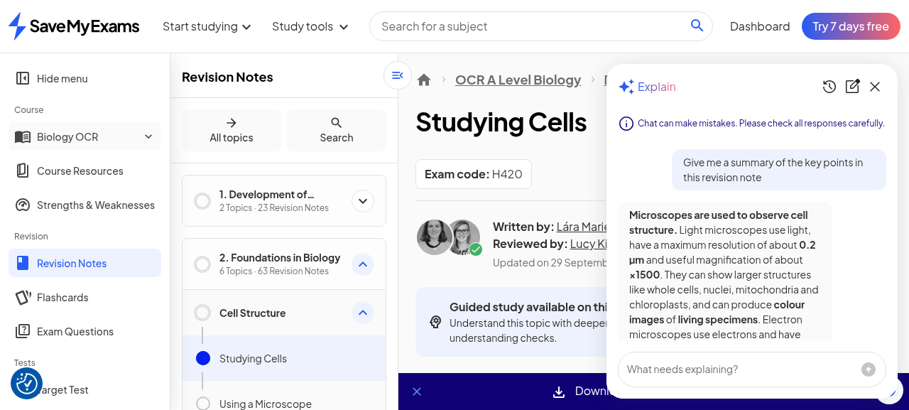
Figure 1. Summary run, complete: one bold-led prose paragraph grounded in the note, closing with an Exam Questions hook.

3.2 Pitfalls
The Pitfalls card served 'What are some common misconceptions in this topic?' and returned the most patterned output of the three: an introductory line, then six misconception items each rendered as a quoted misbelief followed by its correction - 'Bigger magnification means better detail.' Not always - resolution matters too; 'Electron microscopes can be used to view living cells.' They cannot - specimens must be in a vacuum; and so on through light-microscope colour imaging, the TEM/SEM image distinction, and SEM surface-only imaging. The quote-then-correction grammar is pedagogically pointed: each item names the wrong belief in the learner's own probable voice before correcting it. Pitfalls is also the only card that produced a dual hook: an in-voice offer ('If you want, I can turn these into quick exam-style flashcards for you.') followed by a rendered 'Try the Flashcards for this topic' link card.
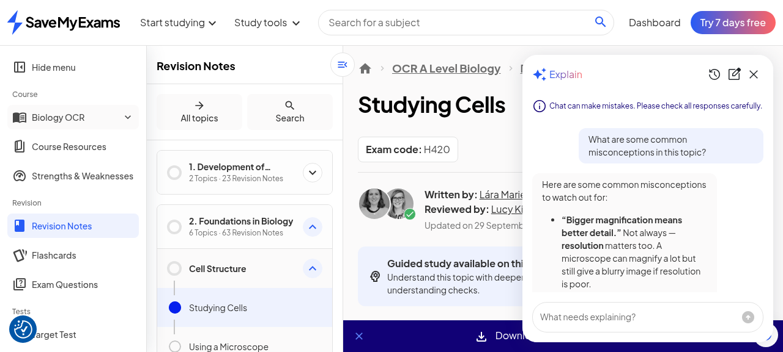
Figure 2. Pitfalls run: six quote-then-correction misconception items and the dual Flashcards hook.

3.3 Exam help
The Exam help card served 'Give me top tips for understanding this topic for my exam' and returned a structured tip list under the heading 'Top tips for this topic:': six numbered tips, several carrying sub-bullets - learn the light/electron differences; what each can show (two sub-lists of structures); the cost, size, living-specimen and vacuum comparisons; TEM-internal-2D versus SEM-surface-3D identification; resolution as the clue for detail; and a practice recommendation naming image comparisons as common exam tasks. The register is exam-technique rather than explanation: where Summary compresses and Pitfalls corrects, Exam help sequences what a candidate should rehearse. The run closes with an in-voice Exam Questions hook carrying an inline link.
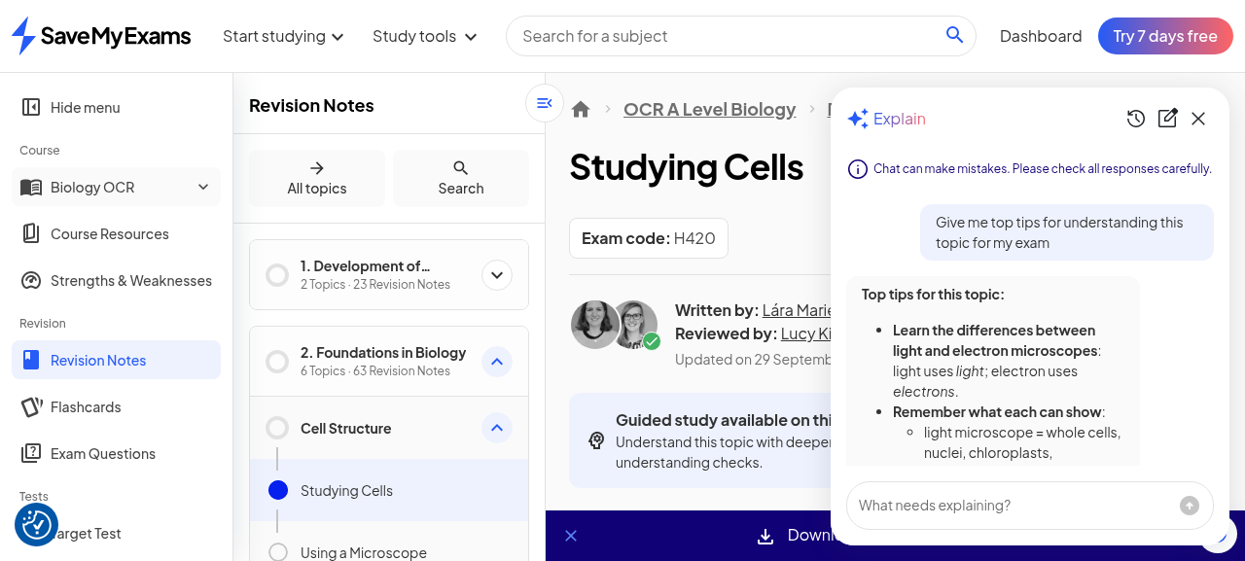
Figure 3. Exam help run: six tips with sub-bullets, closing with an inline Exam Questions link.

3.4 Cross-run comparison and structural findings
With all four cards now observed on one note, the prompt-card system reads as a set of fixed lenses over a shared corpus. The grounding document is identical across runs, yet the output form, register and post-turn routing all differ by prompt intent. This is the cheap adaptivity pattern again, seen from the chat side: no model-in-the-loop personalisation is needed to make one note feel like four study modes, only four output grammars plus four router targets.
Table 1. Prompt-card runs on note 2-1-1 (Definitions from pass 2 included for completeness)
Card | Served prompt | Output grammar | Hook target | Hook form
Definitions (pass 2) | Define the key terms in this revision note | 7-term one-line glossary | Flashcards | In-voice offer + link
Summary | Give me a summary of the key points in this revision note | Single bold-led prose paragraph | Exam Questions | In-voice sentence + link
Pitfalls | What are some common misconceptions in this topic? | 6 quote-then-correction items | Flashcards | In-voice offer + link card (dual)
Exam help | Give me top tips for understanding this topic for my exam | 6 tips with sub-bullets | Exam Questions | In-voice sentence + inline link
Two structural findings complete the comparison. First, the cards are thread-openers only: after any response the card grid disappears and the drawer offers only the free-text input, the new-chat reset and the history list - a canned prompt can never fire mid-conversation, so the prompt set defines openings and nothing else. Second, persistence is account-scoped and cross-session: the Previous chats list after the three runs showed the new threads at 53 seconds, 2 minutes and 4 minutes, with the pass-2 thread still listed at 9 hours - the same server-side durability the pass-2 record established, now confirmed across days.

4. Surface Pivot: Guided Practice Gated, Static Bank Open
The Smart Mark leg began on the pass-1 route and hit the gate described in section 2: the guided-practice launcher renders, but Start practising is wrapped in the trial modal on every attempt with no free escape (the modal's complete control set is Close and Start your 7-day free trial). The launcher itself shows the account's pass-1 session residue - 0 Questions, dash-percent Score, 3 percent Topic progress - so the account's prior activity is remembered even while new sessions are refused. This is the first hard enforcement boundary observed on any interactive surface; until now the platform's only wall had been PDF downloads.
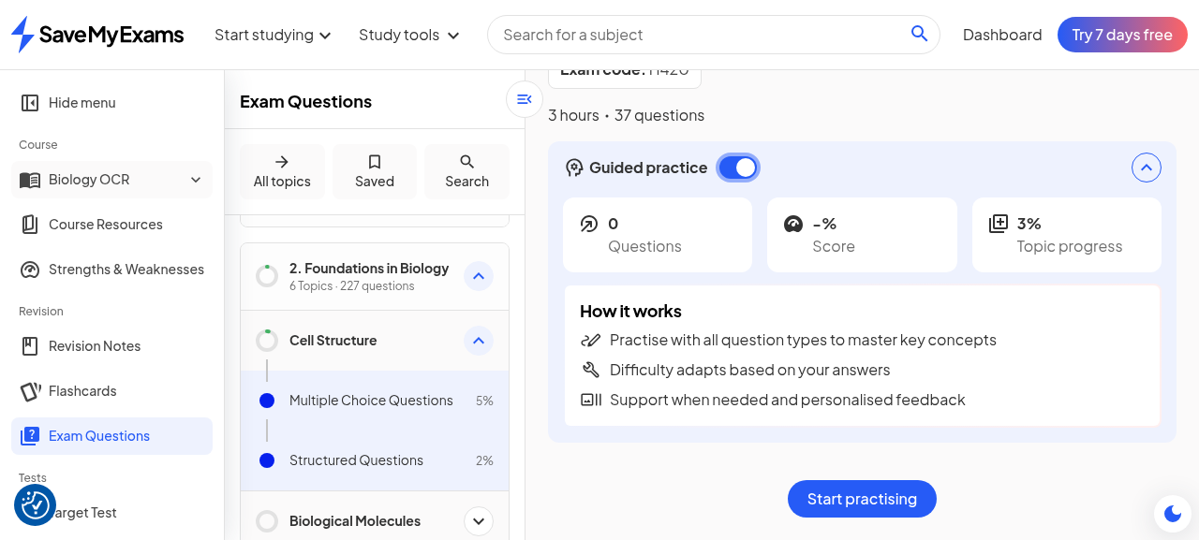
Figure 4. The guided-practice launcher of record (counters, How it works, Start practising) - now upsell-gated behind the trial modal on every attempt.
The pivot surface was the same topic's structured-questions bank view without guided practice. Per question part it exposes: the question stem and marks, a rich-text 'Your answer' editor (TipTap/ProseMirror, collapsed until clicked), a 'How did you do?' self-score box, a Mark my answer button (Smart Mark), a Question help action, and a View answer toggle - with the floating Help me understand pill anchored bottom-right of the page. One availability rule was recorded: the table-completion part (1b) has no Mark my answer button at all, so Smart Mark is question-type-gated, not universal. The page-level furniture includes a 'Was this exam question helpful?' pair and a Next question control.

5. Smart Mark, Exercised on Structured Questions

5.1 First mark: the interstitial and the loop
The first Mark my answer click on the account raised an 'Introducing Smart Mark' interstitial - 'Get immediate, exam-specific feedback on your answers to Topic Questions with Smart Mark, powered by AI and our team of expert teachers and real examiners.' - whose Try Smart Mark button proceeds to the actual marking. Marking is asynchronous: the score area collapses to a skeleton shimmer for roughly fifteen to twenty-five seconds before the result renders. The Q1a answer submitted was deliberately partial (one mark point: higher resolution of TEM; the size-of-structures point withheld), and Smart Mark scored it exactly 1/2, awarding '[1 mark]' for the resolution point and '[0 marks]' for 'You did not state that chloroplasts are small organelles'. The per-part grammar - one feedback line per mark point, each tagged with its award - scales with the mark count: the three-mark part 1c produced three credited lines.
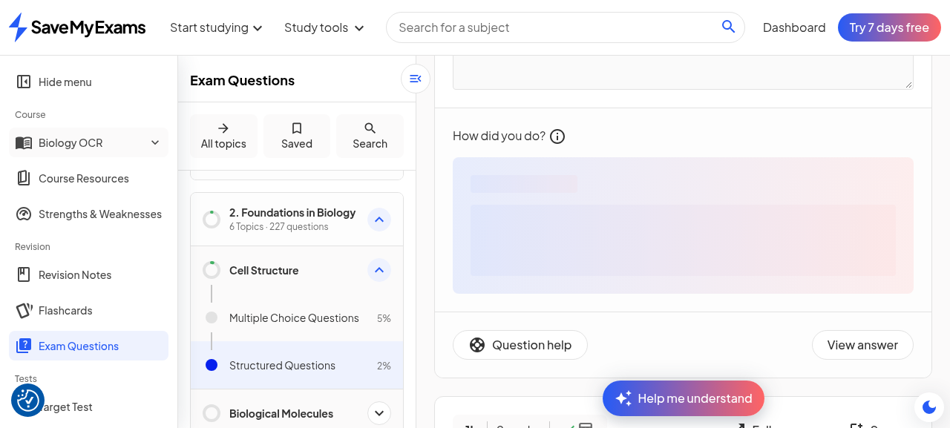
Figure 5. Marking in flight: the score area renders a skeleton shimmer while the async mark runs.
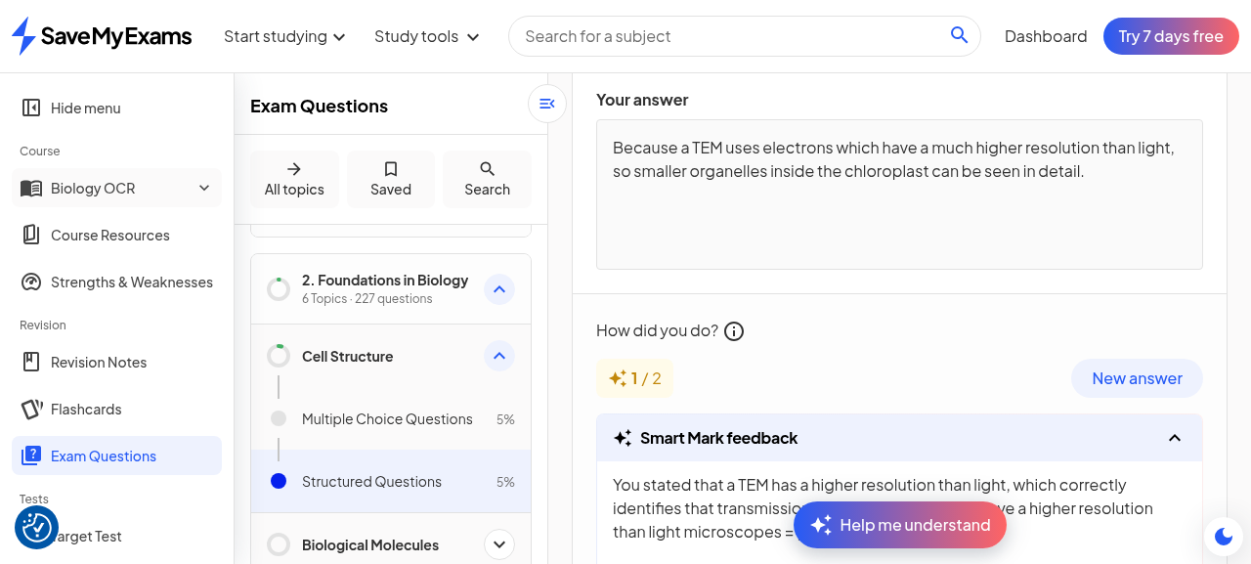
Figure 6. Q1a result: 1/2 with per-point awards - the withheld size point correctly identified as the miss.

5.2 Second mark: full marks on part 1c
Part 1c ('Describe how the structure of the chloroplast relates to its function', 3 marks) received a full three-point answer (thylakoid membranes stacked into grana for surface area and chlorophyll; stroma containing the light-independent-reaction enzymes). Smart Mark returned 3/3, crediting each point in its own line and closing with 'Well done!'. The full-mark state also changes the page furniture: the score chip renders as a green pill carrying the Smart Mark sparkle glyph (the 1/2 state rendered as plain text), and the topic tree's Structured Questions progress ticked up with each marked part (2 percent before the session, 5 percent after Q1a, 7 percent after Q1c) - marking results feed the platform's progress model directly.
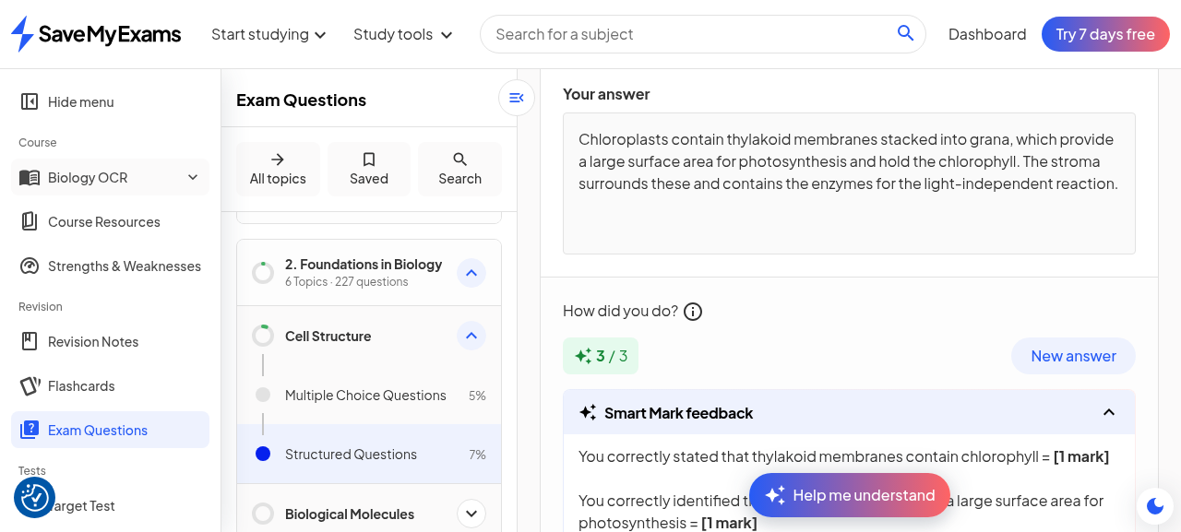
Figure 7. Q1c result: 3/3, three credited point lines, 'Well done!', and the green Smart Mark score chip.

5.3 Re-attempt economics
Every marked part offers a New answer control, and the editor beneath the result block accepts a fresh attempt (a corrected answer was inserted into the live editor during the pass). Submitting that re-attempt, however, raises an 'Unlock Smart Mark' trial modal - 'Access immediate, exam-aligned assessment of your answers to Exam Questions, powered by AI.' - so the economics are: first mark per question part free, re-marks gated behind the trial. The improvement loop the UI advertises (attempt, get marked, improve, re-mark) is therefore a one-shot free sample of its second half. This pairs with the guided-practice session gate as the second observed paywall boundary, and both are disclosed here as observed on one free-tier account on one day.

6. The Feedback Tabs: Coach, Do Not Leak
The Smart Mark result block embeds two tabbed AI tools - Improve my answer and Explain my feedback - both rendering inline in the card rather than in a chat thread, and both observable in sequence on the 1/2 result. Explain my feedback opens with praise scoped to the correct point ('well done for correctly identifying the higher resolution of electron microscopes'), explicitly frames the gap as a growth opportunity rather than a failure ('There is no significant knowledge gap present... here is a growth opportunity to deepen your explanation'), and then hints at the missing point without stating it: it urges linking 'the microscope's resolving power directly to the tiny physical size of the specimen', offers a book-and-letters analogy, and hands off to the sibling tool ('For guidance on structuring your points to include all key details, try the "Improve my answer" tool.'). Improve my answer similarly praises ('You have made a fantastic start...'), gives two improvement bullets about linking resolving power to physical scale, adds a magnifying-glass-versus-bacteria analogy - and stops short of rewriting the learner's answer into the model one.
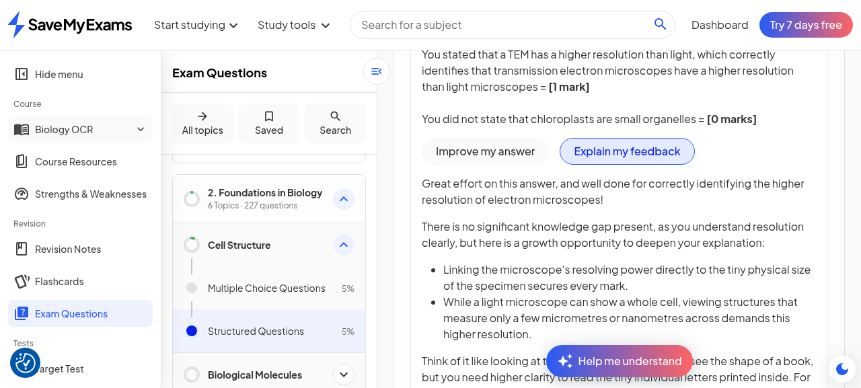
Figure 8. Explain my feedback tab: praise, growth framing, hint-level coaching, cross-tool handoff.
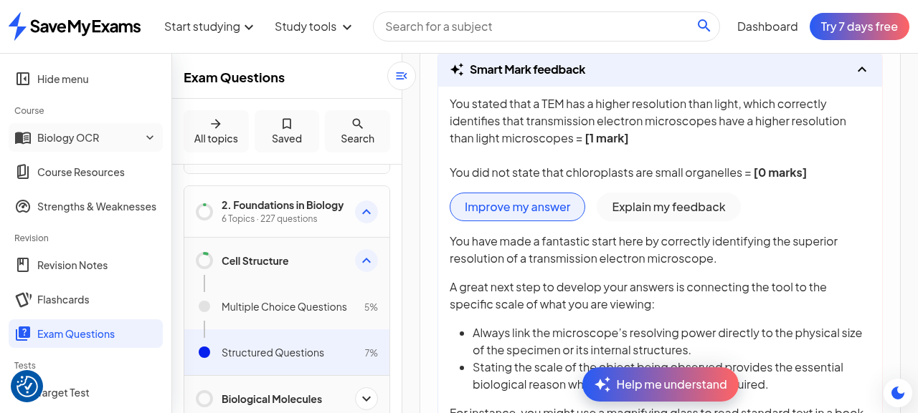
Figure 9. Improve my answer tab: improvement bullets and analogy - coaching, not a model-answer rewrite.
The design point is the deliberate contrast with the chat (next section): the tabs coach at hint level and never hand over the missing mark point, whereas the chat, once asked directly, is fully explicit. Both tabs also sit above the card's own helpfulness loop - 'Was this feedback helpful for improving your answer? Yes / No', which collapses to 'Leave feedback' once answered. The two-tab structure is thus a two-tier disclosure system: tier one (tabs) protects the assessment value of the unseen mark-scheme point; tier two (chat) trades that protection for remediation depth when the learner explicitly engages.

7. Smart Mark and Chat, Interplaying

7.1 The chat knows the marking
Opening the floating Help me understand pill on the marked question brings up the same Explain drawer grammar as the note surface - same disclaimer, same drawer title, but the question-surface prompt pair (Understand, Approach) - and a free-text input. Asked 'Why did I get 1 out of 2 on this question?', the chat answered with complete marking-state awareness: it quotes the learner's submitted answer verbatim under a 'You wrote:' heading, states 'You got 1 mark for correctly stating that a TEM has a much higher resolution than a light microscope. That's a key point the examiner wanted.', then names the missing second mark explicitly - including acceptable alternatives the marker had not listed ('mention something about the size of the structures being observed... or to give a comparison of the actual resolution values (e.g. TEM: 0.5 nm, light microscope: 200 nm)'), a 'What you missed:' section diagnosing the reasoning gap, a two-step exam-technique tip for two-mark explain questions, and a Socratic close: 'Can you try rewording your answer to include this second point?'
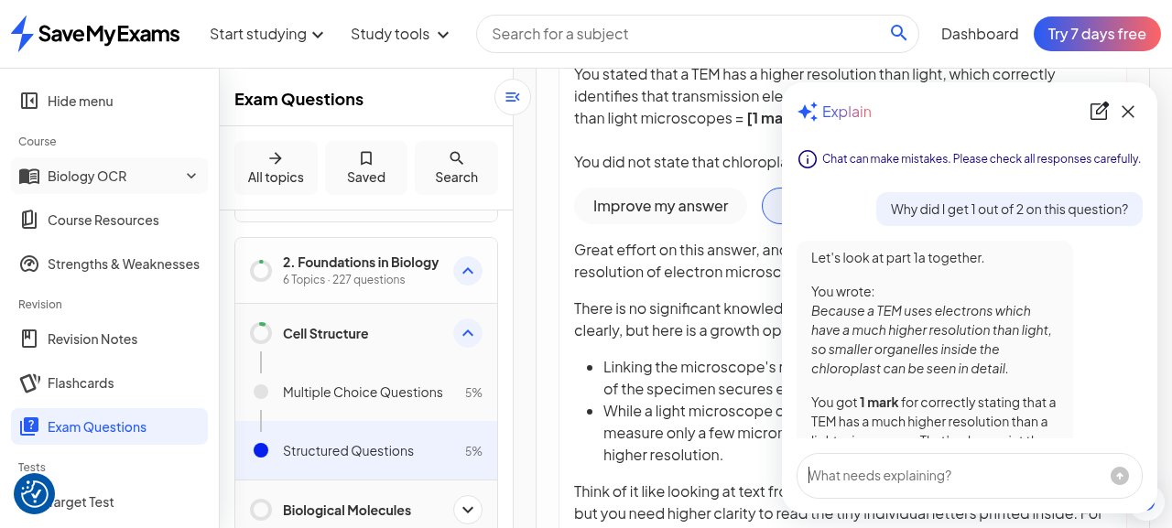
Figure 10. The chat's answer opens by quoting the submitted answer verbatim and the mark awarded.
Figure 11. Full remediation turn: what was missed, acceptable alternatives with numeric values, Socratic rewording invitation.

7.2 Cross-part memory
After part 1c was marked 3/3, the same thread was asked to 'Compare my performance: how did I do on part 1a versus part 1c?'. The response synthesises both parts' marking state without any further disclosure from the learner: part 1a 'You earned 1 out of 2 marks' with what-was-missing restated, part 1c 'You earned all 3 marks' with the three credited features enumerated, a summary paragraph contrasting the two, per-question-type exam technique tips (linked points for short explains; structure-function-link per mark for describe questions), and a dual router hook into Flashcards and a personalised Target Test. The chat thread survived closing and reopening the drawer within the page session, and the answer confirms the context ingest covers every marked part of the question set, not merely the last.
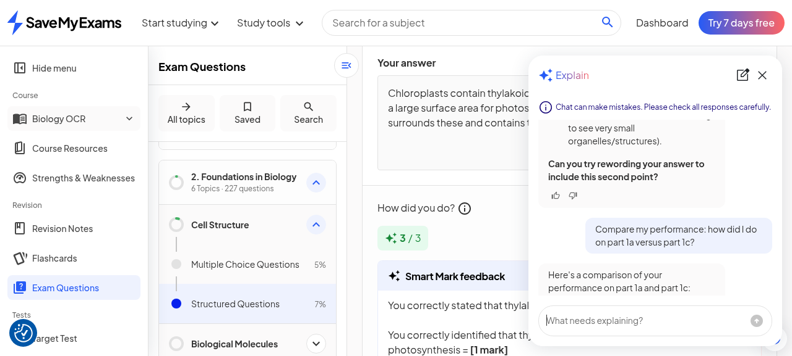
Figure 12. Cross-part comparison: both parts' scores, misses and strengths synthesised, dual router hook.

7.3 Surface asymmetries and the survey
Three asymmetries of record. First, the question-surface drawer has no Previous chats browser (its header carries only the new-chat and close controls), although its thread demonstrably persists in page session - history browsing remains a note-surface affordance. Second, the thread that persists is the page-question thread, so the question chat's continuity is anchored to the question set rather than being a global stream. Third, after substantive chat usage a survey widget fired bottom-right - 'How useful did you find the AI chat feature?' with a five-star control that expands into a two-field feedback form and a Submit (the pass rated five stars with a one-line research-account answer; the platform acknowledged with a Thank you card). No equivalent survey was observed for Smart Mark itself, whose helpfulness loop lives inline in the feedback card.
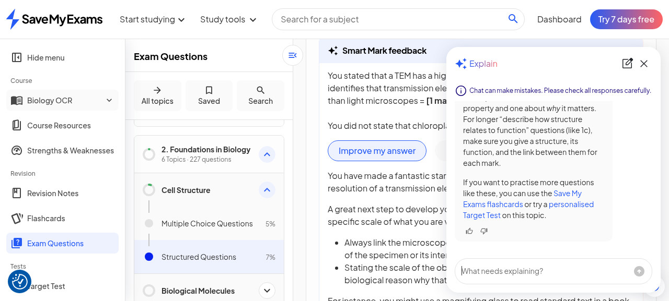
Figure 13. Question-surface drawer: thread intact after close/reopen, but no Previous chats browser on this surface.
One quality seam is worth naming for the record: the chat's acceptable-answer set for the missing mark point was broader than the marker's own wording. Smart Mark's marker line said 'You did not state that chloroplasts are small organelles'; the chat, remediating, accepted either the size statement or a numeric resolution comparison. A learner remediated by the chat could resubmit an answer the marker again scores 0 for that point. This is an inter-tool consistency risk inherent to having two generators (marker and tutor) consuming the same mark scheme - the seam the pass-2 record's post-generation-linting advice would want to cover: conformance should run across tools, not within each.

8. Cross-Cutting Analysis
Read together, the pass sketches the platform's full assessment-feedback economy. Marking is the scarce, metered resource (first mark free, re-marks gated, sessions gated); the feedback tabs are the unlimited coaching layer that makes the single free mark feel generative (praise, hints, analogies, cross-tool handoffs); and the chat is the pressure valve that converts frustration into explicit remediation - at the cost of disclosing mark-scheme content only after the learner has committed an attempt and engaged voluntarily. The anti-leak gradient is therefore not a wall but a slope: View answer (explicit, learner-controlled), tabs (hint-level, automatic), chat (explicit, Socratic), each gated by progressively more learner intent.
The enforcement picture also sharpened. Within one day the platform grew from one observed paywall (downloads) to three: guided-practice session starts, Smart Mark re-marks, and (carried from the plan copy) the premium positioning of both. The free tier still samples every surface at least once - one full mark per part, the full chat, the full feedback tabs - which is a classic trial-design posture: let the learner feel the whole loop once, then meter the repetition. A caveat stands: one account, one day, and the pass-1 walk consumed guided-practice quota the day before; quota versus enforcement change cannot be separated from here, and a future pass on a fresh account would disambiguate.
Finally, the prompt-card finding completes the chat architecture picture begun in pass 2. The cards are not conversation features; they are navigation features - four fixed entry points that each demonstrate one output grammar and one router target, after which the conversation is the learner's to drive. The entire assistant, across both surfaces, can be summarised as: fixed lenses on entry, Socratic maintenance in the middle, router hooks at every exit.

9. Implications for SyllabAI (Delta)
First, marking-context injection is the interplay pattern worth copying wholesale: when a learner asks a chat about a marked answer, the assistant must receive the submitted text, the per-point awards and the mark scheme as grounding - the observed behaviour (verbatim quote-back, per-point accounting, explicit remediation with alternatives) is exactly what a marking-aware assistant should do, and it is unimplementable without plumbing the mark state into the chat context. SyllabAI's Smart Mark and Smart Chat should share a context contract from day one.
Second, the two-tier feedback philosophy is a direct answer to the assessment-integrity problem: automatic feedback should coach at hint level (never disclose the unseen mark point), while explicit disclosure belongs behind a deliberate conversational act. The hint-level tier also generates the cross-tool handoffs for free. Third, re-attempt economics: metering the second mark, not the first, is the right free-sample boundary - the first mark teaches the learner what the feedback feels like, and the improvement loop is where willingness to pay concentrates. Fourth, prompt cards as navigation: a fixed set of thread-opening lenses with per-intent router targets is cheap to build, fully deterministic to QA, and doubles as onboarding for the free-text mode. Fifth, the cross-tool marking-consistency seam extends pass 2's linting advice: if marker and tutor are separate generations, their shared inputs (mark-scheme points, acceptable-alternative sets) should be materialised once and consumed by both, rather than re-derived.
Sixth, a small UX asymmetry to avoid copying blindly: history browsing existing on one assistant surface but not the other reads as an oversight rather than a design choice, since both threads persist server-side. And seventh, the progress-attribution loop observed here (each marked part visibly advancing topic progress and tree percentages) is a cheap retention mechanic that pairs naturally with a syllabus product's existing structure tracking.

10. Evidence Index
All evidence files from the three passes live in the same directory as this document. Files 01 through 53 belong to the base record; 54 through 91 to pass 2; 92 is the pass-2 account-rotation receipt; 93 through 124 were captured in this pass and map as follows.
Files | What they evidence
93 | Note 2-1-1 page with chat entry affordances (session restored from saved state)
94 - 95 | Summary run: mid-stream and complete states with router hook
96 | Pitfalls run: six quote-then-correction items, dual Flashcards hook
97 | Exam help run: six tips with sub-bullets, inline Exam Questions link
98 | Previous chats list: three new threads plus pass-2 thread (9 hours)
99 | Guided-practice launcher (pre-gate state, counters and How it works)
100 - 102 | Start-practising attempts: trial modal on every click; post-reload bank state
103 | Q1a partial answer staged in the TipTap editor
104 | Introducing Smart Mark interstitial (first-ever mark attempt)
105 - 106 | Q1a marking: skeleton shimmer in flight; 1/2 result with per-point awards
107 | Helpfulness loop answered Yes (collapses to Leave feedback)
108 | Explain my feedback tab: praise, growth framing, hint-level coaching
109 - 110 | Question-surface drawer opened; chat quoting the marked answer verbatim
111 | Full remediation turn: missed point, alternatives, numeric values, Socratic close
112 - 113 | Re-attempt UI state; Unlock Smart Mark modal on second mark + 5-star chat survey
114 - 116 | Unlock Smart Mark modal clean; survey 5 stars, expanded form, submitted
117 | Improve my answer click (first attempt, overlaid by pill)
118 - 119 | Q1c marking in flight; 3/3 result with three credited lines and green chip
120 - 121 | Cross-part comparison question and full synthesis answer
122 - 123 | Improve my answer tab rendering: bullets and analogy, no model rewrite
124 | Question-surface drawer: no Previous chats browser (asymmetry)
Caveat of record: this pass observes one free-tier account on 2026-10-19, one day after a walk that consumed guided-practice activity on the same account. The guided-practice gate and the re-mark gate may be enforcement changes or quota exhaustion; surfaces remain badged Beta and copy, gating and limits may change without notice. Verbatim quotes are preserved from captured screenshots and extracted text.

