P R O D U C T R E S E A R C H - P A S S 2
Save My Exams Smart
Chat & Confidence
Branches
Addendum to the Guided Learning & Practice walkthrough: the Medium/High confidence branches and the Smart Chat surfaces, exercised first-hand
Target: savemyexams.com guided study (Beta) + AI chat surfaces
Method: live authenticated walkthrough, headless browser, 38 further screens captured
Session: 2026-10-18 (second pass, same research account), free tier, desktop viewport
Prepared by: SyllabAI product research (lane r4-api-b)

SyllabAI Research 2026-10-18

Table of Contents
1. Executive Summary
1. Executive Summary 1
2. Method of This Pass 1
3. The Confidence Branches, Exercised 2
3.1 The confidence step, verbatim mechanics 2
3.2 The Medium branch, walked end to end 3
3.3 The High branch, walked end to end 4
3.4 Low, re-verified on lesson 1 5
3.5 Branch comparison, the no-re-rate rule, and limits 5
4. Smart Chat I: Revision Note Chat (the Explain Drawer) 5
4.1 Entry points and panel anatomy 6
4.2 The Definitions run 6
4.3 Free-text questioning, memory and pedagogy 7
4.4 History and new chat 7
5. Smart Chat II: Exam Question Chat (the Understand Panel) 8
5.1 Entry and anti-leak prompt design 8
5.2 The Approach run and the Socratic loop 8
6. Cross-Surface Analysis and Caveats 9
7. Implications for SyllabAI (Delta to the Base Record) 9
8. Evidence Index 10

Note: This Table of Contents is generated via field codes. To ensure page number accuracy after editing, please right-click the TOC and select "Update Field."

1. Executive Summary
The base walkthrough record filed earlier the same day (Save My Exams Guided Learning & Practice, 2026-10-18) closed with two explicit caveats: the Medium and High confidence branches of the guided-study confidence gate had not been observed, and the Smart Chat surfaces had not been exercised. This addendum closes both gaps in a second authenticated pass on the same research account. Thirty-eight further evidence screenshots (files 54 through 91 of the same evidence directory) accompany this record.
On the confidence gate, the headline finding is structural: the Medium and High branches do not change the walkthrough template. Every branch - Low, Medium and High - opens with the same 'In plain words' layer, unfolds through progressively deeper explanation stages, terminates in the same 'Helpful terms' glossary plus 'An example' worked passage, and ends at the same five-question multiple-choice check. What the confidence choice demonstrably gates is the sequencing of pre-written layers and the starting depth, not the presence or absence of content: the branch is a pacing control over a fixed authored stack, not a route into different content sets. A further mechanic of record: the confidence rating is captured once per lesson and cannot be re-rated on a completed lesson - reopening one resumes the same layered sequence - so a same-lesson cross-branch comparison is impossible on one account, a limitation disclosed in section 3.5.
On Smart Chat, the platform's umbrella term covers two distinct embedded assistants, both live and both exercised. Revision Note Chat (drawer title 'Explain') sits on revision-note pages with four suggested prompts (Definitions, Summary, Pitfalls, Exam help), answers grounded in the page's own note, sustained multi-turn memory, a Socratic nudge style, and an explicit router hook after every turn pointing at another tool (flashcards or exam questions). Exam Question Chat (panel title 'Understand', floating pill 'Help me understand') sits on exam-question pages with two prompts engineered to avoid answer leakage, and runs a strict Socratic loop: it restates the question, asks the learner to reason first, confirms a correct learner answer only after the attempt, recaps every option's role, appends an 'Exam tip' strategy note, and offers a similar practice question. Neither surface presented a usage cap, paywall or trial prompt across roughly six messages in three threads on the free tier, despite plan copy marketing Smart Chat as a paid-tier feature. One live generation glitch (a stray Devanagari token inside an English sentence) was captured and is filed in section 6.

2. Method of This Pass
The second pass re-used the research account created in the first session (disclosed address syllabai.research.r4b@gmail.com, credentials held locally with 0600 permissions and never reproduced here). Login went through the dedicated /login/ page this time rather than the signup modal, required the same three fields (email, password, submit) and redirected straight to the members dashboard with no verification step - the no-verify property therefore holds for logins, not only signups. Browser session state was saved to disk after authentication so future passes can skip the login step entirely.
Surfaces exercised, in order: the guided-study panel on the Studying Cells revision note (A Level Biology OCR, exam code H420), lesson 2 (Electron Microscopy) on the Medium branch, lesson 3 (TEMs and SEMs) on the High branch, and lesson 1 (Why Use Microscopes?) on Low to re-verify the base record's branch on the current build; then the Revision Note Chat drawer on the note page, then the Exam Question Chat panel on the topic's multiple-choice questions page. Every state transition was captured as a PNG screenshot; the evidence index in section 8 maps each file to what it shows. As in the base record, all observations are of one free-tier account on 2026-10-18 on a surface the platform itself badges as Beta; copy, gating and limits may change without notice.

3. The Confidence Branches, Exercised

3.1 The confidence step, verbatim mechanics
Each micro-lesson opens with a 'Confidence check' frame: the heading 'Tell us your confidence level against the key points', a 'What you know already' primer paragraph, a 'Key points of understanding' list of four to five authored bullets for the lesson, then a 'Select confidence level' radio group (Low, Medium, High) and a Continue button that stays disabled until a choice is made - the gate is enforced in the UI, not merely suggested. The primer is context-aware: on lesson 2 it recapped light microscopy ('You have already met light microscopes...'), on lesson 3 it chained from lesson 2's content ('You should already know that electron microscopes use electrons to form images...'), while on lesson 1 - which has no predecessor - it fell back to a static topic-level sentence. The primer is therefore derived from the previously completed lesson, which quietly turns a linear note into a prerequisite-aware sequence.
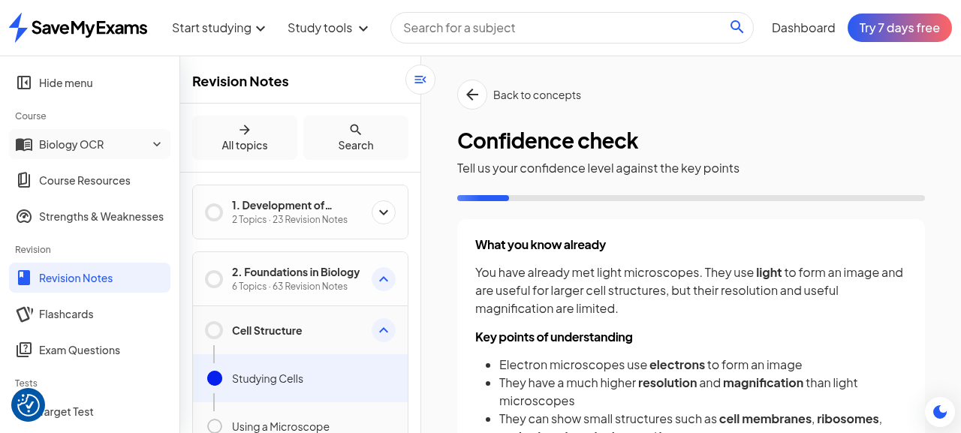
Figure 1. Lesson 2 confidence check: primer, key points, and the Low/Medium/High radio gate (Continue disabled until selection).
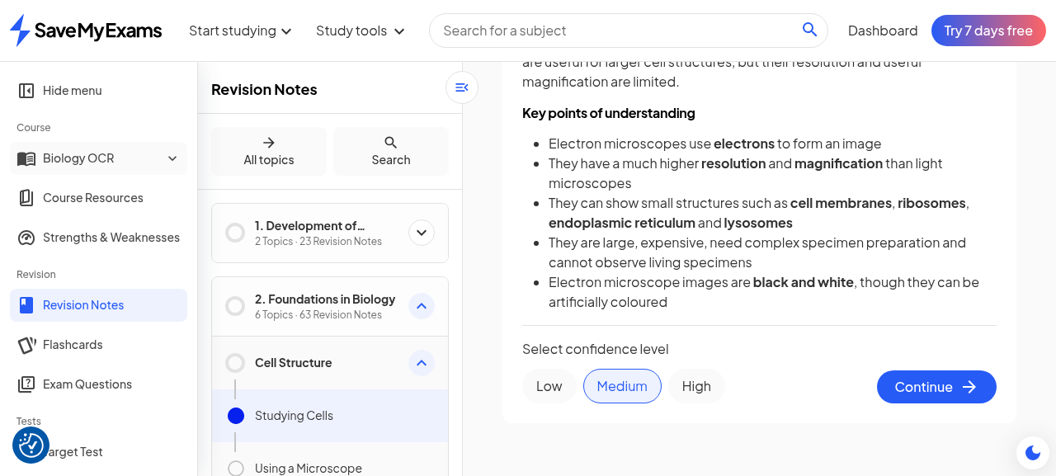
Figure 2. Medium selected on lesson 2 - the gate releases Continue.

3.2 The Medium branch, walked end to end
Lesson 2 (Electron Microscopy: Higher Detail and Limitations) on Medium unfolded in eight content stages before the check, each Continue revealing one further pre-written layer: (1) the opening 'In plain words' definition - electron microscopes use electrons, the key difference from light microscopes; (2) resolution in numbers (light: about 0.2 micrometres; electron: about 0.0002 micrometres, i.e. 0.2 nanometres); (3) magnification (around one million times and up); (4) which small structures become visible (cell membranes, ribosomes, endoplasmic reticulum, lysosomes); (5) practical limitations (large, expensive, complex specimen preparation); (6) vacuum conditions and the consequence (no living specimens) plus black-and-white imaging; (7) a 'Helpful terms' glossary defining four terms; (8) an 'An example' passage walking an electron micrograph. The check then presented 'Multiple choice, 1 of 5'; the first question was definitional in style ('Which statement best explains why...'), and a correct submission produced the thumbs-up confirmation and a full explanation exactly as recorded in the base record.
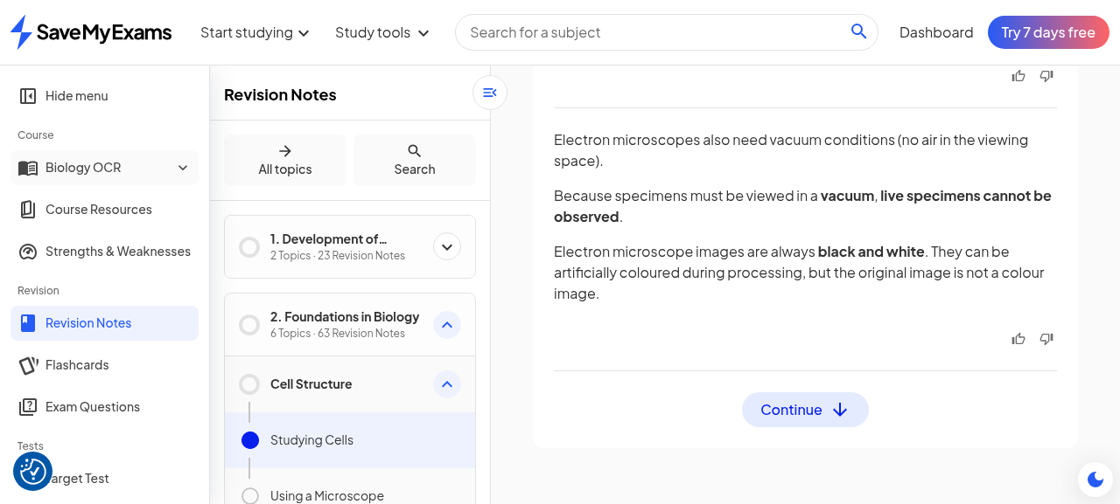
Figure 3. Medium branch mid-sequence: limitations, vacuum and black-and-white layers stacked stepwise.
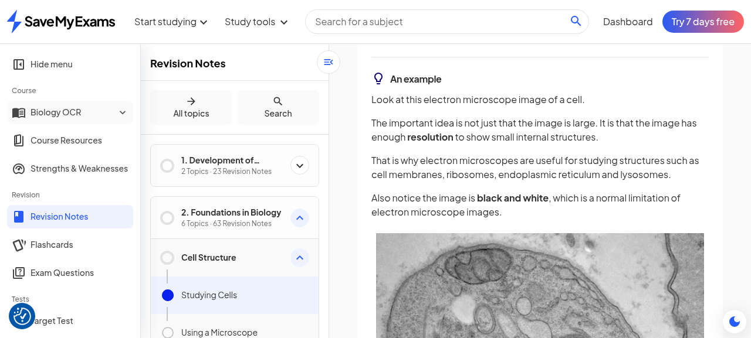
Figure 4. Medium terminus: 'Helpful terms' glossary, 'An example', and the Check understanding gate.
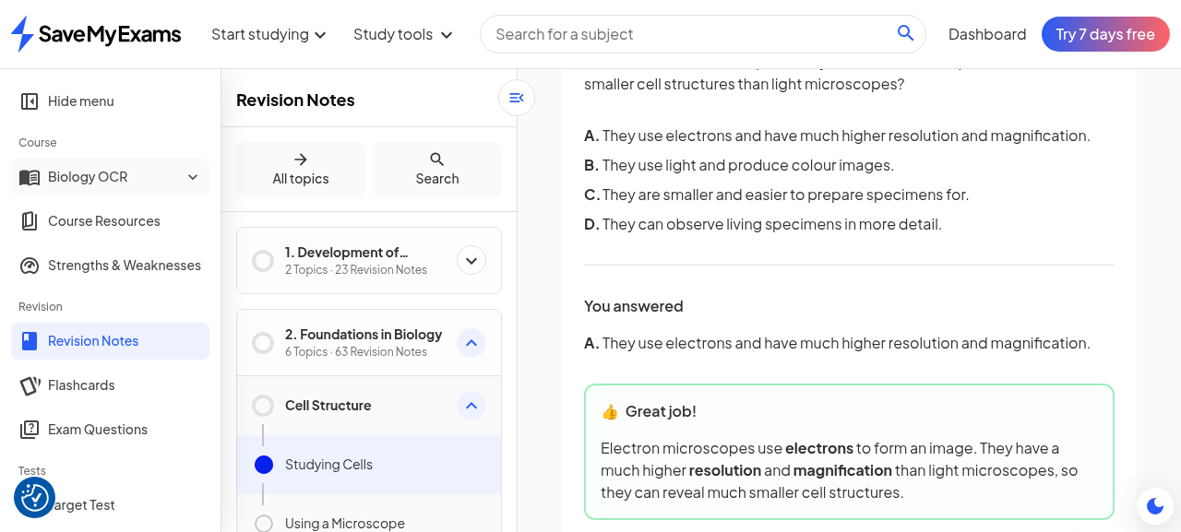
Figure 5. Medium check, question 1 of 5 answered correctly: confirmation plus explanation.

3.3 The High branch, walked end to end
Lesson 3 (TEMs and SEMs: Comparing Electron Microscope Images) on High unfolded in six content stages: (1) the same 'In plain words' opening, defining TEMs and SEMs and the inside-versus-surface key difference; (2) the TEM mechanism (beam through the specimen, denser parts darker, internal structures, high-resolution, two-dimensional); (3) the SEM mechanism (beam across the surface, bounced electrons detected, three-dimensional surface images, lower maximum resolution than TEM); (4) an identification heuristic ('ask one simple question: am I looking inside, or at the outside surface?'); (5) a 'Helpful terms' glossary of four terms; (6) an 'An example' passage contrasting two images. The check again ran five questions, and its opening question was applied rather than definitional ('Which microscope would most likely produce a three-dimensional image of the surface of bacteria?') - consistent with the learner having declared high confidence. The same toggle quirk observed in the base record reproduced here: the 'Review explanation' action collapses the answered-question view back to the lesson content rather than expanding further material, so the explanation block shown after submission is already the full review state.
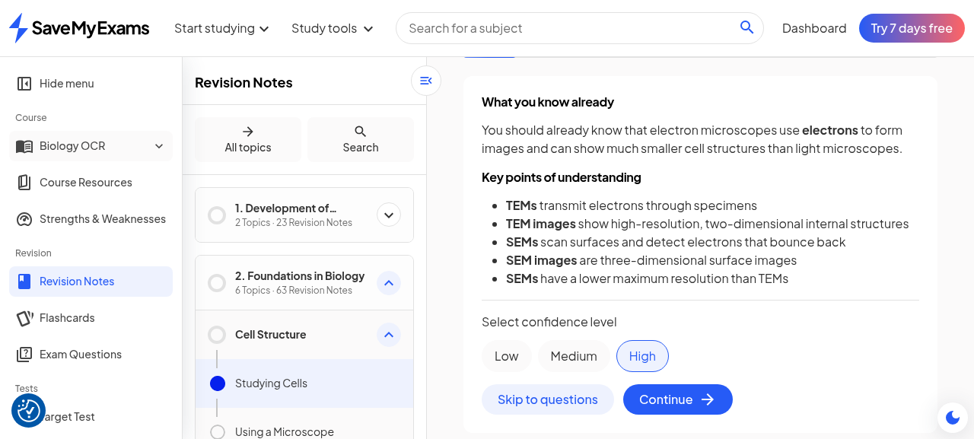
Figure 6. Lesson 3 confidence check with High selected; the primer chains from lesson 2.
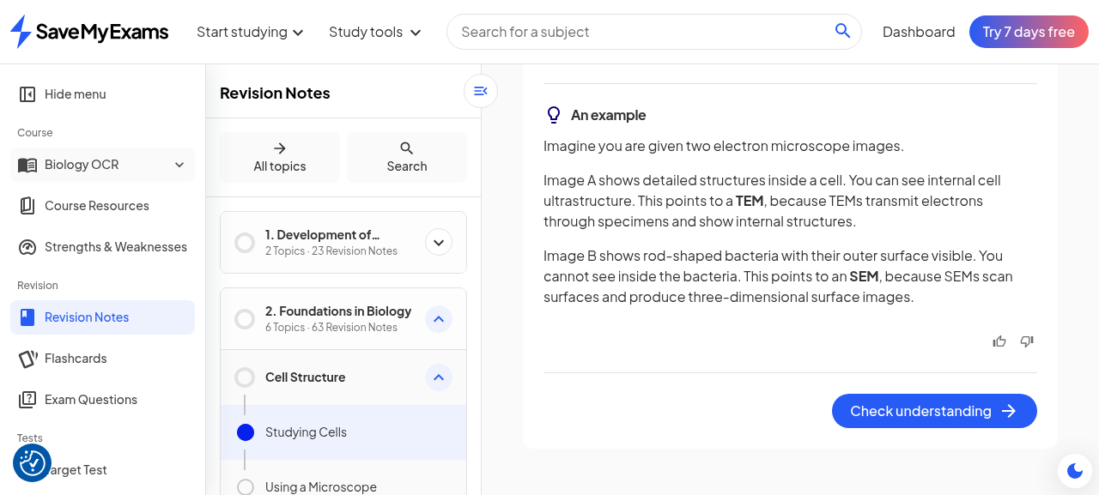
Figure 7. High branch terminus: glossary, two-image worked example, check gate.
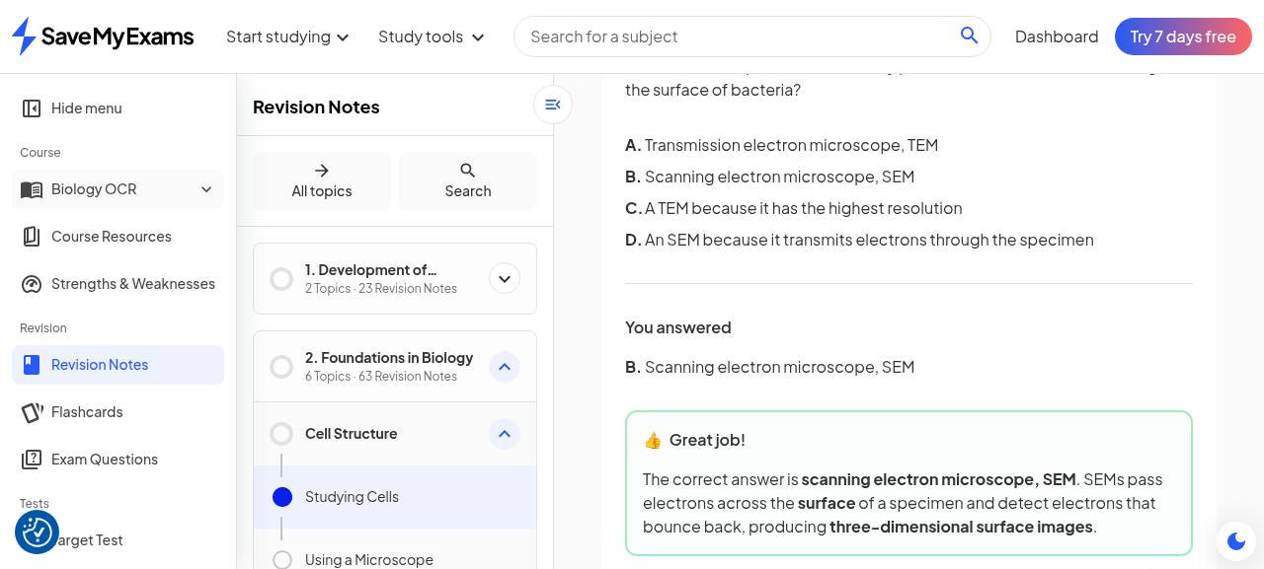
Figure 8. High check, question 1 of 5: applied identification question, correct answer confirmed.

3.4 Low, re-verified on lesson 1
Lesson 1 (Why Use Microscopes? Light Microscopy) still showed 'Start' in the lesson picker - the first pass had abandoned it mid-check - and re-offered the full confidence gate. Selecting Low and walking to the terminus produced six content stages with the identical layer grammar: 'In plain words' opening (what microscopy is for), progressively deeper light-microscopy layers, a 'Helpful terms' glossary, an 'An example' light-micrograph passage, then the five-question check. This confirms the base record's Low observation on the current build and completes the tri-branch picture on one account.

3.5 Branch comparison, the no-re-rate rule, and limits
The structural result across all three branches is uniformity of template: plain words in, glossary and example out, five-question check at the end, in every branch. The branches differ in how many pre-written layers are revealed and in the register of the check questions observed (definitional on the declarer-of-low-confidence lesson, applied on the high-confidence one), which is exactly the behaviour one would design if the confidence self-rating were being used as a cheap adaptivity proxy: it cannot change what is taught, because the content is authored; it can change the order and pacing with which fixed layers are fed to the learner, and it can bias question selection.
Table 1. Confidence branches exercised, 2026-10-18 pass 2
Lesson | Branch | Content stages before glossary | Glossary | Example | Check
1 Why Use Microscopes? Light Microscopy | Low | 6 | Yes (4 terms) | Yes | 5 MCQ
2 Electron Microscopy: Higher Detail and Limitations | Medium | 8 | Yes (4 terms) | Yes | 5 MCQ
3 TEMs and SEMs: Comparing Electron Microscope Images | High | 6 | Yes (4 terms) | Yes | 5 MCQ
Two limits of record. First, stage counts are lesson-specific as well as branch-specific, and because a completed lesson cannot be re-rated (next paragraph), a same-lesson cross-branch measurement was impossible on this account; the table therefore evidences template identity, not per-branch layer deltas. Second, progress persistence is one-way in the observed UI: lessons completed in this pass (2 and 3) now show 'Continue' rather than 'Start', and reopening them resumes the layered sequence at its last stage without re-offering the confidence gate. The rating is written once per lesson. The lesson picker also surfaced an unobtrusive panel-level feedback widget ('Was the guided study feature helpful? Yes / No') once lessons had been completed, matching the per-note feedback widget on the note page itself.

4. Smart Chat I: Revision Note Chat (the Explain Drawer)

4.1 Entry points and panel anatomy
On a revision-note page the chat entry is an 'Open AI chat' button alongside a 'Help me understand' affordance in the note's action area. Activating it slides in a right-hand drawer titled 'Explain' with a sparkle glyph, a chat-history (clock) icon and a new-chat icon in its header, an immediately visible disclaimer line ('Chat can make mistakes. Please check all responses carefully.'), four suggested prompt cards in a two-by-two grid - Definitions ('Define the key terms in this revision note'), Summary ('Summarise the key points'), Pitfalls ('Examine common misconceptions'), Exam help ('Tips for understanding this topic') - and a free-text input placeholder 'What needs explaining?'. The drawer overlays the note without leaving the page, so the assistant is contextually anchored to the note the learner was reading.
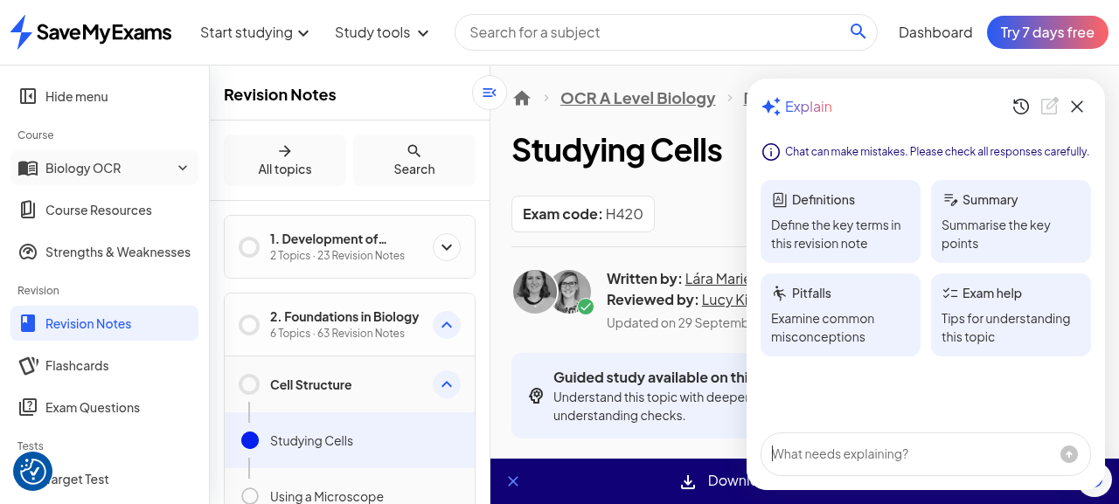
Figure 9. The Explain drawer on a revision note: disclaimer, four prompt cards, free-text input.

4.2 The Definitions run
Clicking the Definitions card produced, within seconds, a seven-term glossary drawn from this note's own vocabulary (resolution, magnification, light microscope, electron microscope, TEM, SEM, vacuum), each defined in one line in the notes' house register, followed by two hooks: an offer ('If you want, I can also turn these into quick flashcard-style Q&As') and a linked call to action into the Flashcards tool ('Use the flashcards to practise these terms'). The response is visibly grounded in the page's content set rather than a generic dictionary answer, which is the practical payoff of anchoring the drawer to the note.
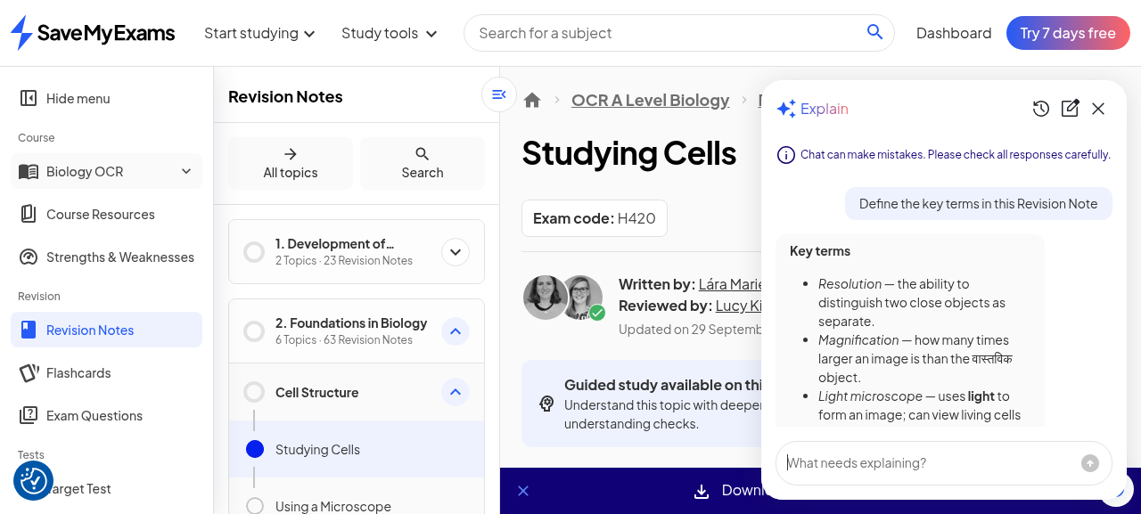
Figure 10. Definitions response: seven terms grounded in the note, closing with a Flashcards router hook.

4.3 Free-text questioning, memory and pedagogy
A free-text question ('Why can't electron microscopes observe living specimens?') returned a two-part answer - vacuum kills living cells; complex preparation damages them - followed by a Socratic nudge ('Think about it: if the microscope needs electrons to pass through or bounce off the specimen, what would happen to a living cell in a vacuum?') and a linked router into Exam Questions on cell structure. A follow-up testing conversational memory ('Does the same limitation apply to light microscopes?') was answered with full context resolved ('No - light microscopes can observe living specimens because they use light, not a vacuum'), a clean two-line contrast of the two microscope families, an offer to build a comparison table, and another exam-questions hook. Memory is therefore sustained across turns, and the persona consistently ends turns by routing the learner onward rather than letting the conversation dead-end.
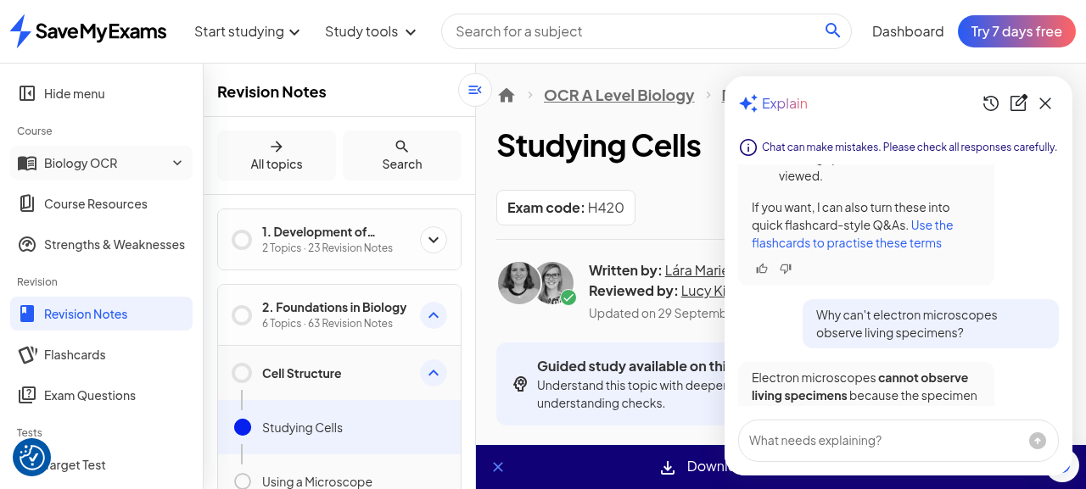
Figure 11. Free-text answer with Socratic nudge and an Exam Questions router link.
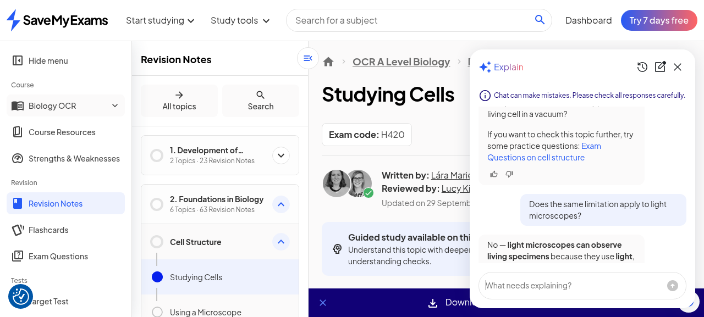
Figure 12. Anaphoric follow-up answered with full context: proof of multi-turn memory.

4.4 History and new chat
The clock icon opens a 'Previous chats' list inside the drawer; the just-closed thread appeared in it with a relative timestamp ('37 seconds ago'), so threads persist server-side per account rather than living only in page state. The new-chat icon resets the drawer to the four prompt cards on a fresh thread. Together these make the chat a durable study surface rather than a throwaway widget, and they match the account-scoped persistence model the rest of the platform uses (lesson progress, saved questions).

5. Smart Chat II: Exam Question Chat (the Understand Panel)

5.1 Entry and anti-leak prompt design
On the topic questions page (multiple-choice questions for Cell Structure), each question view carries a floating pill button bottom-right, 'Help me understand', plus a 'Question help' action in the question toolbar. Opening it shows a panel titled 'Understand' with the same disclaimer line and exactly two suggested prompts: 'Explain what this question is asking' and 'Approach - Help me work through this question'. The design point worth recording is what is absent: there is no 'give me the answer' prompt, and the two offered verbs (explain the question, work through it) steer the assistant toward process help. Combined with the Socratic behaviour documented next, the panel is engineered to tutor rather than to solve, which also protects the platform's assessment content from being trivially harvested.
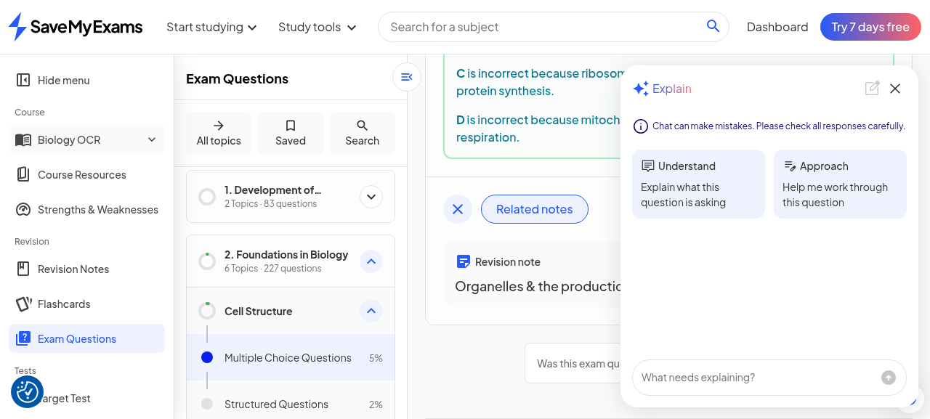
Figure 13. The Understand panel: two prompts, no answer-delivery path offered.

5.2 The Approach run and the Socratic loop
Triggering 'Approach' on an organelle question produced a full restatement of the question stem and all four options, then handed the thinking back to the learner: 'Which one do you think is responsible for modifying and packaging lipids and proteins?... Let me know your thoughts, or if you want a hint about any of the options!' No answer was disclosed. Replying as a student ('I think it's B, the Golgi apparatus') produced the confirm-and-consolidate move: praise, a reasoning check (modification and packaging into vesicles, glycoproteins and glycolipids), a one-line role recap of every distractor (lysosomes digest waste; ribosomes synthesise protein; mitochondria respire), an explicit 'Exam tip:' paragraph on elimination strategy for multiple choice, and an offer to generate a similar practice question or review any organelle in more depth. The loop - attempt first, then confirm, then consolidate, then extend - is the same pedagogy the guided-study check uses, delivered conversationally.
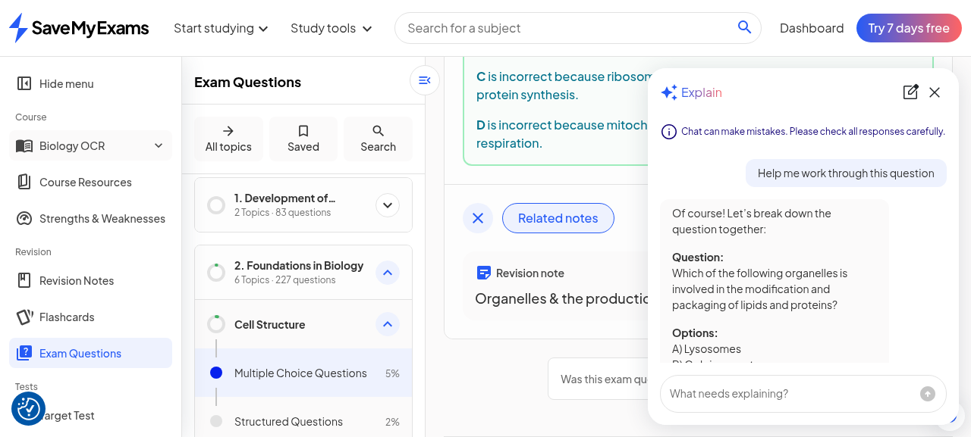
Figure 14. The Approach run: question restated, learner asked to reason first, answer withheld.
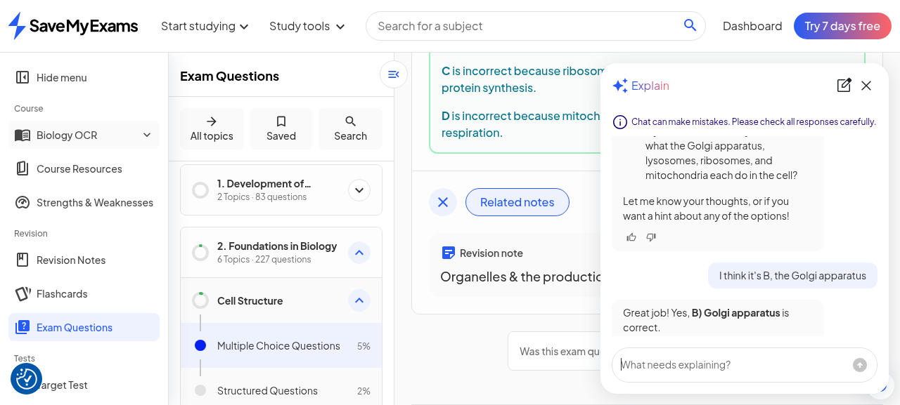
Figure 15. After the learner's answer: confirmation, reasoning check, per-option recap, Exam tip, practice offer.

6. Cross-Surface Analysis and Caveats
Smart Chat is best understood as the connective tissue between the platform's authored surfaces rather than as a standalone product. Every assistant turn observed ended with a router hook into another tool - flashcards after a definitions answer, exam questions after an explanation - so the chat continuously recirculates attention into the engagement loops (notes, checks, practice) that the base record documented. The persona is consistent across both surfaces: explain in the notes' register, nudge Socratically, never lead with the answer, consolidate after the learner commits. That consistency is what makes two separately embedded panels feel like one tutor.
Free-tier posture: across the pass the account sent roughly six assistant messages in three threads (definitions, two free-text turns, approach, learner reply) with no usage counter, no cap message, no trial prompt and no paywall. Plan copy places 'Revision help with Smart Chat' inside the paid tiers (the Essential list on the plan page; competitor coverage describes the same), so the observed openness either reflects a beta enforcement posture, like guided practice in the first session, or a generous sampling allowance. Either way, the enforcement perimeter observed to date remains the download wall and nothing else.
Quality caveat of record: the Definitions response contained one live generation glitch - the English phrase 'how many times larger an image is than the actual object' rendered with the word 'actual' as the Devanagari token for the same word. The screenshot preserves it verbatim. The standard disclaimer ('Chat can make mistakes. Please check all responses carefully.') is shown before any content in both panels, so the platform's risk framing is at least stated up front; the glitch is nonetheless a useful datapoint that responses are generated, not curated, even when they are well grounded in the note.

7. Implications for SyllabAI (Delta to the Base Record)
First, on adaptivity architecture: the confidence gate's real function - pacing fixed authored layers, biasing question register - is implementable without any model in the loop, and the branch-uniformity finding strengthens the base record's advice that SyllabAI can ship the decomposition-plus-gate pattern cheaply and reserve genuine AI for the marking layer. The once-per-lesson rating also simplifies data modelling: confidence is a lesson-level attribute with a write-once semantic, not a continuously updated state.
Second, on prerequisite chaining: the 'What you know already' primer derived from the previously completed lesson is a small mechanic with outsized sequencing value, and it falls back gracefully to a static primer when no predecessor exists. A syllabus product is unusually well positioned to do this well, because the prerequisite graph is already explicit in the syllabus rather than inferred.
Third, on embedded assistants: the two-chat split (Explain on notes, Understand on questions) with different prompt sets per surface is the right shape. Prompt sets engineered against answer leakage on the assessment side protect content value, and the router hook after every turn is a cheap, effective retention device that turns the assistant into internal navigation. SyllabAI should treat its own future assistant as a router between notes, checks and practice from day one, with per-surface prompt cards and the same no-answer-first posture on anything that counts as assessment.
Fourth, on operational hygiene: the captured generation glitch inside a definitions answer argues for post-generation linting on any assistant that echoes a curated corpus - a language-consistency pass and a term-list conformance check are cheap automatable guards that would have caught the observed failure. The pre-content disclaimer is necessary but not sufficient; catching the glitch is better than disclaiming it.

8. Evidence Index
All evidence files from both passes live in the same directory as this document. Files 01 through 53 belong to the base record; files 54 through 91 were captured in this pass and map as follows.
Files | What they evidence
54 | Guided study panel reopened on Studying Cells (lesson picker, progress states)
55 - 56 | Lesson 2 confidence check; Medium selected, Continue released
57 - 64 | Medium branch stages 1-8 (plain words through glossary and example)
65 - 66 | Medium check question 1; correct-answer feedback
67 - 68 | Lesson 3 confidence check with chained primer; High selected
69 - 74 | High branch stages 1-6 (plain words through glossary and example)
75 - 76 | High check question 1 (applied question); correct-answer feedback
77 - 78 | Review-explanation toggle behaviour (collapse quirk)
79 - 80 (7 frames) | Lesson 1 Low branch re-verification, stage-by-stage to terminus
81 | Revision note page with chat entry affordances
82 - 86 | Explain drawer: anatomy, Definitions run, free-text, memory follow-up, history
87 - 88 | Topic questions page, per-option explanations, Help me understand pill
89 - 91 | Understand panel: prompt design, Approach run, Socratic confirm loop
Caveat of record: both passes observe one free-tier account on 2026-10-18 on surfaces the platform badges as Beta. Confidence gating, chat limits and tier enforcement are all subject to change without notice; statements about paid-tier behaviour are grounded in displayed plan copy, not a paid session.

