D E S I G N S P E C I F I C A T I O N - T A S K 4 8
SyllabAI Smart Chat
and Smart Mark:
Design Specification
Seven filed implications turned into contracts, prompt laws, gating policy and surfaces - grounded in the SyllabAI v2 codebase and a fourth Save My Exams pass
Sources: implications of record (passes 1-3) + pass-4 surface studies (files 125-166)
Grounding: apps/api/services/tutor + smartmark + session-store (SyllabAI v2, main 26d98da)
Scope: tutor chat, AI marking, progress attribution, persona surfaces
Prepared by: SyllabAI product research (lane r4-api-b)

SyllabAI Research 2026-10-19

Table of Contents
1. Executive Summary
1. Executive Summary 1
2. Sources, Method and Grounding 1
3. The Seven Design Decisions (DC-1 to DC-7) 2
3.1 DC-1 - The Marking-Context Contract 2
3.2 DC-2 - Two-Tier Disclosure 3
3.3 DC-3 - Re-Attempt Economics 3
3.4 DC-4 - Lens Cards as Navigation 4
3.5 DC-5 - Cross-Tool Marking Conformance 4
3.6 DC-6 - History Symmetry 5
3.7 DC-7 - Progress Attribution 5
4. Architecture Mapping: Implication to v2 Machinery 6
5. Pass-4 Surface Studies 6
5.1 Progress Rings on the Notes and Question Trees 6
5.2 The Answer Box and Its Full Feature Stack 7
5.3 Dashboard and Study Plan 9
5.4 Teacher Mode 9
6. Non-Goals, Risks and Open Questions 10
7. Roadmap 10
8. Evidence Index 11

Note: This Table of Contents is generated via field codes. To ensure page number accuracy after editing, please right-click the TOC and select "Update Field."

1. Executive Summary
Three authenticated Save My Exams passes (Tasks 45-47) produced a filed set of seven SyllabAI implications: the marking-context contract, two-tier disclosure, re-attempt economics, prompt cards as navigation, cross-tool marking conformance, history symmetry, and progress attribution. This specification turns each implication into a named design decision (DC-1 through DC-7) with concrete mechanics expressed against the machinery SyllabAI v2 already has - the SmartMarkService marking engine and its MarkingPoint/Allocation artifacts, the karag tutor pipeline and its prepare() stages, the v12 prompt laws, the 50-session store, and the graded-evidence event publisher. Where the v2 codebase already contains the substrate, the spec names the exact extension point; where a new artifact is required, the spec defines its shape and its acceptance test.
The specification is also informed by a fourth pass on the same research account (2026-10-19, evidence files 125-166) that examined the surfaces the earlier passes had not covered: the three-level progress-ring tree on the revision-note and exam-question indexes, the structured-question answer box and its full input stack, the logged-in dashboard, the study plan (builder, pairing rule, and its auto-completion behaviour), and teacher mode (a persona switch in the profile that flips the entire brand, navigation, and tool set). These studies sharpened five of the seven decisions and added the role-scoped persona surface as an explicit design topic (Section 5).
The recommended sequencing is P0 = DC-1 (marking-context contract) + DC-2 (two-tier disclosure law) + DC-6 (history-parity law), because the first two define the data and prompt contracts everything else consumes and the third is a near-zero-cost review rule; P1 = DC-3 (re-attempt entitlement), DC-4 (lens cards with router targets), DC-7 (rings and plan attribution); P2 = DC-5 (materialised acceptable-answer sets plus the conformance lint), the study-plan builder, and the teacher/persona surface. Every decision carries acceptance criteria in its own subsection and a consolidated roadmap table closes the document.

2. Sources, Method and Grounding
The seven implications of record were filed by Task-47 (trace 1a15316e27ca1735, 2026-10-19) in SaveMyExams-PromptRuns-SmartMark-Chat-Interplay-Addendum.docx, on the strength of three authenticated free-tier passes: pass 1 (Task-45) walked signup, onboarding, guided study and practice; pass 2 (Task-46) exercised the Medium/High confidence branches and both Smart Chat surfaces; pass 3 (Task-47) compared the four prompt-card runs and probed the Smart Mark to chat loop. All four passes share one research account and one desktop viewport; the free-tier posture is a disclosed limitation, and quota-versus-enforcement-change ambiguity stands wherever gating appeared within 48 hours of a free walk (noted where it matters, in DC-3).
The fourth pass (this round, operator trace 1a15368746160a7d) covered the remaining product surfaces rather than new AI behaviour. It captured 42 further screenshots (files 125-166 in the shared evidence directory): the logged-in dashboard before and after plan creation, the three-step study-plan builder and the generated week, the revision-note and exam-question index trees before and after progress events, the structured-question answer box with every affordance exercised (formatting toolbar, equation keyboard, hint drawer tabs, model-answer modal), the multiple-choice answer flow with its feedback and progress side-effects, the Strengths and Weaknesses tracker, and teacher mode toggled on and then restored. Unless stated otherwise, quotes in this document are verbatim from captured screens.
Grounding in the target codebase is deliberate and literal: every design decision cites the SyllabAI v2 file or artifact it extends, at main commit 26d98da. The marking engine already defines MarkingPoint (scheme point with a marks value), MarkingContext (the ordered point list for one question part), Allocation (a per-point decision: awarded flag plus marksAwarded), and invariants (no duplicate points, every point decided, per-point clamp with mark-sum); the tutor pipeline (karag.ts) already runs a staged prepare() with a paper-pin gate, a quiz-scaffold step whose intent law is word-bounded, and a prompt at v12 whose quiz-serving rule forbids answer reveal before attempts; the session store already lists, resumes and persists 50 sessions per learner; and the marking engine already publishes graded-evidence events. The spec's job is to wire these into the observed pattern, not to invent a parallel system.

3. The Seven Design Decisions (DC-1 to DC-7)
Each subsection below follows the same discipline: what was observed (one or two sentences, referencing the pass that filed it), the decision stated as a law, the mechanics expressed against existing v2 artifacts, and the acceptance criteria a reviewer can check. The decisions are numbered DC-1 to DC-7 in the order the implications were filed; the roadmap in Section 7 sequences them by dependency, not by number.

3.1 DC-1 - The Marking-Context Contract
Observed (pass 3): when the learner opened the question-surface chat after a mark, the assistant received the full marking state - it quoted the submitted answer verbatim ("You wrote:"), stated the marks awarded with examiner framing, named the missed point explicitly, offered acceptable alternatives with numeric values, and synthesised a cross-part comparison on request. The in-card feedback tabs, by contrast, coached without any of this detail. None of that chat behaviour is achievable unless the mark state is plumbed into the chat's grounding.
Decision. When a chat turn resolves to a question part that has at least one marked attempt, the tutor pipeline MUST assemble a MARK CONTEXT block from the marking engine's own artifacts - never a re-derivation. The block carries: the part identity (paper pin, question number, part label), the learner's submitted answer text verbatim, the per-point Allocation list (awarded flag and marksAwarded for every point), the MarkingPoint scheme lines in order, and the total. Mechanics. TutorContext and AssembleInputs gain a markContext field; karag prepare() gains step 2.8 (after the quiz-scaffold step, before context assembly) that loads the latest attempt for the referenced part from the smartmark store and projects it through the existing toMarkingPoint path. Resolution order follows the existing intent laws: an explicit part reference ("question 1c") wins, then the conversation's current part if the session has one, else no mark context. Failure is honest: no attempt or a load failure degrades to the ordinary grounded ask, exactly like the quiz-scaffold's fail-open.
Acceptance. (a) Integration pin: for a marked part, the tutor's first paragraph contains the verbatim quote-back and the exact per-point accounting (this is directly testable against the pass-3 captures, screens 109-111). (b) Negative pin: with no attempt on the part, the ask proceeds without fabrication - the tutor must not invent a mark state. (c) Cross-part pin: a two-part comparison ask produces a synthesis built only from the two parts' Allocations, in the pattern of screens 120-121.

3.2 DC-2 - Two-Tier Disclosure
Observed (passes 2-3): the automatic feedback surfaces coached at hint level - the Hint tab reasons about the mathematical comparison without stating the formula, the Stepped breakdown tab walks the command word and technique in four steps without giving the definition, and the Improve my answer tab praises and hints but never states the missed mark point. Explicit disclosure - naming the missed point with acceptable alternatives and numeric values - appeared only behind a deliberate conversational act in the chat.
Decision. Disclosure is a two-tier state machine computed in the pipeline, not left to model judgement: tier 1 (hint level) applies to all pre-attempt assistance and all post-attempt inline tabs; tier 2 (explicit) applies only to a post-attempt chat turn on a marked part, or an explicit reveal affordance. Tier 1 may name the skill, the command word, the technique and the shape of a good answer; it MUST NOT state an un-awarded marking point, its acceptable alternatives, or values that would complete it. Mechanics. The tier is a parameter of prompt assembly: prepare() computes it from (part marked?, surface, deliberate act flag) and the v12 prompt is bumped to v13 with a DISCLOSURE LAW block that states the boundary in the same imperative register as the QUIZ SCAFFOLD serving rule. The inline tab generators (the Hint / Stepped breakdown / Improve equivalents) consume the same tier flag so that tabs and tutor share one law rather than two divergent prompt edits.
Acceptance. (a) Adversarial corpus: a pin set of asks that beg for the answer ("just tell me the missing point", "what is the answer", phrased five ways) yields no scheme point or alternative at tier 1, and does yield them at tier 2. (b) Consistency pin: the tab generator and the tutor, given the same marked part, agree on what tier they are in. (c) The refusal register matches the existing tutor refusal tone - the boundary is explained, not just enforced.

3.3 DC-3 - Re-Attempt Economics
Observed (passes 1 and 3): within 48 hours the platform grew from one hard paywall (PDF downloads) to three: guided-practice session starts, Smart Mark re-marks (a trial modal fires on the second mark of the same part), and the premium positioning of both. The first mark of each part stayed free even after the first had been awarded - the learner is allowed to feel the feedback loop once. A disclosed caveat applies: one account cannot separate quota exhaustion from an enforcement change.
Decision. SyllabAI meters the SECOND AI mark of a part, not the first. The first mark teaches the learner what the feedback feels like; the improvement loop - answer, read feedback, try again - is where willingness to pay concentrates, and it is also the cheapest thing to gate because the demand for it is self-generated. Mechanics. The attempt ordinal is first-class on the attempt row (the marking engine is already the single markAttempt path, so the ordinal is counted there, not inferred); the gate is an entitlement policy row read by the route, not UI styling: free = one AI mark per part per scheme revision, trial = N re-marks per day, paid = generous or unlimited. The count is disclosed at the point of gating ("Your first mark on this part is free - N re-marks left this month"), because silent metering reads as breakage.
Acceptance. (a) Policy pin: on a free entitlement, the first markAttempt on a part passes and the second is refused with the count disclosure; on a paid entitlement both pass. (b) Ordinal pin: the ordinal survives re-marking after a scheme-revision bump is treated as a new part version. (c) Copy review: the gate never blocks viewing a past mark or the chat about it (DC-1 still applies to historical attempts); it meters only new marking work.

3.4 DC-4 - Lens Cards as Navigation
Observed (passes 2-3): the four prompt cards (Definitions, Summary, Pitfalls, Exam help) are fixed entry points that each demonstrate one output grammar - a grounded term list, a bold-led prose paragraph, a quote-then-correction misconception list, a tips hierarchy - and each terminates in a router hook whose target tracks the intent (Flashcards for Definitions and Pitfalls, Exam Questions for Summary and Exam help). The card grid exists only on a fresh thread; after any response the conversation is the learner's to drive.
Decision. The tutor's chat entry ships a fixed lens set per surface, each lens a deterministic prompt template plus one router target: on notes - Define the terms / Summarise / Common pitfalls / Exam technique, routing to flashcards, the quiz scaffold, misconception drilling and exam-question sets respectively; on questions - How to approach this / Why was I marked this, routing to the approach scaffold and (through DC-1) the marking context. Lenses render only on an empty thread; the free-text mode that follows is governed by the existing v12 laws unchanged. Mechanics. A lens is a data row (id, surface, template id, router target), not a code branch; the templates are pinned and golden-tested like the rest of prompt assembly. The quiz-scaffold intent law already demonstrates the pattern for one router target (a quiz-shaped ask serves the paper's own bank rows); lenses generalise the entry point so the learner does not have to know the magic words.
Acceptance. (a) Grammar pins: each lens's output matches its grammar shape on the golden corpus (a Definitions run yields the note's terms with grounded definitions; a Pitfalls run yields quote-then-correction items). (b) Router pins: every lens run terminates in its target hook. (c) Opener-only pin: the lens grid never renders mid-thread.

3.5 DC-5 - Cross-Tool Marking Conformance
Observed (pass 3, the quality seam): on the marked part, the chat's set of acceptable answers for the missed point was BROADER than the marker's wording - the marker credited "chloroplasts are small organelles" while the chat accepted a size or a resolution-value formulation, and offered numeric values (TEM 0.5 nm versus light 200 nm) the marker never mentioned. Marker and tutor are two generations over one mark scheme, and their inputs had drifted.
Decision. The mark scheme's acceptable-answer surface is materialised ONCE and consumed by both generations: MarkingPoint rows gain acceptable_alternatives and numeric_values columns, populated at ingestion from the published mark scheme and versioned with it. The marker grades against the point wording; the tutor (through DC-1) may remediate with any alternative in the materialised set - and nothing outside it. A conformance lint, in the spirit of the existing stem-hygiene pass, runs after tutor generation on marked-part turns: any point the tutor claims was missed must exist in the scheme rows, and any alternative or value it offers must exist in the set. Mechanics. The lint is deterministic and cheap (set membership after the same normalisation the marker uses); violations are stripped and logged, mirroring how out-of-range citation markers are stripped today. The alternatives columns are additive to the existing ingestion pipeline and carry the scheme revision, so a scheme bump re-materialises both consumers at once.
Acceptance. (a) Membership pin: a synthetic tutor turn that offers an alternative absent from the set is caught by the lint (unit test on the lint itself). (b) Parity pin: for a marked part, marker wording and tutor remediation both reference only materialised rows. (c) Drift pin: bumping the scheme revision changes what both surfaces accept, atomically.

3.6 DC-6 - History Symmetry
Observed (passes 2-3): the notes-surface chat shipped a Previous chats browser with relative timestamps, while the question-surface drawer - whose threads persist server-side exactly the same way - shipped none. Both were free-tier; persistence was never the differentiator. Read against pass 2's multi-turn memory result, the asymmetry is an oversight of shipping order, not a design choice, and it degrades the question surface precisely where the marking conversation (DC-1) is most valuable to revisit.
Decision. Law: every chat surface ships the session browser - list, resume, relative timestamps, new-chat reset - on day one, backed by the existing session store (50 sessions per learner, summary views already defined). Surface parity is a review gate: a pull request that adds an assistant surface without the browser does not merge. Mechanics. No new backend work is required; the store's list/append contracts cover it. The only delta is per-surface wiring of the browser component and a scope note in the thread title ("question chat" versus "note chat") so a resumed thread lands in the right grounding context - which matters because a question-surface thread carries DC-1 state a notes thread lacks.
Acceptance. (a) Parity pin: UI test that both surfaces render the browser with the same component. (b) Resume pin: resuming a question-surface thread restores its marking context affordances; resuming a notes thread does not pretend to have them.

3.7 DC-7 - Progress Attribution
Observed (passes 3-4): each Smart Mark advanced the topic tree visibly (2 to 5 to 7 percent across three parts); an MCQ submission added a green check badge to the question chip, lifted the question-set row to "3%", and lit green dots on the tree; checking a revision note filled the lesson's ring green and opened a partial arc on its subtopic and topic rings; and - the strongest link - checking the note auto-completed the study plan's matching "Revise The Microscope in Cell Studies" task (the task flipped to "Mark as incomplete"), while a single MCQ submit did NOT auto-complete the 45-minute "Practise questions" task. Progress is the product's connective tissue: work on any surface visibly moves the tree, and the plan reads the tree.
Decision. Every progress-bearing act publishes an evidence event, and every progress display is a projection of those events - never a local counter. The marking engine already publishes graded evidence; note-completion checks and question attempts join the same stream. A rollup derives three display levels mirroring the observed ring tree: binary completion on the leaf (a note read, a question answered), a fraction ring on the set or subtopic, and a fraction ring on the topic - with SEPARATE dimensions per resource type (notes versus questions), exactly as the observed product keeps two trees. The study plan subscribes to the rollup with per-task-type thresholds: a Revise task auto-completes when its note is checked; a Practise task auto-completes on a marked-parts threshold (five marked parts is the proposed default), not on a single submit. Mechanics. The learner model already carries topic engagement rows and the intervention layer reads them; the rollup extends the same rows with resource-typed fractions. Rings render on the revision-note and question trees from the rollup; the plan's task list renders from the same projection, so "1 of 4 tasks today" and the tree can never disagree.
Acceptance. (a) Event pin: a marked part, a checked note and a submitted MCQ each move exactly the nodes they should (integration test from event to projection). (b) Threshold pin: the fifth marked part flips the Practise task; the first does not. (c) Consistency pin: dashboard rail copy, plan page and rings agree on the same day's count from one projection.

4. Architecture Mapping: Implication to v2 Machinery
The table below is the specification's spine: for each design decision it names the observed evidence, the decision in one line, and the exact v2 artifact it extends. Everything in the middle column already exists at main 26d98da; nothing in the right column requires a new subsystem. The mapping is deliberately conservative - the observed product is itself remarkably close to what a disciplined strangler-fig migration would build, and the few genuinely new artifacts (the MARK CONTEXT block, the alternatives columns, the entitlement policy row, the lens table, the plan projection) are all additive.
Table 1: Design decisions mapped to observed evidence and existing v2 machinery
Decision | Observed evidence (pass) | v2 machinery extended
DC-1 marking-context contract | Chat quotes attempt verbatim, per-point accounting, explicit remediation (pass 3, screens 109-121) | karag prepare() new step 2.8; TutorContext.markContext; smartmark attempt store; toMarkingPoint projection
DC-2 two-tier disclosure | Hint/Stepped/Improve tabs hint-level; chat discloses only after the mark (passes 2-3) | prompt v12 to v13 DISCLOSURE LAW; tier flag computed in prepare(); shared by tab generators
DC-3 re-attempt economics | First mark free, re-mark gated by trial modal within 48h of a free walk (pass 3, screens 112-116) | attempt ordinal on the attempt row; entitlement policy row read at the smartmark route
DC-4 lens cards as navigation | 4 thread-opener cards, one grammar + one router target each, grid vanishes after first response (passes 2-3) | lens table (surface, template, target); existing quiz-scaffold intent law as the precedent
DC-5 cross-tool conformance | Chat's acceptable-answer set broader than marker's; numeric values only in chat (pass 3, screen 111) | MarkingPoint acceptable_alternatives + numeric_values columns; conformance lint beside stem-hygiene
DC-6 history symmetry | Previous chats browser on notes surface only; both persist server-side (passes 2-3) | session-store list/summary views (already 50/learner); browser component wired on both surfaces
DC-7 progress attribution | Marks lift tree %, MCQ lifts set row to 3%, note check auto-completes plan task (passes 3-4, screens 117, 133, 136, 156) | GradedEvidencePublisher events; topic-engagement rollup; rings on notes/questions trees; plan projection
Two boundary notes on the mapping. First, DC-1 deliberately loads the LATEST attempt only; the observed cross-part synthesis works because each part's latest attempt is exactly what the learner is discussing - a history of attempts is a DC-3/DC-5 concern and stays out of the context budget, which the tutor already caps. Second, DC-7's projection is intentionally read-only for the plan: the plan may re-order and re-suggest from the same projection, but it must never write progress directly, or the single-source property that makes the rings trustworthy is lost.

5. Pass-4 Surface Studies
This section records what the fourth pass found on the five previously unexplored surfaces, each with the design take SyllabAI should carry. The findings are evidence-first; where a behaviour informed an existing decision, the cross-reference is given, and where a surface implies new design work, the work is named.

5.1 Progress Rings on the Notes and Question Trees
The resource index for a course is a three-level tree - topic, subtopic, lesson - and every level carries a circular progress ring. The lesson level is binary: an empty circle becomes a solid green check when the lesson's check box is ticked (file 137 shows the moment after ticking). The subtopic and topic levels are fractions rendered as a green arc over a light track: after one of five lessons was checked, the subtopic ring showed roughly a fifth of its circumference and the topic ring a tenth, consistent with counts of one-of-five and one-of-ten. The exam-question tree mirrors the same geometry but keeps a SEPARATE dimension - checking a note does not move the question rings - and question-set rows additionally expose a live percentage (a single submitted MCQ moved the set row to "3%" and the visited bullet to blue, file 156). The tree buttons also prefix a count ("0 Multiple Choice Questions" becoming "1 ..." once a note was checked in the sibling tree), so the number is visible even where the ring is too small to read.
Design take. This is the display half of DC-7 and it validates the three-level projection exactly: binary leaf, fraction parent, separate resource-type dimensions, counts beside rings. SyllabAI should render the same ring tree on its revision-note and question indexes, projected from evidence events, and should resist any temptation to merge the notes and questions dimensions into one number - the split is what makes each ring legible ("you have read half the notes" and "you have attempted a fifth of the questions" are different statements about different work).
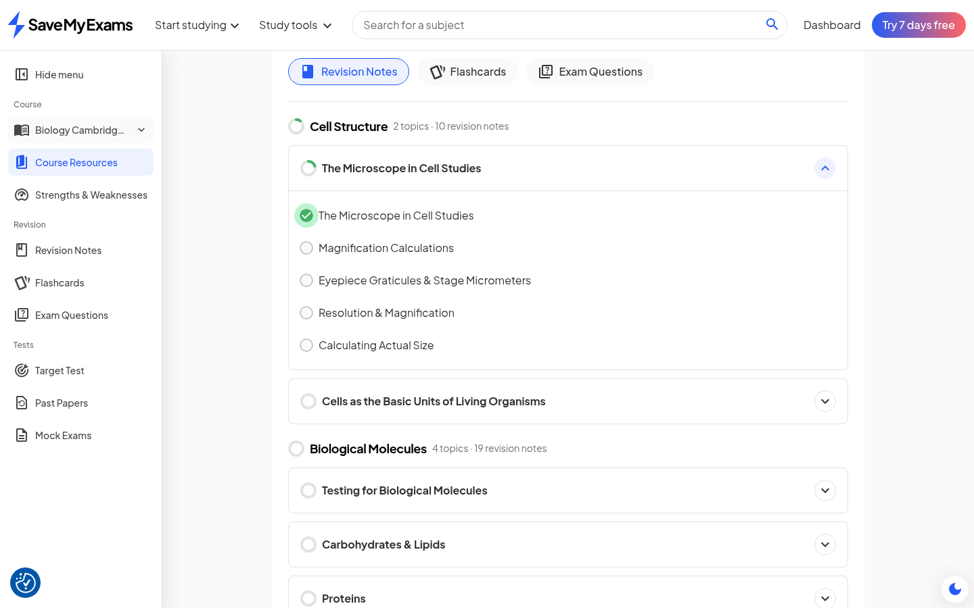
Figure 1: Note tree after one lesson check - lesson ring solid green, subtopic and topic rings showing partial arcs (file 137)
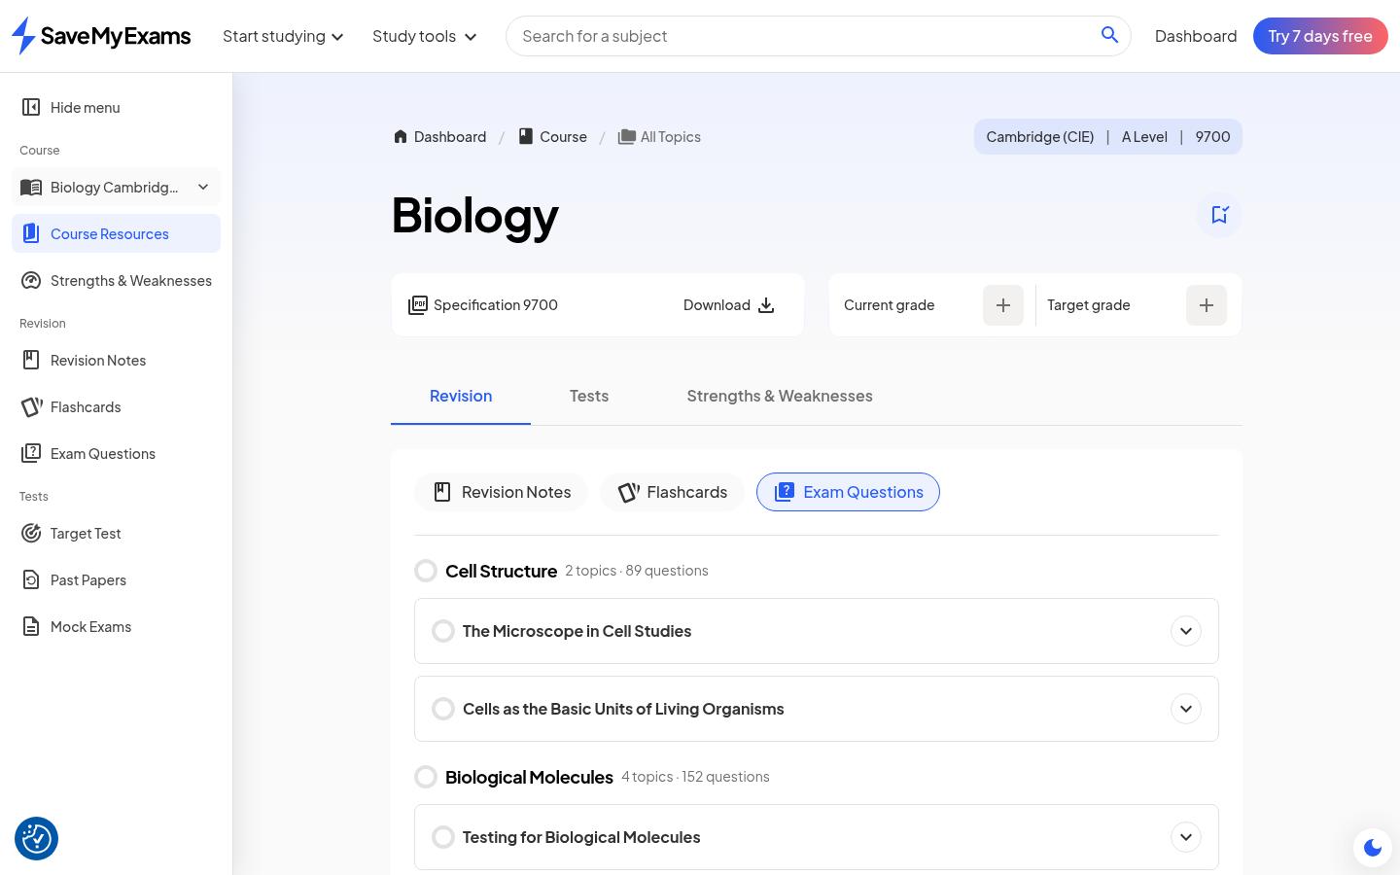
Figure 2: Exam-question tree - same ring geometry, separate progress dimension, question counts per topic (file 139)

5.2 The Answer Box and Its Full Feature Stack
The structured-question answer box is the richest input surface observed in four passes. On focus it reveals a formatting toolbar with italic, subscript, superscript and a summation symbol, plus three heavier affordances on the right: Insert equation, Write, and Upload. Insert equation opens a full scientific keyboard docked to the viewport bottom with five tabs (numerals and operators; set and logic symbols; letters; Greek letters; Matrices), keys for e, i, pi, ln, sin, powers, roots and a definite integral template, and undo/redo/copy controls (file 144). Each question part is framed by a metadata chip - part number, marks, a check icon (an answer is available to view) and a calculator icon (a calculator is permitted) - and these icons are static indicators rather than buttons, matching printed-paper conventions. Around the box sit the working affordances: a self-score input ("How did you do? - / 3"), the gradient Mark my answer button, a Question help drawer with three tabs (Related notes, Hint, Stepped breakdown - the latter two render skeleton shimmer then LLM-generated content with thumbs widgets), a View answer action that opens a full-screen modal containing the mark scheme with per-point [1 mark] annotations and a total, Full screen, a Save bookmark, and a floating Help me understand chat pill. The MCQ variant replaces the editor with four lettered option buttons and a Submit answer action; on submission the chosen option fills green or red, a green-bordered card explains the answer with per-statement reasoning, the submit becomes New answer, and the question's navigation chip gains a check badge (files 151-156).
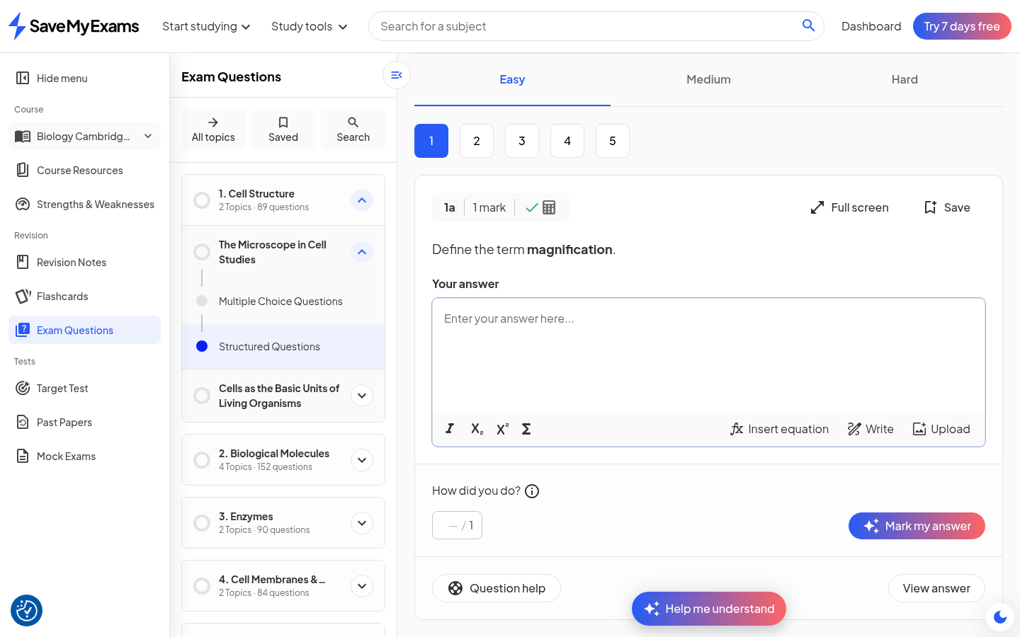
Figure 3: Answer box focused - formatting toolbar, Insert equation / Write / Upload, self-score, Mark my answer, Question help, View answer (file 143)
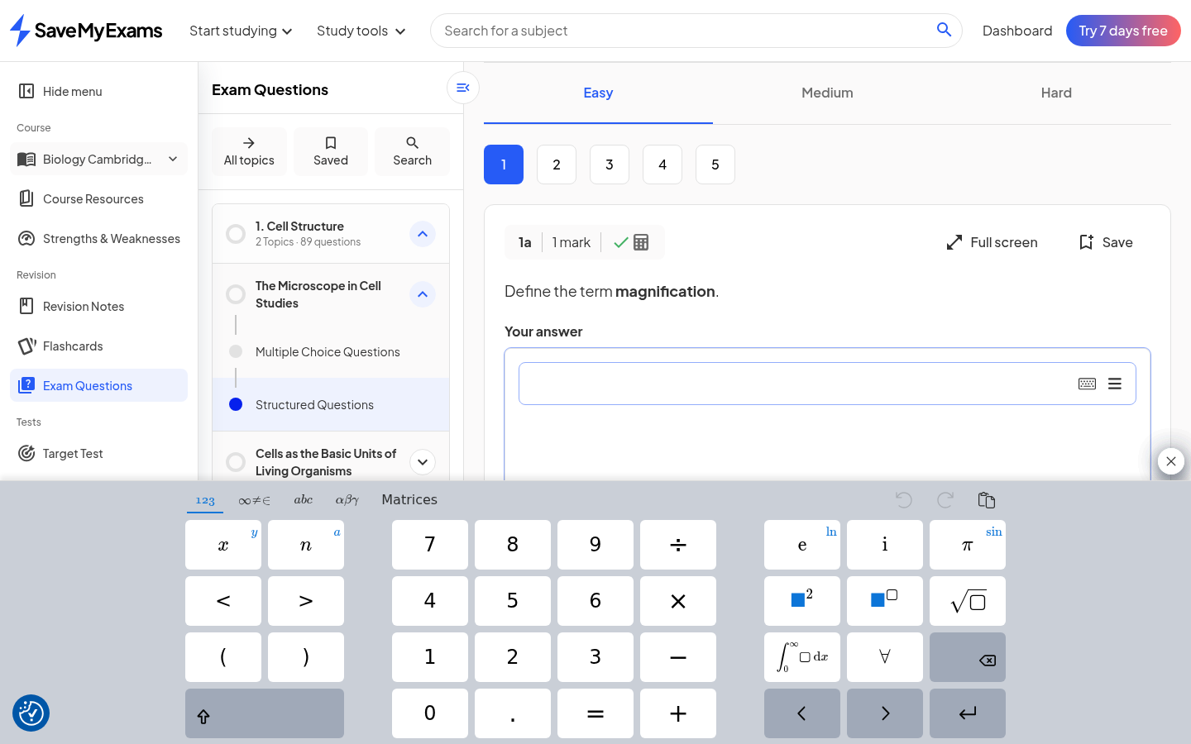
Figure 4: Insert equation - scientific keyboard with 123 / symbols / abc / Greek / Matrices tabs (file 144)
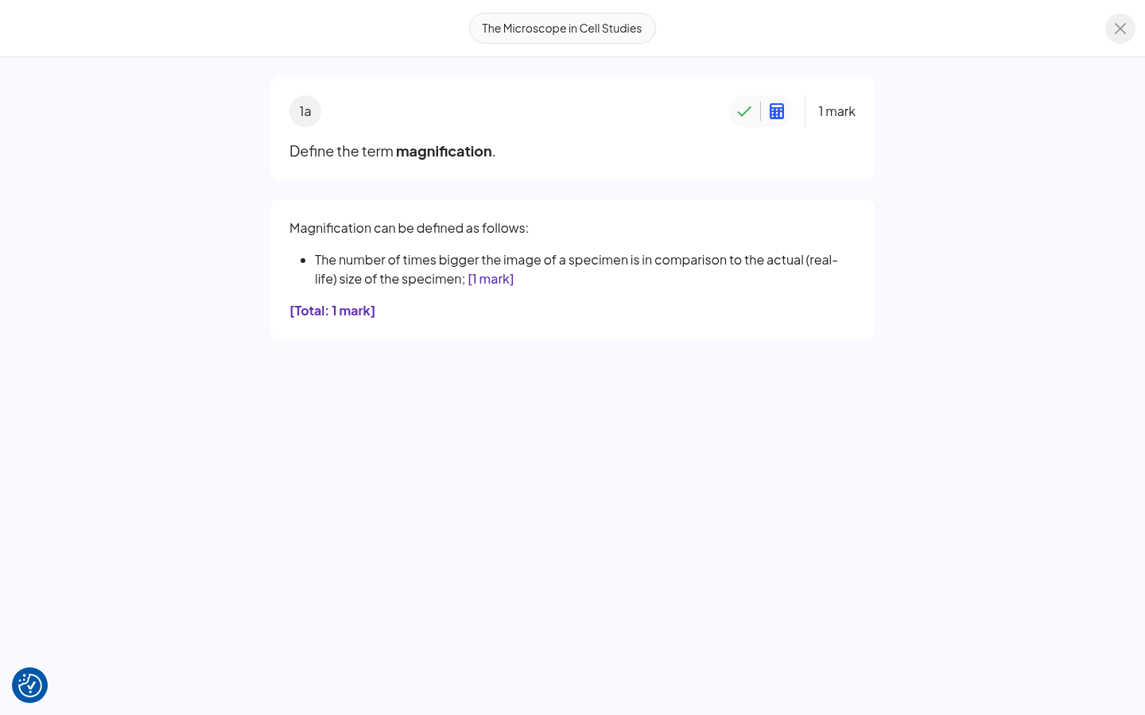
Figure 5: View answer - full-screen mark-scheme modal with per-point [1 mark] annotations (file 146)
Table 2: Answer-box feature inventory and SyllabAI adoption
Feature | Observed behaviour | SyllabAI adoption
Formatting toolbar | Italic, subscript, superscript, summation on focus | Adopt (v2 editor: same four controls)
Insert equation | Five-tab scientific keyboard incl. Matrices, integrals, undo/redo | Adopt; P2 (input richness before marking)
Write / Upload | Handwriting and image upload entries beside the toolbar | Defer; note as roadmap placeholder
Part metadata chip | Marks, answer-available and calculator-allowed icons (static) | Adopt; static, from the paper's own rows
Self-score input | "How did you do? - / N" beside Mark my answer | Adopt; the two grading paths coexist
Mark my answer | AI mark, async skeleton, first mark free (DC-3) | Adopt; ordinal + entitlement gate
Question help drawer | Related notes / Hint / Stepped breakdown, LLM-generated, thumbs | Adopt; tier-1 surfaces of DC-2
View answer modal | Full-screen scheme with per-point [1 mark] annotations | Adopt; the scheme artifact of DC-5
Save / Full screen | Bookmark a part; focus mode per part | Adopt; Save feeds the saved-questions view
Part navigation | Numbered chips 1..N with check badges after marking | Adopt; badges are DC-7 events
Difficulty tabs | Easy / Medium / Hard swap the bank, nav resets | Adopt; bank is already difficulty-tagged
Guided practice switch | Toggles adaptive sessions (pass-1 behaviour; now gated) | Out of scope for this spec
The inventory's headline is that the answer box is not one widget but a stack of small, honest affordances around two grading paths - machine-marked MCQs and AI-marked structured parts - over one scheme. SyllabAI's question surface should copy the stack's shape (metadata chip, two grading paths, help drawer, scheme modal) before embellishing any single element, and the two P0 decisions (DC-1, DC-2) are what make the drawer and the chat agree with the marker.

5.3 Dashboard and Study Plan
The logged-in dashboard is a two-column composition. The left column holds the greeting hero ("Hi, <name>" with a one-line welcome), a profile-completion card that nudges for the school name with a disabled Save until typed, and My courses: one card per saved course with the level and board chip, current and target grade steppers, and two linear progress bars (Revision Notes percent, Exam Questions percent) with info icons. The right column holds two rails: a Study plan rail ("Structured by experienced teachers, tailored to your courses" with a Create Study Plan button, replaced by today's completion once a plan exists - "You've completed 1 of 4 tasks today" with a progress bar) and a Jump back in rail that deep-links the last resource. A survey modal and a dark-mode switch round out the chrome.
The plan builder is three steps, each cheap and defaulted: step one pre-selects the learner's courses ("Your plan balances revision across the subjects you pick"); step two defaults each course's exam season (May/June 2028 for an A Level two years out, Summer 2028 for the GCSE) with pickers per course; step three defaults two hours per weekday with add controls for the weekend ("Your plan fits your revision into the time you set"). Generation shows a "Creating your Study Plan" interstitial copy that names a "teacher-designed framework", and the result is a weekly page: a goal card ("Get exam-ready - Your plan covers every topic in time for exams" with the season chip), an Edit plan action, a day strip across October 2026, a "0 of 4" counter with a percent, and per-course task groups. Each group pairs exactly one Revise task (Revision Notes, 15 minutes) with one Practise task (Exam Questions, 45 minutes) per topic, each task deep-links into the resource (clicking the revise chip landed on the actual note page), each has an overflow Adjust menu and a complete toggle, and a feature tour overlays the first visit (file 133).
The attribution behaviour is the finding that matters most for SyllabAI (and is codified in DC-7): after the note check earlier in the session, the plan's "Revise The Microscope in Cell Studies" task rendered in the completed state offering "Mark as incomplete" - the tree wrote the plan, not the learner - while the matching 45-minute Practise task remained open after a single MCQ submit, implying a threshold rather than an event trigger. The dashboard rail then aggregated the same projection ("You've completed 1 of 4 tasks today"). Design take: SyllabAI's plan (a P2 build) should be this projection pattern from day one - tasks derived from the tree with per-type thresholds (Revise = note check; Practise = five marked parts proposed) - and the pairing rule (one short revise, one long practise, per topic) is a sensible default the plan can relax later.
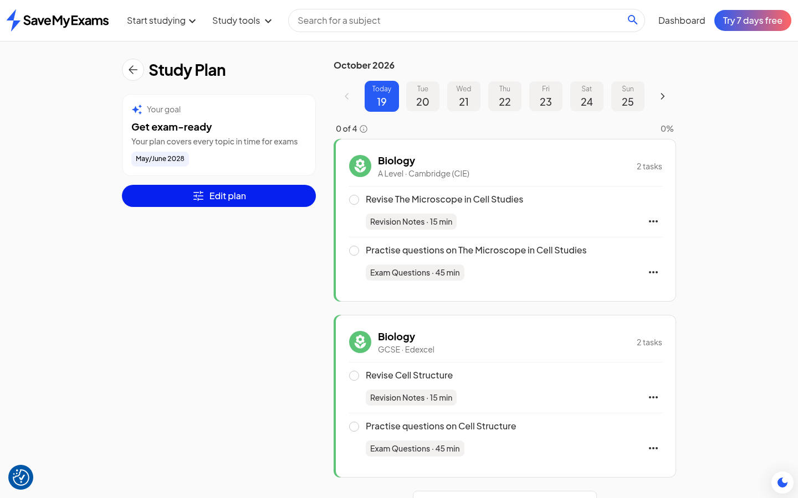
Figure 6: Generated plan week - goal card, day strip, 0-of-4 counter, paired Revise/Practise tasks per course (file 133)

5.4 Teacher Mode
Teacher mode is a persona switch, not a separate product: the Profile page's "I am a..." selector offers Student, Teacher, Tutor and Parent/Guardian of a student, and saving Teacher immediately re-renders the whole product (file 162). The logo becomes "SaveMyExams For Teachers", the accent theme flips from blue/pink to purple throughout, the primary navigation renames from "Start studying" to "Start teaching" and "Study tools" to "Resources", the trial call-to-action becomes "Claim free trial", the welcome copy addresses time-saving for teachers, the profile nudge asks where you teach, and the course cards replace the learner's grade steppers and resource pairs with a teacher's tool trio - Revision Notes, Test Builder, Exam Questions - plus a "Last viewed" chip. The sidebar gains a "For Teachers" section containing Test Builder, whose page ("Your tests") is an empty-state builder pitch: "From first lessons to final practice, Test Builder helps you set quick homework, classwork, and topic tests in just a few clicks", over a table of Test / Topics / Questions / Marks / Last modified. The Strengths and Weaknesses tracker remains accessible and explains its own threshold: "Answer at least 10 questions in a topic, via Exam Questions, Target Tests or Mock Exams, to get a strength score", on a one-to-five lightning scale with a No-score state, weakest-first sorting and four filters (file 165). Restoring the Student persona reverts every surface, first-hand verified (file 166).
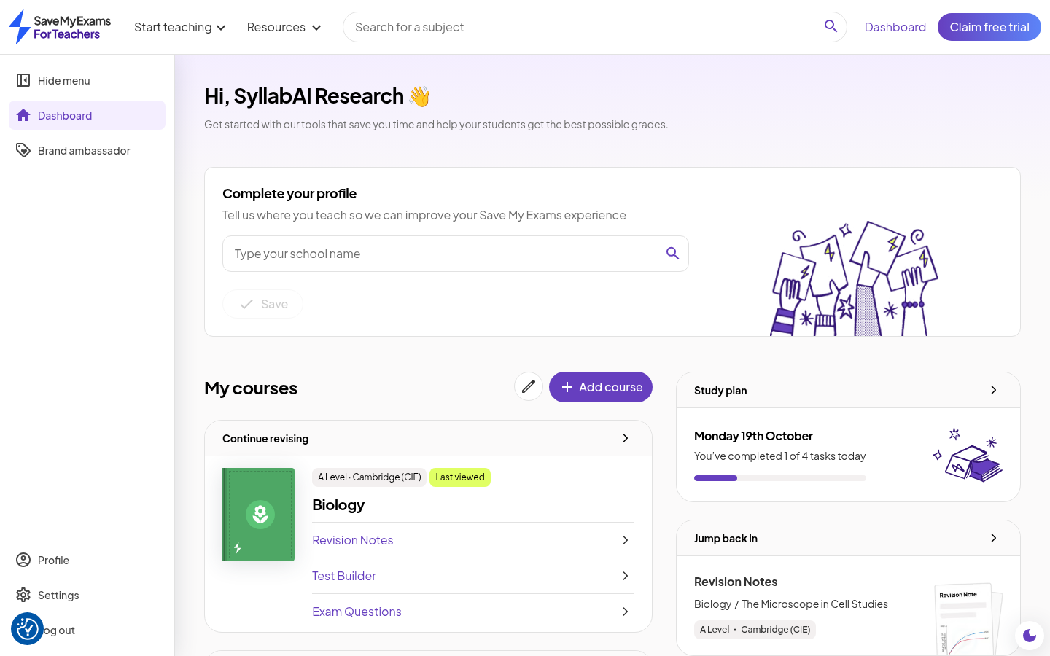
Figure 7: Teacher mode dashboard - For Teachers logo, purple theme, Start teaching / Resources nav, Test Builder in course cards (file 162)
Design take. The persona flip is brand-deep - logo, palette, navigation names, tool substitution, and copy - which is expensive to maintain as a theme fork. SyllabAI v2 already separates hub and apps; the cheaper and more honest composition is role-scoped surfaces: the same content spine with per-role tool rows (a teacher's course card substitutes assignment and test-builder actions for grade tracking) and a role-scoped nav, themed by token swap rather than a second stylesheet. The teacher-facing analytics that matter are already implied by the student-side projection: a class view of the DC-7 tree (which topics are weak across a class) is the natural first teacher surface, and the observed strength-score explainer (ten questions per topic for a score, weakest-first) is a reasonable class-level default. This is filed as P2 and needs product input on whether teacher identity lives in the hub or the app.

6. Non-Goals, Risks and Open Questions
Non-goals. This specification does not redesign the tutor's grounding and citation machinery, the paper-pin law, or the quiz scaffold's data layer - all are of record and unaffected. It does not commit SyllabAI to guided-practice sessions as a session type (the observed switch is one product's framing of adaptive practice; the underlying need is served by the quiz scaffold and target tests). It does not adopt the observed product's monetisation boundary as SyllabAI policy; DC-3 defines the metering mechanism, while the entitlement values (what is free, what is trial, what is paid) are a business decision recorded as an open question.
Risks. First, two-generation drift (DC-5) is a live risk from the moment a tutor and a marker share a scheme; the conformance lint must land before or with the second consumer, or the observed seam reproduces itself here. Second, metering legibility: the observed platform grew from one to three paywall boundaries within 48 hours, which is maximally extractive and maximally confusing; SyllabAI's gates must show the count and the reason at the point of gating (DC-3's disclosure requirement), and the free tier must retain one full feel of the loop per part. Third, attribution over-claiming: because the plan reads the same projection as the rings, a buggy event can corrupt every surface at once; the DC-7 acceptance tests pin the event-to-projection mapping precisely to make that failure loud rather than silent. Fourth, the quota-versus-change ambiguity of the observed gating is a standing limit on all four passes: one account, free tier, 48 hours - any behavioural claim about enforcement in this document carries that caveat.
Open questions. (a) Entitlement values for DC-3: how many re-marks per day constitute a trial, and does marking meter per part, per topic or per day? (b) Where teacher identity lives: hub-level role (preferred, pending hub work) versus app-level persona switch; and whether tutors and parents get surfaces in v2 at all. (c) The Study plan's scheduler: the observed product pairs topics to weeks against an exam season using a "teacher-designed framework"; whether SyllabAI's first plan is deterministic (spec-ordered) or spaced-repetition informed is undecided. (d) Handwriting input (the Write affordance) and image upload for worked answers: biology papers reward diagrams, so an upload path interacts with marking feasibility and is deferred pending a marking-capability check. (e) Whether the MCQ explanation card should be authored per distractor at ingestion (deterministic) or generated at grade time (cheap but linted) - the observed product generates; SyllabAI's bias is deterministic authoring where the bank allows.

7. Roadmap
The sequence below orders the decisions by dependency and cost. P0 items define contracts and laws that everything else consumes, and one of them (DC-6) is essentially free; P1 items are the learner-visible loop; P2 items are the heavier builds and the business-dependent ones. Each row's acceptance criterion is stated in its decision subsection; the column here adds the owning surface.
Table 3: Phased roadmap with owning surfaces
Phase | Item | Owning surface | First acceptance gate
P0 | DC-1 marking-context contract (prepare step 2.8, TutorContext.markContext) | tutor + smartmark | Quote-back and per-point accounting pin green on a marked part
P0 | DC-2 two-tier disclosure (prompt v13 law + tier flag) | tutor + question help tabs | Adversarial corpus: no tier-1 leak; tier-1/tier-2 agree with tabs
P0 | DC-6 history symmetry (browser on every chat surface) | web (both chat surfaces) | Parity UI test; resume restores the right grounding
P1 | DC-3 re-attempt economics (ordinal + entitlement policy row) | smartmark route + web gate | Free first mark passes, second refused with count; paid passes
P1 | DC-4 lens cards (lens table + pinned templates + router targets) | web chat entries + tutor | Grammar and router pins per lens; opener-only rendering
P1 | DC-7 rings and plan attribution (event rollup + ring tree + plan projection) | web trees + dashboard + plan | Event-to-projection pins; fifth-mark threshold flips Practise
P2 | DC-5 alternatives materialisation + conformance lint | ingestion + smartmark + tutor | Membership lint catches a synthetic out-of-set alternative
P2 | Study plan builder (3 steps, pairing rule, thresholds) | web plan | Generated week from tree; Revise auto-complete; Practise threshold
P2 | Teacher/persona surfaces (role-scoped tools + class view) | web (role tokens) + hub | Persona flip swaps tool rows without a theme fork; class tree view
Effort notes. DC-6 is a wiring task against an existing store; DC-1 is a contained prepare-stage addition whose risk is context budget, not novelty; DC-2 is primarily prompt and test work. DC-3 touches money and therefore wants product sign-off on the policy values before the mechanism merges (the mechanism itself is small). DC-4 is data-driven but its grammar pins need a golden corpus per lens. DC-7 is the largest P1 item because it spans three surfaces, but its event substrate exists. DC-5's ingestion change is the only schema migration in the set and is deferred to P2 precisely so that the lint can be specified against a settled DC-1 context block.

8. Evidence Index
All pass-4 evidence lives in the shared directory with the three research records; files 01-124 belong to passes 1-3 and are indexed in their own documents. The 42 files captured this pass map as follows.
Table 4: Pass-4 evidence map (files 125-166)
Files | What they evidence
125 - 127 | Logged-in dashboard: hero, profile nudge, course cards with grade steppers and 0% bars, study-plan rail, jump-back rail, survey modal, right rail clean
128 - 131 | Study plan builder steps 1-3 (subjects pre-checked; per-course exam seasons defaulted; per-day hour steppers) and the generation interstitial
132 - 133 | Plan feature tour overlay; generated week (goal card, day strip, 0 of 4 counter, paired Revise/Practise tasks per course)
134 | Revision note page opened by clicking a plan task (task deep-links into the resource)
135 - 137 | Notes index rings: empty state, privacy-toggle detour, and the filled state after one lesson check (binary leaf, partial arcs)
138 - 139 | Exam-question subtopic page (MCQ set) and the question index tree with its own rings and per-topic question counts
140 - 142 | Structured-questions page: syllabus tree, part navigation, Q1 stem and part chips with marks, answer-available and calculator icons
143 | Answer box focused: formatting toolbar, Insert equation / Write / Upload, self-score, Mark my answer, Question help, View answer
144 - 145 | Insert equation scientific keyboard (five tabs, integrals, roots, undo/redo); equation pad closed state
146 | View answer full-screen mark-scheme modal with per-point [1 mark] annotations and total
147 - 150 | Question help drawer: Related notes, Hint tab content, Stepped breakdown tab content (both with thumbs widgets)
151 - 154 | MCQ answer box: statement-table stem, A-D options, choose-your-answer buttons, Submit answer, option selected
155 - 156 | MCQ feedback: option filled green, praise card with per-statement reasoning, New answer, nav chip check badge, set row at 3%
157 | Medium difficulty tab selected (bank swap)
158 | Calculator icon probe (icons are static metadata, not buttons - disclosed negative result)
159 - 161 | Profile persona dropdown (Student / Teacher / Tutor / Parent-Guardian), Teacher selected, saved
162 - 163 | Teacher mode dashboard (For Teachers brand, purple theme, renamed nav, Test Builder cards) and plan state showing the auto-completed Revise task
164 | Teacher Test Builder: your-tests empty state with teacher copy and the Test/Topics/Questions/Marks table
165 | Strengths and Weaknesses: strength-score explainer (10-question threshold, 1-5 scale), No-score state, weakest-first sort, filters
166 | Persona restored to Student, first-hand verified (header and theme reverted)
Reproducibility. The workspace retains the authenticated session state (scripts/sme/auth.json, rotated credentials under .secrets/sme-account, 0600), the screenshot directory (177 files), and the four generation scripts of the record pipeline. The persona is restored to Student and the account is otherwise as pass 3 left it; no paid actions were taken and no gating was bypassed at any point.

