**Name :نوال سرور احمد فؤاد**

**B.N: 998**

**Date : 6/6/2020**

**Topic** **prograaning languages:**

**Github link :**

**Github page :**

**Application brief :**

A programming language is a set of commands, instructions, and other syntax use to create a software program. Languages that programmers use to write code are called "high-level languages." This code can be compiled into a "low-level language," which is recognized directly by the computer hardware.

High-level languages are designed to be easy to read and understand. This allows programmers to write source code in a natural fashion, using logical words and symbols. For example, reserved words like function, while, if, and elseare used in most major programming languages. Symbols like <,>, ==, and! = Are common operators. Many high-level languages are similar enough that programmers can easily understand source source code written in multiple languages.

Examples of high-level languages include C ++, Java, Perl, and PHP. Languages like C ++ and Java are called "compiled languages" since the source code must first be compiled in order to run. Languages like Perl and PHP are called "interpreted languages" since the source code can be run through an interpreter without being compiled. Generally, compiled languages are used to create software applications, while interpreted languages are used for running scripts, such as those used to generate content for dynamic websites.

Low-level languages include assembly and machine languages. An assembly language contains a list of basic instructions and is much more difficult to read than a high-level language. In rare cases, a programmer may decide to code a basic program in an assembly language to ensure it operates as efficiently as possible. An assembler can be used to translate the assembly code into machine code. The machine code, or machine language, contains a series of binary codes that are understood directly by a computer's CPU. Needless to say, machine language is not designed to be human readable.

**Screeshots :**

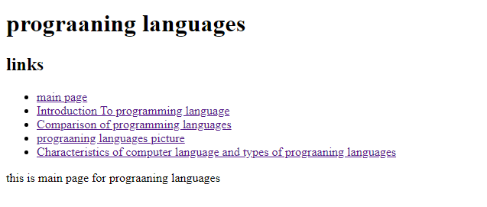

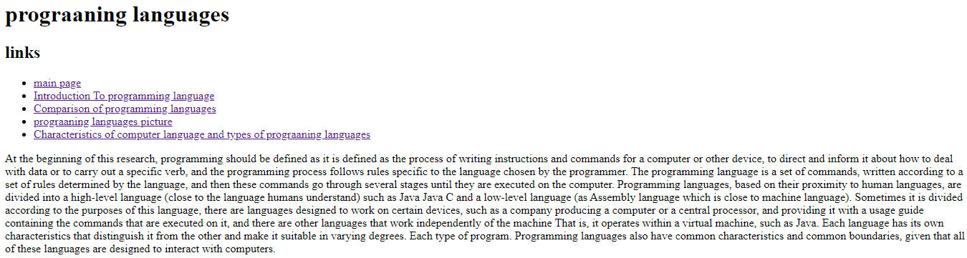

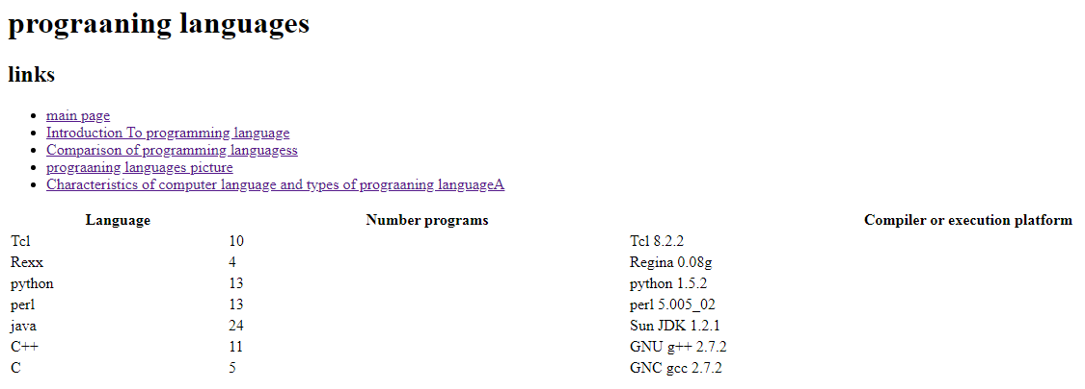

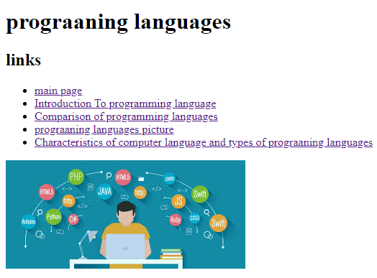

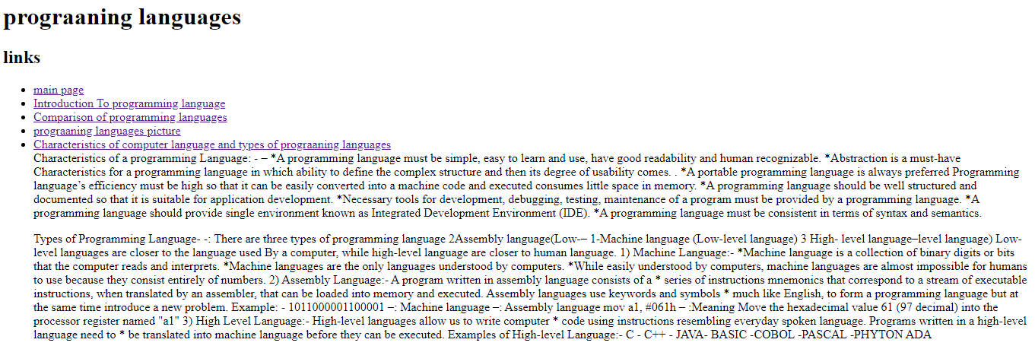

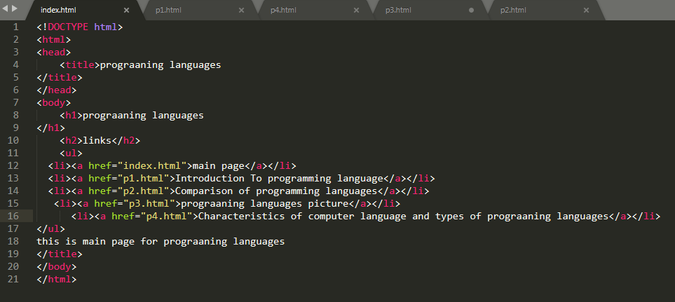

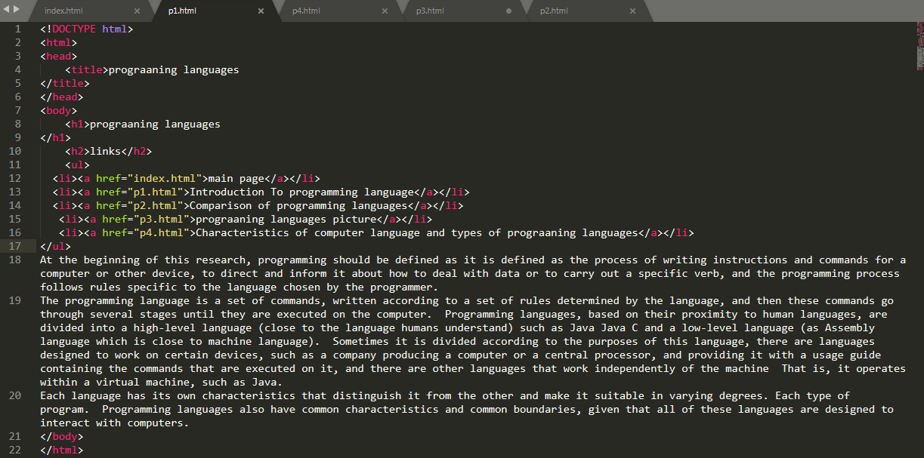

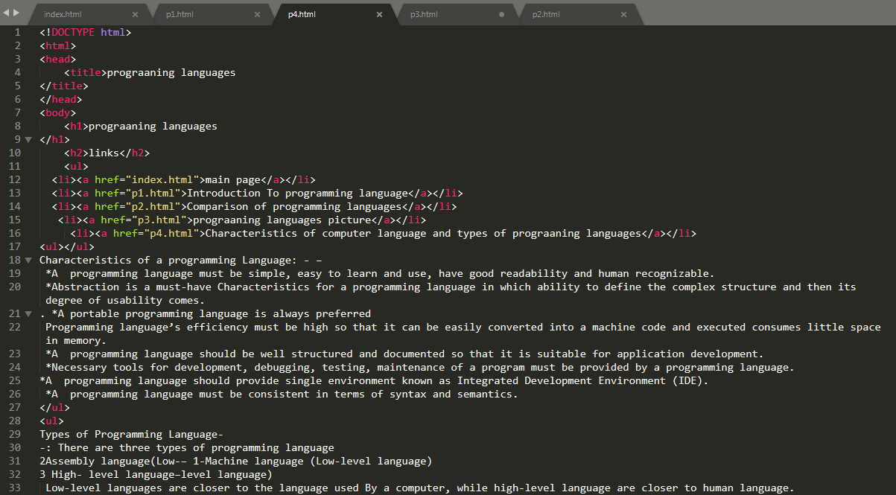

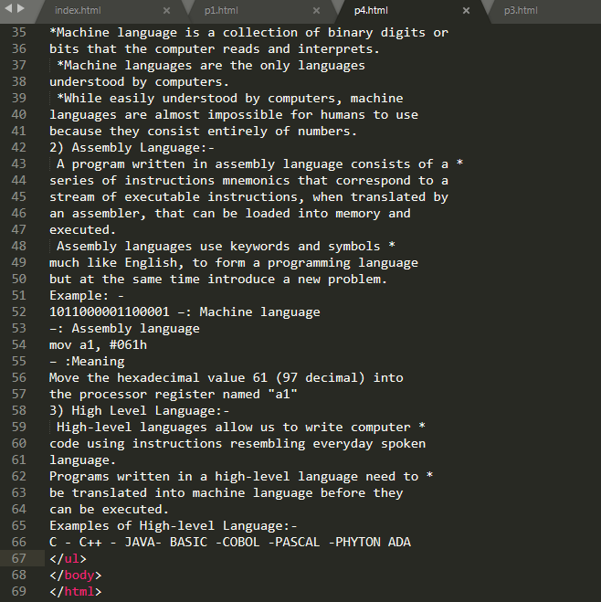

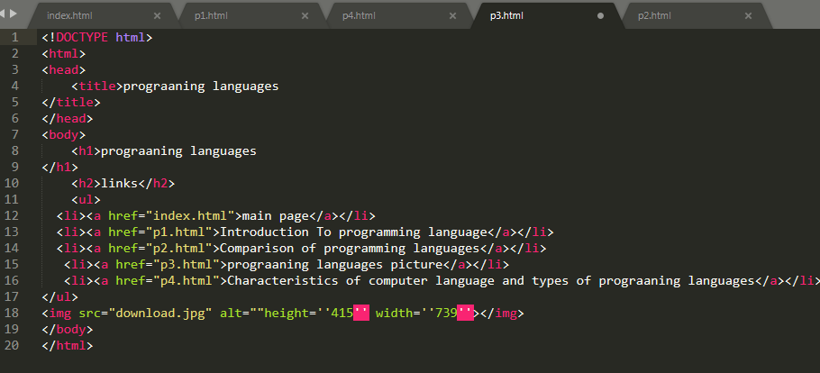

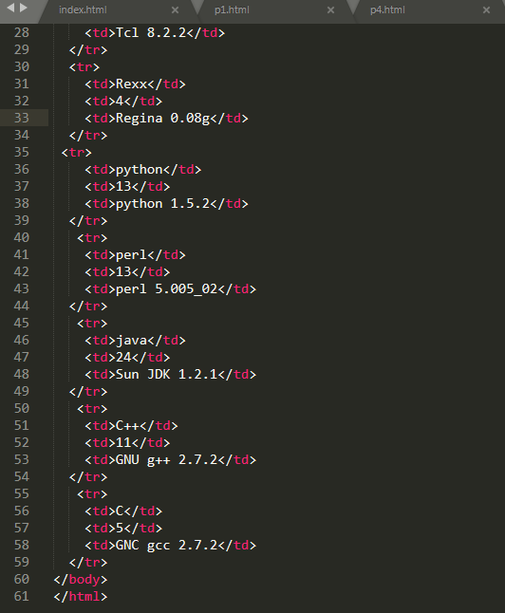

**Reference**

* [**https://www.britannica.com/technology/computer-programming-language**](https://www.britannica.com/technology/computer-programming-language)
* [**https://cs.lmu.edu/~ray/notes/pltypes/**](https://cs.lmu.edu/~ray/notes/pltypes/)
* [**https://www.opennaukri.com/different-types-of-programming-languages/**](https://www.opennaukri.com/different-types-of-programming-languages/)