**Perguntas para procura**

Somente ritmica:

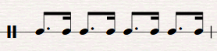

18th 16th 18th 16th 18th 16th 18th 16th

Somente melodia:

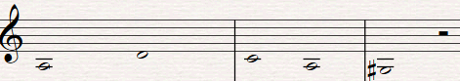

A D C A G#

Ambos:



½D ½A ½F ½ D ½C 4D 4E#