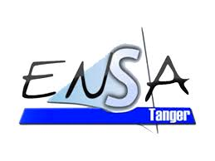

**Implementation Report**

**Term Project: Interactive Generative Art Gallery**

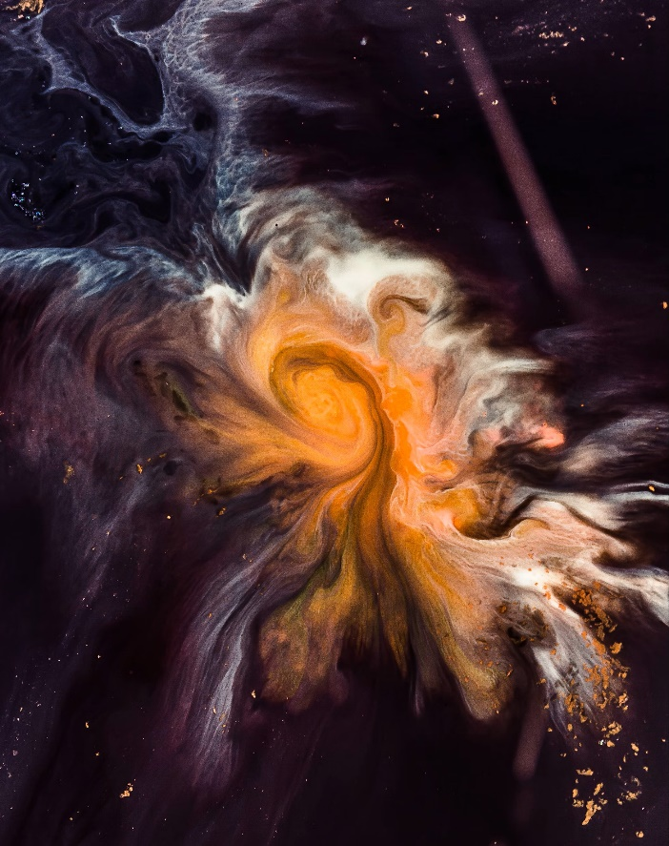

**Project Team:**

* EL OUKILI Nada
* EL HAOUAT Nawar

**Academic Year:** 2024-2025 **Supervised by:** Pr. IBN EL AHRACHE **Program:** Computer Engineering - GINF1

**1. Introduction** The "Interactive Generative Art Gallery" is a web-based application that integrates generative art, image and audio manipulation, and interactive visualizations. The project was developed using Python with Flask as the web framework, incorporating Pygame for interactive art, Matplotlib for data visualization, PIL and OpenCV for image processing, and PyDub for audio effects. The objective was to create an engaging platform where users can explore and interact with creative digital artworks.

**2. Features Implemented**

* **Generative Art with Pygame**: Users can interact with dynamic shapes that move and respond to inputs.
* **Data Visualization with Matplotlib**: A 3D visualization of disease cases in Morocco was implemented.
* **Image Manipulation with PIL and OpenCV**: Various filters such as grayscale, sepia, inversion, and glitch effects were applied to images.
* **Audio Processing with PyDub**: Users can modify audio speed, apply fade effects, reverse tracks, or generate soundscapes.
* **Web Hosting with Flask**: The gallery provides an intuitive interface allowing users to upload images, process them, and view results interactively.
* **Style Transfer with PyTorch**: A deep learning-based style transfer feature was included to transform images artistically.

**3. Challenges Encountered and Solutions**

* **Integration of Pygame with Flask**: Since Pygame runs as a local application and Flask is web-based, executing interactive art dynamically required executing Pygame scripts independently and redirecting users accordingly.
* **Data Visualization Performance Issues**: Rendering complex 3D plots in Matplotlib within a web environment was slow; optimizing the dataset and reducing unnecessary computations improved performance.
* **Image Processing Compatibility**: PIL and OpenCV have different handling of images, which required careful preprocessing to avoid errors when applying filters.
* **Audio Processing File Support**: Some audio formats were not supported by PyDub, requiring additional conversion steps to ensure compatibility.
* **Style Transfer Processing Time**: Running style transfer on high-resolution images took significant time. Using pre-trained models and reducing input size helped improve response times.
* **Server Load and Optimization**: Hosting the application required efficient handling of multiple user requests. Caching techniques and load balancing were considered to optimize performance.

**4. Technical Architecture** The project consists of multiple components:

* **Frontend**: HTML, CSS, and JavaScript were used to create an intuitive user interface.
* **Backend**: Flask handles user requests, executes Python scripts, and serves processed images and audio.
* **Database Management**: File-based storage was used to manage uploaded content efficiently.
* **Third-Party Libraries**: Libraries like Matplotlib, PIL, OpenCV, PyDub, and PyTorch were used to handle data processing and visualization tasks.
* **Scalability Considerations**: Future versions could integrate cloud computing and containerization using Docker to allow better scalability.

**5. User Experience and Interactivity** The platform was designed to be user-friendly with easy navigation and interactive features:

* **Drag-and-Drop Uploads**: Users can quickly upload files for processing.
* **Live Previews**: Image and audio modifications are displayed in real-time.
* **Custom Controls**: Users can tweak parameters for filters and effects.
* **Multi-Device Support**: The web interface adapts to different screen sizes.
* **Accessibility Features**: Future improvements include voice commands and keyboard navigation for enhanced accessibility.

**6. Conclusion and Future Improvements** The project successfully combines multiple disciplines, allowing users to explore digital creativity interactively. Overcoming technical challenges led to a better understanding of integrating various libraries efficiently. Future improvements include optimizing real-time interactivity, expanding the range of available artistic effects, implementing a cloud storage solution for better file management, enhancing style transfer performance using more advanced machine learning techniques, and incorporating real-time collaboration where multiple users can interact with the artwork simultaneously. Additionally, plans include the development of mobile compatibility and a dedicated desktop application to provide a seamless experience across different platforms.