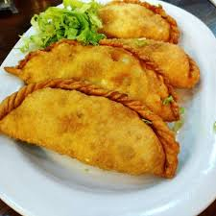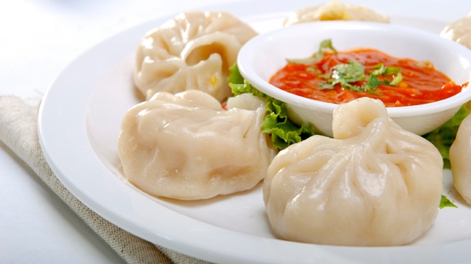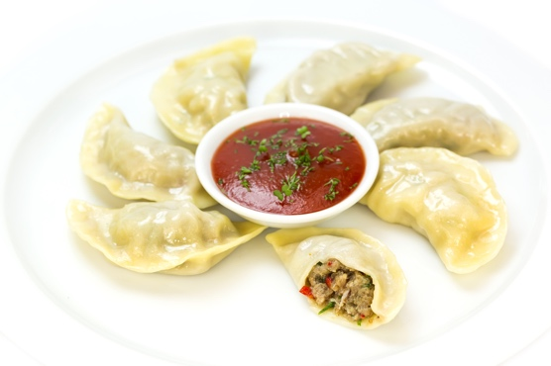Tibet kitchen

# Soup

Soup of the day

# Tibetan specialties

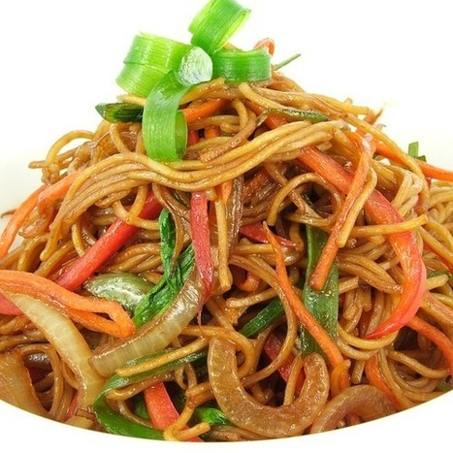Steamed Momo’s (8 pcs) 05,00

(beef, pork, chicken, veg)

Fried Momo’s (8 pcs) 07,00

(beef, pork, chicken, veg)

Chowmein 06,00

(beef, pork, chicken, veg, scampi)

Shabaley (2 pc) 06,00

(Beef, chicken)

Fried rice 06,00

(Beef, pork, chicken, veg, scampi)

Thukpa 06,00

(Beef, Pork, chicken, veg)

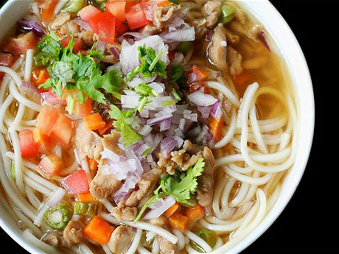Shapta with 2 tingmo’s 08,00

Shapta only 06,00

Chilli chicken with 2 tingmo’s 08,00

Chilly chicken only 06,00

Tingmo 01,00

Rice 02,00

# Asian snacks

* Lumpia 05,00

(3 pcs)

# Drinks

* Tibetan butter tea 2,50
* Indian masala Chai 2,50
* Tea 2,00
* Coffee 2,00

## Cold drinks

* Cola, cola zero 2,20
* Fanta 2,20
* 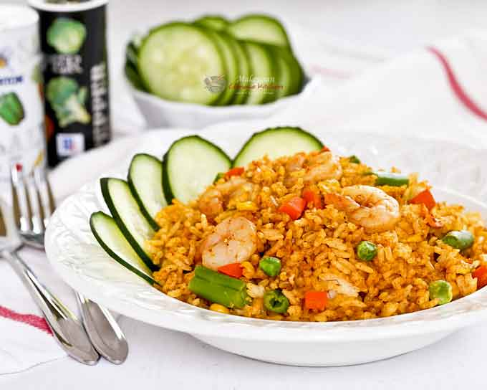Ice tea 2,20
* Fresh orange juice 2,20

## Alcoholic drinks

* Brugse zot 3,00
* 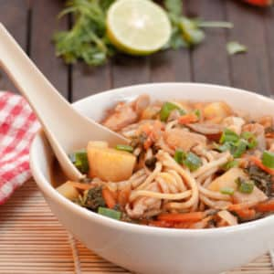Leffe blond/ brown 3,00
* Jupiler 3,00

## Wine

* Red/ white/ Rosé (glas) 4,00
* Champaign (glas) 4,00

## Dessert

* Damblanch 05,00
* 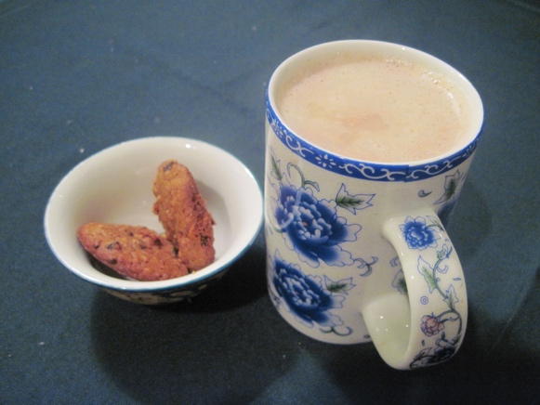Sorbé 05,00