E-Commerce DevOps Project Flow

Architecture Flow

Developer
↓
HTML • CSS • JavaScript
↓
Git
↓
GitHub
↓
Docker
↓
Docker Hub
↓
AWS EC2
↓
Kubernetes Cluster
↓
Deployment
↓
Pods (Multiple Replicas)
↓
Service (NodePort :8080)
↓
Internet
↓
Users
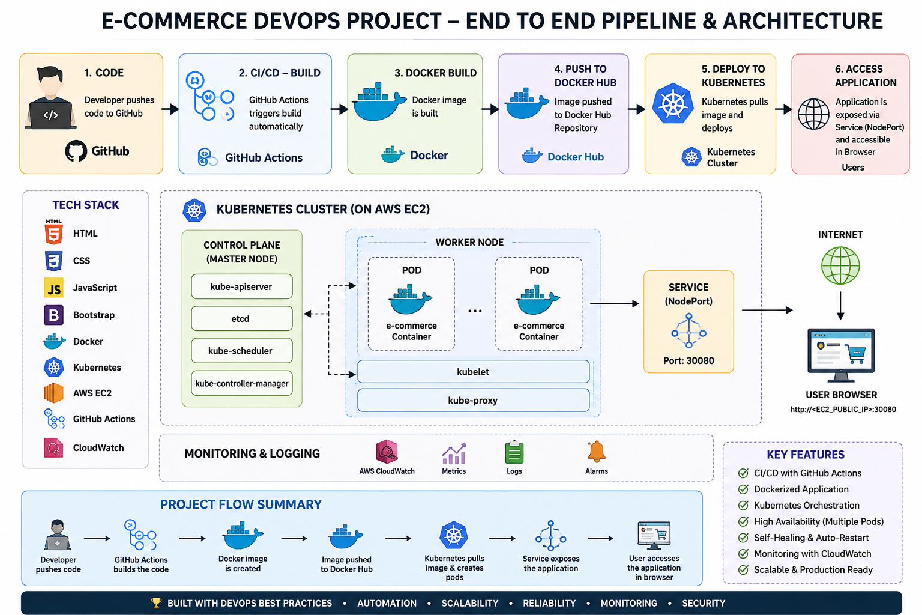

1. HTML/CSS/JavaScript
Develop the e-commerce website frontend.

2. Git
Track code changes and maintain version history.

3. GitHub
Store and share the source code remotely.

4. Docker
Package the application into a portable container image.

5. Docker Hub
Store and distribute Docker images.

6. AWS EC2
Host the application on a cloud virtual machine.

7. Kubernetes
Manage deployments, scaling, self-healing, and rolling updates.

8. Deployment
Maintain the desired number of application Pods.

9. Pods
Run containerized instances of the application.

10. Service
Expose Pods using NodePort 8080 and load balance traffic.

11. Users
Access the application through a web browser.

STEP BY STEM PROCESS

Step 1: Develop the Website
Technologies Used
- HTML
- CSS
- JavaScript
Purpose
Develop the e-commerce website
Complete website source code.

Step 2: Git
Purpose
Git tracks every change in your project.
Purpose:
- Save project versions
- Roll back changes
- Work safely without losing code

Step 3: GitHub
Purpose
GitHub stores source code online.
- Backup
- Collaboration
- Version history
- Easy deployment source

Step 4: Docker
Purpose
Docker packages your entire application into one portable image.
Docker Image
│
├── Website
├── Nginx
├── Configuration
└── Everything required to run
application behaves the same on every machine.

Step 5: Docker Hub
Purpose
Docker Hub stores Docker images .Instead of copying your project manually to every server.
Any Server downloads the image
Step 6: AWS EC2
Purpose
AWS EC2 provides a virtual Linux server in the cloud.
Now the website is available publicly.
Step 7: Kubernetes
Problems:
- Container crashes
- High traffic
- Manual restart
- No automatic scaling
Kubernetes solves all these issues.

Pod
Purpose:
A Pod runs your Docker container.Deployment
Purpose:
Deployment manages Pods.
Kubernetes automatically creates a new Pod.
This feature is called self-healing.
Service
Purpose:
Pods have temporary IP addresses.
A Kubernetes Service provides one stable endpoint for users.
In project:
Service
↓
Port 8080
↓
Routes traffic to available Pods

Step 8: Nginx Web Server
Purpose:
Nginx serves HTML, CSS, JavaScript, and image files.
Nginx is lightweight and fast, making it ideal for static websites.

Step 9: User Access
Every Users access the e-commerce application through the internet.

