**LAB # 2**

**INTRODUCTION TO VVM PROGRAMMING**

Introduction to the architecture of Visible Virtual Machine (VVM) and its Instruction set

**OBJECTIVE**

Learn VVM Programming and simulate VVM program.

**TIME BOXING**

|  |  |  |
| --- | --- | --- |
| Activity Name | Activity Time | Total Time |
| Instruments Allocation + Setting up Lab | 10 mints | 10 mints |
| Walk through Theory & Tasks (Lecture) | 60 mints | 60 mints |
| Implementation & Practice time | 90 mints | 80 mints |
| Evaluation Time | 20 mints | 20 mints |
|  | Total Duration | 180 mints |

**THEORY**

# VVM Programming

**VVM** has its own simple Programming Language which supports such operations as conditional and unconditional branching, addition and subtraction, and input and output, among others. The language allows the student to create reasonably complex programs, and yet the language is quite easy to learn and to understand -- only eleven unique operations are provided

**VVM** programs can be written in Machine Language, in Assembly Language, or in a combination of both. The Machine Language format is represented in decimal values, so there is no need for the student user to interpret long binary machine codes. In the Machine Language format, each instruction is a three-digit integer.

**VVM** programs are converted to machine language format and loaded into the 100 data-word virtual RAM which is fully visible to the user during program execution.

# The Language Instructions

The eleven operations of the **VVM** Language are described below. The Machine Language codes are shown in parentheses, while the Assembly Language version is in square brackets.

* **Load Accumulator (5*nn*) [LDA *nn*]** The content of RAM address *nn* is copied to the Accumulator Register, replacing the current content of the register. The content of RAM address *nn* remains unchanged. The Program Counter Register is incremented by one.

* **Store Accumulator (3*nn*) [STO *nn*] (or [STA *nn*])** The content of the Accumulator Register is copied to RAM address *nn*, replacing the current content of the address. The content of the Accumulator Register remains unchanged. The Program Counter Register is incremented by one.

* **Add (1*nn*) [ADD *nn*]** The content of RAM address *nn* is added to the content of the Accumulator Register, replacing the current content of the register.The content of RAM address *nn* remains unchanged. The Program Counter Register is incremented by one.
* **Subtract (2*nn*) [SUB *nn*]** The content of RAM address *nn* is subtracted from the content of the Accumulator Register, replacing the current content of the register. The content of RAM address *nn* remains unchanged. The Program Counter Register is incremented by one.
* **Input (901) [IN]** A value input by the user is stored in the Accumulator Register, replacing the current content of the register. The Program Counter Register is incremented by one.
* **Output (902) [OUT]** The content of the Accumulator Register is output to the user. The current content of the register remains unchanged. The Program Counter Register is incremented by one.
* **Halt (0*nn*) [HLT]** Program execution is terminated. The operand value *nn* is ignored in this instruction and can be omitted in the Assembly Language format.
* **Branch if Zero (7*nn*) [BRZ *nn*]** This is a conditional branch instruction. If the value in the Accumulator Register is zero, then the Program Counter Register is replaced by the operand value *nn*. The result is that the next instruction to be executed will be taken from address *nn* rather than from the next sequential address. Otherwise (Accumulator < > 0), the Program Counter Register is incremented by one, and the next sequential instruction is executed.

* **Branch if Positive or Zero (8*nn*) [BRP *nn*]** This is a conditional branch instruction. If the value in the Accumulator Register is positive or zero, then the Program Counter Register is replaced by the operand value *nn*. The result is that the next instruction to be executed will be taken from address *nn* rather than from the next sequential address. Otherwise (Accumulator < 0), the Program Counter Register is incremented by one, and the next sequential instruction is executed.
* **Branch (6*nn*) [BR *nn*]** This is an unconditional branch instruction. The current value of the Program Counter Register is replaced by the operand value *nn*. The result is that the next instruction to be executed will be taken from address *nn* rather than from the next sequential address. The value of the Program Counter Register is not incremented with this instruction.
* **No Operation (4*nn*) [NOP]** This instruction does nothing other than increment the Program Counter Register by one. The operand value *nn* is ignored in this instruction and can be omitted in the Assembly Language format. (This instruction is unique to the VVM and is not part of the original Little Man Model.)

o

## Embedding Data in Programs

Data values used by a program can be loaded into memory along with the program. In Machine or Assembly Language form simply use the format “*snnn”* where *s* is an optional sign, and *nnn*  is the three-digit data value. In Assembly Language, you can specify “DAT *snnn”* for clarity.

## The VVM Load Directive

By default, VVM programs are loaded into sequential memory addresses starting with address 00. VVM programs can include an additional load directive which overrides this default, indicating the location in which certain instructions and data should be loaded in memory. The syntax of the Load Directive is “*\*nn”* where *nn* represents an address in memory. When this directive is encountered in a program, subsequent program elements are loaded in sequential addresses beginning with address *nn*.

# Program#1

**Simple conditional structure using “brp” & “br” instruction.**

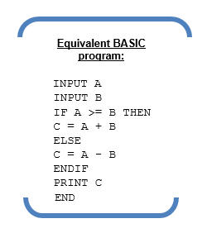

in Input A

sto 98 Store A

in Input B

sto 99 Store B

lda 98 Load value of A

sub 99 Subtract B from A

brp 11 If A >= B,branch to 11 A is < B Find difference

lda 98 Load value of A

sub 99 Subtract value of B

sto 97 Store C

br 14 Jump to 14

lda 98 [11] Load A (A is >=B)

add 99 Add B

sta 97 Store C

out [14] Print result

hlt Done

# LAB TASKS

1. Take any integer as input, if the number is greater than 5 print it

If a >5, print a

Else if a = 0, then Halt

Else if a < 5, then halt

**Code:**

in

sto 98

lda 98

sub 99

brz 09

brp 07

hlt

lda 98

out

hlt

*99

dat 005

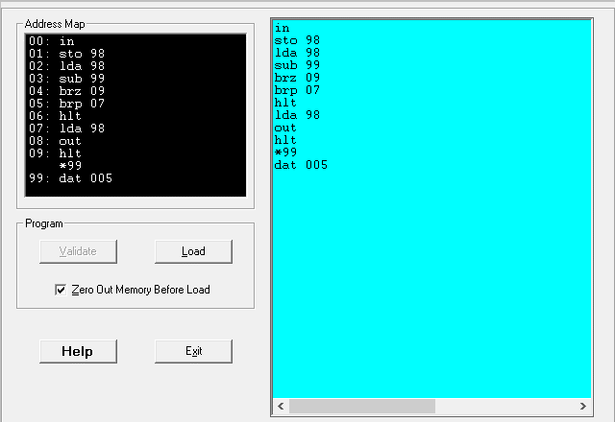

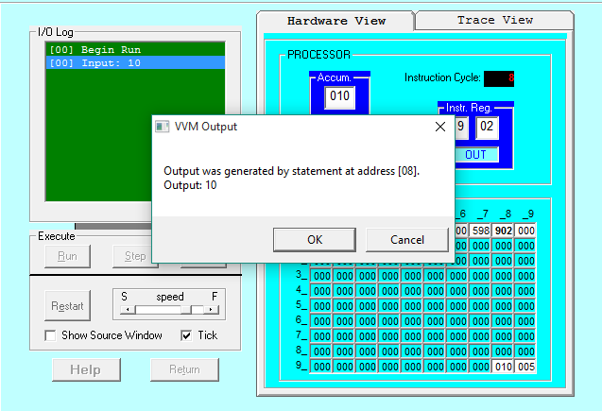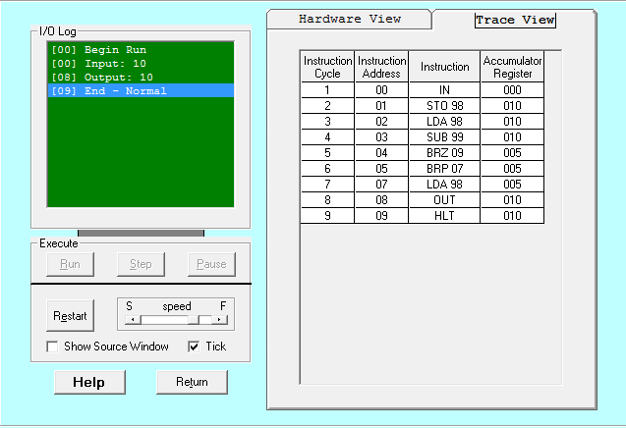

1. Take two numbers as input and print the larger number.

in

sto 98

in

sto 99

lda 98

sub 99

brp 10

lda 99

out

hlt

lda 98

out

hlt

