TestyShare Recipe system
Design Document

Version 1.0



Group Id: S25PROJECTD15D9

Supervisor Name : Rizwana Noor

Revision History
Date (dd/mm/yyyy) | Version | Description | Author
Current date | 1.0 | Introduction of the project | bc210426502

Table of Contents

- Introduction of Design Document
- Entity Relationship Diagram (ERD)
- Sequence Diagrams
- Architecture Design Diagram
- Class Diagram
- Database Design
- Interface Design
- Test Cases

- Introduction of Design Document
This design document provides a comprehensive overview of the technical architecture and implementation details for TastyShare, a web-based recipe sharing platform. The system enables users to discover, share, and review recipes while providing administrative capabilities for content moderation and user management.

The platform follows a client-server architecture with a responsive web frontend and a Python-based backend using SQLite for data persistence. The design emphasizes usability, security, and scalability while maintaining a clean, modular codebase for future enhancements.

- Entity Relationship Diagram
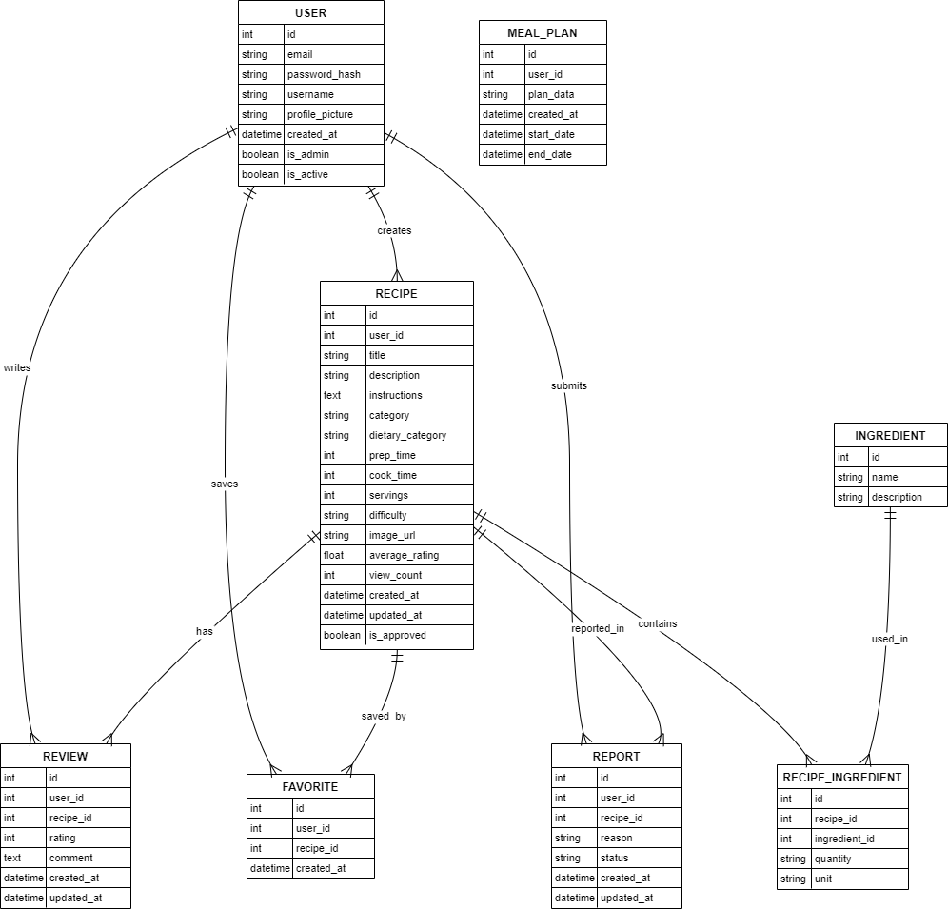
- Sequence Diagrams
User Registration Sequence:
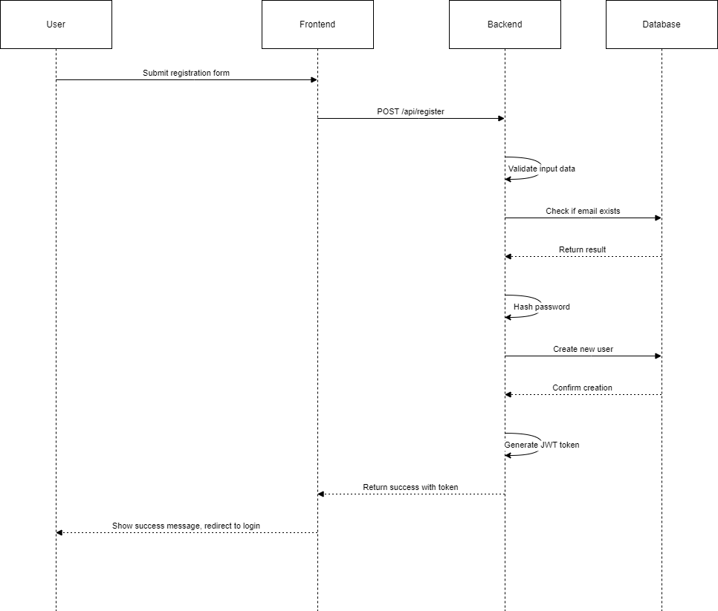

Recipe Creation Sequence:
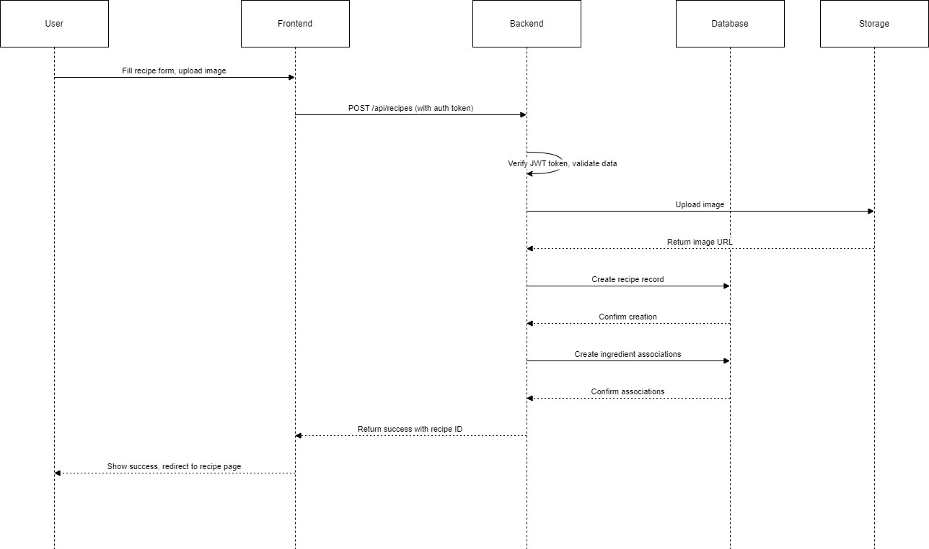

- Architecture Design Diagram
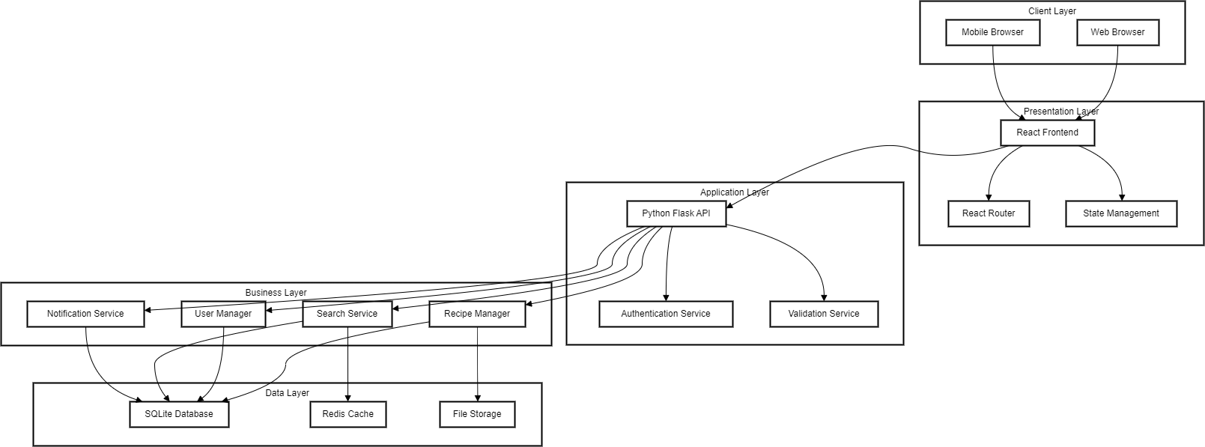

- Class Diagram

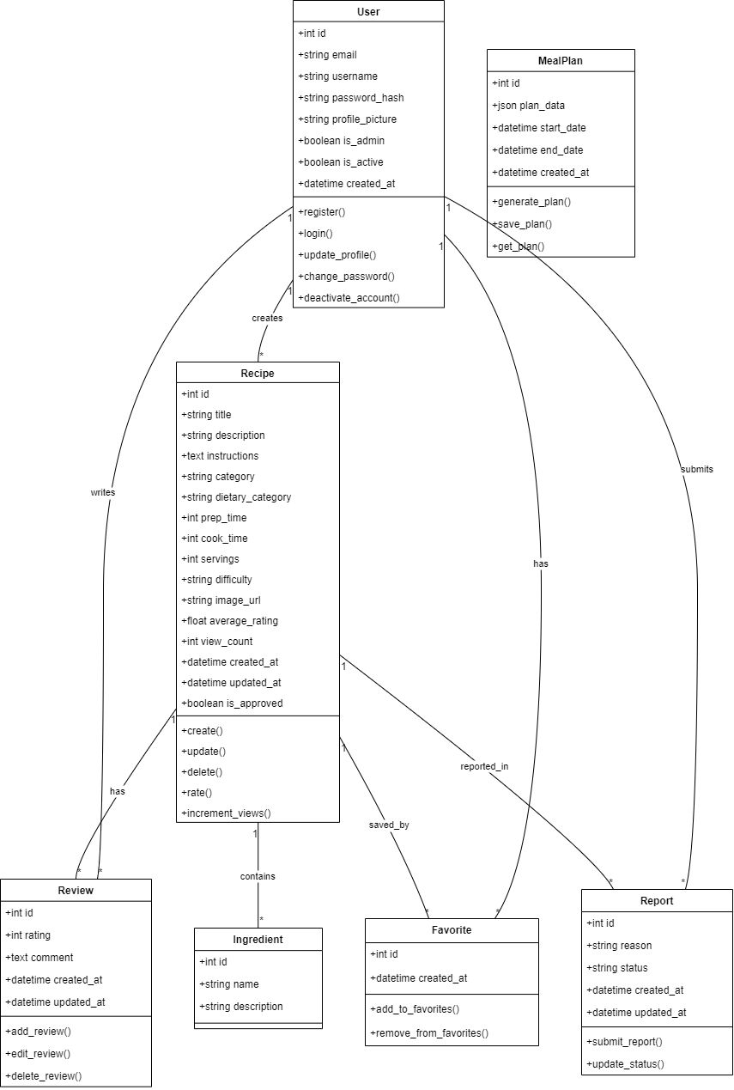

- Database Design

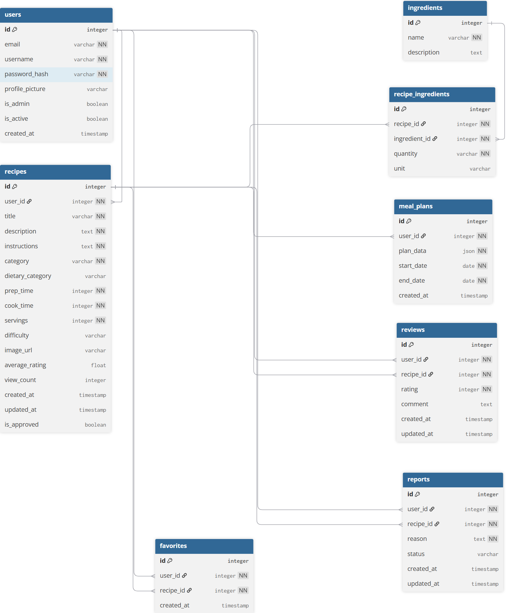

- Interface Design


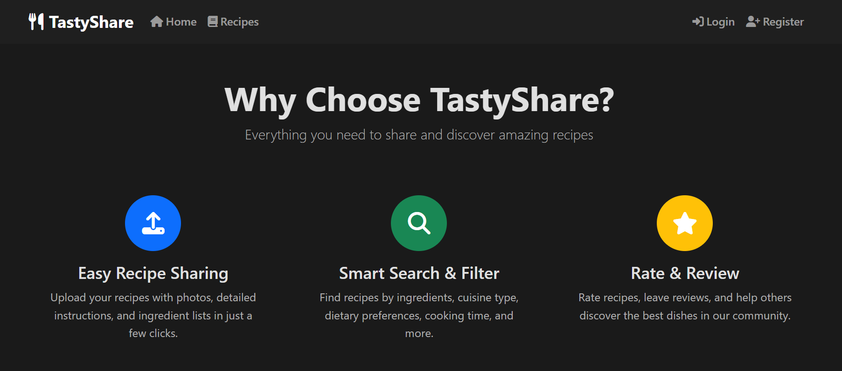

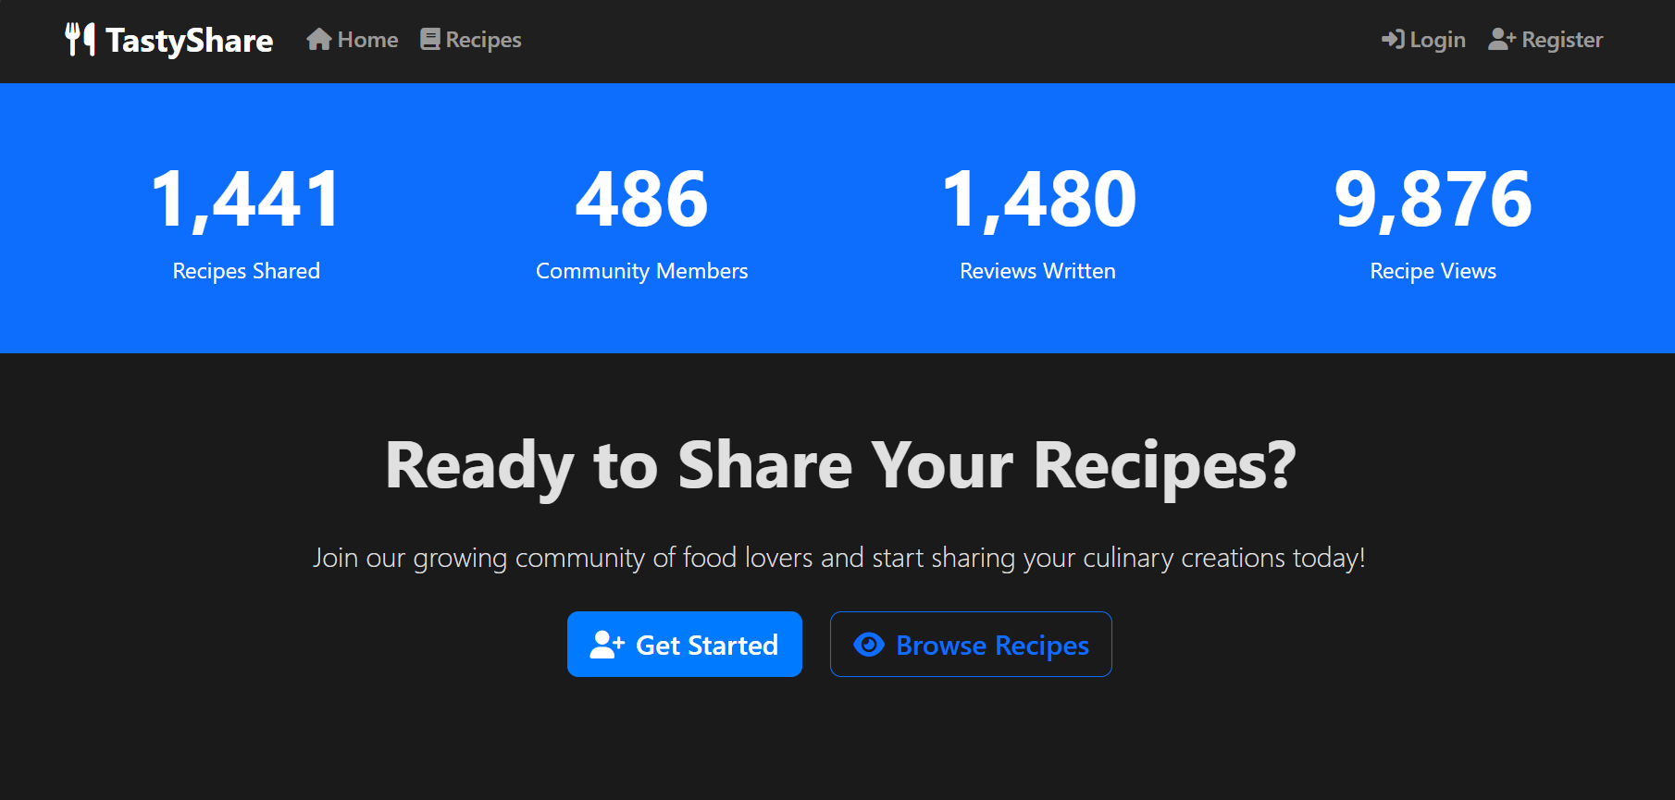
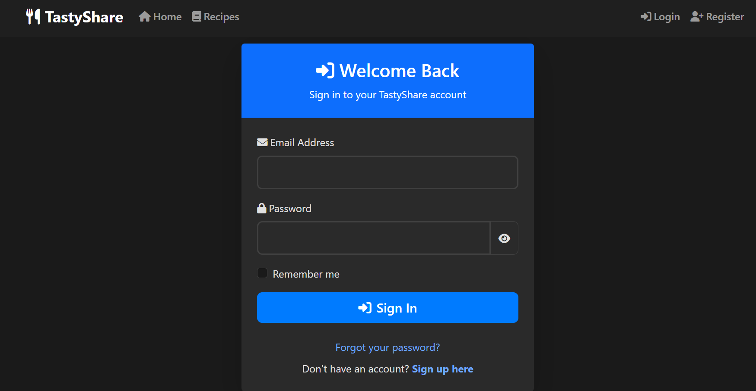
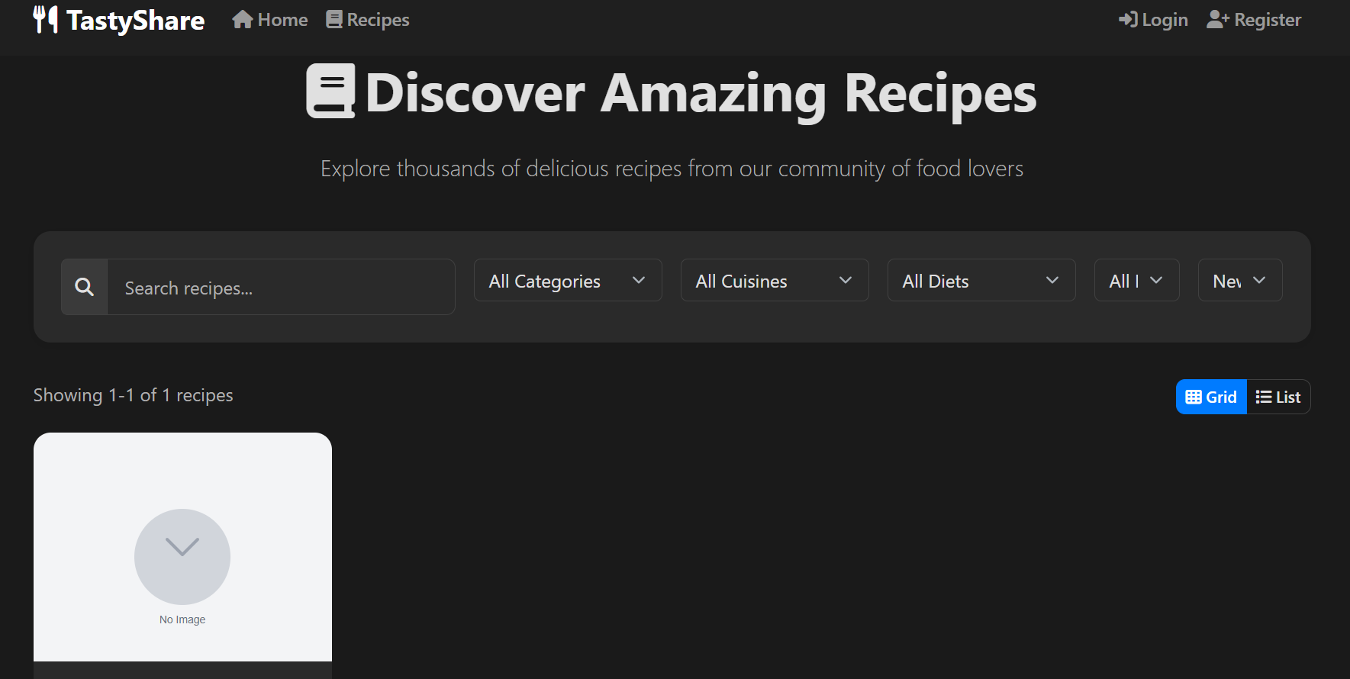

- Test Cases

Test Case ID | Description | Steps | Expected Result
User Authentication Tests
TC-AUTH-001 | User Registration | 1. Navigate to registration page  2. Fill valid details  3. Submit form | Account created successfully, redirect to login
TC-AUTH-002 | User Login Valid | 1. Navigate to login page  2. Enter valid credentials  3. Submit | Successful login, redirect to homepage
TC-AUTH-003 | User Login Invalid | 1. Navigate to login page  2. Enter invalid credentials  3. Submit | Error message displayed, no redirect
Recipe Management Tests
TC-REC-001 | Create Recipe Valid | 1. Login as user  2. Navigate to create recipe  3. Fill all required fields  4. Submit | Recipe created successfully, redirect to recipe page
TC-REC-002 | Create Recipe Invalid | 1. Login as user  2. Navigate to create recipe  3. Skip required fields  4. Submit | Error messages displayed, form not submitted
TC-REC-003 | Edit Own Recipe | 1. Login as user  2. Navigate to own recipe  3. Click edit  4. Modify fields and save | Recipe updated successfully
Search Functionality Tests
TC-SEARCH-001 | Search by Keyword | 1. Enter keyword in search bar  2. Press enter | Recipes containing keyword in title/ingredients displayed
TC-SEARCH-002 | Filter by Category | 1. Select category from filter  2. Apply filter | Only recipes from selected category displayed
TC-SEARCH-003 | Filter by Dietary | 1. Select dietary preference  2. Apply filter | Only recipes matching dietary preference displayed
Admin Functionality Tests
TC-ADMIN-001 | Review Reported Recipe | 1. Login as admin  2. Navigate to reports dashboard  3. Review reported recipe  4. Take action | Appropriate action taken, report status updated
TC-ADMIN-002 | Delete Inappropriate Recipe | 1. Login as admin  2. Navigate to recipe  3. Click delete  4. Confirm | Recipe removed from system, user notified
TC-ADMIN-003 | Manage Users | 1. Login as admin  2. Navigate to users management  3. Suspend problematic user | User account suspended, cannot login
Performance Tests
TC-PERF-001 | Page Load Time | 1. Navigate to homepage  2. Measure load time | Page loads within 2 seconds
TC-PERF-002 | Search Response Time | 1. Perform search  2. Measure response time | Results displayed within 1 second
TC-PERF-003 | Concurrent Users | 1. Simulate 100 concurrent users  2. Monitor system performance | System remains responsive, no crashes

