File structure:
Contains just 3 files:
- Index.html
- script.js
- style.css

Instruction for Deployment:
- Just keep all above 3 files in same folder and launch index.html

Technology Used:
- HTML 5
- Angular JS
- JQuery
- CSS

Note: For importing above all JS or CSS files CDN link is being used.

Feature:
- Implemented all the required functionalities
- Has dynamic search function
- Has sorting functionality
- Has very interesting UI sticky notes type

USP: We can use both dynamic search and filter together at once.

Screenshots:

Default Screen:
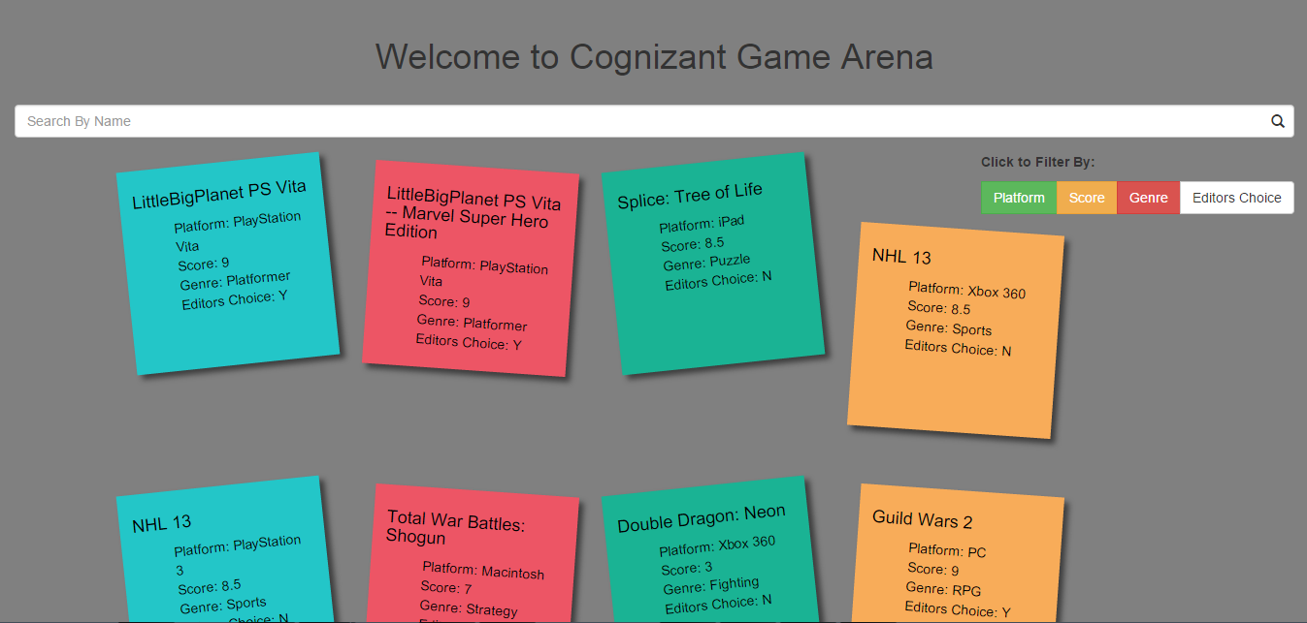

Dynamic Search in action: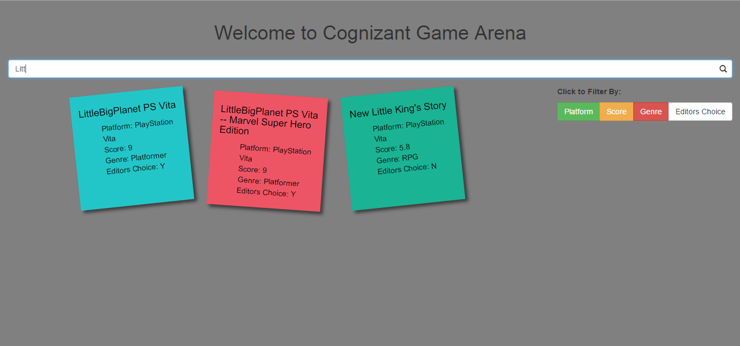

Filter (Score) in action:
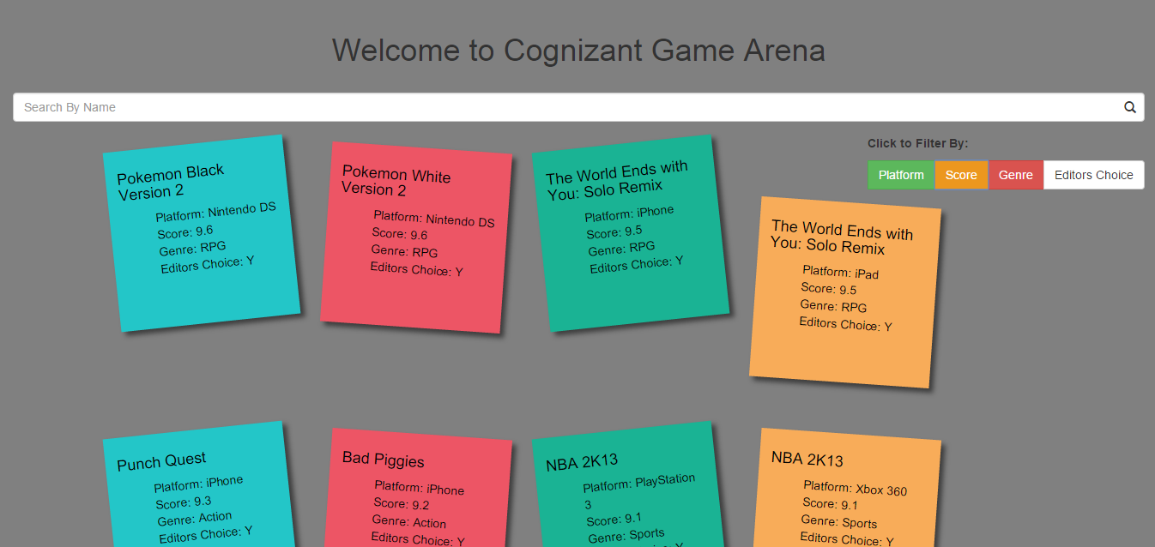

Dynamic search and Filter (Score) both in action:
