Some elements will always appear to start on a new line in the browser window. These are known as **block level** elements.

Examples of block elements are **<h1>**, **<p>**, **<ul>**, and **<li>**.

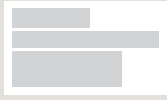

Some elements will always appear to continue on the same line as their neighboring elements. These are known as

**inline** elements.

Examples of inline elements are

**<a>**, **<b>**, **<em>**, and **<img>**.



The **<div>** element allows you to group a set of elements together in one block-level box. For example, you might create a **<div>** element to contain all of the elements for the header of your site (the logo and the navigation), or you might create **<div>** element to contain comments from visitors.

In a browser, the contents of the **<div>** element will start one new line, but other than this it will make no difference to the presentation of the page. Using an **id** or **class** attribution the **<div>** element, however, means that you can creates style rules to indicate how much space the **<div>** element should occupy on the screen and change the appearance of all the elements contained within intuit can also make it easier to follow your code if you have used**<div>** elements to hold each section of the page.

Since there may be several other elements inside a **<div>**element, it can be helpful to add comment after the closing**</div>** tag. This allows you to clearly see which opening tag it is supposed to correspond to, as shown at the end of the example here.

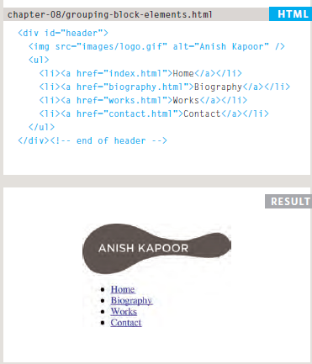

The **<span>** element acts like an inline equivalent of the **<div>**element. It is used to either:

1. Contain a section of text where there is no other suitable element to differentiate it from its surrounding text.

2. Contain a number of inline elements.

The most common reason why people use **<span>** elements is so that they can control the appearance of the content of these elements using CSS.You will usually see that a **class** or **id** attribute is used with**<span>** elements:●● To explain the purpose of this**<span>** element●● So that CSS styles can be applied to elements that have specific values for these attributes.

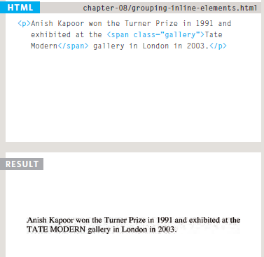

**Seamless**

In HTML5, a new attribute called **seamless** can be applied to an iframe where scrollbars are not desired. The **seamless** attribute (like some other newHTML5 attributes) does not need a value, but you will often see authors give it a value of **seamless**. Older browsers do not support the **seamless** attribute.

**There are some characters that are used in**

**and reserved by HTML code. (For example, the**

**left and right angled brackets.)**

Therefore, if you want these characters to appear on your page you need to use what are termed "escape" characters (also known as escape codes or entity references). For example, to write a left angled bracket, you can use either **&lt;** or**&#60;**. For an ampersand, you can use either **&amp;** or **&#38;**.There are also special codes that can be used to show symbols such as copyright and trademark, currency symbols,

Mathematical characters, and some punctuation marks. For example, if you want to include copyright symbol on a web page you can use either **&copy;** or**&#169;** .When using escape characters, it is important to check the page in your browser to ensure that the correct symbol shows up. This is because some fonts do not support all of these characters and you might therefore need to specify different font for these characters in yo

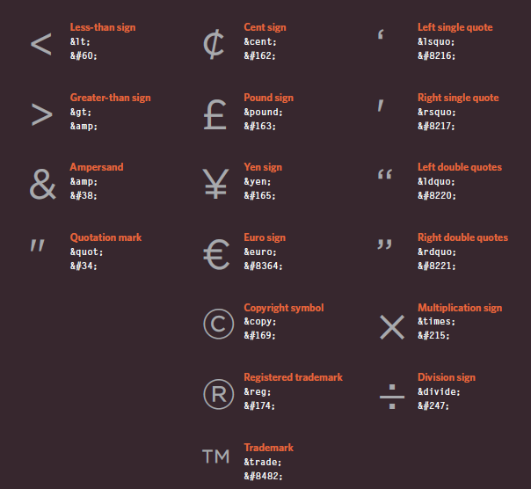ur CSS code.