3-tier:

**User interface:**

MainView

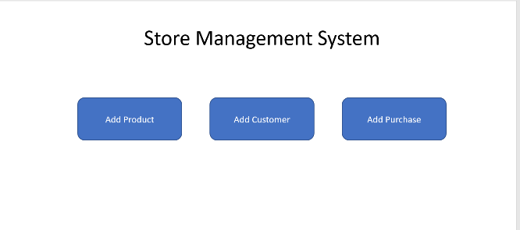

AddProductView class,

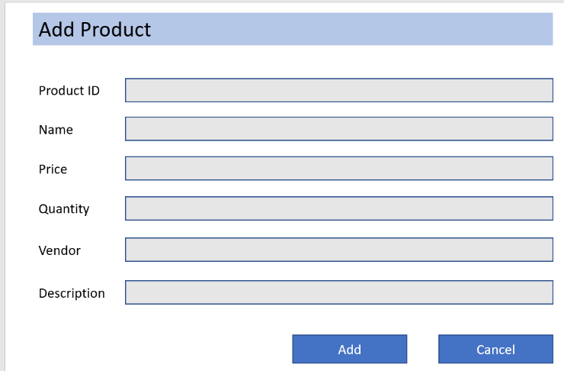

AddCustomerView class,

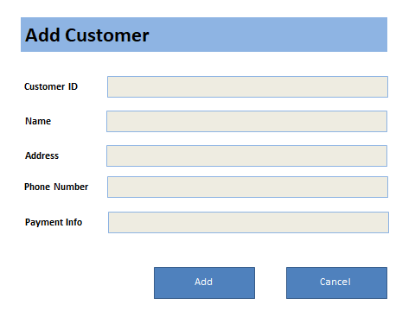

AddPurchaseView class,

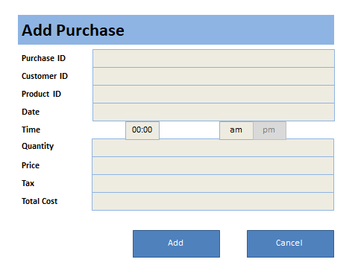

**Business Logic**

ProductModel class: store information of a product

AddProductController: process events of AddProductView

StoreManager: main application object

**Data Access**

* SQLiteDataAdapter class: read/write data

MVC Interface

DATA ACCESS

SQLiteDataAdapter

Read data from

Store Information to

BUSINESS LOGIC

ProductModel

AddProductController

StoreManager

USER INTERFACE

Mainview

AddProductView

AddCustomerView

AddPurchaseView

Send command prompts to

Write data to