Internship Project Report

Project Title: Streamlining Ticket Assignment for Efficient Support Operations

Intern Name: Shaik Mohammed Yaseen Nawazish

Domain: ServiceNow Administration

Organization: ABC Corporation

# 1. Acknowledgement

I would like to express my sincere gratitude to ABC Corporation for providing me the opportunity to work as a ServiceNow Administration Intern. I extend my thanks to my mentors, team members, and the entire support department for their continuous guidance and support throughout this project.

# 2. Introduction

This report presents the details of my internship project focused on automating the ticket assignment process in ServiceNow. The primary objective was to reduce manual intervention, improve support team efficiency, and ensure faster issue resolution through intelligent routing mechanisms.

# 3. Objective

To implement an automated system in ServiceNow that assigns incoming IT support tickets to appropriate teams based on specific conditions, thus improving ticket resolution time and optimizing support operations.

# 4. Technology Stack

- Platform: ServiceNow  
- Modules: Incident Management, Assignment Rules, Business Rules, Flow Designer  
- Scripting: JavaScript  
- Tools: Dashboards & Reports

# 5. Skills Gained

- Configuring Assignment & Business Rules  
- Designing workflows in Flow Designer  
- Server-side scripting with Glide APIs  
- Dashboard creation and performance analytics

# 6. Implementation Details

## 6.1 Assignment Rule Configuration

Created assignment rules to automatically route tickets based on criteria like category, urgency, and user attributes.

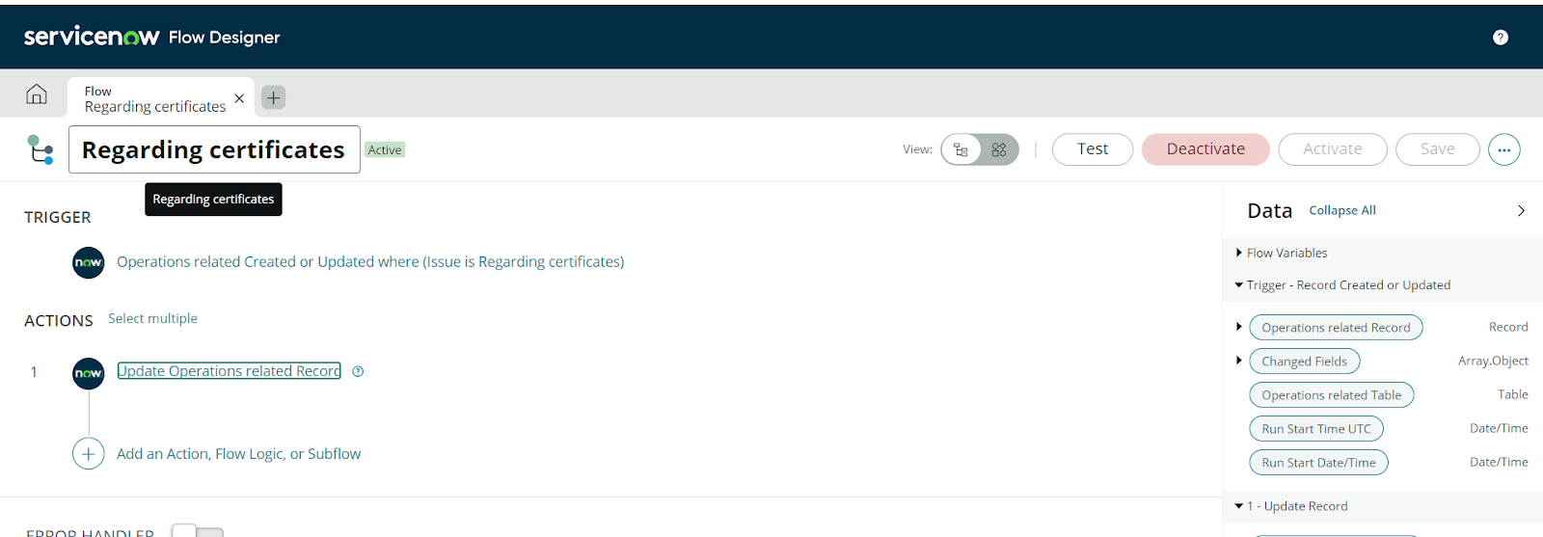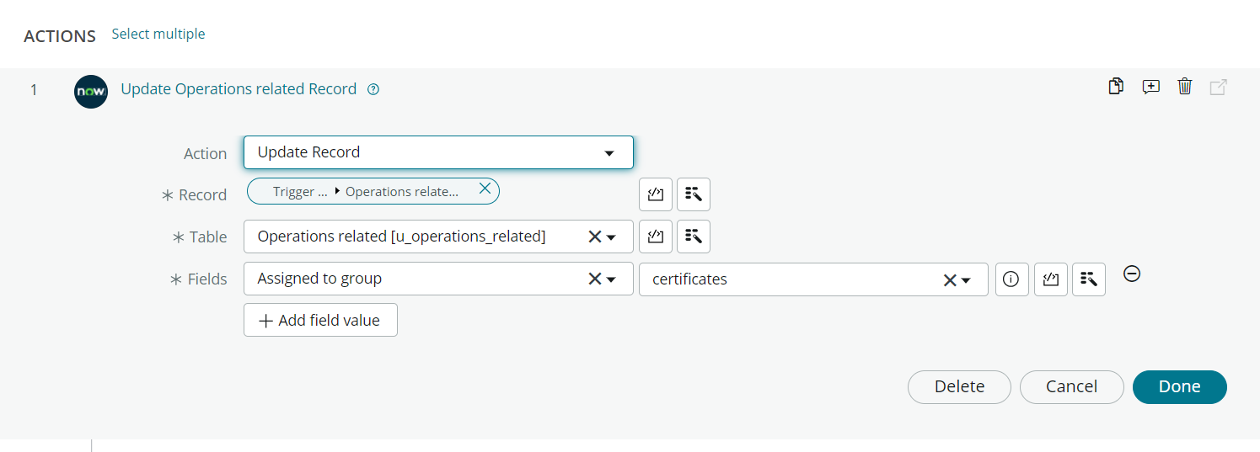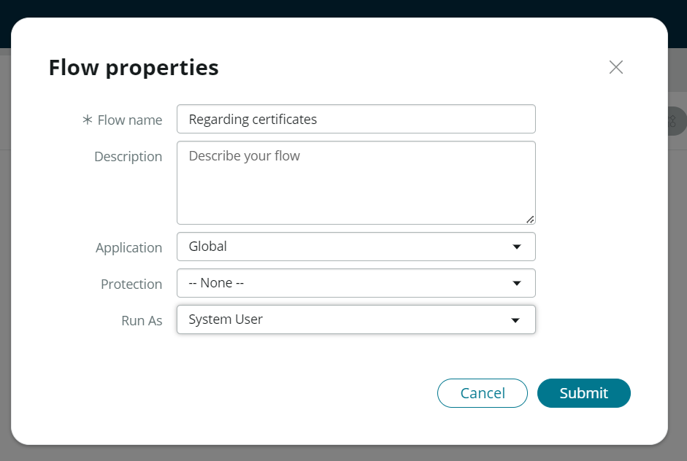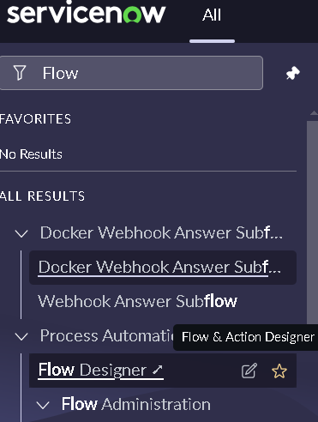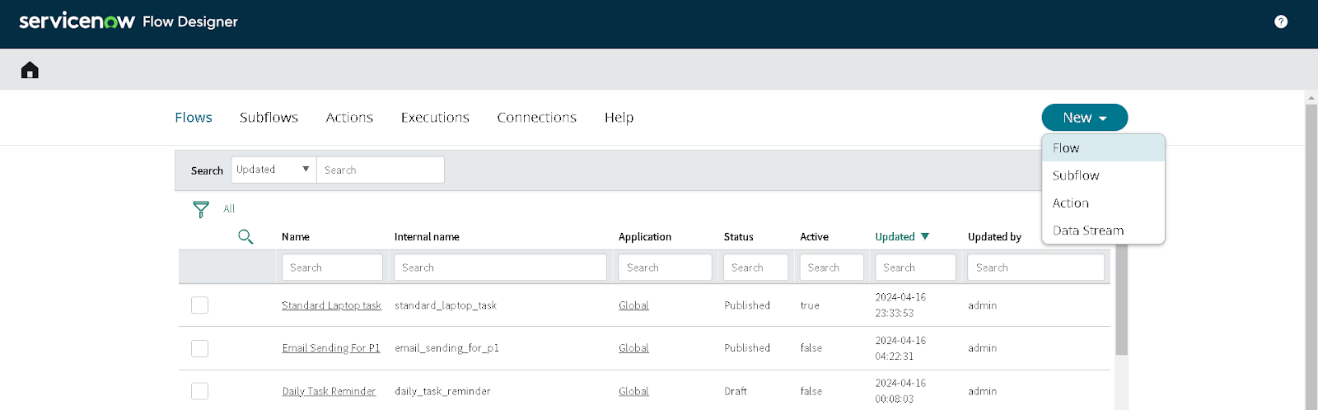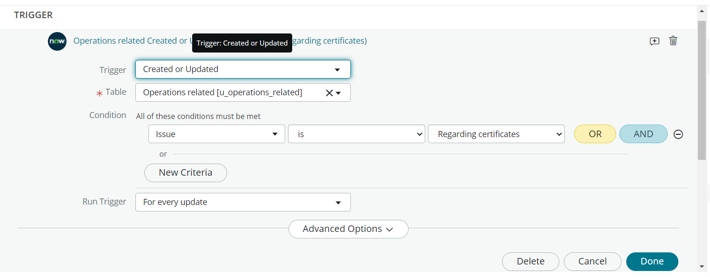

## 6.2 Flow Designer Workflow

Utilized Flow Designer to set up workflows for escalation, reassignment, or auto-approval based on dynamic inputs.

[Insert Screenshot: Flow Designer Workflow]

## 6.3 Business Rule Scripts

Used Business Rules to handle complex logic such as keyword-based routing and automatic field population.

## 6.4 Form Enhancement

Customized Incident form layouts to ensure proper data capture and user input validation.

## 6.5 Reporting & Dashboards

Created real-time dashboards tracking routing accuracy, group workload, and SLA performance.

# 7. Results & Outcomes

- 30–40% faster ticket routing and resolution  
- Reduced manual errors and misassignment  
- Higher first-contact resolution rate  
- Real-time performance tracking via dashboards

# 8. Challenges

- Learning Glide API and JavaScript scripting  
- Testing automation in a sandbox environment  
- Managing rule conflicts between Flows and Business Rules

# 9. Conclusion

The implementation of the automated ticket routing system at ABC Corporation has been a significant success. By leveraging the capabilities of ServiceNow, we have streamlined the process of assigning support tickets to the appropriate teams, addressing the challenges of manual routing, and ensuring timely resolution of issues. This project not only contributed to operational efficiency but also enhanced my technical skills in ServiceNow Administration.

# 10. References

- ServiceNow product documentation  
- ServiceNow Community & Developer Forums  
- ABC Corporation internal knowledge base