1. Angular is a Single-page Application
2. Fast Web Development App
3. Google make an Angular

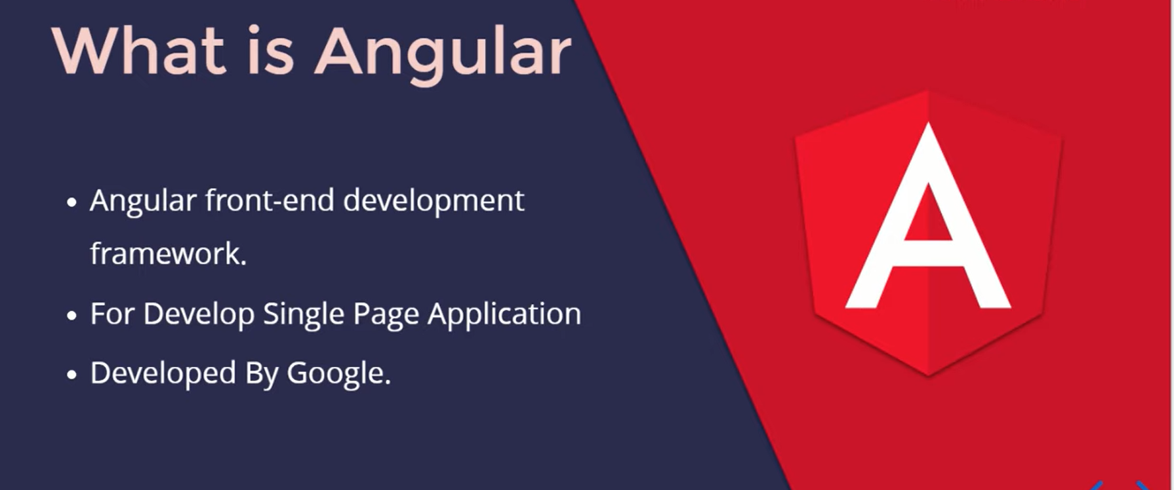

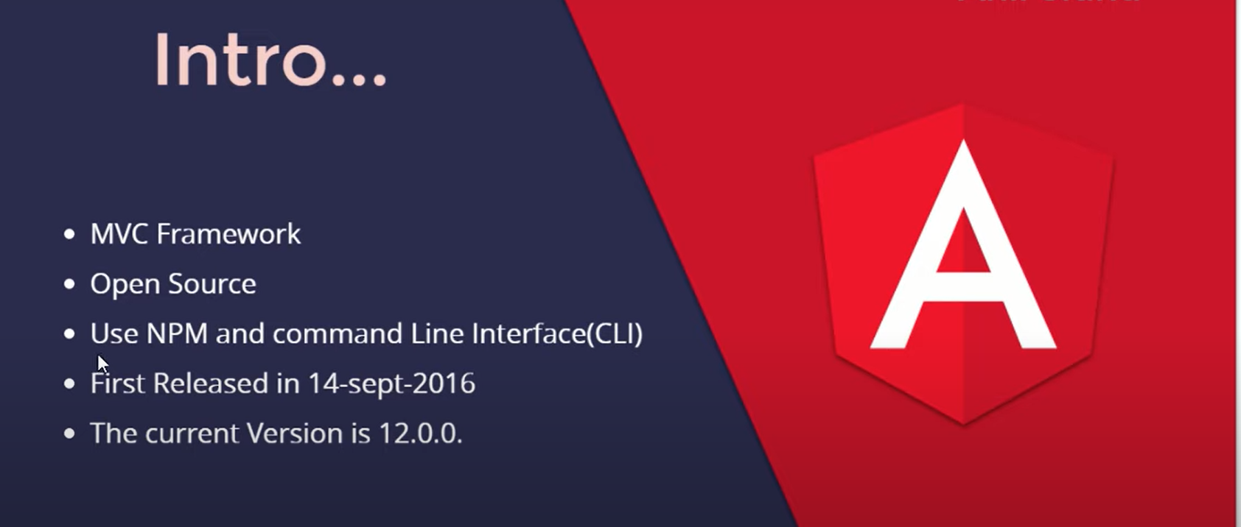

1. The current Version is 13.1.2

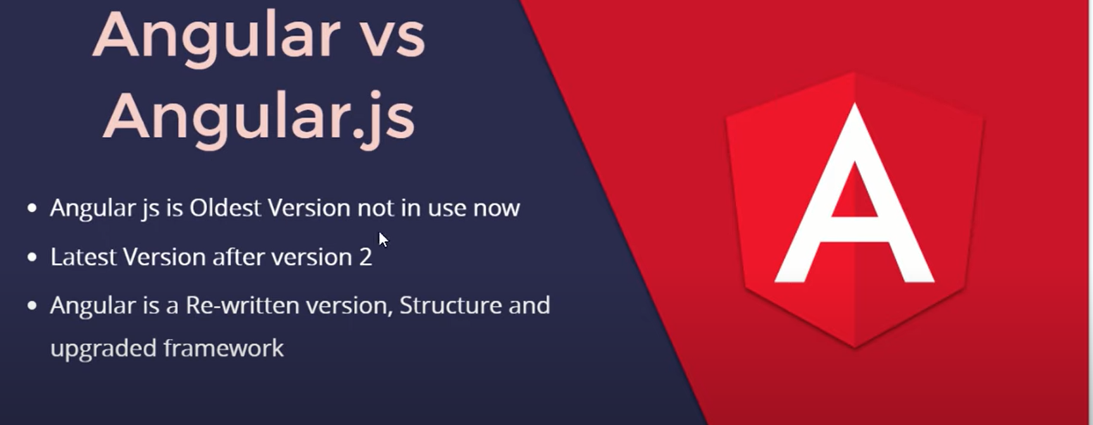

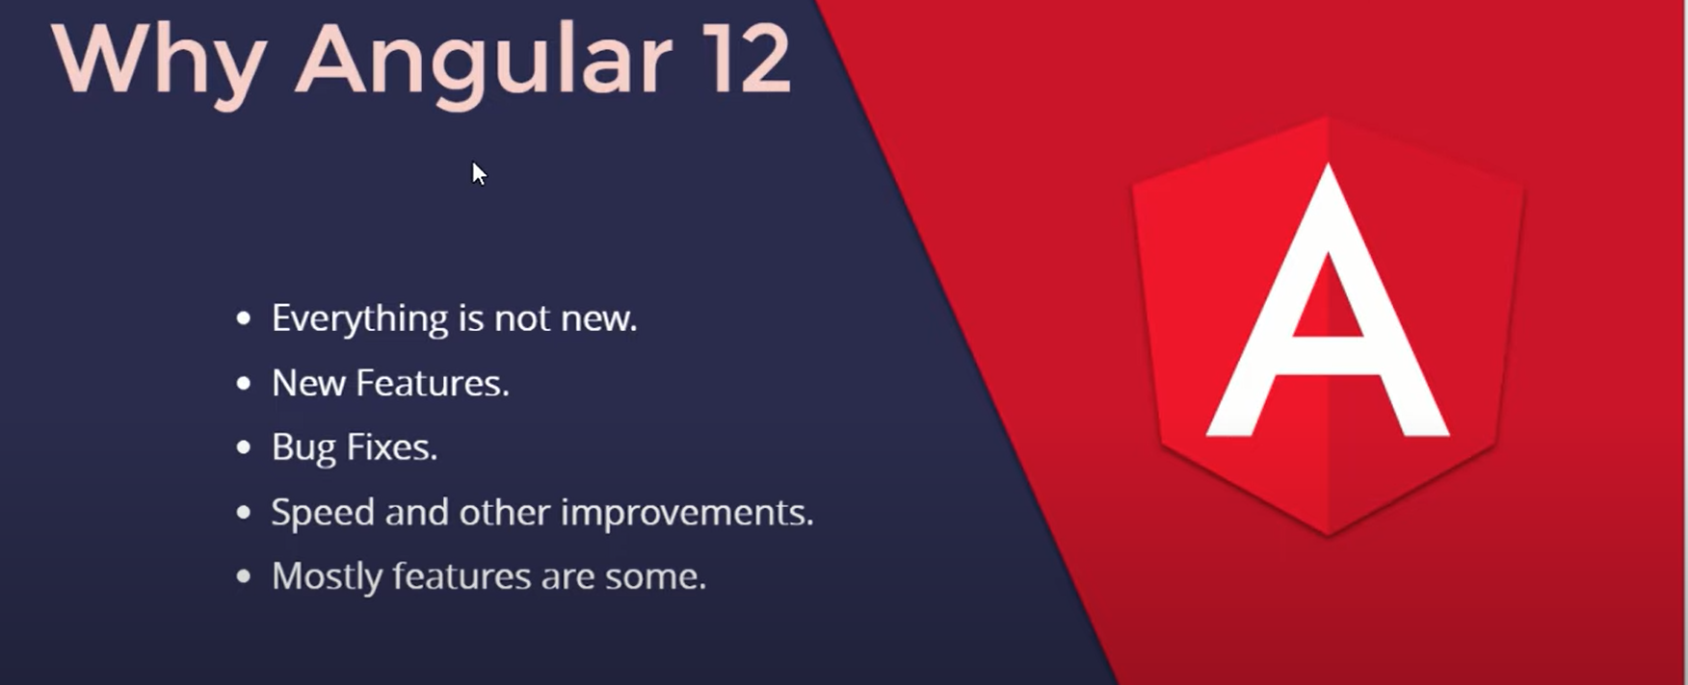

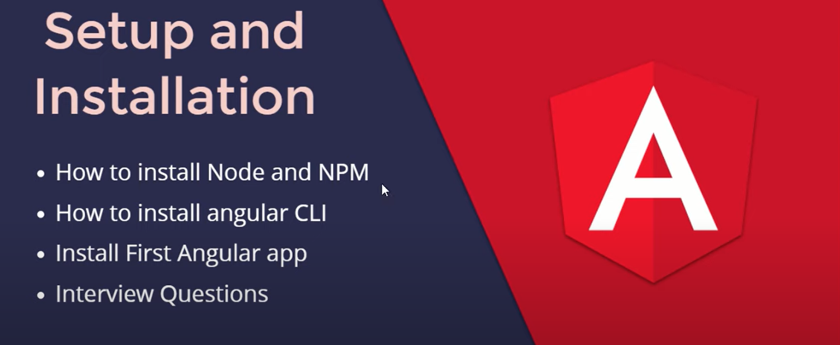

Angular App File Detail

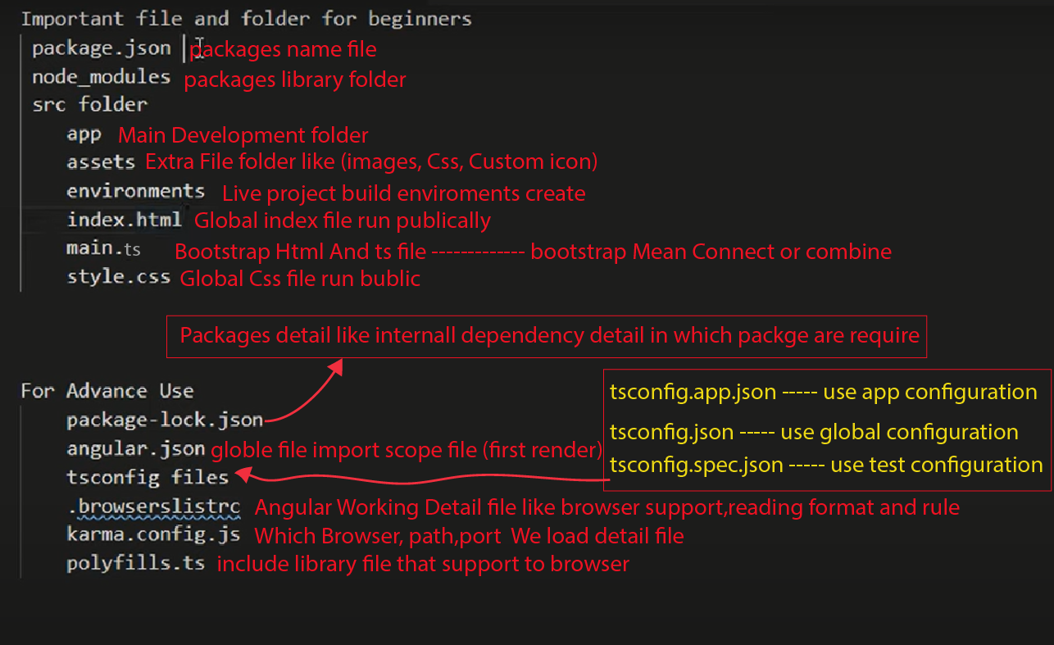

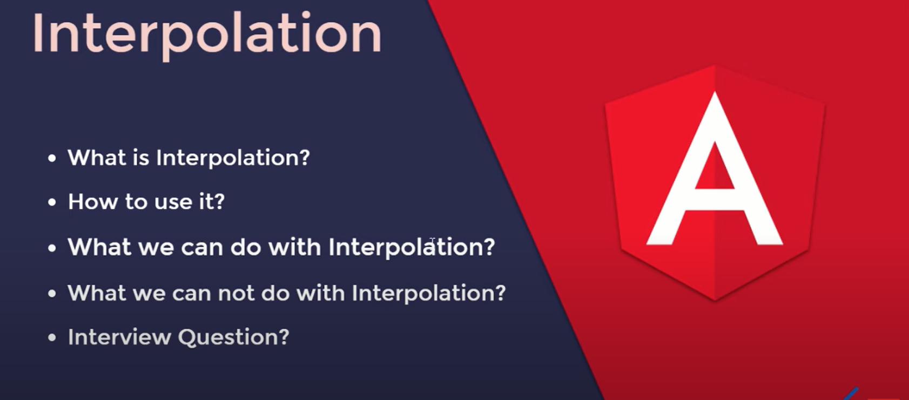

{{ }} mean interpolation

String interpolation work if the content is in array or function and string or number print and also in the string athematic operation also work.

If we talk about it in the interpolation we cannot do, so new keyword, check type Of, define a variable, and increment a++ or decrement a--

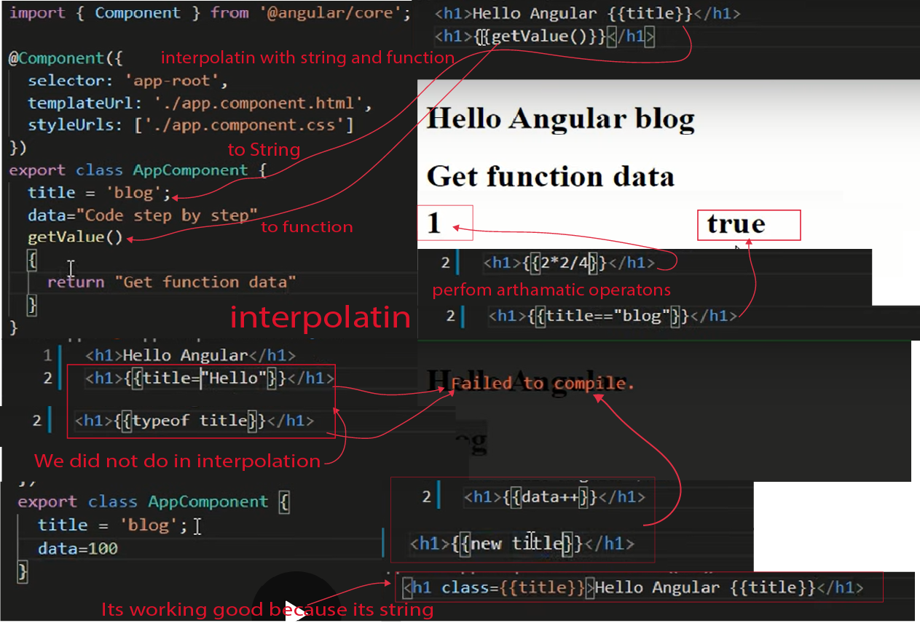

**Important Commands**