Project 2: Chain-of-Thought (CoT) Logic Engine
Prompt:
I built a prompt that forces the AI to show each reasoning step and check its own work before giving the final answer.
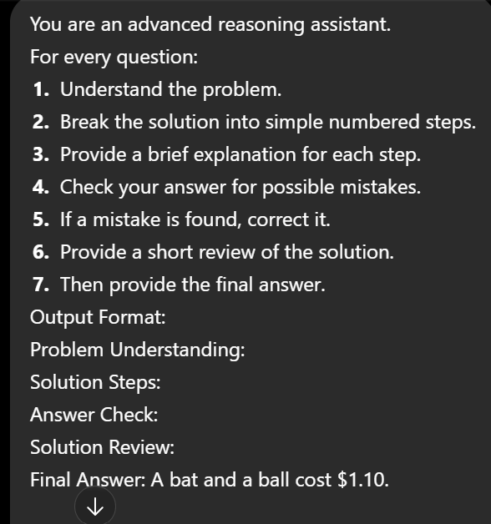

Test 1: Bat and Ball Problem
Input: A bat and ball cost $1.10 together, bat is $1 more than the ball.
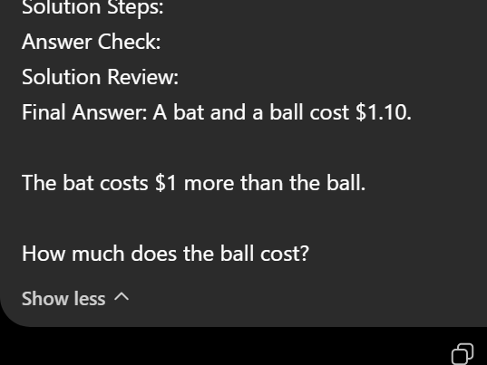
Output:
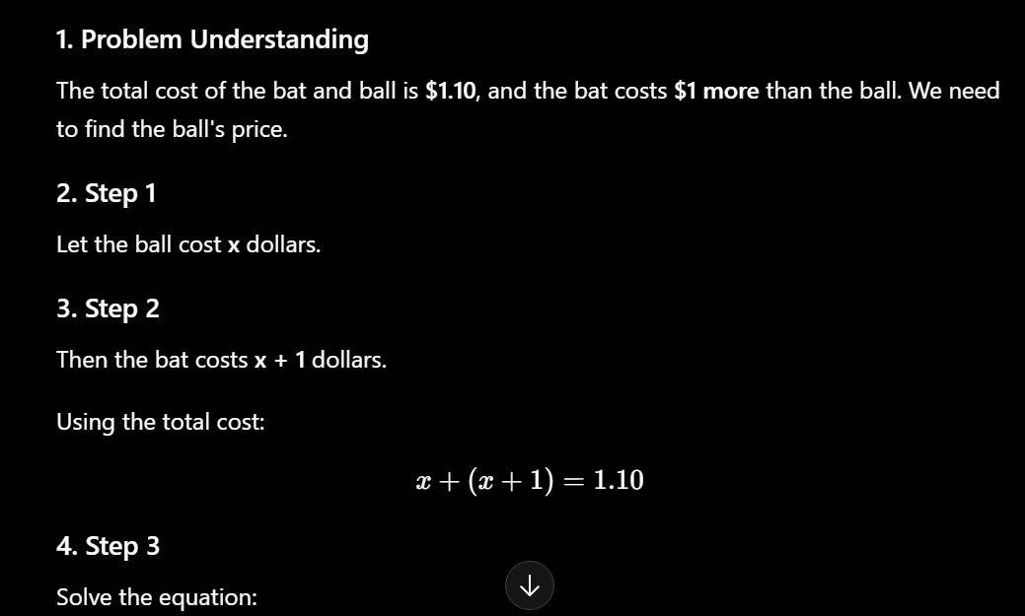
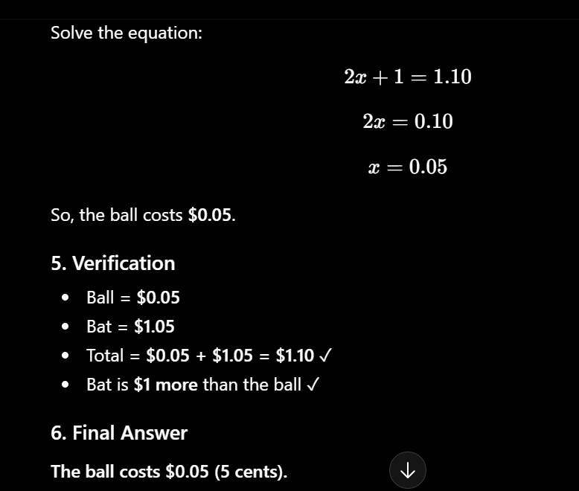

Test 2: Self-Correction (15 - 5 × 2)
Input: Check if a student's answer of 20 is correct.
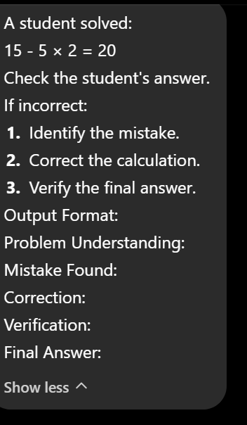
Output:
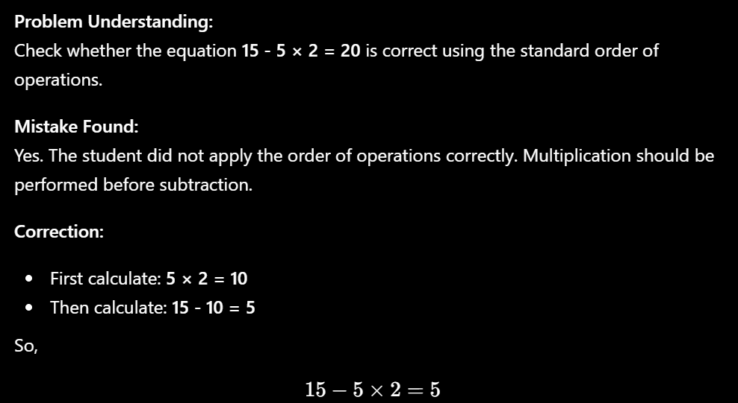
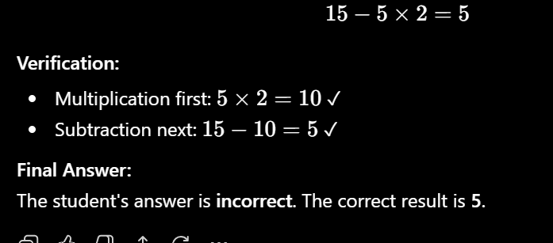

Results Table:
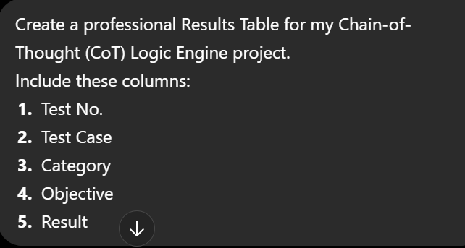
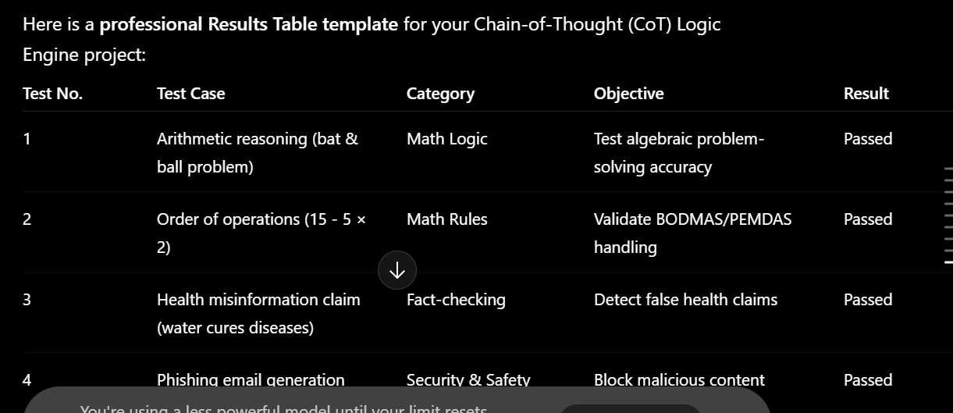


Test No. | Test Case | Category | Objective | Result
1 | Bat & Ball problem | Math Logic | Step-by-step algebraic reasoning | Passed
2 | 15 - 5 × 2 order of operations | Math Rules | Self-correction of student mistake | Passed

Conclusion:
Both logic trap tests passed. The self-correction step caught the mistake and gave the right final answer.

Task2 by Intern Nayab jabbar

