**1 LOW LEVEL DESIGN** 

Low Level Design

**Top 500 Company Market Analysis**

| **Written By** | Ankita Nayak,Abhishek Nayak |
| --- | --- |
| **Document Version** | 0.1 |
| **Last Revised Date** | **14 Jan 2023** |

1

**2 LOW LEVEL DESIGN** 

**DOCUMENT CONTROL**

**Change Record:**

| **VERSION** | **DATE** | **AUTHOR** | **COMMENTS** |
| --- | --- | --- | --- |
| 0.1 | 14- Jan -  2023 | Ankita Nayak,Abhishek Nayak | Architecture & Architecture description appended and updated. |
|  |  |  |  |
|  |  |  |  |
|  |  |  |  |

**Reviews:**

| **VERSION** | **DATE** | **REVIEWER** | **COMMENTS** |
| --- | --- | --- | --- |
| 0.2 | 21- May -  2021 | Author 3 | Unit test cases to be added |

**Approval Status:**

| **VERSION** | **REVIEW**  **DATE** | **REVIEWED BY** |  | **APPROVED BY** | **COMMENTS** |
| --- | --- | --- | --- | --- | --- |
|  |  |  |  |  |  |

**HOUSE PRICE PREDICTION** 2

**3 LOW LEVEL DESIGN** 

**Contents**

**1. Introduction………………………………………………………………………………………………………… 04 1.1 What is Low-Level Design Document? …………………………………………………….. 04 1.2 Scope ……………………………………………………………………………………………………... 04**

**2. Architecture ……………………………………………………………………………………………………….. 05 3. Architecture Description …………………………………………………………………………………… 08 3.1 Data Description ……………………………………………………………………………………… 08 3.2 Web Scrapping ………………………………………………………………………………………… 08 3.3 Data Transformation ……………………………………………………………………………… 08 3.4 Data insertion into database …………………………………………………………………... 08 3.5 Connection with SQL server ……………………………………………………………………. 08 3.5 Export Data from database ……………………………………………………………………… 12 3.6 Deployment …………………………………………………………………………………………… 12 4. Unit test cases ………………………………………………………………………………………………………15**

**HOUSE PRICE PREDICTION** 3

**4 LOW LEVEL DESIGN** 

**1. Introduction**

**1.1 What is Low-Level design document?**

The goal of the LDD or Low-level design document (LLDD) is to give the internal logic design of the actual program code for the House Price Prediction dashboard. LDD describes the class diagrams with the methods and relations between classes and programs specs. It describes the modules so that the programmer can directly code the program from the document.

**1.2 Scope**

Low-level design (LLD) is a component-level design process that follows a step-by-step refinement process. The process can be used for designing data structures, required software architecture, source code and ultimately, performance algorithms. Overall, the data organization may be defined during requirement analysis and then refined during data design work.

**HOUSE PRICE PREDICTION** 4

**5 LOW LEVEL DESIGN** 

**2. Architecture**

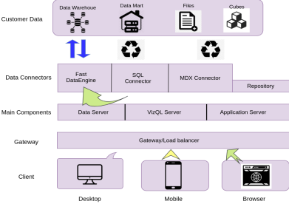

**Tableau Server Architecture**

Tableau has a highly scalable, n-tier client-server architecture that serves mobile clients, web clients and desktop-installed software. Tableau Server architecture supports fast and flexible deployments.

The following diagram shows Tableau Server’s architecture:

**6 LOW LEVEL DESIGN** 

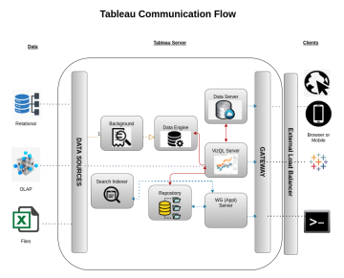Tableau Server is internally managed by the multiple server processes.

**1. Gateway/Load Balancer**

It acts as an Entry gate to the Tableu Server and also balances the load to the Server if multiple Processes are configured.

**2) Application Server:-**

Application Server processes (wgserver.exe) handle browsing and permissions for the Tableau Server web and mobile interfaces. When a user opens a view in a client device, that user starts a session on Tableau Server. This means that an Application Server thread starts and checks the permissions for that user and that view.

**3) Repository:-**

Tableau Server Repository is a PostgreSQL database that stores server data. This data includes information about Tableau Server users, groups and group assignments, permissions, projects, data sources, and extract metadata and refresh information.

**4) VIZQL Server:-**

**7 LOW LEVEL DESIGN** 

Once a view is opened, the client sends a request to the VizQL process (vizqlserver.exe). The VizQL process then sends queries directly to the data source, returning a result set that is rendered as images and presented to the user. Each VizQL Server has its own cache that can be shared across multiple users

**5) Data Engine:-**

It Stores data extracts and answers queries.

**6) Backgrounder:-**

The backgrounder Executes server tasks which includes refreshes scheduled extracts, tasks initiated from tabcmd and manages other background tasks.

**7) Data Server:-**

Data Server Manages connections to Tableau Server data sources

It also maintains metadata from Tableau Desktop, such as calculations, definitions, and groups.

**3. Architecture Description**

**3.1. Data Description**

The Dataset contains house price of cities that fall under the categories A,B and C based on the availability of parking, rainfall, its built-up area etc

1. Mar Cap - Crore ,Mar-cap: Market Capitalization in crores.

2. Sales Qtr- Crore ,Sales-qtr Sales quarter in crores 3.df['Mar-cap'].max()-Highest amount of Market capitalization

4.df.loc[df['Mar-cap']==df['Mar-cap'].max(),:]-Locate the company with the highest amount of market capitalization

5.df.loc[df['Mar-cap']==df['Mar-cap'].min(),:]-Locate the company with the lowest amount of market capitalization

6.df.loc[df['Sales-qtr']==df['Sales-qtr'].max(),:]-Locate the company with the lowest Sales qtr

7.df.loc[df['Sales-qtr']==df['Sales-qtr'].min(),:]--Locate the company with the lowest Sales qtr

8.df['Ratio'] = df['Mar-cap']/df['Sales-qtr']

df.head()

-Ratio between the two KPI,Market capitalization and Sales qtr

9.df.loc[df['Ratio']==df['Ratio'].max(),:]-

Locate the maximum ratio

10.df.loc[df['Ratio']==df['Ratio'].min(),:]

-Locate the minimum ratio

11.df.query('USD>1000')

-Sort large cap companies

12.df.query('USD>200 & USD <1000')

-Sor mid cap companies

7

**8 LOW LEVEL DESIGN** 

**3.2. Web Scrapping**

Web scraping is a technique to automatically extract content and data from websites using bots. It is also known as web data extraction or web harvesting. Web scrapping is made simple now days, many tools are used for web scrapping. Some of python libraries used for web scrapping are Beautiful Soup, Scrapy, Selenium, etc.

**3.3. Data Transformation**

In the Transformation Process, we will convert our original datasets with other necessary attributes format. And will merge it with the Scrapped dataset.

**3.4.Loading data into the visualization tool-Tableau**

**Step 1: Configuring Tableau**

Launch Tableau on your workstation anand open Tableau public..

To connect with tableau, you will need to provide information about the server which hosts your database. If you want to connect to a contained database, you can also specify the name of the database.

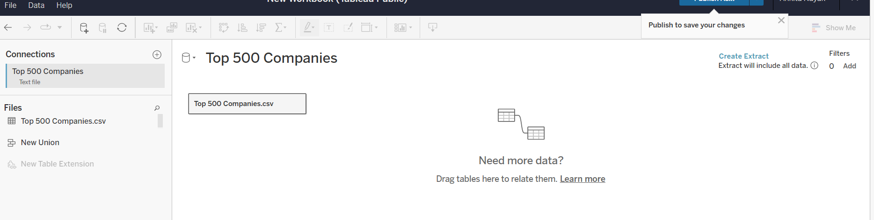

**10 LOW LEVEL DESIGN** 

**Step 2: Configuring Data Source**

The data source page loads up after configuring the Tableau connector and successfully signing in. This is how the page looks like:

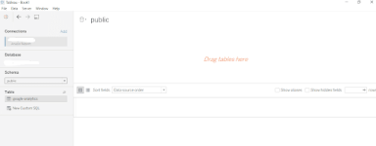

Select the data source name option and give a unique name to the database you are using. It’s considered a good practice to have a unique name as it makes it much easier for users to identify the database from which data is being fetched.

To select the desired schema, you can use the schema drop-down list from the column on the left. You can also perform a text-based search to find the desired option. Now similarly find and select the desired table and drag it onto the canvas.

**3.5. Export Data from Database**

Data Export from Database - The data in a stored database is exported as a CSV file to be used for Data Pre-processing.

**3.6 Deployment.**

Once you’ve completed your dashboard, follow these steps:**- Server, Tableau Public, Save to Tableau Public As**

You may be prompted to log into your Tableau Public profile first if this is your first time publishing.

11

**12 LOW LEVEL DESIGN** 

Next, fill out the title you want your viz to have and click “save”.

. Tableau Public cannot host live connections, so you’ll need to convert your connection to an extract (like a frozen screenshot of your data).



**H**