*House Price Data Analysis* ***Wireframe Documentation***

Homepage

As per the problem statement, we have divided analysis into two sections: -

**1.Market Capitalization:**

In this section we designed our first dashboard and tried to interpret the followings

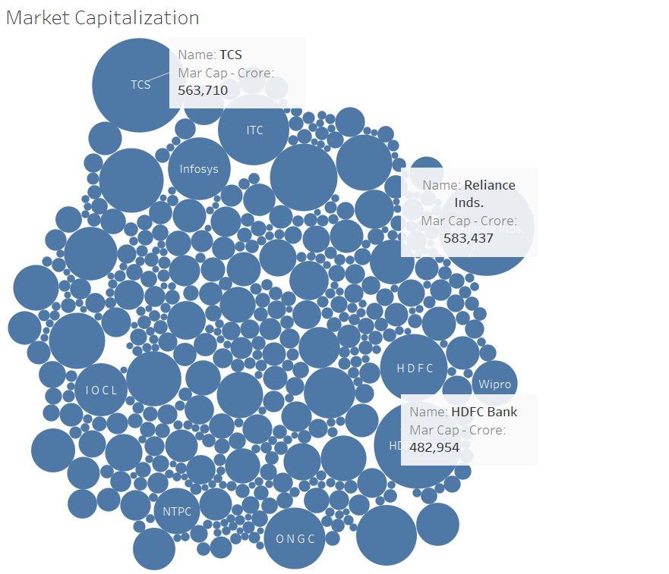

◼ The top 3 market capitalization is that of Reliance ,TCS & HDFC

**2.Sales quarterly comparision:**

