SANKALP

Mail: [email@example.com](mailto:email@example.com) | call: 0123456789

Where you promise to your future

DISCOVER YOUR FUTURE

WITH US

**Future Students Best Curriculum Our Community**

If you believe that you can win We are dedicated at providing We have huge community of

the world with your skills then the well research and best the students who love to change

you can surely be our best in the class curriculum for our the world with us and help

student students each other succeed

**Welcome to the Sankalp**

We maintain student’s marks and attendance and give them a best assistance using our state of the art AI system to make their life good

**Features of our Website**

**Simple Interface**

**With Sankalp you’ll get a fast, simple, and secured assistance for your students to improve themselves**



**End to End Encryption**

**We provide built in end to end encryption support to your data, so that no one can access your data**



**Facilitate Learning Goals**

**We provide tools that helps students to improve their overall academic performance**

**About Us**

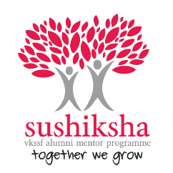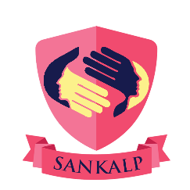**TEAM SANKALP**

**Team Sankalp is a group of people who are under**

**Sushiksha, which is a Mentoring program organized**

**For scholars of Vishwa Konkani Student Scholarship Fund (VKSSF) by members of VKSSF Alumni Association (VAA). Sushiksha was started in 2018 by Royal Denzil Sequeira, a member of VAA since 2015, with 20 mentees. Since then Sushiksha has grown to be family of 170 mentees and 20 mentors. Mentees of Sushiksha are undergraduate scholars of VKSSF who are determined to thrive and be successful in their area of study and career. Mentors of Sushiksha Program are experienced professionals who were once the scholars of VKSSF and have lived through their own share of successes and failures but believe in empowering the scholars early on in their career path.**

**An Initiative by**

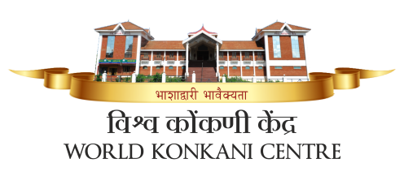

**Email:**

Email@example.com

© Copyright **Sankalp**. All Rights Reserved