B.M.S. COLLEGE OF ENGINEERING, BENGALURU
Autonomous Institute, Affiliated to VTU


An AAT Report on
on

“Automatic Classification of Sexism in Social
Networks: An Empirical Study on Twitter Data”

Submitted in fulfilment for the award of degree of
Master of Technology
In
Computer Science and Engineering

Submitted by

P Yogesh Nayaka (1BM25SCS003-T)

Under the Guidance of
Dr. Umadevi V
Professor, BMSCE



B.M.S. COLLEGE OF ENGINEERING
(Autonomous Institution under VTU)
BENGALURU-560019
2025-2026

B.M.S. College of Engineering,
Department of Computer Science and Engineering

DECLARATION
This is to declare that the AAT work entitled “Automatic Classification of Sexism in Social
Networks: An Empirical Study on Twitter Data” carried out by P Yogesh Nayaka (1BM25SCS003-T), is a part of the course Artificial Intelligence (MCS101) of 1st Semester M.Tech (CSE), Department of Computer Science and Engineering, B.M.S. College of Engineering, Bangalore. This AAT work has been carried out under the guidance of Dr. Umadevi V during the academic semester Nov 2025 - Feb 2026. I declare that this work is original and has not been submitted elsewhere for any other degree or award.

Signature of the Candidate

P Yogesh Nayaka (1BM25SCS003-T)

B. M. S. COLLEGE OF ENGINEERING
DEPARTMENT OF COMPUTER SCIENCE AND ENGINEERING



CERTIFICATE

Certified that the AAT entitled "Automatic Classification of Sexism in Social
Networks: An Empirical Study on Twitter Data" is a bonafide work carried out by P Yogesh Nayaka (1BM25SCS003-T), in partial fulfillment for the award of Master of Technology in Computer Science and Engineering of the Visvesvaraya Technological University, Belagavi, during the academic year 2025-2026. This report satisfies the academic requirements prescribed for the said degree.

Guide

Dr. Umadevi V
Professor
Department of CSE
BMSCE

List of Figures

Sl. NO. | TITLE | PAGE NO.
1 | Dataset Column Names | 7
2 | Model-wise Metrics Comparison | 9
3 | ROC-AUC | 10

List of Tables

Sl. NO. | TITLE | PAGE NO.
1 | Comparison between paper and implementation | 10

Table of Contents

Sl. NO. | TITLE | PAGE NO.
1 | Introduction | 6
2 | Problem Statement Addressed | 6
3 | Objectives of the Paper | 6
4 | Datasets Description | 7
5 | Tools and Technology used for implementation | 7
6 | GitHub link of the code | 8
7 | Methodology | 9
8 | Results Obtained | 9
9 | Learning Outcome | 11
10 | Paper reference | 11
11 | Screenshot of Similarity & AI Generated report | 11

- Introduction:
Social Media has changed how people communicate, interact and create social identities. With its benefits, it also comes with drawbacks. People spread hate based on a person’s colour, sex, nationality, political identity, religion etc. Sexism [Hate based on sex] is among them, these comments are pervasive, since most people online are anonymous the problem is amplified. Exposure to these comments are not just unpleasant, they have consequences on mental health, public participation and freedom of expression.
Sexism is not always obvious. It is often subtle, normalized, objectification statements that are hidden as humor or concern. These expressions are widespread, socially embedded and overlooked by human moderators and automated systems.

- Problem Statement:
Attempts are being made to reduce the number of comments posted online, most automatic systems are limited to identifying explicit hate speech or misogynist content. This approach is narrow and fails to capture the full spectrum of sexist behavior, particularly implicit and non-violent forms of sexism that hurt people's feelings while remaining socially normalized. This leaves small portions of comments to go unnoticed on social media.
This paper tackles the issue by introducing a new task for its detection, building a manually annotated dataset from Spanish Twitter posts, and testing both classical models and deep learning models.

- Objectives:
The aim of the paper was to design and evaluate an automated approach for detecting sexist content on social media. It introduces a new sexism detection task, creating a manually annotated dataset of Twitter posts in Spanish and comparing the performance of classical machine learning models and deep learning models in identifying sexist posts. The study contributes towards the development of a more reliable and socially responsible content moderation system.
Though the objective of the paper is to explore automatic detection of sexist posts using machine learning models and deep learning models. The paper uses Twitter’s API to pre-process the text data, due to unavailability of the original dataset, this project adopts a dataset with texts in it rather than twitter_id. The work aims to preprocess raw text data, extract features and evaluate the performance of different classic machine learning models

- Dataset Used:
The dataset used in this project is the Sexism Detection in English Texts dataset, it contains English text samples labeled for the presence of sexist content. The dataset has six columns rewire_id, text, label_sexist, label_category, label_vector and split.

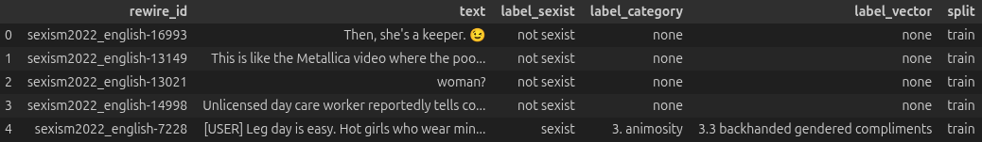
Fig 1: Dataset Column Names
Each row has a unique identifier rewire_id which is a text segment. The text column has the tweets which are processed and used for training classic machine learning models. The label_sexist is the target column which has two classes: sexist and not sexist. With these columns the dataset also has label_category and label_vector, which describe the type of sexism. The dataset has a total of 20,000 rows, which are divided into training and testing sets. The training set has 16,000 rows and the testing set has 4,000 rows.

- Tools Used for Implementation:
5.1 Programing Language:
- Python: Python was used due to its extensive support for machine learning libraries. Its simple syntax makes it easy for writing and experimenting with models.
5.2 Python Libraries:
- Pandas: Pandas is mainly used to work with structured data like tables. It offers DataFrame which is fast and flexible making it easy to clean, transform, filter, analyze etc datasets. Pandas is used to load, handle missing values, preprocess data and prepare data for training models.
- Matplotlib: Matplotlib is used for visualizing and plotting data in python. It offers a wide range of plots like bar chart, scatter plot, histogram, pie chart and subplots to analyze data visually and track model performance. Matplotlib is used to visualize evaluation metrics and compare models making it easy to interpret.
- SciKit-Learn: sklearn is used for building and evaluating machine learning models. Its offers common models like Simple Linear Regression, Logistic Regression, KNN, Decision Tree, Support Vector Machine, Random Forest etc, with mentioned models it also offers tools for feature extraction like TF-IDF etc and tools for evaluation like accuracy_score, classification_report etc.
5.3 Text Cleaning Libraries:
- Regular Expression(re): re is used for pattern matching and text cleaning. Mostly used for NLP tasks to remove problematic characters, URLs etc from text data. It standardizes raw text data before feature extraction.
- String: string is a helper function that helps in handling punctuations, digits and whitespaces.
- Emoji: emoji is used to detect, extract and remove emoji from text. Emojis adds noise to text data, this library cleans user-generated text by converting emojis to descriptive text.
- NLTK: nltk or Natural Language Toolkit offer a range of basic natural language processing tools. nltk.corpus.stopwords gives a list of common stop words that can be used to reduce noise in text. nltk.stem.ProterStemmer is used to reduce words to their root form, which groups similar words.
5.4 Machine Learning Models:
- Logistic Regression: Logistic Regression is a linear classification model that uses sigmoid function to find probability of a given data point.
- Support Vector Classifier(SVC): SVC uses a margin to classify points by finding optimal decision boundaries with maximum margin.
- Random Forest Classifier: Random forest is an ensemble model that uses multiple decision trees to improve accuracy.

- Github Link: Twitter Text Classification
- Methodology:
This project follows the standard machine learning pipeline. First, loading and exploring the data. Pandas is used to understand the data and see class distribution. Then raw text was cleaned by lowercasing, removing punctuation, URLs, emojis, stopwords and stemming to reduce word to root form.
After preprocessing, the cleaned data is transformed into a numerical feature using TF-IDF, it captures the importance of words in the document. The data is split in an 80-20 ratio, 80% being the training set and 20% being the testing set.
Three machine learning models are used-Logistic Regression, Support Vector Classifier, Random Forest Classifier. These models were trained on TF-IDF features and evaluated using accuracy, precision, recall, F1-score and ROC-AUC.

- Results Obtained:
The trained models were evaluated on the test dataset using different metrics like, accuracy, precision, recall, F1-score and ROC-AUC. Logistic Regression and Support Vector Classifier show strong performance while Random Forest Classifier showed comparatively lower performance.
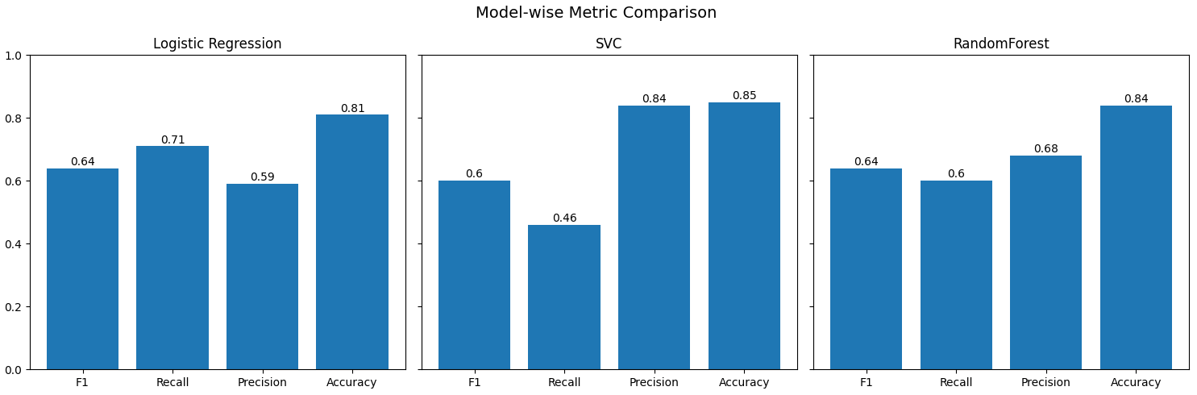
Fig 2: Model-wise Metrics Comparison

Visual analysis using bar plots and ROC-AUC showed that linear models have better balance between precision and recall, making them suitable for sexism tasks.
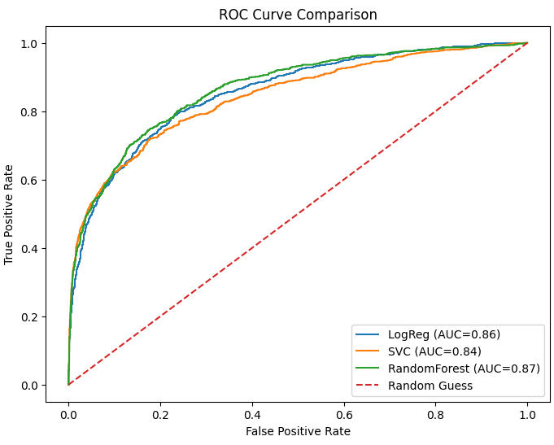
Fig 3: ROC-AUC

Model | Paper Result |  |  |  | Implemented Result
 | Accuracy | Precision | Recall | F1-Score | Accuracy | Precision | Recall | F1-Score
LR | 0.71 | 0.62 | 0.64 | 0.62 | 0.81 | 0.59 | 0.71 | 0.64
SVC | 0.71 | 0.61 | 0.63 | 0.61 | 0.85 | 0.84 | 0.46 | 0.60
RFC | 0.72 | 0.67 | 0.57 | 0.6 | 0.84 | 0.68 | 0.60 | 0.64
Table 1: Comparison between paper and implementation

- Learning Outcome:
Through this project, a practical understanding of nlp and text classification was developed. Highlights include text preprocessing, feature extraction using TF-IDF and model selection for respective tasks. The project also provided hands-on experience with evaluating machine learning models using different metrics, not just accuracy.
This project helped understanding of applying machine learning techniques to real-world social issues like sexism detection in text data.
- Paper Reference:
- Rodríguez-Sánchez, F., Carrillo-de-Albornoz, J. and Plaza, L., 2020. Automatic classification of sexism in social networks: An empirical study on twitter data. IEEE Access, 8, pp.219563-219576.
- Screenshot of Similarity & AI Generated report:

