URL for Project: <http://ec2-35-162-60-111.us-west-2.compute.amazonaws.com:5000/>

Following are some screenshot of my project.

1. Login page:

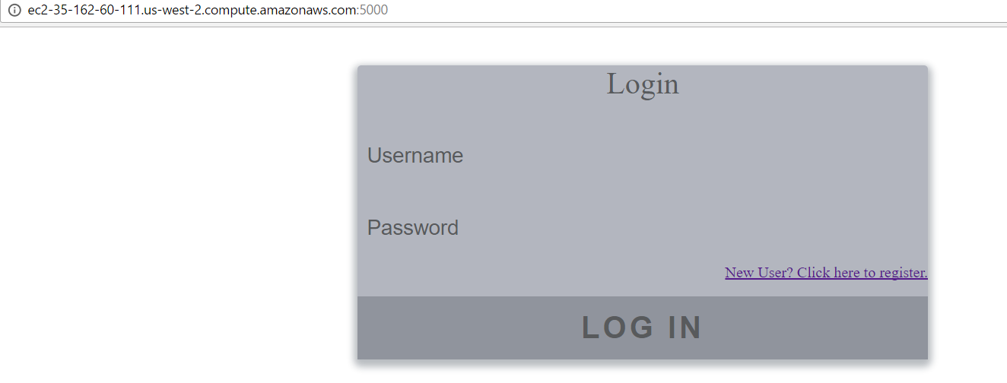

1. Sign Up page:

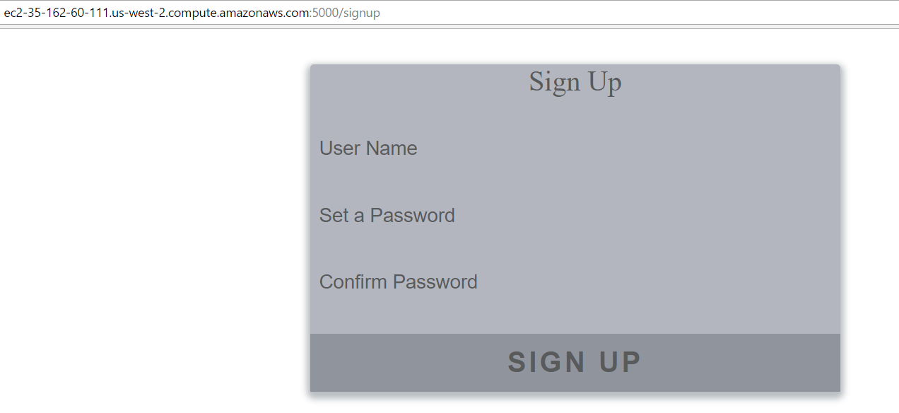

1. Error page if user name or password does not meet requirements:

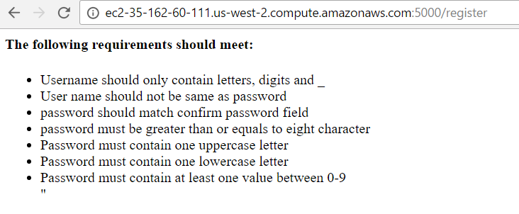

1. If user is already registered:

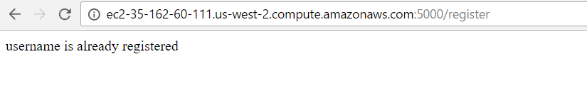

1. Home page:

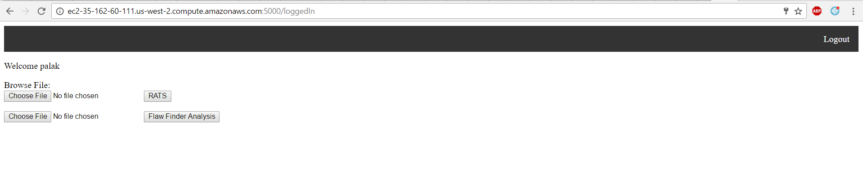

1. Rats Analysis:

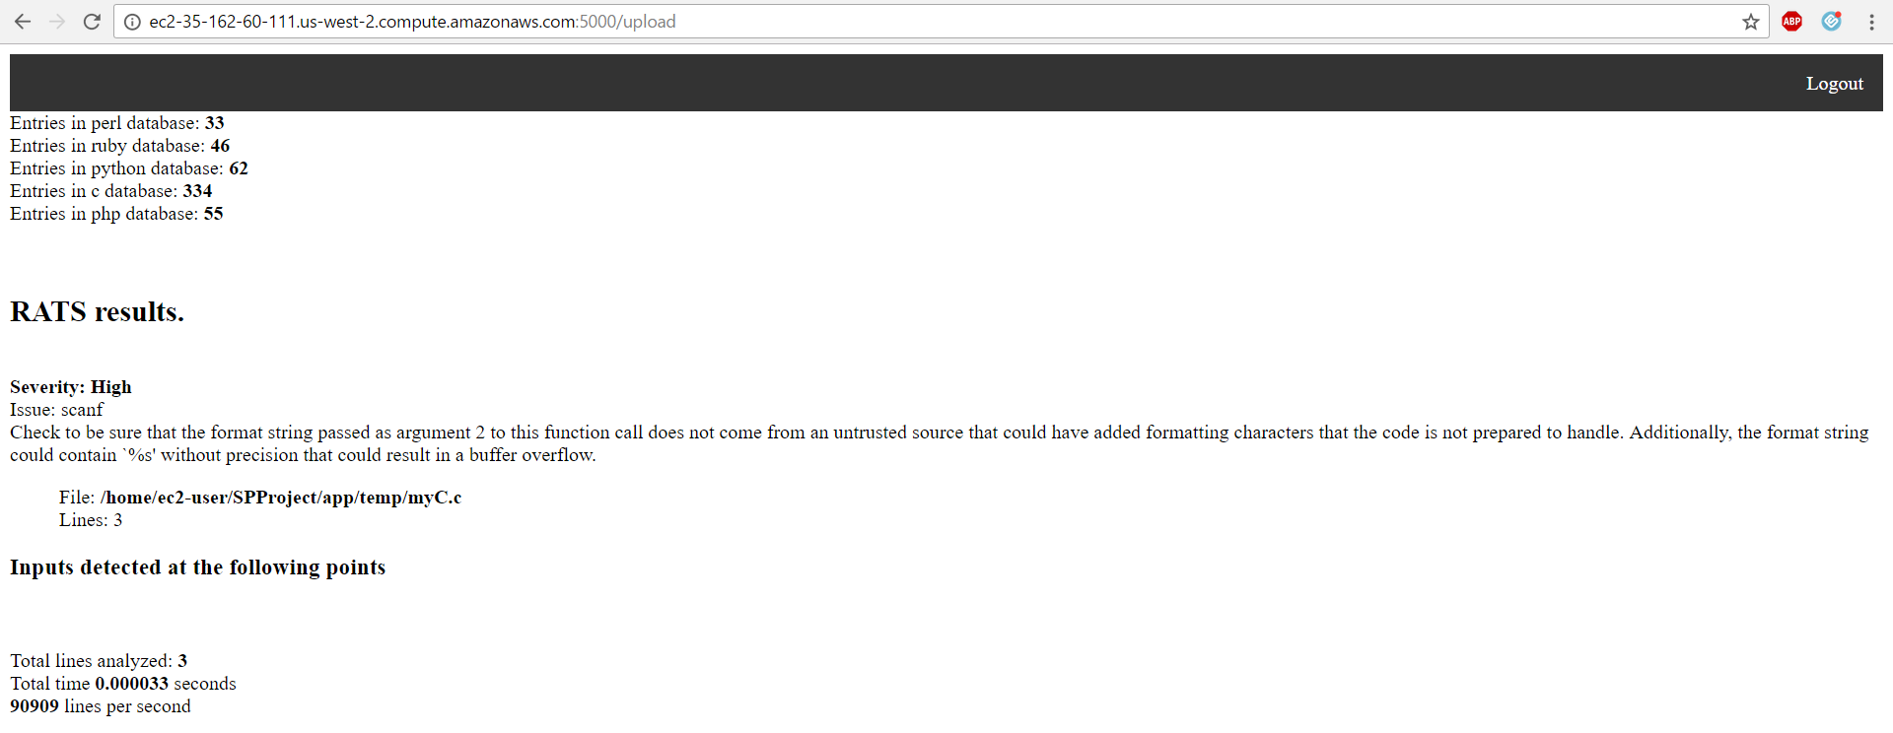

1. Flaw Finder Analysis:

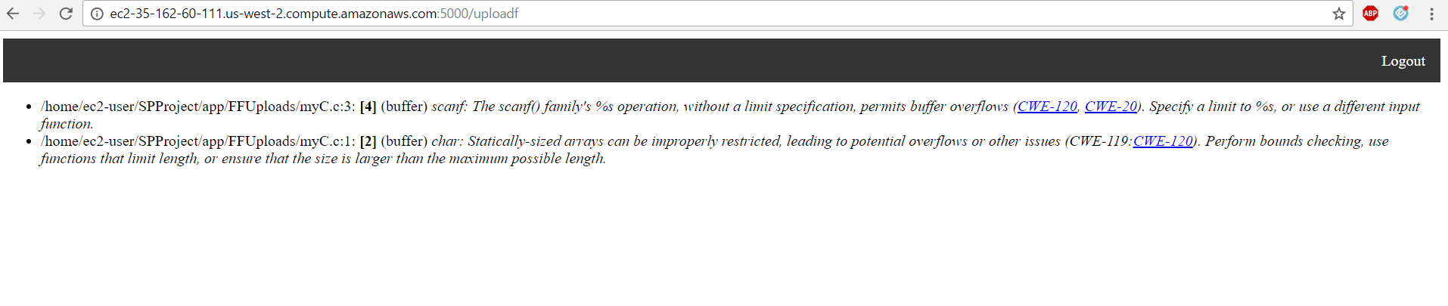

1. Functionality of Logout:



1. If it does not found valid extension of file:



Other than this, I have implemented session management so that only valid user can access to their own file and attackers cannot enter to any page by entering direct URL.