BIG_DATA_LAB 26-04-2022
1nt19is117 PRATHEEK P NAYAK

> db.pratheek.find().pretty()
{
"_id" : ObjectId("624bb94df18c2d2b4fde2979"),
"name" : "Sai",
"dept" : "ISE",
"college" : "NMIT",
"marks" : 100
}
{
"_id" : ObjectId("624bc0a6f18c2d2b4fde297c"),
"name" : "Pratheek",
"dept" : "ISE",
"marks" : 80
}
{
"_id" : ObjectId("624bc0a6f18c2d2b4fde297d"),
"name" : "Shriman",
"dept" : "ISE",
"marks" : 100
}
{
"_id" : ObjectId("624bc0a6f18c2d2b4fde297e"),
"name" : "Praneeth",
"dept" : "ISE",
"marks" : 80
}
>
AGGREGATE FUNCTIONS:
COUNT:

> db.pratheek.aggregate([{$match : {"dept" : "ISE"}}, {$count : "Total STUDENTS in ISE"}])



Now one student is updated to CSE dept


> db.pratheek.aggregate([{$match : {"dept" : "CSE"}}, {$count : "Total STUDENTS in ISE"}])

Total student in cse is 1

MAXIMUM MARKS:

> db.pratheek.aggregate(
... [{$group : {_id : "$dept", max_marks: {$max: "$marks"}}}]
... )

maximum marks in each department is printed

MINIMUM MARKS:

> db.pratheek.aggregate( [{$group : {_id : "$dept", max_marks: {$min: "$marks"}}}] )


Marks greater than 50:

> db.pratheek.aggregate([{$match : {marks: {$gt : 50}}}]).pretty()

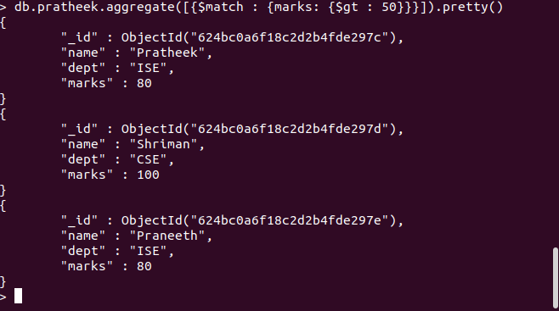

marks 50 is not printed

Marks less than 70:

> db.pratheek.aggregate([{$match : {marks: {$lt : 70}}}]).pretty()

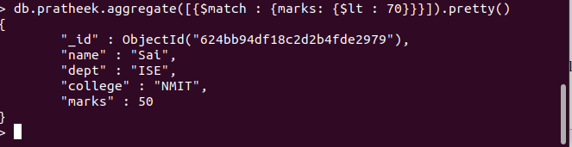
Student with 50 marks is printed

SORTING:

> db.pratheek.aggregate([{"$sort" : {"marks" : 1}}]).pretty()

here marks : 1 is given to sort in ascending order

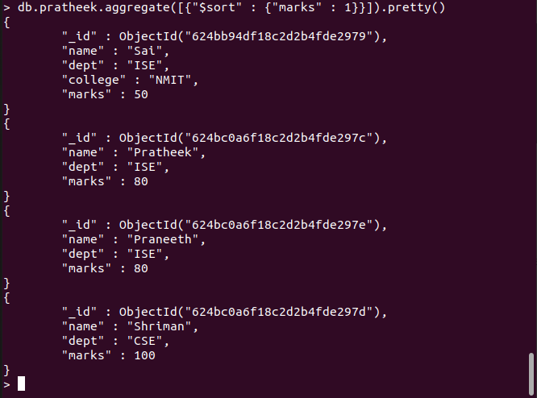

Sorting in DECENDING ORDER:

> db.pratheek.aggregate([{"$sort" : {"marks" : -1}}]).pretty()

-1 is given for decending order:
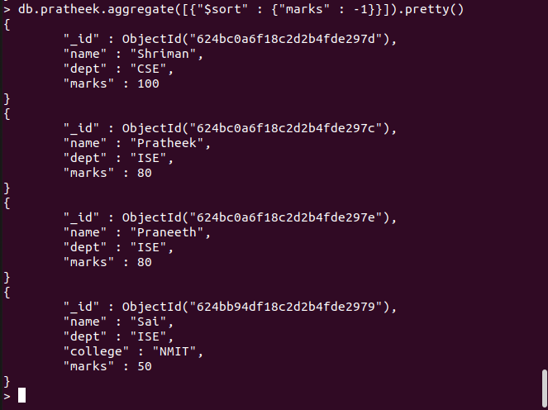

Sum of all marks:

> db.pratheek.aggregate([{$group : {_id: null, total : { $sum : "$marks"}}}]).pretty();

AVG of all marks:
> db.pratheek.aggregate([{$group : {_id: null, total : { $avg : "$marks"}}}]).pretty();

