BIG_DATA_LAB 24-05-2022

1. Create a directory by your name

hadoop fs -mkdir pratheek

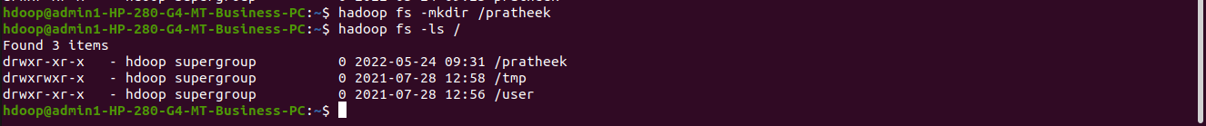

2. Add two empty files into it

file 1:

hadoop fs -touchz /pratheek/file1.txt
file 2:

hadoop fs -touchz /pratheek/file2.txt

3. List all the files in the directory you have created:

4. Create one more directory by your usn inside the directory of your name

hadoop fs -mkdir /pratheek/1nt19is117

5. Create a file in your local system by the name_usn.txt and add the contents as
"Syntax to list Is command is hadoop fs -ls”

cat > pratheek_1nt19is117.txt
Syntax to list Is command is hadoop fs -ls
^Z
[4]+ Stopped cat > pratheek_1nt19is117.txt

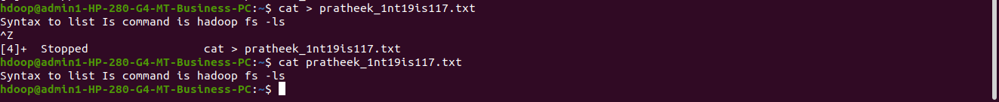

Put empty file of hdfs into the local file system

hadoop fs -copyToLocal /pratheek/file1.txt
hadoop fs -copyToLocal /pratheek/file2.txt
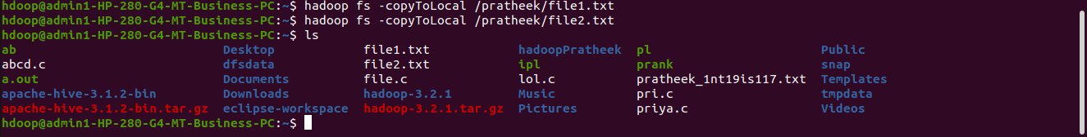

Put the file usn_name.txt in your hdfs directory called usn

hadoop fs -moveFromLocal 1.txt /pratheek/1nt19is117

pratheek_1nt19is117.txt file is in the hadoop directory

Experiment of cp command

hadoop fs -cp /pratheek/file1.txt /pratheek/1nt19is117

file1.txt is copied from /pratheek to pratheek1nt19is117

hadoop fs -ls /pratheek/1nt19is117

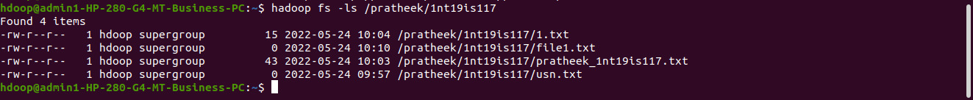

mv command to move files within hdfs:

hadoop fs -mv /pratheek/file2.txt /pratheek/1nt19is117

now file2 is not in pratheek but in pratheek/1nt19is117

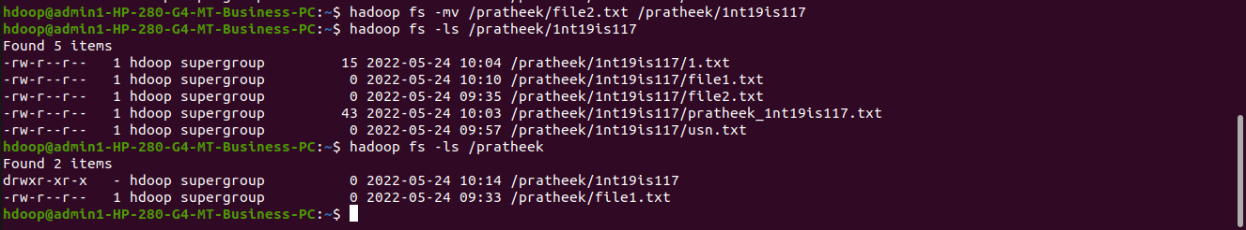
to find the size of files in directory:

hadoop fs -du /pratheek

hadoop fs -du /pratheek/1nt19is117

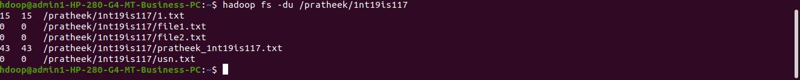
stat command to check modified time of directories

hadoop fs -stat /pratheek

hadoop fs -stat /pratheek/1nt19is117

appendToFile command:

local file
cat > file.txt
hello there

append to file /pratheek/1nt19is117/usn.txt
hadoop fs -appendToFile file1.txt /pratheek/1nt19is117/usn.txt
hadoop fs -cat /pratheek/1nt19is117/usn.txt

file1.txt appended to /pratheek/1nt19is117/usn.txt

