BIG_DATA_LAB 05-04-2022

$ mongo

> use pratheek
switched to db pratheek
> db
pratheek

Insert One:
> db.pratheek.insertOne({"name" : "Pratheek", "dept" : "ISE"})

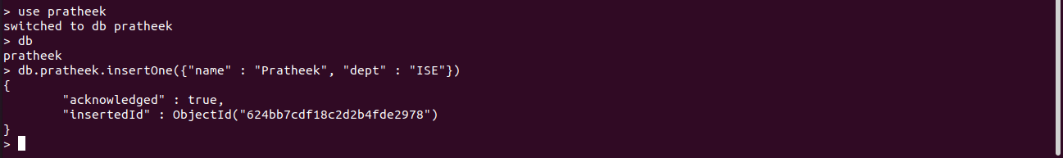
> db.pratheek.count()
1

Insert Many:

> db.pratheek.insertMany(
... [
... {"name" : "Sohan", "dept" : "ISE"},
... {"name" : "Shriman", "dept" : "ISE"},
... {"name" : "Praneeth", "dept" : "ISE"},
... ]
... )

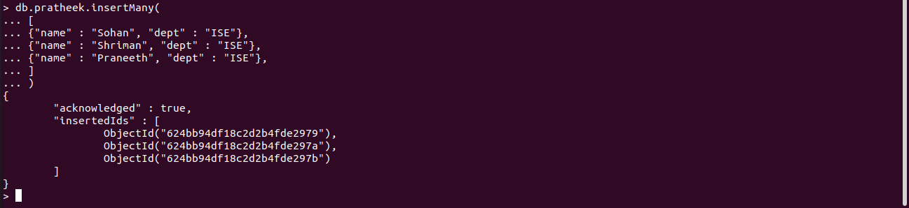

> db.pratheek.count()
4

Reading:

> db.pratheek.find()
{ "_id" : ObjectId("624bb7cdf18c2d2b4fde2978"), "name" : "Pratheek", "dept" : "ISE" }
{ "_id" : ObjectId("624bb94df18c2d2b4fde2979"), "name" : "Sohan", "dept" : "ISE" }
{ "_id" : ObjectId("624bb94df18c2d2b4fde297a"), "name" : "Shriman", "dept" : "ISE" }
{ "_id" : ObjectId("624bb94df18c2d2b4fde297b"), "name" : "Praneeth", "dept" : "ISE" }
>
find().pretty():

> db.pratheek.find().pretty()

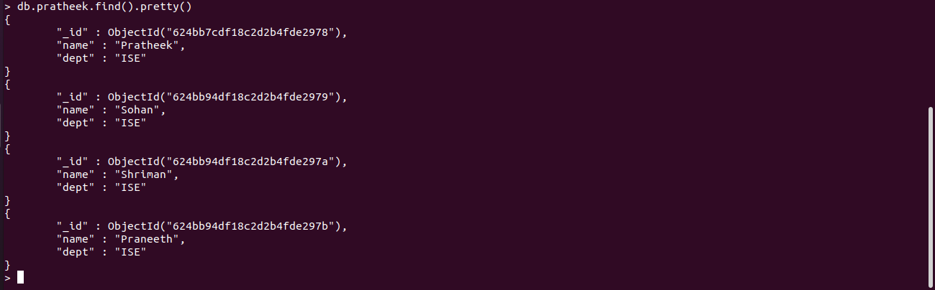

Update many():

> db.pratheek.updateMany(
... {},
... {
... $set : {"college" : "NMIT"}
... }
... )
{ "acknowledged" : true, "matchedCount" : 4, "modifiedCount" : 4 }

> db.pratheek.find().pretty()
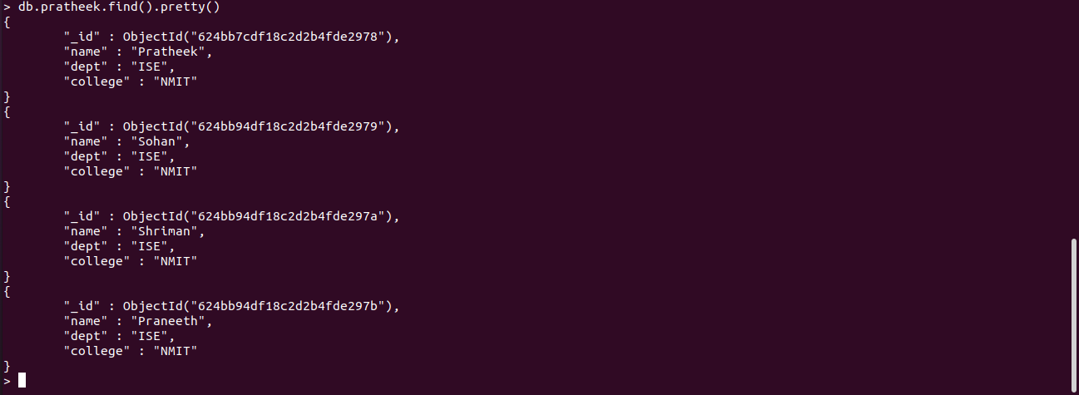

UpdateOne():

> db.pratheek.updateOne(
... {"name" : "Sohan"},
... {
... $set : {"dept" : "ECE"}
... }
... )
{ "acknowledged" : true, "matchedCount" : 1, "modifiedCount" : 1 }

Sohan’s department changed to ECE

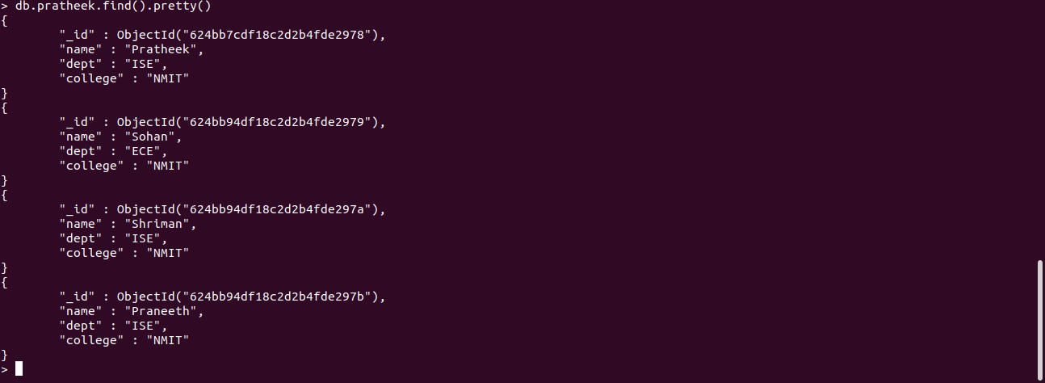

deleteOne():
> db.pratheek.deleteOne({"name" : "Praneeth"})

Praneeth got deleted

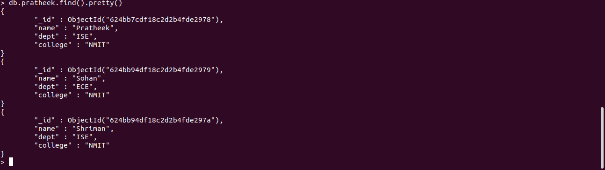

deleteMany():

> db.pratheek.deleteMany({"dept" : "ISE"})

Details with dept will all be deleted
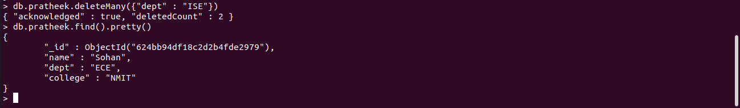

Replaceing the document:

replaceOne():

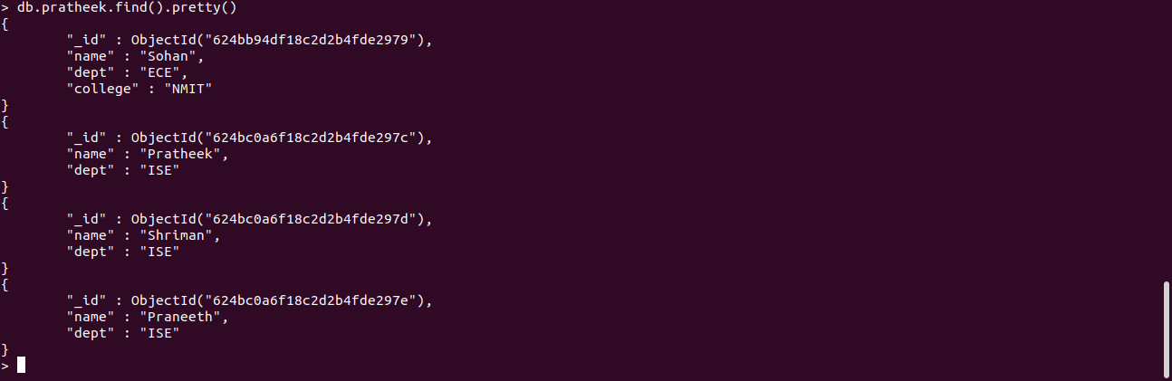

db.pratheek.replaceOne(
... {"name" : "Sohan"}, {"name" : "Sai", "dept" : "ISE", "college" : "NMIT"})
{ "acknowledged" : true, "matchedCount" : 1, "modifiedCount" : 1 }

Sohan is replaced with sai

