BIG_DATA_LAB 12-04-2022

Update with unset:

> db.pratheek.update(
... {"name" : "Shriman"},
... {
... $unset : {"dept" : ""}
... }
... )
Shriman’s department field is gone.

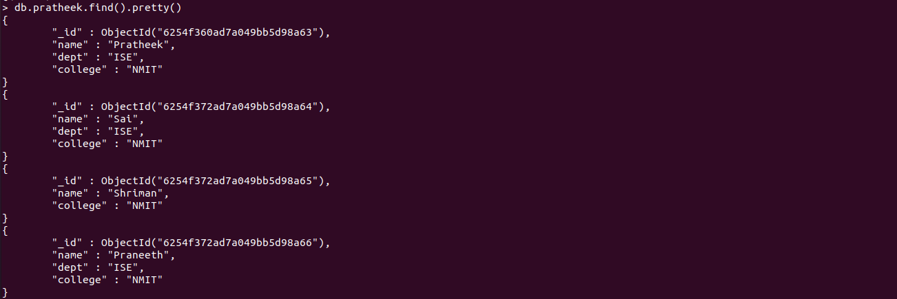

Update with set:

> db.pratheek.updateOne(
... {"name" : "Shriman"},
... {
... $set : {"dept" : "ISE"},
... }
... )
{ "acknowledged" : true, "matchedCount" : 1, "modifiedCount" : 1 }

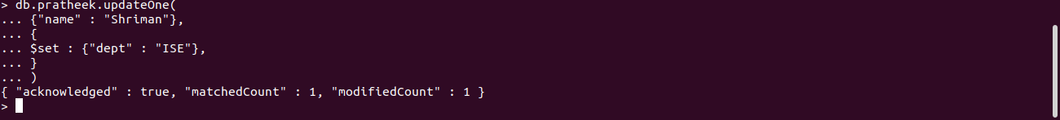
> db.pratheek.find().pretty()
{
"_id" : ObjectId("6254f360ad7a049bb5d98a63"),
"name" : "Pratheek",
"dept" : "ISE",
"college" : "NMIT"
}
{
"_id" : ObjectId("6254f372ad7a049bb5d98a64"),
"name" : "Sai",
"dept" : "ISE",
"college" : "NMIT"
}
{
"_id" : ObjectId("6254f372ad7a049bb5d98a65"),
"name" : "Shriman",
"college" : "NMIT",
"dept" : "ISE"
}
{
"_id" : ObjectId("6254f372ad7a049bb5d98a66"),
"name" : "Praneeth",
"dept" : "ISE",
"college" : "NMIT"
}
>


OR operation in find():

> db.pratheek.find({$or : [{"dept": "ISE"}, {"dept" : "CSE"}]}).pretty()

{
"_id" : ObjectId("6254f360ad7a049bb5d98a63"),
"name" : "Pratheek",
"dept" : "ISE",
"college" : "NMIT"
}
{
"_id" : ObjectId("6254f372ad7a049bb5d98a64"),
"name" : "Sai",
"dept" : "ISE",
"college" : "NMIT"
}
{
"_id" : ObjectId("6254f372ad7a049bb5d98a65"),
"name" : "Shriman",
"college" : "NMIT",
"dept" : "ISE"
}
{
"_id" : ObjectId("6254f372ad7a049bb5d98a66"),
"name" : "Praneeth",
"dept" : "ISE",
"college" : "NMIT"
}
{
"_id" : ObjectId("6254facaad7a049bb5d98a67"),
"name" : "Vinayak",
"dept" : "CSE",
"college" : "NMAMIT"
}

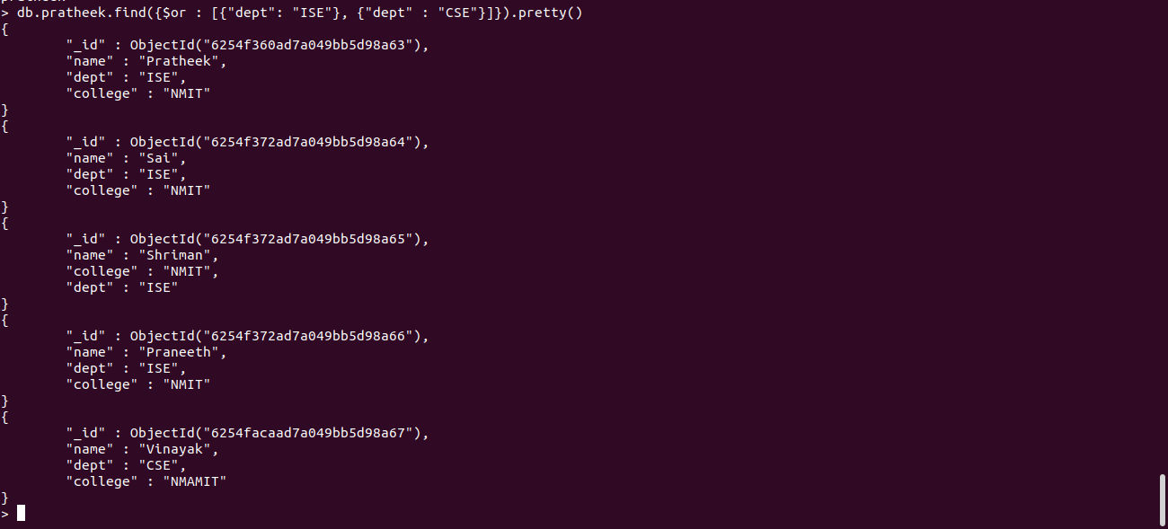

AND OPERATION:

> db.pratheek.find({$and : [{"dept": "ISE"}, {"college" : "NMAMIT"}]}).pretty()
for the above code empty set will come

> db.pratheek.find({$and : [{"dept": "ISE"}, {"college" : "NMIT"}]}).pretty()

for this output will be obtained

{
"_id" : ObjectId("6254f360ad7a049bb5d98a63"),
"name" : "Pratheek",
"dept" : "ISE",
"college" : "NMIT"
}
{
"_id" : ObjectId("6254f372ad7a049bb5d98a64"),
"name" : "Sai",
"dept" : "ISE",
"college" : "NMIT"
}
{
"_id" : ObjectId("6254f372ad7a049bb5d98a65"),
"name" : "Shriman",
"college" : "NMIT",
"dept" : "ISE"
}
{
"_id" : ObjectId("6254f372ad7a049bb5d98a66"),
"name" : "Praneeth",
"dept" : "ISE",
"college" : "NMIT"
}

