- Problem Statement : Matrix Multiplication program using MapReduce

Step1:goto Search button run cmd prompt as administrator
Step2: Initiate all required component of hadoop by command
start-all.cmd
Step3: Create a weather.csv file where we have folder running hadoop java program in my case I have created in Desktop folder D:\hadoopprograms\weatherinput
U can create anywhere as u wish with weather and content looks as in below
06-07-2025 | 35 | 22 | 0
07-07-2025 | 18 | 10 | 12.5
08-07-2025 | 40 | 28 | 0
09-07-2025 | 25 | 15 | 0

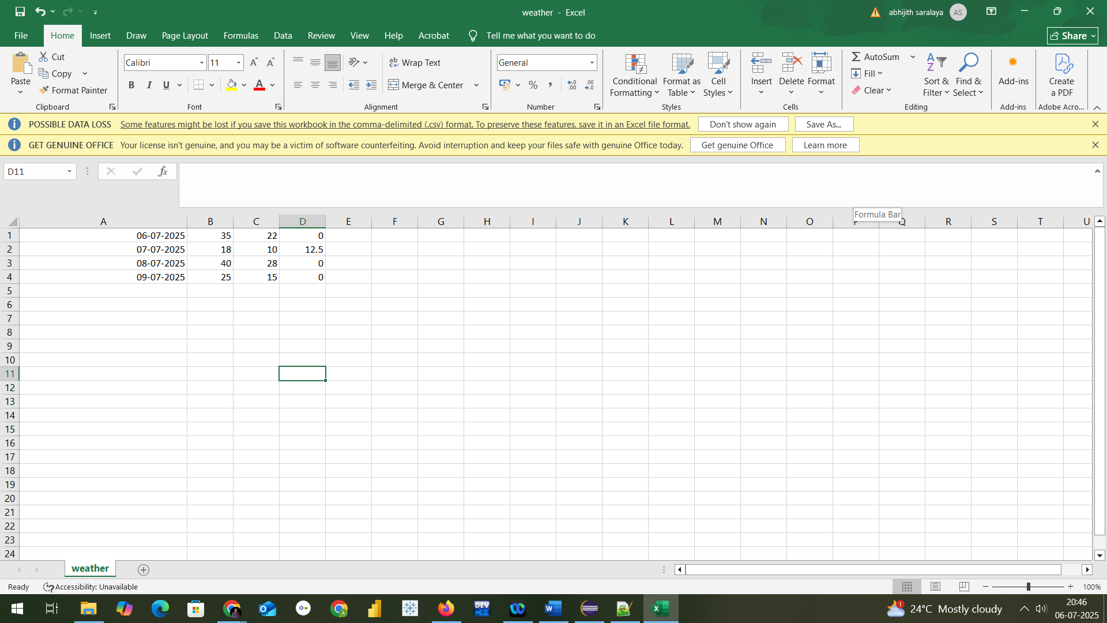

Step3: Now we need a jar file to execute mapreduce program fr wordcount
So open Eclipse
Create a java project with name MapReduceWeather
Select execution environment as JavaSE-1.8
And click on next&finish

Step4: Right Click on Projectname--- Click on New---create a package with name com.mapreduce.mm and click on Finish
Step5: Add required libraries to support hadoop by navigating as in below
Right Click on Project-------Right Click on BuildPath------- Configure Buildpath Then goto Libraries as in screen below
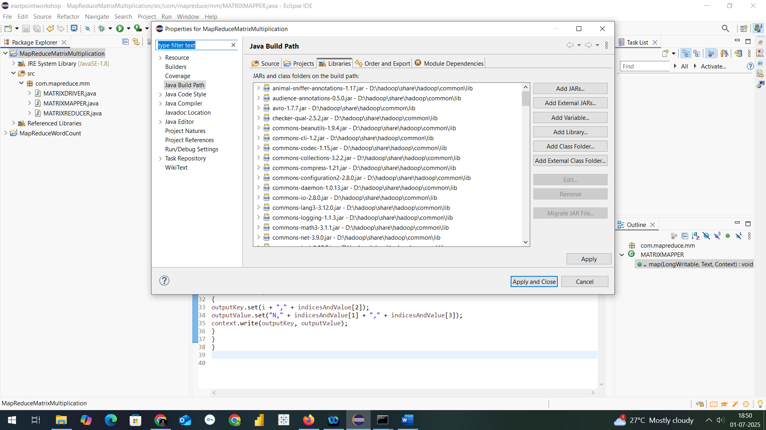

Step6: Add necessary External jar file from D:\hadoop\share\hadoop
Like clients,common,hdfs,mapreduce & yarn to support packages for hadoop
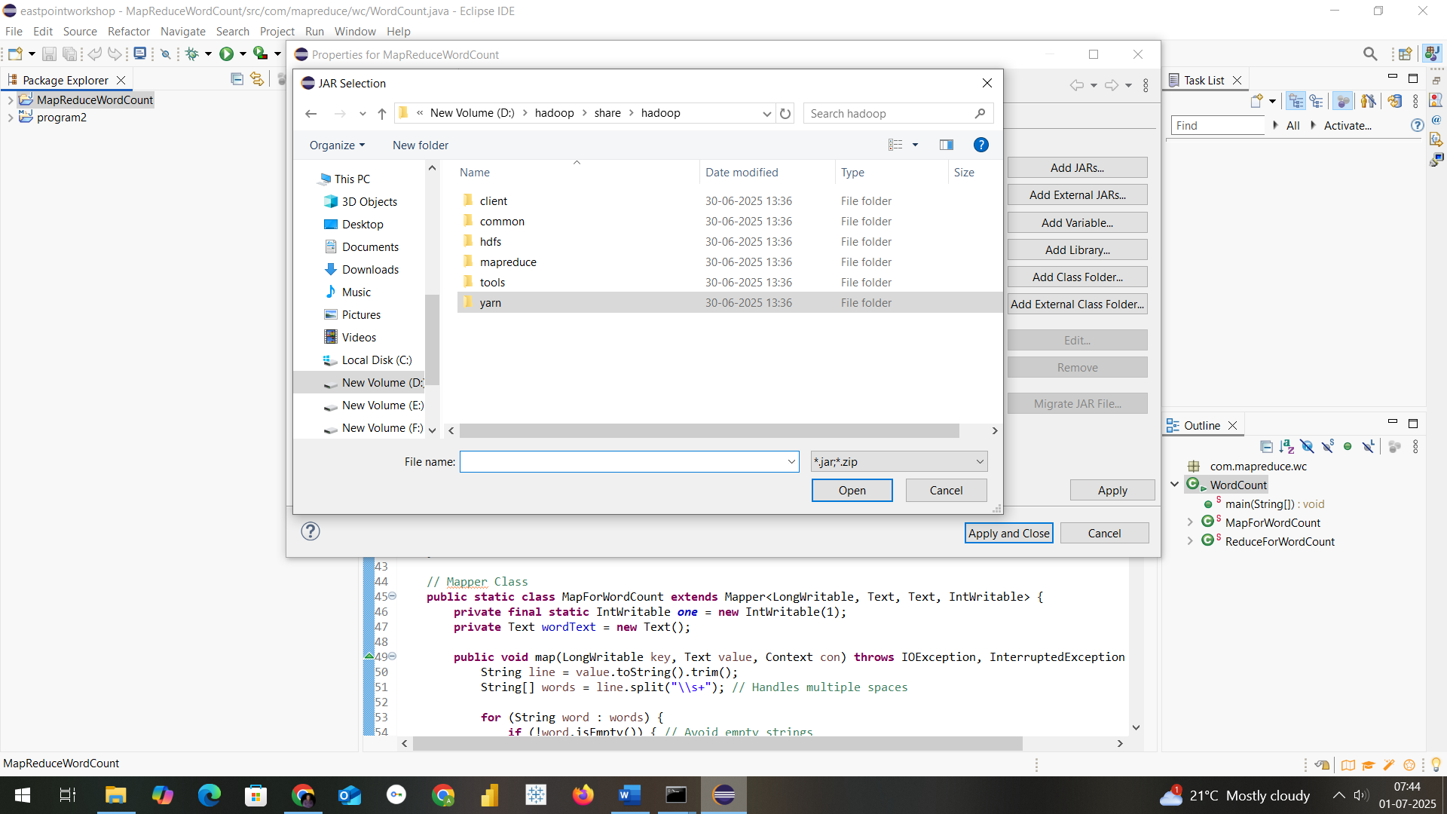

Step7: Create a class within package com.mapreduce.we with name WeatherAnalysis and paste this code
package com.mapreduce.we
import java.io.IOException;
import org.apache.hadoop.conf.Configuration;
import org.apache.hadoop.fs.Path;
import org.apache.hadoop.io.*;
import org.apache.hadoop.mapreduce.Job;
import org.apache.hadoop.mapreduce.Mapper;
import org.apache.hadoop.mapreduce.Reducer;
import org.apache.hadoop.mapreduce.lib.input.FileInputFormat;
import org.apache.hadoop.mapreduce.lib.output.FileOutputFormat;

public class WeatherAnalysis {

public static class WeatherMapper extends Mapper<LongWritable, Text, Text, Text> {
public void map(LongWritable key, Text value, Context context)
throws IOException, InterruptedException {

String line = value.toString();
String[] fields = line.split(",");

if (fields.length == 4) {
String date = fields[0];
try {
float tmax = Float.parseFloat(fields[1]);
float tmin = Float.parseFloat(fields[2]);
float prcp = Float.parseFloat(fields[3]);

String message = "";

if (tmax > 35) {
message += "Hot day ";
}
if (tmin < 15) {
message += "Cold day ";
}
if (prcp > 10) {
message += "Rainy day ";
}

if (message.isEmpty()) {
message = "Normal weather";
}

context.write(new Text(date), new Text(message.trim()));
} catch (NumberFormatException e) {
// Ignore malformed rows
}
}
}
}

public static class WeatherReducer extends Reducer<Text, Text, Text, Text> {
public void reduce(Text key, Iterable<Text> values, Context context)
throws IOException, InterruptedException {
for (Text val : values) {
context.write(key, val); // One value per date
}
}
}

public static void main(String[] args) throws Exception {
Configuration conf = new Configuration();
conf.set("mapreduce.framework.name", "local");
conf.set("fs.defaultFS", "file:///");
conf.set("n", "3");

Job job = Job.getInstance(conf, "Weather Analysis");

job.setJarByClass(WeatherAnalysis.class);
job.setMapperClass(WeatherMapper.class);
job.setReducerClass(WeatherReducer.class);

job.setOutputKeyClass(Text.class);
job.setOutputValueClass(Text.class);

FileInputFormat.addInputPath(job, new Path(args[0])); // Input file path
FileOutputFormat.setOutputPath(job, new Path(args[1])); // Output directory path

System.exit(job.waitForCompletion(true) ? 0 : 1);
}
}

Step8: Procedure to create jar file from eclipse project
Now Right click on Project and click on export and select jar as in screen
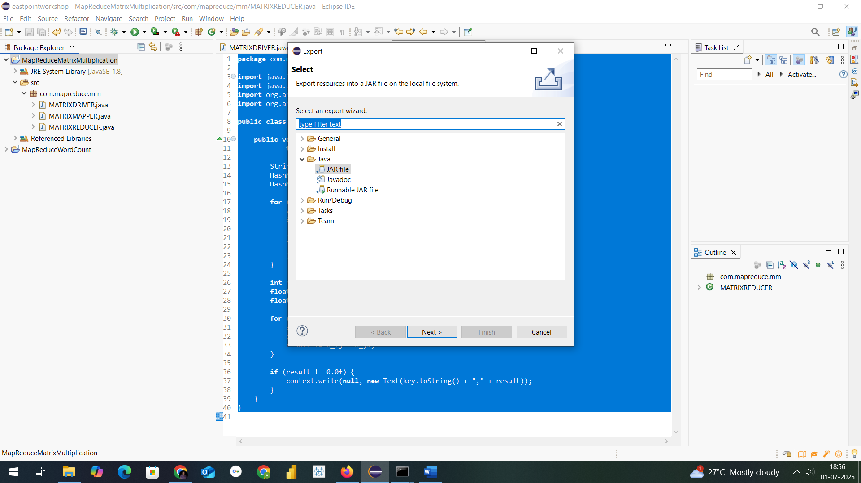
Mention the path where u want to save jar with name of Jar File in my case I have saved in D:\hadoopprograms as Weather.jar

Final step: Run the jar file with command as in below
hadoop jar D:\hadoopprograms\Weather.jar com.mapreduce.we.WeatherAnalysis D:\hadoopprograms\weatherinput\weather.csv D:\hadoopprograms\weatheroutput

After execution in command the output looks as in below screens
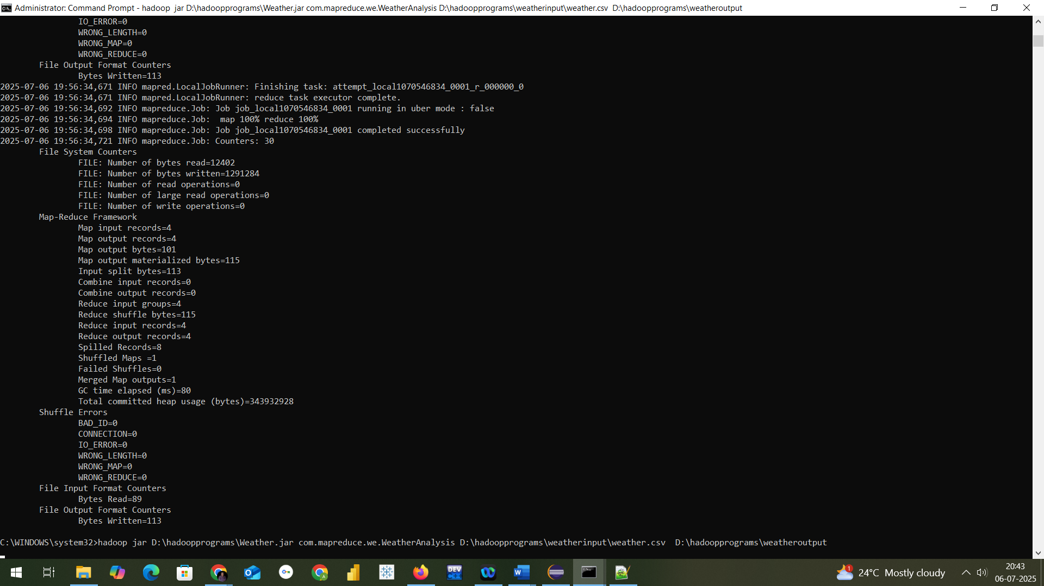

THE OUTFORMAT WILL BE CREATED THIS TIME IN LOCALFOLDER WHERE MENTIONED
---- D:\hadoopprograms\weatheroutput
In part-r-00000 text file

NOW TO CHECK THE RESULT OF A PROGRAM
Thank You
