- Problem Statement : Matrix Multiplication program using MapReduce

Step1:goto Search button run cmd prompt as administrator
Step2: Initiate all required component of hadoop by command
start-all.cmd
Step3: Create a text file where we have folder running hadoop java program in my case I have created in Desktop folder D:\hadoopprograms\matrixm
U can create anywhere as u wish with m.txt and content looks as in below
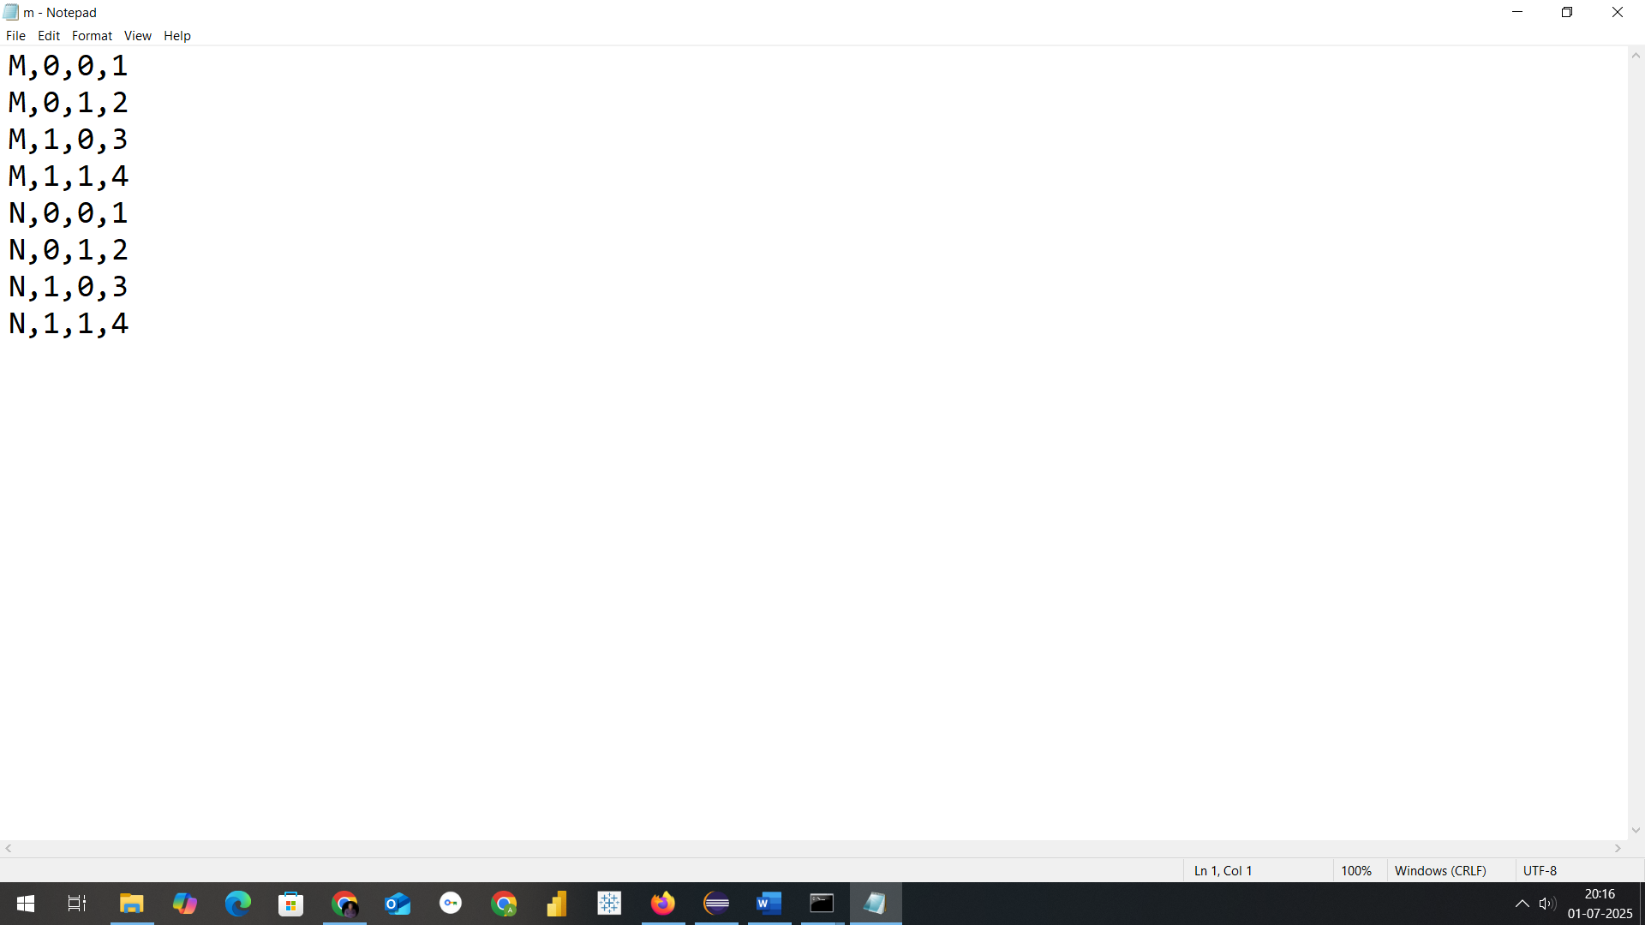

Step3: Now we need a jar file to execute mapreduce program fr wordcount
So open Eclipse
Create a java project with name MapReduceMatrixMultiplication
Select execution environment as JavaSE-1.8
And click on next&finish

Step4: Right Click on Projectname---🡪 Click on New---🡪create a package with name com.mapreduce.mm and click on Finish
Step5: Add required libraries to support hadoop by navigating as in below
Right Click on Project-------🡪Right Click on BuildPath-------🡪 Configure Buildpath Then goto Libraries as in screen below
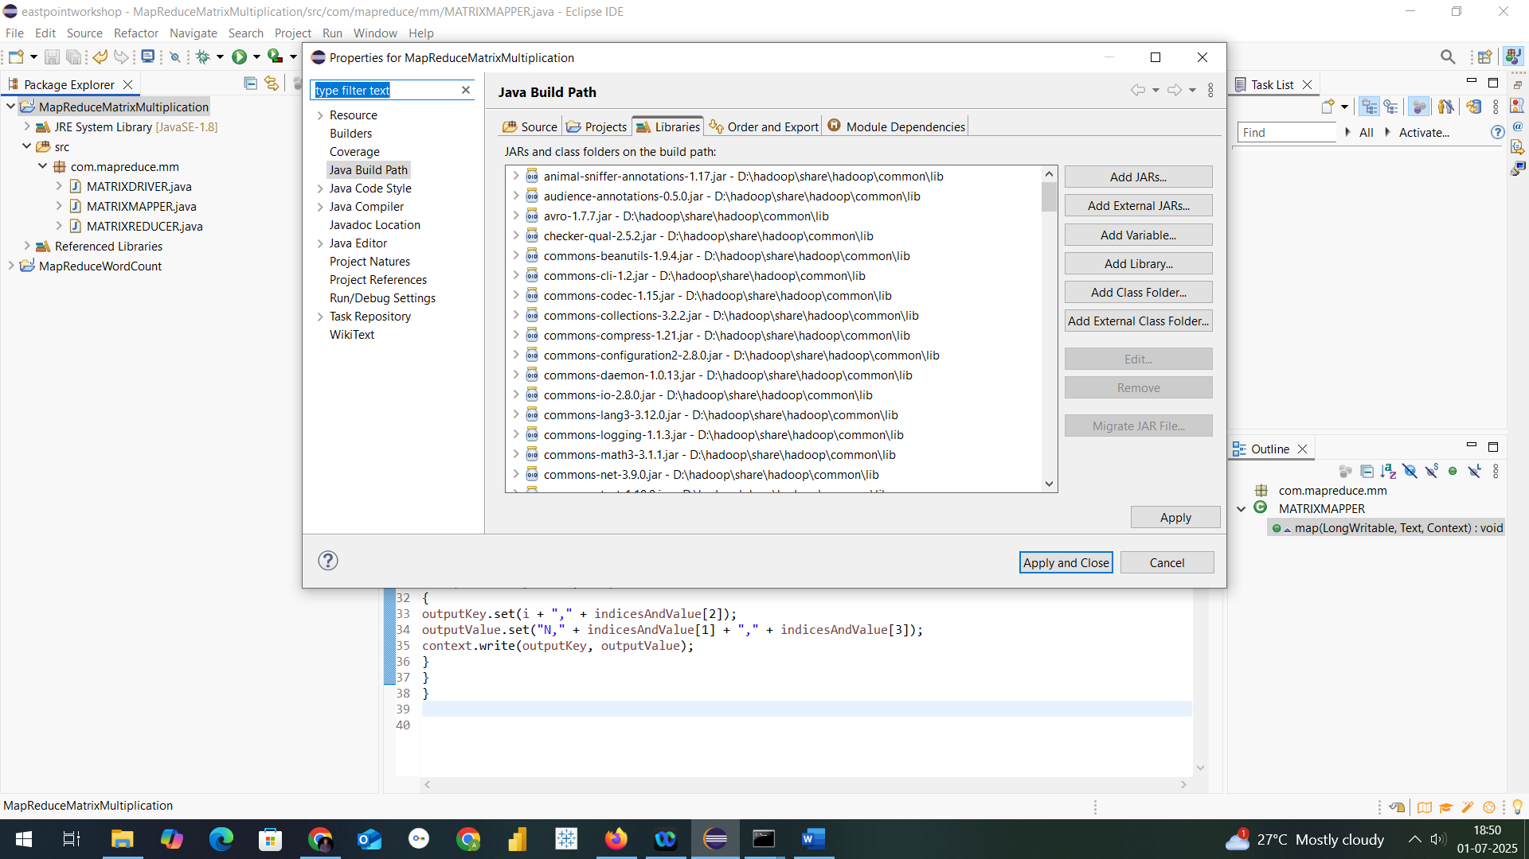

Step6: Add necessary External jar file from D:\hadoop\share\hadoop
Like clients,common,hdfs,mapreduce & yarn to support packages for hadoop
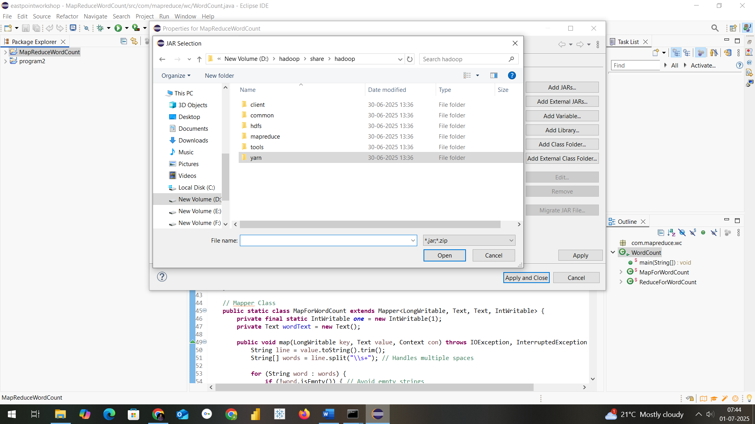

Step7: Create a class within package com.mapreduce.mm with name MatrixMultiplication and paste this code
package com.mapreduce.mm;
import java.io.IOException;
import java.util.HashMap;

import org.apache.hadoop.conf.Configuration;
import org.apache.hadoop.fs.Path;
import org.apache.hadoop.io.Text;
import org.apache.hadoop.mapreduce.*;
import org.apache.hadoop.mapreduce.lib.input.FileInputFormat;
import org.apache.hadoop.mapreduce.lib.output.FileOutputFormat;

public class MatrixMultiplication {

// Mapper Class
public static class MatrixMapper extends Mapper<Object, Text, Text, Text> {
public void map(Object key, Text value, Context context)
throws IOException, InterruptedException {

String[] tokens = value.toString().split(",");
String matrixName = tokens[0]; // M or N

int i = Integer.parseInt(tokens[1]);
int j = Integer.parseInt(tokens[2]);
float val = Float.parseFloat(tokens[3]);

Configuration conf = context.getConfiguration();
int n = Integer.parseInt(conf.get("n")); // Matrix dimension

if (matrixName.equals("M")) {
// Emit for each column in N
for (int k = 0; k < n; k++) {
context.write(new Text(i + "," + k), new Text("M," + j + "," + val));
}
} else {
// Emit for each row in M
for (int k = 0; k < n; k++) {
context.write(new Text(k + "," + j), new Text("N," + i + "," + val));
}
}
}
}

// Reducer Class
public static class MatrixReducer extends Reducer<Text, Text, Text, Text> {
public void reduce(Text key, Iterable<Text> values, Context context)
throws IOException, InterruptedException {

HashMap<Integer, Float> hashA = new HashMap<>();
HashMap<Integer, Float> hashB = new HashMap<>();

for (Text val : values) {
String[] parts = val.toString().split(",");
String matrix = parts[0];
int index = Integer.parseInt(parts[1]);
float value = Float.parseFloat(parts[2]);

if (matrix.equals("M")) {
hashA.put(index, value);
} else {
hashB.put(index, value);
}
}

Configuration conf = context.getConfiguration();
int n = Integer.parseInt(conf.get("n"));
float result = 0.0f;

for (int k = 0; k < n; k++) {
float a = hashA.getOrDefault(k, 0.0f);
float b = hashB.getOrDefault(k, 0.0f);
result += a * b;
}

if (result != 0.0f) {
context.write(key, new Text(String.valueOf(result)));
}
}
}

// Driver (Main Method)
public static void main(String[] args) throws Exception {
Configuration conf = new Configuration();

// Set matrix dimension n (number of columns in M or rows in N)
conf.set("mapreduce.framework.name", "local");
conf.set("fs.defaultFS", "file:///");

conf.set("n", "3");

Job job = Job.getInstance(conf, "Matrix Multiplication");
job.setJarByClass(MatrixMultiplication.class);
job.setMapperClass(MatrixMapper.class);
job.setReducerClass(MatrixReducer.class);

job.setMapOutputKeyClass(Text.class);
job.setMapOutputValueClass(Text.class);
job.setOutputKeyClass(Text.class);
job.setOutputValueClass(Text.class);

FileInputFormat.setInputPaths(job, new Path(args[0]));
FileOutputFormat.setOutputPath(job, new Path(args[1]));

System.exit(job.waitForCompletion(true) ? 0 : 1);
}
}

Step8: Procedure to create jar file from eclipse project
Now Right click on Project and click on export and select jar as in screen
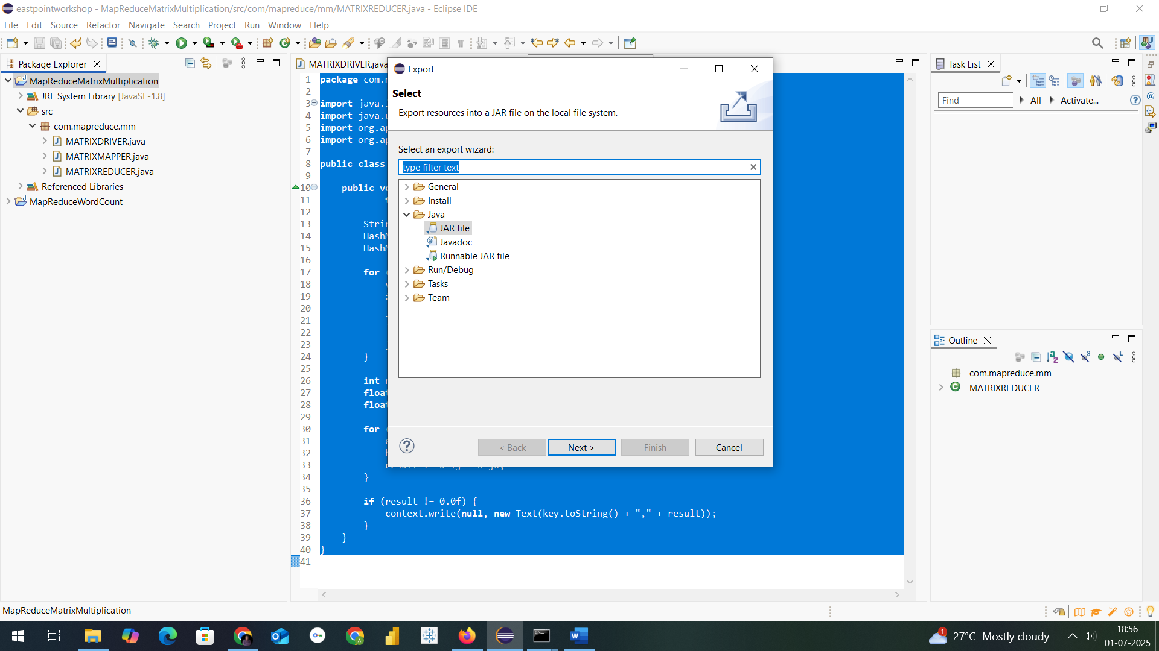
Mention the path where u want to save jar with name of Jar File in my case I have saved in D:\hadoopprograms as MatrixMultiplication

Final step: Run the jar file with command as in below
hadoop jar D:\hadoopprograms\MatrixMultiplication.jar com.mapreduce.mm.MatrixMultiplication D:/hadoopprograms/matrixm/m.txt D:/hadoopprograms/matrixm/matrixoutput1

After execution in command the output looks as in below screens
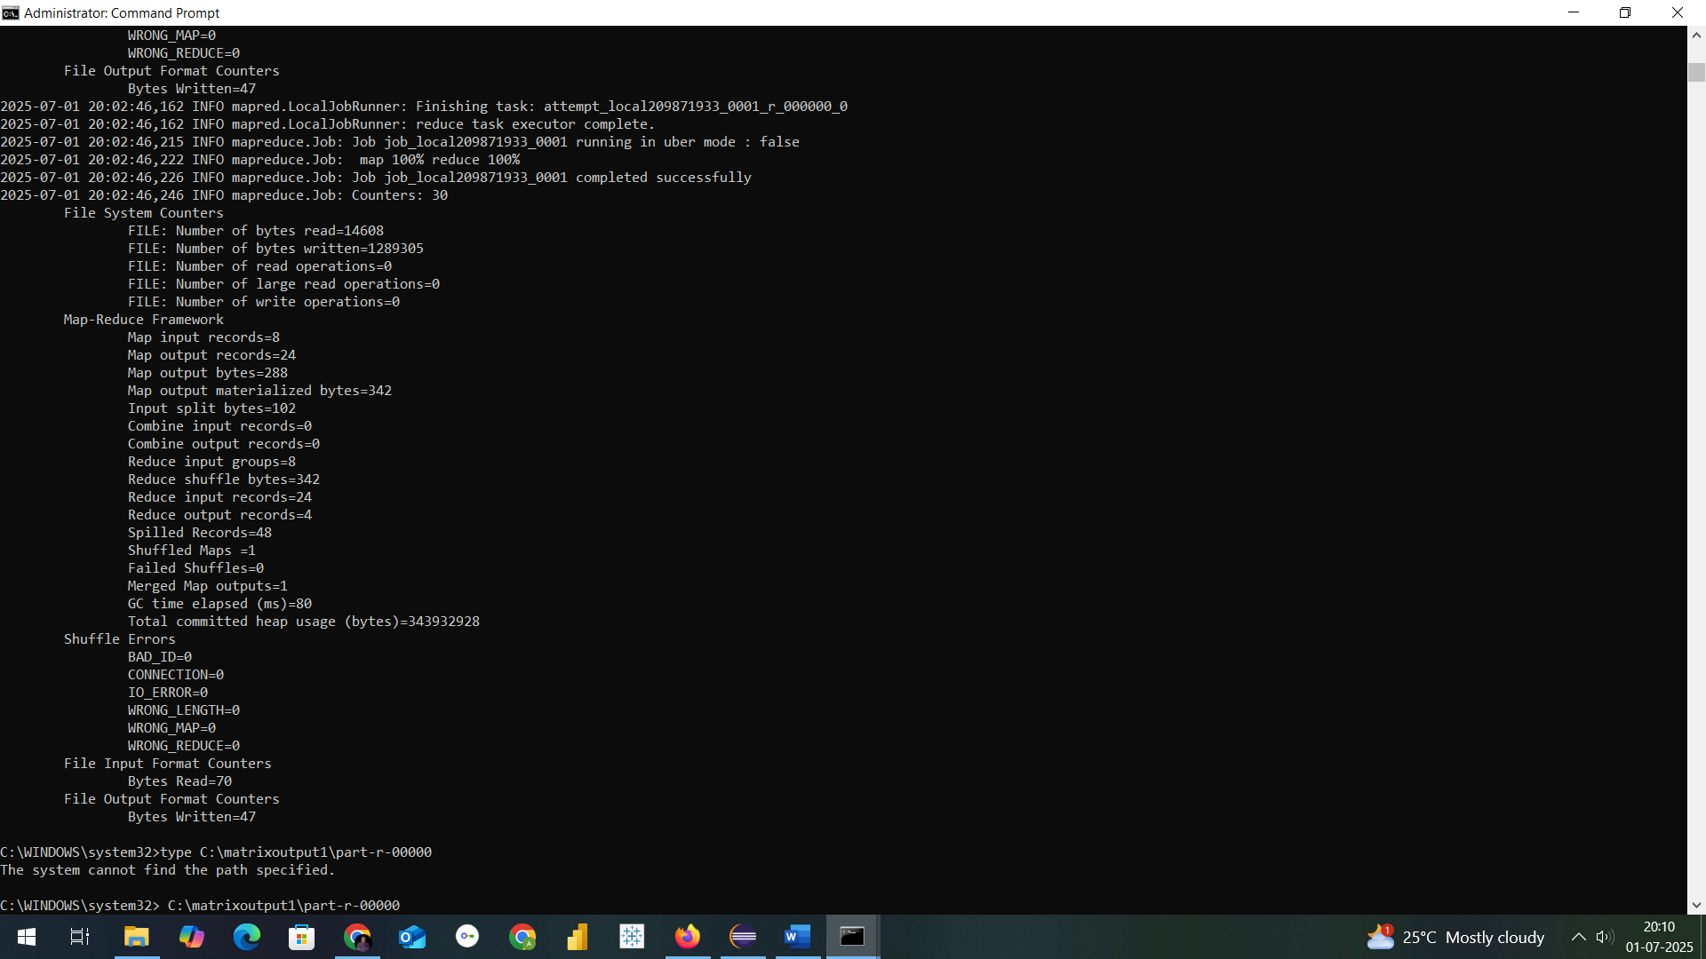

THE OUTFORMAT WILL BE CREATED THIS TIME IN LOCALFOLDER WHERE MENTIONED
----🡪 D:\hadoopprograms\matrixm\matrixoutput1
In part-r-00000 text file
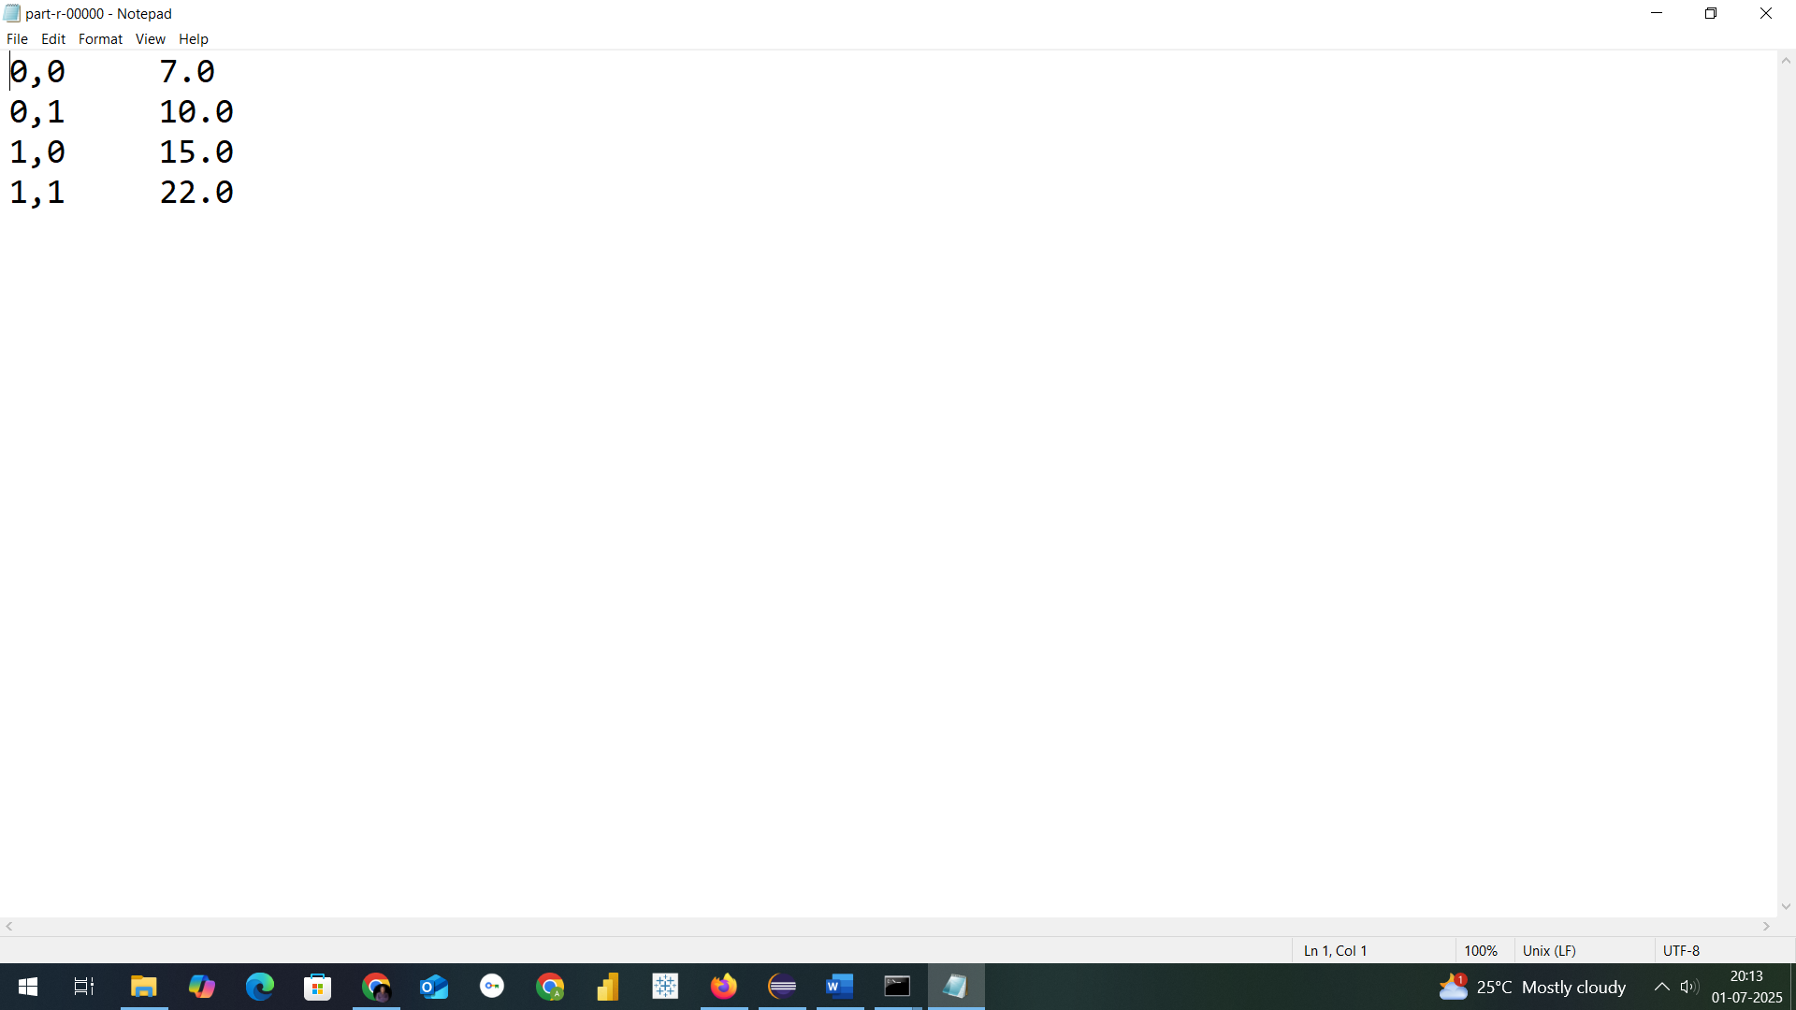

NOW TO CHECK THE RESULT OF A PROGRAM
Thank You

