Customer Churn Prediction
Using Machine Learning
Subham
Internship Project Report

Student Name | Subham

Table of Contents

Table of Contents 1
1. Abstract 2
2. Introduction 3
3. Problem Statement 3
4. Objectives 4
5. Dataset Description 4
5.1 Feature Descriptions 4
5.2 Class Distribution 5
6. Tools and Technologies 5
7. Data Quality Analysis 6
7.1 Dataset Shape 6
7.2 Duplicate Records 6
7.3 Missing Values 6
7.4 TotalCharges — Hidden Blank Strings 6
7.5 customerID Column 6
7.6 Class Distribution 6
8. Data Cleaning 6
9. Exploratory Data Analysis 7
9.1 Target Variable Distribution 8
9.2 Numerical Feature Distributions 8
9.3 Churn Rate by Contract Type 9
9.4 Churn Rate by Tenure 9
9.5 Churn Rate by Internet Service Type 10
9.6 Churn Rate by Add-On Services 10
9.7 Churn Rate by Payment Method 11
9.8 Correlation Analysis 11
10. Feature Engineering and Preprocessing 12
10.1 Target Encoding 12
10.2 Train / Test Split 12
10.3 Preprocessing Pipeline 12
10.4 Prevention of Data Leakage 13
11. Machine Learning Methodology 13
11.1 Logistic Regression 13
11.2 Decision Tree Classifier 13
11.3 Random Forest Classifier 13
11.4 Gradient Boosting Classifier 14
11.5 Why Multiple Models Were Compared 14
12. Model Evaluation 14
12.1 Metric Definitions 15
12.2 Results Table 15
12.3 Confusion Matrices 15
12.4 ROC Curves 16
12.5 Metric Comparison 16
12.6 Why Accuracy Is Misleading Here 17
13. Model Interpretation 17
13.1 Logistic Regression Coefficients 17
13.2 Random Forest Feature Importances 18
13.3 Gradient Boosting Feature Importances 18
13.4 Cross-Model Feature Agreement 19
14. Final Model Selection 19
14.1 Selection Criteria 19
14.2 Decision: Random Forest Selected 20
15. Final Prediction / Inference 20
16. Limitations 21
17. Future Scope 22
18. Conclusion 23
19. References 23

1. Abstract
Customer churn — the voluntary cancellation of a service subscription — represents a significant revenue risk in the telecommunications industry. This project develops a machine learning pipeline to predict whether a telecom customer is likely to churn, using demographic, service subscription, contract, and billing data from 7,043 customer records sourced from the publicly available Telco Customer Churn dataset (Kaggle / IBM Watson Analytics).
Four binary classification models were trained and evaluated on a held-out test set of 1,405 rows: Logistic Regression, Decision Tree, Random Forest, and Gradient Boosting. All preprocessing — including standard scaling and one-hot encoding — was encapsulated within scikit-learn Pipeline objects to prevent data leakage. Models were compared using Accuracy, Precision, Recall, F1-Score, and ROC-AUC on the positive class (Churn = 1).
Random Forest was selected as the final model on the basis of its highest F1-Score (0.6168), competitive ROC-AUC (0.8372), and the most balanced profile between Precision (0.5520) and Recall (0.6989). The final pipeline is saved to disk and demonstrated on synthetic new customer records. All findings are presented as statistical associations; no causal claims are made.

2. Introduction
Customer retention is a strategic priority for telecommunications providers. Industry evidence consistently shows that the cost of acquiring a new customer substantially exceeds the cost of retaining an existing one. Churn — when a customer discontinues their subscription — not only represents direct revenue loss but also signals dissatisfaction that can influence other customers.
Predictive modelling offers a proactive approach: by identifying customers who show a statistical profile similar to those who have churned historically, a business can prioritise retention interventions such as personalised offers or service reviews before the customer leaves. Machine learning is well-suited to this problem because churn is influenced by a combination of factors — tenure, contract type, service bundles, billing method, and demographics — whose interactions are difficult to capture with simple rules.
This project implements a complete, reproducible end-to-end pipeline across nine structured Jupyter notebooks, progressing from data quality audit and cleaning through exploratory analysis, preprocessing, model training, evaluation, interpretation, and final inference on new customer records.

3. Problem Statement
Task type: Binary classification — predict whether a customer will churn (positive class = 1) or remain (negative class = 0).
Input: A set of 19 feature columns describing each customer's demographic characteristics, service subscriptions, account configuration, and billing information.
Output: A predicted label — Churn (1) or No Churn (0) — and an associated probability score representing the model's estimated likelihood that the customer will churn.
The class distribution is moderately imbalanced: approximately 73.6% of customers did not churn and 26.4% did. A naive model predicting "No Churn" for every customer would achieve approximately 73.6% accuracy while identifying zero churners — illustrating why accuracy alone is an insufficient metric for this problem.

4. Objectives
- Conduct a systematic data quality audit to identify and document all data issues before modelling.
- Clean the dataset and record the rationale behind every cleaning decision.
- Perform exploratory data analysis (EDA) to understand feature distributions and their associations with churn.
- Build a leakage-free preprocessing pipeline using scikit-learn Pipeline and ColumnTransformer.
- Train four baseline classification models using consistent preprocessing and reproducible hyperparameters.
- Evaluate all models on a held-out test set using metrics appropriate for imbalanced classification.
- Interpret model outputs through coefficient analysis and feature importances.
- Select and document the final model using transparent, criteria-driven reasoning.
- Demonstrate inference on new, unseen hypothetical customer records using the saved final pipeline.

5. Dataset Description
The project uses the Telco Customer Churn dataset, a publicly available dataset from Kaggle (originally published as part of IBM Watson Analytics sample data). It represents a snapshot of 7,043 customers of a fictional telecommunications provider.
Property | Value
Dataset Name | Telco Customer Churn
Source | Kaggle / IBM Watson Analytics Sample Data
Raw Records | 7,043 rows × 21 columns
Records After Cleaning | 7,021 rows × 20 columns
Target Variable | Churn (Yes / No — encoded as 1 / 0)

5.1 Feature Descriptions
Feature | Data Type | Description
gender | Categorical | Customer gender: Male or Female
SeniorCitizen | Numeric (0/1) | Whether the customer is a senior citizen (1 = yes, 0 = no)
Partner | Categorical | Whether the customer has a partner: Yes or No
Dependents | Categorical | Whether the customer has dependents: Yes or No
tenure | Numeric (integer) | Months the customer has been with the company (0–72)
PhoneService | Categorical | Whether the customer has phone service: Yes or No
MultipleLines | Categorical | Multiple phone lines: Yes, No, or No phone service
InternetService | Categorical | Internet service type: DSL, Fiber optic, or No
OnlineSecurity | Categorical | Online security add-on: Yes, No, or No internet service
OnlineBackup | Categorical | Online backup add-on: Yes, No, or No internet service
DeviceProtection | Categorical | Device protection add-on: Yes, No, or No internet service
TechSupport | Categorical | Tech support add-on: Yes, No, or No internet service
StreamingTV | Categorical | TV streaming: Yes, No, or No internet service
StreamingMovies | Categorical | Movie streaming: Yes, No, or No internet service
Contract | Categorical | Contract term: Month-to-month, One year, or Two year
PaperlessBilling | Categorical | Whether the customer uses paperless billing: Yes or No
PaymentMethod | Categorical | Payment method: Electronic check, Mailed check, Bank transfer (automatic), or Credit card (automatic)
MonthlyCharges | Numeric (float) | Monthly amount charged to the customer (USD)
TotalCharges | Numeric (float) | Total amount charged over tenure; converted from string dtype in cleaning
Churn | Binary target | Whether the customer churned: Yes (1) or No (0)

5.2 Class Distribution
The target variable Churn is moderately imbalanced, with approximately 73.6% of customers not churning and 26.4% churning. This 3:1 ratio is accounted for through class weighting in model configuration and through the use of metrics (F1, ROC-AUC) that are more appropriate than accuracy for imbalanced classification.
Class | Count | Percentage
No Churn (0) | 5,164 | 73.6%
Churn (1) | 1,857 | 26.4%

6. Tools and Technologies
The following Python packages were used throughout the project. All version numbers reflect the development environment.
Category | Package | Version | Role
Language | Python | 3.12 | All notebooks and pipeline code
Data manipulation | pandas | 2.3.3 | Loading, cleaning, transforming, and analysing tabular data
Numerical computation | NumPy | 1.26.4 | Array operations, coefficient extraction, importance arrays
Visualisation | Matplotlib | 3.10.8 | All plots including histograms, bar charts, and ROC curves
Visualisation | seaborn | 0.13.2 | Statistical plots, heatmaps, KDE overlays, theme styling
Machine learning | scikit-learn | 1.4.1 | Pipelines, preprocessing, models, and all evaluation metrics
ML dependency | SciPy | 1.17.0 | Required by scikit-learn solvers and internal computations
Model serialisation | joblib | 1.5.3 | Saving and loading trained pipelines and data splits
Notebook environment | Jupyter Notebook | 7.6.1 | Interactive execution of all nine project notebooks
Kernel | ipykernel | 7.2.0 | Python kernel for Jupyter cell execution

7. Data Quality Analysis
A systematic data quality audit was performed on the raw CSV before any cleaning or modelling. The following issues were identified.

7.1 Dataset Shape
The raw dataset contains 7,043 rows and 21 columns, including customerID (an administrative identifier) and the target column Churn.

7.2 Duplicate Records
A complete row-level deduplication check found zero duplicate rows. No rows were removed for duplication.

7.3 Missing Values
Pandas .isnull().sum() returned zero missing values across all columns. However, this result was misleading for one column.

7.4 TotalCharges — Hidden Blank Strings
TotalCharges was stored as object dtype (string) despite containing numeric values. A secondary check for blank or whitespace-only strings revealed 11 rows in which TotalCharges was an empty string — a form of missing data that pandas standard NaN detection does not flag. All 11 affected rows had tenure = 0.
Check | Finding
TotalCharges dtype | object (string) — should be float64
Rows with blank TotalCharges | 11
tenure value for all 11 blank rows | 0 (customers in first billing period)

7.5 customerID Column
customerID is a unique administrative identifier (7,043 unique values, one per row). It carries no predictive information and was flagged for removal.

7.6 Class Distribution
The target variable Churn has a moderately imbalanced distribution in the raw dataset: approximately 73.5% No Churn and 26.5% Churn. This imbalance is addressed through class weighting in model configuration and appropriate metric selection during evaluation.

8. Data Cleaning
All cleaning operations were applied to a copy of the raw DataFrame. The raw CSV was never modified. The following operations were performed.
Operation | Action | Rationale
Remove customerID | Dropped the customerID column | Arbitrary identifier with no predictive value; including it could cause tree-based models to memorise training rows
Convert TotalCharges dtype | Applied pd.to_numeric(..., errors="coerce") to convert from object to float64 | Column contains numeric values stored as strings due to the 11 blank entries
Impute blank TotalCharges | Filled 11 resulting NaN values with 0.0 | All 11 rows had tenure = 0 — customers had not completed a billing cycle; zero is factually correct
Retain SeniorCitizen as int | No action | Already a clean binary indicator (0/1); round-tripping to string would be unnecessary
Service category values | No modification | "No internet service" is a valid category, not a missing-value indicator; replacing it with NaN would be incorrect

After cleaning: 7,021 rows × 20 columns, zero missing values.

9. Exploratory Data Analysis
All findings in this section are stated as associations observed in the dataset. They do not imply causal relationships between features and churn.

9.1 Target Variable Distribution
The target class is moderately imbalanced at approximately 3:1. A naive model predicting "No Churn" for every customer would achieve ~73.6% accuracy without learning any pattern — illustrating why accuracy alone is insufficient for this dataset.
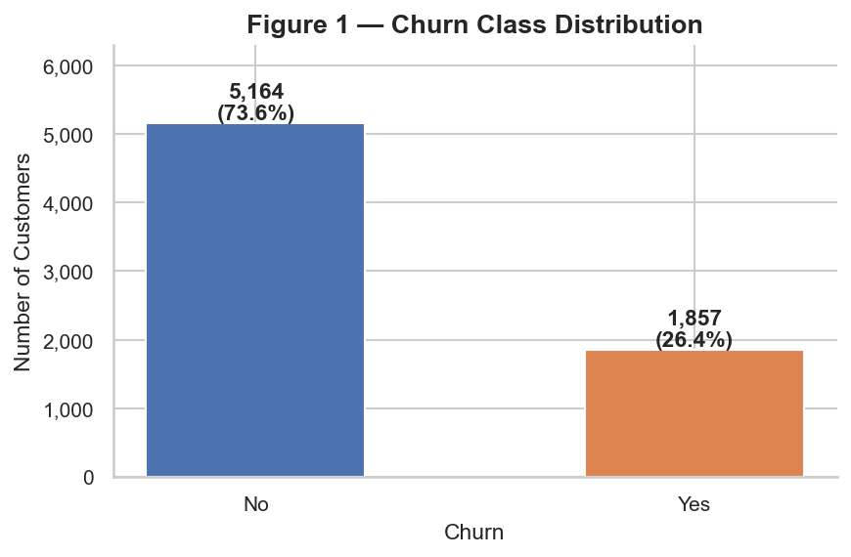
Figure 1 — Churn Class Distribution. 73.6% No Churn vs 26.4% Churn (N = 7,021).

9.2 Numerical Feature Distributions
tenure is bimodal — many customers are either very new (0–5 months) or long-tenured (50–72 months). MonthlyCharges is right-skewed with a cluster around $20. TotalCharges is heavily right-skewed, closely related to tenure × MonthlyCharges.
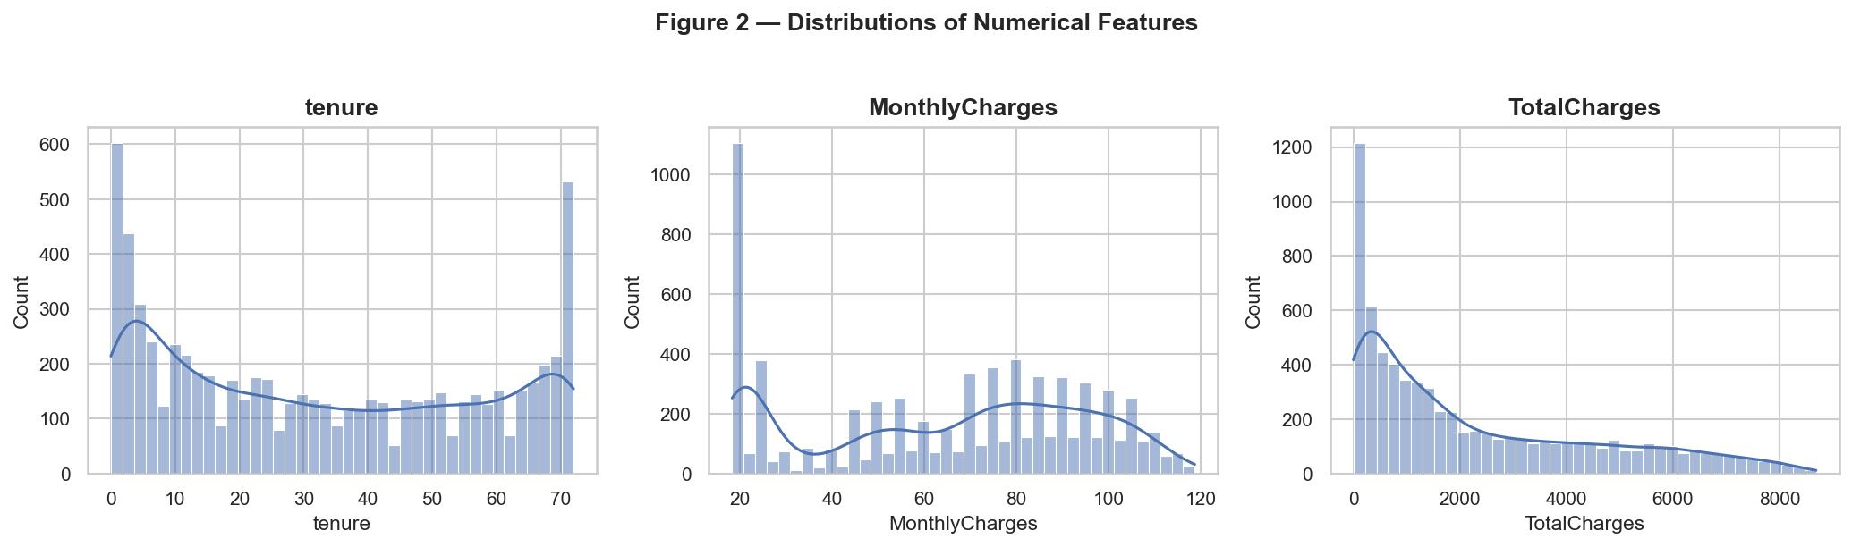
Figure 2 — Overall distributions of tenure, MonthlyCharges, and TotalCharges.
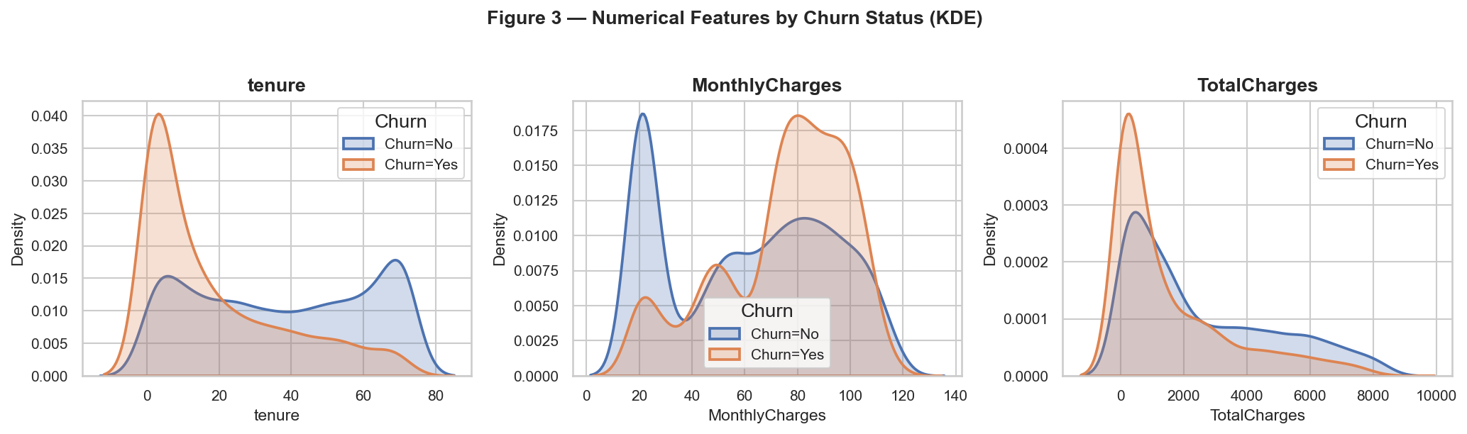
Figure 3 — Numerical feature distributions split by Churn status. Churned customers have shorter tenure and higher monthly charges on average.

9.3 Churn Rate by Contract Type
Contract type shows the largest churn rate gap of any single categorical feature. Month-to-month customers churn at approximately 43%, compared to 11% for one-year and 3% for two-year contracts.
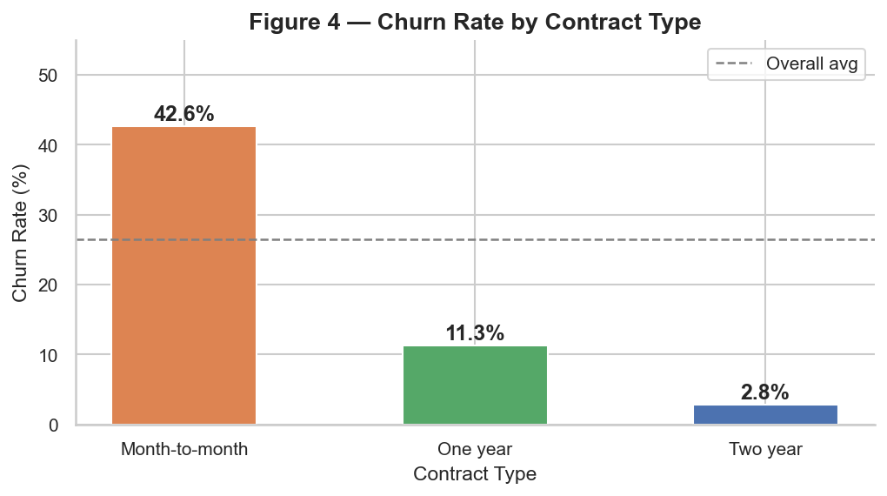
Figure 4 — Churn Rate by Contract Type. Month-to-month customers show a churn rate more than four times the dataset average.

9.4 Churn Rate by Tenure
Churn risk is highest in the first year (~48%) and declines monotonically with increasing tenure to below 10% for customers with 61–72 months tenure.
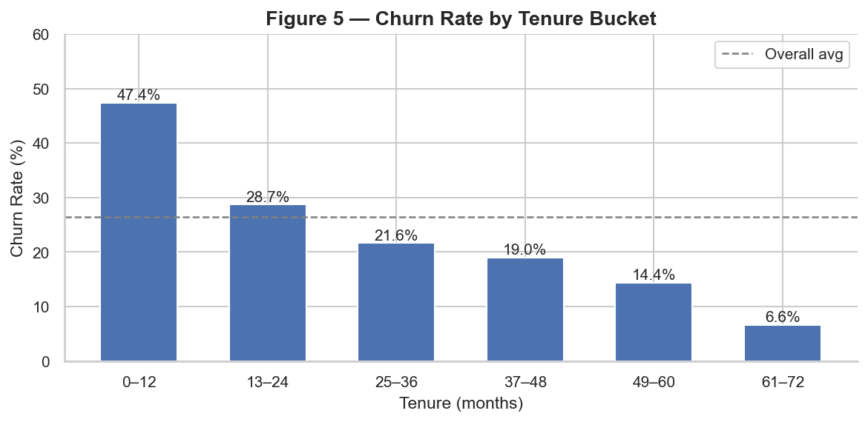
Figure 5 — Churn Rate by Tenure Bucket. The rate declines sharply with increasing tenure.

9.5 Churn Rate by Internet Service Type
Fibre optic customers churn at approximately 42% — more than double the rate of DSL customers (~19%) and six times the rate of customers with no internet service (~7%).
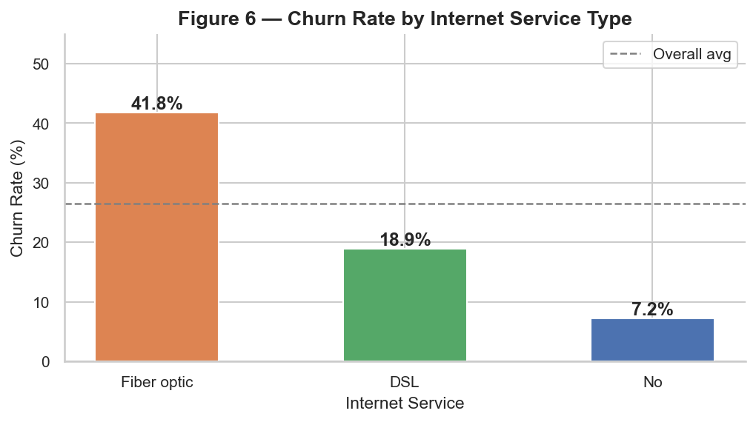
Figure 6 — Churn Rate by Internet Service Type. Fibre optic customers show the highest churn rate.

9.6 Churn Rate by Add-On Services
Across Tech Support, Online Security, Online Backup, and Device Protection, customers without add-on subscriptions show churn rates of 40–42%, compared to 14–16% for subscribers.
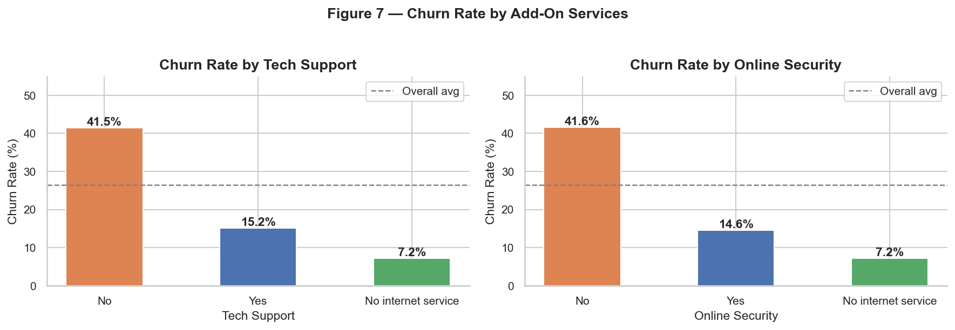
Figure 7 — Churn Rate by Tech Support and Online Security. Customers without add-on services show substantially higher churn rates.

9.7 Churn Rate by Payment Method
Electronic check payers churn at approximately 45% — nearly three times the rate of customers on automatic payment methods (16–18%).
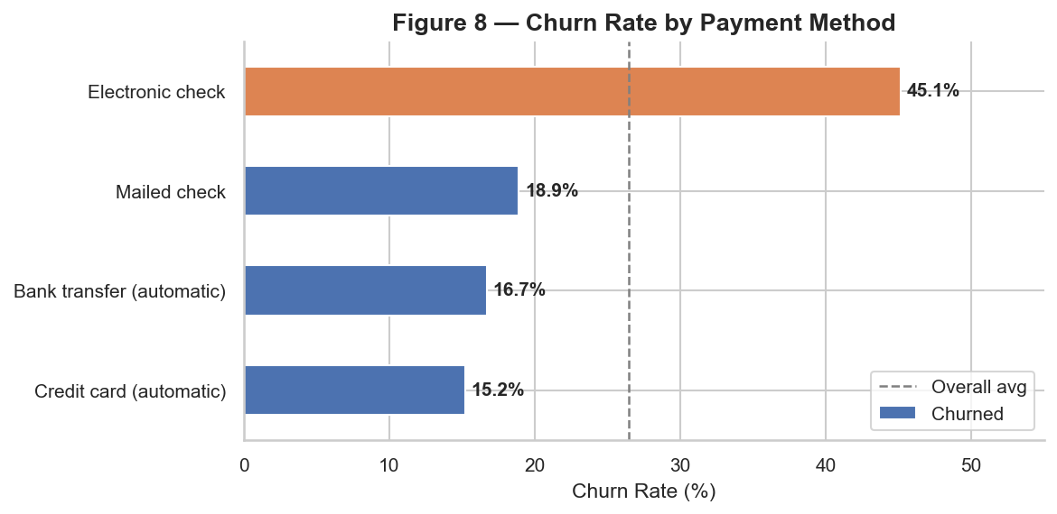
Figure 8 — Churn Rate by Payment Method. Electronic check payers show the highest churn rate.

9.8 Correlation Analysis
tenure and TotalCharges are strongly correlated (r = +0.83), signalling potential multicollinearity. tenure shows a moderate negative correlation with Churn (r = −0.35). MonthlyCharges shows a weak positive correlation (r = +0.19).
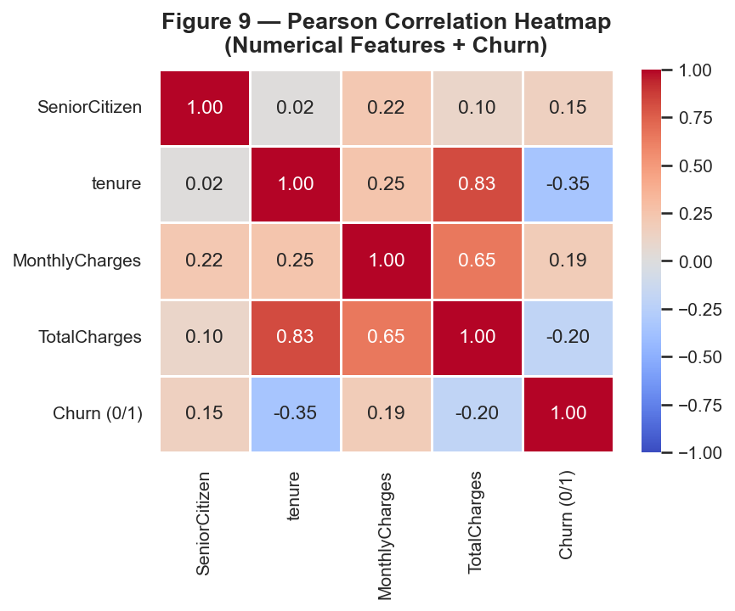
Figure 9 — Pearson Correlation Heatmap. Strong correlation between tenure and TotalCharges (r = 0.83) indicates potential multicollinearity.

10. Feature Engineering and Preprocessing

10.1 Target Encoding
The target column Churn (string: "Yes"/"No") was encoded as binary integer: "No" → 0 (retained), "Yes" → 1 (churned). This is the standard expectation of scikit-learn classifiers.

10.2 Train / Test Split
Parameter | Value | Rationale
test_size | 0.20 | 80/20 split; 1,405 test rows provides reliable metric estimates
random_state | 42 | Full reproducibility across runs
stratify | y | Preserves 73.6/26.4 class ratio in both partitions
Training rows | 5,616
Test rows | 1,405

10.3 Preprocessing Pipeline
All preprocessing is encapsulated inside a scikit-learn ColumnTransformer, which is the first step of each model Pipeline. This ensures preprocessing is applied consistently before every prediction.
Numerical pipeline (4 features: SeniorCitizen, tenure, MonthlyCharges, TotalCharges): SimpleImputer (strategy="median") → StandardScaler. The scaler centres each feature at zero and scales to unit variance, which is required for distance-sensitive models.
Categorical pipeline (15 features): SimpleImputer (strategy="most_frequent") → OneHotEncoder (handle_unknown="ignore", sparse_output=False). One-hot encoding is used instead of ordinal integer encoding because all 15 categorical features are nominal — assigning integers would impose false ordinal relationships.
The ColumnTransformer produces 45 output features: 4 scaled numerical + 41 one-hot encoded columns.

10.4 Prevention of Data Leakage
The train/test split is performed before any preprocessing is fitted. Each model Pipeline calls .fit(X_train, y_train), which fits the scaler and encoder exclusively on training data. Calling .predict(X_test) then applies the already-fitted parameters to the test set — the test set never influences the transformation parameters.

11. Machine Learning Methodology
Four binary classification models were trained. Each is wrapped in a Pipeline(preprocessor → classifier), ensuring consistent preprocessing and preventing leakage. All models use random_state=42 for reproducibility.

11.1 Logistic Regression
A linear probabilistic classifier that models the log-odds of churn as a weighted sum of scaled input features. Provides interpretable coefficients and serves as the linear baseline. Configured with C=1.0, max_iter=1000, class_weight="balanced" (to compensate for the 73.6/26.4 imbalance), solver=lbfgs.

11.2 Decision Tree Classifier
A non-linear model that learns axis-aligned decision rules through recursive binary splitting on individual features. Without depth constraints a single tree memorises the training set. Configured with max_depth=10, min_samples_leaf=20, class_weight="balanced".

11.3 Random Forest Classifier
An ensemble of 200 independently trained decision trees, each fitted on a bootstrap sample with a random feature subset at each split. Aggregating over trees reduces variance substantially compared to a single tree. Configured with n_estimators=200, min_samples_leaf=5, class_weight="balanced_subsample", n_jobs=-1.

11.4 Gradient Boosting Classifier
An ensemble that trains trees sequentially, each correcting the residual errors of the current model. Configured with n_estimators=200, learning_rate=0.1, max_depth=4, subsample=0.8. Does not support class_weight; the boosting mechanism provides partial compensation for class imbalance.

11.5 Why Multiple Models Were Compared
No single algorithm dominates on all tabular classification tasks. Logistic Regression provides an interpretable linear baseline; Decision Tree captures non-linearity; Random Forest and Gradient Boosting reduce variance/bias through ensembles. Comparing all four on the same held-out test set provides an evidence-based foundation for model selection rather than assuming one approach is superior.

12. Model Evaluation
All evaluation metrics were computed on the held-out test set (1,405 rows, untouched during training). The positive class is Churn = 1.

12.1 Metric Definitions
Metric | Formula | Interpretation in Churn Context
Accuracy | (TP + TN) / N | Overall fraction correct; misleading when classes are imbalanced
Precision | TP / (TP + FP) | Of all customers predicted to churn, the fraction that actually did
Recall | TP / (TP + FN) | Of all customers who actually churned, the fraction the model identified
F1-Score | 2·(P·R) / (P+R) | Harmonic mean of Precision and Recall; high only when both are reasonable
ROC-AUC | Area under ROC curve | Probability that the model ranks a random churner above a random non-churner; threshold-independent

12.2 Results Table
The following metrics were measured on the test set. Bold values indicate the highest score in each column.
Model | Accuracy | Precision | Recall | F1 Score | ROC-AUC
Logistic Regression | 0.7416 | 0.5079 | 0.7796 | 0.6151 | 0.8398
Random Forest | 0.7701 | 0.5520 | 0.6989 | 0.6168 | 0.8372
Gradient Boosting | 0.7907 | 0.6413 | 0.4758 | 0.5463 | 0.8333
Decision Tree | 0.7274 | 0.4898 | 0.7124 | 0.5805 | 0.8148

The Random Forest row is highlighted as the selected final model.

12.3 Confusion Matrices
Each matrix shows TN / FP / FN / TP counts and row-normalised percentages. False Negatives (FN) — missed churners — are typically the most costly error in a retention context. Gradient Boosting has the highest FN rate (~52%), while Logistic Regression and Decision Tree have the lowest.
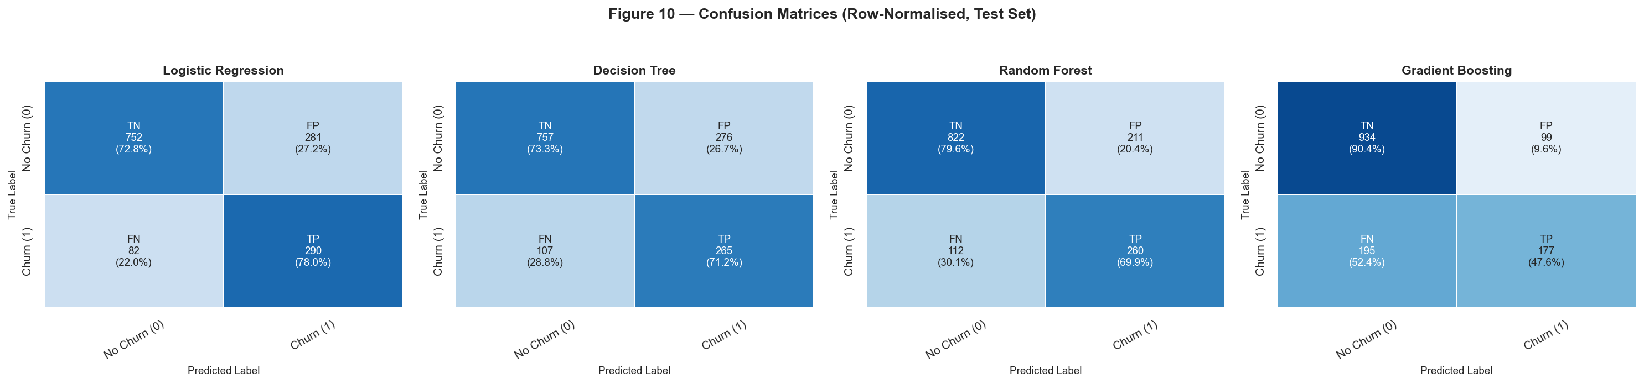
Figure 10 — Confusion Matrices for all four models (test set, row-normalised). Cells show label, raw count, and row percentage.

12.4 ROC Curves
ROC-AUC measures the model's ability to rank churners above non-churners at all probability thresholds. All four models substantially outperform random classification (AUC = 0.50). The differences between Logistic Regression (0.8398), Random Forest (0.8372), and Gradient Boosting (0.8333) are small; model selection is better driven by precision–recall trade-offs.
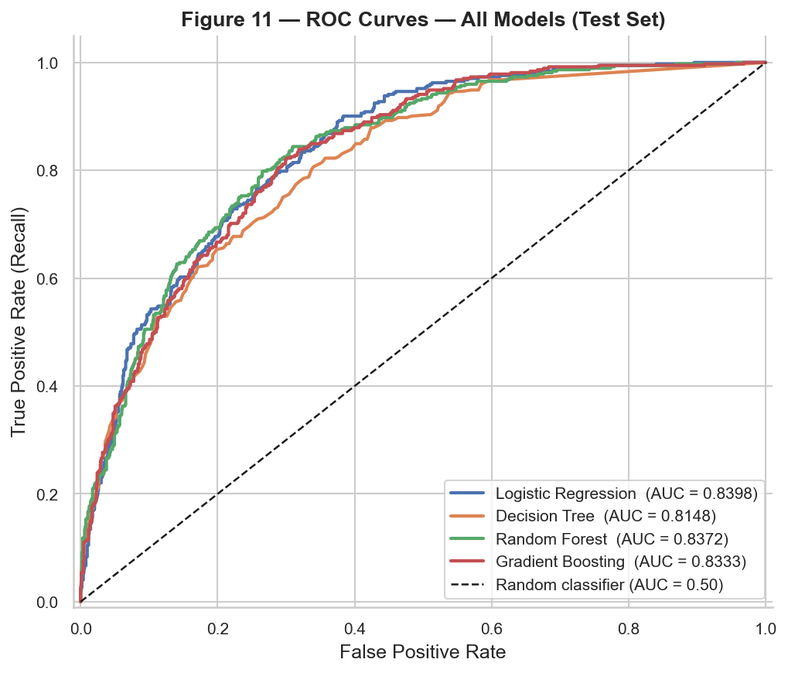
Figure 11 — ROC Curves for all four models (test set). Dashed diagonal line = random classifier baseline (AUC = 0.50).

12.5 Metric Comparison
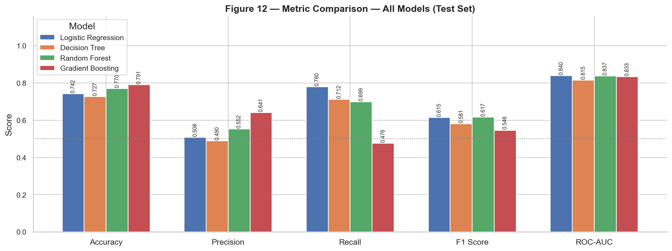
Figure 12 — All five evaluation metrics compared across models (test set). Gradient Boosting has the highest accuracy and precision; Logistic Regression has the highest recall; Random Forest has the highest F1-Score.

12.6 Why Accuracy Is Misleading Here
A trivial model predicting "No Churn" for every customer would achieve approximately 73.6% accuracy on this test set — higher than Logistic Regression and Decision Tree — while having a Recall of 0 (identifying zero churners). This illustrates why Recall, F1-Score, and ROC-AUC are more informative for imbalanced classification tasks.

13. Model Interpretation

13.1 Logistic Regression Coefficients
After fitting, each of the 45 preprocessed features has a coefficient reflecting its association with the log-odds of churn in the linear model. A positive coefficient means the feature is associated with higher predicted churn probability; a negative coefficient with lower. The absolute magnitude reflects the strength of that association.
Important caveat: These coefficients describe the model's linear fit to the training data. They are associations, not causal effects. The coefficient of Contract_Month-to-month does not mean that changing a customer's contract would reduce churn probability by a fixed amount.
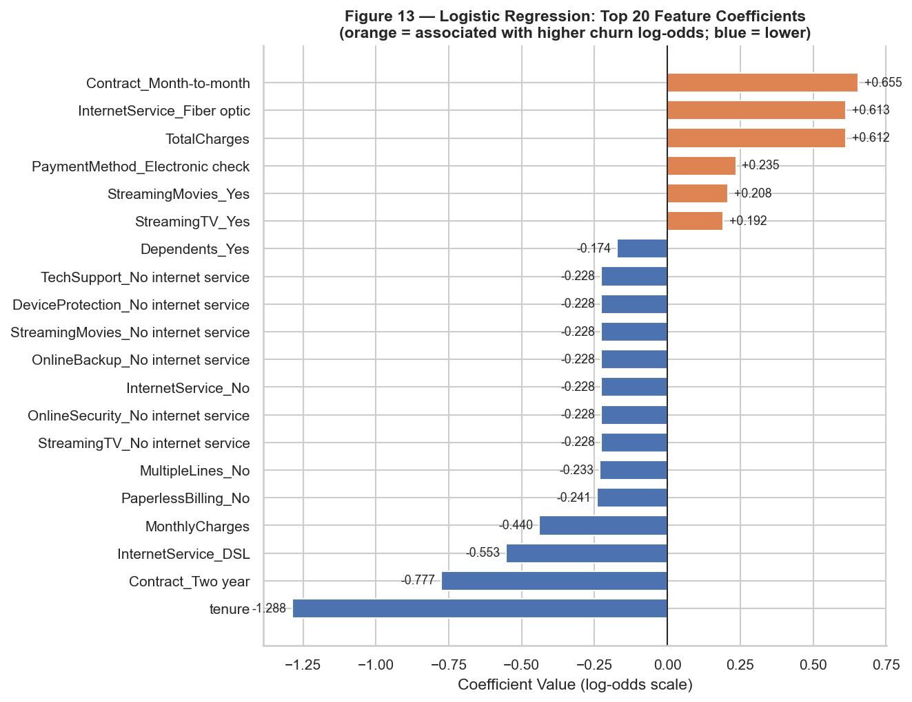
Figure 13 — Logistic Regression: Top 20 Feature Coefficients. Orange = positive association with churn log-odds; blue = negative association.

13.2 Random Forest Feature Importances
Random Forest's feature_importances_ reports mean Gini impurity reduction per feature across all 200 trees. Since categorical features are one-hot encoded into multiple columns, their importances are summed back to the original feature level for the aggregated view.
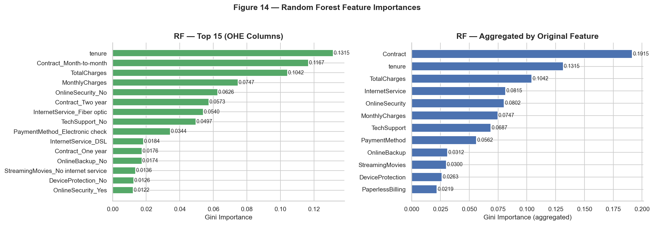
Figure 14 — Random Forest Feature Importances: individual OHE columns (left) and aggregated by original feature (right). tenure, MonthlyCharges, TotalCharges, and Contract are the most important features.

13.3 Gradient Boosting Feature Importances
Gradient Boosting exposes the same Gini importance mechanism. Its importance rankings broadly agree with the Random Forest rankings, with tenure, MonthlyCharges, and Contract consistently appearing among the top features.
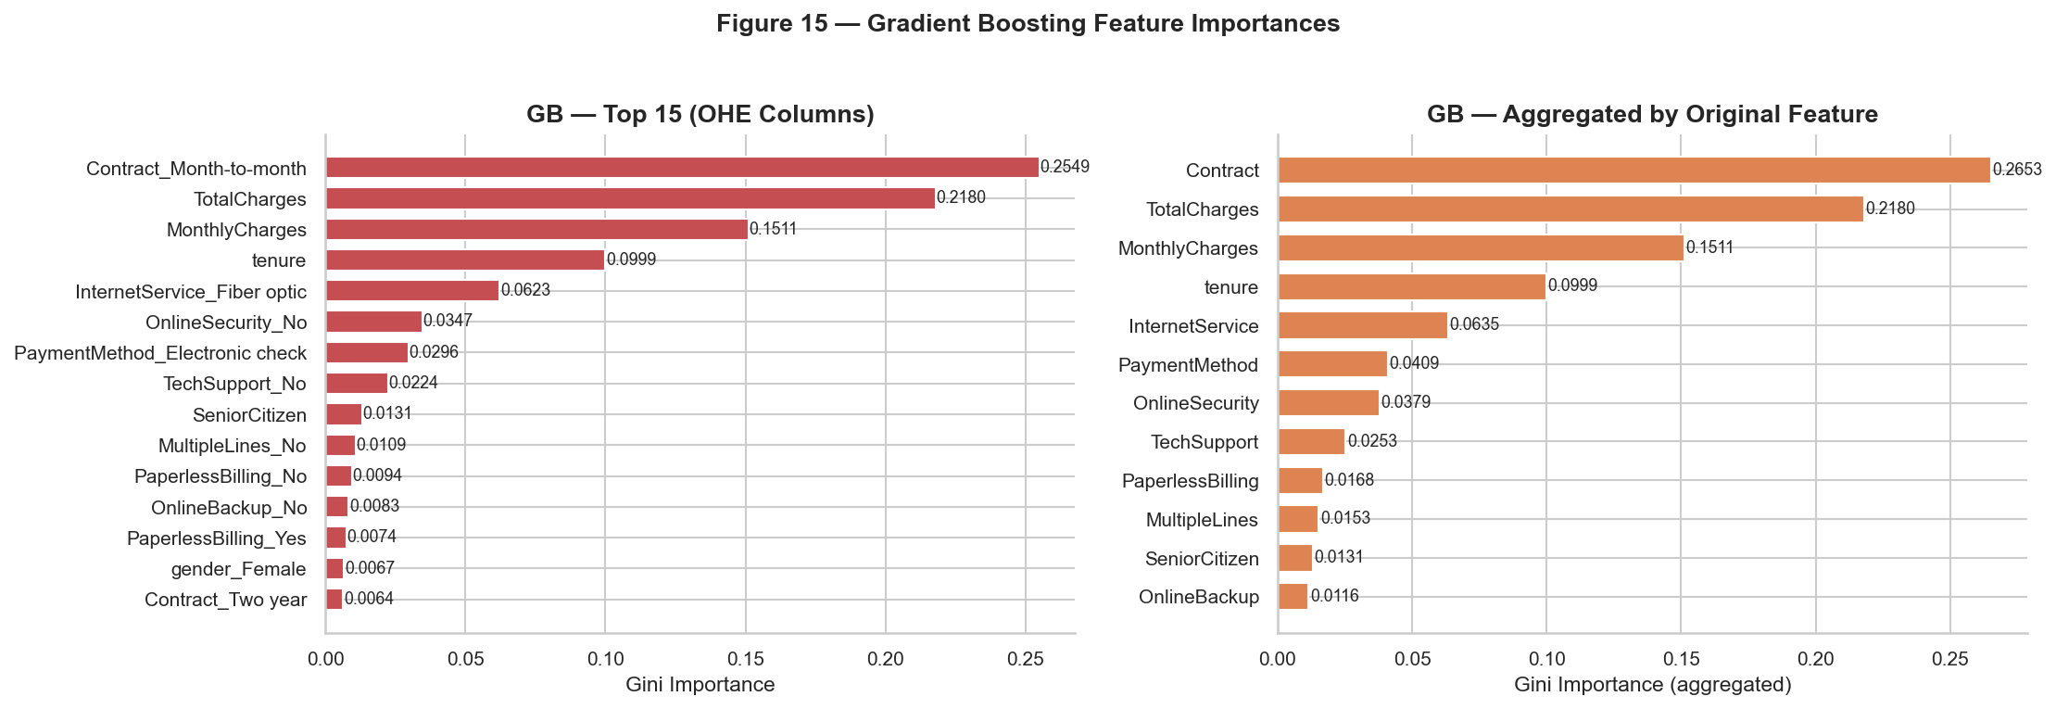
Figure 15 — Gradient Boosting Feature Importances: individual OHE columns (left) and aggregated by original feature (right).

13.4 Cross-Model Feature Agreement
Feature | RF | GB | LR | Consistently Important
tenure | Top | Top | Top | Yes
MonthlyCharges | High | High | High | Yes
TotalCharges | High | High | High | Yes (correlated with tenure)
Contract | Top | Top | Top | Yes
InternetService | High | High | Medium | Yes
OnlineSecurity | Medium | Medium | High | Yes
gender | Low | Low | Low | No
PhoneService | Low | Low | Low | No

Caveat: Feature importance describes predictive utility in this dataset — it does not establish causal influence on churn. Gini importance can overestimate the importance of correlated features (tenure and TotalCharges, r = 0.83).

14. Final Model Selection

14.1 Selection Criteria
The primary objective is to identify customers at risk of churning so that targeted retention interventions can be applied. Metrics are prioritised as follows:
Metric | Priority | Business Rationale
F1-Score | Highest | Balances Precision and Recall; a model must both catch churners and limit false alarms
Recall (Churn) | High | Missing a churner (False Negative) is typically the more costly error
ROC-AUC | High | Threshold-independent ranking; determines effectiveness of risk prioritisation
Precision (Churn) | Medium | Excessive false alarms waste retention resources
Accuracy | Low | Misleading on this imbalanced dataset — not used as primary criterion

14.2 Decision: Random Forest Selected
Random Forest was selected as the final model. It achieves the highest F1-Score (0.6168), the second-highest ROC-AUC (0.8372), and identifies approximately 70% of actual churners (Recall = 0.6989) while maintaining the best Precision among models with competitive Recall (0.5520).
Logistic Regression achieved a slightly higher ROC-AUC (0.8398) and higher Recall (0.7796) but at the cost of substantially lower Precision (0.5079) — roughly half of all churn predictions are incorrect. Gradient Boosting showed the highest Precision (0.6413) but missed 52% of actual churners (Recall = 0.4758), making it unsuitable as the primary model for retention. Decision Tree was dominated by the other models on all key metrics.
This selection is based on measured results under baseline hyperparameter configurations. A different business prioritisation (e.g., maximising Recall at all costs) would favour Logistic Regression. The model is not claimed to be universally optimal.

15. Final Prediction / Inference
The saved pipeline (models/final_churn_model.joblib) contains the complete fitted Pipeline — ColumnTransformer + RandomForestClassifier. Inference on new customer data requires only loading the file and calling predict() or predict_proba().
Five synthetic customer records were constructed in Step 9 to demonstrate inference. These records are entirely hypothetical and not from the original dataset.
Customer ID | Profile | Predicted Class | Churn Probability | Risk Tier
C001 | Two-year contract, 58m tenure, DSL, security=Yes, bank transfer | No Churn | 0.1058 | Lower
C002 | Month-to-month, 2m tenure, Fibre optic, security=No, e-check | Churn | 0.8853 | Higher
C003 | One-year contract, 24m tenure, DSL, security=Yes, mailed check | No Churn | 0.1095 | Lower
C004 | Month-to-month, 6m tenure, Fibre optic, security=No, e-check | Churn | 0.9389 | Higher
C005 | Two-year contract, 65m tenure, no internet, credit card auto | No Churn | 0.0140 | Lower

Risk tiers (illustrative only — not validated business thresholds): <0.30 = Lower; 0.30–0.60 = Intermediate; >0.60 = Higher. The default classification threshold is 0.50.
These probabilities are model outputs based on patterns learned from historical training data. They are not guarantees that a customer will or will not churn, and they should not be interpreted as causal statements.

16. Limitations
- Single dataset, single time period. The model was trained on one historical snapshot of a single provider's customer base. Performance on data from a different provider, geography, or time period is not guaranteed.
- No hyperparameter optimisation. All four models use baseline configurations. Systematic cross-validated tuning (e.g., GridSearchCV) has not been applied.
- Class imbalance not fully resolved. The 73.6/26.4 ratio is partially addressed through class_weight parameters; SMOTE oversampling and threshold calibration were not implemented.
- No temporal validation. The model has not been validated on a future time window (out-of-time testing).
- Limited feature set. The model uses only the 19 features in the dataset. Customer service interaction history, lifetime value, or competitor pricing data may add predictive value.
- Predictions are not causal. A high predicted churn probability means statistical similarity to past churners — it does not mean any feature caused the customer to churn.
- Not production-ready. There is no serving infrastructure, API, model monitoring, drift detection, or retraining pipeline.
- Gini importance limitations. Impurity-based importance can overestimate the importance of high-cardinality and correlated features. More robust methods (SHAP values) were not computed.
- Default threshold not calibrated. The 0.50 threshold is used throughout. The optimal threshold depends on the relative cost of False Positives and False Negatives, which requires business input.

17. Future Scope
The following improvements are proposed. None have been implemented in the current project.
- Hyperparameter optimisation using GridSearchCV or RandomizedSearchCV with stratified k-fold cross-validation on the training set.
- Threshold calibration — select an operating threshold based on the business cost ratio of False Negatives to False Positives.
- SMOTE oversampling applied within a cross-validation loop to address class imbalance more directly.
- Additional model families — compare against XGBoost, LightGBM, or CatBoost.
- SHAP values for per-prediction local explanations, enabling transparent risk-score communication to business stakeholders.
- Out-of-time validation — hold out a future time period to verify temporal stability of model predictions.
- Feature engineering — derive composite features (e.g., charges per tenure month, interaction terms between Contract and InternetService).
- Model monitoring pipeline — track prediction score distributions and feature statistics over time to detect data drift.
- Deployment — build a web-based inference interface (e.g., using Flask or Streamlit) for real-time churn probability scoring.

18. Conclusion
This project demonstrates a complete, reproducible machine learning workflow for customer churn prediction using the Telco Customer Churn dataset. The project was implemented across nine Jupyter notebooks, progressing from raw data inspection through a systematic quality audit, data cleaning, exploratory data analysis, preprocessing pipeline construction, model training, evaluation, interpretation, final model selection, and inference demonstration.
The primary data quality issues identified were a TotalCharges column stored as a string due to 11 blank values (resolved by type coercion and zero-imputation for tenure-0 customers) and the customerID column (removed as non-predictive). The cleaned dataset contained 7,021 rows with zero missing values.
EDA revealed that contract type, customer tenure, internet service type, the presence or absence of add-on services, and payment method are all associated with meaningfully different churn rates in this dataset. All findings were stated as statistical associations without causal claims.
Model | Accuracy | Precision | Recall | F1 Score | ROC-AUC
Logistic Regression | 0.7416 | 0.5079 | 0.7796 | 0.6151 | 0.8398
Random Forest ★ | 0.7701 | 0.5520 | 0.6989 | 0.6168 | 0.8372
Gradient Boosting | 0.7907 | 0.6413 | 0.4758 | 0.5463 | 0.8333
Decision Tree | 0.7274 | 0.4898 | 0.7124 | 0.5805 | 0.8148

Random Forest was selected as the final model (★) on the basis of its highest F1-Score (0.6168), competitive ROC-AUC (0.8372), and the most balanced trade-off between Recall (0.6989) and Precision (0.5520). The final pipeline (models/final_churn_model.joblib) can be loaded with a single joblib.load() call and applied directly to new 19-column customer data.
The results and findings are presented as statistical associations observed in the training data. They should not be interpreted as causal conclusions about customer behaviour. The model is intended as a demonstration of the end-to-end machine learning workflow and is not presented as production-ready.

19. References
[1] Telco Customer Churn Dataset — IBM Watson Analytics Sample Data. Available at: https://www.kaggle.com/datasets/blastchar/telco-customer-churn
[2] Pedregosa, F. et al. (2011). Scikit-learn: Machine Learning in Python. Journal of Machine Learning Research, 12, 2825–2830. Documentation: https://scikit-learn.org/stable/
[3] The Pandas Development Team (2023). pandas-dev/pandas: Pandas. Documentation: https://pandas.pydata.org/docs/
[4] Harris, C.R. et al. (2020). Array programming with NumPy. Nature, 585, 357–362. Documentation: https://numpy.org/doc/
[5] Hunter, J.D. (2007). Matplotlib: A 2D Graphics Environment. Computing in Science & Engineering, 9(3), 90–95. Documentation: https://matplotlib.org/stable/
[6] Waskom, M.L. (2021). seaborn: statistical data visualization. Journal of Open Source Software, 6(60), 3021. Documentation: https://seaborn.pydata.org/
[7] Joblib Development Team. joblib: Lightweight pipelining. Documentation: https://joblib.readthedocs.io/
[8] Kluyver, T. et al. (2016). Jupyter Notebooks — a publishing format for reproducible computational workflows. Positioning and Power in Academic Publishing, 87–90. Documentation: https://jupyter-notebook.readthedocs.io/
[9] Rahman, F. (2019). "Telco Customer Churn – Logistic Regression". Kaggle. Reference consulted during project development. Available at: https://www.kaggle.com/code/farazrahman/telco-customer-churn-logisticregression

