**ISM 6208: Data Warehousing**

**Final Project**



**GLOBAL INFLATION ANALYSIS**

**Submitted By:**

Lakshmi Sravya Dama

Sudeshna Mullaguru

Nikhil Namani

Vinaya Nayak Rajaram

Gayathri Shanmuga Sundaram

**Index**

Executive Summary Page-3

Problem Statement Page-3

Literature Review Page-4

Database Design Page-4

Data Collection and Preparation Page-5 to 17

Exploratory Data Analysis Page-17 to 20

Reporting, Modeling, and Storytelling Page-20 to 27

References Page-27

**Executive Summary:**

Global inflation analysis is a critical area of study that examines the patterns, trends, and factors influencing the rise and fall of prices for goods and services on a worldwide scale. Inflation, a key economic indicator, has far-reaching implications for businesses, governments, and investors. This data warehouse project aims to centralize and analyze diverse datasets, providing stakeholders with a comprehensive view of global inflation trends. By harnessing historical data, conducting comparative analyses, and employing forecasting models, this project seeks to empower decision-makers with the insights needed to navigate the complex landscape of international economics.

**Problem Statement:**

In the current dynamic and interconnected global economic landscape, the lack of a centralized and comprehensive platform for analyzing inflation trends poses a significant challenge for stakeholders. Disparate sources of inflation-related data, varying formats, and a lack of standardized processes hinder the ability of businesses, policymakers, and investors to make well-informed decisions. Without a dedicated data warehouse project, there is a notable absence of a unified system capable of historical analysis, cross-country comparisons, and accurate forecasting. This creates a pressing need for a solution that can integrate and analyze inflation data on a global scale, providing actionable insights to navigate the complexities of the international economic environment effectively. The problem at hand is the absence of a centralized and robust data warehouse for global inflation analysis, limiting the ability of stakeholders to derive meaningful conclusions and make proactive decisions in the face of ever-changing economic conditions.

**Literature Review:**

In today's world, how prices change, and companies decide on layoffs are big deals for everyone. We want to understand which countries are dealing with high prices, which companies had to let go of many employees, and how inflation affects things like house prices and loan rates. This review digs into what experts have found about these topics, helping us see the bigger picture and make smarter choices in a fast-changing economy.

1. What are the countries with high inflation rate by continents?
2. Which are the top companies that laid of maximum number of employees?
3. What are the impacts of inflation rate on housing price and interest rate?
4. What are the types of Inflation and its proportion?
5. Is there a correlation between the GDP Rate and Inflation Rate in different countries over the years?
6. Which countries had the highest layoff percentage in the last 3 years?

**SCHEMA**

From the above snapshot, the Fact table orders data at the center, and dimensional tables are joined to the fact table using primary keys.

Tables are joined using the below combinations:

1. Global_Economic_Facts table and Layoff_dimenison tables are joined using layoff_cid foreign key to country_code and year composite key.
2. Global_Economic_Facts table and Housing_Pricing_Dimension tables are joined using house_cid foreign key to country_code and year composite key.
3. Global_Economic_Facts table and Interest_Rate_Dimension tables are joined using interest_cid foreign key to country_code and year composite key.
4. Global_Economic_Facts table and Date_Dimension tables are joined using year foreign key to country_code and year composite key.
5. Global_Economic_Facts table and GDP_Data_Dimension tables are joined using GDP_Cid foreign key to country_code and year composite key.
6. Global_Economic_Facts table and Inflation_Dimension tables are joined using Infl_Cid foreign key to country_code and year composite key.
7. Global_Economic_Facts table and Country_Dimension tables are joined using country_Cid foreign key to country_code and year composite key.

**Data Collection**

**Data Sets:**

1. **Inflation Data**: This table consists of data on the Inflation Rate of various countries from the year 2018 to 2022.

2. **GDP Rate**: This table consists of data related to the GDP of the countries from 2018 to 2022.

3. **Housing Price**: This table consists of data related to housing prices like Price Income Ratio, Price Rent Price Ratio, Rent Price, and so on from 2018 to 2022.

4. **Interest Rate**: This table has interest rates implied by the prices at which government bonds are traded on financial markets from 2018 to 2022.

5. **Layoff**: This table consists of data related to company layoffs, industry, employee count, source, employee details, and dates from 2020 to 2023.

6. **Country and Continent**: The table consists of countries or areas in alphabetical order, and their three-digit numerical codes used for statistical processing purposes by the Statistics Division of the United Nations Secretariat.

**Sources**:

1. World Bank

2. International Monetary Fund

3. Organization for Economic Cooperation and Development

4. International Organization for Standardization

5. United Nations Statistics Division

**Data Preparation**

Data has been collected from Kaggle and from a GitHub repository. We then cleaned the dataset and created the corresponding fact and dimensional tables. It has been gathered from multiple sources and a few columns are generated manually. Data has been designed according to normalization rules to avoid redundancy.

These are the table names.

**Global_Economic_Facts,Layoff_Dimension,Housing_Pricing_Dimension,Inflation_Dimension,Country_Dimension,Date_Dimension,GDP_Date_Dimension,Interest_Rate_Dimension.**

Below are the queries used to create the tables:

**COUNTRY_DIMENSION TABLE:**

**LAYOFF_DIMENSION:**

CREATE TABLE "LAYOFF_DIMENSION"

( "COUNTRY_CODE" VARCHAR2(40 BYTE),

"COUNTRY" VARCHAR2(100 BYTE),

"month" NUMBER(38,0),

"day" NUMBER(38,0),

"year" NUMBER(38,0),

"COMPANY" VARCHAR2(128 BYTE),

"LOCATION_HQ" VARCHAR2(26 BYTE),

"INDUSTRY" VARCHAR2(26 BYTE),

"STAGE" VARCHAR2(26 BYTE),

"REGION" VARCHAR2(26 BYTE),

"CONTINENT" VARCHAR(38 BYTE)

) SEGMENT CREATION IMMEDIATE

PCTFREE 10 PCTUSED 40 INITRANS 1 MAXTRANS 255

NOCOMPRESS LOGGING

STORAGE(INITIAL 65536 NEXT 1048576 MINEXTENTS 1 MAXEXTENTS 2147483645

PCTINCREASE 0 FREELISTS 1 FREELIST GROUPS 1

BUFFER_POOL DEFAULT FLASH_CACHE DEFAULT CELL_FLASH_CACHE DEFAULT);

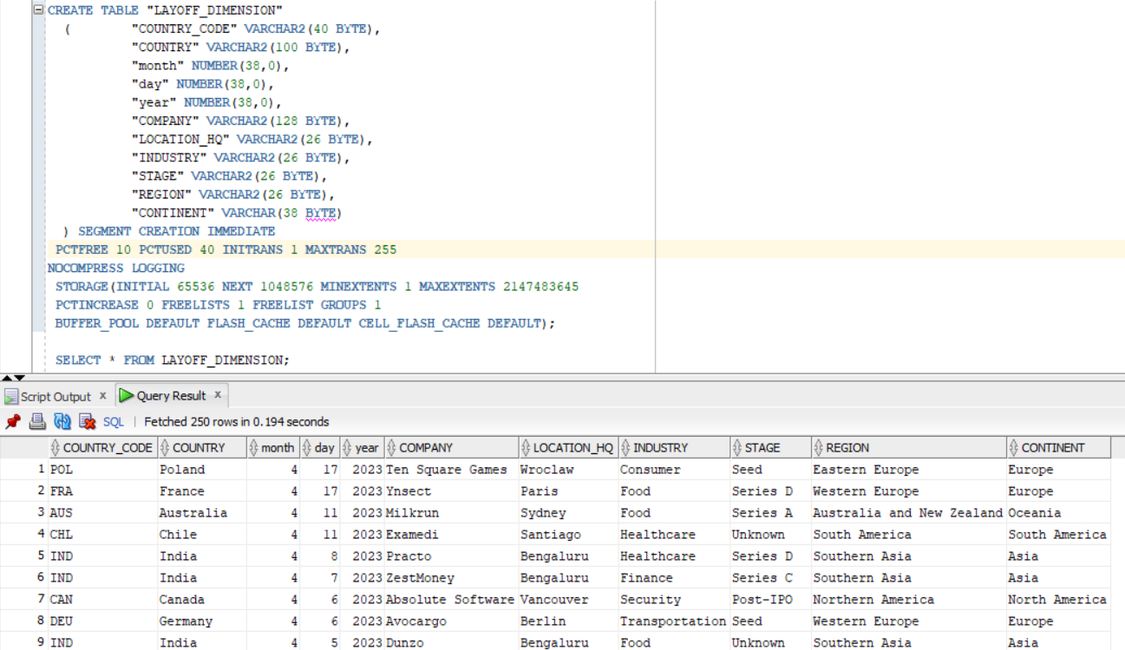

**INTEREST_RATE_DIMENSION:**

CREATE TABLE "INTEREST_RATE_DIMENSION"

( "COUNTRY_CODE" VARCHAR2(40 BYTE),

"YEAR" NUMBER(38,0),

"COUNTRY" VARCHAR2(128 BYTE),

"REGION" VARCHAR2(26 BYTE),

"CONTINENT" VARCHAR(38 BYTE)

) SEGMENT CREATION IMMEDIATE

PCTFREE 10 PCTUSED 40 INITRANS 1 MAXTRANS 255

NOCOMPRESS LOGGING

STORAGE(INITIAL 65536 NEXT 1048576 MINEXTENTS 1 MAXEXTENTS 2147483645

PCTINCREASE 0 FREELISTS 1 FREELIST GROUPS 1

BUFFER_POOL DEFAULT FLASH_CACHE DEFAULT CELL_FLASH_CACHE DEFAULT);

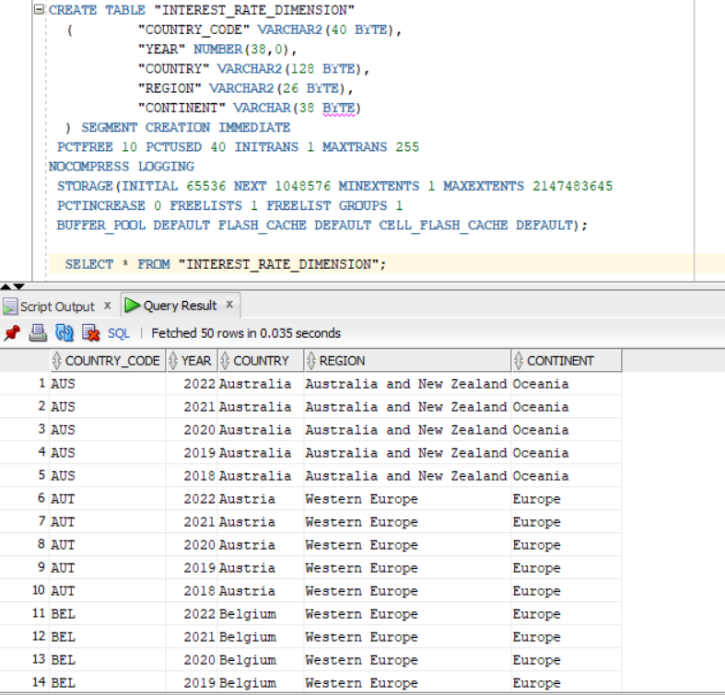**INFLATION DIMENSION:**

CREATE TABLE "INFLATION_DIMENSION"

( "COUNTRY_CODE" VARCHAR2(40 BYTE),

"YEAR" NUMBER(38,0),

"COUNTRY" VARCHAR2(128 BYTE),

"INFLATION_TYPE" VARCHAR2(128 BYTE),

"NOTE" VARCHAR(128 BYTE),

"REGION" VARCHAR2(26 BYTE),

"CONTINENT" VARCHAR(38 BYTE)

) SEGMENT CREATION IMMEDIATE

PCTFREE 10 PCTUSED 40 INITRANS 1 MAXTRANS 255

NOCOMPRESS LOGGING

STORAGE(INITIAL 65536 NEXT 1048576 MINEXTENTS 1 MAXEXTENTS 2147483645

PCTINCREASE 0 FREELISTS 1 FREELIST GROUPS 1

BUFFER_POOL DEFAULT FLASH_CACHE DEFAULT CELL_FLASH_CACHE DEFAULT);

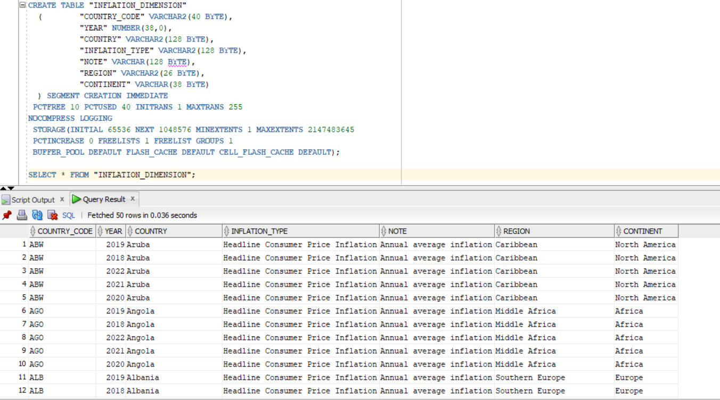

**HOUSING_PRICE_DIMENSION:**

CREATE TABLE "HOUSING_PRICE_DIMENSION"

( "COUNTRY_CODE" VARCHAR2(40 BYTE),

"YEAR" NUMBER(38,0),

"COUNTRY" VARCHAR2(128 BYTE),

"SUBJECT" VARCHAR2(128 BYTE),

"REGION" VARCHAR2(26 BYTE),

"CONTINENT" VARCHAR(38 BYTE)

) SEGMENT CREATION IMMEDIATE

PCTFREE 10 PCTUSED 40 INITRANS 1 MAXTRANS 255

NOCOMPRESS LOGGING

STORAGE(INITIAL 65536 NEXT 1048576 MINEXTENTS 1 MAXEXTENTS 2147483645

PCTINCREASE 0 FREELISTS 1 FREELIST GROUPS 1

BUFFER_POOL DEFAULT FLASH_CACHE DEFAULT CELL_FLASH_CACHE DEFAULT);

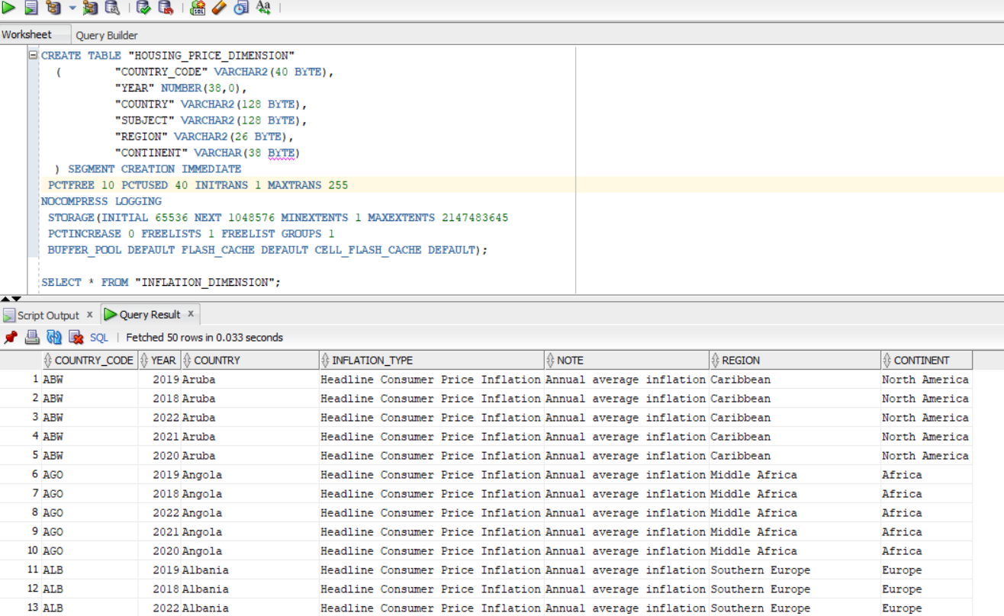

**GDP_DATA_DIMENSION:**

CREATE TABLE "GDP_DATA_DIMENSION"

( "COUNTRY_CODE" VARCHAR2(40 BYTE),

"YEAR" NUMBER(38,0),

"COUNTRY" VARCHAR2(128 BYTE),

"REGION" VARCHAR2(26 BYTE),

"CONTINENT" VARCHAR(38 BYTE)

) SEGMENT CREATION IMMEDIATE

PCTFREE 10 PCTUSED 40 INITRANS 1 MAXTRANS 255

NOCOMPRESS LOGGING

STORAGE(INITIAL 65536 NEXT 1048576 MINEXTENTS 1 MAXEXTENTS 2147483645

PCTINCREASE 0 FREELISTS 1 FREELIST GROUPS 1

BUFFER_POOL DEFAULT FLASH_CACHE DEFAULT CELL_FLASH_CACHE DEFAULT);

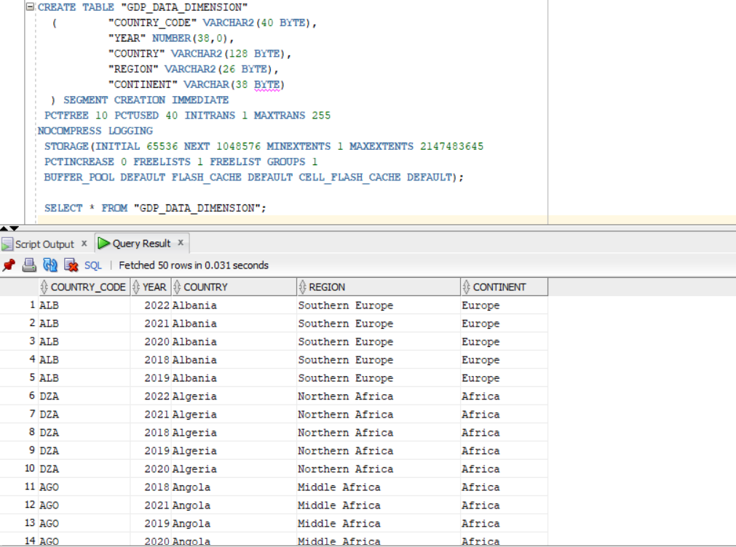

**GLOBAL_ECONOMIC_FACTS :**

**Exploratory Data Analysis (EDA)**

**1. What are the countries with high inflation rate by continents?**

select CONTINENT,COUNTRY_CODE,COUNTRY,SUM(INFLATION_RATE) AS infl_rate from

INFLATION_DIMENSION idi join global_economic_facts gef on gef.INFL_CID = idi.COUNTRY_CODE AND idi.YEAR = gef.year

GROUP BY CONTINENT,COUNTRY_CODE,COUNTRY

order by CONTINENT ,SUM(INFLATION_RATE) desc

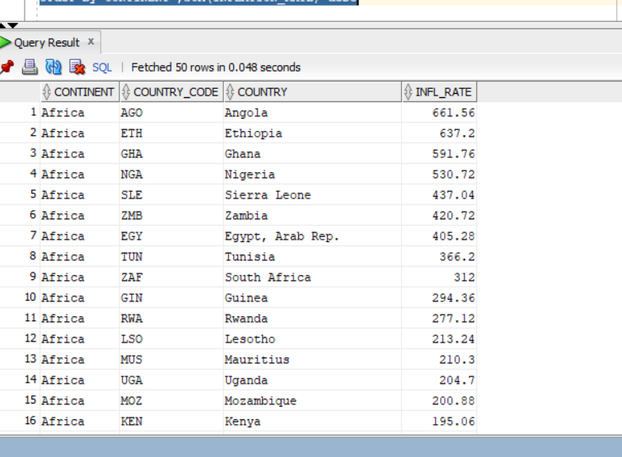

**2. Which are the top companies that laid of maximum number of employees?**

select COMPANY,ROUND(sum(LAID_OFF_COUNT)) AS "laid_off" from

LAYOFF_DIMENSION LAYD join global_economic_facts gef on gef.LAYOFF_CID = LAYD.COUNTRY_CODE AND LAYD.YEAR = GEF.YEAR

group by company

ORDER BY sum(LAID_OFF_COUNT) DESC

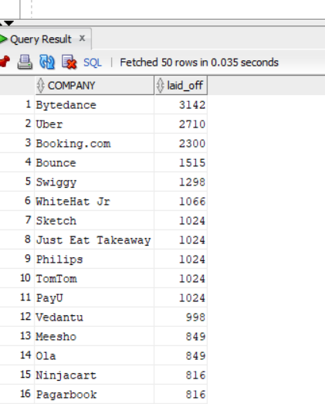

**3.What are the impacts of inflation rate on housing price and interest rate?**

SELECT distinct GEF.YEAR,INFLATION_RATE,INTEREST_RATE,HOUSE_VALUE

FROM global_economic_facts gef JOIN HOUSING_PRICE_DIMENSION HPD ON HPD.COUNTRY_CODE = GEF.HOUSE_CID AND HPD.YEAR = GEF.YEAR

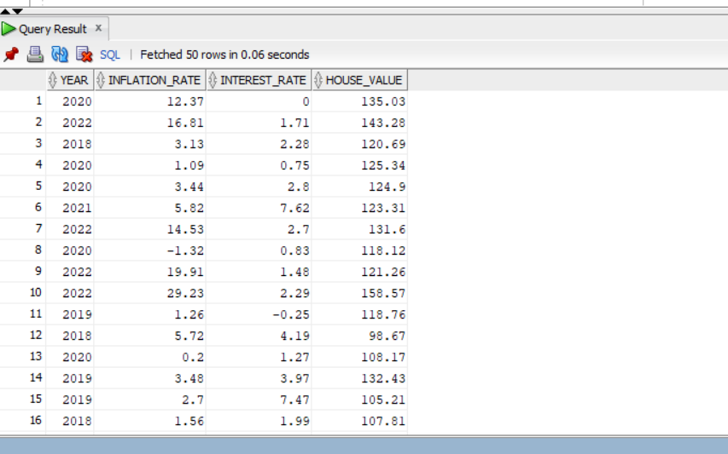

**Reporting, Modeling and Storytelling**

Below are the important findings that we found from the data warehouse model. We have addressed the questions below using the tableau.

**1. What are the countries with high inflation rate by continents?**

We used a bar chart as we must analyze the average inflation rate trend over a specific point in time.

From the chart, it is evident that Inflation Rate spiked over the last three years.

2. What are the types of Inflation and its proportion?

It is clearly understandable from the chart that the top Inflation Price is Headline Consumer Price and Food Consumer Price and Official Core Consumer Price is the least. Also, except for Official Core Consumer Price inflation, almost all the other inflations are in almost the same proportion.

3. What are the countries with High Inflation Rates by Continent?

We used the Horizontal bar chart with the drill-down option. Also, we used the color option to help in distinguishing the top countries in each Continent.

It is clear from the graph that South America has the Highest Inflation Rate. An interesting insight is that Iran, Yemen, and Turkey have Inflation Rate has a similar range of Inflation Rates. Europe looks like the one country with lowed Inflation Rate making it the best country for people to live.

4. Is there a correlation between the GDP Rate and Inflation Rate in different countries over the years?

Here we chose to use the lined chart to show how is the trend over the years between the GDP Rate and the Inflation Rate.

From the chart it is evident that the GDP and inflation have an inverse relationship. A high rate of inflation can lead to a decrease in the GDP rate, as it can increase costs for businesses and consumers, reduce purchasing power, and discourage investment.

On the other hand, a low rate of inflation can be beneficial for economic growth, as it can increase consumer and business confidence, encourage investment, and make it easier for businesses to plan.

5. What are the impacts of the Inflation Rate on the Housing Price Rate and Interest Rate?

Here we chose to use the double bar chart to show how is the trend over the years between the Interest Rate and the Inflation Rate.

It is understandable from the graph that they both are interlinked to each other. When the Inflation goes high, the interest goes high like in 2022. Inflation can lead to an increase in interest rates, as lenders may demand higher interest rates to compensate for the decrease in purchasing power caused by inflation. High inflation rates can also lead to a decrease in the demand for bonds, which can cause bond prices to decrease and interest rates to increase.

From this graph it is evident that housing price rate and Inflation go hand in hand. Both rates shoot up so high in the year 2022.

1. Which countries had the highest layoff percentage in the last 3 years?

We used the map in this scenario, as we would like to see the layoff percentage globally. Also, we used color to show the intensity of layoff.

From the map, it is evident that on comparing past years from 2020 and 2023, India, and Canada have the highest layoff percentage.

**Conclusion**:

From the above graphs and effective visualization, the relationship between Inflation Rate is clear between GDP, Housing Price Rate, and Interest Rate. The Inflation Rate goes hand in hand with Housing Price Rate and Interest Rate. However, the relationship between housing prices and inflation can be influenced by a variety of other factors, such as changes in interest rates, supply and demand for housing, and government policies related to housing and the economy. For example, if interest rates rise, it can lead to a decrease in demand for housing and a subsequent decrease in housing prices, even if inflation is still high.

Gross Domestic Product (GDP) and inflation have a complex relationship that can be influenced by a range of factors. In general, when the GDP of a country is growing, it can put upward pressure on prices and cause inflation to rise. This is because as the economy grows, demand for goods and services can increase, and this increased demand can push up prices. Additionally, as the cost of producing goods and services increases, producers may need to raise prices to maintain their profit margins.

Regarding the Layoff overview, on providing the given data it has predicted more likely the recession would come down over 2023 year eventually.

**References**:

Dataset:

World Bank. (URL: https://www.worldbank.org)

International Monetary Fund. (URL: [https://www.imf.org](https://www.imf.org/))

Organisation for Economic Co-operation and Development. (URL: [https://data.oecd.org](https://data.oecd.org/))

Layoffs.fyi. (URL: <https://layoffs.fyi/>)

Statistics Times. (URL: <https://statisticstimes.com/geography/countries-by-continents.php>)